GMP 3

Good Measurement Practice
for
Method of Reading a Meniscus Using Water or Other Wetting Liquid

Meniscus Reading in Calibrations
The meniscus of most liquids used in volumetric calibrations is concave-up, with the lowest point in the center that is used to determine the meniscus reading. The curvature of a meniscus is related to the surface tension of the liquid and inversely related to the diameter of the tubing in which it is formed. When reading any meniscus, it is important to ascertain that it is in an equilibrium position. Tapping of sight glasses and/or small motions of containers may be used to induce slight displacements of the meniscus. Return to the same reading is evidence of a stable meniscus.
The meniscus formed by a non-wetting liquid, such as mercury (Hg), is convex with the highest point in the center and is no longer regularly used for volumetric calibrations. In the case of a convex meniscus, the highest point is used to make the reading. The reading of a mercury barometer or thermometer is a classic example of this kind.
In all apparatus where the volume is defined by a concave-up meniscus, the setting or reading is made on the lowest point of the meniscus. In order that the lowest point may be observed, it is necessary to place a shade of some dark material immediately below the meniscus, which renders the profile of the meniscus dark and clearly visible against a light background. A convenient device for this purpose is a collar-shaped section of thick black rubber tubing, cut open at one side and of such size as to clasp the tube firmly.

Types of Meniscus Readers
Several types of meniscus readers are available. These include black/white meniscus card readers, magnifying glasses with cross-hairs, and collar shaped tubes that may be placed around the graduated neck of the volumetric container. Black/ white meniscus card readers are simple to create as shown in the figure below.

Figure 1. Example meniscus reader.
This type of meniscus reader is generally preferred for the Option A method of reading the meniscus. More elaborate card readers may be purchased that allow placement around the neck of a flask.
Another type of meniscus reader consists of a clear lens (plastic or glass) with etched lines on the front and back that are aligned to prevent parallax errors in reading. This type may or may not include magnification. This type of reader is preferred for Option B.

Methods for Meniscus Reading
Two common methods are used for setting and visually reading a meniscus: Options A and B. The method used in calibration should be consistent with the intended use of the volumetric standard. For interlaboratory comparisons, the method to be used should be defined during the planning stages of the comparison. The width of the graduation on the neck scale will affect the readability of the meniscus and should be estimated to the nearest 1/10 of a division when using either Option A or Option B.

Option A
Option A is suitable when graduation lines extend more than 75 percent of the circumference of the sight gage area, for example with graduated neck type flasks or single mark flasks.
The position of the lowest point of the meniscus with reference to the graduation line is such that it is in the plane of the middle of the graduation line. This position of the meniscus is obtained by making the setting in the center of the ellipse formed by the graduation line on the front and the back of the tube as observed by having the eye slightly below the plane of the graduation line. This is illustrated below. The setting is accurate if, as the eye is raised and the ellipse narrows, the lowest point of the meniscus remains midway between the front and rear portions of the graduation line. By this method it is possible to observe the approach of the meniscus from either above or below the line to its proper setting.
Front Side of Index Line
Meniscus Surface
Rear Side of
Index Line
FRONT VIEW
Observer’s View from Slightly Below the Horizontal Level of the Graduation Line.
SIDE VIEW
Exaggerated Curvature Meniscus Surface
Circumferential Graduation Line
Line-of-Sight to Front Side of Index
Observer’s Eye
Line-of-Sight to Rear Side of Index
Line-of-Sight to Meniscus
Black Rubber Opaque Screen Placed a Fraction of a Millimeter Below the Graduation Line (or a Card Reader with the Black Side on the Bottom.)
Figure 2. Front and side view of reading a meniscus (Option A).

Option B
Option B, is typically used with opaque liquids or when the graduation mark does not extend around the circumference of the volumetric standard. (Option B is also referenced in several ISO and OIML standards for glassware, thus it is important to review meniscus reading practices with the user.)
In setting the meniscus or taking a reading, the observer's eye should be normal to and in the same horizontal plane as the meniscus. The illumination is adjusted to get a sharp definition of the meniscus. Elimination of parallax error is very important and can be judged by slight fluctuations of eye level that do not affect the reading.
The position of the lowest point of the meniscus with reference to the graduation line is horizontally tangent to the plane of the upper edge of the graduation line. The position of the meniscus is obtained by having the eye in the same plane of the upper edge of the graduation line as shown below. Offsets from reading in the same plane will produce parallax errors.

Graduation Line
Observer’s Eye
Figure 3. View of reading the meniscus (Option B).

Comparison of Option A and Option B Methods
For most practical applications, the difference between these two methods is insignificant compared to the tolerances of the volumetric standards. However, a component for measurement uncertainty should be included as appropriate. When performing calibrations, using the glassware as precision standards with clear liquids, or when comparing results among laboratories the difference in meniscus setting is directly related to the visible thickness of the meniscus and the volume of liquid contained in the neck between the top of a graduation line and the middle of the graduation line as shown in the following diagram as 1) which results with Option B when clear liquids are used and 2) which results with Option A and is only possible when clear liquids are used.
Figure 4. Comparison of Option A (left) and Option B (right) with visible meniscus location.

Graduation Line
Graduation Mid-point

When opaque liquids are used, an additional error or correction factor based on the volume contained between the upper and lower edges of the meniscus may need to be considered. The curve of the meniscus and impact of this error is dependent on the diameter of the meniscus and surface tension of the liquid being used.

Uncertainty and Error Analysis in Meniscus Readings
The standard deviation of replicate meniscus readings of volumetric measures provides an estimate of precision that can be used in the uncertainty analysis. However, potential errors in reading a meniscus may be caused by poor eye alignment, using Option A or B, by lack of cleanliness on material surfaces, by variations in visual acuity, by lighting, using cameras or other optical tools, and by the thickness of the graduation line and characteristics of the meniscus itself. Repeatability, or precision, provides an estimate of the process variability, but the potential errors may result in systematic inaccuracies or biases.
Potential systematic errors (inaccuracies) in meniscus readings are included as an uncertainty component in volume calibrations. An estimate of the meniscus error and variability may be captured as part of the process standard deviation only when multiple staff perform measurements where a check standard is maintained. Potential systematic variability is not captured using standard deviation or range charts alone because the process for each person may be repeatable, but accuracy of meniscus reading cannot be assessed without using a check standard or making special efforts to capture meniscus reading differences among staff.
“Precision” in the following graphic illustrates the repeatability of the measurement process and “Accuracy” demonstrates the possible systematic inaccuracy of the mean value versus a reference value, due to uncorrected errors.
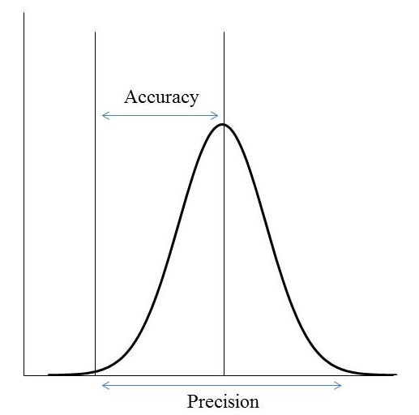
Figure 5. Accuracy and precision in meniscus reading.
The sensitivity of the volume measurement to the meniscus reading uncertainty may be calculated using the equation for the volume of a cylinder and the neck diameter.
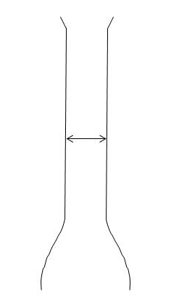
where r is the radius of the internal diameter and h is the height of the line or meniscus reading uncertainty. Units will be determined based on the dimensional units that are used. For example, radius in cm² and height in cm, will provide results in cm³ or mL. The meniscus itself often has an observed “thickness” that is larger than the graduation lines, so this should be considered as well. The potential error in meniscus reading is usually treated as a triangular distribution.
Figure 6. Meniscus error analysis for a glass flask.

Example for a Glass Flask
If the internal diameter of a flask is 1.5 cm (15 mm) and the height of the graduation line is 0.50 mm, the volume associated with the line can be calculated as follows: = 88.36 mm³ (0.088 mL).
These values are rounded for illustrative purposes only; significance must be evaluated based on measuring instruments and flask resolution. Experimental data obtained by reading a meniscus among multiple laboratory staff members may also be used to incorporate an estimate of uncertainty in meniscus reading.

Example for a Test Measure or Prover
In a test measure or prover, the volume inside the gauge also represents the volume inside the neck. So, two volumes can be calculated and added together to determine the impact.
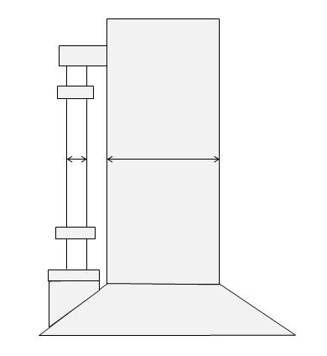
If the internal diameter of the gauge tube is 13 mm (0.5 in) and the height of the graduation line is 0.50 mm, the volume associated with the line inside the gauge tube can be calculated as follows: = 66.4 mm³ (0.066 mL). This amount alone is generally not readable on the test measure or prover. But, the equivalent amount of volume that this gauge tube volume represents in the neck (given a 3 in neck) can be calculated as follows: = 2.28 mL. These two volumes are added together, giving a sum of 2.346 mL, or about 0.143 in³. In the case of a 5 gal test measure, the typical calibration uncertainty is about 0.35 in³, so this potential error is significant.
Figure 7. Meniscus error analysis for a test measure or prover.
Using the example for the test measure or prover, and a triangular distribution, two examples for estimating the uncertainty of meniscus reading are shown. The values are based on the estimate of error in reading the meniscus, e_{m}. When the pooled standard deviation of the process is less than the calculated triangular distribution estimates, use the calculated values shown below as a minimum value. Note that this value is unrelated to graduation size.
Estimate 1, with multiple staff and check standard available:
Estimate 2, in a one person lab or with no check standard available:
These values are rounded for illustrative purposes only; actual significance must be evaluated based on measuring instruments and resolutions. Experimental data obtained by reading a meniscus among multiple laboratory staff members may also be used to incorporate an estimate of uncertainty in meniscus reading provided the examples and assessments are fully documented.

