# Honorary President’s Address

## National Institute of Standards and Technology

Detroit, Michigan

July 15, 2015

Dr. Willie E. May

Acting Under Secretary of Commerce for Standards and Technology and Acting Director

* Thanks Carol for that very gracious introduction.
* Good morning everyone.
  + I’d like to thank Chairman Gaccione and Don Onwiler of NCWM for again, inviting me to present the annual Honorary President’s Address.
* It’s great to be here in the Motor City.
  + Detroit has given this country so much considering the pioneering work that has been done here.
  + This city has, in many ways, laid the foundation for the United States as we know it today.
    - It kindled our love affair with the automobile and with the freedom it represents.
* **Detroit is known for its history of innovation.** It’s where the assembly line was born, as well as the first paved road, the first traffic light, the first freeway, the first international tunnel, and most importantly, the first automatic coffeemaker.
* Some people think that Detroit’s best days are behind it, but I have to disagree.
  + For a while, we were a nation that had stopped making things, but we’ve started to see that trend reverse, and I believe that this city can and will turn itself around.
  + While there is a still a lot to be done to regain our momentum, automakers in this town have begun doing some very innovative things.
  + I’m really looking forward to seeing what the future holds.

**About NIST**

* NIST and Detroit actually have something in common. For one, we were both born about the same time.
* NIST was founded in 1901 to perform measurement research vital to industry and to provide a framework for the preservation and faithful dissemination of standard measurement units, which are vital to industrial and scientific progress and to commerce.
* Eight years later, 1909, the first Model T rolled off the line. Between 1920 and 1930, the number of cars registered in the United States leapt from 9 million to 26.5 million, and well over half of them were Model Ts and nearly all of them were built right here – in Detroit.
* Geologists at the time believed that the supply of oil would be gone in as little as 10 years, so some of NIST’s first research related to the automobile industry was concerned with improving fuel economy. We worked to improve ignition systems, carburetors, and lubricants, as well as the quality of the gasoline.
* Working with the U.S. Army, we published performance metrics for engines, fuels, and lubricating oils.
* We tested brakes, driver reaction times – and in the 1960s, NIST research was also integral to seat belt and car safety standards.
  + And we still today have a number of collaborations with and provide measurement services for the automotive industry.

**NIST NOW and RESEARCH EXAMPLES**

* Our new Center for Automotive Lightweighting is working to help the industry make vehicles that are much lighter in weight, but just as safe. We’re providing the data the industry needs to reliably manufacture vehicle components from lightweight substitutes, including aluminum alloys, high-strength steels, and polymer composites.
* A lighter automobile needs less fuel to move a given distance, whether that’s **gasoline**, **diesel**, **electricity**, **hydrogen**, **liquefied natural gas**, **or some hybrid approach**,
* Using less fuel means lower emissions and better air quality.
* While we love going for a drive, frankly most of the time we’re driving we’re really just trying to get home. And we’ve made some real innovations concerning energy efficient homes as well.

**NET Zero Energy House**

* We constructed and demonstrated the efficacy of a “net zero energy home” that looks just like any home in suburbia and yet generates as much energy as it needs. And our researchers did it with commercially available technologies and without sacrificing anything in terms of creature comforts or energy usage.
* NIST has also been active in our role as an organizer, bringing stakeholders to the table to solve common problems that would be difficult for them to solve on their own.

**CYBERSECURITY FRAMEWORK AND FORENSICS**

* This past February, NIST released the first version of our cybersecurity framework. We brought people from the nation's financial, energy, healthcare, and other critical sectors together to work out a way that they could better protect their information and physical assets from cyber-attack.
* The framework describes the characteristics of a comprehensive cybersecurity program, complete with standards, guidelines, and practices that organizations of any size can use to manage their risks.
* The framework is voluntary. It’s not a prescription. And it’s a living document. It is open to constant revision as the information security landscape changes, but it is a starting point, and a way forward to ensuring that at least the most vital sectors of our infrastructure are hardened against hackers.

**VCAT Report**

On another cybersecurity - related note: due to the allegations made in one of the Edward Snowden leaks, we (NIST) charged our primary independent advisory panel, the Visiting Committee on Advanced Technology (VCAT**),** to oversee a review of our Cryptographic Standards and Guidelines Development Process. The allegation was in regard to a faulty random number generator baked into one of our Cybersecurity Standards, which NIST obtained from NSA.

The VCAT asked a blue ribbon Committee of Visitors (COV) to assess NIST’s existing cryptographic standards and guidelines and the process by which those standards and guidelines are developed. Each COV member provided an independent report to the VCAT.

That “blue ribbon” Committee of Visitors included:

* **Vint Cerf** of Google;
* **Edward Felten** of Princeton University;
* **Steve Lipner** of Microsoft Corporation;
* **Bart Preneel** of Katholieke Universiteit Leuven;
* **Ellen Richey** of Visa Inc.;
* **Ron Rivest** of the Massachusetts Institute of Technology (MIT); and
* **Fran Schrotter** of the American National Standards Institute (ANSI).

**The VCAT took this input and made recommendations to NIST that fall into four basic categories:**

They asked that we:

* Assure that our (NIST’s) process for producing standards and best practices is open and transparent.
* Increase our capability and capacity in cryptography – so that we **were not dependent** on NSA for input.
* Increase the involvement of the cryptographic community, including academia and industry, in our standards-development process.
* Review and clarify our relationship with NSA.
* Following up on something that I discussed with you last year, NIST and the Department of Justice have also just recently named the members to the first forensic science standards board, which we established to improve the scientific basis of forensic evidence used in courts of law.
* Some of you may be surprised to learn that, much like the nation’s weights and measures system used to be, there are few national standards or uniformity in forensic science. The confidence that a forensic scientist has in how well a piece of evidence connects a suspect to a crime is largely a matter of his interpretation. It may not be based on any objective standards.
* This lack of national uniformity is reflected in every forensic science discipline. How many points of comparison do you need to say conclusively that a fingerprint found at a crime scene belongs to the suspect? What about the marks left on a shell casing or even DNA?
* A new forensic science board, which is modeled on the structure of the NCWM, will be dedicated to answering these questions, and to establishing a uniform system of national standards that will ensure that evidence is collected, analyzed, and interpreted the same no matter where a crime is committed.
* No one wants to see the innocent go to prison for crimes they didn’t commit.
  + When the innocent go to prison, the guilty go free.
  + Objective standards will help improve our justice system.

**ADVANCED COMMUNICATIONS**

* NIST’s initiative in advanced communications got a boost earlier this year when the former operations director for our labs in Boulder, Colorado, Kent Rochford, returned from a year and a half stint with Sharp Electronics to lead our new Communication Technology Laboratory and Center for Advanced Communications – a joint venture with the National Telecommunications and Information Administration.
* The proliferation of cell phones and other communication technologies has begun to really eat up the electromagnetic spectrum. The airwaves are simply getting crowded. The new center’s mission is to advance our understanding of the wireless spectrum and to foster innovations that will make wireless communications faster and more reliable.

**HYDROGEN FUEL VEHICLES**

* Now, getting back to the Motor City theme, three automakers plan to begin selling hydrogen-fueled vehicles to consumers in 2015. Now, once you have these zero-emission vehicles on the road, you need a place to fill them up. And if you are building refueling stations, you need a way to make sure that that fuel is being dispensed accurately.
* Our researchers have recently completed work on a new field test apparatus to confirm the accuracy of hydrogen fuel dispensers. Once the standard is fully tested, we plan to offer it as a model for constructing “Provers” for state weights and measures inspectors to use.
* The state of California has really gotten behind hydrogen-fuel-cell vehicles and is putting the infrastructure in place to support them. They’ve opened nine refueling stations so far, and they are funding the construction of an additional 28 stations over the next few years. They plan to fund the construction of 100 in total.
* This body recently adopted standards for the sale of hydrogen. NIST Handbook 44 reads that hydrogen will be sold by the kilogram, and that hydrogen-dispensing pumps must be accurate to within plus or minus two percent, or plus or minus 20 grams per kilogram.
* So while a kilogram of hydrogen has approximately the same energy content as a gallon of gasoline, the allowable error is a little less stringent than for gasoline.
* Some have argued that even these larger tolerances are too tight, and that errors as high as 10 or 20 percent should be allowed. It’s hard to see how that would be fair for anyone. Our preliminary tests have shown that the flow meters used to dispense hydrogen fuel are capable of doing so with an error as little as one percent or less. Why would we allow less than the best measurements we can make? Shouldn’t we always aim to achieve the highest accuracy, the most transparency, and the fairest system?
* Mass flow meters dispense according to weight, the standard for weight in the United States is the kilogram, and it has been since 1893. It makes sense that it would be sold in the same terms in which it was measured. **I understand that you have a similar question before you this week.** 
  + An important decision needs to be made regarding the sale of liquefied natural gas.
* I know that people have strong opinions about this issue and that you have been studying the issue intently. NIST’s scientific position is well-known, so I won’t repeat it here, but I will urge you to remember the consumer when you are voting this week and remember the importance of having and promoting a rational, science-based measurement system.

**Let me close by discussing “RATIONAL MEASUREMENT UNITS”**

* You know, one of the reasons that the metric system came into being is because the French had found the old way of doing things had become untenable.
  + By the time of the French Revolution there were as many as 250,000 different measurement units. Each commodity had its own measure, and there was little uniformity between them. There was no way to know definitively that a wine gallon in Marseilles was the same as a wine gallon in Paris—no doubt very distressing, especially if you are French.
* It was hard to do business without a science-based system.
* After a few stops and starts, the French succeeded in creating something beautiful, a system of units the entire world could use.
* Back when NIST was founded, the United States was in sort of the same fix as France had been. While our nation was a signatory to the Treaty of the Meter – and its international units for measurement – the Congress did not make its adoption mandatory.
* What we had was a system that we inherited from our Forbearers – some units we simply just invented in various locales.
  + We had eight different gallons and four different feet and very little in the way of agreement between them.
* Way back in 1909, when NIST and the newly formed NCWM were investigating the state of U.S. legal metrology, they found that in many of the states “official” weights and measures were in a state of severe disrepair, if they could be found at all.
* In many states, even having a standard set of weights or measures was not required by law.
  + For the most part, the state weights and measures inspector was not a paid position, **and at the county level, that job usually fell to the treasurer, or even the school superintendent.**
* A survey of over 30 000 scales being used in more than 3,000 shops and stores across the nation found half of them to be woefully inaccurate and most frequently favored the shopkeeper – surprise, surprise.
* But with the efforts of the hardworking men and women of the NCWM, the situation quickly improved.
  + The people in our country had resigned themselves to the thought that there would always be cheating – that a fair deal was just not to be had.
  + There could be no trust in the marketplace.
* But the NCWM, **and a good dose of bad press**, turned that all around.
  + The American people began to see that corruption and cheating didn’t have to be the norm.
  + They began to see that chaos did not have to reign.
* This body brought fairness, order, and trust to the marketplaces of this country.
* Now, you have gathered here to continue this noble mission.
  + Our citizens are depending on you to look out for their interests.
* I urge you to remember that while you are deliberating this week.
  + Remember that the right thing to do is not always the easiest thing to do.
* I have no doubt that you will live up to this charge.
* Thank you for your attention.

THIS PAGE INTENTIONALLY LEFT BLANK

|  |
| --- |
|  |
|  |
|  |
|  |
|  |
|  |
|  |
|  |
|  |
|  |
|  |
|  |
|  |
|  |
|  |
|  |
|  |
|  |
|  |
|  |
|  |
|  |
|  |
|  |
|  |
|  |
|  |
|  |
|  |
|  |
|  |

# Chairman’s Address

## National Conference on Weights and Measures

Detroit, Michigan

July 17, 2014

John Gaccione

Westchester County, New York

Thank you Director Hockert.

It is my pleasure to welcome everyone here to the 99th Annual Meeting of the National Conference on Weights and Measures here in Detroit. We have over 250 attendees, the most in over 15 years. At our meeting in January, we had over 150 attendees, near record attendance for an Interim Meeting. The Executive Director passed along that it was a great year for NCWM attendance and everyone worked hard to get the word out about the regional meetings and the NCWM Meetings. When I asked at one of the Board of Directors meetings if the attendance increase had to do with who is the Chairman, there was a long awkward silence followed by quick motion to adjourn. Thank you all for attending and for participating.

I want to take a minute to thank our distinguished guests, Dr. May, Acting Under Secretary for Standards and Technology and Acting Director of NIST, Chief Deputy Director Wenk of the Michigan Department of Agriculture and Rural Development, and Carol Hockert, Director of the NIST Office of Weights and Measures.

Thanks go to the City of Detroit and to Craig VanBuren and his staff for all they have done to welcome us to Michigan. To our presiding officers, thank you Jack Walsh, Jerry Butler, Marco Mares, and Scott Ferguson.

Please take a minute to look around the hotel and the surrounding area. I would say that Detroit is a city on the rise.

Thanks to the NCWM Staff: Don, Jim, Elisa (who if you didn’t know, started the year with the last name of Robertson and switched along the way to Stritt (congratulations Elisa), Tyler, and to Darrell.

My theme at the beginning of my tenure as chairman was “Meeting Tomorrow’s Challenges Today.” Well Folks, tomorrow’s challenges are here. We talked about some of the challenges yesterday. Examples include:

* CNG/LNG fueling for everyday on-road vehicle use;
* electric vehicles and the ability to charge those vehicles and travel hundreds of miles between charges; and
* railroad scales that speed up the weighing of freight by two to three times.

Another challenge was to continue to support the regions, and in turn, the jurisdictions that make up those regions. We continued and expanded the Train the Trainer Program. With NIST’s help, we began to help not just the supervisors, but the field inspectors. On the NCWM webpage, we now have a list of certified trainers available to help the regions and their jurisdictions.

We continued to expand the Professional Certification Program. As mentioned earlier, more exams will be brought online, expanding the number of available exams.

NCWM has faced this year’s challenges. NCWM rose to its challenges. NCWM welcomes new challenges.

Being Chairman brings with it a two to three page list of responsibilities and duties. When I first looked at that list, it became an “uh oh” moment.

We have L and R; we have S and T; we have PDC, WWMA, and CWMA, SWMA, and NTEP and so on and so on. I didn’t get the cheat sheet of abbreviations and acronyms.

I have to tell you that being associated with the employees of NCWM has been nothing less than terrific. They work hard, put the interests of the members first, and provide a level of service second to none. Look at how well these past few days have gone.

To my fellow board members, thanks for making it easy to be the Chairman. The Board of Directors this year faced a number of issues. We took them all in stride and did what was best for the Conference. We recognized a need and added the necessary staff.

Part of being Chairman includes traveling to each of the regional meetings. To me it wasn’t an obligation or chore, it was a pleasure. At each of the regions, I spoke about how NCWM could and would support the region, and how well supported regions help NCWM. The NCWM model works and it works well.

In preparing for today, I was looking for a phrase, an adage, or a line from a song that would put in context my regional experiences. Something that could sum it all up, some phrase everyone could relate to, and something that was, yes, probably corny.

Some years back, there was a Broadway Show called “Rent.” Some of you may have seen the movie. Part of the chorus of one of the songs is; “How do you measure, measure a year.” Perfect for a weights and measures official.

The song continues:

“Five hundred twenty five thousand six hundred minutes, how do you measure, measure a year.”

How did I measure this year? I measured it in people (hundreds). I measured it in regions (four). I measured in national meetings (two).

Historians say it was Horace Greeley, the famous 19th century author and newspaper publisher that said “Go west young man, go west.” It wasn’t. It was really Kurt Floren of Los Angeles County, California, who said it.

This year the Western Regional had almost 100 attendees and representation from every state in the region except two - very impressive. That’s the most for any of the 2013 - 2014 regionals. Thanks to Mahesh Albuquerque, the Western Regional Chair, and the host State of Montana.

Just as an aside, Kurt never stopped reminding me we were at the Western Regional and how the Western is first of the regional cycle. I had to constantly remind him of the east coast – west coast, right coast – left coast rivalry. We continued, and I finally remarked that he lived three hours behind civilization. Without hesitation, Kurt recommended I visit Santa Monica, California, for a long walk on a short pier.

Next was south to West Virginia. I decided to drive to Charleston (about 11 hours) and what a great ride it was. Again, excellent attendance at a regional meeting – about 70 attendees and only 2 states didn’t have representation. The Southern Region has two Commonwealths and many thanks to Rich McComas and the State of West Virginia for their hospitality.

When arriving at the Southern Regional Meeting, I was greeted by the ever smiling Tim Chesser of Arkansas. Tim gave me a warm welcome, and said John, “Don’t worry about a thing; I will take care of everything.”

Everyone has a moment of revelation, an “ah hah” moment; this was an “oh no” moment.

Next was to the Northeast Region to Manchester, New Hampshire. To NEWMA, the little region that could, don’t dare tell them they can’t. Yet meeting attendance wasn’t so little with 50 attendees, and again, only 2 states not represented and another region with two Commonwealths. Thanks to Chair Lou Sakin and to the host State of New Hampshire. As always, NEWMA lived up it to its hard working, hard playing reputation. Anything else about the NEWMA Annual Meeting can be read in the Manchester, “New Hampshire Police Blotter.”

And, finally to Central, 75 attendees and only 2 states not represented. Again, great attendance; many thanks go to Ron Hayes, our Chair-Elect. After a long and sometimes heated discussion about how to pronounce the name of the host state between members of the host delegation, I ended up leaving there the same as I came, not knowing whether to say Missoura or Missouri?

At several of the regions, I was asked which region I liked the most, what region was best at this or best at that. My carefully worded response was and continues to be, every region was great, every region was unique, and every region had great hospitality rooms.

NCWM is about equity. It is about a safe and fair marketplace. NCWM is about its people.

There was something I repeated at each of the regions. I reminded everyone that the work they do affects everyone in the marketplace almost every day. Let’s not forget that.

So again, thank you to everyone for attending and participating, and thank you for making NCWM the successful organization that it is.

THIS PAGE INTENTIONALLY LEFT BLANK

# Chairman Elect’s Address

## National Conference on Weights and Measures

Detroit, Michigan

July 17, 2014

Ronald G. Hayes

***“One Hundred Years: Building on the Past”***

I feel so very honored to stand before you as the Chairman of the National Conference on Weights and Measures, especially on the eve of the 100th meeting and the 110th anniversary. I want to thank those that have given me guidance in preparing me for this role.

As I looked back at agendas of past chairs of the Conferences, I noticed the goals set for the Conference could not always be met in the short one-year term. Many times these goals were not implemented until after their term expired. In 1991, N. David Smith from North Carolina was Chairman of the Conference. His vision was to establish a Petroleum Subcommittee to expand from a basic petroleum laboratory guide and develop fuel quality laws and regulations. This Subcommittee is, of course, now known as FALS. States such as Minnesota, Tennessee, Illinois, New York, and Michigan had already committed resources to improve the quality of fuels. This idea would take a few years to complete and the following chairman, Mr. Sid Colbrook from Illinois, appointed the Committee, comprised of both public members and industry representatives. A few of the original appointees, who are still active, are at this meeting. It was a great pleasure for me to read the Distinguished Service Award given to Mr. Randy Jennings, State of Tennessee, for continuous excellence of service on the Fuels and Lubricants Subcommittee.

Goals:

1. Continue the enhanced training by NIST.
2. Build closer relationships with other standards development organizations.
3. Establish a more effective communication plan with federal agencies.

In the last few years, under the leadership of Ms. Carol Hockert, NIST has placed more instructors throughout the nation, increasing training on fundamentals of weights and measures functions. This also complements the current NCWM Certification program.

From the very beginning of the National Conference on Weights and Measures, we have partnered with other standards development organizations, such as the American Society for Testing and Materials, scale manufacturers associations, the American Petroleum Institute, Gas Pump Manufacturers Association, and others. As new ways of measuring commodities evolved, we gained working relationships with other standards writing organizations. For example, in 2011 we allowed seed count for agriculture seed. Without an automatic seed counter, it would not have been possible to verify seed count claims. Thanks to the American Seed Trade Association and the Association of Official Seed Analysts, we were able accept the use of seed counter devices.

Our standards often reference standards from other standard writing organizations. However, I think it’s time we have our standards recognized in more federal and industry standards. NCWM and other standards organizations need to complement each other’s standards when we can. For example, PEI has several standard practices for storage tanks. Our labeling requirements could be referenced in their documents making their standards more complete.

In the last month, letters from PALS and FALS were sent to the FTC on separate proposed rules. A more effective communication plan with federal agencies will allow NCWM and federal agencies to be more efficient in both of our regulatory roles.

I am looking forward to the next 12 months. I will continue to enjoy my interaction with each regional association and each opportunity to share our knowledge with each other.

**Appointments**

**Specifications and Tolerance Committee:**

* Ivan Hankins, Iowa, five-year term

**Laws and Regulations Committee:**

* Kristin Macey, California, five-year term

**Professional Development Committee:**

* Angela Godwin, Ventura County, California replacing Kristin Macey, two-years term
* Dale Saunders, Virginia

**Nominating Committee:**

* Committee Chair – John Gaccione, Westchester County, New York
* Judy Cardin, Wisconsin
* Charles Carroll, Massachusetts
* Randy Jennings, Tennessee
* Joe Gomez, New Mexico
* Kurt Floren, Los Angeles County
* Steve Benjamin, North Carolina

**Parliamentarian:**

* Louis Straub, Fairbanks Scale, Inc.

**Chaplain:**

* Stephen Langford, Cardinal Scale Manufacturing, Co.

**Credentials Committee:**

* Ethan Bogren, Westchester County, NY

**Presiding Officers:**

* Lawrence Nolan, Los Angeles County
* Jack Walsh, Town of Wellesley, Massachusetts
* Tim Chesser, Arkansas
* Marco Mares, San Diego County, California

Again, thank you for the privilege of being asked to serve on this incredible conference.

# 2014 National Conference on Weights and Measures

## Special Award Recipients

**Contributions Award:** Mr.Nigel Mills, Hobart (accepted by Mr. Rob Upright, President of Scale Manufacturer’s Association (SMA) on behalf of Mr. Mills.

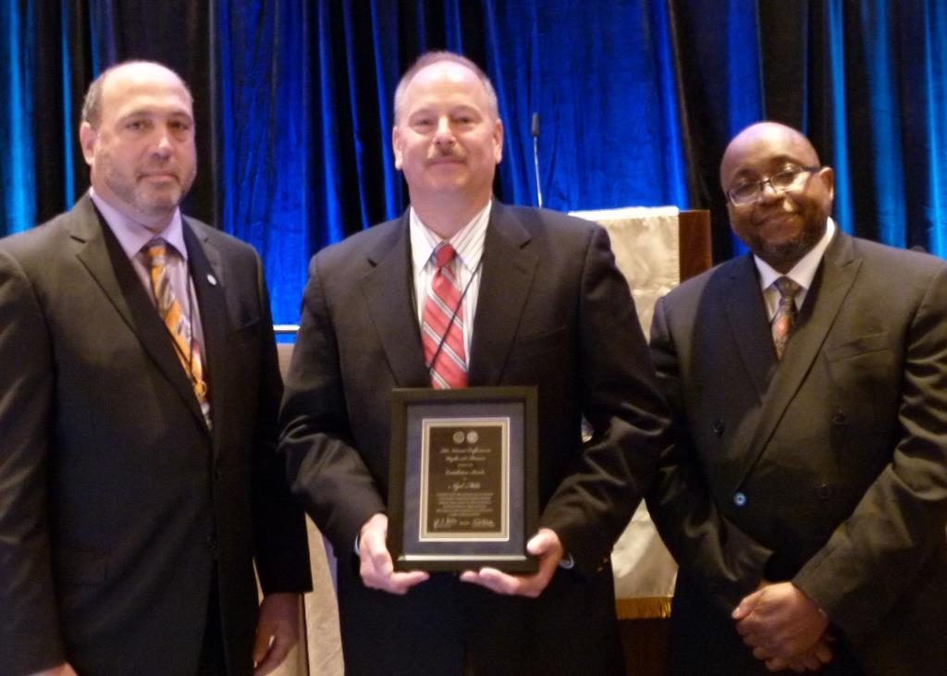

**Figure 1.** Left to Right: Mr. John Gaccione, NCWM Chairman; Mr. Rob Upright, SMA President; and Dr. Willie May, NCWM Honorary President.

**Distinguished Service Awards:** Mr. Randy Jennings, Tennessee, andMr. Joe Gomez, New Mexico.

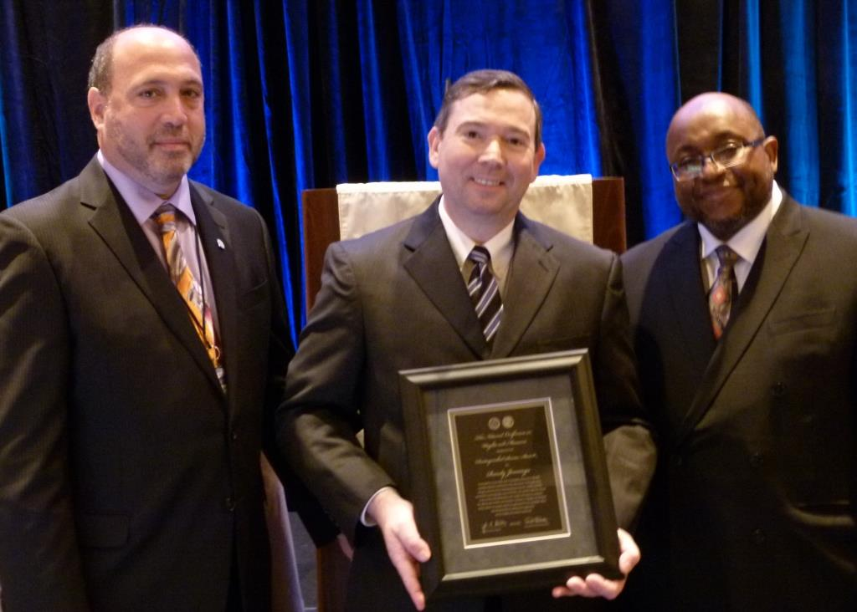

Figure 2. Left to right: Mr. John Gaccione, NCWM Chairman; Mr. Randy Jennings, Tennessee; and Dr. Willie May, NCWM Honorary President.

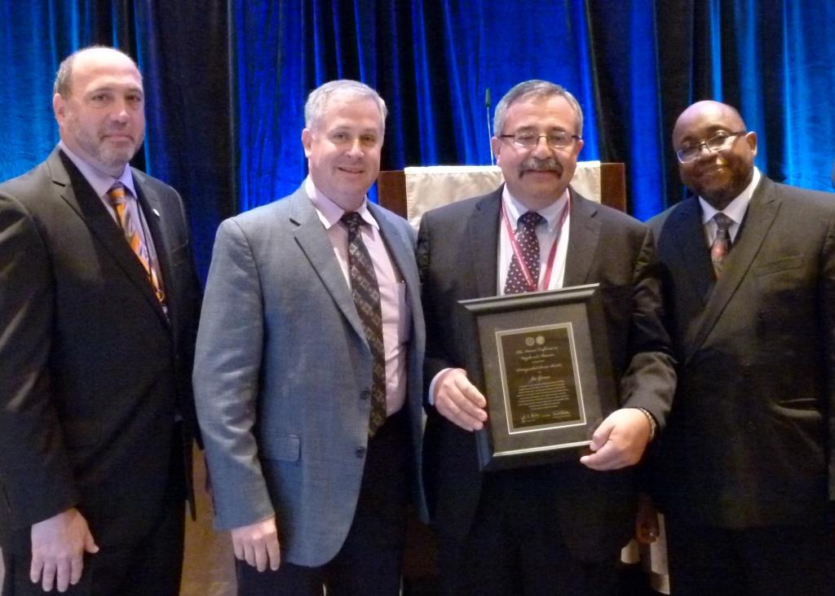

**Figure 3.** Left to Right: Mr.John Gaccione**,** NCWM Chairman**;** Mr. Jeff M. Witte, Director/Secretary of Agriculture; Mr. Joe Gomez, New Mexico; and Dr. Willie May**,** NCWM Honorary President**.**

**Lifetime Achievement Award:** Mr. N. David Smith, North Carolina.

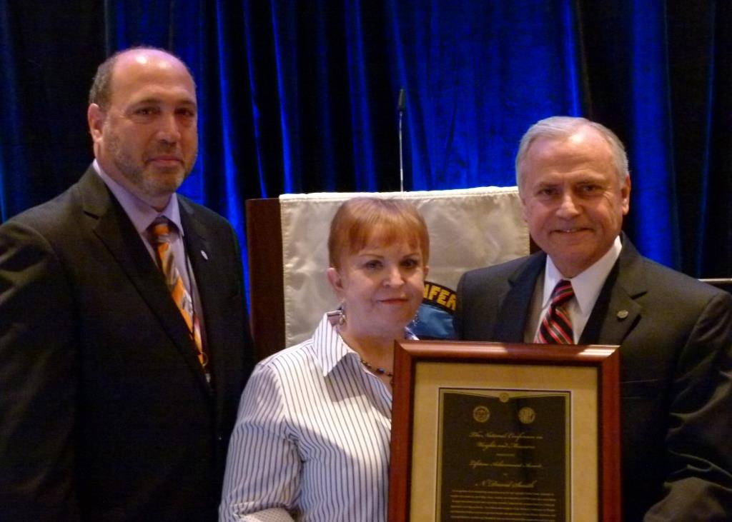

Figure 4. Left to right: Mr. John Gaccione, NCWM Chairman; Ms. Pam Smith; and Mr. N. David Smith, North Carolina.

**Attendance Recognition:**

|  |  |
| --- | --- |
| 5 Years   * Richard Harshman * Paul Menard * Sam Bell   10 Years   * Hal Prince * Carol Hockert * Kristin Macey * Steven Beitzel * John Gaccione | 15 Years   * Clark Cooney * Joe Gomez * James Cassidy   20 Years   * Randy Jennings   25 Years   * Ron Hayes   45 Years   * Joseph Silvestro |