APPENDIX B

Federal Register
Notice from the Department of Agriculture
Food and Safety Inspection Service
9 CFR Parts 317, 381, and 442

Determining Net Weight Compliance for Meat and Poultry Products

THIS PAGE INTENTIONALLY LEFT BLANK
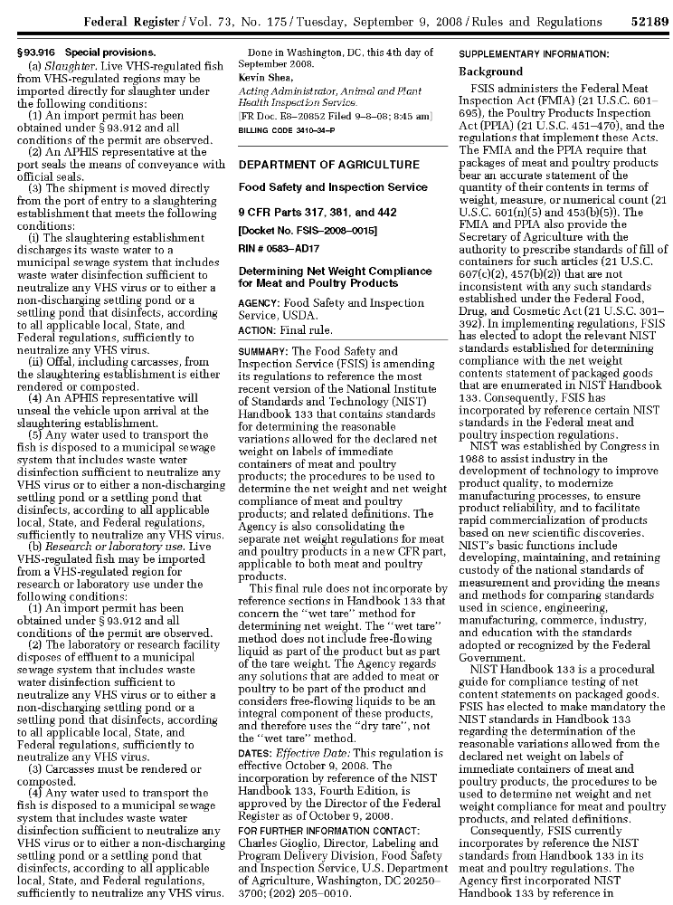
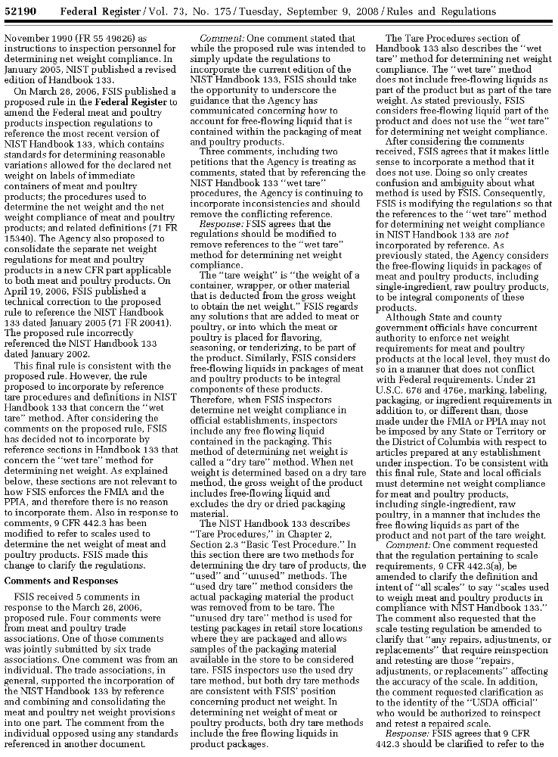
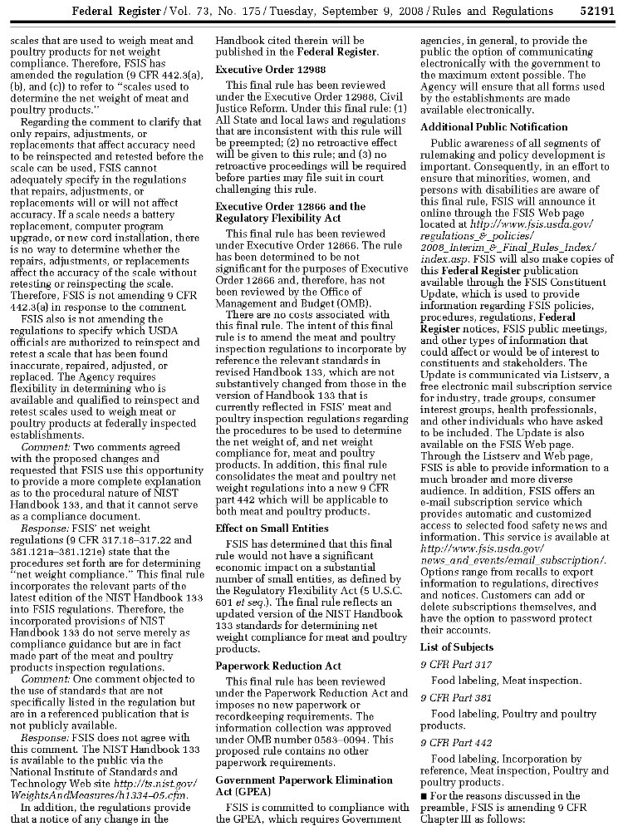
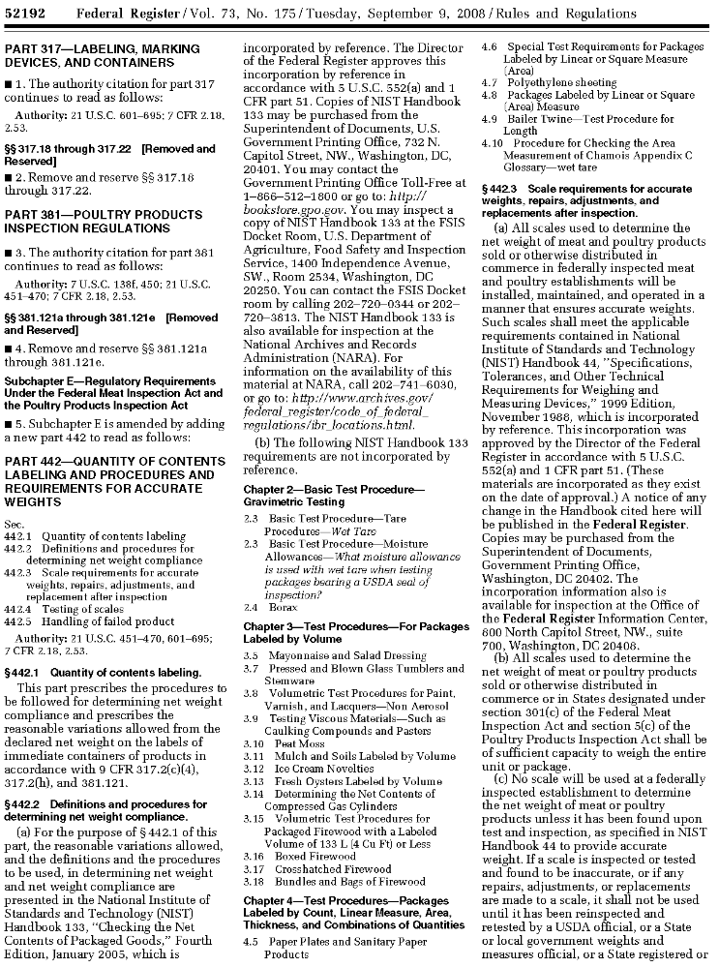
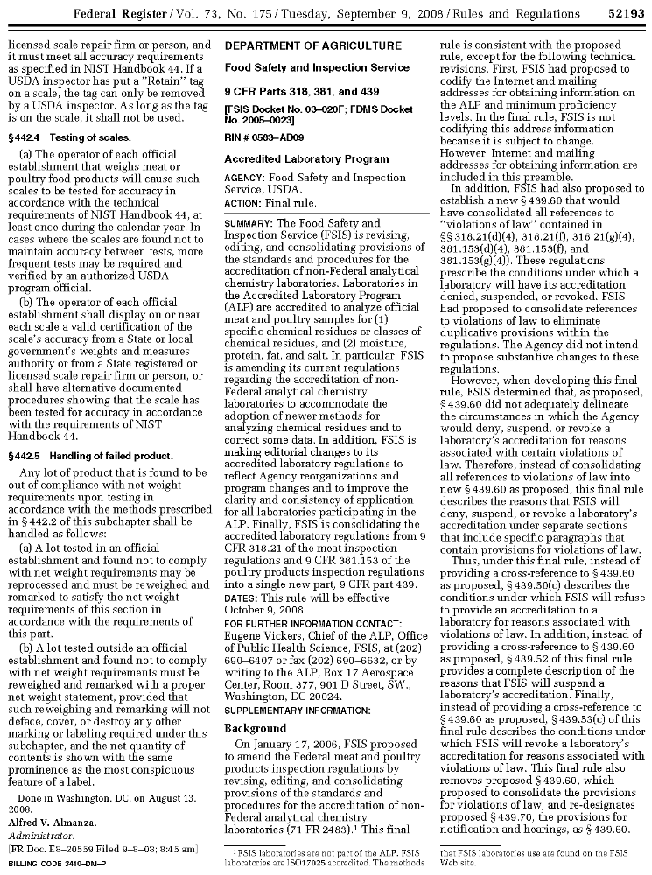

THIS PAGE INTENTIONALLY LEFT BLANK

