Appendix E

Food and Drug Administration (FDA) Letter to the International Ice Cream Association (IICA)

on Uniform Compliance Date for Pelletized Ice Cream

(Letter dated October 22, 2009)

THIS PAGE INTENTIONALLY LEFT BLANK
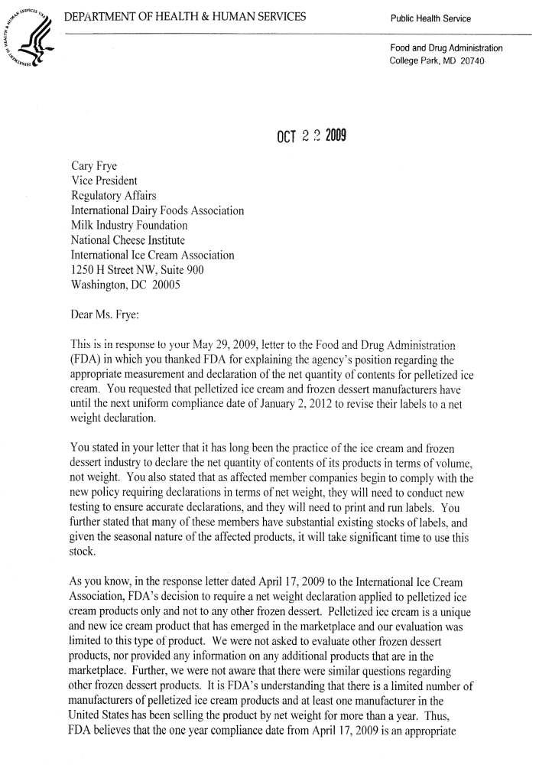
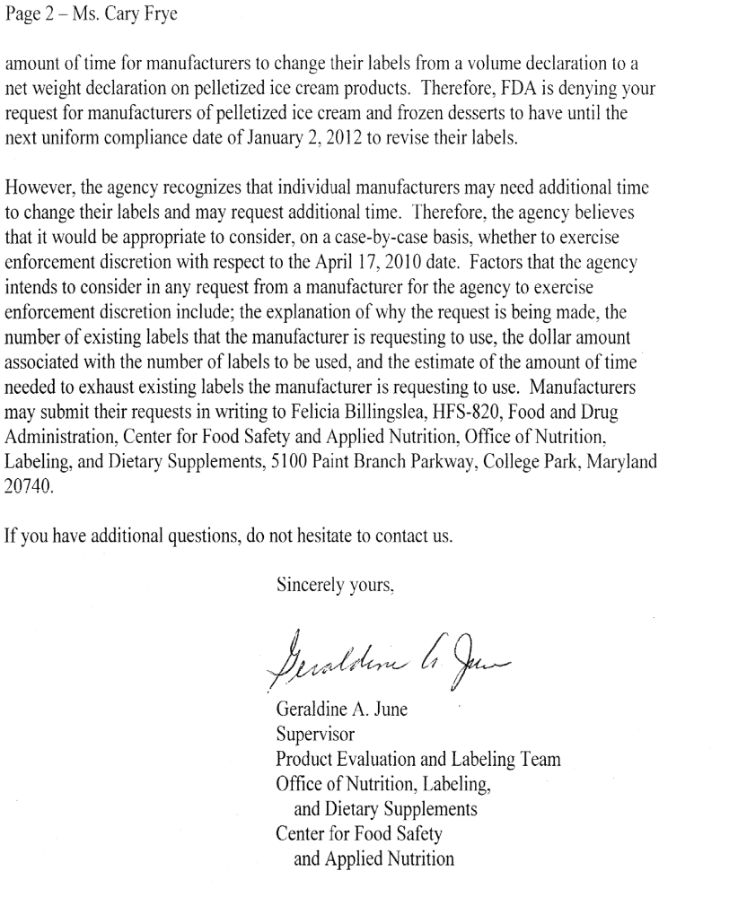
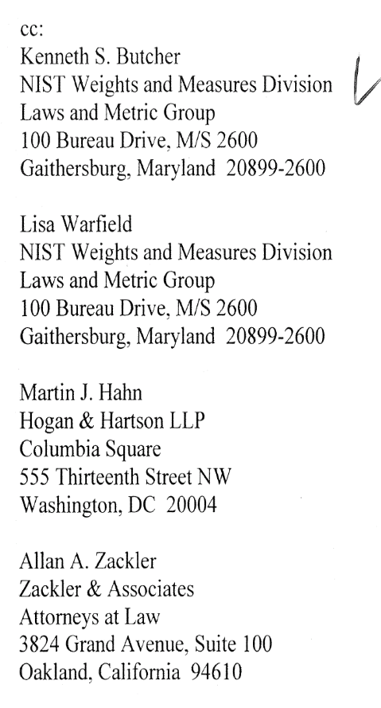

THIS PAGE INTENTIONALLY LEFT BLANK

