Appendix H

Item 260-4: Handbook 133, Seed Count for Agriculture Seed

Table of Contents

Page
American Seed Trade Association (ASTA) H3
AOSA Rules for Testing Seeds H6
NIST Handbook 133, New Procedure for Testing Seed Count, A Call for Repeal Action Taken at the
95th NCWM H12
Association of American See Control Officials (AASCO) H26

THIS PAGE INTENTIONALLY LEFT BLANK


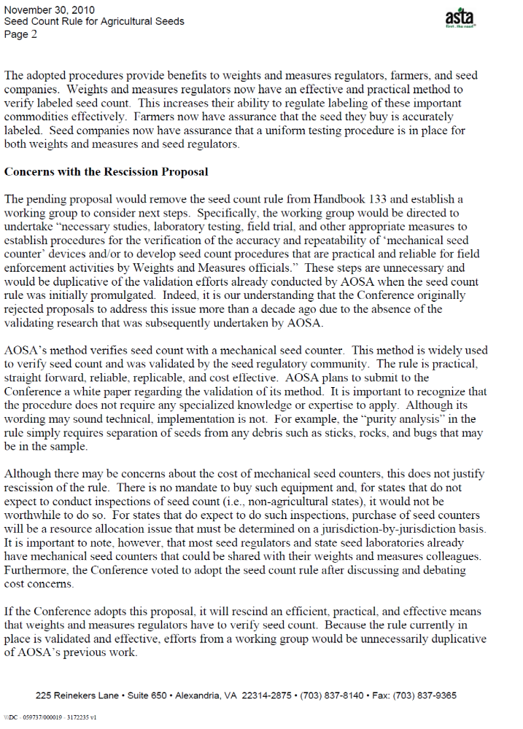
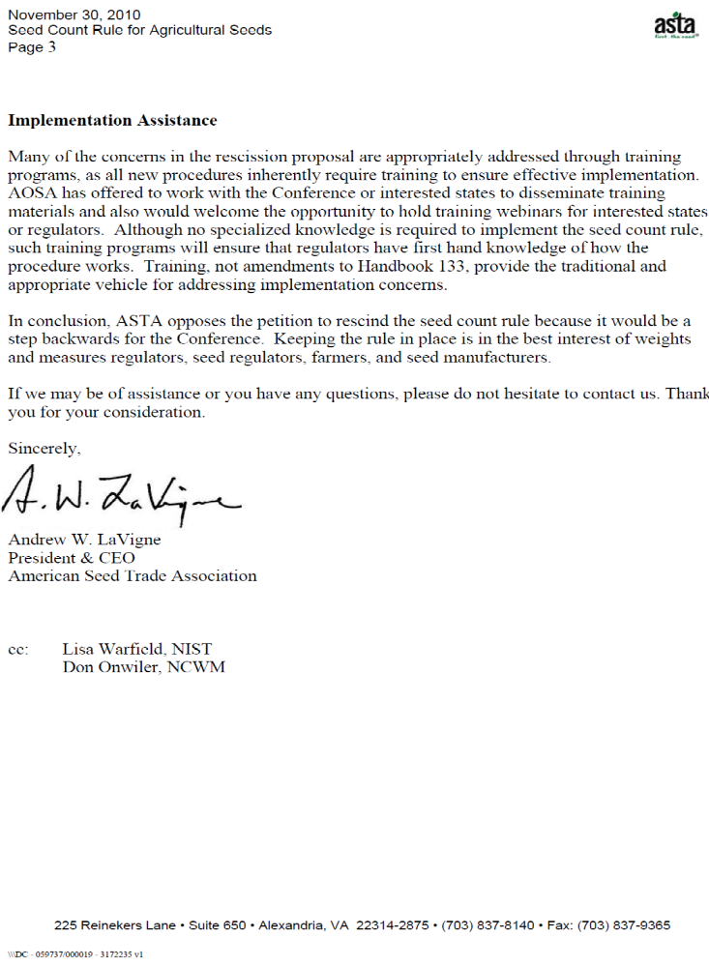
AOSA Rules for Testing
- Coated or encrusted seed: seed that has been covered by a layer(s) of materials that obscure the original shape and size of the seed resulting in a substantial weight increase. The addition of biologicals, pesticides, identifying colorants or dyes, and/or other active ingredients including polymers can be included in this process. Refer to sections 3.8 and 6.8 I.
- Film-coated seed: film-coated seed retains the shape and the general size of the raw seed with a minimal weight gain. The film coating may contain polymers, pesticides, biologicals, identifying colorants or dyes, and other additives. The coating should result in a more or less continuous covering that eliminates or minimizes product dust-off.
- Inoculated seed: seed that has received a coating of a commercial preparation containing a microbial product, e.g. Rhizobium sp.
- Pelleted seed: seed that has been covered by a layer(s) of materials that obscure the original shape and size of the seed resulting in a substantial weight increase and improved plantability or singulation. The addition of biologicals, pesticides, identifying colorants or dyes, and/or other active ingredients including polymers can be included in this process. Refer to sections 3.8 and 6.81.
- Raw seed: seed that is free of any applied materials.
- Treated seed: seed with a minimal covering of various materials whose primary objective is to reduce or control certain disease organisms, insects or other pests attacking the seed or seedlings growing therefrom and that contains identifying colorants or dyes.
2.2 Obtaining the working sample
The working sample on which the actual analysis is performed shall be taken from the submitted sample in such a manner that it will be representative. A suitable type of mechanical divider (conical, centrifugal, riffle, etc.) should be used. To avoid damage when dividing large-seeded crop kinds such as beans, peas, etc., prevent the seeds from falling great distances onto hard surfaces. When dividing coated, encrusted, and pelleted seeds, mechanical dividers may be used only if the distance of the fall does not damage the applied materials.
For seed moisture determination, sub-samples must be drawn quickly to avoid exposing the seeds to the ambient air. Mechanical dividers are not appropriate for this purpose. Refer to section 2.2 b (3).
a. Mechanical dividers. — This method is suitable for most kinds of seeds. The apparatus divides a sample into two approximately equal parts. The submitted sample is mixed by passing it through the divider, recombining the two parts and passing the whole sample through a second time and similarly a third time. After
mixing, the sample shall be reduced by passing the seed through the divider repeatedly, removing half the sample on each occasion. This process of successive halving is continued until a working sample of approximately, but not less than the minimum weight(s) stated in Table 2A is obtained.
Use of compressed air or a vacuum is highly recommended for cleaning mechanical dividers.
(1) Centrifugal divider (Garnet type): This divider is suitable for all kinds of seed though it is not recommended for oilseeds (such as rapeseed, canola, mustards, flax) and kinds susceptible to damage (such as peas, soybeans, etc) and the extremely chaffy types.
The divider makes use of centrifugal force to mix and scatter seeds over the dividing surface. The seed flows downward through a hopper onto a shallow rubber cup or spinner. Upon rotation of the spinner by an electric motor the seeds are thrown out by centrifugal force and fall downward. The circle or area where the seeds fall is equally divided into two parts by a stationary baffle so that approximately half the seeds fall in one spout and half in the other spout. The centrifugal divider tends to give variable results when not carefully operated, and therefore the following procedure must be used:
(a) Preparation of the apparatus:
- Level the divider using the adjustable feet.
- Check the divider and four containers for cleanliness. Note that seeds can be trapped under the spinner and become a source of contamination.
(b) Sample mixing:
- Place a container under each spout.
- Feed the whole sample into the hopper; when filling the hopper, the seed must always be poured centrally.
- After the sample has been poured into the hopper, the spinner is operated and the seed passes into the two containers. Turn off spinner.
- Full containers are replaced by empty containers. The contents of the two full containers are fed centrally into the hopper together, the seed being allowed to blend as it flows in. The spinner is operated.
- The sample mixing procedure is repeated at least once more.
(c) Sample reduction:
- Full containers are replaced by empty containers. The contents of one full container are set aside and the contents of the other container are fed into the hopper. The spinner is operated.
- The successive halving process is continued until the working sample(s) of not less than the minimum weight(s) required stated in Table 2A are obtained.

(iii) Ensure that the divider and containers are clean after each mixing operation.
(2) Soil/Riffle divider: This divider is suitable for most kinds of seed. For round-seeded kinds such as Brassica species, the collection containers should be covered to prevent the seeds from bouncing out.
This divider consists of a hopper with attached channels or ducts, a frame to hold the hopper, four collection containers and a pouring pan. Ducts or channels lead from the hopper to the collection containers, alternate ones leading to opposite sides. Riffle dividers are available in different sizes for different sizes of seed. The width and number of channels and spaces are important. The minimum width of the channels must be at least two times the largest diameter of the seed or any possible contaminants being mixed.
This apparatus, similar to the centrifugal divider, divides the sample into approximately equal parts.
(a) Preparation of the apparatus:
- Place the riffle divider on a firm, level clean surface. Ensure the divider is level.
- Ensure that the divider and the four sample collection containers are clean. Check all channels, joints and seams of the divider and collection containers to ensure there are no seeds or other plant matter present before each use.
- Two clean empty collection containers shall be placed under the channels to receive the mixed seed.
(b) Sample mixing:
- Pour the whole sample into the divider by running the seed backwards and forwards along the edge of the divider so that all the channels and spaces of the divider receive an equal amount of seed.
- The two full containers shall be replaced with two clean empty containers.
- The contents of one full container shall be poured into the divider by holding the long edge of the pan against the long edge of the riffle hopper and then rotating the bottom up so that the seeds pour across all channels at the same time, followed by the other full container using the same procedure.
- This process of mixing the entire submitted sample shall be repeated at least one more time before successive halving begins.
(c) Sample reduction:
(i) The contents of one full container are set aside. Empty containers are placed under each channel, and the contents of the other container is poured into the hopper by holding the long edge of the pan against the

(a) Preparation of the apparatus: Ensure that two trays, spatula and spoon are clean.
(b) Sample mixing:
- The sample is poured uniformly over a tray with a side to side swinging motion.
- The receiving pan should be kept level.
- This mixing procedure is repeated a minimum of three times.
(c) Sample reduction:
- A tray, a spatula and a spoon with a straight edge are required. After the preliminary mixing, pour the seed evenly over the tray with a side-toside swing, alternately in one direction and at right angles to it. The depth of the seed in the pan shall not exceed the height of the vertical sides of the spoon. Do not shake the tray thereafter.
- With the spoon in one hand, the spatula in the other, and using both, remove small portions of seed from not less than five random places on the tray.
- Sufficient portions of seed are taken until the working sample(s) of not less than the minimum weight(s) required stated in Table 2A are obtained.
(2) Hand-halving method: This method can be used when a proper mechanical divider is not available.
Procedure:
- Seed is poured evenly onto a clean smooth surface.
- The sample shall be thoroughly mixed using a flat-edged spatula and placed into a pile.
- The pile shall be divided in half using a straight edge or ruler.
- Each half portion is divided in half.
- Each of the portions is divided into half again. There are now eight portions.
- Arrange the eight portions into two rows of four.
- Alternate portions should be combined to obtain two halves e.g. combine the first portion from row I with the second portion from row 2. Remove the remaining four portions.
- Repeat steps (a) to (g) until sufficient portions of seed are taken to constitute a working sample(s) of not less than the minimum weight(s) required stated in Table 2A are obtained.
(3) For seed moisture determination, mix the submitted sample by tumbling or shaking the submitted sample bag, then open bag and use a spoon to remove portions from several random locations within the bag to obtain the appropriate working weight for one replicate. Place seeds in a moisture testing container. Repeat the procedure of mixing and sampling for the second replicate. Do not expose the sample to ambient air for more than one minute.

SECTION 12: MECHANICAL SEED COUNT
The following method shall be employed when using a mechanical seed counter to determine the number of seeds contained in a sample of soybean (Glycine max), corn (Zea mays), wheat (Triticum aestivum) and field bean (Phaseolus vulgaris).
12.1 Samples.
Samples for testing shall be of at least 500 grams for soybean, corn and field beans and 100 grams for wheat and received in moisture proof containers. Samples shall be retained in moisture proof containers until the weight of the sample prepared for purity analysis is recorded.
12.2 Seed counter calibration.
The seed counter shall be calibrated daily prior to use.
- Prepare a calibration sample by counting 10 sets of 100 seeds. Visually examine each set to insure that it contains whole seeds. Combine the 10 sets of seeds to make a 1,000 seed calibration sample. The seeds of the calibration sample should be approximately the same size and shape as the seeds in a sample being tested. If the seeds in a sample being tested are noticeably different in size or shape from those in the calibration sample, prepare another calibration sample with seeds of the appropriate size and shape. Periodically re-examine the calibration samples to insure that no seeds have been lost or added.
- Carefully pour the 1,000 seed calibration sample into the seed counter. Start the counter and run it until all the seeds have been counted. The seeds should not touch as they run through the counter. Record the number of seeds as displayed on the counter read out. The seed count should not vary more than ±2 seeds from 1,000. If the count is not within this tolerance, clean the mirrors, adjust the feed rate and/or reading sensitivity. Rerun the calibration sample until it is within the ±2 seed tolerance. If the seed counter continues to fail the calibration procedure and the calibration sample has been checked to ensure that it contains 1,000 seeds, do not use the counter until it has been repaired.
12.3 Sample preparation.
Immediately after opening the moisture proof container, mix and divide the submitted sample, in accordance with section 2.2, to obtain a sample for purity analysis and record the weight of this sample in grams to the appropriate number of decimal places (refer to section 2.3 a). Conduct the purity analysis to obtain pure seed for the seed count test.
RULES FOR TESTING SEEDS
12.4 Conducting the test.
After the seed counter has been calibrated, test the pure seed portion from the purity test and record the number of seeds in the sample.
12.5 Calculation of results.
Calculate the number of seeds per pound to the nearest whole number using the following formula:
Number of seeds per pound = | 453.6 g/Ib x no. of seeds counted in d.
Number of seeds per pound = | weight (g) of sample analyzed for purity

12.6 Tolerances for results from different laboratories.
Multiply the labeled seed count or first seed count test result by four percent for soybean samples, two percent for corn (round, flat or plateless) samples, five percent for field bean samples and three percent for wheat samples. Express the tolerance (the number of seeds) to the nearest whole number. Consider the results of two tests in tolerance if the difference, expressed as the number of seeds, is equal to or less than the tolerance.
Example:
Kind of seed: Corn
Label claim (1st test): 2275 seed/lb.
Lab Test (2nd test): Purity working weight = 500.3 g
Seed count of pure seed = 2479 seeds
453.6 glib x 2479 seeds
Number of seeds per pound = = 2247.6 seeds/lb
500.3 g
Rounded to the nearest whole number = 2248 seeds/lb
Calculate tolerance value for corn:
multiply label claim by 2%
2275 seeds/lb x 0.02 = 45.5 seeds/lb;
rounded to the nearest whole number = 46 seeds/lb
Determine the difference between label claim and lab test:
2275 seeds/lb — 2248 seeds/lb = 27 seeds/lb
The difference between the lab test (2nd test) and the label claim (1st test) is less than the tolerance (27 < 46); therefore, the two results are in tolerance.

Slide 1 | 
Slide 2 | 
Slide 3 | 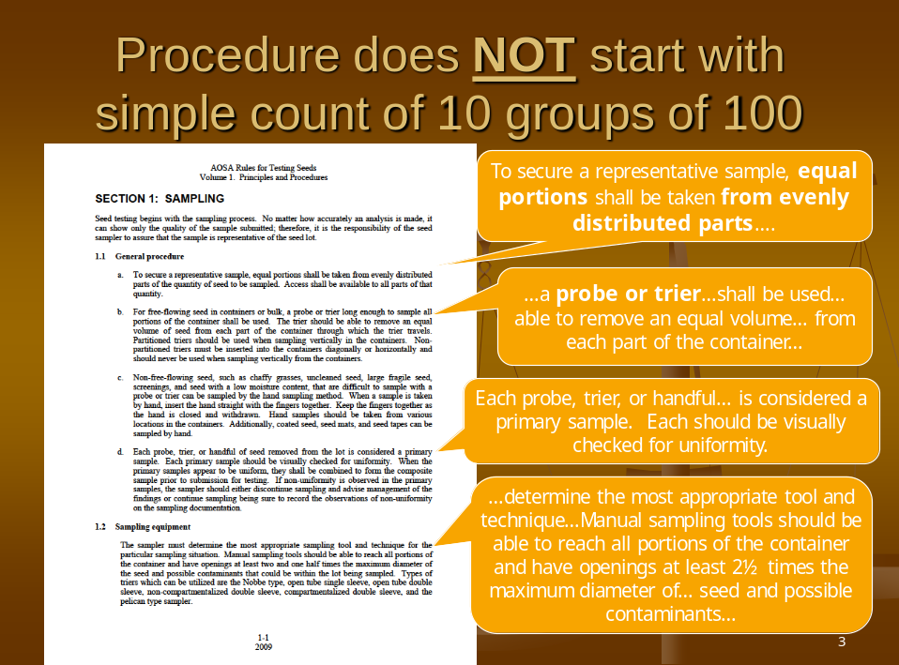
Slide 4 | 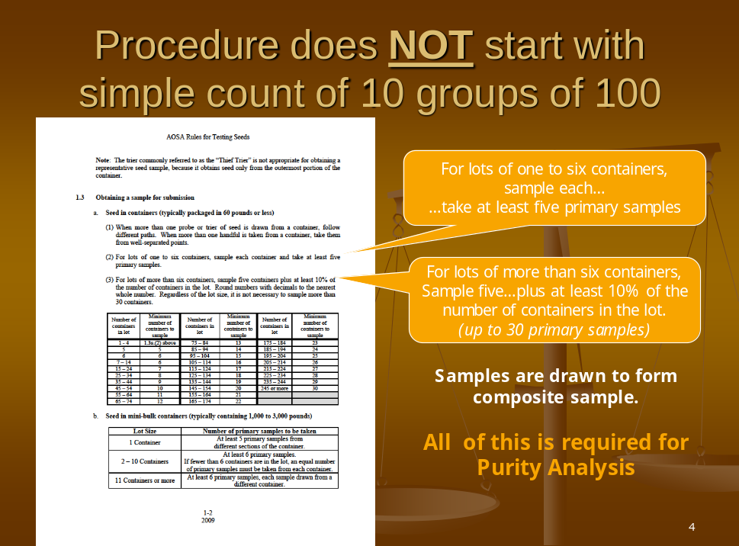
Slide 5 | 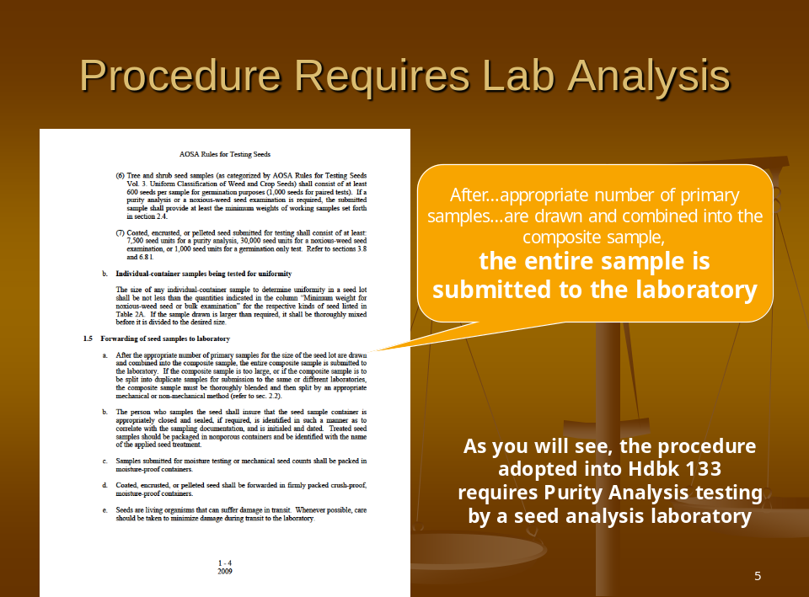
Slide 6 | 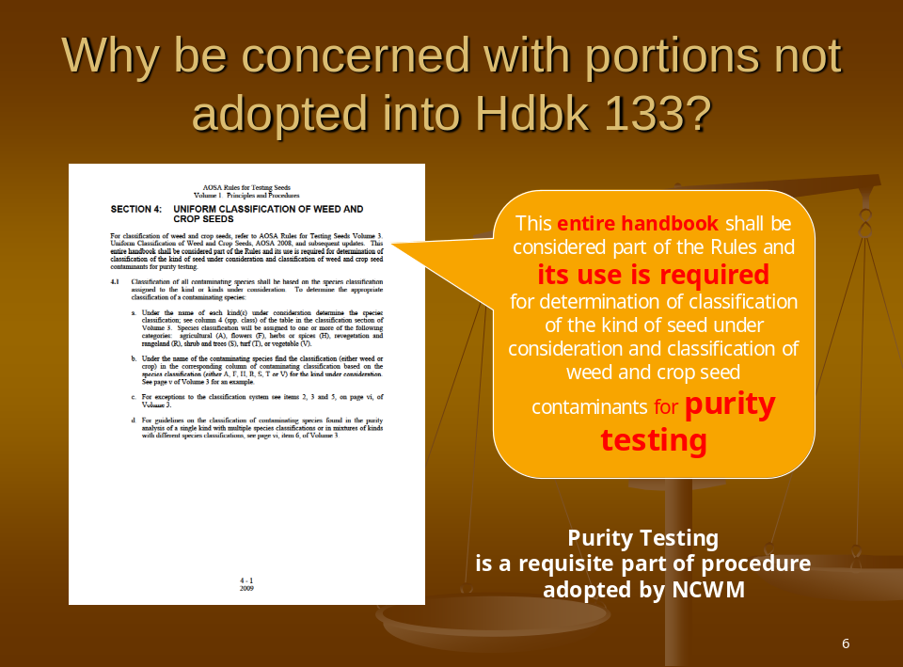
Slide 7 | 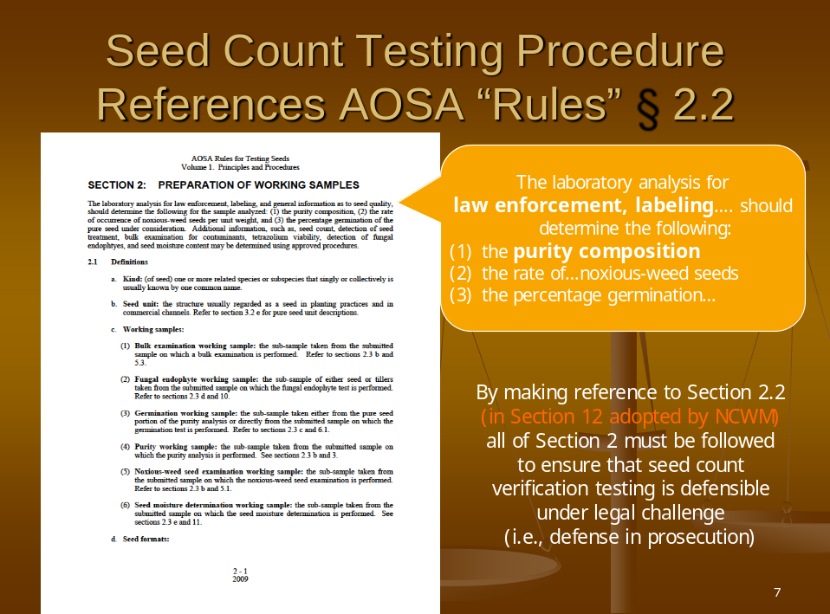
Slide 8 | 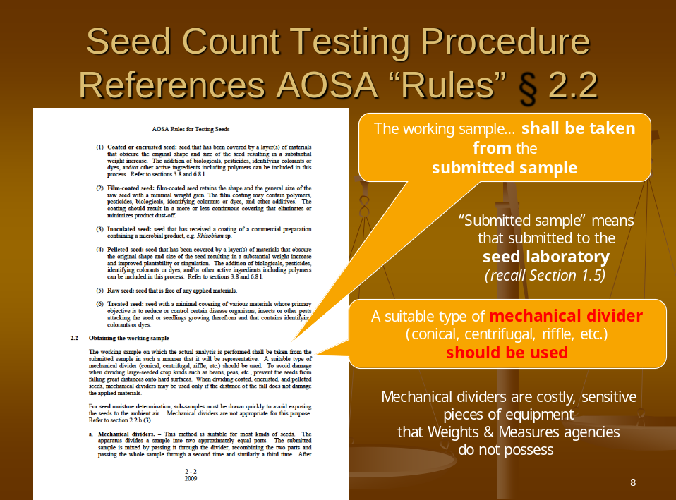
Slide 9 | 
Slide 10 | 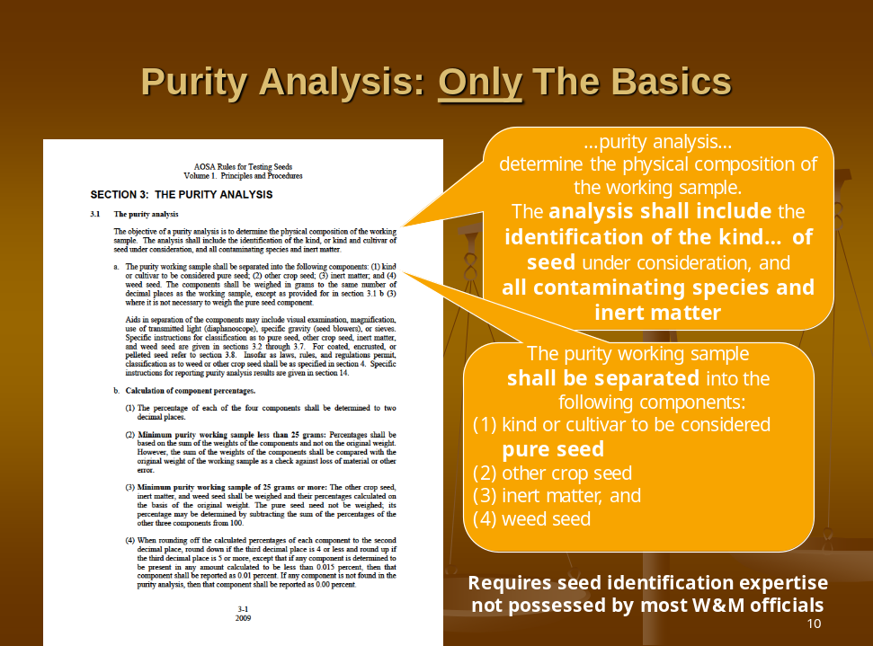
Slide 11 | 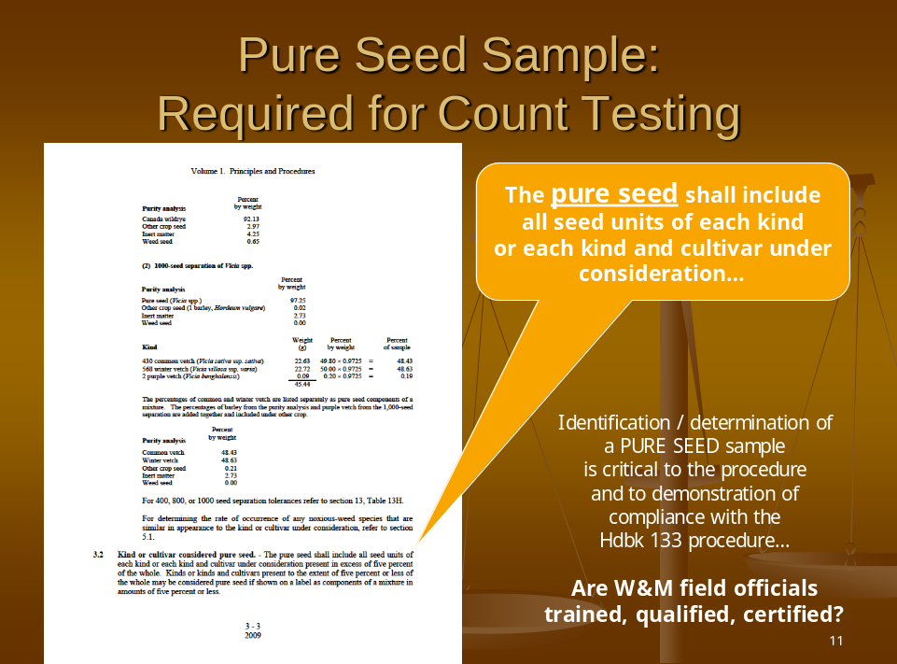
Slide 12 | 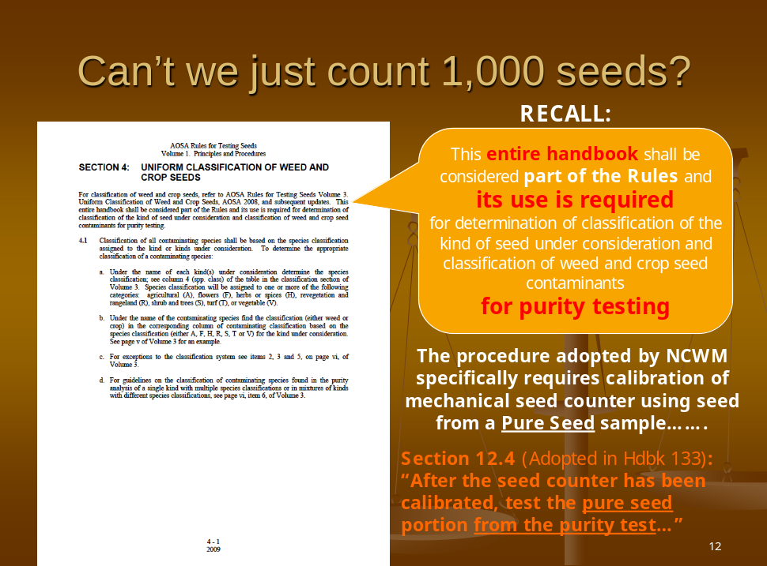
Slide 13 | 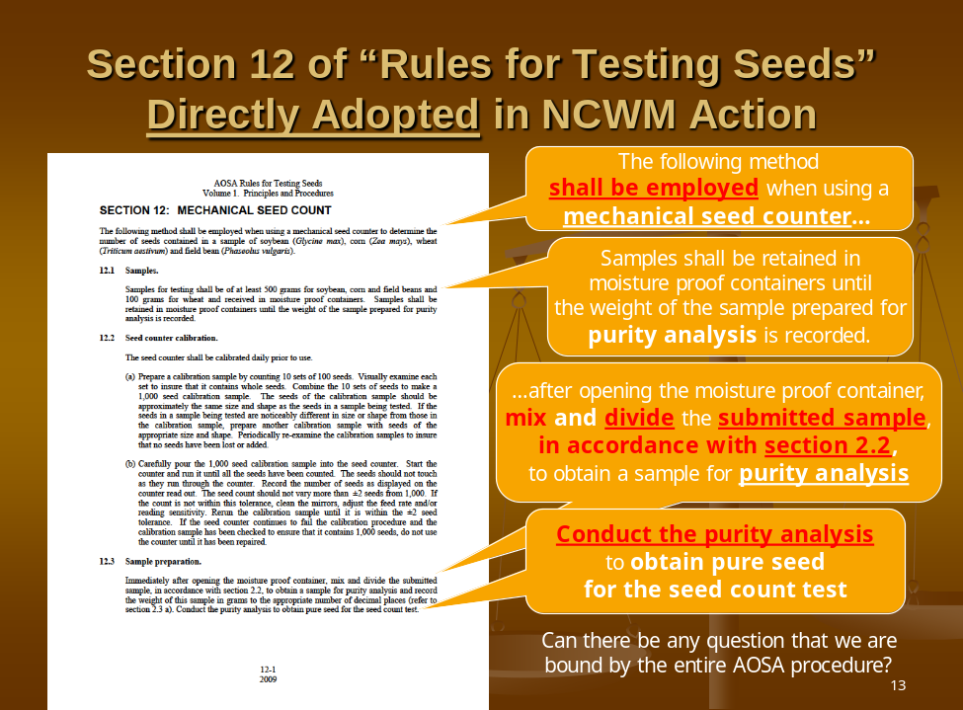
Slide 14 | 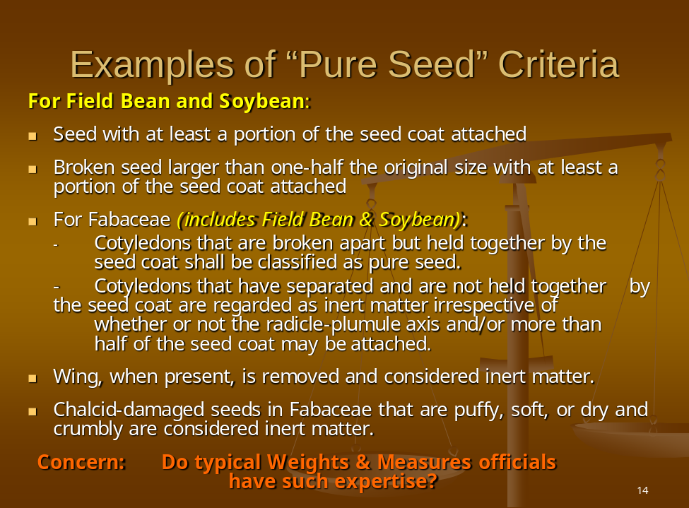
Slide 15 | 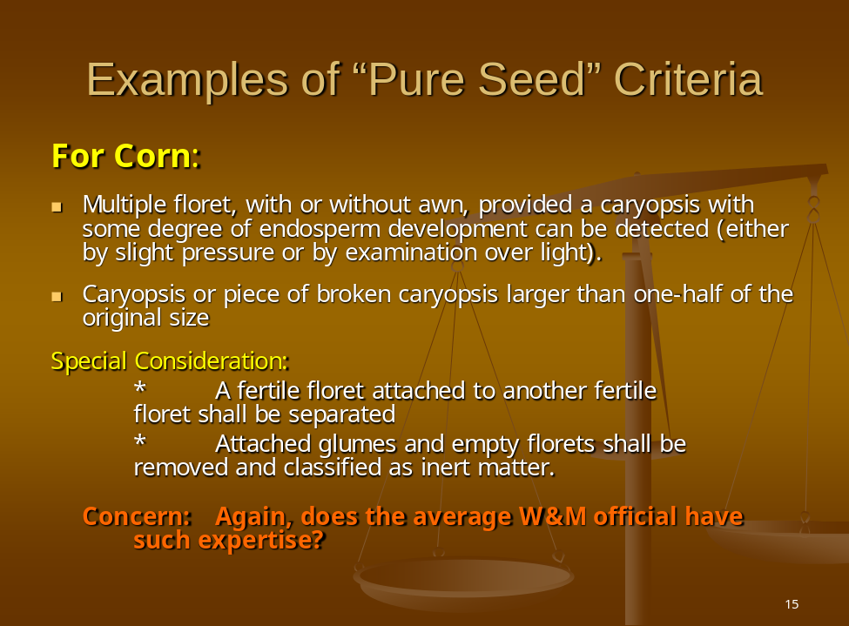
Slide 16
Slide 17 | 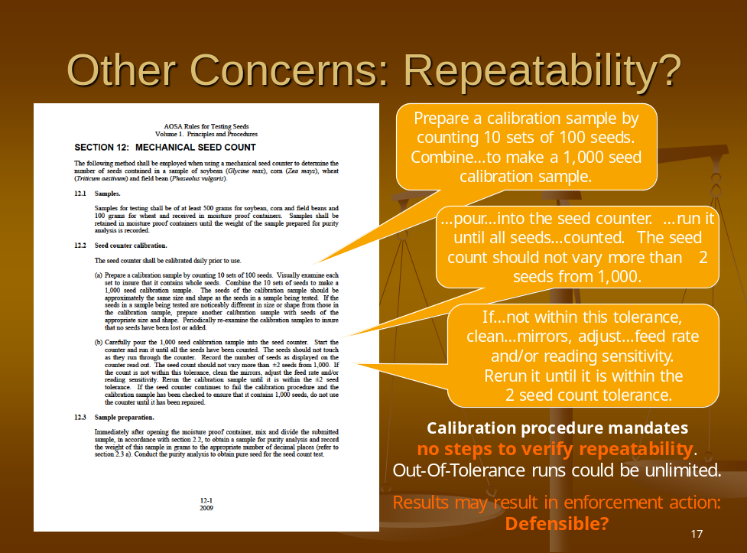
Slide 18
Slide 19 | 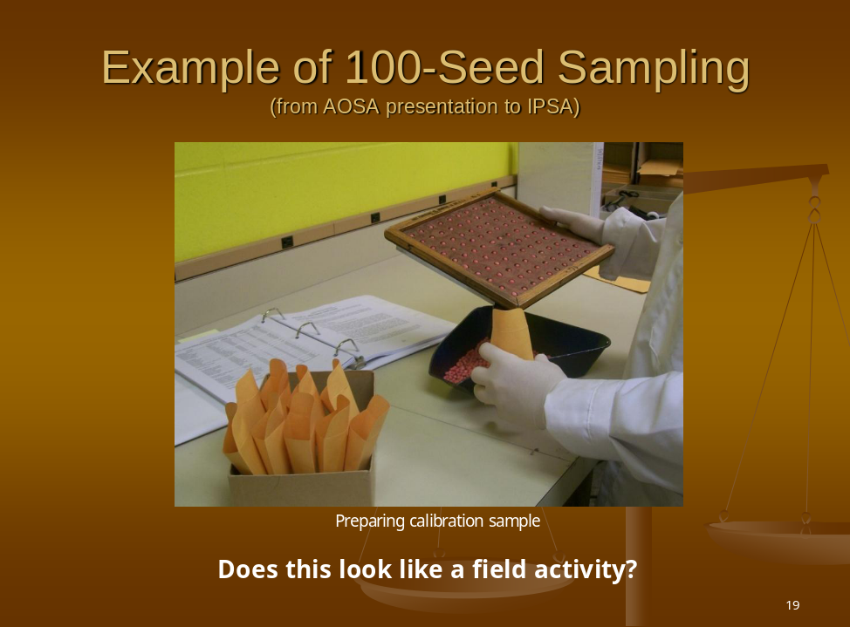
Slide 20 | 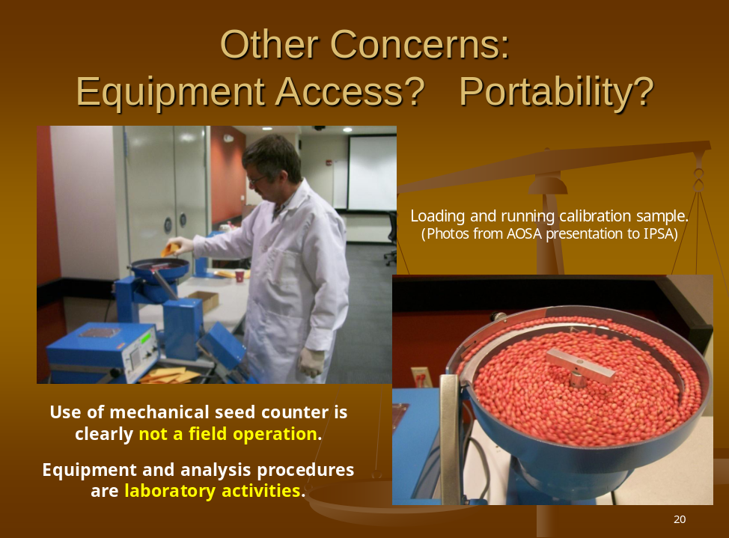
Slide 21 | 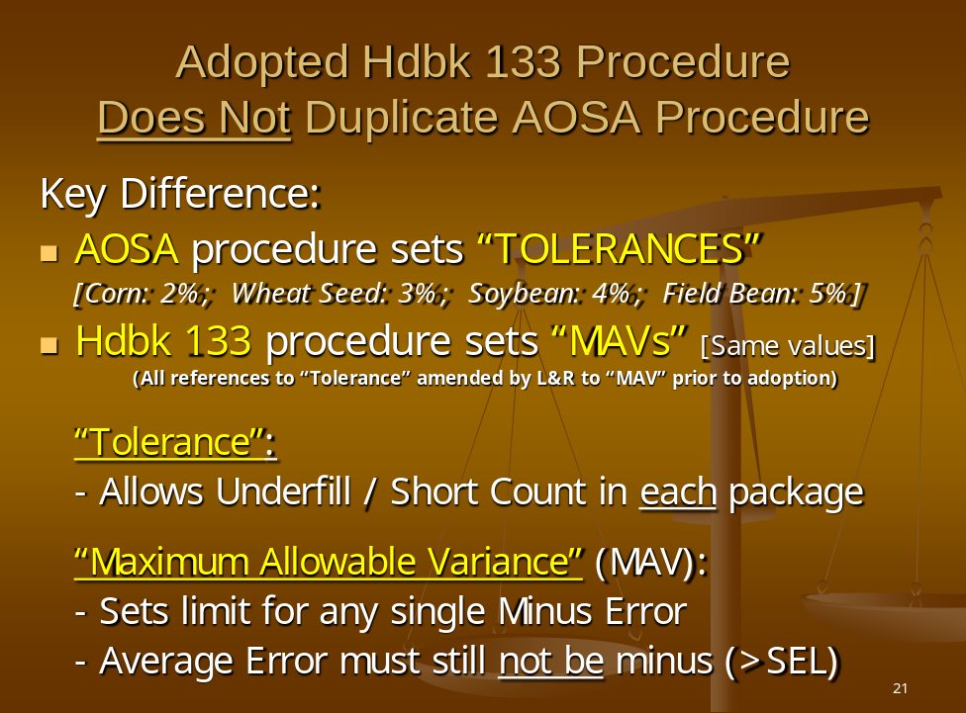
Slide 22 | 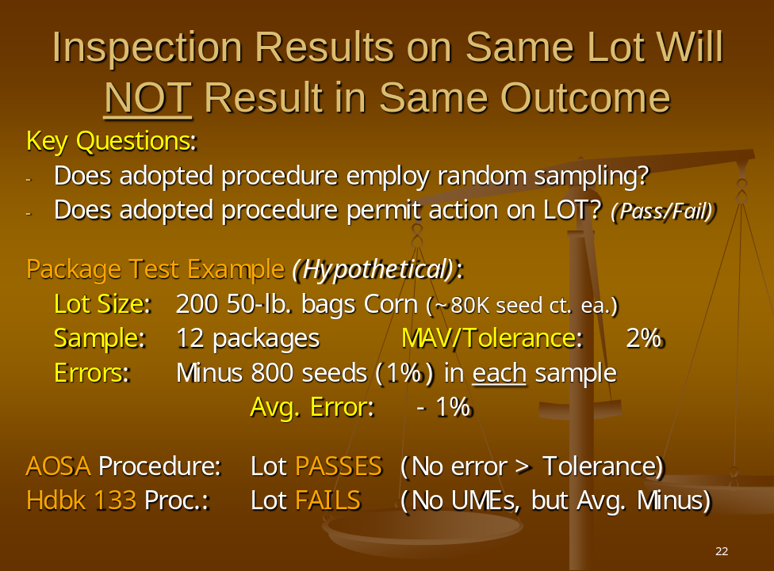
Slide 23 | 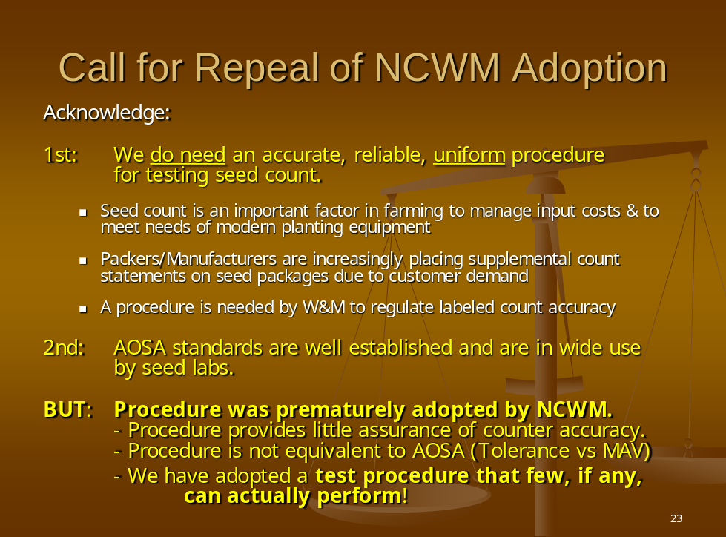
Slide 24 | 
Slide 25 | 
Slide 26 | 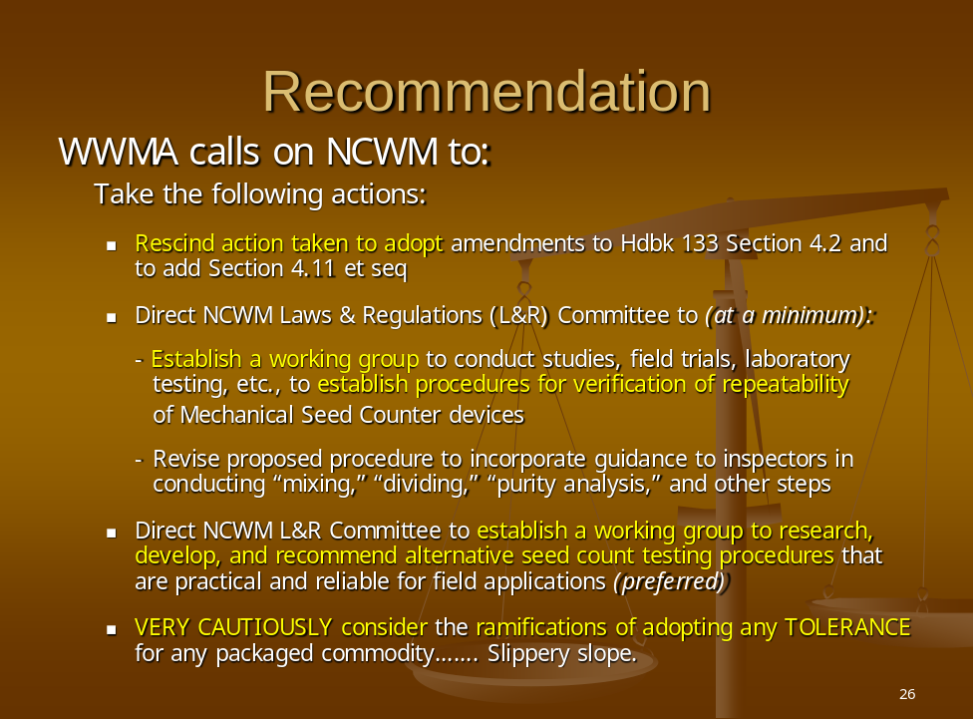
Slide 27 | 



