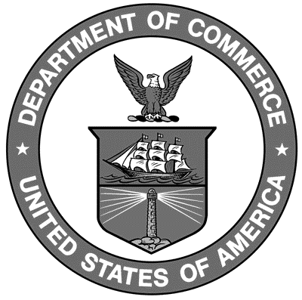

Uniform Laws and Regulations
in the areas of
legal metrology and
engine fuel quality

as adopted by the 94th National Conference on Weights and Measures 2009 and
95th National Conference on Weights and Measures 2010

Editors:
Linda Crown
David Sefcik
Lisa Warfield

Carol Hockert, Chief
Weights and Measures Division

National Institute of Standards and Technology
Weights and Measures Division
Gaithersburg, MD 20899-2600

U.S. Department of Commerce
Gary Locke, Secretary

National Institute of

Standards and Technology
Patrick D. Gallagher, Director
NIST Handbook₁₃₀
2011 Edition
Supersedes NIST Handbook 130, 2009 Edition
Certain commercial entities, equipment, or materials may be identified in this document in order to describe an experimental procedure or concept adequately. Such identification is not intended to imply recommendation or endorsement by the National Institute of Standards and Technology, nor is it intended to imply that the entities, materials, or equipment are necessarily the best available for the purpose.

National Institute of Standards and Technology Handbook 130, 2011 Edition
Natl. Inst. Stand. Technol. Handb. 130, 2008 Ed., 300 pages (October 2010)
CODEN: NIHAE2

WASHINGTON: 2010

