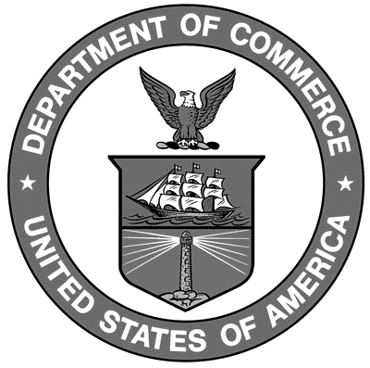

Uniform Laws and Regulations
in the areas of
legal metrology and
engine fuel quality

as adopted by the 97th National Conference on Weights and Measures 2012

Editors:
Linda Crown
David Sefcik
Lisa Warfield

Carol Hockert, Chief
Office of Weights and Measures

National Institute of Standards and Technology
Office of Weights and Measures
Gaithersburg, MD 20899-2600

U.S. Department of Commerce
Dr. Rebecca Blank, Acting Secretary

National Institute of

Standards and Technology
Patrick D. Gallagher, Director
NIST Handbook₁₃₀
2013 Edition
Supersedes NIST Handbook 130, 2012 Edition
Certain commercial entities, equipment, or materials may be identified in this document in order to describe an experimental procedure or concept adequately. Such identification is not intended to imply recommendation or endorsement by the National Institute of Standards and Technology, nor is it intended to imply that the entities, materials, or equipment are necessarily the best available for the purpose.

National Institute of Standards and Technology Handbook 130, 2013 Edition
Natl. Inst. Stand. Technol. Handb. 130, 2013 Ed., 298 pages (October 2012)
CODEN: NIHAE2

