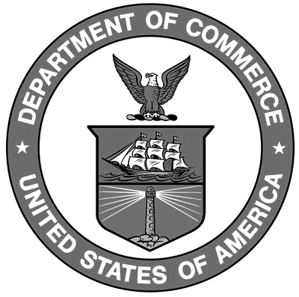

Uniform Laws and Regulations
in the areas of
legal metrology and
engine fuel quality

as adopted by the 93rd National Conference on Weights and Measures 2008

Editors:
Linda Crown
Lisa Warfield

Carol Hockert, Chief
Weights and Measures Division

National Institute of Standards and Technology
Weights and Measures Division
Gaithersburg, MD 20899-2600

U.S. Department of Commerce
Carlos M. Gutierrez, Secretary

National Institute of

Standards and Technology
James Turner, Deputy Director
NIST Handbook₁₃₀
2009 Edition
Supersedes NIST Handbook 130, 2008 Edition
Certain commercial entities, equipment, or materials may be identified in this document in order to describe an experimental procedure or concept adequately. Such identification is not intended to imply recommendation or endorsement by the National Institute of Standards and Technology, nor is it intended to imply that the entities, materials, or equipment are necessarily the best available for the purpose.

National Institute of Standards and Technology Handbook 130, 2009 Edition
Natl. Inst. Stand. Technol. Handb. 130, 2008 Ed., 303 pages (October 2008)
CODEN: NIHAE2

WASHINGTON: 2008

