Specifications, Tolerances, and Other Technical Requirements for
Weighing and Measuring Devices
as adopted by the 99th National Conference on Weights and Measures 2014
Editors:
Tina Butcher
Linda Crown
Rick Harshman
Juana Williams

Carol Hockert, Chief
Office of Weights and Measures
Physical Measurement Laboratory

http://dx.doi.org/10.6028.NIST.HB.44
November 2014
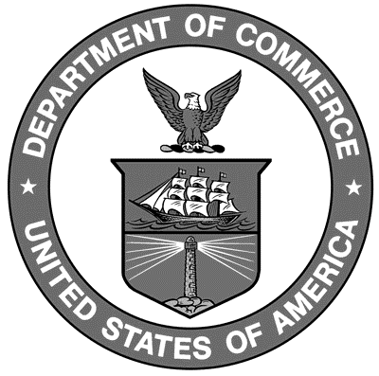

U. S. Department of Commerce
Penny Pritzker, Secretary

National Institute of Standards and Technology
Willie May, Acting Under Secretary of Commerce for Standards and Technology and Acting Director
NIST Handbook | 44
2015 Edition
Supersedes NIST Handbook 44, 2014 Edition

Certain commercial entities, equipment, or materials may be identified in this document in order to describe an experimental procedure or concept adequately. Such identification is not intended to imply recommendation or endorsement by the National Institute of Standards and Technology, nor is it intended to imply that the entities, materials, or equipment are necessarily the best available for the purpose.

National Institute of Standards and Technology Handbook 44, 2015 Edition
Natl. Inst. Stand. Technol. Handb. 44, 2015 Ed., 482 pages (Nov. 2014)
CODEN: NIHAE2

