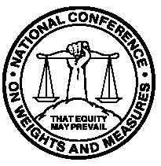
Report of the 93rd
National Conference
on Weights and Measures

Burlington, Vermont – July 13 through 17, 2008
as adopted by the 93rd National Conference on Weights and Measures 2008

Editors:
Linda Crown
Technical Advisors to the Standing Committees

Carol Hockert, Chief
Weights and Measures Division

National Institute of Standards and Technology
Weights and Measures Division
Gaithersburg, MD 20899-2600

U.S. Department of Commerce
Carlos M. Gutierrez, Secretary

National Institute of

Standards and Technology
Patrick D. Gallagher, Deputy Director
NIST Special Publication ₁₀₈₀
November 2008

The National Conference on Weights and Measures is supported by the National Institute of Standards and Technology and is attended by officials from various states, counties, and cities, as well as representatives from the U.S. Government, other nations, industry, and consumer organizations.

