# National Institute of Standards and Technology Address to the National Conference on Weights and Measures to Commemorate Their 100th Meeting

Philadelphia, Pennsylvania

July 21, 2015

Carol Hockert, Chief,   
NIST, Office of Weights and Measures

My goal here today is to give you a brief history of weights and measures and the National Conference on Weights and Measures (NCWM), and to give you a feel for how and why National Institute of Standards and Technology (NIST) and NCWM are so closely intertwined.

To set the stage: In 1905, life expectancy was 47 years; 14 % of homes had bathtubs and 8 percent had telephones. There were 8000 cars in the United States and 144 miles of paved road. The speed limit in most cities was 10 mph. California had 1.4 million people; the 21st most populous state. Tallest building – the Eiffel Tower. Average U.S. wage – $0.22 per hour. The American flag had 45 stars – missing Arizona, Oklahoma, New Mexico, Alaska, and Hawaii. Two of every 10 adults couldn’t read or write. Only 6 % graduated from high school. Most births took place in the home (95 %)

February 13, 1904: A letter was sent by the National Bureau of Standards (NBS) director to governors of the states proposing a meeting of state sealers. This meeting occurred early in 1905. At the first meeting, Louis Fischer read a paper that gave a brief history of weights and measures in the United States. Of note, he mentioned the following historical actions.

* 1781 – In the Articles of Confederation, ratified by the colonies in 1781, there is found the authority for Congress to "fix the standard of weights and measures throughout the United States."
* 1788 – U.S. Constitution: It is the responsibility of the Congress to regulate both international and interstate commerce and to “fix the standards of weights and measures” in the United States.

Despite this, because Congress took no action, most of the states had adopted and secured their own standards. Studies of the marketplace found there was little uniformity within most states and still less between the states.

May 19, 1828: Congress adopts the troy pound for the standard of coinage. The brass troy pound weight obtained by the United States from London and kept at the Mint in Philadelphia, became the standard troy pound of the Mint of the United States. This became the *defacto* mass standard in the United States.

Note: When it was created, the Office of Weights and Measures was under the Treasury Department and prior to the creation of NIST in 1901, that agency defined the units and standards of measurement.

In 1832, large discrepancies were found to exist among the weights and measures in use at the different ports so…

Without waiting for authority from Congress, the Treasury Department, under the direction of Mr. Ferdinand Hassler, had the necessary weights and measures constructed for the customs service.

The avoirdupois pound adopted by Mr. Hassler as the standard for the Treasury Department was derived from the troy pound of the mint.

June 14, 1836: Congress finally directed sets of standards to be completed and delivered to the governor of each state. Most states adopted the standards once received, making the first attempt at uniformity. By 1850, states in the union, at that time, all had a complete set, and this continued as new states joined; the last set going to North Dakota in 1893. [How many states here today still have some of these original standards?]

July 28, 1866: Metric Act – This Act made it legal to employ the weights and measures of the metric system.

Interesting that only one day earlier: Congress authorized the delivery of metric standards to each state. The first state standards were made of brass.

May 20, 1875: Meter Convention – The United States was an original signatory to the Treaty of the Meter. When the reference standards of the United States arrived from France (meter and kilogram), they were inspected by the President himself. The U.S. standards resided with OWM from the time of their arrival here.

April 5, 1893: With the Mendenhall Order, the United States defines all customary weights and measures in metric units.

1901: Congress created the National Bureau of Standards.

Now, back to that first meeting in 1905. After Mr. Fischer gave this historical recount, the states provided reports on the status of weights and measures in their states. Here are some notable comments that were made:

* The Commonwealth of Massachusetts Deputy Sealer (1905) had this advice – States should create a separate office for weights and measures work, with a State sealer, who should be appointed by and be responsible to the governor. He noted that this system had been adopted and was in force in the State of Rhode Island and that it was working.
* He said that the office of sealers in the cities and towns should be placed in the civil-service and an examination required, so those hired are competent for the work. He also recommended that these officers be required to make an annual report of work performed to the State sealer.
* Professor Weld, State Superintendent of Weights and Measures in Iowa told an interesting story about the vault at the university in Iowa City that was the original capital of Iowa and included the old capital building where the standards were kept. He said that no one knew what the standards were for or even that they were there. There were rumors that the vault was haunted.
* He also said the laws of Iowa with reference to weights and measures were, like those of other States, exceedingly lax. In the rare occasion that standards were sent to Iowa City for inspection, the condition of the standards was pretty bad.
* And my favorite quote from the Professor of Mathematics from Iowa, “The time will presently come, I hope, when it will be necessary for me to lay down the office in my own State, in order to make way for someone whose other interests are not dominant, for someone with the necessary scientific training and endowed with the energy and executive ability essential to successful administration.” [When I read this, I think of Ivan Hankins.]
* It was reported that in Michigan, when the sealer of weights and measures in Grand Rapids resigned, the mayor decided that the work could be done by the police.
* Mr. John Richardson, of Virginia indicated that standards only needed to be tested and sealed every 10 years, which he called a “farce.”
* Mr. Isaac Brown of Pennsylvania suggested there should be annual meetings of the state sealers with the NBS and that a national law should be developed.

Moving ahead to the 1920 NCWM meeting:

* California had developed the prototype for today’s weight cart: an “automobile testing truck” with four tons of test weights on each.
* In Connecticut, gasoline pump inspections were conducted undercover. In 156 inspections, 80 were within tolerance, only 4 gave product away. Fifty were short, but not beyond 1 qt in 5 gal. Twenty dealers were convicted of violations of the weights and measures law.
* In Illinois, 432 gas pumps were inspected and all but two were condemned.
* New Hampshire published a brochure called “Practical Facts for the Purchasing Public” to market weights and measures.
* States were beginning to pass net weight laws.
* In Pennsylvania, inspectors were called “cheater chasers.”
* In South Dakota, their first year of inspections of devices showed a 90 % compliance rate! But, they could only test scales up to 30 lb, and they had two inspectors to cover the whole state.
* New York was testing vehicle weights with a portable vehicle scale.
* In New Jersey, the State Association believed they had the best set of weights and measures laws in the country, and they had the best paid staff.
* Nevada reported that after a visit by NBS in 1911, Nevada passed its first weights and measures law which went into effect in 1913.
* In Utah, they equipped two cars for weights and measures work with sleeping accommodations so the inspectors would not have to find a large town with a hotel.
* In Vermont, the owners of gas pumps were required to test them before the first sale each day with a sealed measure.
* Wisconsin reported using automobile trucks (1 ton) to cover their territory. Three trucks with two men in each.
* Maine passed a type approval law, requiring NBS approval on devices used in commerce.
* The sale of coal (large and small quantities) was a big deal. It’s how people heated their homes!

Let’s jump ahead again, to 1935 – the 25th Conference of NCWM. There hadn’t been a meeting since 1931 due to the great depression.

* Florida sent an Assistant State Chemist, who reported that while the State had no weights and measures division, there was a growing interest in the subject.
* Georgia sent a State Oil Chemist, who reported that some changes had been made in the weights and measures law at the last session of the legislature, but stated it was not being enforced, since no money had been appropriated for this purpose.
* In Maryland, it was reported that while the state had a general weights and measures law there was no State Department of Weights and Measures to enforce it and that few of the counties had sealers.
* In North Carolina, it was reported that under the approval-of-type law, some 3000 types of devices were submitted, and more than 1000 had failed of approval.
* In Virginia, it was reported that there were an increased number of jurisdictions now having weights and measures officials and that the state law was now similar to the model law adopted by the NCWM.
* In Wyoming, it was reported that some types of devices were regularly tested twice a year; however, others, such as coal scales and vehicle tanks, were tested only upon request, while still others, including most large capacity scales, were not tested at all on account of lack of personnel and equipment.
* In 1935, a tentative code for person weighers (scales used to weigh people) was modified and adopted. These were scales where you put a penny in the machine to get your weight. They didn’t have bathroom scales back then. The Conference report shows that this topic was discussed at length over a several days.
* There was also extensive discussion on vehicle tank measurements.
* States were acquiring special equipment for large capacity scale testing.
* With the legalization of beer in 1933, legal capacities for beer barrels became an issue.
* Did you know there is on record a death during an NCWM meeting? During the night between the first and second day of this Conference in 1935, the Deputy sealer of Maine died, “Apparently he was walking in his sleep, he fell from a window, and it is now announced that he is dead.” (I wonder if there’s more to this story?)
* John Dickinson, Assistant Secretary of Commerce said, “We must find where the lines between the Federal Government and the State powers come. Those differences are not very likely to be raised if the Federal power and the State power work hand in hand and step by step in a cooperative manner.”

In 1965, the NCWM celebrated their 50th meeting.

* Forty-three States and Territories (and D.C.) represented; over 650 attendees.
* Much has changed in 30 years, with the Conference now electing officers and a chairman. NBS has changed too. Moving to Gaithersburg, Maryland later that year (from Connecticut Avenue in D.C.).
* NBS Director Allen Austin attended a ribbon cutting ceremony to open exhibition. He reported on the CGPM meeting where they voted to redefine the second in terms of the invariant transition of the cesium atom.
* Austin talked about the development at NBS of a new weighing technique for very large weights that would save millions of dollars. It was called elastic weighing and used load cells as comparators. They were also beginning to use lasers for length measurements.
* OWM assisted the U.S. Postal Service (USPS) to develop maintenance test procedures for their scales. At this Conference, the USPS welcomed officials and inspectors to test postal scales.
* A model laboratory was on display.
* Tom Stabler introduced the new state standards program, the most recent delivery of standards and equipment to the states by NBS. Many of these standards are in use today, while others (Russell balance) have been retired after a long and productive career.
* There were strings attached to getting this set of standards. States needed to demonstrate that they had an adequate facility and full time personnel to run the lab. Huge change was taking place at this time. The state laboratory program was being launched. In the meantime, OWM was going to provide calibrations for the states until such time as their labs were ready. I love this quote from the Conference report:

“We in the Office of Weights and Measures eagerly anticipate the establishment of weights and measures laboratories in all States of the United States and the training of qualified personnel to perform a most essential service, necessary not only for weights and measures activities of the States, but also for educational institutions, industry, business, and for research and development effort.”

And what a success this program has been. We have state labs that today are better than a number of the National Metrology Institutes around the world.

* The British had recently announced that they were switching to the metric system over the next ten years. Speculation on US changeover was discussed with agreement that the U.S. would follow suit.
* There was a presentation given on “Weighing in 1985”, 20 years down the road. In it, was the prediction that instrumentation and computers will be the backbone of industry, and that weighing devices will be more and more associated with data handling of process control equipment.
* It was noted in the 1965 annual report that the SMA provided over 5000 Third Man posters that were distributed for Weights and Measures Week. [Ken Tichota from Nebraska is sending one to OWM.]
* At this meeting they voted to change the time during which acceptance tolerances should be applied, reducing it from 90 to 30 days.
* Also at the 50th meeting, Ohio Chief of Weights and Measures gave a presentation on NCWM – a Program for the Future: He said that the organization of the National Conference will likely change, and talked about how change was good and even important. He also said the following: “However, regardless of the organization [of NCWM], it should have its roots in the National Bureau of Standards- that I do not expect to change.”

Jumping ahead again, to 1990:

* At this meeting, there was a re-enactment of the first meeting of the Conference. How many of you attended the meeting in 1990? And remember this re-enactment? Do you still have the red booklet?
* Most correspondence was still done via mail. Documents weren’t available online. There was discussion of staggering the publication of the handbooks to reduce costs.
* There were 318 delegates (123 guests) and 45 states, two territories present. At that time, 20 states had 100 % membership in NCWM.
* Gilles Vinet, Measurement Canada, attended the NCWM meeting in 1990 and determined that they were of value and that Canada would continue participation in the future.
* NTEP was still growing, expanding and being adopted by the states.
* Polyethylene sheeting was on the L&R Committee agenda, as was camera film, softwood lumber, moisture loss in pasta and pet food, and animal bedding. On S&T Committee, marking requirements for load cells made the list, along with minimum test weight load for railway truck scales, and tolerance tables in the scales code.
* The National Training Program was underway with 52 jurisdictions signing Letters of Agreement to participate. There was even discussion of a Certification program for NCWM.
* Ken Butcher, from Maryland, was one of the Vice-Chairmen nominees to NCWM. Dick Suiter, from Nebraska, was appointed to the S&T Committee.
* Incoming Chairman, N. David Smith, talked about preparing for the 21st century. It was a great speech and I look forward to hearing what he has to say this afternoon. He started by talking about the old conference reports, similar to what I am doing now, and he mentioned that some things never change, like the fact that the integrity of the S&T Committee had always been questioned. He suggested that the NCWM was undervalued and perhaps consciously avoided publicity. He also talked about what weights and measures would be like in 20 years, and how technology would change all aspects how we do our work. Finally, he challenged the NCWM to take stock of where they were and to plot a course for the future. He even created a task force to shake things up at NCWM. He wanted NCWM to go to the membership rather than having the membership come to the NCWM.

In the 1990 Keynote address by Congressman Valentine from North Carolina, he talked about the challenges we face ahead of us and ended his speech with this: “Therefore, I hope that business and government, at all levels, can continue to work together to meet the challenge. Let's begin now to lay the groundwork so that we have something really big to celebrate in 2015 at the centennial meeting of the National Conference on Weights and Measures.”

So here we are 25 years later. Life expectancy is 78.8 years, average wage is $10.50 per hour, there are 254 million cars on the road, and 2.65 million miles of paved roads. Many predictions made in previous years have come to pass. Many things have changed, and mostly for the better. A couple of items mentioned in David’s speech in 1990 that I believe have changed for the better are that the integrity of the S&T Committee is no longer questioned at every meeting, and the NCWM is no longer avoiding publicity. Further, the NCWM has taken their services to the membership through its website, an example of which is having NTEP certificates available on mobile devices.

But some things have not changed, including the close relationship between the NCWM and NIST. As in all relationships, there have been growing pains and we’ve weathered some storms, but the commitment by both organizations to our common mission of uniformity and equity in the marketplace has allowed those times to fade in our memories.

I truly believe the NCWM has never been stronger or more effective than it is today, and it is positioned very well for the next 100 years. I will leave it to your chairman to talk about the specifics of where we are today as an organization, and what’s in store for the future.

To paraphrase Louis Fischer at the first NCWM meeting: In conclusion, I know that in preparing such a short summary of so broad a topic, many things have been omitted, but I hope I have succeeded in giving you an outline of the growth and progress of our weights and measures system and the roles that NIST and the NCWM have played along the way.

Thank you very much for your attention. And now I’d like to present, on behalf of the NIST Office of Weights and Measures, this plaque to commemorate the 100th meeting of the National Conference on Weights and Measures.

|  |
| --- |
| A slide presentation to go with the talk given by Carol Hockert.  This slide has: 1781 to 2015 From the Birth of a Nationa through the Growing Pains of Developing a Weights and Measures System. |
|  |
| Slide with pictures of a bathtub of the era, telephone, automobile, motar board and books (education) Eiftle Tower, American Flag, Stork carrying babies, and a pictorial map of California. |
|  |
| Invitation is issued by S.W. Stratton, Dorecitor of NBS (National Bureau of Standards) It is a copy of the text taken from the early NCWM Reports inviting weights and measures reprsentatives to attend a meeting of state sealers, which was to be held in the Spring of 1904 in Washington (D.C.). |
|  |
| Louis Fischer presented a brief history of weights and measures in the United States. |
|  |
| Graphic of the U.S. Constituion document and notes: 1781 - Articles of Confederation 1788 - U.S. Constitution |
|  |
| Congress Adops the Troy Pound  British Imperial Troy Pound, 1758 (picture) Troy Pound of the Philadelphia Mint, 1827 (picture) |
|  |
| Picture of the U.S. Treasury |
|  |
| FPicture of Ferdinand Hassler, 1770 to 1843 Picture of types of testing balances furnished to the states. |
|  |
| Picture of the various tools for measuring weights (mass), vessels (liquid measure), and length. |
|  |
| Metric measuring standards picture for mass, volume, and length. |
|  |
| Picture of metric bar and kilogram delivered from the BIPM and picture of the International Burueau of Weights and Measures |
|  |
| Picture of Mendenhall |
|  |
| Picture of the National Bureau of Standards (NBS)  NBS is formed |
|  |
| Picture of the National Conference on Weights and Measures (NCWM) seal.  Graphic of several states attending the first meeting.  Graphic of the title page from the report of the first conference meeting. |
|  |
| Pictures from 1920 of various measuring and weighing devices. |
|  |
| Pictures of scales from the era. |
|  |
| Pictures deplicting the time period. |
|  |
| When you make a purchase at the food store, fill your tank with gasoline at the service station, or buy any merchandise by weight or by measurement, you think the transaction is only between you and the vendor. It may be a surprise to know that every such transaction is participated in by a third man even though he is not present in person.  The "third man" is the Weights and Measures Official who checks all weighing and volume measuring devices used in sales made to the public. This "third man" is always present in spirit, protecting both buyer and seller. He is a dedicated man working quietly and tirelessly to save customers money and to safeguard vendors' businesses. Errors in either direction, over or under will cause someone to suffer. What he stands for is just "good business." |
|  |
| Pictures of 35 mm film, dry pasta, Paul Bunyeon, NIST campus in Gaithersburg, MD, lumber, and railroad scale. |
|  |
| Pictures of:  U.S. Department of Commerce seal; NCWM seal; NIST logo, cell phones; and pictures of "modern" life, and time. |
|  |
| Thank you. . . Congratulations to NCWM! |

THIS PAGE INTENTIONALLY LEFT BLANK

# National Conference on Weights and Measures

## Chairman’s Address

Picture of Chairman Ron Hayes


Philadelphia, Pennsylvania

July 21, 2015

Ronald G. Hayes

Director, Missouri Department of Agriculture  
Weights, Measures and Consumer Protection Division

Jefferson City, Missouri

Good morning,

I am honored to have this opportunity to speak to you as Chairman of the 100th Annual Meeting of the National Conference on Weights and Measures (NCWM).

I have been fortunate to be part of NCWM for more than 30 years, but I have to say these last two years have been the most fulfilling of my career. It has been great to meet many of the local weights and measures jurisdictions throughout the country and share this knowledge with both my state and regional associations. Thank you for your hospitality and generously sharing your knowledge and ideas.

Three goals were selected for the Conference this year, so I thought I would start by sharing a progress report on those goals and finish with NCWM’s path to the future.

The first goal was to continue to enhance our training programs and the Professional Certification Program. The NCWM Professional Certification Program provides confidence that an individual has a strong understanding of U.S. weights and measures standards as adopted by NCWM and published in National Institute of Standards and Technology (NIST)Handbooks 44, *Specifications and Tolerances and Other Technical Requirements for Weighing and Measuring Devices,* 130*, Uniform Laws and Regulations in the Areas of Legal Metrology and Engine Fuel Quality,* and 133, *Checking the Net Contents of Packaged Goods*.” The Certification Program was a huge undertaking for a committee of volunteers, so the Board of Directors (BOD) took action to get the test exams on a faster pace. Mr. Ross Andersen, retired New York Weights and Measures Director, accepted the challenge to lead the development of these testing examinations. In the last quarter, three more exams have been posted to the NCWM website making a total of six modules. I would like to thank Ross, the Professional Development Committee (PDC) members, and the many volunteers who provided test questions. Next on PDC’s schedule is the liquefied petroleum gas (LPG) and price verification modules. Volunteers are needed.

It may be that I have simply been more aware of training opportunities, but it seems that training is at an all-time high. NIST’s grant and leadership role for training has provided many training opportunities throughout the country. Not only has NIST staff been at each of the regional meetings assisting in the technical committees, but they’ve also been there to provide additional training in specialized areas. The NIST “Train the Trainer” classes have strategically positioned qualified trainers evenly throughout the country. Many thanks to the Associate Membership Committee (AMC) who provided assistance with sharing expenses for trainers in many of the local training classes. I would also like to recognize Mr. Michael Cleary (retired from the state of California) for his willingness to travel and provide training to regional associations on the “Model-Field Training Program.”

The second goal was to build a closer relationship with other standards development organizations. An example of this would be our relationship with the Petroleum Equipment Institute (PEI). PEI has fourteen recommended practices including design, installation, and service and repair in areas of underground fuel storage systems, above ground fuel systems, motor-fuel dispensers, diesel exhaust fluids, and compressed natural gas. PEI maintains relationships with federal, state, and local agencies, and other industry related groups allowing them to funnel regulatory interpretations and information on current technology and compliance issues. Twice a year, following the NCWM Interim and Annual Meetings, PEI reports a summary of the activities from these meetings in their “PEI Journal”. I urge you to visit their website [www.pei.org](http://www.pei.org/) and review the latest “NCWM feature report” following each Interim and Annual Meeting.

Another standards development organization, ASTM International, is headquartered in the Philadelphia metro area. On Tuesday afternoon’s technical session during our 100th Annual meeting, the Conference will have a panel discussion on “Complementary Collaboration, A Case Study in Standards Development Cooperation.” The panel will include representatives from NCWM and ASTM International. Additionally, the Conference will have another panel of experts presenting the recent CRC Report No. 667 – Diesel Fuel Storage and Handling Guide. This presentation will be a condensed version of an ASTM workshop that was held at the D02 Committee on Petroleum Products, Liquid Fuels, and Lubricants meeting in June 2015. The NCWM representation was included in this workshop presenting the role of the weights and measures official in the area of fuel quality.

Recently, Ms. Kristy Moore, a NCWM member and a member of Fuels and Lubricants Subcommittee (FALS), was attending a Society of Automotive Engineers (SAE) meeting. In a committee meeting, there was discussion related to problems with new gasoline dispenser nozzles not fitting properly in new vehicles. Kristy informed the Committee that NCWM recently adopted a SAE standard practice for diesel dispenser nozzles to address mis-fueling of diesel powered vehicles. Members of this SAE Committee were pleased that the Conference had adopted the practice but encouraged NCWM to adopt the same practice for gasoline and flex-fuel vehicles.

These ongoing examples are just a few of the ways we collaborate with other standards writing organizations and demonstrate the impact NCWM can have.

ASTM International, American Petroleum Institute (API), SAE International, Petroleum Equipment Institute (PEI), American National Standards Institute (ANSI), National Fire and Protection Association (NFPA), UL, NCSL International, International Organization of Legal Metrology (OIML), and other standards writing organizations develop specialized standards and recommended practices; but they have no significance unless they are used in contract agreements or adopted by a law or regulation. For the common consumer, it is impractical to have a contractual agreement for each transaction. This is why it is necessary to have a law or regulation to protect both the buyer and seller.

The third goal is to work closer with federal agencies such as the Federal Trade Commission (FTC), Food and Drug Administration (FDA), U.S. Department of Agriculture (USDA), and others. Both the FALS and the Package and Labeling Subcommittees (PALS) have been providing guidance to FTC and FDA during the rulemaking process. Many of the NCWM recommendations are being recognized giving the work of the Conference acceptance in federal regulations.

A major milestone of the Conference was reached in 1984 when motor fuel users were complaining to weights and measures officials about fuel quality and vehicle performance. While a few officials argued weights and measures officials should not cross the line from quantity assurance programs to programs regulating quality, delegates were persuaded that the issue needed immediate attention. This new area of responsibility complements the device inspection part of weights and measures. This provides for a government that is more responsive and efficient. A few years later, the Conference created and adopted a Uniform Engine Fuels and Automotive Lubricants Regulation.

Traditional fuels are changing, and many new fuels and energy sources are emerging to meet the demand for environmental quality and to minimize climate change. In the last 30 years, mass flow meter technology has evolved to handle these new fuels as well as other commodities that are difficult to measure with traditional meter technology. Model specifications for these devices were needed and were developed.

As technology moves forward so does NCWM by forming various Subcommittees, Work Groups, Steering Committees, Sectors, and partnering with NIST and national experts. The structure of the Conference is working well. Since the establishment of our home base in Lincoln, Nebraska, the Conference is more responsive to the needs of society than ever before. I do not hesitate in saying, NCWM is the best it has ever been.

In our changing world for more energy, alternative energy, green energy, and zero emission vehicles, fuels are being developed to meet the requirements creating new challenges. We have some of the world’s best fuel experts as members of the NCWM Fuels and Lubricants Subcommittee.

Autonomous (driverless) vehicles are currently under development. In the very near future, we will see driverless taxi cabs. Weights and measures officials will again have new issues to address. Consumers will wonder if tipping is still expected, and I will wonder if the ride from the airport to the hotel will be as thrilling as the one I experienced this week.

Chair elect, Mr. Jerry Buendel, will discuss the vision of NCWM. I believe we should take another look at our voting process and consider voting more than once per year on issues. On another topic, we must continue to do more to move this country towards the use of the metric system.

Ms. Carol Hockert’s presentation on the history and evolution of the Conference shows how dynamic this organization is. The diversity of knowledge shared among our regulatory officials and industry partners makes this a great organization. Success happens when we are willing to work together!

Our special event will be at the National Constitution Center where we can explore the history and relevance of the Constitution, celebrate our freedom, and embrace our role in the story of “We the People.”

Congratulations NCWM on your 100th Annual Meeting!

THIS PAGE INTENTIONALLY LEFT BLANK.

# Mr. Smith gave the Keynote Address to the assembled participants in celebration of the 100th Annual Meeting of the Conference.National Conference on Weights and Measures

## Keynote Address

N. David Smith

North Carolina

Thank you for asking me to be your keynote speaker at the 100th Annual Meeting of the National Conference on Weights and Measures, which I will primarily refer to hereafter as simply, the Conference. As some of you may know, I have experience being the keynote speaker at centennial celebrations. In June 2004, I was the keynote speaker at the centennial banquet for ASTM Committee D02 on Petroleum Products, Liquid Fuels and Lubricants. My involvement as the keynote speaker at Committee D02 and here today is an interesting story. I know many of you have already considered I have a long history with both organizations, and it’s probably extremely rare for one individual to be asked to give the keynote address at two centennial celebrations even though there is a close and long history with both organizations. Yes, that is correct but there is an even more interesting story behind the story.

When Committee D02 was planning its centennial celebration, the Planning Committee sought to invite a speaker of note and one with a connection to the petroleum industry. Their first choice was former President George H. W. Bush. An invitation letter was extended, and a regrets reply was promptly received indicating that the timing of the DO2 celebration coincided with the Bush family’s traditional summer vacation in Maine. The Planning Committee revised their criteria to concentrate on availability. I became the available keynote speaker.

I’m told the Conference Planning Committee also wanted a national speaker of note. It was reported to me; they discussed inviting former Secretary of State Hillary Clinton until they learned of her $350,000 speaking fee. The Planning Committee revised their criteria to concentrate on cheap. Apparently someone suggested they could get N. David for airfare and hotel expenses — in other words, somewhat cheap.

So, my reputation as a keynote speaker is now intertwined with available and cheap. If there are any aspiring keynote speakers in the audience, you may want to be known as the available and cheap choice.

While planning my comments for this celebration, I reviewed my presentation to Committee D02. I was able to use some of the same material; further strengthening my cheap reputation. A quote from Henry Ford, “Coming together is a beginning; keeping together is progress; working together is success.” Not many organizations involving government officials and private industry members can say they have been meeting together for 100 years. The quote from Henry Ford is a perfect description of the National Conference on Weights and Measures.

It is customary to start a presentation by acknowledging special guests and dignitaries in the audience. I have sat through enough political speeches to know that many speakers take up too much time introducing the notables in the audience, and then they leave out a few. Any good will they had hoped to generate was lost by an unintended oversight. I will limit myself to two individuals and two very special groups.

The special guests I want to acknowledge are Ann Turner and Otto Warnlof. If you were associated with the Conference during the 1980s and 1990s, you came to rely on Ann for everything. Ann was the gatekeeper, solver of problems, and confidant when things did not go according to plan. Meetings did not get done without Ann’s guiding touch. Ann gave everyone confidence that every meeting would be flawless. Otto was Mr. Specifications and Tolerances for over 20 years. He was the technical adviser to the S&T Committee and nothing was added or taken from NIST Handbook-44 without his approval. In addition, Otto was part of the greatest generation as chronicled by Tom Brokaw. Otto was a B-17 co-pilot in the U.S. Army Air Corp, the Mighty Eighth. He will not tell me how many missions he flew in World War II. Please join me in thanking Ann and Otto for their dedication to the Conference.

Events like this just do not come together without planning. Your 100th Annual Meeting Planning Committee members deserve your appreciation for their hard work and dedication. It is not an easy task to plan a special event. Please join me in showing our appreciation.

The last special guest I want to recognize is — each of you. It is the dedication of you, the individual member, which makes the Conference so successful. Please give yourself a hand.

Your speaker is a country boy from rural North Carolina. I grew up on a small farm in the eastern part of the state. Until I started working for the North Carolina Department of Agriculture, the biggest trip I had experienced was to Myrtle Beach, South Carolina. My involvement with the Conference changed everything. I have visited almost every state, made friends with many great people, slept and ate in some very fancy hotels, and had the opportunity to make a positive contribution to the business of weights and measures.

While pondering what I wanted to incorporate in my presentation, I decided there was no need for me to review the beginning history of the Conference. After all, we have Charlie Carroll and Joe Silvestro in attendance and they can probably give a first person account of the initial meeting between Dr. Stratton and the nine state representatives. I decided to concentrate on the time I first attended the Conference moving forward to more recent times. For those of you who have been involved with the Conference for less than fifteen years and especially for less than eight years, you may not know that much has changed. The Conference is a completely different organization today versus my initial exposure in 1978 at the 63rd Conference.

The 63rd Conference was held at the Shoreham-Americana Hotel in Washington, DC. A single room was about $25 and a double in the $30 range. Registration was $50. I need to take a few minutes to describe the hotel. The hotel was built in 1930. In its heyday it was a major social and political powerhouse. According to a Forbes article I found, the hotel was home to many well-known senators and congressmen. It was common knowledge that former Missouri Senator Stuart Symington frequently hosted President Truman in his room for all-night poker sessions. In 1933 to accommodate President Roosevelt’s wheelchair for his first inaugural ball, the hotel built a special ramp and elevator. The Beatles rented the entire seventh floor for their February 1964 Washington concert, which was their first concert in the United States. It was reported the Beatles had to schedule several concerts to cover their travel expenses because Ed Sullivan only paid them $8,500 for three television appearances. Here is the story I particularly like. To avoid wartime alcohol rationing, the hotel purchased all the stocks of a Scottish distillery.

The hotel featured one of the swankiest nightclubs in Washington, the Blue Room. The Blue Room was where Liza Minelli gave her first public performance. It is where presidents took their wives for fancy night on the town dates. The hotel is where the political satirist and comedian, Mark Russell, skewered Democrats, Republicans, and Independents alike from the Marquee Room.

According to the same Forbes article, the Blue Room closed in 1975 and the hotel fell into disrepair. My exposure to the Conference and the hotel was in 1978. When the taxi pulled up to the hotel, it was easy to see the hotel was a magnificent place. Its architecture was grand, big, and bold.

I was excited because I had never stayed in such a grand hotel. The lobby was magnificent, but as you looked around, you got the sense the hotel had seen better days. You could look at the furniture and see the wear and other signs of aging and neglect. Still, I was excited and eager to see my room. Imagine my surprise when I unlocked the door only to find the ceiling in the bathroom had collapsed to the floor. That was my introduction to the National Conference on Weights and Measures.

I must point out my first Conference revealed the depth and quality of the leaders of this organization. As an example, the Resolutions Committee honored the Chairman of the previous Conference, Earl Prideaux of Colorado. Like Otto, Earl was a member of our greatest generation. If you have ever seen a picture of General George Patton relieving himself in the Rhine River in Germany, you have also seen Earl. He is one of the officers standing alongside General Patton. At that point, I knew strong leadership would be the hallmark of this organization.

I did not attend the Conference the following year when it met in Portland, Oregon. I returned in 1980 when the Conference again staged its Annual Meeting, where else but the Shoreham. I don’t recall much from that Annual Meeting; at least I don’t recall any issues with my room. To be honest, the hotel is now owned by the Omni Corporation, and I understand they have pumped millions of dollars into the hotel to return it to a grand state.

I want to return to my history lesson for the most recent members of the Conference. How is the Conference different today versus my initial exposure? For one thing, the hotels have improved greatly. Let’s start with the Interim Meeting. During my early years in the Conference, the Interim Meeting was always held at the National Bureau of Standards in Gaithersburg, Maryland. We just called it the Bureau for short. The timing of the meeting has not changed, mid to late January, but in that timeframe, there is a big difference in temperatures between Gaithersburg and San Diego, California, the location of the 2016 Interim Meeting. We could always expect to see snow piled on the street corners; often times it would be snowing or at the least we could expect a cold, miserable rain.

Those attending the Interim Meeting were housed in a hotel near the Bureau. Sometimes it would be a nice hotel; other times there were issues. I recall being located in one of those smaller hotels that cater to the casual family traveler as opposed to business clientele. The hotel was not prepared for over 100 people to all take showers at 6:00 in the morning. After the first morning of cold showers, we all agreed to take showers in shifts beginning at 4:00 a.m. and to give the water heater enough time to recover between shifts. We never went back to that place.

At that time the Bureau was located in a somewhat remote location. It was surrounded by farms that were rapidly transitioning to housing developments and commercial uses. It was a journey just to get to the Bureau. For those arriving by air, you landed at Washington National Airport and carried your luggage across the street to the Metro rail stop. Note I said you carried your luggage because that was before someone came up with the brilliant idea to put wheels on luggage. For those of us not savvy to the ways of commuter trains, it was always an adventure to figure out how to buy a ticket to the correct stop. Once the ticket purchase was accomplished, you caught the yellow line to its intersection with the red line. You skipped over to the red line and hoped that you were on your way to Shady Grove (Gaithersburg), Maryland, the end of the line and the getting off place for the Bureau. Maybe you had made arrangements for someone to pick you up and take you to the hotel. Maybe you could find a waiting taxi. Maybe a fellow Conference member was on the same train and you would have a companion while you figured out how to get to the hotel. I want to remind everyone this was long before anyone had a cell phone. Sure, I could use a pay phone (they had those back then) and enter my state issued calling card number which consisted of about 32 numbers and later explain to our accounting department why it was necessary to call a taxi while in Shady Grove, Maryland.

Eventually you would arrive at the hotel where you would be greeted by your fellow Interim Meeting colleagues. The entire Interim Meeting experience was something like going to camp in the middle of winter. Each morning at 7:00 the Bureau would send a bus to pick everyone up and deposit them near the front door of the Bureau. By bus, I mean a green school bus type vehicle; not unlike the ones used by prison departments to transport inmates. That bus was important because it was going to be your transportation back to the hotel after 5:00 p.m. Once you stepped foot inside the lobby of the Bureau, you were officially Bureau property. You ate breakfast and lunch in the Bureau’s cafeteria, lived by their rules, and checked the time on the many clocks that were strategically positioned throughout the building. I always thought it odd that even at the National Bureau of Standards not all the clocks showed the same time. Regarding the cafeteria, it was industrial with little regard to food presentation, and they served the worse coffee ever offered to mankind.

It was a fascinating time for me. Here I was at the National Bureau of Standards where the lobby was filled with plaques and citations honoring all the scientists that had worked at the Bureau and all the scientific discoveries coming from the work done there. Just reading the plaques was humbling because you knew you were in the presence of great scientific and engineering thinking and cutting edge experimentation. There I stood surrounded by scientific greatness and my main concern was getting folks to understand that 16 ounces equaled one pound.

Each Committee was assigned a room, which resembled a large interrogation room in a big city police department. The Committee members sat at the center table surrounded by industry representatives sitting in straight back chairs lining the walls. Each Committee had an adviser from the Office of Weights and Measures and each one was dedicated to his or her craft. We plowed through our agendas with our advisers taking careful notes because they were often the ones who put the final product on paper. So, when the bus picked us up at 5:00 p.m. our advisers remained at the Bureau to bang out what had been decided that day. Again, recall, this was in the days before modern word processors. You make a mistake, you start over.

One day during the week, we would have lunch with the Director of the Bureau, who for many years was Dr. Earnest Ambler. He was a likeable fellow who would always tell us the Bureau was short on funding, but he was generously allocating funds to the Office of Weights and Measures because he so appreciated our dedication and loyalty to weights and measures principles. Over lunch he invited our comments and questions. I think our relationship started to change in the mid-1980s when Joe Swanson of Alaska said “Ernie, you are just not getting it done for weights and measures.” We just didn’t know how much and dramatically things were about to change.

After lunch on Friday, the Bureau would release us from its hold and we would reverse the Metro trip from Shady Grove to the stop at Washington National Airport. Looking back on those days, while they were mind numbing because you were essentially held hostage at the Bureau surrounded by bone chilling temperatures, it was a time deep friendships were formed with colleagues from other states, jurisdictions, and the private sector. Standing in the Bureau’s lobby waiting for the bus and taking the bus to and from the hotel allowed you time to really get to know your fellow weights and measures colleagues. We had conversations about the value of weights and measures, how to make our laws and regulations better, and how to be more effective and efficient in our programs. Maybe the Bureau had a plan after all.

The annual meetings were much different back then. They would start on Sunday and end Friday afternoon. The program was packed with scientific and scholarly presentations on subjects relating to weights and measures and measurement standards. The state metrologists met during the Conference, and they had a full weeklong agenda of technical training. I also want to point out that the Standing Committee meetings were taking place while the formal presentations were being made, and the Standing Committee meetings were all scheduled at the same time. It was easy to miss an important discussion because you were in the wrong place at the wrong time. From the registration list of the 1978 Annual Meeting, I count 170 state and local officials, 179 industry representatives, 54 U.S. government officials, and 28 representatives of foreign countries as well as retired individuals and representatives of non-profit organizations. That is a total of 431 registered participants. Don Onwiler tells me his research shows, during the 1960s and 1970s, it was not uncommon for the attendance to average 500. Contrast that to the 2010 Annual Meeting with 235 participants and even this one with around 275 registered participants. Except for addresses by the leadership of the Conference, little time is now spent on anything but presenting the business of the Conference. I guess it’s all about being efficient with time and money. Looking at the agenda for my first Conference, I count 15 presentations outside the ones given by the Conference leadership. For the meeting this week, I count two.

I don’t miss those scientific presentations because they seem so dated looking back now. For example, at my first Conference there was a presentation on electromagnetic interference and what must be done to protect all those devices that would soon be driven by microprocessors. The speaker focused on CB radios and the problems they were causing. He noted that in 1975 truck manufacturers started installing electronically-controlled anti-skid braking systems. Eighteen thousand trucks had to be recalled due to break interference by CB or mobile radios located in the truck or in a passing truck. I can’t imagine he had a clue that one day virtually all of us would walk around with a small, powerful device that would allow us to communicate in various forms with anyone in the world regardless of the locations of the users. In fact, I have some interesting information regarding cell phone usage. The population of the United States is about 319 million, and it is estimated there are 328 million cell phones in use. In March 2013, the United Nations estimated that 6 billion of the 7 billion inhabitants on earth had cell phones. That is almost 90 % of the earth’s inhabitants. The United Nations went on to say there are more people with cell phones (6 billion) than have access to working toilets (4.5 billion). This is just one example of how quickly events and circumstances change and often they have a tremendous impact on how we conduct our business.

I was handed the Chairman’s gavel in July 1990 at the J. W. Marriott in Washington, D.C. Looking back we may have been near the apex of our relationship between the National Institute of Standards and Technology, yes the name changed in 1988, and the National Conference on Weights and Measures. Storm clouds were on the horizon, but I’m not sure any of us saw what was coming and how dramatically it would change that relationship.

In my incoming Chairman’s remarks to the Conference, I used my son, Eric, as the poster child for the future of weights and measures. Eric was 10-years old at the time. Eric is here today, but in a completely different role than I talked about in July 1990. It is hard to believe it has been 25 years. I foresaw Eric as the weights and measure inspector of the future where he would need to have a scientific or engineering background to work through the complexities of weights and measures enforcement; where auditing device and packaging performance was more important than actual inspections because field inspections were rare due to devices being self-calibrating. I foresaw Eric as a weights and measures device manufacturer that seamlessly put his devices in trade throughout the world because of uniform international standards. I foresaw Eric as a packager that openly understood that net contents records would be shared with regulatory officials and any shortages would be resolved quickly and targeted to the affected markets. I foresaw Eric as a consumer more concerned about the cost of health care, the environment, and food and product safety than the importance of weights and measures. Lastly, I foresaw Eric, the taxpayer, whose priorities reflected those of Eric the consumer. I posed the question — in the year 2000 would any weights and measures program be a general fund obligation or will the programs be solely supported by inspection and registration fees? There is still some general fund support but many of us now exist on fees and other non-general fund receipts. Collecting money, in addition to inspecting devices and packages, is now part of the job description.

So what has Eric done in the past 25 years? He has fulfilled many of my predictions; just not as a weights and measures inspector. He has a degree in chemical engineering and works for a major pharmaceutical company. I will point out his choice of degree was influenced by Chip Kloos, a former industry representative with Hunt-Wesson Foods, who for many years was a major contributor to the Laws and Regulations Committee. Eric works from home collaborating with his team members located in several countries. He devotes time to auditing records and solving problems remotely rather than being at a production facility. Of course, he is concerned about the cost of health care because he is part of that industry — his income depends on it. He takes weights and measures for granted because he rarely hears any news about weights and measures scandals or the cost to consumers, taxpayers, or the regulated community.

I concluded my year as Chairman when we met at the Four Seasons hotel in Philadelphia. It seems fitting we are back in Philadelphia today for the 100th Annual Meeting celebration. Much of my professional life is centered around the City of Philadelphia. I attended my first ASTM meeting at the former ASTM headquarters on Race Street and the Philadelphia airport is by far my most visited airport. I recall my stay at the Four Seasons where Pam, Eric, and I were assigned the presidential suite. Eric had his own room. It was at the Four Seasons where Eric discovered room service. He declared there was nothing better than having food brought to your room and being able to watch TV while eating. I discovered that room service for every meal is expensive. Another interesting memory of that meeting was what happened to my shoes. As a perk, if you hung your shoes on the door at night, the hotel would polish them and return your shoes early the next morning. At the same time, we were at the hotel, the Kennedy family was having a wedding there. I suspect someone connected the presidential suite and the Kennedy family and decided to make off with a pair of what they thought to be Kennedy shoes. I have often wondered how many times my loafers have been passed off as authentic Kennedy memorabilia.

As I said at the beginning, this presentation will concentrate on more recent times rather than the entire history of the Conference. In the past 40 years, this organization has been blessed with great leadership. I don’t intend to name all the chairmen and leaders, but I would like to highlight a few.

* Syd Andrews from Florida was a leader in the Conference and in ASTM. I learned a great deal from Syd and I owe him my gratitude. He was a mentor and dear friend.
* Jim Lyles of Virginia was the consummate Southern gentleman who had the ability to tell someone they were wrong in their beliefs and receive a thank you for pointing that out.
* Ken Simila of Oregon, who was noted for not holding back on his comments, once famously declared the Oregon legislature had repealed the law of gravity.
* George Mattimoe of Hawaii was a character that was enhanced by his traditional Hawaiian attire of white, baggy pants and floral shirts or as some of us were fond of saying — the only person permitted to attend a formal session of the Conference while dressed in pajamas.
* Darrell Guensler and Barbara Bloch of California brought steady guidance and leadership to the Conference during times of change. I think California’s governance system for weights and measures gave them unique leadership skills. By the way, I think California has contributed more Conference Chairmen, seven, than any other state.
* Dr. Charles Green and Fred Gerk of New Mexico brought insightful thinking and common sense. They, along with their wives, also introduced us to Southwestern cuisine as they would prod us to try different and sometimes very spicy dishes, which they fixed and dished up themselves often from their RVs.
* Tom Geiler of Barnstable, Massachusetts, pushed the Conference into making hard, difficult decisions. He is probably the only person to transport a three-gallon pot of clam chowder across the country only to prove that New England clam chowder is better than some western state fish stew. Can you imagine getting that pot through airport security today?
* Wes Diggs of Virginia served the Conference twice and the last time under difficult circumstances. We owe Wes and the State of Virginia for the extra time devoted to the Conference.
* Randy Jennings of Tennessee continues to be a leader in the Conference and in ASTM. He brings tremendous creditability to any task he undertakes.
* Steve Benjamin of North Carolina is my colleague in my interface with the Conference and the Southern Weights and Measures Association, and in our ongoing state budget deliberations. Steve and I work together to support and defend his budget before State legislative committees and to avoid being the second State on record to repeal the law of gravity.
* Jim Truex of Ohio brought great technical skills to the Conference, and he continues in that role today where he is now on the Conference payroll.
* Ross Anderson of New York started his involvement with the Conference as a metrologist and worked his way up to chairman. Like Jim, Ross contributed outstanding technical skills that continue to pay dividends today because he added to the Conference’s technical reputation.
* Don Onwiler of Nebraska has perhaps had the greatest and most lasting impact of any Chairman. Not only did he serve the Conference in a volunteer role, he now serves as the Executive Director and from my observation, he is doing a fine job.
* Too numerous to mention are the private sector members who contributed to the success of the Conference. Without their input and guidance, our decisions could not stand the test of time and regulatory scrutiny.
* I want to acknowledge the considerable contributions from the Office of Weights and Measures. Harold Wollin was the recognized leader when I first joined the Conference. Al Tholen was a saint, but we drove him to have a heart attack. Dr. Carol Brickenkamp had the patience of Job and we tested that patience at every opportunity. Then came Henry Oppermann whom we respected on many levels for his metrology expertise and professionalism. The most recent leader is Carol Hockert, whom has the respect of everyone and as Carol told me Sunday night, she respects the Conference.

What have we accomplished in the past 100 years? I suppose I could ask everyone in this room for a response and receive many different answers. There would be some overlap, but not everyone would agree on the top eight accomplishments. Why eight? That is just the number I settled on. To get the conversation started, here are my top eight. We can debate them in the hallways and watering holes over the next couple of days. I look forward to those conversations.

* In the face of budget cutbacks, industry consolidation and distain for government programs, the Conference has remained a significant force for over 100 years. Through good times and bad, “volunteers” have continued to show up at meetings, read and comment on reports, and make a strong case that fairness in the marketplace does matter. The Conference is a national forum for those interested in expressing an opinion about anything involving weights and measures. It works, it is open to anyone and is conducted in complete transparency.
* NIST Handbook 44, *Specifications and Tolerance and Other Technical Requirements for Weighing and Measuring Devices*, continues to be the standard for weights and measures devices. It is a living document that does not go through the federal review process; yet it is used by federal agencies because it is recognized by everyone as the bible for weighing and measuring devices.
* NIST Handbook 133, *Checking the Net Contents of Packaged Goods*, was controversial from the beginning. No one thought it had a chance of being accepted by anyone. Here we are today, and it is relied on and accepted by virtually every entity involved in the packaging industry.
* The long standing participation and support of the private sector. Without the support and participation of the scale manufacturers, gas pump manufacturers, the consumer products industry, the packagers, and a host of other business sectors, the Conference would be a one sided affair lacking the necessary balance to be a legitimate organization. It must be noted that many of the private sector members have tenure in the Conference rivaling any weights and measures official. That longevity is simply remarkable in this day and time.
* For a long time, the importance of having a recognized standard for engine fuels was not on the radar of many state agencies. It was not until the Conference got seriously involved in the conversation that the importance gained national attention. Prior to the Conference’s involvement, the debate was primarily between the petroleum producers and the automobile manufacturers. The Conference’s involvement brought the discussion to the actual user — the person who buys the product. The interest of the Conference has also aided ASTM because more states have gotten involved in the ASTM standard development process. As an aside, I think the purchase of engine fuel is one of the most unique purchases in the retail market. A purchaser puts the product in his or her vehicle before paying. How do you give it back if there is a dispute about the quantity or quality of what has been dispensed? It is purchased sight unseen without any way to value what has been dispensed. It is done on faith and trust in the system.
* NTEP started as a concept to ensure production meets type, especially with respect to load cells. Today it is a testament to our earlier desire that we institute a national, uniform system for approving devices so manufacturers do not have to gain approval from every state. NTEP continues to grow with wide acceptance of its Verified Conformity Assessment Program.
* The strong leadership of the Conference’s executive staff and Board of Directors. In recent years, they have taken bold action in the face of long odds. I’m not surprised. Those individuals have faced long odds at home with budget decisions and program direction. They simply used their experiences to make decisions that benefitted the Conference for the long term. I commend all of them for being bold and decisive.
* On the display piece in the room are the approval seals of 57 states, jurisdictions and territories. You also have a copy rolled up in that cardboard tube you received at check-in. The piece represents 57 sovereign units of our national government. Yet, all of them are working for a common goal — That Equity May Prevail. I find it remarkable in this day and time all of us are striving to accomplish a common, national goal without being housed under a federal agency. We should be proud of what we have accomplished and the way we conduct our business.

That sums it up. We have traveled a long journey. We have been led by many different individuals, but we have never lost sight of the goal line. Fairness, transparency, and equity do matter in our daily lives. Look back on the first 100 meetings with pride and look forward to the next 100 meetings with anticipation based on our great weights and measures foundation founded on the principles of strong leadership and a belief that equity in the marketplace does matter.

For our future leaders, I urge you to look for new ways to accomplish the routine. Like your Conference mentors, be bold in your thinking, be confident in your decisions, and know that technology and world events will change overnight to challenge your thinking and decisions. Yet, as John Adams began his report to Congress in 1821, “Weights and measures may be ranked among the necessaries of life to every individual of human society.” We can’t let the importance of weights and measures programs pass silently into the night. Work hard, be decisive, engage a diversity of supporters, be transparent in your deliberations, look for new, more efficient ways to accomplish the routine, and continue to be inclusive in your membership. I am confident the National Conference on Weights and Measures will continue to be a strong force for the next 100 years.

Thank you for asking me to share my thoughts on the anniversary of our 100th meeting.

# National Conference on Weights and Measures

## Chairman Elect’s Address

Philadelphia, Pennsylvania

July 23, 2015

Jerry Buendel   
State of Washington

It is indeed an honor to be entrusted with the role of Chairman of the National Conference on Weights and Measures (NCWM). In the past year, I have had the pleasure of traveling to the regional meetings to meet officials and industry members and come to recognize the incredible talent we have in this organization.

In watching our Chairman, Ron Hayes, and the Chairmen before him, I’ve learned this job requires uncommon dedication and tests one’s skills in ways that our present jobs and past experiences do not prepare us for. Thank you Ron for setting an excellent example and for your work in making this celebration of our 100th meeting a rousing success.

I pledge to you that I will do my best to lead this organization and more importantly to lead by making the most of the willing and talented individuals in this organization.

I certainly hope the Nominating Committee didn’t offer my name using the same criteria as our keynote speaker – “cheap and available.”

Ms. Carol Hockert spoke so eloquently of our past and both her verbal presentation and the wonderful photos painted a picture of where we’ve been, the many challenges our predecessors dealt with, and the high standards they set – except for the death of the Deputy Sealer of Maine who died in 1935. Steve Giguere – these aren’t footsteps you want to follow. I only hope that I can in some measure contribute to their body of work and not be mentioned in the body of work of our friends Sven, Ole and Lena. Carol – thank you for that visit with the ghosts of the past and for entertaining us with the misadventures of those characters.

As is our practice I need to speak of the future and I think it is appropriate at this 100th meeting to talk about vision and of goals for the next year. I have chosen a theme of “NCWM – Strengthening a Progressive Organization.”

I’d like to spend the next few moments talking about our future as an organization, a vision of coping with change and some goals for the next year.

I think we should spend some time in thoughtful reflection and try to imagine what the next 100 years will bring and what you, as an individual, will do to meet those challenges in writing the history of this organization.

First let me speak of a vision around change. I was inspired last night by the courage and conviction of our founding fathers that was so well depicted at the Constitution Center. The intense debates and collaboration must have been a sight to behold. These were passionate, highly intelligent people focused on a common goal and committed to creating a system of government that would allow its citizens to live and prosper in ways that mankind had never conceived of or operated under before. That government, our wonderful democratic system, has proven to be lasting, durable, and amenable to gradual yet profound change to meet the needs of a growing and evolving society.

While moving through the displays that walked us through our rich history, I came to see some similarities with our organization, NCWM. I recognized the work our predecessors did in structuring our Committees, taking on things like motor fuel quality, making adjustments to our operations, establishing NCWM as a nonprofit corporation, and operating the National Type Evaluation Program. I also came to realize a call for change as our members spoke sometimes in the hearings and sometimes in the halls of the need to explore ways to conduct our business so that we can quickly and responsibly respond to a rapidly changing marketplace and the needs of industry.

The strength of NCWM is its ability to respond to marketplace regulatory needs with the best thinking available. We regularly do the “hard” things well. I want to be proactive in responding to that call. I will begin by charging your Board of Directors (Board) to look at the way we operate, develop standards and interact with the many stakeholders and identify areas for improvement and recommendations for changes. I will expect them to be bold yet thoughtful and mindful of our fundamental values in their work.

Next, I’ll talk about one of two goals for the coming year.

The inspiration for my first goal came on Tuesday while listening to our keynote speaker, Mr. N. David Smith. He outlined the eight strengths and achievements of NCWM. He reminded us that equity does matter and he spoke of building and maintaining a progressive and vibrant organization. At the very heart of progressive, vibrant organizations are professionals delivering the highest quality service to the public and to the customers they serve. I would argue that having well trained staff bearing credentials from a rigorous certifying body is a major step toward achieving uniformity and assuring equity in the marketplace.

The first goal for next year is really a modification of a goal from last year. That goal is to continue to enhance our training and Professional Certification Programs. As the Professional Development Committee nears completion of the Professional Certification Exams your Board is directing them to begin developing basic competency exams that can be used by jurisdictions to certify service technicians and to assure their newly hired staff are progressing in their training and are competent to begin their regulatory duties in the marketplace.

Inspiration for my second goal comes from Chairman Ron Hayes in his toast to NCWM at the beginning of our outing, “The most powerful organization that no one has ever heard of” is both a source of pride in our organization and a challenge that must be addressed. As the most impactful consumer protection organization in the country, our stories must be told – our organizations must be supported. The Tool Kit Work Group has had a breakthrough with the video you saw on Tuesday. I am challenging them to continue their efforts in producing more of these videos that can be used either outright or serve as a model for local production. The work group has also made progress on developing models to show the economic impact of weights and measures, and I challenge them to further develop these models and have them ready for publication by our 2016 Annual Meeting.

I want to take a moment to express sincere appreciation to our Associate Members for their work in developing standards and for their leadership in this organization – without you, our work would be impossible.

I also want to thank NIST for their tireless efforts in providing technical support, training, and funding to the Conference and the member jurisdictions.

Thanks also to our friends from Canada that so faithfully participate and bring their technical expertise and friendship to the Conference.

Thank you to the NCWM staff that work hard to make our work and our celebrations successful.

Finally, I want to thank you all in advance for the hard work you will be doing throughout the year.

I think now is a good time to take heed of the words in *Poor Richard’s Almanac*, “A man may speak too long on a good topic,” and close by announcing appointments for 2016.

The Associate Membership Committee (AMC) has selected their slate of officers for 2016 and they are:

* Chair, David Calix, NCR
* Vice Chair, Richard Shipman, Rice Lake Weighing Systems, Inc
* Secretary/Treasurer, Bill Callaway, Crompco

I am pleased to announce the following Committee appointments:

Specifications and Tolerance (S&T) Committee:

* Rochelle Miller, Wisconsin

Laws and Regulations (L&R) Committee:

* Ha Dang, San Diego County, California
* Ethan Bogren, Westchester County, New York

Professional Development Committee (PDC):

* Cheryl Ayer, New Hampshire – Cheryl did not attend this year. I thought it curious that the New Hampshire delegates to the Constitutional Convention, John Langdon and Nicolas Gilman, did not attend because their legislature refused to foot the bill. Some things never change.

Nominating Committee:

* Ron Hayes Chairman
* John Gaccione, Northeastern Representative
* Stephen Benjamin, Southern Representative
* Kurt Floren, Western Representative
* Randy Jennings, Tennessee
* Joe Gomez, New Mexico
* Charles Carroll, Massachusetts

Parliamentarian:

* Lou Straub

Credentials Committee:

* Lori Jacobson, South Dakota
* Matt Maiten, Santa Barbra County, California

Presiding Officers:

* Laurence Nolan, Los Angeles County, California
* Jack Walsh, Town of Wellesley, Massachusetts
* Tim Chesser, Arkansas
* Steve Harrington, Oregon

Chaplain:

* Constantine Cotsoradis

Sergeants-at-Arms:

* This positions will be announced later and I intend to fill those positions with individuals from our host state.

Please mark you calendars for the Interim Conference – January 17 to 20, 2016, in San Diego, California.

THIS PAGE INTENTIONALL LEFT BLANK

# Special Awards and Recognitions

## Presented at the 100th NCWM Annual Meeting

Philadelphia, Pennsylvania

July 21, 2015

## NIST Recognition

The National Conference on Weights and Measures recognizes the National Institute of Standards and Technology for 110 years of dedicated support and cooperation with the National Conference on Weights and Measures in the mission of fair and equitable weights and measures standards for the states and territories of the United States of America.

*“That Equity May Prevail…”*

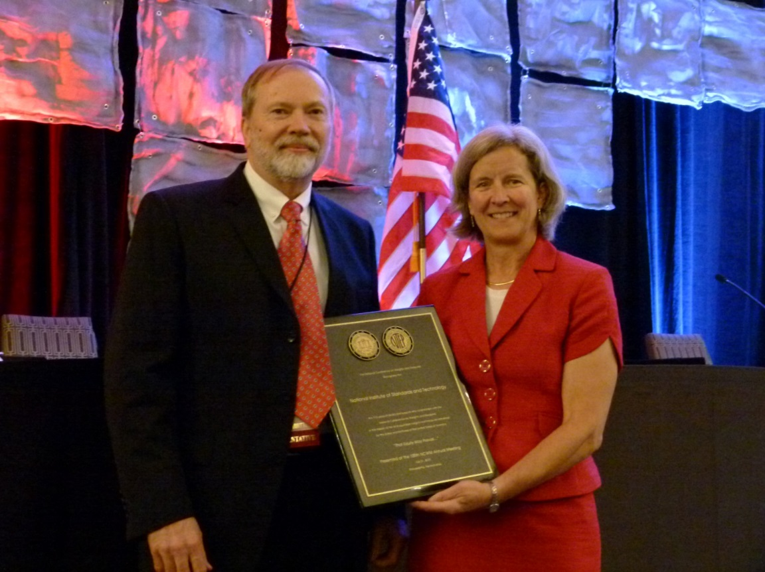

Figure 1. Chairman Ron Hayes presenting to Carol Hockert, NIST Office of Weights and Measures.

## \Celebration Luncheon\Past-Present-NISTEmployees.JPGPresent and Past NIST Employees in Attendance

Figure 2. Kevin Chesnutwood, Ann Turner, Richard Suiter, Carol Hockert, Otto Warnlof, David Sefcik, Ralph Richter, Tina Butcher, Steven Cook, Henry Oppermann, Clark Cooney, John Barton, and Marc Buttler.

## Measurement Canada Recognition

The National Conference on Weights and Measures recognizes Measurement Canada for promoting equitable commerce between Canada and the United States of America through participation on critical standards development committees, National Type Evaluation Program Sectors, the NCWM Board of Directors, and for participation in the Mutual Recognition Arrangement for type evaluation of weighing and measuring devices between Canada and the National Conference on Weights and Measures.

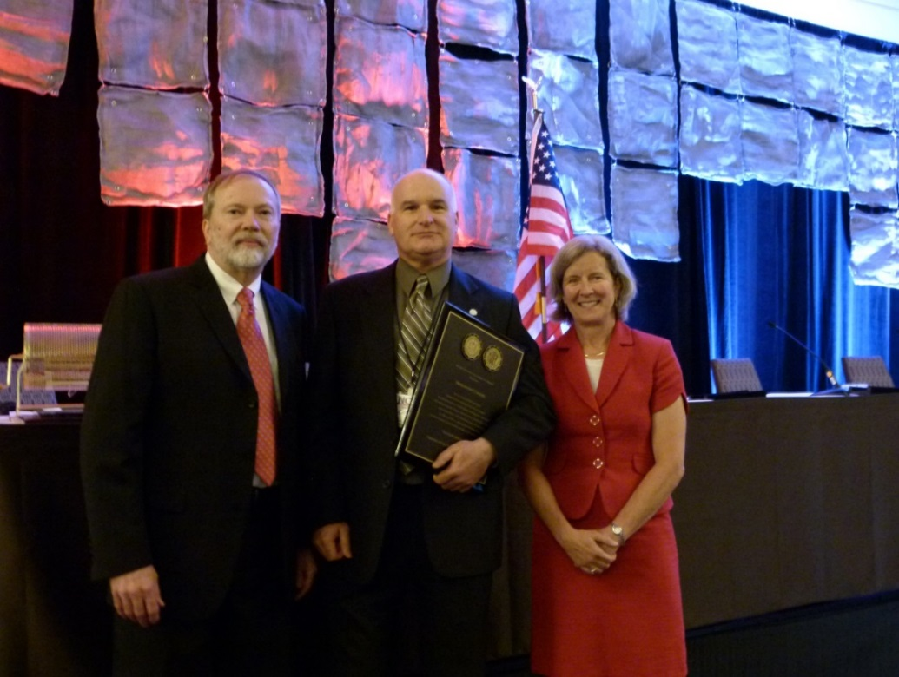

Figure 3. Chairman Ron Hayes presenting to Gilles Vinet, Measurement Canada with Carol Hockert, NIST OWM.

## Lifetime Achievement Award

Commonwealth of Massachusetts Recognition

The National Conference on Weights and Measures recognizes the Commonwealth of Massachusetts and its Communities for representation at all 100 Annual Meetings held from 1905 to 2015 and for dedicated support in the mission of fair and equitable weights and measures standards for the states and territories of the United States of America.

Celebration Luncheon
MassachusettsRecognition-100PercentAttendance-RonHayes-CharlesCarroll-CarolHockert.JPG

Figure 4. Chairman Ron Hayes presenting to Charles Carroll, Massachusetts with Carol Hockert, NIST OWM.

## Distinguished Service Awards

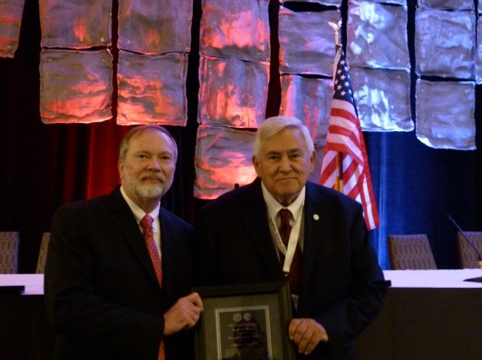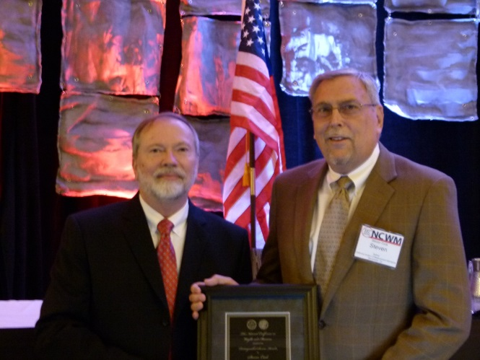

Figure 6. Chairman Ron Hayes presenting to Stephen Langford, Cardinal Scales

Figure 5. Chairman Ron Hayes presenting to Steven Cook, Retired, California.

## Chairman Ron Hayes resents a recognition award to Brett Saum of San Luis Obispo County, California.

Figure 7. Chariman Ron Hayes Presenting to Brett Saum, San Luis Obispo County, California.

## 

## Contributions Award

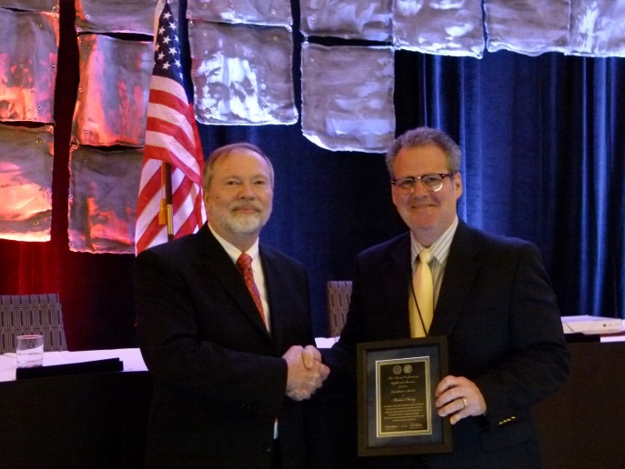

Figure 8. Chairman Ron Hayes presenting to Michael Cleary, Retired, California.

## NCWM Retired Members RecognitionNCWM Retired Members Recognition

Figure 9. Retirees Present ­ Joe Silvestro, Otto Warnlof, Ross Andersen, Charles Gardner, Ann Turner, Michael Cleary, Roger Macey, Steven Cook, Curtis Williams, Dean Ely, Brett Saum, Richard Suiter, David Quinn

## NCWM Past Chairmen Recognition

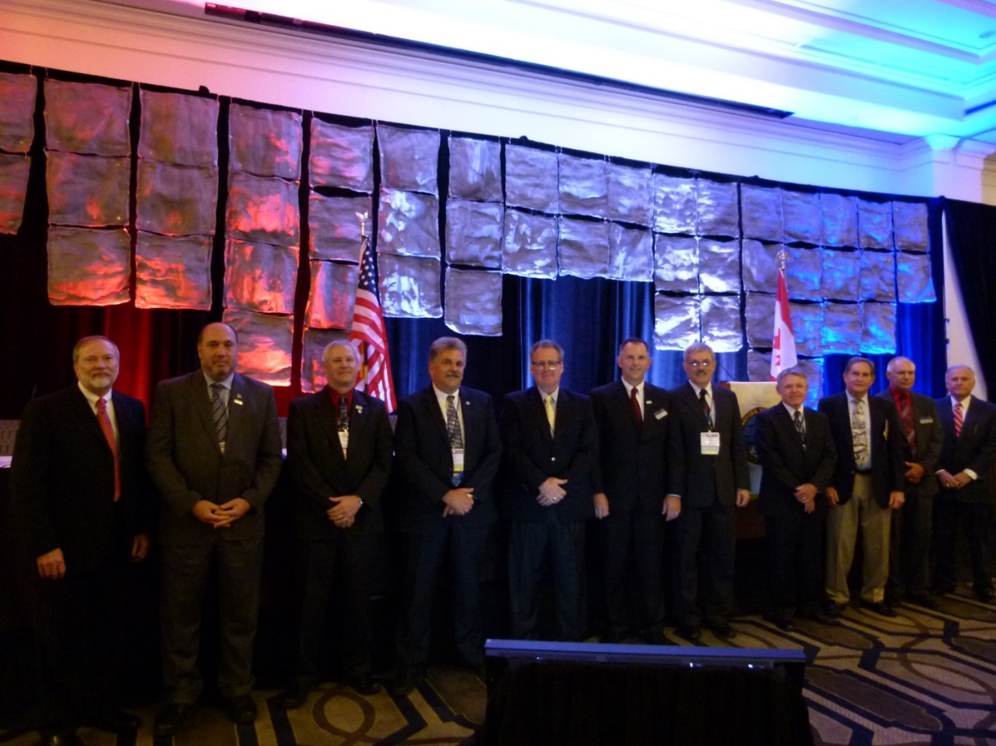

Figure 10. Ron Hayes – 2015; John Gaccione – 2014; Stephen Benjamin – 2013; Kurt Floren – 2012; Michael Cleary – 2007; Don Onwiler – 2006; Ross Andersen – 2003; Louis Straub – 2001; Charles Gardner – 1996; James Truex – 1995; N. David Smith – 1991.

## Attendance Award Certificate Recipients

5 Years Attendance

|  |  |
| --- | --- |
| * Kevin Ferrick | * Bradley Stotler |
| * Roger Macey | * Rob Upright |
| * Derek Regal |  |

10 Years Attendance

|  |  |
| --- | --- |
| * Mahesh Albuquerque | * Rich Lewis |
| * Stephen Benjamin | * Ken Ramsburg |
| * Rob DeRubeis | * Prentiss Searles |
| * Jason Glass | * David Sefcik |

15 Years Attendance

|  |
| --- |
| * Brett Gurney |
| * Curtis Williams |

20 Years Attendance

|  |
| --- |
| * Robert Feezor |

25 Years Attendance

|  |
| --- |
| * Gordon Johnson |
| * N. David Smith |

35 Years Attendance

|  |
| --- |
| * Henry Oppermann |
| * James Truex |

## Door Prizes

## 1st Prize: 1950s Wayne Model 90 Dispenser

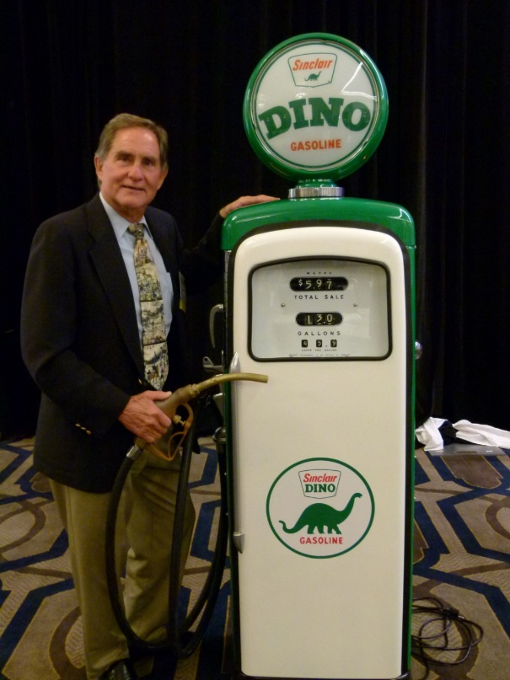

Figure 11. First Prize Winner, Charles Gardner, Retired, Suffolk County, New York.

## 2nd Prize: 1930’s Dayton Price Computing Candy Scale

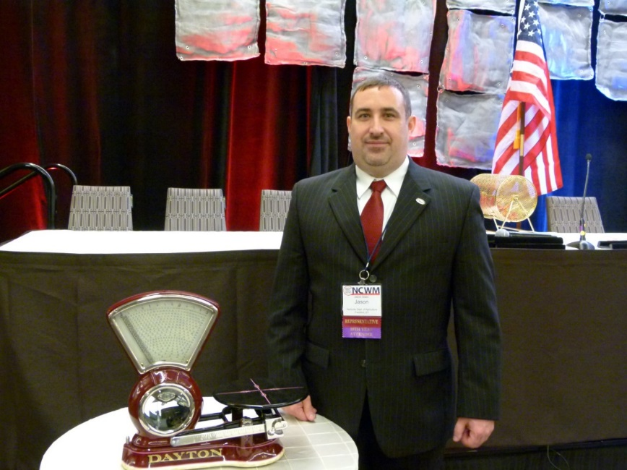

Figure 12. Second Prize Winner, Jason Glass, Kentucky

## 3rd Prize: Framed Inspection Decals of all States, Territories, District of Columbia and Navajo Nation

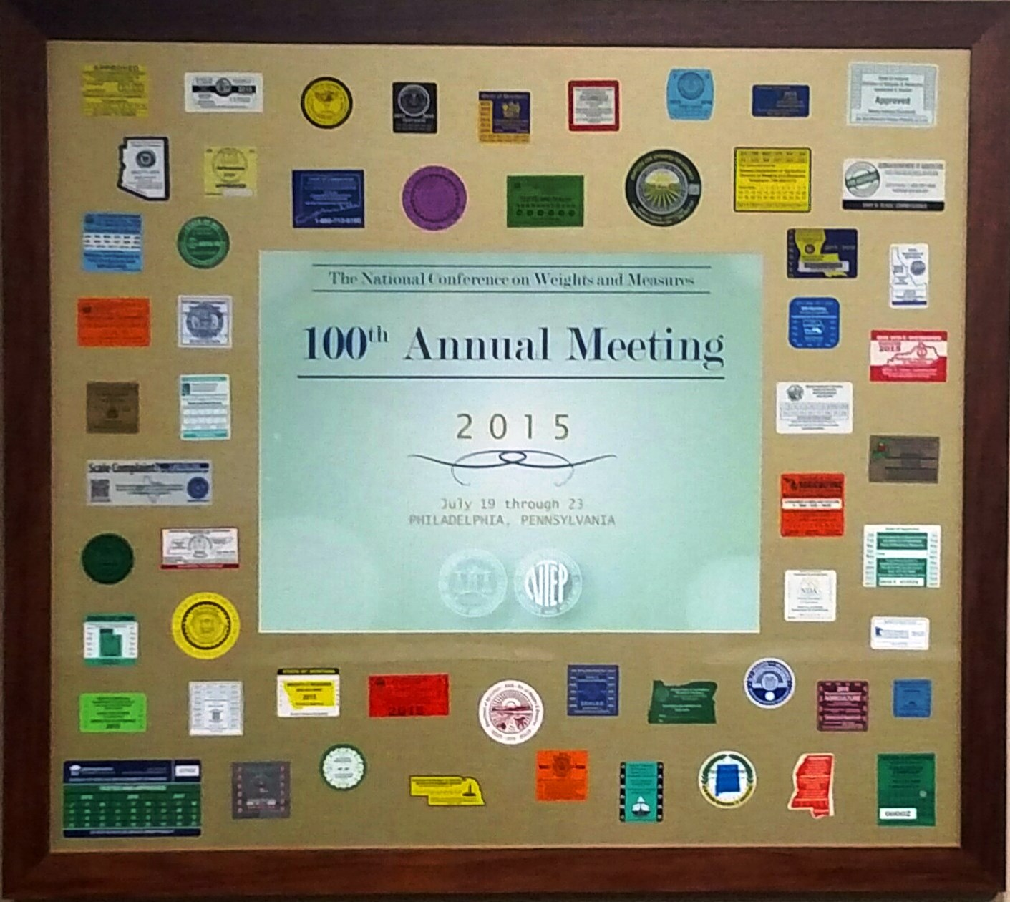

Figure 13. Third Prize Winner: Charles Carroll, Massachusetts.