Appendix B

Alaska Fuel Metering Project

THIS PAGE INTENTIONALLY LEFT BLANK

Alaska Fuel Metering Project
Final Report
7/5/2009

Prepared by:
Northern Economic Research Associates
7300 Chena Hot Springs Rd. Fairbanks Alaska 99712

for

State of Alaska Department of Transportation and Public Facilities
Measurement Standards and Commercial Vehicle Enforcement
Table of Contents
Executive Summary B7
The Crux of the Issue B7
Markets Affected B7
Gross vs. Net Gallons B8
Cost Benefit Results B9
Introduction and Literature Review B10
Introduction B10
Impetus for Study B12
Temperature Compensation at Wholesale vs. Retail B12
Interest Groups and Media Coverage B14
California’s Study and Application to Alaska B15
Canada and Permissive ATC B16
Hawaii and Redefining the Fixed Volume Standard B18
Belgium Adopts Mandatory ATC at Retail B19
Professional Literature Review B20
California Study B22
Recent National and Federal Government Actions and Studies B25
Market Adjustments to Changes in Supply B27
Petroleum Production, Consumption, and Sales in Alaska B33
Introduction B33
Refining in Alaska B35
Flint Hills North Pole B36
Tesoro Nikiski B37
Petro Star – North Pole and Valdez B38
BP Prudhoe Bay and Conoco-Phillips Kuparuk B38
Total Production B39
Alaska Prime Suppliers Sales Volumes (US EIA) B39
Alaska Division of Tax Annual Reports B40
ISER Reports B42
Components of Delivered Fuel Prices 2008 (ISER) B42
Barged Fuel and Remote Alaska Communities B43
Alaska Community Fuel Use 2008 (ISER) B44
Reconciling Fuel Reports B45
Temperature Data Analysis B46
Benefits of Temperature Compensation B48
Introduction B48
Seasonal Transparency and the Murphy-Topel Approach B49
Transparency Across Suppliers B51
Comparing Variances in Gallons Across Regimes B52
Sources of Temperature Variance Amongst Gross Retailers B52
Case Study B56
Consumer Loss calculations from Temperature Variations B59
Costs of Conversion to ATC B61
Introduction B61
Retrofit Kit Component Costs B62
Dispenser/Meter Data Sets: Number of Conversions B64
Cost to Convert B67
Calibration and Inspection/Certification B69
Recurring Annual Costs B70
Effect of Temperature Changes on Volume or Price per Gallon B73
Method of Volume Adjustment B73
Consumer Awareness, Product Labeling, Signage and Invoicing B78
Introduction B78
Existing Regulations Governing ATC in Canada and the NIST B79
Conclusion B82
Inventory Control B83
Accounting of Inventory Control B84
Profit and Loss Accounting B86
Real Inventory Losses from Temperature Changes B91
Summary B93
Tax Implications of Gross vs. Net Gallons B94
Economics of ATC Devices for the Individual Firm B95
Price Rigidity in Remote Barge Communities B98
Bibliography B100
Appendix 1 B103
Temperature Data Analysis for Refineries, Tank Farms and Underground Tanks PLEASE REFER
TO FILE Appendix 1 Alaska Fuel Metering Project B103
Appendix 2 B103
Benefits Computations for ATC Regulatory Regimes PLEASE REFER TO FILE Appendix 2
Alaska Fuel Metering Project B103
Appendix 3 B103
Estimated Fuel Use for Heating and Electricity Production PLEASE REFER TO FILE Appendix 3
Alaska Fuel Metering Project B103

Executive Summary

The Crux of the Issue
It comes as a surprise to Alaska consumers that there are two different kinds of gallons being sold in certain retail petroleum markets. To a layman, a “gallon” means the standard U.S. gallon, ( 231 cu. inches). That gallon will have to be called a “gross” gallon in this report because there is another kind of gallon being sold too. It is well known to petroleum professionals, and is called a “net” gallon.
For the layman, it is really not useful to go beyond the fact that a net gallon is smaller in Alaska. So we have smaller gallons being sold alongside larger gallons. With two different gallons being sold, consumers cannot make meaningful price comparisons. They can very well be buying the more expensive gallon when they think they are buying the less expensive gallon.
The purpose of this report was to determine what definition of “gallon” should prevail in Alaska petroleum retail markets. The conclusion of the report is that given present technology, there should be one retail petroleum gallon in Alaska – and it should be the standard “gross” gallon already familiar to consumers. A requirement to sell “net” gallons would force the statewide adoption of more expensive dispensing equipment, and the costs would outweigh the benefits.
Comment on the draft report suggested that the study may have pursued the objective of choosing the retail gallon that was the least expensive for the consumer. But that was not the objective of the study. It is tantamount to saying benefits were not considered. They were. But benefits did not justify the costs vis-à-vis a gross gallon standard.

Markets Affected
In Alaska, retail fuel is sold either at gas stations (land and marine) through gas pumps, or it is delivered by fuel trucks. Gasoline stations sell both gasoline and diesel to cars and trucks, and at marine stations fuel is sold to vessels. Fuel trucks on the other hand deliver fuel oil to homes and businesses for heat, to electrical plants, and also to aircraft at airports. There is also some off-road diesel delivered for heavy equipment by fuel trucks.
States have different rules governing gas pumps and fuel truck deliveries. In Alaska, gas station pumps sell gross gallons. There are no net gallon gas station pumps in Alaska. There are none in the USA although certain groups are pushing for it. But fuel trucks can deliver either gross gallons or net gallons in Alaska. So it is in fuel truck deliveries only where both gross and net gallons are being sold – not in gasoline stations.
Home heating oil, fuel oil for electricity production, aviation gasoline – these are the markets where retail customers might be buying net gallons and might be buying gross gallons, depending on the method of delivery selected by the retailer. If your invoice reads “volume adjusted to 60 F” it means you have bought net gallons.
It is quite possible that in the future gasoline stations will be able to sell either net or gross gallons unless regulations are established by Alaska that choose one or the other. This has occurred in Canada already. Part of the study purpose is to determine whether net gallons should be sold through gas pumps at gasoline stations like in Canada.

Gross vs. Net Gallons
Fuel expands as it warms and contracts as it cools. The idea of a “net” gallon is to adjust the size of the gallon as fuel either expands or contracts. As stated earlier, a gross gallon is 231 cubic inches. It does not vary with temperature. The volume of a net gallon depends on temperature. At 60 F a net gallon is the same volume as a gross gallon. Below 60 F, which is the majority of the time across Alaska, the net gallon is smaller than the gross gallon (see figure E1):
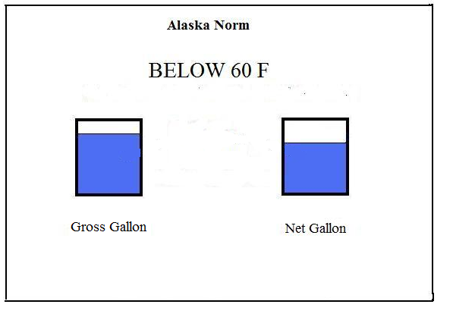
Figure E1
A rule of thumb for gasoline is that for every 15 degree drop in temperature, the net gallon is 1% smaller. At thirty below zero the net gallon is about 6% smaller than the gross gallon. It is also true that at temperatures above 60 F, the net gallon is larger than the gross gallon. But as a practical matter for Alaska net gallons are smaller, particularly when we understand that the major fuel oil season is in the winter when temperatures are extremely cold.
It is more expensive to meter net gallons because it requires taking the temperature of the fuel and adjusting the size of the gallon, depending on that temperature. Ultimately, the cost of doing so will be borne by the consumer.
In the language of the layman, should Alaska allow the smaller gallon and the larger gallon to be sold alongside one another when consumers do not know the difference? Should the smaller gallon be the standard? Should the larger gallon be the standard?
Draft comment from industry representatives that purchased ATC devices suggest the use of “smaller” and “larger” gallon is inflammatory and should not be used. But obscuring that fact to consumers deprives them of the most important thing for them to understand.

Cost Benefit Results
The objectives of weights and measures standards are price transparency, equity, and of course economy. In this report we consider both net and gross gallon sales in gasoline station and fuel truck markets. It is clear that allowing both is the worst case scenario for consumers. Allowing either net or gross gallon sales at the same time introduces what is probably the largest discrepancy in gallon sizes from retailer to retailer in the entire nation.
It is fairly clear that the net gallon standard is more ideal from an engineer’s perspective. But it requires more sophisticated equipment to meter fuel this way. The temperature of the fuel must be measured, and the size of the gallon must be either increased or decreased accordingly.
It would cost millions to outfit either fuel trucks or gasoline stations in Alaska this way, and the cost would be relatively more onerous for bush Alaska than for communities along the road system. Installation of retrofits for dispensers or trucks in remote sites are in the ten thousand dollar range, and the benefits of doing so are so small as to be essentially nil.
It is true that the additional cost of ATC equipment is small on a per gallon basis. But a small inefficiency is not a net benefit.
The gross gallon standard is not a perfect way of metering fuel, but it is the most economical. In all of the studies that were reviewed where gross gallon vs. net gallon standards were studied from a cost/benefit standard, the gross gallon proved to be superior. So it should not come as a surprise to find the same thing in Alaska.

Introduction and Literature Review

Introduction

“…good, open measurement leads to fair, honest and just trade.”

This sums up one of the main motivations for studies on temperature-adjusted vs. absolute volumetric measuring of fuel sales at retail. Is the gross gallon better, the net gallon, or should it be permissive, where either method is used at the discretion of willing buyers and sellers? Yet another approach is to redefine the volume standard for a gallon, which is an approach Hawaii took.
Measuring by volume has historically been the least-costly method of dispensing fuel at the retail pump. It is extremely simple and reliable. A meter is merely a device that spins as fuel moves, and it drives another device that registers the quantity of fuel metered. There is very little that can go wrong mechanically. Weights and Measures departments of state governments have for many decades accepted and presided over their use as efficient and equitable.
If fuel could be sold by weight, there would be no temperature adjustment controversy. But selling by weight is much less practical than metering in the customary manner. Temperature adjustment can be thought of as a way to approximate selling fuel by weight instead of by volume. But it is a more expensive means of doing so.
Changes in technology over time, such as the adoption of digital registers in fuel dispensers, have made it less expensive to adopt temperature compensation at retail. It is still more expensive than gross gallon metering, but in part the reduction in expense has caused some consideration for whether it should be utilized as a universal method of sale.
For lack of a better word, automatic temperature compensation (ATC) has “crept” into some markets such as Canada and Alaska without prior economic analysis of its costs and benefits. This literature review shows that in general where ATC has been practiced at retail it has not been studied from a cost/benefit perspective – and where it has, ATC has not been adopted.
Definitions:
U.S. Gallon or Gross Gallon = 231 cu. in. (regardless of temperature)
Petroleum Gallon or Net gallon = Temperature Corrected Gallon (231 cu in. @ 60⁰F)
The effect of temperature on fuel volume has been known for a very long time. A given gasoline or fuel oil volume increases with temperature. A widely cited rule of thumb for gasoline is that there is one percent fuel volume expansion for each fifteen degree temperature increase. The expansion is a little less for fuel oil or diesel. The warmer the fuel, the less energy and fewer miles to the gallon a vehicle will receive – or the less heat it will produce per unit volume.
If one wants to standardize by weight or energy content, a reference temperature has to be selected. For the U.S. that reference temperature is 60 F. A petroleum gallon or net gallon is the same volume and weight as a gross gallon at 60 F. At temperatures above 60 F the net gallon is larger in volume than 231 cu. Inches, but it has the same weight and energy content as it did at 60 F. At temperatures less than 60 F the net gallon has smaller volume, but again the same weight and energy content as it did at 60 F.
In Alaska we would be speaking about fuel contraction rather than expansion – as fuel cools it becomes denser and has more energy per unit volume. Using our rule of thumb, a net gallon of gasoline at -60 F has about 8% smaller volume than it does at 60 F. A net gallon would be about 214 cu. inches at – 60 F. The total energy in the smaller, net gallon stays the same, but, since the volume is smaller, the energy per cubic inch (or whatever volumetric unit is used) would be greater. Please refer to Figure 1.
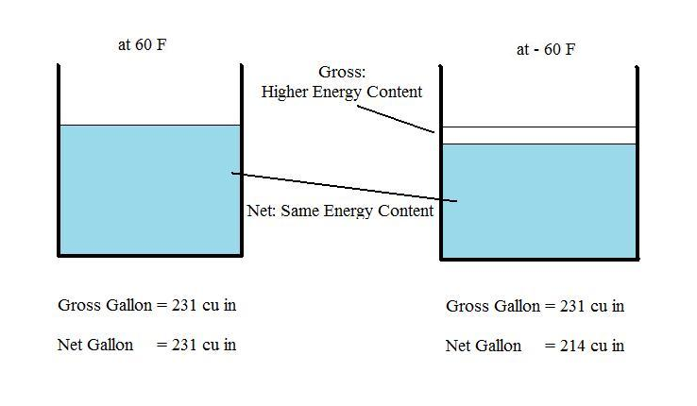
Figure 1

As we can see from the figure, a gross gallon in Alaska at – 60 F is considerably larger (231 cubic inches) than the net gallon (214 cubic inches). The gross gallon has about 8% more energy content in total than the net gallon. It would be true to say that a net gallon more or less guarantees the same energy content every time. But it is a guarantee that energy content is lower than that provided by a gross gallon at the temperatures of retailed fuels in Alaska.

Impetus for Study
Trade is facilitated by universally accepted standards of measure, and impeded when standards differ, or where they are not enforced. What is meant by “price” is not transparent when the unit of measure differs across retailers. Equity amongst retailers / suppliers and amongst customers will not prevail when there are different measures meted by one supplier vs. another. Differences in temperatures of fuel between suppliers introduces a potential lack of transparency and equity in the marketplace. It raises the question whether net gallon sales should be adopted at retail.
So generally the question for researchers in the net gallon vs. gross gallon debate has been which gallon to adopt at retail – gross or net. In this study however we are beginning with a situation in which both net and gross gallons are being sold in the marketplace, specifically for fuel metered from vehicle tanks. , and therefore whether elimination of one of them passes a cost/benefit test.
Because Alaska has had a permissive approach to fuels delivered by vehicle tanks, there are differences in gallon contents across suppliers that may very well exceed those for any other jurisdiction in the nation. Under the permissive standard, delivering fuel on a net gallon basis is essentially the same as delivering fuel at 60 F. We cannot say with very much precision what the average temperature difference is between gross gallon retailers, but the temperature data collected indicates it would be an order of magnitude less than what is possible between net and gross retailers.
During the winter the average effective difference between a gross gallon supplier and a net gallon supplier can exceed sixty degrees. This is the primary heating oil season. When gross gallon retailers are storing and transporting their fuel in a similar manner, the temperature of the fuel is going to be similar with both following the ambient much more closely than 60 F.
Whatever differences there are between gross gallon suppliers, and whatever lack of transparency or equity exists under a gross gallon standard – the permissive standard introduces an order of magnitude more problems in transparency and equity.
Regardless of whether the gross gallon standard or the net gallon standard is more efficient in a cost-benefit setting, it is abundantly clear that the permissive standard is inferior to either one. The permissive standard introduces an order of magnitude more differential between retailers than weather or refining or delivery schedules can on their own. Also, the permissive standard has some costs associated with it that the gross gallon standard does not (more expensive metering and calibrating on the net gallons). So if we were to rank legal regimes, the permissive standard is the worst due to cost, lack of transparency and inequity to the consumer. The public policy question becomes whether the net or gross standard is more efficient.

Temperature Compensation at Wholesale vs. Retail
For a refinery purchasing at wholesale, temperature is important because the warmer the crude oil it is purchasing, the fewer gallons of product that will be produced at the end of processing (warmer gallons contain less energy). When you are processing millions of barrels and profit margins are small percentages, it makes enough difference to matter. So in the early part of the last century the method of temperature correction was developed, a reference temperature selected, and tables produced where anyone could compute the net gallon content given a product density, temperature, and volume.
The petroleum industry has generally relied on temperature-adjusted gallons for these large wholesale transactions for an additional reason. It is economical to perform temperature adjustment in large quantities. If you are offloading a ship with millions of gallons, then measuring temperature, measuring gross volume, and calculating the net gallon content is essentially costless on a per gallon basis. If there is any benefit at all in taking such a measure, it will be worth it.
The smaller the transaction, the more costly is the attempt to measure accurately. When we move from millions of gallons to thousands to mere gallons in a transaction, any additional measuring cost starts to become significant. In comments before the California Commission, the Chief of New York State Weights and Measures estimated that in moving from wholesale to retail fuel transactions, there were about fifty times the number of meters measuring the fuel (fifty retail meters per wholesale meter). What makes sense at ten thousand gallon transactions does not necessarily make sense at ten gallons when you are multiplying that cost by fifty times.
Increased “accuracy” does not even make sense from a technical perspective when the transactions become small enough. Observe the tolerance specifications in the National Institute of Standards and Technology (NIST) Handbook 44 when we move from larger retail sales to smaller retail sales:
Tolerance by Flow Rates - Temperature Compensation
Flow Rate |  | Tolerance | Degrees
Over 30 gpm |  | 0.15% | 2.25
>1-30 gpm |  | 0.30% | 4.5
1 gpm |  | 0.75% | 11.25
Figure 2
The published tolerances are in percentage errors. We can convert those into degrees Fahrenheit to ask essentially the same question – how much can temperature be misjudged before the meter is no longer within acceptable tolerances? For flow rates above 30 gallons per minute (such as many home heating oil deliveries), the meter can be off by two degrees and it is still within tolerance. At flow rates of 1-30 gallons per minute (gasoline station dispensers) it can be off by four degrees and still be within tolerance. And for very small transactions of 1 gallons per minute or less – the meter can be off by over ten degrees.
It isn’t even technically feasible as a practical matter to temperature compensate a cup or even a quart of fuel given that some initial flow is required to stabilize a temperature reading. There isn’t any cost that is justified once the transactions become small enough, regardless of whether in theory temperature compensation is superior.
The issue is not whether temperature compensation of fuels makes “academic” sense at retail. The question is whether it is practical. Do the benefits outweigh the costs? When we are speaking about retail transactions, the variation in temperatures amongst retailers has to become fairly significant before temperature compensation meters can even “tell the difference” – meaning discriminate with an accuracy greater than tolerance specifications.
The required discrimination is not between the delivered temperature and 60 F. The discrimination must be between suppliers essentially across the street from one another – ones that are competing for the same customers. It makes no difference to temperature compensate fuels when temperature fluctuations are minimal between suppliers. It does not make sense to bear the cost of adjusting for something that as a practical matter makes no difference.
We are not concerned whether delivered fuel temperatures vary from 60 F. We are concerned with how much temperatures variation there can be between retailers essentially across the street from one another and competing for the same customers. It makes no difference to temperature compensate fuels when temperature fluctuations are minimal between suppliers. It does not make sense to bear the cost of adjusting for something that as a practical matter makes no difference.

Interest Groups and Media Coverage
In reviewing literature on this matter, it is clear that consumer and supplier groups have different motivations driving their opinion about net vs. gross gallons, depending on what side of 60 F fuel temperatures we are speaking of. These differing motivations cloud public policy debates because interest groups push agendas that suit their objectives, and their ideas work their way into the popular media.
All else the same, consumers would like to buy the larger gallon whereas retailers / suppliers would like to provide the smaller one. In cold states retailers have an incentive to sell petroleum gallons, or net gallons, because they are smaller. In warm states, they would like to sell gross gallons because those are the smaller gallons above 60 F. But consumer groups have the opposite incentive, and make efforts towards requiring suppliers to sell net gallons in warm states. However, consumer groups have not yet been active in requiring gross gallon sales in cold states.
Some of the arguments made for public consumption by various interest groups are significant nuisances to decision making. For example, it is somewhat easy to manipulate consumers into thinking they will get larger gallons at the same price if the retailers are forced to sell larger gallons – as if doubling the size of a gallon will result in half the cost to consumers. This is a fallacy of the free lunch.
It is also somewhat easy to manipulate consumers into thinking that there is some kind of fraud going on with suppliers when they are “buying net and selling gross” in warm states. There is a belief by somewhat misguided consumer groups that inventory is created out of thin air in this manner because the retailer is purchasing larger (net) gallons, but selling smaller (gross) gallons. However, there simply is no principle that retailers are obligated to sell products in exactly the same units or content that they were purchased in. More will be said on this presently.

California’s Study and Application to Alaska
California undertook the most extensive study to date, and the results were recently published. It is a “warm fuel” state where temperatures are above the 60 F standard. It is quite important to understand that one significant impetus for that study was very different from Alaska’s motivation. We are referring to the persistent assertion by many groups that retailers were purchasing fuel on a net gallon basis, but delivering on a gross gallon basis (buying large gallons and selling small ones) – thereby profiting from the creation of inventory gallons by sleight of hand.
That assertion (creation of inventory by buying net and selling gross) turns out to not only be untrue, but also irrelevant to transparency and equity. What is important is whether fuel varies in temperature across suppliers – not whether fuel from all suppliers varies from 60 F. Whether they all sell fuel at 120 F or they all sell fuel at -30 F, there is no lack of transparency and no lack of equity. Everyone is selling the same gallon.
There are two red herrings in this arena of “buy net and sell gross” that need to be eliminated in the public policy debate. The California study did address these, but we wish to make the points more direct and forceful. First, there is no relation whatsoever between “buying net” (at 60 F reference) and the actual temperature of the fuel. The fuel might be 100 F, and it might be – 20 F when purchased by a retailer. The reference temperature is not the temperature of the fuel. In November through February of 2008, for example, the average temperature of #1 heating oil at the North Pole Flint Hills rack was in the 20’s. It was invoiced to retailers at the reference temperature of 60 F. Whatever shrinkage occurred was not relative to 60 F, but to 20 F, an average of about forty degrees less.
Secondly, it is not a given that changing the method of delivery from gross to net, or vice-versa, will allow consumers to extract from suppliers a bigger gallon at the same price. Hawaii tried to accomplish this extraction in its conversion of a gallon from 231 cubic inches to 233 cubic inches. The law might just as well define a gallon to be a thousand cubic inches. If all suppliers are selling in the same unit of measure, it does not matter what that unit is; 233 cubic inches or 1000 cubic inches. There is nothing to be gained in transfers between consumers and suppliers when we only change the unit of measure. We must retain focus on the objectives of transparency and equity, which has to do with variations in content between suppliers.
California’s study in the end hinged on whether small (10 F), random differences in the temperatures of delivered fuel from retailer to retailer were worth the cost of imposing net gallon metering. The costs were well over a hundred million dollars (more expensive meters and more expensive ongoing maintenance and calibration) and the benefits were estimated at around two hundred thousand dollars (half from eliminating seasonal variations in the energy content of a gallon and the remainder from eliminating retailer to retailer fluctuations) - net gallon metering did not pass the cost-benefit test. This 10 degree temperature differential (between suppliers on a given day) was not established by the temperature study itself, but was the maximum proposed in theory.
In view of the California study, in order for Alaska to pass a cost-benefit test for a net gallon standard the temperature differentials amongst suppliers would have to be extreme – so extreme that it is impossible to come up with a scenario where such differentials could be sustained. Moreover, since Alaska has such a low volume of fuel turnover in remote locations, and a much higher cost of installation, the costs are even more onerous by comparison.

Canada and Permissive ATC
It has been observed that Canada has permissive temperature compensation for motor fuels at retail, and over 90% of Canadian retailers have adopted temperature compensation. The reason for this conversion is perfectly straightforward: Selling the smaller liters, when consumers don’t know the difference, makes the best economic sense to an individual retailer, although not necessarily to society as a whole. Canada is a “cold fuel” state where net liters are smaller than gross liters.
The Canadian government has itself not produced a report explaining with clarity how ATC devices came to be used in their country, nor evaluated the costs and benefits. This is partly because their introduction was not the result of legislative or executive branch inquiry into the temperature-corrected fuels issue in the first place. What we can find instead is interesting for what it lacks in particulars. This is from Measurement Canada in a recent information bulletin pertaining to temperature compensation:
Is Temperature Compensation New?
Temperature compensation has been used in applications such as pipelines, ship-loading and tank farm transfers for decades and for the retail sale of gasoline for the past 20 years. Prior to the advent of modern electronics, there was no way to perform this function accurately in retail dispensers. In 1984, a Canadian electronics manufacturer designed a device which could readily measure the temperature of liquids and perform the necessary calculations. Now, the vast majority of gasoline pumps in Canada are equipped with automatic temperature compensating equipment.
The passage makes it seem as though the change in technology was enough of a breakthrough that both sides of the market (consumers and retailers) adopted a more mutually agreeable system of dispensing.
We have to look a little harder for the history. Testimony before Congress in 2007 by Hugh Cooley of Shell oil is quoted extensively here:
Number 4: Why is automatic temperature adjustment used for retail sales in Canada?
My understanding is that the government of Canada approved temperature adjustment for retail gasoline fifteen years ago at the urging of the manufacturer of a temperature adjustment device. A few years later, some retailers began to temperature adjust, presumably to obtain a competitive advantage over other retailers as a result of their lowered unit cost. Once the trend became apparent, other retailers followed to avoid a competitive disadvantage.
Similar testimony in later passages:
My current understanding is as follows: The Canadian government made automatic temperature adjustment permissive at the retail level approximately fifteen years ago. Media reports indicate that a manufacturer of automatic temperature adjustment devices first proposed that Canadian regulators allow automatic temperature adjustment and then marketed the device after the law was changed. We also understand that few, if any, retailers installed automatic temperature adjustment devices in Canada for the first few years after it was allowed. Apparently some retailers started to install automatic temperature adjusting devices, which allowed them in a cold climate to sell smaller volumetric gallons than their non-adjusting competitors, giving them a potential competitive advantage over other retailers because they had a lower effective unit price. Once a number of retailers had installed automatic temperature adjustment devices, other retailers appear to have followed suit to avoid being competitively disadvantaged. Shell Canada apparently followed those retailers that started the trend to convert to automatic temperature adjustment. After most stations had converted and the market essentially had transitioned to automatic temperature adjustment, basic economics leads us to believe that prices at the street level would have adjusted to take into account the new temperature adjusted unit of measure.
What is meant by “lowered unit cost”? This is a device that costs money to install. But if you are selling a smaller liter than your competition, then on an equivalent basis it is indeed a lower cost.
The introduction of the temperature compensating devices took place exactly in the manner one would expect from a profit-maximizing perspective: where the devices paid for themselves most handsomely first: that is, where the volumes were highest. Regular no-lead occurred first, followed by premium and blended fuels. This is not to say there is anything untoward or shady in their use. It was a legal method of sale, and it was introduced where it was most profitable first.
One of the very interesting responses of the Canadian government to their use was a regulation prohibiting the intentional switching on-and-off of ATC devices: turning them on in the winter and off in the summer. The intentions to use them in this way demonstrates what was stated earlier – the incentive is simply to sell the smaller gallon at all times.
It is acknowledged that a stated rationale for their use was to ameliorate inventory losses from fuel shrinkage in the cold. That is a similar argument made by proponents of their use in Alaska.
But selling a smaller gallon against competition selling a larger gallon (or liter) is profitable whether there is shrinkage, no shrinkage, or expansion of inventory. It is profitable regardless of what is happening to inventory. If all retailers are in the aggregate losing inventory in the winter months, basic economics dictates that market price adjusts to a higher level from the loss in supply regardless of whether individual retailers even consciously acknowledge this themselves.
Moreover, inventory loss from handling, from vaporization, from sump drainage, from theft, spills, etc. all occurs. The answer to these problems is not to sell smaller gallons, but rather to factor such losses into the price. Additionally, the amount of inventory shrinkage bears no relation to the 60 F or 15 C temperature reference. There is no reason to temperature compensate to 60 F if the fuel was purchased at 20 F.

Hawaii and Redefining the Fixed Volume Standard
Hawaii is the only case we can find where a change in the legal volume standard was put into effect in order to “correct” in some way for fuel expansion or contraction. A “Hawaii gallon” is 233.8 cubic inches rather than 231 cubic inches because it is based upon a reference temperature of around 80 F. Hawaii is a hot fuel state where fuel is retailed consistently above 60 F.
The drive behind changing the Hawaii volume standard was Mr. George Mattimoe, who was previously the Deputy Director, Division of Weights and Measures, Department of Agriculture, State of Hawaii, and former chair of the National Conference of Weights and Measures.
The motivation is supplied in a paper Mr. Mattimoe submitted to the California Commission in January of 2009. On page 9 the crux of the matter is identified: that retailers “short” consumers about 3.1 cubic inches of gasoline by selling a 231 cubic inch gallon when, on average, the temperatures of retailed fuels in Hawaii would result in 234.1 cubic inches if sold as net gallons. This number is based on the average temperature of fuel stored in underground service station tanks.
The logic simply does not follow. There need be no relation whatsoever between what the units of measure are at wholesale and what they are at retail. In virtually all markets, wholesalers purchase in different units than they sell at retail. Purchases might be in metric tons, and sales in pounds or ounces. Purchases might be in concentrations of product vastly exceeding the concentrations at retail – in the cases of drugs, demanding they be equivalent would result in injury or death.
In the case of juices, soft drinks, and a host of other commodities it would preclude their sale altogether because people would not buy them if the ingredient quantities or concentrations purchased were required to be retailed in their wholesale form or quantity. This idea is some kind of fictional concept of business – that whatever is purchased by a vendor must be passed on precisely in the same form and content to consumers. The most basic premise of retailing is to purchase in larger quantities than are sold – so it very nearly turns the entire retailing principle on its head when applied elsewhere.
Rather than imposing sales of net gallons at retail though, the approach in the case of Hawaii was to fix the volume of the gross gallon to its net gallon equivalent on average. That strategy seems to be one of imposing recalibration costs without the benefits cited by the NCWM for ATC. Hawaii is still selling a gross gallon. So it does not eliminate retailer-to-retailer fluctuations in temperatures.
Every retailer was selling the same sized gallon at 231 cu. inches before. Every retailer is selling the same sized gallon now at 233.8 cu. inches. It could just as easily be 235 or 300 or 500 cubic inches, and price transparency or equity would not change in the least.
Redefining the volume standard for a gallon is not under consideration in this study. Doing so seems to reflect a lack of understanding in basic economics. As long as the units of volume for sales are the same across retailers, it simply does not matter what that standard is.

Belgium Adopts Mandatory ATC at Retail
This leaves us at one significant case to study where mandatory ATC has been adopted at retail: Belgium. It is difficult to find technical analysis underlying the Belgian decision, but the GAO did interview Belgian officials directly regarding their rationale:
Belgium adopted temperature compensation for retail sales, in part, because some retailers were artificially heating fuel, and the government sought greater consistency in the energy content of the fuel sold to consumers, according to a weights and measures official

As the GAO notes later in their report, the costs and benefits of ATC have not actually been formally studied for Belgium. We have a rationale here that is familiar amongst ATC advocates, and that is the intention to provide consistency in the content of fuel sold to consumers. But the costs and benefits have not actually been measured.
The statement above though does point to something that is of interest – the idea of retailers profiting from, and consumers being harmed by artificially heating fuel. We might remark that the least expensive way of effectively doing that in a “cold fuel” state is to temperature compensate fuels when competitors are not – because temperature compensating gallons to 60 F is effectively the same thing as heating fuel to 60 F.
Nobody in this arena seems to have noticed that permissive ATC provides, essentially, the cheapest and most reliable manner of heating fuel to 60 F in cold environments, and that permissive ATC is induces essentially the exact opposite effect intended by mandatory ATC advocates: consistency in the energy content of fuel sold to consumers.

Professional Literature Review
We shall review a variety of professional literature on temperature compensation at retail. In general, it has not done very well under scrutiny. The most recent report of value to us was performed by California (2009). Given what preceded it, the results should not really be surprising.
Dickerman and Radian Corp (1982) prepared a report for the American Petroleum Institute. They stated that
“The principle argument against requiring temperature adjustment at the retail service station level is that it could impose hundreds of millions of dollars in capital for retrofit and new installations without commensurate benefits. The costs of purchasing and maintaining automatic temperature compensators would be passed on to the consumer; the increased costs of regulating this practice would be passed on to the taxpayer ... all without increasing the supply of product.
To the extent that the petroleum product market is competitive and that all outlets in a given market area are similarly affected by temperature changes, there should be little or no gain or loss to the consumer from the effects of product shrinkage or expansion ... In this way the market itself serves to remove inequities within a market area – assuming a high degree of competition.”

A number of useful studies have been done in Australia. The Australian Institute of Petroleum (1996) report, the Industry Commission Report into Petroleum Products (1994), and the Access Economics (1992) report all agreed that mandatory temperature corrections were not justified in there. From Access Economics:
“The central argument for temperature correction is an equity argument: that is, the “benefits” of temperature correction are essentially distributional benefits. The case for correction is not intrinsically an efficiency argument at all: gross costs of temperature correction are a quantifiable drain on scarce resources, but the gross benefits are gains to some at the expense of others within the economy.
In net terms, from a national economic perspective, temperature correction by definition is a negative-sum proposal. The economy as a whole must lose if temperature correction is costly, with the distribution of that loss depending on the temperature at which sales are made.”

The Australian Institute of Petroleum (1996) report pointed out the use of a 15°C reference temperature for the collection of excise ensures that there is consistency in the taxation base. This excise is imposed directly on the refiner marketer companies, not the motorists. It is unrelated to issues of equity between consumers. (The 15°C number does not represent the average temperature of fuel). The net loss from mandatory temperature correction per motorist was estimated to be between $5 to $24 per year depending on location.
This report estimated capital costs of $300 million and annual operating costs of $50 million for a change to mandatory correction. For perspective, an additional capital cost of $300 million represented nearly total annual profits of all four refiner marketer companies in the Australian downstream oil industry at the time. These costs would simply be passed on to consumers.
The Industry Commission Report (1994) flatly stated there were no economic efficiency arguments for requiring temperature adjustment. It cited self-adjusting market behavior and “When trialled in several Canadian provinces, temperature correction did not lower prices or otherwise win consumer favour.”
The last Australian report reviewed was the Victoria Consumer and Business Affairs (2001) study. This report recommended that wholesale transactions at refineries/terminals be temperature adjusted. It again cited numerous authorities pointing to the cost-inefficiency of requiring so for retail sales at the pump. An increasing problem with “hot fuel” sales to retailers, the complexity resulting from taxes being assessed on petroleum gallons and some concern over transparency and relative market power resulted in this wholesale rule.
In the UK Temperature Compensation Study (1999) the main focus was the apparent volume losses of product due to temperature changes within the distribution chain. At the time, the petroleum gallon system was used throughout the UK industry for bulk transfers and for duties on fuels. Stable retail temperatures, as well as high capital and labor expense involved in correction made the temperature-adjusted concept cost-inefficient when applied to either retailers or final customers.
But by 1999 in the UK, the move to sealing road tankers due to environmental regulations eliminated the enforcement powers (dipping for volume) of the Trading Standards Officer or customers. Fuel shrinkage from cooling in transport or storage would imply “losses” into the environment unless volumes were temperature-adjusted. So multiagency regulation interaction was occurring in the UK that partly drove the ATC fuel discussion.
Ultimately the UK report recommended that as changing technology brought capital and labor retrofit costs down that Standard Temperature Accounting be adopted but should be voluntary and based on contract negotiation. At this time there are no temperature-compensation meters at retail gas pumps in the UK. Oil companies still use voluntary temperature-adjusted exchange agreements within the industry.

California Study
California is being looked to by a number of states. In 2007 AB 868 directed the California Energy Commission to conduct a Fuel Delivery Temperature Study. That study has now been completed and the upshot is that temperature compensation costs are not worth the limited and unclear benefits.
The amounts are instructive. The initial costs were estimated to be at least $110,000,000, along with increased annual costs in the $7 million dollar range; the benefits were on the order of $200,000 per year. This was under the best case scenario for temperature compensation.
There are a number of reasons why benefits are probably overstated. One is the lack of recognition that temperature compensated sales themselves still vary from retailer to retailer because of the tolerances mentioned earlier. The assumption in the California study was that every gallon of temperature compensated sales was perfectly measured. Correspondence with Murphy and Topel also pointed out an additional analytical reason benefits are overstated, but it simply is not worth quibbling over details when the results are so overwhelming.
The California result can be summarized fairly succinctly by saying that in the long run the costs are on the order of a thousand times more than the benefits. The costs are not large when brought to a per gallon figure, but nevertheless are an inefficiency and essentially a nuisance.
There are a few very important observations about the initial motivations behind the California study that ultimately were not clearly addressed in the final report, yet were absolutely central to its conclusions.
Ultimately, it boils down to the fallacy of the free lunch, but it begins with a myth about inventory “fraud”. As mentioned earlier, there has been a misguided consumer advocacy theory that retailers are “buying net and selling gross” and that in a hot fuel state this means they are profiting from the purchase of larger gallons than they are selling. To address this problem, retailers ought to be forced into selling larger gallons.
Computing benefits in such a scenario is straightforward. The California Study was at the county level. They had proposed measuring temperatures in every county, along with sales, to estimate benefits per county in accordance with the following formula:
County Benefits = (fuel volume) x (fuel price) x (volume correction factor)
As the logic of the California study initially went, since different counties have different average temperatures and sales, the benefits will vary across counties. But in all cases, since the gallons sold after ATC implementation will be larger, the benefits will be positive. Requiring temperature controlled sales in this framework fosters the illusion that consumers will recapture gains the industry allegedly makes with this shady practice of selling warmer (lower BTU) U.S. gallons instead of the temperature-adjusted gallons that they are buying.
In the end, this methodology was dropped after economists from Chicago (Murphy and Topel, 2009) intervened with what is conceptually a fairly simple idea, but analytically difficult to estimate. The upshot is that Murphy and Topel forced a focus on what the NCWM articulated about transparency and equity. It is the temperature differences between retailers that is of concern, and not the difference between retail temperatures and the 60 F reference temperature.
We had thought that the California temperature study would provide data on the differences in temperature from retailer to retailer on any given day, and that this information could be correlated with other information, such as refinery production schedules or storage practices. This information would be useful in adapting results elsewhere, including Alaska.
But because the methodology of that study was directed towards comparing prices on average to the 60 F reference, the temperature variations that turn out to be the most important for cost-benefit analysis were not derived. In the Murphy-Topel analysis it was assumed, and reasonably so, that the differences amongst suppliers on any given day would not exceed ten degrees.
Testimony during the course of the study directed attention to the manner in which inventories are actually calculated by service stations in order to address what is best termed a myth about the creation of inventory out of nothing when retailers “buy net and sell gross”.
Ample professional testimony demonstrated that retail fuel stations are within 0.1 or 0.2 percent accuracy over the year in inventory control. It is a myth that there are extra gallons being sold. This was not clearly demonstrated in the final report. The “extra gallon” myth is worthwhile to explore because there is a corollary on the other side of 60 F – that there is inventory loss necessitating the sale of smaller gallons when fuel is cold.
In California, inventories enter the retail station books as gross gallons, even though the total cost is determined by a net gallon price.
“There are bills of lading that are produced when the wholesale transaction is consummated. And that bill of lading information… has both net, gross, temperature, even density information on the bill of lading, as well as the date, obviously”.
“But the gross gallon figure on the bill of lading is the one that went into the inventory record. And that's how they run their business. Even though they may pay on a net gallon calculation of price, the number that they take into their inventory is a gross gallon figure. And that's the only way they can make their inventory balance at the end of the year.”
We are hearing the same observation from retailers in Alaska: they clearly recognize and are concerned with shrinkage of fuel as ambient air temperatures fall from the 70’s and 80’s in the summertime to -30’s and -40’s in the wintertime. It is a legitimate concern.
Any fuel to a remote location and stored over the wintertime will shrink. We have to ask the question then, what happens when a fuel supply is lost for any reason – whether it is a hurricane, war in the Middle East, the depletion of reserves, or what have you.
We of course accept the premise that market supply is reduced from temperature induced shrinkage. What is true for any one retailer must be true for the market as a whole. In the aggregate losses are a summation across supply losses for each retailer. We are compelled by basic economics to conclude that the price increases accordingly, as shown in Figure 3. Supply shifts from S₁ to S2 and price increases from P1 to P2.

Recent National and Federal Government Actions and Studies
There are two sources of information we have found that converge in Hearings before Congressman Kucinich in June of 2007. Certain consumer advocacy groups were lobbying for ATC requirements under the theory consumers were being shorted with “hot gallons”. Numerous private lawsuits had accumulated by this time and more attention was being brought to the issue because of high fuel prices. The National Institute of Standards and Technology (NIST) had been debating the issue for decades and Richard Suitor spoke on behalf of the NIST before Kucinich’s committee:
For over 30 years, temperature compensation has been discussed and debated in the weights and measures community. NIST has been in the middle of the discussion, providing technical advice and information as evidenced by the 1979 publication of our report: "Symposium on Temperature Compensated Volumes in the Sale of Petroleum Products."
So what is temperature compensation? Temperature compensation as it relates to the sale of petroleum is an adjustment made that assures that each gallon of fuel sold contains the same energy content. To put it simply, energy per unit of fuel is measured at 60 degrees Fahrenheit and when the external temperature is warmer it causes the fuel to expand. A warm gallon of gas does not provide as much energy as a cold one. That is because when that cold gallon of gas is warmed, its volume expands.
We have placed emphasis here on the assertion about energy content because although that may be the intent, it is not strictly true. It assures sales by weight instead of by volume, and the intention is fulfilled only when everyone sells the same product. There will also still be differences in additives for boutique mixes by region and season as well as other inherent qualities of the oil being refined that differ across gasoline sold at different stations.
It is also the case that variation amongst retailers will occur because, under ATC, tolerances are provided that clearly allow such variation. If temperatures only vary a couple of degrees between retailers there is essentially no benefit provided by temperature compensation; measurement tolerances for ATC allow for about that much variation in the first place.
A good summary of the situation across states was given in this testimony:
In some states, compensating for the temperature of refined petroleum products being sold has taken place at the wholesale level – but not at the retail gas pump (diesel included) or for deliveries of home heating fuel. Some states prohibit temperature compensation at retail and some states prohibit temperature compensation anywhere in the petroleum distribution chain. Most states require temperature compensation for certain products, such as for liquefied petroleum gas (LPG) sales, or propane for home heating, but not necessarily for other products.
In 2000 a delegate from the State of Oregon, through the Western Weights and Measures Association, submitted an item to the NCWM Specifications and Tolerances Committee to recognize temperature compensation in NIST Handbook 44 for vehicle-tank meter applications. These include meters installed on home heating fuel delivery trucks. The Specifications and Tolerances committee is made up of weights and measures officials with some expertise in the design and operation of commercial devices. As mentioned earlier NIST/WMD serves as technical advisor to the Specifications and Tolerances committee.
After two years of committee development, the issue became a voting item on the Committee's agenda in 2002. At the NCWM Annual Meeting, the conference could not reach an agreement during the voting process. Because the NCWM is a consensus organization, the item was returned to the Specifications and Tolerances Committee for further development. The same result occurred at the conference the following two years. The item has remained as an information item on the Committee's Agenda since that time. In 2004, an item was submitted to the NCWM Laws and Regulations Committee proposing a change to the Uniform Regulation for the Method of Sale of Commodities to require temperature compensation in certain applications such as heating oil tanker trucks, loading rack meters at wholesale gasoline, diesel or even ethanol tank farms, and high volume (truck stop) dispensers. The proposal was modified in January 2007 to recognize voluntary temperature compensation at all levels and is currently a voting item on the committee agenda that is expected to be taken up in July 2007. If adopted this would permit temperature compensation adjustment at additional levels of the distribution chain, but not mandate it.
A steering committee of the NCWM was formed and met through 2008, producing literature that demonstrates we are no further along than we have been before. It is acknowledged that in theory, temperature compensated fuels could provide greater price transparency and equity when we assume there are temperature variations across retailers. The steering committee did not take a position pro or anti-ATC.
The council steering committee recommended that if ATC were adopted at all that it be mandatory. It recommended a phase-in period of one year that includes permissive use should be followed by full conversion to mandatory ATC.
In late 2008, the GAO released a report on temperature compensation, and a couple of summary comments are worth noting here:
…the two governments with the longest experience in temperature compensation of retail fuel sales (Hawaii and Canada) have not studied the effect of their policies. As a result, a policy debate is being played out without good information about the potential costs and benefits…
In Belgium, temperature compensation has been implemented too recently to study its effects.
What we can say in having scrutinized the literature regarding temperature compensation is that where ATC has been implemented, there is an absence of preliminary cost/benefit analysis and instead we are still waiting on some kind of professional analysis regarding its effects. Wherever it has been studied carefully in a cost/benefit framework, it has not been implemented.
To be fair to industry that has invested in ATC in Alaska, and since these hearings have been cited, it bears commenting on Representative Kucinich’s statement on ATC in those hearings Representative Kucinich had the impression in calling the hearings that the industry was operating under some “double standards”. After the June 12 Alaska Fuel Project meeting, that testimony was submitted for consideration.
Representative Kucinich relies on the premise that if industry does it at wholesale, the default position is that it must be the appropriate retail too. Otherwise it is a “double standard”. In the first place this is again the fallacy that whatever form the wholesaler purchases the commodity in must be preserved in retailing. There simply is no such principle.
The premise also ignores the basic diminishing returns economics to ATC. When there are fifty times the number of meters at retail vs. wholesale, the benefits have to be vastly greater to pass a cost-benefit test. It does not follow that what is economical at wholesale is economical at retail.
Kucinich furthermore argues the nearly universal adoption in Canada under a permissive standard proves something is amiss in the USA. He does not understand the smaller gallon is sold in each respective market – cold vs. warm. Finally, Representative Kucinich observes that LP gas is sold with ATC making another “double standard”. That ignores the much higher temperature expansion coefficient for LP gas which absolutely does work in favor of ATC vis-à-vis fuel oil or gasoline.

Market Adjustments to Changes in Supply
It might be a mystery how the market adjusts for temperature when it actually matters. But this point is absolutely essential to a cost/benefit study. It is something that we do not see recognized anywhere in the professional literature. Carl Boyett, representing the Society of Independent Gasoline Marketers of America provided, revealing testimony in the California study that is relevant to Alaska:
“We operated a station in South Lake Tahoe for ten years roughly. And during the winter I know we lost thousands of gallons of gasoline. And so, you know, that probably was partly due to temperature, with snow on the ground and whatever. So we consciously raised prices to try to compensate for that during that period of time.”
We are hearing the same observation from retailers in Alaska: they clearly recognize and are concerned with shrinkage of fuel as ambient air temperatures fall from the 70’s and 80’s in the summertime to -30’s and -40’s in the wintertime. It is a legitimate concern.
Any fuel to a remote location and stored over the wintertime will shrink. We have to ask the question then, what happens when a fuel supply is lost for any reason – whether it is a hurricane, war in the Middle East, the depletion of reserves, or what have you.
We of course accept the premise that market supply is reduced from temperature induced shrinkage. What is true for any one retailer must be true for the market as a whole. In the aggregate losses are a summation across supply losses for each retailer. We are compelled by basic economics to conclude that the price increases accordingly, as shown in Figure 3. Supply shifts from S₁ to S₂ and price increases from P₁ to P₂.
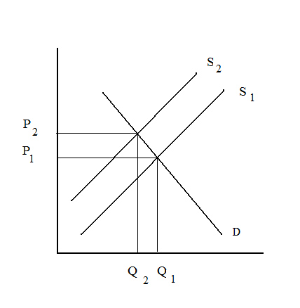
Figure 3
To deny that this is the case is to assert that markets do not work. It really isn’t even necessary to introduce testimony that specific retailers are acknowledging supply losses by factoring it into price. The way markets generally work is that retailers notice that at the current price, sales indicate the market will bear a higher price. Alternatively, if sales become sluggish at the current price, it indicates the market is signaling a lower equilibrium price is required.
We are surprised that this basic lesson has not been introduced anywhere that we have seen. Generally the temperature compensation issue has been “hottest” in warm fuel states where it is asserted supplies are increasing from fuel expansion. One cannot simultaneously assert, however, that supply is expanding while at the same time price is not adjusting (falling). Whatever gains are had from fuel expansion by any individual retailer are reduced on a net basis by the fact price is falling at the same time.
We do agree that it is beyond the power of any individual retailer to arbitrarily increase his price independent of other retailers. Instead it is market forces working in the aggregate that cause prices to adjust whether or not any individual retailer acknowledges that is the underlying reason.
Contents
Executive Summary 5
The Crux of the Issue 5
Markets Affected 5
Gross vs. Net Gallons 6
Cost Benefit Results 7
Introduction and Literature Review 8
Introduction 8
Impetus for Study 10
Temperature Compensation at Wholesale vs. Retail 10
Interest Groups and Media Coverage 12
California’s Study and Application to Alaska 13
Canada and Permissive ATC 14
Hawaii and Redefining the Fixed Volume Standard 16
Belgium Adopts Mandatory ATC at Retail 17
Professional Literature Review 18
California Study 20
Recent National and Federal Government Actions and Studies 22
Market Adjustments to Changes in Supply 25
Petroleum Production, Consumption, and Sales in Alaska 30
Introduction 30
Refining in Alaska 32
Flint Hills North Pole 33
Tesoro Nikiski 34
Petro Star – North Pole and Valdez 35
BP Prudhoe Bay and Conoco-Phillips Kuparuk 35
Total Production 36
Alaska Prime Suppliers Sales Volumes (US EIA) 36
Alaska Division of Tax Annual Reports 37
ISER Reports 38
Components of Delivered Fuel Prices 2008 (ISER) 39
Barged Fuel and Remote Alaska Communities 39
Alaska Community Fuel Use 2008 (ISER) 41
Reconciling Fuel Reports 42
Temperature Data Analysis 43
Benefits of Temperature Compensation 45
Introduction 45
Seasonal Transparency and the Murphy-Topel Approach 46
Transparency Across Suppliers 47
Comparing Variances in Gallons Across Regimes 48
Sources of Temperature Variance Amongst Gross Retailers 49
Case Study 52
Consumer Loss calculations from Temperature Variations 55
Costs of Conversion to ATC 57
Introduction 57
Retrofit Kit Component Costs 58
Dispenser/Meter Data Sets: Number of Conversions 60
Cost to Convert 63
Calibration and Inspection/Certification 65
Recurring Annual Costs 66
Effect of Temperature Changes on Volume or Price per Gallon 69
Method of Volume Adjustment 69
Consumer Awareness, Product Labeling, Signage and Invoicing 74
Introduction 74
Existing Regulations Governing ATC in Canada and the NIST 75
Conclusion 78
Inventory Control 79
Accounting of Inventory Control 80
Profit and Loss Accounting 82
Real Inventory Losses from Temperature Changes 87
Summary 89
Tax Implications of Gross vs. Net Gallons 90
Bibliography 95
Appendix 1 98
Temperature Data Analysis for Refineries, Tank Farms and Underground Tanks PLEASE REFER TO FILE Appendix 1 Alaska Fuel Metering Project 98
Appendix 2 98
Benefits Computations for ATC Regulatory Regimes PLEASE REFER TO FILE Appendix 2 Alaska Fuel Metering Project 98
Appendix 3 98
Estimated Fuel Use for Heating and Electricity Production PLEASE REFER TO FILE Appendix 3 Alaska Fuel Metering Project 98

Petroleum Production, Consumption, and Sales in Alaska

Introduction
There are a number of sources from the federal and state government pertaining to the fuel industry in Alaska. The full statewide scope and regional details are not accounted for in any one place. Their objectives and authorities are all different. We cannot speak with a lot of precision except in the case of taxed fuels, but we can form a pretty good idea of relative magnitudes overall. Jet fuel production and consumption leads the list; for international flight refueling. Highway fuels subject to motor fuels taxation would be a pretty distant second, then heating fuel. Fuel for production of electric power would be close behind heating fuel, and then marine fuel.
We don’t have independent reports with comprehensive and complete data either, but some good efforts under the circumstances of so few firms and the associated privacy restrictions on reporting data. What material we do have from federal and state sources seems inconsistent in some ways, and to some degree that is expected because the data collection methodologies and categorizations of fuel are different. Some data are from tax reporting requirements and are therefore quite complete and reliable. Voluntary surveys are just that – voluntary.
Fuel sales data are proprietary and it is understandable why, in a small retail market – possibly with only one or two suppliers – information is not reported, even when it has been collected. When there are many firms, private information is not being given out because only category totals are given, and not assigned to any particular firm. Not so in a one or two-firm market such in rural Alaska. Because of this, there is a degree of uncertainty in the completeness and accuracy of what data we have.
It is a bit difficult to reconcile the different sources with one another. Nevertheless we will review and compare these sources in order to formulate an idea about the fuel industry in Alaska:
- Refineries in Alaska (Division of Oil and Gas Annual Report (2007) Section Five (Refining)
- Alaska Prime Suppliers Sales Volumes (U.S. Energy Information Agency)
- Alaska Division of Tax Annual Reports
- Institute of Social and Economic Research (ISER) Reports
- Institute for Social and Economic Research, Components of Delivered Fuel Prices in Alaska prepared for the Alaska Energy Authority June 2008
- Institute for Social and Economic Research, Alaska Community Fuel Use prepared for the Alaska Energy Authority October 2008.

But first, we discuss a schematic overview of the Alaska Petroleum industry in Alaska. This is accomplished in Figure 4.
Alaska Crude oil is produced in two places – the North Slope and Cook Inlet. The North Slope oil is delivered by pipeline to Valdez, through North Pole. There are two refineries in North Pole and one in Valdez. Cook Inlet oil production is exclusively refined at the Tesoro facility in Nikiski.
There are three refineries that process oil from the Trans-Alaska Pipeline System (TAPS). Finished product is distilled from a crude stream, and a residual of up to 75% may be re-injected into the pipeline. There are also a couple of refineries on the North Slope for production of Arctic Heating Oil. This production is strictly in association with oil field operations and is not marketed south of the Brooks Range.
The refineries in North Pole produce finished products such as jet fuel, gasoline, diesel, and heating oil that are distributed by road, rail, and air. The railroad delivers fuel from North Pole to an Anchorage terminal and from there by pipeline to the Anchorage Port. From the Anchorage “rack” and the Port it is further distributed by barge, road, and rail throughout Alaska. Fuel is also trucked by road to Nenana, where it is barged throughout Interior Alaska on the Tanana and Yukon River to local village tank farms.
Cook Inlet oil processed at the Nikiski Refinery is distributed by pipeline to the Anchorage Port, and also by spur line to the Anchorage International Airport. Fuel is also distributed by barge and by road from the Nikiski Tesoro facility. Refinery output in Valdez is distributed by barge and road. Of course, the majority of crude oil is being exported by tanker out of Valdez.
Finally, we have barged fuel both arriving to Alaska from Northwest U.S., (occasionally foreign) and some refined products being shipped south. Heavy oils and seasonal gasoline go south from the Nikiski refinery along with the crude oil from the pipeline terminus in Valdez. Refined jet fuel, diesel, marine fuel, gasoline and aviation gasoline come up from Puget Sound largely to Southeast Alaska, but also further north.
The refinery data appearing on Figure 4 refers to throughput capacity. Finished products are varying proportions of throughput that may be as low as 25%. The refineries are not all operating at capacity, but it is the relative sizes of the refineries that are important here. The capacity data sometimes disagrees across sources, but the magnitudes are close enough.
The Flint Hills refinery is the largest by far, located in North Pole at 210,000 barrels per day. It is followed by Tesoro’s Nikiski refinery at 72,000. Petro Star has a combined capacity in Valdez and North Pole that is close behind at 65,500. The North Slope refineries are a combined 17,500 barrel per day capacity.
Barged fuel from Puget Sound is delivered throughout Southeast, but potentially as far as Dutch Harbor. At Haines it can be delivered to the interior by road. The Port of Anchorage also receives refined fuels distributed from there throughout Alaska

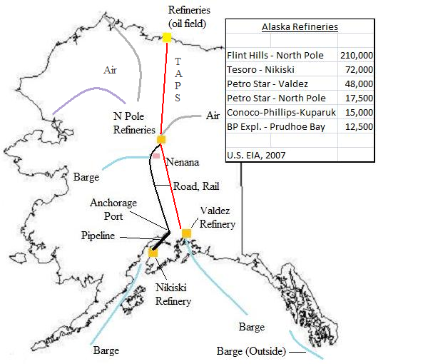
Figure 4

Refining in Alaska
This section will discuss the refining industry in Alaska, for the most part following the Alaska Department of Oil and Gas 2007 Annual Report – the most recent available. There are some small discrepancies with US EIA (Energy Information Administration) numbers on capacity but nothing major. The discrepancies in fuel produced or sold however, are substantial. We will illustrate where.
A few words on refining first:
Final products from refining include these major groups:
Motor Gasoline – for vehicles with reciprocating engines
Aviation Gasoline – For aircraft with reciprocating engines
Jet Fuel – kerosene based fuel for aircraft with turbine engines
Distillates
#1 – Fuel oil, heating oil or diesel fuel
#2 – Fuel oil, heating oil or diesel fuel
There are a number of different potential products, some of which are made in Alaska. For example naphtha is similar to gasoline or white gas, at the lighter end. Golden Valley uses it in turbines for electrical production for example. At the other end are heavier oils and asphalts. These are produced in Nikiski and marketed in Alaska and exported. Aviation gasoline (100 low lead) is imported.
According to ISER, the estimated combined production from the four refineries in Alaska was about 127,000 barrels per day in 2008. In the sections that follow from the DOG report, data are not all from the same year, and are expressed as ranges., but roughly agree with this figure. The total throughput potential is about three times that much. Refineries do not operate at full capacity in Alaska and moreover only a portion of the stream taken off the Trans-Alaska Pipeline System is refined. The remainder is returned to the pipeline.

Flint Hills North Pole
The Flint Hills Resources Refinery in North Pole is the largest in Alaska. The refinery receives Alaska North Slope crude oil from the Trans Alaska Pipeline. According to the Alaska State Division of Oil and Gas, it has throughput of about 226,500 barrels per day. Of that, about 60,000 barrels per day of refined products are produced and sold. That’s about 911 million gallons per year. The remainder is injected back into the TAPS and sent on to Valdez.
Flint Hills produces mostly jet fuel and #1 fuel oil as can be seen in Figure 5. The State DOG indicates about 60% of Flint Hills production serves the aviation market. It does so primarily in Anchorage, where the bulk of international flight refueling takes place at the Anchorage International Airport. One source of fuel they do not produce is ultra-low sulfur diesel. It is imported from elsewhere and distributed by Flint Hills.

Flint Hills Production
Gasoline & Naptha | 10%
Jet Fuel #1 Fuel Oil | 77%
#2 Diesel | 8%
Gas Oil | 4%
Asphalt | 1%
Figure 5

The company owns two large terminals (racks) in Fairbanks and Anchorage that store and distribute asphalt, diesel, jet fuel, and gasoline. There is a also a Fairbanks terminal located at the International Airport. It stores fuel that has been delivered by tanker truck from the refinery. From there, jet fuel is loaded from tanks into 10,000 gallon aircraft refueling trucks. Between 18 and 24 flights a day are refueled.
The Anchorage terminal storage facility has 700,000 gallons of capacity. Fuel is delivered by rail in tanker cars to this facility where it is further distributed by truck, rail, and pipeline. The pipeline delivers fuel about half a mile away to the Port of Anchorage terminal where 60-80 vessels a year are loaded for bulk deliveries to other Alaska locations.
The State Division of Oil and Gas reports over 577.5 million gallons a year delivered to the Anchorage terminal for 2006.

Tesoro Nikiski
Tesoro operates the oldest refinery in Alaska at Nikiski, which refines all of the oil produced in Cook Inlet. It also refines Alaska North Slope oil and imported foreign crude oil. The refinery has a capacity throughput of 72,000 barrels a day. About 55,000 barrels a day are produced for distribution to its 125 Tesoro retail stations and other retailers across Alaska.
Tesoro Production
Gasoline & Naphtha | 28%
Jet Fuel
Diesel | 45-55%
Gas Oil
Bottoms/Resid (Asphalt) | 22%
Figure 6
The company operates a 75-mile multi-product pipeline northward across Cook Inlet to the Port of Anchorage where its terminal facility is located. A spur-line to the Anchorage International Airport delivers to the airport tank farm. It is estimated that Tesoro supplies about 40% of the monthly jet fuel demand.
The residuals are sold to Alaska markets (Asphalts), but largely these are heavy oils exported to states in the Lower ’48. Gasoline produced in the summertime is all marketed in Alaska, whereas in the winter both gasoline and diesel are exported to the Pacific Northwest.

Petro Star – North Pole and Valdez
Petro Star owns refineries extracting throughput from TAPS in both North Pole and Valdez. They operate similarly to Flint Hills, refining a portion of throughput (about 25%) and returning the rest to the pipeline. The larger and newer of the two facilities is in Valdez, processing about 48,000 barrels per day, with jet fuel as the primary refined product. The North Pole facility has a capacity of about 18,000 barrels per day. It was established primarily for producing and distributing light fuels for heat.

Petro Star N. Pole + Valdez Production
Jet Fuel/Fuel Oil | 68%
Diesel/#2 Heating Oil | 32%
Figure 7
Petro Star owns Sourdough Fuels, a primary fuel oil distributor in Interior Alaska, along with a lubricant distribution concern. Both military and commercial air customers are served in Anchorage. It distributes fuels in western Alaska through companies such as Kodiak Oil sales and North Pacific Fuel. The Valdez petroleum terminal is owned by Tesoro.

BP Prudhoe Bay and Conoco-Phillips Kuparuk
The Prudhoe Bay facility processes crude from a North Slope oil transit line and is for the purpose of refining arctic heating fuel. It returns the remainder to the transit line. The fuel is strictly for heating North Slope operations.
Two plants are capable of processing about 7-8,000 barrels per day, with 1,200 to 1,400 barrels of arctic heating fuel as finished product. The remainder is reinjected into the transit line. Occasional batches of jet fuel are run, but 97% of the finished production is heating fuel.
The Conoco-Phillips Topping Plant also processes crude for arctic heating fuel in support of various oil company operations in the area. The plant processes about 14,500 barrels per day in order to produce 1,700 to 2,400 barrels of finished product. The amount depends on end use requirements.

Total Production
If we take the data from the DOG report and summarize it, we have an approximate total output statewide of around 131,000 barrels per day, close to the ISER estimate for 2008 at 127,000. That works out to about 2 billion gallons a year, or 2.1 if we include refined heating product for oilfield operations.

Approximate Capacity and Production - Alaska Refineries
Commercial Sales vs. Oilfield Operations
 | Refining | Barrels | Gallons per
 | Capacity | Daily Production | Year
Flint Hills, N. Pole | 226,500 | 60,000 | 919,800,000
Tesoro, Nikiski | 72,000 | 55,000 | 843,150,000
Petro Star, N. Pole Plus Valdez | 66,000 | 16,500 | 252,945,000
 | sum | 131,500 | 2,015,895,000
BP, Prudhoe Bay | 15,000 | 2,500 | 38,325,000
Conoco-Phillips, Kuparuk | 14,500 | 2,050 | 31,426,500
 |  | Sum | 2,085,646,500
Figure 8

Alaska Prime Suppliers Sales Volumes (US EIA)
The Energy Information Agency (EIA) has produced source data in tables that titled “Prime Supplier Sales for Alaska”. This data incorporates estimated sales of fuel produced in Alaska as well as imports into Alaska from outside. Derivations from these tables have been reproduced elsewhere, including the State Division of Oil and Gas publications. These figures are sometimes referred to as Alaska’s consumption of petroleum. This data is the result of surveys the Energy Information Administration sends to refiners and to distributors of fuel.
Figure 9 produces the Energy Information Agency data on Alaska Prime Suppliers. Their original tables are in thousands of gallons per day, whereas we have multiplied by 365, and again by 1,000 in order to arrive at annual gallon amounts. We can see that sales of motor gasoline are just less than 268 million gallons. Diesel is included in the category “Total Distillate and Kerosene, confidentiality requirements preclude us from seeing diesel separately.

Alaska Prime Supplier Sales Volumes
(in Gallons 2007)
Motor Gasoline | 267,545,000
Kerosene type Jet Fuel | 1,055,142,000
Total Distillate and Kerosene | 310,505,500
Sum | 1,633,192,500
Figure 9
The data reported in the federal estimate of motor gasoline and total distillates above are substantial underestimates, as we shall see. We can establish this by looking at the state highway fuel tax data, and the estimates of fuel used for electricity production and building heat provided by ISER in the following sections. The total supplier sales estimate of 1.6 billion is less than the refined product estimate in the previous section. It should be the other way around if primary fuel supplier data includes imports. (Unless Alaska exports from the lone refinery at Nikiski exceed imports by hundreds of millions of gallons).

Alaska Division of Tax Annual Reports
The state of Alaska produces data on fuel sales that are taxed. We can be confident that the data will be complete because it is not a voluntary survey. However, the largest sector in the retail fuel industry is not taxed – sales to international flights. The taxed fuel number is still necessary when we address question of the effect of fuel delivery methods on state taxes. As indicated earlier there is a disagreement between federal and state sources on the size of taxed fuel sales. We will present the state data now, and give the presumption of accuracy to the state where possible insofar as it is the closest to the subject matter and has the highest incentive for accuracy.
Figure 10 shows the list of motor fuels subject to tax that are reported by the State of Alaska Division of Tax in its annual report. The data are for fiscal year 2008, which runs from July of 2007 through June of 2008.

Taxed Fuels in Alaska FY 2008
Motor Fuel Type | Gallons
Highway | 369,568,110
Marine Fuel | 115,536,050
Jet Fuel | 142,874,628
Aviation Gasoline | 14,822,878
Gasohol | 388,300
Figure 10
In terms of taxed fuels, the highway fuels dominate the list at about 370 million gallons. It includes gasoline for automobiles and diesel for trucks – all highway use. Jet fuels subject to tax are second with about 143 million gallons, used in domestic flights. Marine fuels are third with 116 million gallons. Aviation gas, used by small single-engine piston aircraft is small by comparison but nearly 15 million gallons. Gasohol is 0.4 million gallons.
Fuel sales not subject to tax are shown on Figure 11. These non-taxable sales indicate where the data on taxed fuels might not represent the industry as a whole.

Exempt from Tax
Heating Fuel
Federal, State, Local Government
International Flights (Jet fuel)
Exports
Power Plants and Utilities
Charitable Institutions
Bunker Fuel (#6 Fuel Oil
Figure 11
Aviation fuel sold to international carriers is by far the most important fuel industry component not included in the tax summary, and we know it to be a minimum of a billion gallons a year. Sales of fuel for heating oil and for electric power production are the next most important nontaxed components. We have a very rough estimate of 600 million gallons extrapolated from ISER work presented in the next section.
Military fuel use is also excluded. As an example, Eielson was quoted to have spent $12.5 million at $2.20 per gallon in the last fiscal year. That works out to about 5.7 million gallons. A full military survey was beyond the scope of this study. But the major Army bases are at Ft. Wainwright in Fairbanks and Ft. Richardson in Anchorage. The Air Force is represented at Elmendorf in Anchorage and Eielson at North Pole.

ISER Reports
The most recent ISER research pertaining to fuels has to do with pricing and community fuel use (ISER’s Components of Delivered Fuel Prices 2008 and Alaska Community Fuel Use 2008). These reports cite Energy Information Agency data we have also cited here. Some is not in the form we seek because it includes all forms of energy.

Components of Delivered Fuel Prices 2008 (ISER)
This report cites a figure of 1,186 million BTUs of energy consumption per capita in Alaska, for example. The most recent EIA report has data for 2005 and the figure is 1,193.9 million BTUs per person.
ISER correctly infers international flight refueling is the main reason for Alaska fuel consumption being on the order of three times the national average (pg 3). That can be seen from our look at the Prime Suppliers data. For purposes of this study, the section of this report that is of most interest to us is the discussion of Alaska barge districts.
The road system logistics of retail fuel sales are fairly straightforward, similar to elsewhere in the U.S. Trucks deliver to gasoline stations and to local tank farms. Local trucks deliver fuel oil to retail consumers of fuel oil/diesel. We have rail delivery from North Pole to Anchorage and Nenana terminals. There is a pipeline from Nikiski to the Anchorage port, with a spur line to the International Airport. We have an additional pipeline from the Anchorage port to the Anchorage International Airport. However, we do not have a complete description of the industry off-road.
This ISER report does address the off-road petroleum industry, with an eye towards the high expense of retailing fuel in the bush. It does not detail two areas of interest though. The first is the far North Arctic region. The study was directed at regions with at least one Power Cost Equalization community.
The second area is flown fuel. Communities off the major waterways, with no road access, must fly fuel in. The largest statewide supplier is Evert’s Air Fuel, and a brief overview of that industry was provided by interview.
Evert’s Air Fuel is a wholesaler. It flies fuel to tank farms from the arctic coast at Pt. Barrow all the way south to Cape Yakutaga. It supplies fuel not only to landlocked villages off the road system like Anaktuvik and Nuixit, but also to villages that have access to barged fuel such as Ft. Yukon, when deliveries are made when the water is too low, or because the price was too high during the barge season.
The company distributes fuel in the range of 9-11 million gallons per year. It is an industry in the aggregate in the tens of millions of gallons per year.

Barged Fuel and Remote Alaska Communities
ISER divided Alaska into five barge regions: The Ice Free Southern Coast, the Kuskokwim River, the Yukon River, the Northwest and Kobuk, and the Arctic. Barging is a difficult and costly endeavor in Arctic conditions. Fuel to remote locations is often lightered off a larger ship into a smaller one before delivery to a local tank farm. Barges lying idle during freeze-up must have capital recovered in very short seasons. It is expensive and risky – this year for example distributors who bought and barged during high fuel prices are competing with flown fuel today paying much lower costs at current refinery prices.

The regions and descriptions are as follows:

Ice Free Southern Coast:
From Southeast Alaska, along the Gulf of Alaska and out along the Aleutian Island chain. Year-round delivery of fuel. Crowley, Delta Western, and Petro Marine Services deliver fuel in this region.

Fuel for this region may be shipped from refineries in Valdez or Nikiski; from the fuel terminal at the Port of Anchorage; or from refineries in Washington or California. It is either shipped directly to communities or to larger hub communities, where it is reloaded onto smaller barges. Sometimes fuel will be lightered directly off the barge into a smaller barge for delivery to a community, thus bypassing the fuel hub.

Kuskokwim River
The Kuskokwim River Region includes all the communities on the Kuskokwim River and its tributaries, as well as coastal communities near the mouth of the river. Bethel serves as the regional hub, and almost all fuel delivered to the region is at least temporarily stored in Bethel. Fuel from Bethel storage tanks must be loaded into smaller barges to navigate the Kuskokwim River upstream of Bethel. Approximately four million gallons of fuel are shipped out of Bethel each year.

Fuel for this region is transported from Anchorage on large barges and must be lightered before being unloaded at the Bethel fuel depot. Once at the Bethel depot, the fuel is loaded onto barges for delivery upstream or to surrounding coastal communities. Both Crowley and Delta Western have tank farms in Bethel and deliver fuel to the surrounding areas.
Yukon River
Nenana serves as the fuel hub for the Yukon River. Fuel arrives at the Nenana hub from refineries in North Pole, or is carried from Anchorage on the Alaska Railroad or by truck. From Nenana, fuel is barged both upstream as far as Fort Yukon and downstream to the mouth of the Yukon River. Crowley is the dominant fuel transporter in the region. Recently, Ruby Marine started competing on a small scale with Crowley.

Occasionally fuel is shipped from the mouth of the Yukon from the Bethel or Nome fuel hubs. Generally the more direct route from the Nenana fuel terminal is less costly, even for communities near the mouth of the Yukon.

Northwest and Kobuk
This region is defined as the area served by fuel hubs in Kotzebue and Nome and consists of Norton Sound, Kotzebue Sound and the Kobuk River. Nome’s port can accommodate large barges and does not require lighterage, while Kotzebue’s port is shallow and does require fuel lightering.

Kotzebue is the fuel hub for communities on the Kobuk River. The cost of barging fuel on the Kobuk is high because of difficult navigation and hazards. Most other communities in the Northwest region are coastal and present less navigational difficulty but have shallow ports.

Arctic
The Arctic Region was not studied by ISER. Fuel is subsidized by the Borough, and it is not a Power Cost Equalization community, the original focus of estimating community fuel use. But Crowley and Evert’s Air fuel are the major distributors.

Alaska Community Fuel Use 2008 (ISER)
The methodology in the Community Fuel Use project was to survey. The project sent surveys to 30 communities that qualified for the Power Cost Equalization (PCE) program. Twenty three of the surveys provided complete information. On that basis, fuel consumption was estimated for 14 of Alaska’s 27 census areas. (The ones containing at least one PCE community.)
This represents the best available data we have for diesel consumption by community, yet it leaves out Fairbanks, Anchorage, and Juneau. That would be the great majority of the population, and the relatively wealthier portion. We would expect fuel consumption to be higher both because income is higher and fuel less expensive. The 14 census areas included in the ISER study accounted for only 64.6 million gallons of fuel consumption. International flight refueling and road system use are not included in the Community Fuel Use Estimate due to the location of the 14 census areas. The data collected is therefore more easily correlated to heating and electricity.
As we look at those communities, they ranged from about 1,500 gallons per household in outer Ketchikan where hydro is available and other fuel use is modest, all the way up to over 6,000 gallons per household in Aleutians West where there are no alternatives to fuel oil for either heating or electric, the environment is harsh, etc. Something on the order of 2,800 gallons annual usage per household looks to be an average in these PCE communities. Appendix 3 takes the Community Fuel Use estimates from this survey and attempts to extrapolate from it a statewide estimate, and it is discussed further below.

Reconciling Fuel Reports
Northern Economic Research Associates (NERA) conducted a proprietary survey of non-taxed jet fuel sales and estimated them at just over 1 billion gallons. We will set that as a minimum and interpret the above data under that criteria. The jet fuel component for international flights alone is on the order of a billion gallons for 2007, and the state’s estimate of taxed jet fuel is 143 million gallons per year. So 1.2 billion gallons would be a conservative estimate for total jet fuels in 2007. (At the moment sales are off by 30% in comparison to last year due to the contraction of international flights.
We will also look more closely at the Motor Gasoline and Total Distillate and Kerosene categories from the Prime Supplier’s report. We should combine these two and discuss total Alaska non-jet fuel production, but we want to understand what we are combining.
“Motor Gasoline” encompasses automobile gasoline (services snow machines, 4-wheelers, generators, and other small engines as well as cars), aviation gasoline (small airplane fuel) and marine gas. “Total Distillate and Kerosene” includes diesel for electricity production, fuel oil used in heating buildings, and diesel fuel used on highways, and for heavy equipment.
According to EIA’s Alaska Prime Supplier Sales Volume data, the non-jet fuel sales in 2007 were about 577.5 million gallons. That is the estimated total for taxed automotive and highway diesel, plus building heat and electricity, electric power generation, military usage, etc. from the nontaxed sector.
From the state tax division data we can estimate total taxed fuel other than jet fuel at 500 million gallons in FY 2008. The state data does not include nontaxed fuels; most importantly building heat and electricity. Seventy-seven million gallons for heating and electricity (577 million total less 500 million estimated taxed fuels) appears to be low. It seems we have a lot of product not accounted for. 77 million gallons is clearly not enough to produce the heating and electrical needs for all of Alaska outside the Southcentral natural gas region.
Since 77 million gallons is clearly not enough to produce the heating and electrical needs of Alaska consumers, the question is how much is it in actuality. We could extrapolate a statewide estimate of fuel use for production of electricity and building heat from the ISER community fuel use data. In the communities they surveyed the average was about 2,130 gallons per household after we subtract fuel use for transportation. We can try to project from this a statewide fuel use estimate by extending it to all populations not served by natural gas.
That attempt is made in Appendix 3, and it also requires consideration for the differences between demographics of households in the ISER survey vs. those that are not. Although some real caution needs to be used in this estimate, it is on the order of 300 million gallons. If we add that to highway fuels we are approaching a billion gallons of non-jet fuel.
If we add Highway fuel of 379 million gallons to 300 million gallons of heating/electrical fuel, along with 115 million gallons of marine fuel, 15 million of aviation gas, and finally the 1.2 billion in jet fuel sales – we have about a 2 billion dollar retail petroleum fuel industry in Alaska.

Temperature Data Analysis
What have we learned from studying the relationship between ambient air temperatures and fuel in this project? We did not have the choice of what data to analyze, as it was a matter of voluntary submissions kindly given by firms that had no obligation to do so. The most ideal data to collect would have been extremely expensive. It would have required taking temperature readings from dispensed fuel at locations all over the state over the period of a year.
Moreover, this temperature data collection would have to be taken simultaneously across suppliers at each point in time – a very costly enterprise. We are concerned ultimately with how retail temperatures might vary from supplier to supplier in ways that make price comparisons non-transparent for consumers. Prices are adjusting in less than a week’s time to market conditions. The most level playing field in terms of gallon content is when temperatures are the same from supplier to supplier within the period of time for which prices are stable enough to be compared.
One of the study assignments was to determine the effect of temperature on gallon content as fuel moves from production to final retail sale. It is more complicated than “fuel cools from the refinery to retail end use”. In the most general terms that is true, as fuels exit the refinery run at temperatures in the 90’s or even over 100 degrees, but by the time fuels are being dispensed at retail they are generally below the sixty degree reference and in some cases dispensed at below – 30 F.
The main distinction it seems for fuel temperatures is whether they are stored above-ground vs. below-ground. Above ground tanks are exposed to ambient temperatures as low as -60 F, whereas below-ground tanks may see temperatures below freezing, but not anywhere near the extremes of above-ground tanks. Hence, motor fuels stored in below-ground tanks can actually warm compared to their state when stored in the larger above-ground tanks in the extreme cold. But since motor fuels are stored similarly across retailers, it isn’t much of an issue for price transparency.
Once fuels are in an above-ground storage tank, and given the manner of distribution in Alaska, they follow ambient air temperatures patterns so closely we can generally predict fuel temperatures with over 90% accuracy knowing nothing but ambient temperatures. In the above-ground storage tanks studied, when we have data on daily temperatures, we can see that the tanks have a “memory” of about a week – meaning a week’s worth of temperatures influence the fuel. In the case of below-ground storage tanks, it is more on the order of a month.
When tanks have a “memory” of about a week, we are not going to see day-to-day variations of much significance unless there is some kind of coincidental convergence of events, and it would have to be at the refinery itself. For example, a storage tank at a refinery is nearly empty and at or near ambient in the extreme cold. A load is picked up by a truck and delivered. During the day the refinery is producing fuel that is added to the storage tank at the same time a Chinook wind brings extremely warm ambient temperatures. Trucks loaded later in the day could be expected to have somewhat warmer temperatures.
A truck could be left inside a heated facility overnight. In the extreme cold of the winter the fuel would have time to rise above that of fuel in an above-ground storage tank loading trucks the next morning. The more empty the truck, the faster the fuel would warm. Alternatively, fuel left in a truck overnight outside will have a chance to settle to ambient whereas that at the refinery will be somewhat warmer than ambient as newly produced (warmer) fuel is added to that stored. So we can envision temperature differentials in this way.
But what quantity of fuel could we possibly be talking about? It is a random affair as opposed to an individual supplier trying to systematically exploit temperature as a competitive advantage. It would require a heated facility large enough to park a fleet of trucks, or heating a fuel storage tank in order to systematically exploit a temperature advantage in this way – and we are aware of no circumstance like this. The only way to effectively accomplish this is to sell temperature compensated fuel when the competition is not.
Instead, the great bulk of fuel is produced, transported, stored, and distributed in the same manner from supplier to supplier. The further we get from the refinery, the less opportunity there is for temperatures to vary across suppliers. Outside Fairbanks and Valdez, there simply is not much opportunity for this. As we looked across correlations from different fuels stored by the same supplier in remote communities (the only data we had) – they were above 90%, and generally approaching near-perfection. Fuel temperatures were generally the same as a practical matter. It is hard to imagine how temperatures can vary significantly and systematically across suppliers at retail.
We did see some temperature variations in remote storage locations that were either significantly different from the other fuels, or from ambient by less than ten degrees. (There was one Jet Fuel reading in Dillingham that was more than ten degrees warmer than the other two fuels stored there). These again are not retail differences, and after the next stage in delivery these differentials would be moderated further due to the relentless impact of ambient temperatures on all fuels, ever more significant as it is transported and dispensed in smaller quantities.
We did see that both ambient air temperatures and stored fuel can have very large variation within a month – fifty degrees or more in the case of Flint Hills refinery truck rack loadings in some winter months (a fraction of that variation at the Anchorage rack as compared with the interior). But all retailers are facing the same temperatures. Since prices are also adjusting faster than the fuel can adjust to temperature we cannot say there is a lack of price transparency due to temperature variations.
We also saw significant variations in temperatures loaded at refineries in Cook Inlet vs. Puget Sound. But after a week or more of transporting by barge, lightering (if applicable), and placement into above-ground storage tanks subject to ambient – the result is the same as a practical matter. It is very difficult to conceive of a scenario where it leads to systematic differences in gallon contents when subsequently delivered by either vehicle tanker truck to end user, or to an underground tank and dispensed as motor fuel.

Benefits of Temperature Compensation

Introduction
The National Conference on Weights and Measures ATC Steering Committee has pointed to this primary benefit of automatic temperature compensation:
ATC would provide transparency in unit price vs. volume
Further:
Each of us must decide for ourselves if the benefit of transparency in the measurement system is worth the cost of implementation to the retailers and consumers.
It isn’t just that perfect transparency is the most desirable outcome. Because measurement accuracy is subject to diminishing returns – the more accurate we wish to be, the higher the cost of any transaction. The smaller the transaction, the larger is this cost of accuracy. In a large wholesale transaction it is clearly worth the cost of one ATC meter. A 2% difference in volume across ten thousand gallons is two hundred gallons, and the cost of one meter is being defrayed across two hundred gallon differences in each ten thousand gallon transaction.
In moving from wholesale transactions to retail transactions, there is an order of magnitude more meters dispensing ten gallons at a time rather than ten thousand and the cost of each meter is being defrayed across 2/10ths of a gallon differences. It can make sense – when fuel is extremely valuable, or when the difference in volumes is large.
We should probably adopt differential terminology for the two types of transparency. The first is transparency across seasons. The second is transparency across suppliers. The best exposition of these two types of transparency, but in a very technical economic fashion, was provided by Murphy and White (2009) in their contribution to the California study. The entire scope of estimated benefits to ATC in the California study were dependent upon that analysis. Each type of transparency (seasonality and supplier) was estimated to contribute about a hundred thousand dollars in benefits, in comparison to the millions of dollars in costs to accomplish temperature compensation at retail.
We should note here that if fuel were sold by weight instead of by volume, there would be no differences across seasons nor across suppliers on any given day in terms of the unit of sale. If everyone transacts in pounds of fuel, then it does not matter what the temperature of the fuel is. A pound is a pound no matter what the season is or the supplier providing it. But it is too impractical (costly) to sell fuel by weight.

Seasonal Transparency and the Murphy-Topel Approach
There were two benefits in the improvement of information to consumers from ATC in the Murphy-Topel analysis. The first was eliminating a lack of seasonal transparency – that when there is seasonal variation in fuel temperatures, consumers are led to either over-estimate or under-estimate the value of the fuel. When it is colder, the fuel has higher energy content and its value is underestimated. When it is warmer the fuel has lower energy content and the fuel is overvalued.
So consumers buy “too much” fuel in the summertime, and “too little” fuel in the wintertime (p 10). Also, in the summertime there is a transfer from the consumer to the supplier, but in the winter there is a transfer from suppliers to consumers. But on average, consumers do not misperceive the energy content of a gallon of fuel, even if the average temperature is substantially different from 60 F.
In the language of the layman, a consumer knows what kind of miles per gallon to expect out of his gallon of gas regardless of the average temperature of his environment. He may be incorrect about the wintertime vs. summertime mileage because fuel is hotter in the summer and colder in the winter, and therefore energy content is different. But on average there is no misperception.
It is argued that ATC would remove misperceptions about the energy content of the fuel the consumers are using.
The authors urged an understanding that this was a best case scenario. ATC may actually lead to a degradation of information content by causing consumers to misperceive that ATC guarantees the same energy content in all seasons. That is not true by virtue of the change in additives or refining characteristics over the course of a year. In places where gasohol is used as a winter mix, mileage is decreased, for example.
However, even in the best case scenario for ATC the authors estimated the benefits of eliminating a lack of seasonal transparency at about $89,000 per year for the entire state of California. This is an industry that is more than a hundred times larger than Alaska’s. A proportional figure for Alaska would be less than a thousand dollars. The methodology could be adapted to Alaska, with larger potential variations in fuel temperatures – especially for those stored above ground and subject to much greater variations from ambient temperatures. If we do so the best case scenario for ATC benefits for highway fuels in Alaska is about $1,343. For fuel oil it is about $5,377
These numbers depend on an analytical framework that is a “best case” scenario for ATC as discussed in their paper. The fuel oil number for Alaska also relies on combining #1 and #2 fuel oil sales and using the seasonal difference in temperatures for #1 fuel oil, which are considerably larger than for those of #2. It also assumes zero variation amongst ATC fuel retailers, which is not exactly true due to calibration differences within legal tolerance limits. We should not place a lot of emphasis on the exact amounts, but rather note their magnitudes. They are indeed “vanishingly small” as noted in the Murphy-Topel work.
In terms of the layman, is the adoption of ATC going to eliminate any social problems that have arisen from gallons of gasoline having higher energy content in the winter rather than summer? Even for order of magnitude underestimates to the value of ATC, the answer is no. If the differences are so small that consumers are ignorant of it in the first place, it comes as no surprise that highly analytical mathematics bears that out.
This analysis ignores something important about the physics of fuel combustion: that regardless of whether consumers correctly perceive the energy content of fuel – internal combustion engines do not misperceive energy content. And if the consumer is buying fuel that does not get him as far as he thought, then his money does not go as far as he thought, and he will have less of it. Expenditures will have to be curtailed when money does not go as far as we think. Likewise, when fuel gets us further than we expect, we have more money on our hands than we planned. So there is actually another force at work ameliorating these numbers for social losses estimated by Murphy-Topel. But the difficulty of estimating this adjustment to their approach when the numbers are so small to begin with is not worth the cost of inquiry.
Lastly, it was not recognized in the Murphy-Topel approach that there is actually some variation amongst net gallon retailers by virtue of differences in calibrations. ATC metering is calibrated within tolerances that allow for variations that depend on the flow rate of delivery. For example, the flow rates associated with motor fuel stations and home heating oil allow for variations that amount to the equivalent of around two degrees. In the California case this is 20% of the variation assumed between retailers under gross gallon delivery. Suffice it to say that this calibration difference makes the best case Murphy-Topel scenario of around $100,000 in benefits to California overstated.

Transparency Across Suppliers
Seasonal variation in “gallon” content under a gross gallon standard is an insignificant social problem. But a potentially significant problem for Alaska where ATC might make a difference is in transparency across suppliers at any given point in time.
The California study detailed this concern as follows:
Energy Commission staff acknowledges that having no knowledge of fuel temperature at the time of a transaction creates a problem because retail fuel consumers cannot adequately compare the benefits or value of fuel prices advertised by two competing retail stations. If consumers seek the lowest priced fuel and if temperature variation is not taken into account in the advertised price per gallon, a consumer could potentially buy a higher priced gallon when they could have received a better value if they had knowledge of the net price of that gallon.
The central feature of any calculation of benefit in such a question is how much difference can be expected from one retailer to another in the temperature of fuel. If there is zero variation in fuel temperatures between retailers, then price transparency is by definition perfect. There is zero benefit to temperature compensation of fuels in terms of transparency across suppliers.
California, despite a great deal of resources dedicated to its temperature study and collection of data, never answered the essential question: how much different are temperatures likely to be for gasoline stations across the street from one another on any given day? We know how temperatures vary over the seasons, but price transparency across suppliers requires measuring actual temperature differences across suppliers on the same day at the point of the retail transaction. It does not matter whether these temperatures differ from 60 F. What matters is whether they vary from each other. Moreover, although distant counties differed in average fuel temperature in a given month, it is stations convenient to one another that matter for competition in the marketplace.

We cannot answer this question with precision because we simply do not have the data to do it. But what we can do is compare in a general way what the difference is between the net gallon standard (no variance) and the gross standard vs. the permissive standard Alaska has at present. That is, we can compare legal regimes in a proximate way.

Comparing Variances in Gallons Across Regimes
There are three legal regimes possible with gross and net gallon retailing. The first is mandatory automatic temperature compensation. The second is a gross gallon standard. The third is a permissive regime where either temperature compensation or gross gallon retailing is permissible, although not at the immediate discretion of the retailer. Under the NIST Handbook 44 standard for example, once a vehicle tank meter is set to ATC, it must remain so for a full year.
With a net gallon standard, there are very small variations in the size of “gallons” between suppliers, strictly those within calibration tolerance. Gallons vary in volume, but not by weight (again, within tolerances). There are potential variations in density of fuel, and in additives, but these are going to be present no matter what standard exists. The question that needs to be addressed in deciding whether mandatory ATC is worth the costs is whether variations in gross gallon deliveries across suppliers on a given day are significant enough to warrant encumbering mandatory ATC costs. The question for a permissive standard is whether it is superior to either one of these, in terms of transparency and equity.
Earlier the NCWM recommendation was mentioned – that If an ATC regime were adopted, it should be mandatory. A one-year phase in period of permissive should precede the final mandatory state. Alaska is simply out of line with what the NCWM would recommend were ATC to be used here. It should be going one way or the other, not continuously permissive.

Sources of Temperature Variance Amongst Gross Retailers
The temperature differences between fuels from different suppliers on any given day is unknown. Yet it remains the principle claim to the benefits of temperature compensation. The California study posed this as a benefit to temperature compensation but collected no data to establish the degree to which temperatures varied amongst suppliers on a given day. Murphy and Topel (2009) made a reasonable inference that temperature variations among suppliers on a given day would probably not exceed temperature variation through the season in California.
Their analysis then involved an analytical derivation for the loss in “consumer surplus” due to consumers’ misallocating spending when they do not know the energy content of gallons varies from supplier to supplier. In that analysis, consumers have an idea about the energy content of a gallon on average. But from supplier to supplier, temperatures can vary. A supplier with hotter fuel than average is supplying a lower value to consumers. The consumer would not normally purchase this lower valued item at the prevailing price.
But since consumers are merely shopping on the basis of price comparisons and are unaware of the differences in energy content, they are sometimes led to buying fuel that is warmer than average. So they suffer a loss in value relative to the case when they have perfect knowledge.
This half of the analysis was originally posed in the California study, and it was amended through the work of Murphy and Topel (2009) to recognize the corollary: there are also firms that are supplying colder fuel than average, and these represent a better value than the consumer expects on average. If the consumer had perfect information he would be willing to transact at a higher price for these gallons, and this is a gain in consumer surplus relative to the average.
So these gains and losses are offsetting to a degree, but there is still some inefficiency in market transactions. Temperature compensation would remove that inefficiency. But it turns out to be so small (in their words “vanishingly small”) that almost no cost is worth bearing such an insignificant gain. In their case, temperature differences were assumed to follow a uniform distribution with a total range of ten degrees variation across suppliers (plus or minus five degrees from an average).
In their analysis they were considering ATC for gasoline stations. In that case, fuel is stored underground and the temperature variations are small over the course of a year – twenty two degrees or so the entire year. By comparison, Alaska underground storage tank temperatures varied by thirty degrees over the course of two years in the NCWM data set. But in the case of above-ground storage tanks in Alaska, the variation can be more on the order of a hundred degrees from the absolute minimum to maximum over the year, although differences in average monthly rack temperature are more like forty degrees.
Even within a month, fuel temperature variations can be extreme in Alaska. The largest difference between any minimum and maximum #1 fuel oil temperature at the North Pole Flint Hills rack in any particular month was in February of 2008, and it was an eighty degree difference. But ambient temperatures also varied by 116 degrees. Prices move in less than a week’s time, so in order to make price per gallon measures meaningful, and speak about differences in value we need to be discussing temperature variations in fuel across suppliers on the same day.
It is also relevant whether these differences are random. When differences are random then on average there is no difference between particular suppliers. Sometimes one is higher in temperature, sometimes the other, but usually close to one another or no difference at all. If some retailer are systematically above the others (if he heats his fuel somehow for example), then there are always consumers getting lower value from these specific suppliers, and firms that are providing that lower value are gaining a competitive edge. The market is working in the opposite direction from what society desires. We desire market forces working to encourage higher value, not lower value.
In this case, where the lower value is provided and consumers do not know the difference, the market result is that firms providing the higher value either adopt the same approach, or they are competed out of existence. This is what happened in Canada. Nearly all retail gasoline stations eventually adopted temperature compensation. The long run result was essentially the same level playing field as prior to the ATC innovation, but at a slightly higher cost per gallon. (Bearing in mind the slight benefits to temperature compensation suggested in the Murphy-Topel analysis)
Where fuel is stored differently – (e.g. above vs. below ground), and where ambient temperatures are most different from refined temperatures we will find the largest temperature spreads from supplier to supplier. For example, the Petro Star refinery has underground storage in Fairbanks at the Sourdough facility, whereas fuels can be drawn from the Flint Hills rack, which is above ground storage. We know from the NCWM data and straightforward physics that fuel stored underground, although it follows a seasonal pattern, is moderated relative to ambient.
In Alaska we have learned that fuels adjust very quickly to ambient air temperatures. It is in fact a problem for #2 diesel and #4 bunker fuel – they need to be delivered before gelling, and stored below ground or heated above ambient at their final destination. As we look at refinery rack temperatures we do see that #2 diesel and #4 bunker fuel are exceptions to the very low winter temperatures for gasolines and #1 fuel oil. The lowest temperature seen for #2 fuel oil in the sample was 32 degrees, whereas other fuels were seen in the -20’s or even -30’s. Bunker fuel (#4) was never cooler than 84 degrees. For these fuels there will be much less variation amongst suppliers than for gasoline or #1 fuel oil.
For those fuels with a greater variation in temperatures, what we do know is that fuel temperatures from suppliers purchasing from the same source and stored in the same manner will for practical purposes be the same. The largest potential differences are in wintertime when some suppliers draw fuel from a recent refinery run that is significantly above ambient and others have stored fuel in a truck or tank that is at or near ambient. There are refineries in North Pole, Valdez, and Nikiski. So these are the limited places where the largest temperature differentials between retailers could occur. We do not expect such differentials in places distant from refineries. The Anchorage/Wasilla area (largest population center by far), all of Southeast, and all of remote Alaska is not subject to this kind of differential.
How maximal could these differences be as a practical matter? We cannot go by the difference between the rack temperature and ambient because the moment a truck leaves the rack, the temperature of the fuel is adjusting to ambient in accordance with some established heat transfer equations:
Q = [1/(1/h₁ + R_{w} + 1/h₂)] A(Delta T)
Where Q = total cooling power in watts
h₁ = heat transfer coefficient of the fuel
h₂ = heat transfer coefficient of air
R_{w} = thermal resistance of tank wall
A = surface area of tank
Delta T = temperature difference between ambient and fuel
We can see that the cooling power is proportional to the difference in temperatures, which means that the larger the differential we would like to pose, the faster the fuel is cooling. A fuel truck carrying from a few thousand to ten thousand gallons has a large surface area relative to volume by comparison to the tank farms considered in the statistical work. As volume diminishes, surface area becomes proportionately larger. So we have to conclude that fuel in a local truck is responding even more quickly to ambient temperatures than what we see in tank farms.
Heat transfer formulas also incorporate circulation and fouling – the more the fluid is moving, the faster the transfer of heat. Fouling of the wall surface impedes heat transfer. A truck moving in traffic will cool its fuel faster than one at rest. Once the truck starts delivering loads, the volume diminishes relative to surface area and the amount of circulation also increases. Even if a fuel truck begins the day at relatively warm temperatures, by the end of the day after a number of loads have been delivered, the residual fuel should rapidly be approaching ambient.
Some trucks are being emptied every few hours, if they are servicing school buildings or a hotel, whereas other trucks may take all day or into the next if servicing 100 gallon to 300 gallon loads. So temperature can vary for an individual supplier, not just between suppliers. One large delivery taken straight from the refinery storage tank will have a warmer average temperature than the last load of twenty 200 gallon deliveries.
Wintertime temperature variations work both ways: ambient temperatures can rise above the temperature in a tank holding hundreds of thousands of gallons. The temperature of the fuel in a truck with a partial load – or one parked inside a shop for the night - can be above the temperature of fuel currently being loaded at the refinery rack. This is especially true when the refinery has produced a large volume of fuel in the weeks before and stored it above ground, as opposed to having a short lead time between refining and distribution.
What we have to pose in order for temperature differentials to be significant between suppliers is a situation that is not sustainable for any length of time unless there is something fundamentally different about the way a supplier is moving fuel from the refinery to the end user. It would be very difficult if not impossible to plan so perfectly that weather, loading and delivery, the refining schedule, etc. were all incorporated into planning in a way that made fuel temperatures for one firm significantly higher than another throughout the year.
The least expensive way to accomplish such a thing is to deliver temperature compensated fuel. It is equivalent to warming fuel to 60 F, but far cheaper. That is not to say this is the intent of those practicing it. Nevertheless it is equivalent to doing so under a permissive standard. We might remark that one of the claims in support of temperature compensated fuels is to eliminate the potential for firms to warm their fuel by leaving trucks indoors overnight. But temperature compensation is a more efficient means of accomplishing the same thing when net gallons are sold alongside gross gallons in the marketplace.

Case Study
The only data set we have that provides daily temperature observations on fuel is the Doyle sample, and for purposes here is quite valuable. We do have to take care with generalizing too much with the sample and will treat it as a case study. Because the data set has various fuel temperatures on given dates we can compare the fuel temperatures to ambient and also to the 60 F standard. These are bulk fuel deliveries of jet, unleaded regular, unleaded supreme, and diesel.
The Murphy-Topel analysis can be utilized to compare the loss in consumer surplus either way vis-à-vis a net gallon standard where there is no variation in energy content of gallons. We are proposing in so doing that variations amongst suppliers in a gross gallon standard are no more than the variation we observe between the refinery rack and ambient. We are also proposing that the variation between a 60 F net gallon retailer and a gross gallon retailer is no more than the difference between 60 F and ambient.
First, we look graphically at the loaded fuel temperatures vs. same-day ambient minimums and maximums. Note that for the most part the fuel temperatures are within this range, with the exception of the most extreme cold ambient temperatures in the sample, occurring in January and February. Note the sixty degree reference temperature horizontal as well: it is clear that the variations of fuel temperature from the sixty degree reference are a lot larger than the variation from ambient temperatures.

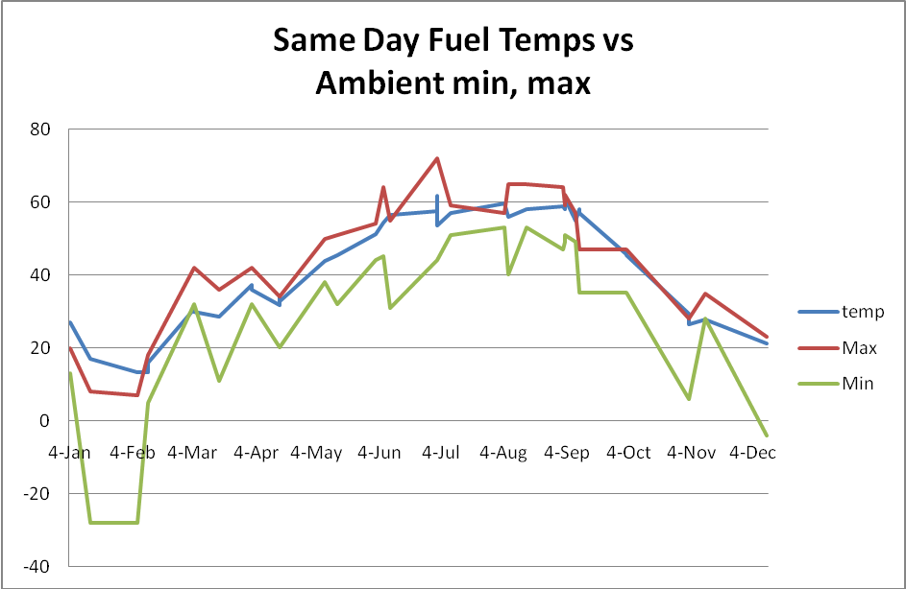
Figure 12

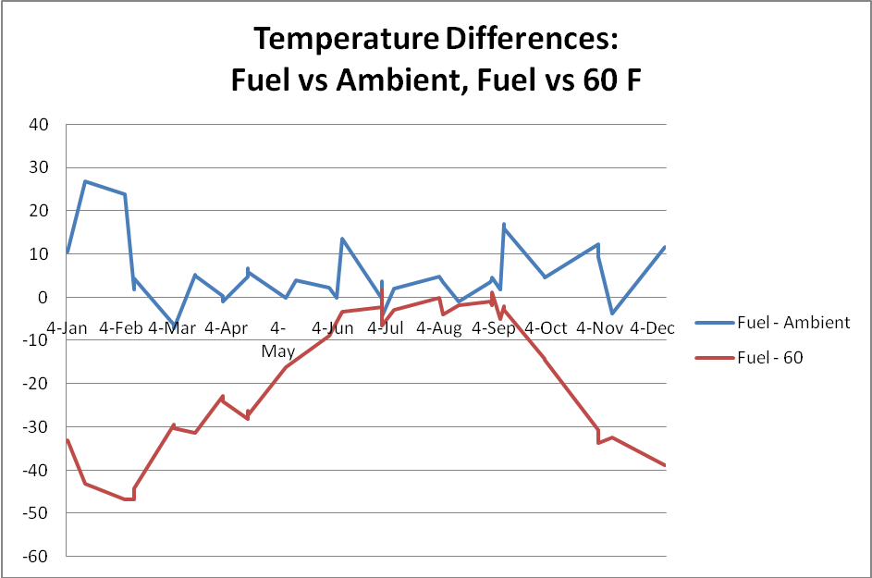
Figure 13
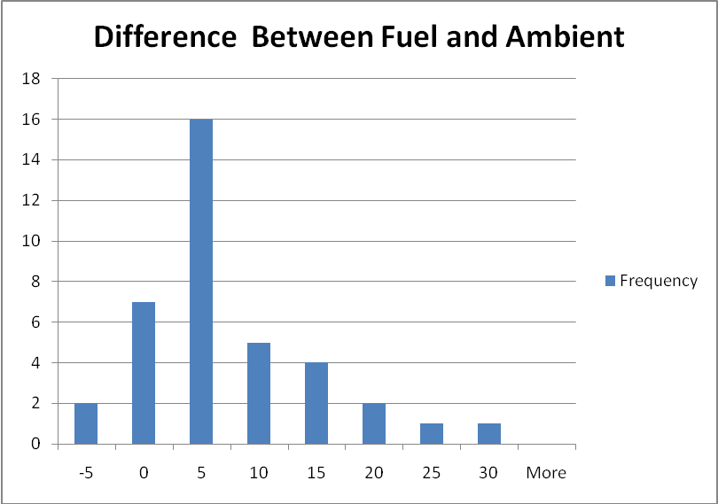
Figure 14

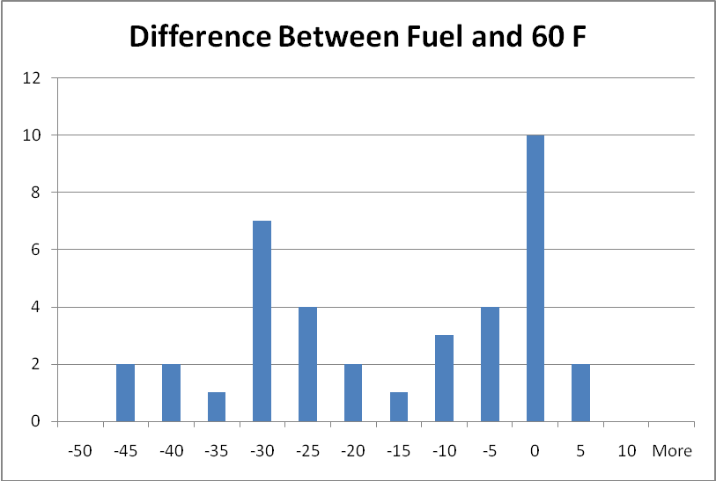
Figure 15
If we look at the distribution of temperature variations from ambient, we see that on average, fuel in this sample is about five degrees warmer than ambient, and the majority of loadings were within a five degree deviation from that mean difference. If we look at how loadings differ from the sixty degree reference temperature, we see that the majority were more than five degree difference, and the maximal differences were considerably larger.
What we can see from this is the extent to which the energy content of a gallon can differ from supplier to supplier when we have a gross gallon standard vs. a permissive standard (with some retailers delivering net gallons). Under a gross gallon standard, random events such as the refinery production schedule, the profile of the firm’s deliveries, etc. make for differences in retail gallon energy content that are not large on average. But we guarantee large variations amongst suppliers under a permissive standard, and it is one that is not random. It is one that will drive the market towards long run net gallon equilibrium whether it is efficient or not.

Consumer Loss calculations from Temperature Variations
We can do a little better than the Murphy-Topel methodology to arrive at the “social cost” of having a gross gallon standard vs. a permissive standard for fuel oil sales. They took a shot in the dark at what the fuel temperatures would be across stations at any time whereas we actually know the temperatures of the loaded fuel each day in this case study, along with ambient temperatures. We also know that the temperatures measured in the sample were loadings received by a retailer, not delivered to the consumer. So in the case of above-ground storage prior to retailing, they will settle closer to retail. This also means that the retail temperature will be even further from the 60 F standard on average because fuel is about five degrees warmer than ambient when purchased wholesale in this sample.
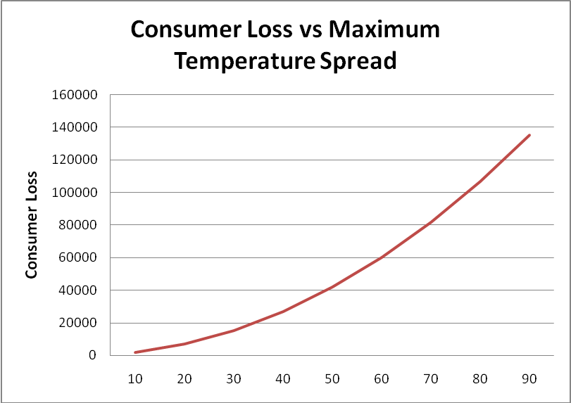
Figure 16
Figure 16 is reproduced from Appendix 2 in order to illustrate calculated consumer losses from effective variations in temperatures of fuel and energy content across suppliers. The calculations are based upon a $.75 billion dollar industry and would increase or decrease proportionately with the price of fuel. Note that for the kinds of maximum temperature spreads reasonably expected given our data, benefits from mandatory temperature compensation are in the thousands or tens of thousands.
These calculations also assume that the temperature differences are random between retailers and that there are no systematic differences in their gallon contents. More will be said on this presently, because if there is a systematic difference between retailers there is another transfer or consumer loss that becomes important to measure.
The temperature variation in a permissive regime increases dramatically. For example, the fuel in two separate vehicle tank trucks may measure 20 degrees and 25 degrees respectively, a difference of only five degrees. A separate truck delivering a net gallon would have the temperature of the fuel set at 60 degrees, a much larger difference. That increased variation increases the losses, and since they are nonlinear in temperature spread, the amounts quickly rise above $50K. For temperatures seen at the Flint Hills rack in North Pole, variations are potentially as large as 90 degrees (rack temperature of -30 F versus the net standard of 60 F). Consumer surplus losses are on the order of $140,000 for this kind of variation.
A great deal of caution needs to be taken here, in understanding that the numbers are for illustrative purposes only. There are a number of factors that would make a difference. We have not actually sampled the differences in temperatures between deliveries. There will be differences between the interior of Alaska and the Kenai peninsula. We have applied the methodology to the entire fuel oil sales estimate for Alaska, and in many areas differences amongst gross gallon suppliers will be insignificant – at any distance from refineries.
What we draw from this example is that the benefits of temperature compensation in terms of reducing market inefficiencies are still very small to begin with. (Alternatively that the costs of not having temperature compensation at retail are low). Secondarily, whatever benefits there are to temperature compensation occur under a mandatory regime, not a permissive one. The introduction of permissive ATC at retail actually introduces the largest possible differences between the “gallons” of various retailers. Thus, between the three possibilities – mandatory net gallon, mandatory gross gallon, permissive – the worst case scenario is the permissive standard, by a considerable margin.
In Appendix 2 we work out a much more significant issue that was mentioned earlier – that when temperature variations are not random, there is an additional measure of consumer loss that is important. This measure is something that is most significant in the initial introduction of permissive ATC in a cold state: a transfer from consumers to ATC retailers that is potentially in the millions of dollars. It is something that ultimately vanishes in the long run as all retailers as a whole adopt temperature compensation.
The size of this transfer depends on the industry size itself, the amount of fuel dispensed net vs. gross, the pass-through rate, the adjustment of consumer perceptions, and the elasticity of demand. But this transfer is far more important, by order of magnitude, than the inefficiency from random variations in fuel temperatures across suppliers. It becomes an equity and transparency issue because under random variations amongst suppliers there is still a level playing field across all retailers and consumers. Nobody can exploit random differences. But when there are systematic differences amongst retailers then equity and transparency are diminished.

Costs of Conversion to ATC

Introduction
Calculating the costs of conversion in Alaska presents some real challenges. The methodology is straightforward conceptually but there are a number of unknowns that make estimation difficult. The costs depend highly on what kinds of assumptions one makes about these unknowns as well as the manner in which conversion takes place. The least costly is gradually over a long period of time and in conjunction with the existing inspection schedule and maintenance/operations schedules of firms in the industry. The most expensive is a short conversion schedule requiring more labor and travel, and less ability to fit retrofitting and calibration into the existing inspection route schedule.
There are one-time costs of conversion associated with retrofitting dispensers at gasoline stations or vehicle tank meters. There are initial calibration and inspection/certification costs. There are also annual costs in the future for maintenance and inspection. We can adapt numbers from the recent California study to the retrofits, and these numbers were also verified with more than one supplier. But the retail fuel industry in Alaska is very different from that of California, especially in bush Alaska.
Alaska has a higher proportion of older equipment that is more costly to retrofit. In fact, the more remote the location and the smaller the throughput, the more likely we are to encounter both “informal” fuel transactions and unregistered devices. Transportation and lodging costs for labor doing retrofits are also much higher. Many remote locations require airfare or ferry transportation to do a retrofit on just one or two dispensers rather than fifty or more.
Initial calibration and certification of newly installed meters must be performed before they can be placed into service. At present the State of Alaska is the only one doing calibration and certification although they can be done by an independent firm that owns the proper equipment. The tests can be done at a regularly scheduled inspection, and there are routes that are designed for economy of inspections. Requesting a calibration test outside of this schedule can be extraordinarily expensive in Alaska. ATC meter calibration testing requires a great deal more equipment, necessitating a truck and trailer being shipped to locations off the road system.
In remote locations, the cost of adopting the more sophisticated ATC metering can be prohibitively expensive. In addition, there is the problem of the downtime associated with equipment failure or the inability to comply. In the California study this was recognized and about 200 locations were identified where the adoption of mandatory ATC essentially threatened the supply of fuel for the area. Their proposal was to place a tax on the urban fuel sales in order to finance the adoption of ATC in these more remote areas. But it begs the question of how much effort it is worth to impose mandatory ATC in the first place if extraordinary means are required to accomplish it.

Retrofit Kit Component Costs
There are a range of ATC options from a minimalist retrofit doing no more than that required to fulfill the law, through units with components that track point-of-sale transactions, inventory, and invoicing on-board a tanker truck or inside the store.
Before discussion of the variation in these costs we introduce a simple diagram of a fuel dispenser and its components (Figure 17). The entire unit is referred to as a dispenser. Inside the cabinet of the dispenser are meters that spin as fuel flows through system piping. The meter is connected to a register that displays the quantity of fuel metered. The register might be electronic (digital), and it might be mechanical (analog).
The illustration shown appears more like a gasoline station dispenser, referred to as an “RD”, or retail device, in the industry nomenclature. But the principle components are essentially the same for a truck mounted measuring and dispensing unit; there will be a meter that spins as fuel moves through it, and this will in turn engage the register. What temperature compensation does is change the ratio of turns or spins per unit movement of the register.

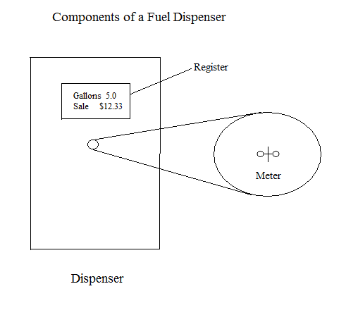
Figure 17

Retrofits vary in cost depending on the number of products, the capacity to blend mid-grade fuels, and in the case of mechanical dispensers the number of nozzles. It appears that retrofits of mechanical registers require replacement with digital registers for RD motor fuel dispensers. In the case of vehicle tank meters, they are not required, but in the long run it appears the more cost-effective solution is conversion to electronic registers.
Retrofit costs for gasoline station (motor fuel) dispensers according to various specifications are illustrated in Figure 18. As can be seen, the kit costs vary from a low of about $1,400 for a dispenser that already has an electronic register up to a high of about $4,000 for a dispenser with a mechanical register and two fuel types. (Mechanical registers must be replaced with electronic registers for RD units). These costs were obtained from the California study.

Automotive ATC Retrofit Kit Costs
by Dispenser Attributes
 | Mid-Grade | Electronic
 | Blending | or |  | Estimated
Fuel Types | Capability | Mechanical | Nozzles | Costs
one | no | Electronic | NA | $1,422
two | no | Electronic | NA | $1,700
three | no | Electronic | NA | $2,042
three | yes | Electronic | NA | $1,700
four | yes | Electronic | NA | $2,426
one | no | Mechanical | one | $3,183
two | no | Mechanical | two | $3,997
Source: California Energy Commission (2009) p 60
Figure 18

In the case of vehicle tank meters, price quotes were obtained from several sources (IDEX, Alaska Petroleum Equipment, Midwest Meter). In discussions with both suppliers of metering equipment and those with experience in their application, it appears that conversion of mechanical systems is problematic for a number of reasons. If the mechanical temperature volume compensator (TVC) fails, there is no field repair, and it will have to be replaced. The electronic TVC and register are both field repairable. The electronic register should require less maintenance. Although the mechanical system may be less expensive to retrofit initially, it is the higher cost in the long run.
It appears that the minimalist conversion kit for a vehicle tank dispenser is about $1,725, excluding labor, shipping, and calibration, but can vary up to about $3,725. Replacing an existing system that has a mechanical register with an electronic register and temperature compensating capability begins at about $4,200. The high end units with the capability of metering several products and on-board invoicing can cost an additional $4,000. Simply purchasing a new meter with electronic register and printer will run about $6,500 to $7,000.

Dispenser/Meter Data Sets: Number of Conversions
There are two data sets we have available for estimating costs of conversion. The first is the route list for “RD” (retail devices) that dispense fuel at automotive gasoline stations or marine fuel locations. The second data set is the list of vehicle tank registrations. In the case of the RD data set, we do know if the register is mechanical or electronic. We also know that 100% of them will have to be converted. There appear to be 375 locations, and something on the order of 1500 dispensers to convert. In the case of vehicle tank meters, there are about 486 meters of which only 53 are ATC. So the majority (433) will have to be converted under mandatory ATC.
We do not know the profiles of RD dispensers in terms of the number of products per dispenser at any location, the capability for blending, or the number of hoses per dispenser. What we know is the total number of “product lines” at each location. If a dispenser has two registers (one on each side) and three grades of unleaded available to the customer on each side, then it has six product lines. If it is an older dispenser with one mechanical register and one grade of unleaded plus diesel, it has two product lines.
Reasonable approximations may be made in most cases – for example if it is a Tesoro station in downtown Anchorage with 36 product lines then we are speaking about a case of most dispensers at that location having three products per side of the cabinet and electronic registers in each dispenser. There might be four meters and there might be six depending on whether there is midgrade product blending.
On the other hand, if there is one product line in one location then there is obviously only one dispenser. If it is a mechanical dispenser at one location on a road system with two products, then it is most likely still one dispenser. Generally speaking when we are in an urban environment the number of product lines per dispenser is higher, and in rural areas it is lower. We know that dispensers with mechanical registers have at most two product lines, so when there is a mix of mechanical and analog meters at a location we can infer the number of dispensers when the total number of product lines at a location is low.
In the case of vehicle tank meters we have a mixture of temperature compensated and non-temperature compensated, as the law presently allows for voluntary temperature compensation. As of October 2008 the profile by region is shown in Figure 19. In total, about 85% of the meters were non-temperature compensated. Slightly more of the medium meters were temperature compensated (86%) than the larger meters (81%).
We cannot say what volumes of fuel are moving through either one despite knowing the proportions of registered meters. The jet fuel metered by International Aviation Services, Inc. (IAS) at the Anchorage International Airport alone (close to a billion gallons in 2008) was delivered net. Additionally, before January 1 of 2009 the practice of distributing fuel through gross meters but invoicing net was practiced by at least one firm in the interior. Moreover, firms with some trucks having gross meters and some net can choose which trucks deliver the higher volume deliveries or which trucks deliver in the coldest time of the year.

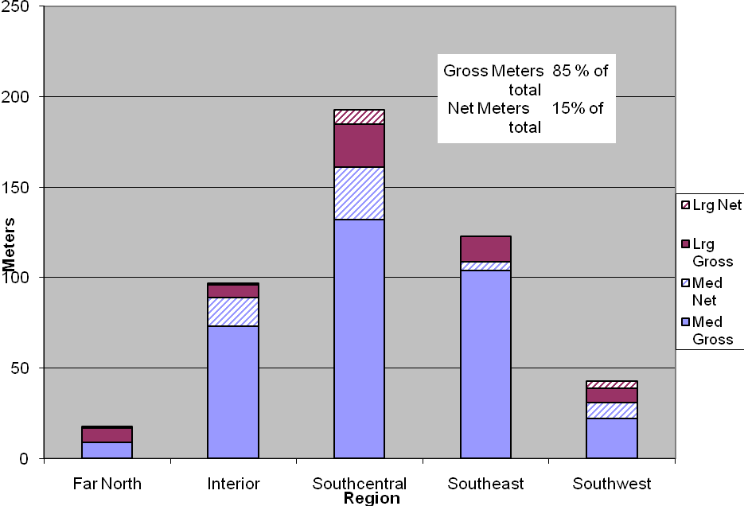
Figure 19

The differences in regional proportions of gross vs. net are significant. The Far North has the highest percentage of gross meters whereas the Southwest has the lowest. The Interior again has one firm metering gross but delivering net, and if the 21 gross meters for that firm were put into the category of net, then prior to 2009 the Interior would have had the lowest proportion of gross meters at about 60%.

Area | Percent Gross
Far North | 94.4%
Interior | 82.5%
Southcentral | 80.8%
Southeast | 95.9%
Southwest | 69.8%
Figure 20

Cost to Convert
In converting Retail Devices (RD) units to temperature compensated devices, a simple and economical approach was developed. There are really three classes of costs. The first is the cost of the components involved in the conversion, such as the TVC unit and certain adaptors. The second is the labor involved in the on-site field work. The third is transportation, lodging, incidentals, and mobilization between locations. All three of these have variation depending on assumptions that are made.
In more remote Southeast Alaska the conversion concept involved the use of a two-man team traveling with truck and equipment via ferry, working systematically between locations, beginning in Bellingham and working north. The ferry trips between locations such as Ketchikan, Kake, Sitka, Hoohah, and Wrangell, Haines, and Glacier Bay area consist of shorter legs between locations instead of multiple longer trips from any point of origin.
In the case of Juneau-Douglass there are enough conversions to support a separate team staying longer term, and possibly Ketchikan as well. But any individual trips beyond these involves less than ten dispensers in a single location, and in some cases just one. Separate trips would raise costs considerably. Although they do not add a great deal to the Alaska total proportionately, they can in some cases double the cost of conversion per dispenser in a remote location.
The use of ferry transportation was assumed for the continuation on out to Dutch Harbor, including Yakutat, Cordova, and Kodiak, except that the point of origin was assumed to be Whittier. Other remote locations such as Barrow, Ft. Yukon, Nome-Teller, Kotzebue, and Bethel have no choice but airline transportation. Both ferry and airline rates were quoted, but ferry rates differ according to season.
In the case of the major population center for the state – Anchorage and the road system through the interior and Kenai Peninsula – we do not have ferry or airline transportation. But all locations including the road system and the Southeast/Southwest areas already discussed have mobilization expenses between locations.
It was decided that a fixed amount per location would be used, with additional amounts where logistics warranted – greater distances between locations, the absence of a truck, etc. Mobilization between locations of $50 was assumed in the low cost scenario. Road system mileage was considered separately.
In the California analysis the source of variation between the low and high scenarios was a combination of two forces – the wage rate and the hours per conversion. Due to the technical nature of ATC dispenser conversions, a high wage rate was assumed there. The “fully loaded” wage rates of between $60 and $70 per hour were assumed for the low and high end, respectively. The hours per conversion were estimated between 1.5 and 4 hours for the low and high end scenarios. It resulted in an estimated range of $9.0 million to $27.9 million for installation.
For Alaska we need to make some adjustment for a higher wage rate, and also the recognition that there will probably be more overtime. In looking at the remote areas in particular, there is either going to be more overtime or more lodging expense because at the median number of hours per dispenser suggested by the California study, a small amount of overtime per day is required just to achieve three dispensers per day.
According to the most recent Bureau of Labor Statistics data, the wage rates in Alaska for Installation and repair technicians are about 18%-21% higher than California, measured at the median and mean, respectively. So whereas California was assuming “fully loaded” wage rates ranging from $60 to $70, Alaska’s numbers adjusted for this wage differential would be somewhere between $70 and $85. California did make a generous assumption about the wage rate relative to the California average so there is not much worry this is an understatement.
Logistically, mistakes in Alaska are far more expensive than in typical urban settings. You don’t have choices of spare parts on shelves or tools convenient to where you are working. Ordering items is expensive and can take days or more. A truck broken down on Prince of Wales Island logging roads or a part that does not work in Unalaska is a completely different situation. The seasons for working outside are short, and productivity in the cold is lower, even when it is not extreme cold. Coastal areas have rain. The interior has snow.
For purposes of this study we will adopt a $75 per hour wage rate but it is probably not wise to adopt the low value of 1.5 hours per conversion and work; it is more like 2 hours at the minimum end. At the maximum end the 4 hours per dispenser was retained.
An equation was developed that linked average RD retrofit costs from the California study.
Cost = $2,000 + $1750 additional for mechanical + labor, room, and board
A “fully loaded” labor rate of $75 per hour was used here in the minimum scenario. A two-hour conversion minimum was assumed. A total of $182 per day for lodging, meals, and incidentals was used based on a survey of room rates and on the state employee per diem rate. Mobilization between locations has to be factored in, and an average of $50 was used. In the high end scenario, a four hour conversion was assumed, with the $85 “fully loaded” labor rate. Also, an $85 mobilization cost was used. In both cases airline and ferry prices were used. But the total travel costs were doubled in the high end.
The results were a cost range of $4.3 million to $5 million to convert existing RD units to temperature compensated units. But there were substantial differences by location, of course. Costs ranged from about $2500 per dispenser to over $6,000 depending on location under the lower scenario, and as much as $6500 per dispenser in the high scenario.
In the case of vehicle tank meters, each company contacted provided different kinds of data. For example, Alaska Petroleum equipment gave some examples of conversion parts, but does not do installations. IDEX provided some rough retrofit component costs. EEI in Canada provided initial calibration and inspection fees, which they are certified for in Canada. Midwest Meter provided low and high retrofits components and since it does installation and calibration simultaneously at its facility, provided those costs as well.
Estimating the low and high scenarios is not a matter of assuming all conversions are the least expensive components on the low end and the most expensive on the high end. It is going to be a mix, and companies will decide on the type of conversion to choose. More than one method of computing costs was undertaken, and the results were similar. Each assumed though that the travel expenses are duplicated as opposed to having the same team convert both vehicle tank meters and motor fuel dispensers.
The estimates for conversion of the non-temperature compensated vehicle tank meters to temperature compensation-capable meters is $2 to $3 million dollars, exclusive of calibration testing. It is assumed for this study that the retrofits are introduced in a schedule that is consistent with the current route calendar, which is the most conservative cost assumption one can make. That is, no special trips are made for calibration and testing of an isolated set of dispensers. Alternatively, the installation is performed by companies that have the capacity to calibrate, inspect, and certify.
Estimates for RD (gasoline station) dispensers vs. vehicle tank meters retrofits in Alaska are presented in Figure 21.

Estimated Retrofit Costs for RD vs. Vehicle Tank Meters
 | RD Low | RD High | Vehicle Low | Vehicle High
Retrofit Costs | $4,272,519 | $4,995,833 | $2,072,750 | $3,137,867
Figure 21

Calibration and Inspection/Certification
Before a meter is placed into service it must be calibrated to certified standards either by the State, or by someone with the proper equipment and qualifications. From discussions with the state weights and measures staff, and with a Canadian corporation performing tests, non-ATC calibration tests can be done with as little as a 1-5 gallon draw whereas calibration tests for ATC require a minimum of 20 gallons. The fuel temperature must be stabilized first in order to obtain an accuracy measure.
As a consequence the testing equipment leaps from a hand-held 5 gallon test measure to much larger devices, such as a slide-in unit that fits into a pickup truck for $15,000. Several more of these units would need to be purchased by the State for initial certifications and subsequent inspections. So there are some additional capital costs for the state whether they are doing the initial calibrations, or whether it is a consequence of subsequent inspections.
It is not clear if the California study addressed the initial calibration/inspection or certification in their report. Inspections thereafter were certainly addressed in the “recurring annual costs” discussion as an increment on top of non-ATC costs. When a new meter is installed, 100% of the costs for calibration/inspection/certification are incurred. If the installation is coincidentally at the time of a periodic inspection for the existing meter, then there would have been an inspection anyway. So the only increment to cost is whatever an ATC inspection and calibration would cost over and above the existing meter.
But if the meter is installed and inspected/calibrated/certified outside the periodic inspection schedule, then the entire cost must be counted, not just the increment for ATC vis-à-vis a non-ATC meter.
In the case of vehicle tank meters, estimates were obtained for both installation and initial calibration/certification as well as costs of complete post-installment inspections and certifications. These can be accomplished for around $300 - $400 per meter. Installation and calibration/certification would add from $130,000 to $173,000 to the equipment costs for retrofitting the existing non-ATC vehicle tank meters.

Recurring Annual Costs
The California Study provided some estimates of recurring annual costs due to adoption of automatic temperature control devices in gasoline service stations. We can adapt these to Alaska with some reservations. First, the kinds of costs were from increased maintenance expenditures on ATC devices vis-à-vis non-ATC. The second was that replacement of some portion of dispensers occurs naturally in the industry, and this will continue except at somewhat higher costs due to ATC dispensers being more expensive. Finally, there are increases in periodic inspection costs.
Additional maintenance costs for ATC devices were estimated, at the low end, to require a service technician spending 8 hours of time at 10% of service stations replacing 25% of the initial costs of ATC components at each of these stations. (An estimate of 20% more cost for rural locations). This estimate was based on a 2.5% failure rate for ATC related equipment.
The higher maintenance scenario assumed 20% of the retail stations requiring a service technician spending 16 hours of field time replacing 50% of the initial costs of ATC components at those stations. The implied average failure rate was 10% per year for ATC related equipment. The fully-loaded wage rate was also assumed to be $70 rather than the $60 assumed in the lower maintenance scenario.
The assumptions above were the best the staff could do without data from Canada where ATC devices are nearly universally deployed. What is probably the most straightforward thing to do is see what proportion of initial retrofit costs these amount to and adapt them to Alaska. The low cost scenario looked to be about 3% of initial retrofit costs, and the higher about 9% in the case of California. In very rough terms the estimates adapted to Alaska look to be about $128,000 to $450,000 per year in the case of RD units and $62,000 to $188,000 in the case of vehicle tank meters.
In the California study (pg 68) the implications for failure of ATC components was discussed. It is somewhat unclear exactly which types of problems result in “error” being displayed on the register resulting in the dispenser being incapable of functioning until a successful power-cycle is achieved vs. errors where the dispenser continues to operate, but as a gross gallon meter. In short, which ones end fuel dispensing altogether vs. which end net gallon metering and return to gross.
The costs of dispensers being inoperable becomes a more important social burden than the direct costs of maintenance as we move further into bush Alaska. In some places, there is actually only one dispenser. Inoperability means no fuel. So the cost is whatever economic activity cannot take place, which is an order of magnitude more important. Where there are a limited number of dispensers, inoperable dispensers are an inconvenience and there are additional costs from inefficiency of economic activity (longer travel to dispenser, more time, etc).
The second category of cost we can adapt numbers to is the ongoing replacement of existing dispensers. Each year, some portion of dispensers is replaced due to age and wear. ATC devices add incremental costs on top of existing replacement costs. In the case of California these amounted to 4% to 6% of the original retrofit costs. If we simply adapt these numbers to Alaska, we have estimates that range from $170,000 to $300,000 in the case of RDs and $83,000 to $188,000 in the case of vehicle tank meters.
Appendix 2 to this report explains the calculations in greater detail.

Recurring Maintenance & Replacement Estimates
 | RD Low | RD High | Vehicle Low | Vehicle High
Retrofit Costs -> | $4,272,519 | $4,995,833 | $2,072,750 | $3,137,867
Maintenance 3% | $128,176 | $149,875 | $62,182 | $94,136
Maintenance 9% | $384,527 | $449,625 | $186,547 | $282,408
Replacement 4% | $170,901 | $199,833 | $82,910 | $125,515
Replacement 6% | $256,351 | $299,750 | $124,365 | $188,272
Total 7% | $299,076.35 | $349,708.31 | $145,092.49 | $219,650.71
Total 15% | $640,877.90 | $749,374.95 | $310,912.48 | $470,680.10
Figure 22

The last category of recurring costs associated with ATC metering is the incremental costs of periodic inspections undertaken as a regular part of state weights and measures duties. It is clear this was adequately addressed in the California study, and their discussion matches the estimated incremental time required for testing ATC vs. non-ATC from discussion with Alaska weights and measures staff.
In the California study, the amounts were given on a per-station basis: about 10% to 20% per station. Since the maximum registration fee is $1,000 in California, the recommendation was to increase that amount to $1,200 in anticipation of higher inspection costs. In their case, these are county-level costs incurred by inspection agencies that must justify their inspection fees on the basis of costs incurred. The amount of time required for each test presently was estimated at 12 minutes, and expected to approximately double. We adopt the same increment to costs as far as time is concerned. But given the increased requirements for equipment, we should also expect higher transportation costs off the road system in Alaska. The amounts range from $37,500 to $75,000, but we should expect the upper end.
In the case of vehicle tank meters, the same 10% to 20% would result in about $34-$68 added to average inspection costs, using data from Canada. This would add some $15,000 to $30,000 in periodic inspection costs, excluding higher transportation costs. So the upper end is more likely.

Effect of Temperature Changes on Volume or Price per Gallon
In studying the effects of temperature on fuel we are led to an understanding of how quickly fuel adjusts to the temperature of its environment before it is retailed. We also can see that it is more complicated than fuel cooling from the refinery to the end user in Alaska. In the case of underground storage of highway fuels for example, fuel that has adjusted to an extremely cold ambient air temperature, when placed in underground storage, has a chance to warm up some before delivery to the consumer.
We can see that all refineries do not operate with the same lead time between production and the loading rack. A short enough lead time will result in temperatures that have not completely adjusted to ambient air at the time the truck has been loaded. In the case of #2 fuel oil produced in the interior at Petro Star, the fuel rarely leaves the refinery at less than 60 F, whereas subzero temperatures for automotive fuels at the Flint Hills loading rack are not unusual in the winter.
Fuel that has been delivered by rail to the Anchorage rack from Fairbanks has already adjusted to ambient air temperature before it is further distributed. Fuel that has been delivered to remote tank farms by barge will have adjusted to ambient air temperature before it is retailed – but the temperature at purchase will vary depending on whether it was loaded at the Port of Anchorage, the Nikiski refinery, the Petro Star Refineries or Puget Sound.

Method of Volume Adjustment
The most precise method of volume correction for temperature according to fuel type involves more than one step. ASTM International (originally known as the American Society for Testing and Materials) produces convenient tables that may be used to first convert an observed American Petroleum Institute (API) gravity measurement at a given temperature to “API Gravity at 60 F”. From there the volume correction is established with a second table given the temperature and API gravity at 60 F. (There are computer programs based on the ASTM tables as well).
API gravity is a measure of how heavy petroleum if relative to water. If it floats on top of water then it is lighter, and has a higher API gravity. In wholesale transactions, both gravity and temperature are given, along with the gross and net gallon readings. The calculations can thus be verified using the petroleum measurement tables.
There are less exact means of correcting volume to 60 F that rely on assumed API values for various products. There are “Coefficients of Expansion” (CoE) that appear in various trade or government publications that may be used as approximations. For example Butcher (2006) cites CoE values of gasoline at 0.00069/°F and diesel at 0.00050/°F. That is to say, each one degree reduction in the temperature of gasoline results in a change of volume by a factor of 0.0007.
What is usually cited more often is that as gasoline cools by 15 degrees, it shrinks by about 1%. This can be seen by multiplying 15 times 0.00069, which is equal to 0.0103 (about 1%). We may use these for illustrative purposes to produce some simple charts or tables demonstrating the effect of temperature on volume, and therefore price per gallon.
Since data was obtained from various Alaska sources, and some of it included actual API values, they can be used to obtain actual CoE figures derived from the Petroleum Measurement Table calculations. These were 0.00052 for Jet Fuel/#1 Diesel, 0.00048 for #2 diesel and 0.00062 for gasoline.
Figure 23 illustrates the volume correction factors for the two major types of fuels – diesel #1 (or jet fuel or heating oil) and gasoline. These factors have again been calculated for observed gravities of fuel produced in Alaska. At 60 F there is no volume correction factor for either. For diesel, it reaches a 0.99 correction factor (shrinks by 1%) at about 41 degrees. For gasoline it occurs sooner, at about 45 degrees. Diesel reaches a 0.98 correction factor (shrinks by 2%) at about 22 degrees. For gasoline the 0.98 correction factor is reached at 28 degrees. At forty below zero they are roughly five and six percent smaller in volume than gross gallons respectively.
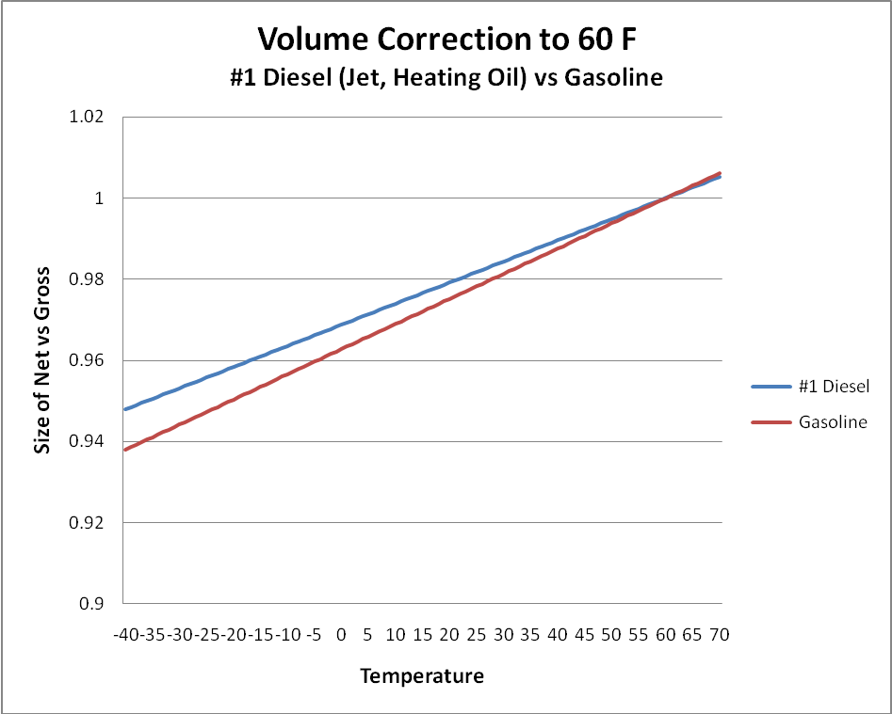
Figure 23

For any given “price per gallon” we can see what happens to the effective price on an equivalent basis when we change from gross to net gallons. This is more in line with the way consumers are shopping for something like fuel oil. They simply compare prices. It is the same information as in the previous figure, but consumers are confused by the difference between gross and net gallons. There is only one “gallon” in the minds of the vast majority of consumers.
In Figure 24 we show the effective price differential when switching between gross and net gallons in the case of diesel, or fuel oil. At sixty degrees the prices are the same. At about 41 degrees the net gallon is 1% more expensive. At 23 degrees it is about 2% more expensive. At 4 degrees it is 3% more expensive, etc. At the very lowest temperatures observed in the data set for fuel sales at the “rack” (-36.2 F) the difference is 5.3%. At the very highest temperature observed for fuel oil at the rack (83 F), net gallons are about 1.2% cheaper. In bush Alaska, sales metered from small above ground tanks can conceivably be as low as -40 F or lower, in which case the difference would be about 5.5% or more.

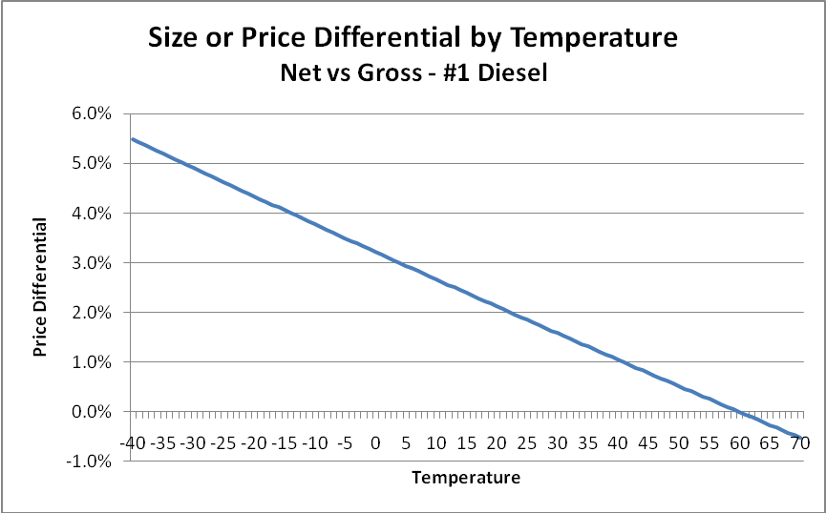
Figure 24

For gasoline, which responds more readily to temperature, the results are a little stronger, and are shown in Figure 25. By 44 degrees the price difference is 1%. By 27 degrees it is 2%. It reaches 3% at 12 degrees and 4% by -4 degrees. The lowest “rack” temperature observed was -34 F and at that temperature the difference was 5.8%. At forty below and colder, the difference is 6.2% or more.
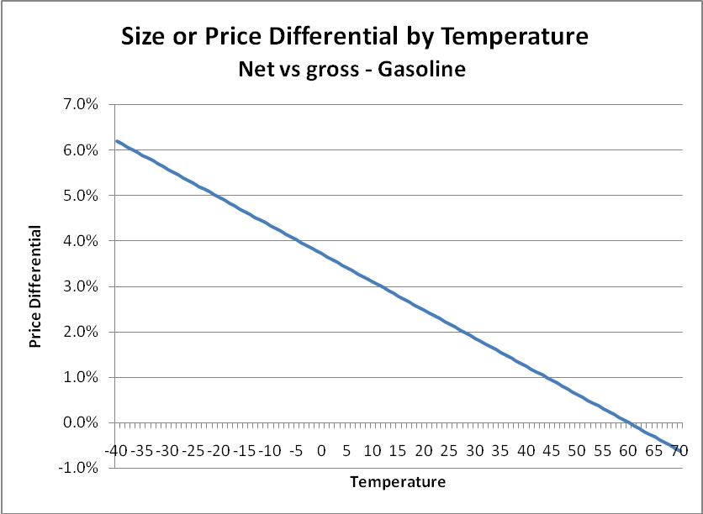
Figure 25
A retailer may look at this in a somewhat different way, but it is nevertheless the same proportion. Retailers are generally buying on a net basis at wholesale. If the temperature of the fuel is – 20 F when they purchase it and also – 20 F when they sell it, then there is a 5% difference between “gallons sold” (gross) and “gallons purchased” (net). Not because the temperature of the fuel has changed, but because the units of sale are different from the units of purchase.
With these kinds of differentials it is clearly a significant matter for both consumers and retailers. We do not have survey results for fuel oil distributors in Alaska, but the lessons from gasoline marketers nationwide is instructive. Convenience stores are the largest distributor of gasoline in the U.S. The National Association of Convenience Stores (NACS) in a 2008 survey found that 32% of consumers would go out of their way in some minor manner to save a penny a gallon, and about a third would travel more than ten minutes out of their way to save three cents per gallon. Price was the most important factor for 73% of respondents.
Retail margins on gasoline have been steadily declining over the last decade, and are around two cents per gallon in the 2008 National Association of Convenience Store survey. So clearly even minor differences in temperature from the 60 F benchmark are going to be significant for retailing gasoline.
We do not have survey results for fuel oil firms in Alaska, and the most recent comprehensive study by ISER (2008) was incapable of identifying retail margins on fuel. In the case of convenience stores the profit on food and beverages sustains them in a manner allowing for intense fuel price competition. So the NACS data are not applicable.
Nevertheless a 1% difference in price at $2.50 a gallon is 2.5 cents – enough to make a $7.50 difference in a 300 gallon tank delivery. At a temperature of -20 F and at a price of $2.50 the difference is $32.50 in a 300 gallon fill-up. Fuel oil sales are primarily in the colder months so this is the kind of range that would be relevant.
In a survey of prices across six firms in Fairbanks on the same day of delivery on December 16 2008, the widest spread for five firms delivering net gallons was $2.28 to $2.32 for a 300 gallon delivery. The sixth firm had the lowest price overall ($2.22) and was also a firm delivering gross rather than net gallons.
With a normal average December temperature of -6 F, the price differential is 8.2 cents on net vs. gross gallons. The price differential for the firm selling gross gallons is actually about twice that suggested by the posted price differential. Clearly, the difference between gross and net gallon invoicing to consumers is at a level in Alaska that matters to a great number of consumers – if they know what the difference is between a net and gross gallon. But in surveying consumers, as is discussed elsewhere in the report, consumers are nearly universally ignorant about the difference.

Consumer Awareness, Product Labeling, Signage and Invoicing

Introduction
One of the issues brought up in the NCWM debates, and in studies pertaining to temperature compensation, is the matter of labeling and consumer awareness. At the crux of this issue is the desire to ensure consumers are making fully-informed decisions about purchases when comparing products across retailers. It is our opinion that this is the most important, yet least explored matter in temperature compensation of fuels.
This is not an ancillary topic, but rather absolutely essential in computing the costs and benefits of legal regimes. There are three possibilities: mandatory net, mandatory gross, and permissive. The benefits and costs depend precisely upon the consumer’s awareness about what is most essential to them: the cost per gallon when measured on an equivalent basis.
Elsewhere we have discussed that the most important issue to consumers in the selection of a retailer for a fuel transaction is price per (equivalent) gallon. The impetus for this study was the lack of transparency in price per equivalent unit. Ostensibly the motivation of labeling, signage, and invoicing requirements is to effect transparency and full information for consumers. The energies put into the matter seem to have lost focus due to the physics involved. The moment attention is diverted from what consumers want (price per equivalent gallon), the objective is lost.
Consumers do not desire to know how gasoline or fuel oil is produced. They do not desire to know whether the fuel came from barrels on the North Slope, from Cook Inlet, or were produced and refined from out of state. They do not need a physics lesson when they are purchasing milk, bread, or fuel. What they need to know is price per equivalent gallon. They need the capacity to make comparisons across suppliers on this basis. None of the suggestions we have seen in the literature and in the regulatory or statutory environment seem to retain focus on this point.
To be fair, in large degree this is because requiring a posting of prices on an equivalent basis means that either gross gallon retailers must compute net gallon prices, or else net gallon retailers must post gross gallon prices. But because temperature varies nearly continuously, either one necessitates nearly a real-time variation in product pricing and display. If this cannot be done, then it points to the necessity of a single standard, and that labeling or signage or invoicing are all really red herrings in the objective of informing consumers.
In the case of the California (2009) study, we find the technical problem associated with the permissive approach (pg 94):
Any attempts to increase the level of information to include net and gross gallons would pose some difficult and problematic issues. Although the ATC retrofit kits possess electronics and software designed to monitor fuel temperature and adjust the volume dispensed to consumers, there is no current capability for this system to convey the two different forms of measurement to the cash register or POS equipment. It is possible that, over time, POS and ATC retrofit manufacturers could collaborate to enable this exchange of data, but the initial expense of this software and some electronic modifications is unknown.

This (price per equivalent gallon) is the only thing important to consumers – and it appears technically infeasible at present.

Existing Regulations Governing ATC in Canada and the NIST
In the case of Canada, it is a permissive regime. Retailers can dispense either gross or net gallons. Retail fuel dispensers have a label affixed: “Volume Corrected to 15⁰ C”. Receipts do not appear to have a requirement. Does this labeling provide anything that allows a consumer to compare prices across retailers? The answer is that it clearly does not. Because even if the consumer is a petroleum engineer with a calculator, the information necessary to compare prices on an equivalent basis for a gross vs. net retailer is the temperature of the fuels along with a fuel expansion coefficient.
A reasonable guess can be formed when ambient temperatures are at either extreme highs or extreme lows, but even perfect knowledge of the fuel temperatures is insufficient to make the pricing calculation. We must also consider that the posted price visible from the road does not indicate whether or not the volume has been adjusted, the consumer making a decision to pull into a station for a purchase would need to know by experience, or guess, whether two particular retailers are dealing in gross or net gallons. In short, the Canadian requirement does not serve the ostensible objective: to effect transparency in pricing.
Note that if Canada had a mandatory ATC retailing regime, the label on the dispenser would be irrelevant. There is no price-discriminatory consumer information gained in posting. Likewise if the legal requirement is for gross gallon delivery – there is nothing gained by posting that either.
In the NIST Handbook 44, 2009 version, there are two pertinent requirements regarding signage, labeling or invoicing, and they pertain to vehicle tank meters:

S.5.6. Temperature Compensation for Refined Petroleum Products. – If a device is equipped with an automatic temperature compensator, the primary indicating elements, recording elements, and recorded representations shall be clearly and conspicuously marked to show the volume delivered has been adjusted to the volume at 15 °C for liters or the volume at 60 °F for gallons and decimal subdivisions or fractional equivalents thereof.

UR.2.5.2. Invoices. – An invoice based on a reading of a device that is equipped with an automatic temperature compensator shall show that the volume delivered has been adjusted to the volume at 15 °C for liters or the volume at 60 °F for gallons and decimal subdivisions or fractional equivalents thereof.
It is worth noting that for testing purposes there is a requirement that the retail device be able to show either gross or net readings, but not at the same time.
We have several observations regarding these requirements. First, consumers make their purchase decision for fuel oil based on a “price per gallon” quote prior to invoicing. For example, in the case of a home heating oil customer this is accomplished by phone. In the case of a school district or other large entity taking bids on a large delivery, it is based on the submitted bids.
Either way these NIST requirements provide nothing of value to the consumer. NERA conducted a survey of fuel oil retailers in December 2008 in Fairbanks. Of six retailers contacted, not one receptionist knew whether the firm sold gross or net gallons, and further inquiry with management was required to clarify. In one case, the telephone number was a cell phone exchange that reached a management level staff, and it was the only case the question could be answered. Moreover, two of the receptionists volunteered that they had never heard the question before.
One of the alleged consumer benefits of temperature compensated gallons is that consumers are guaranteed the same energy content in every transaction. If that is a priority of consumers, then why has this question never been asked of a receptionist? Why is it that receptionists, whose primary responsibility is providing pricing information and arranging delivery, were not even aware their company was delivering net gallons? These are fair questions. Regardless of the answers though it is clear that the legal requirement for invoicing has had zero impact on the objective of price transparency.
A second small survey of consumers was conducted after newspaper, radio, and television coverage was conducted regarding this study. The coverage was in January and was not extensive, and the survey was conducted in March. Twenty random home fuel oil customers were reached. One question was asked, but phrased differently for two sets of ten respondents: did they know what the difference was between a gross and net gallon? Did they know what a temperature corrected gallon was? Not one in twenty knew. (One did guess that the answer had something to do with how much product is lost along the chain of production between bringing the oil out of the ground and final delivery of the refined product.)
Obviously these are very small samples, but there simply is no value in conducting large ones. It is of little value to determine precisely the amount of consumer ignorance – whether 80% or 90% or 99% – when we are dealing with such high proportions.
NERA also interviewed two smaller air services in Fairbanks in December of 2008 – Warbelow’s and Guardian Flight. In the case of Warbelow’s, the owner indicated that he had been “fooled for years” on gross vs. net gallon pricing, despite having received invoices labeled under the NIST requirements. In the case of Guardian, the chief of flight operations had never heard of gross vs. net gallons. If individuals who are professionals in the industry do not know the difference between gross and net gallons – when it is the largest single component of their operations costs – then the invoicing is obviously useless in conveying anything of value to the common consumer.
When NERA interviewed the Manager of Policy Development and Promotion at the Alberta Motor Association in December of 2008, it was clear that the net effect of temperature compensated metering was not understood. The impression was that through the year there was no difference on average between gross and net gallons. Here again, if a professional motoring consumer advocacy group does not correctly understand the differential between net and gross gallon content in a cold climate, then how can common consumers be expected to understand?
One of the more revealing sets of interviews NERA conducted in December of 2008 was with the Alaska Airmen’s Association principals. Written comments to the State of Alaska by one of the fuel retailers had asserted that provision of net gallons to air customers was necessitated in order to properly compute weight and balance. Yet, these principals had never heard of a gross vs. net gallon. A notice was posted in their newsletter, which read in pertinent part:
A study is being conducted on the effect of Automated Temperature Compensating Devices used for sale of refined petroleum retail products on all affected public entities. A public meeting is scheduled for January 12, 2009, Board Room, Dena'ina Convention Center, 600 West 7th Avenue, 2;00pm - 5:00pm. This is an independent study for the State of Alaska analyzing the cost and benefits of using gross gallon vs. a net gallon as the method of sale.

It was with some urging that NERA requested any language indicate directly that one “gallon” was generally smaller than the other, given Alaska temperatures. The response was that the Association had to be “careful” – that the primary fuel retailer was a corporate sponsor to the Airmen’s Association. Furthermore, although a price survey appears on their website, no acknowledgement of the distinction between gross or net gallons is made.
The result of this newsletter announcement was one contact to NERA – from a fuel retailer. We could draw different conclusions from this result, but there really is only one reasonable one: no information of value is transmitted to consumers when we skip what is important to them: price per gallon. When we begin discussing fuel expansion, temperature compensation, net vs. gross gallons – we are immediately lost in a maze of trade terms, physics, and potentially obfuscatory red herrings that the consumer is not going to be capable of condensing into the one thing he needs: price per gallon.
The State of Alaska has also undertaken major fuel price studies, e.g. ISER(2008), without acknowledgement of the distinction between gross vs. net gallons. Here again we have professional researchers in arguably the premier social research organization for the State of Alaska that are unaware there are different retail gallons in Alaska. Yet size of gallon and price per gallon are exactly the same thing – for example a 2% smaller gallon vs. a 2% higher price.
NERA furthermore conducted interviews of two school district purchasing agents (Gateway, and Fairbanks North Star Borough School districts); neither of them knew the distinction between net and gross gallons or alternatively the temperature compensation of fuels. Bidding documents did not specify which gallons to deliver, and as a consequence the invoicing requirements have no effect on pricing transparency precisely where it actually matters: when comparing bids.

Conclusion
Enough surveying and interviewing was done to establish decisively that existing invoicing requirements and labeling of dispensers do not fulfill the objective of price transparency – not in Canada, and not in Alaska, where permissive regimes exist. In either case sales have been ongoing for more than ten years.
Moreover it is logically inescapable that current or major proposed regulations governing labeling, invoicing, or signage are irrelevant when there is a single standard either way: gross vs. net. It is true that under a gross gallon standard, there are variations in temperature and therefore content from one retailer to another. But the extent of this variation has never been documented anywhere in a way that lends itself to cost-benefit analysis.
Generally speaking, in social policy it is unwise to adopt known costs when benefits are unclear. The burden of proof in accepting costs is that the expected benefits must be larger. The one thing that has been demonstrated unequivocally in the case of temperature correction for fuels is that the permissive regime introduces insurmountable problems in price transparency amongst retailers in a way that is absent in either mandatory approach.
Without an effective capacity to simultaneously translate gross prices into net, or vice versa across retailers, consumers gain almost nothing through labeling, signage, or invoicing requirements. Pricing information on an equivalent basis has to be determined before the purchase decision has been made. It is for this reason that the State of Alaska is taking the correct approach to a single standard regardless of what that standard is, when the objective is price transparency and equity across the marketplace.

Inventory Control
One of the advantages or rationales for temperature compensated sales posed by suppliers is the amelioration of inventory loss from fuel shrinking in the cold. It is quite true that shrinkage introduces a problem of inventory tracking for suppliers that requires they monitor the temperature of their stored fuels. In Alaska, there is a requirement for reporting monthly inventory of taxed fuels, and indeed these are purchased on a net gallon basis and invoiced on a gross gallon basis through retail devices at automotive gasoline stations. A specific line item for fuel loss from temperature changes is provided in these tax forms for suppliers tracking inventory by gross gallons.
It is easily shown that the method of invoicing customers and the inventory control problem are independent. Fuel shrinks in the cold regardless of how you invoice it. Whether inventory is kept by gross gallon, or inventory is kept by net gallon, exactly the same information is needed to perform inventory reconciliation – the volume and temperature of the fuel. It is true that there are some small efficiency gains in tracking every single sale on a net gallon basis.
But the claim that net gallon sales of fuel are required in order to solve an inventory loss problem has no more merit than claiming losses from handling, vaporization, and fuel sump draining require sales of smaller gallons. They are all problems, yes – but not ones that necessitate selling smaller gallons. The price of the fuel must incorporate all costs to the retailer, and these are just some of them.
So long as suppliers face the same ambient temperatures, they face the same potential losses while fuel is stored or transported. The key advantage to selling on a net gallon basis is realized when competitors are selling on a gross gallon basis. It isn’t because fuel losses are minimized. This gain over competitors exists whether fuel expands, contracts, or stays at exactly the same volume. The retailer selling the smaller volume gallon has the competitive edge in all three cases so long as the consumer does not know the difference.
It has been argued that although retailers can sell smaller volume gallons to rectify the problem of fuel shrinkage in the cold, charging a higher price is either not possible or will cost consumers too much. But isn’t selling more, smaller gallons the same as selling less, larger gallons at a higher price? All gasoline stations in the United States, including Alaska, have these exact inventory control problems and incorporate losses (or gains) into their pricing structure, consciously or not, through market forces. If the aggregate quantity of fuel is reduced from shrinkage in a marketplace, the market price rises whether a specific retailer is consciously factoring this in or not.
In this section we investigate the accounting of inventory control along with profit and loss accounting. It is important to do this to demonstrate that buying and selling on the same unit basis is not necessary to properly control inventory.

Accounting of Inventory Control
There are many reasons to monitor inventory. It is an indispensable planning tool for management. Inventory control detects and prevents, or allows for mitigation of, losses from theft, spills, etc. Firms that pay motor fuel taxes in Alaska are required to produce a monthly inventory reconciliation on the Alaska Motor Fuel Tax Return.
In order to do inventory accurately the operation needs to be shut down while the inventory is taking place. Fuel cannot be flowing while an inventory is being conducted. For example, it may be a monthly exercise on a Sunday at midnight or some routine that does not interfere in normal operations.
Whether inventory control is for a gasoline station or a fuel oil retailer with a tank farm the accounting methodology is basically the same. The inventory reconciliation form from the motor fuel tax return is shown here for illustration:
Inventory Reconciliation |  | Gallons
 | 1) Beginning Physical Inventory
 | 2) Receipts
 | 3) Disbursements
 | 4) Gain (Loss)
 | 5) Transfers
 | 6) Ending Physical Inventory
Figure 26

Essentially the inventory control in short form is:
Ending inventory = Beginning Inventory + net gain (loss)
Where items 2) through 5) above establish the net gain or loss in the case of a retail service station. One of the values of exploring this particular form is that retail gasoline stations in Alaska, as elsewhere in the U.S., are largely (but not exclusively) invoiced by suppliers on a net gallon basis, but retail on a gross gallon basis. To pose that this is an intractable problem when it is done monthly by every gasoline station in Alaska is untenable.
Receipts and disbursements are straightforward enough – and more will be said on them below. Losses occur during handling, transportation, and storage. The largest of these, according to the largest retail distributor of fuel in the state, is sump drain losses. Transfers would be fuel acquired for one purpose but used for another (e.g. jet fuel sold as diesel). But one item in particular draws our attention, in 4, above: Gain (loss) that is specifically sanctioned by regulation:
15 AAC 40.310 (a)(5) “losses of volume due to temperature changes of fuel”.
Inventory can be calculated either way by a firm – gross or net. So long as both volume and temperature can be observed, all of the information necessary to make the calculation either way is known. Wholesale transactions are generally invoiced on a net basis, but both net and gross gallons are recorded with the transaction, so receipts are known either way. A retail service station can choose to enter inventory into its ledger as gross gallons, or as net gallons. But it makes no sense to enter receipts as net and disburse as gross or vice-versa. This was an important observation by Ross Anderson (2008, 2009) Director of Weights and Measures for the State of New York, along with retailers before the California Commission and in other hearings before Congress.
The context in which the comments arose is the near perennial accusation that service stations in warm states buy net gallons and sell gross as a means of profiting. Since warm states have temperatures greater than 60 F, the accusation amounts to saying gas stations are selling gallons that they did not purchase.
This is really a red herring in the first place, since it would be irrelevant whether gasoline stations did this or not. If someone is selling a product they obtained by gift, by discovery, or as manna from heaven it is their right to sell it at whatever the market will bear. But it is somewhat odd that the myth persists despite being relatively easy to disprove in the inventory control context. It is also worth demonstrating that it reflects a complete lack of understanding of how businesses work and how profit and loss accounting is performed.
The easiest way to show this is to begin with zero inventory, and have the firm sell all of its inventory. Assume a retail station receives inventory of 10,000 net gallons delivered at 93 F, so that the gross gallon delivery is 10,200. The temperature stays constant at 93 F throughout this exercise. Let’s just try to do the monthly inventory in accordance with the logic of the hot fuel inventory fraud myth:

The Hot Fuel Inventory Fraud Myth
Initial Inventory |  | 0
Receipts |  | 10,000 | gallons (net)
Disbursement |  | 10,200 | gallons (gross)
Ending Inventory |  | -200
Figure 27

The firm enters into inventory the 10,000 net gallons as the theory goes, and then sells 10,200 gallons gross, also in accord with the theory. All of the fuel bought has been sold. There is no gain or loss of fuel. No spills, no transfers in. If we follow the logic through to its implied result, at the end of the month the firm reports a -200 gallon balance to the state tax authority. Now, consider that this is actually a cumulative phenomenon, occurring every month. Firms across the U.S. in “hot fuel” states ought to have inventory balances in the high billions of gallons (negative) by now.
Obviously, this is an impossible situation and defeats the purpose of doing inventory control in the first place. The units of measure for receipts and disbursements must be the same. According to the testimony referred to above, gasoline stations under the jurisdiction of the respondents do inventory on a gross gallon basis, but it could also be accomplished on a net gallon basis.
An alternative but equally ridiculous story is that firms enter into their monthly accounting filings with state tax authorities a gain in inventory from the clever trick of “net in gross out” accounting. The problem with this story is that, as we just showed for the state of Alaska, it is permissible to enter gains or losses due to temperature changes – but there has been no temperature change. This is instead a change in the definition of units between lines in an accounting form for the same month, which is impermissible.

Profit and Loss Accounting
It is also worth dispensing with additional myths in this arena, pertaining to the way businesses do their accounting, and how inventory control is in reality separated from the accounting of profits and losses. When a retail firm receives a delivery of fuel it will have a truck manifest, and an invoice seen in simplified form on Figure 28.

Truck Manifest |  |  |  | Invoice
Gross | Temp | Net |  | Net | Unit | Total
Gallons |  | Gallons |  | Gallons | Price | Due
10,200 | 93 F | 10,000 |  | 10,000 | $2.00 | $20,000
Figure 28

The firm knows what it has received in both gross and net delivery, but it is invoiced in net gallons. The firm has an accounting of all the costs that go into the sale of this fuel, and a simplified cost of goods sold is illustrated with a profit and loss statement here:
Cost of Goods Sold |  |  |  | Profit/Loss Statement
Fuel |  | $20,000 |  | Revenue (P = $2.75) |  | $28,050
Labor |  | $5,000 |  | Costs |  | $27,000
Etc. |  | $2,000
Total |  | $27,000 |  | Gross Profit |  | $1,050
 |  |  |  | Taxes |  | $150
# Units |  | 10,200
Cost/unit |  | $2.65 |  | Net Profit |  | $900
Figure 29

The firm has paid $20,000 for the fuel it purchased, and has additional costs for labor and other items as shown. Total costs are $27,000. Since 10,200 units have been sold, the cost of goods sold is $2.65. The fact the firm bought on a net basis and sold on a gross basis is completely irrelevant to the cost of goods sold. The only thing that matters is the number of units sold and whatever expenses were incurred in achieving those sales.
In the profit/loss statement, we show a price per unit of $2.75, (which compares to a cost per unit of $2.65), and results in total revenues of $28,050. The total costs are again $27,000, resulting in a gross profit of $1050. After tax the firm shows a profit of $900.
There are some important lessons in showing this accounting, and it was something missing in the California study and in studies on hot fuel/cold fuel in general. The first is that there is a separation between the inventory control problem and the cost of goods sold, unit pricing, and profit/loss accounting. The hot fuel inventory fraud myth relies on an audience that understands neither inventory control nor basic accounting.
Firms in hot fuel states do not invoice customers in net gallons and do not temperature compensate gallons because it is less profitable to do so, but the inventory fraud myth misleads us. In terms of inventory control, there is no benefit to invoicing in net gallons in a hot fuel state. Monthly reports are correctly filed with taxing authorities despite fuel being sold at temperatures significantly higher than the 60 F net gallon reference temperature they are invoiced at themselves.
In Alaska, the problem is the reverse, where fuel is colder than the 60 F standard. We can construct examples in the opposite direction that serve the same point. Let us consider a situation in which fuel is purchased at -20 F, but is invoiced to the retailer at the 60 F reference temperature. We are going to leave the fuel at -20 F throughout this discussion to clarify a point obfuscated by changing it. A simplified truck manifest and invoice is shown on Figure 30.
Truck Manifest |  |  |  | Invoice
Gross | Temp | Net |  | Net | Unit | Total
Gallons |  | Gallons |  | Gallons | Price | Due
10,000 | - 20 F | 10,500 |  | 10,500 | $2.00 | $21,000
Figure 30

Observe again that the retailer knows both the net and gross gallon quantities of the fuel. It can enter into inventory either way. We recognize that there may be time enough for the fuel to have changed temperature between the loading rack at the refinery or tank farm and the time the full load of fuel is received. We will discuss that situation separately in order to clarify the difference between the reference temperature and the temperature of the fuel. If we tried to do inventory reconciliation with buying net and selling gross, then we would have something that looked like Figure 31 it were done incorrectly:
Cold Fuel Inventory - Incorrectly
Initial Inventory |  | 0
Receipts |  | 10,500 | gallons (net)
Disbursement |  | 10,000 | gallons (gross)
Ending Inventory |  | 500
Figure 31

Of course, the firm cannot end up with 500 gallons of inventory if it has sold all of the fuel that it purchased, and it started with no fuel in the first place. So it has to do its inventory on either a net gallon basis or a gross gallon basis. Moreover, this inventory can proceed on either basis without regard to how the firm is making its pricing and profit/loss accounting. That is, assume the firm has an ending inventory of zero in either net or gross gallons for simplicity, but it is selling its fuel on a gross gallon basis. (Because retail gasoline stations in Alaska sell on a gross gallon basis). The inventory statement will look like either of the tables in Figure 32:

Cold Fuel Inventory - Correctly (net)
Initial Inventory |  | 0
Receipts |  | 10,500 | gallons (net)
Disbursement |  | 10,500 | gallons (net)
Ending Inventory |  | 0
Cold Fuel Inventory - Correctly (gross)
Initial Inventory |  | 0
Receipts |  | 10,000 | gallons (gross)
Disbursement |  | 10,000 | gallons (gross)
Ending Inventory |  | 0
Figure 32

This is again fuel that was brought into inventory at -20 F. It is important to remember that the 60 F reference is not the temperature of the fuel. Inventory loss from fuel shrinkage has nothing to do with the reference temperature of the fuel. The reference temperature could be a thousand degrees and it is irrelevant to inventory loss. Since the fuel came in at -20 F and left at -20 F there has been no inventory loss.
In the next frames we show the cost of goods sold accounting. The fuel invoice is for $21,000, and is entered along with $5,000 labor and $2,000 in other costs as before. Total cost of goods sold is $28,000, and since 10,000 gross gallons are sold, it results in a unit cost of $2.80. It is irrelevant whether inventory was done on a gross or net basis for this accounting.
In the profit and loss accounting we show a unit price of $2.90, and thus total revenues of $29,000. With costs of $28,000, we have a gross profit of $1,000. Taxes are shown as $100, leaving a net profit of $100. Note that it is irrelevant that every customer at the gasoline station bought on a gross gallon basis, but inventory was done on a net gallon basis (or gross, as the case may be). The retail dispenser is metering in gross gallons and reporting to the cashier or internal accounting system the amount of the sale, and printing a receipt in gross gallons. But the inventory tracking system is separate from the “point of sale” transaction data. Software can be acquired that can do either or both, but it is important to understand that the consumer invoicing and inventory tracking systems are not the same thing.

Cost of Goods Sold |  |  |  | Profit/Loss Statement
Fuel |  | $21,000 |  | Revenue (P = $2.90) |  | $29,000
Labor |  | $5,000 |  | Costs |  | $28,000
Etc. |  | $2,000
Total |  | $28,000 |  | Gross Profit |  | $1,000
 |  |  |  | Taxes |  | $100
# Units |  | 10,000
cost/unit |  | $2.80 |  | Net Profit |  | $900
Figure 33

We are about to close in now on what is an advantage to selling net gallons. The advantage is in a market where some firms are selling gross and other firms are selling net – and consumers do not know the difference. So assume now that the price is still $2.90 but the firm is now selling 10,500 net gallons instead of 10,000 gross gallons. The cost of goods sold is the same. The inventory reconciliation is the same. It is irrelevant whether inventory is kept in gross or net gallons. But now revenue is $30,450 instead of $29,000. Profits are $2,350 instead of $900.
Clearly, selling smaller gallons when your competitors are selling larger gallons results in an extra profit margin that has nothing to do with stemming losses from fuel shrinking in the cold. This is not to imply inventory loss doesn’t happen. Rather, it is to demonstrate that there is a conflation of two separate advantages to selling net gallons – and the temperature data from Flint Hills makes clear that fuel is loaded at the rack at temperatures far below the reference standard. It is irrelevant that you “bought” the fuel at a reference temperature of 60 F. That does not mean one has purchased warm fuel and sold cold fuel.
Cost of Goods Sold |  |  |  | Profit/Loss Statement
Fuel |  | $21,000 |  | Revenue (P = $2.90) |  | $30,450
Labor |  | $5,000 |  | Costs |  | $28,000
Etc. |  | $2,000
Total |  | $28,000 |  | Gross Profit |  | $2,450
 |  |  |  | Taxes |  | $100
# Units |  | 10,000
cost/unit |  | $2.80 |  | Net Profit |  | $2,350
Figure 34

Real Inventory Losses from Temperature Changes
We have glossed over in this example what happens when fuel temperatures change over the course of purchase and delivery. But it was important to first dispense with any confusion over inventory losses being associated with the reference temperature of 60 F. Inventory “losses” occur in one situation only: when inventory is kept on a gross gallon basis and the fuel has cooled while it is in inventory.
The most radical changes that will occur in temperature for a retailer purchasing wholesale in Alaska are in three different potential situations. One is when fuel is transported over a long distance and conditions change in the interim, such as a barge loading fuel in Washington State and then delivering in Unalaska – or a barge loading at the Nikiski refinery before it has adjusted to ambient completely and delivering to a remote location such as Bethel many days later.
Another is when there is a short lead time between a refinery run and rack loading in the extreme cold of the winter. There can be a seventy degree difference between minimum and maximum loading temperatures in February at the Flint Hills North Pole rack, given the right combination of lead time and ambient temperatures. The last situation is when, regardless of source, fuel in a remote location such as Kotzebue, Bethel, Ft. Yukon, etc. is delivered in the short barge season and stored for the entire winter at a tank farm.
In a study of barge service from Anchorage vs. Washington State, NERA (2006) gave distances, barge speeds, and travel time estimates. The distance between Anchorage and False Pass is 688 nautical miles (NM), while the distance between Seattle and False Pass across the Gulf of Alaska is 1,643 nautical miles. At a barge speed of 8 NM per hour, the minimum conceivable time just for this leg of the journey is either four days or nine days with no additional stops. This is plenty of time for fuel to change temperature in a significant way.
But the fuel can be entered into inventory on either a gross or net basis at the time of offloading or at the time of the next inventory reconciliation. All that is necessary to know is the temperature of the fuel placed into inventory. In some states this is actually done as fuel is received. In others it is done at the next regular inventory accounting.
Temperature changes in fuel stored above-ground over the course of the long winter months are potentially very significant as we have seen in our temperature study (Appendix 1). This is the worst case scenario insofar as cooling and inventory losses, so we will construct an extreme example for illustration. Suppose a fuel vendor purchases fuel on a net gallon basis, but from a refinery such as Nikiski at 80 F. The fuel is sent in a company barge to Kotzebue or some distant place where it cools to -40 F in the winter.
In our example to simplify things we will have a 10,000 gallon load that is purchased and none of it is sold the entire time it is in inventory. It is simply stored and an inventory reconciliation is performed. (In reality, the inventory reconciliation would be performed multiple times and the numbers would not be so extreme, but we wish to make a point by having the example be a worst-case scenario.) Regardless of whether we are keeping inventory on a net basis or a gross basis, we need to know the temperature of the fuel or we cannot perform an inventory reconciliation either way. The following information is based on the Coefficient of Expansion 0.00052 for #1 heating oil:
Temperature | Net | Gross
80 F | 10,000 | 10,104
-40 F | 10,000 | 9,450
Figure 35

If the inventory is kept in net gallons, what is the inventory loss? The answer is zero. If the inventory is kept in gross gallons, then what is the inventory loss? The answer is 554 gallons. Both methods of inventory reconciliation are shown below. Exactly the same information is required to do either one of them. A temperature reading and a volume reading on the tank level:
Inventory Reconciliation (net) |  |  |  | Inventory Reconciliation (gross)
Beginning Inventory |  | 10,000 |  | Beginning Inventory |  | 10,104
Receipts |  | 0 |  | Receipts |  | 0
Disbursements |  | 0 |  | Disbursements |  | 0
Inventory Loss |  | 0 |  | Inventory Loss |  | -554
Ending Inventory |  | 10,000 |  | Ending Inventory |  | 9,450
Figure 36

Does it matter what the units of sale are? No. There have been no sales. The inventory loss is strictly due to the manner in which inventory is being kept. That may seem counterintuitive, which is why it is so important to work through these examples. We are on the cusp now of making a very important observation about the equivalency of either adjusting price or the units of sale to result in exactly the same outcome.
Assume now for simplicity the entire load of fuel is sold to one customer. This is not necessary for any purpose but making the math easier. It could just as easily be ten thousand customers getting a gallon each. Let us also assume that regardless of how we invoice that the fair return on our purchase requires $30,000 in revenue from the customer. It is exactly the same load of fuel, at exactly the same temperature, so either of two manners is exactly equivalent:
 | Gallons | Price | Invoice
Net | 10,000 | $3.00 | $30,000
Gross | 9,450 | $3.17 | $30,000
Figure 37
If we are invoicing in gross gallons then the price has to be $3.17. If we are invoicing in net gallons the price is $3.00. It cannot be argued that the firm can sell smaller gallons at a lower price, but it cannot sell larger gallons at a higher price. This is exactly the same load of fuel – the same volume, the same temperature, and the same invoice regardless of which way it is handled. It is the same information required to do either transaction.
Finally, it doesn’t matter how inventory is kept. It can be kept in net gallons and the sales transacted in gross. It can be kept in gross gallons and the sale transacted in net. What is important either way is that the firm keep track of both inventory temperature and tank level. Approved Alaska Division of Environmental Conservation (DEC) automatic tank gauging systems can provide daily reports with the necessary information, or for that matter manual tank gauging can as well.

Summary
To summarize, the inventory control and invoicing or financial accounting systems are separate concerns. Inventory must be performed either one way or the other, but the fact inventory is kept one way does not interfere in invoicing and financial accounting in the other. There is a myth or hoax that has been propagated in “hot fuel” states that pretends firms are capable of creating inventory out of accounting trickery and profiting from it.
There is somewhat of a corollary in cold fuel states. It is quite true that fuel is much colder in Alaska than the 60 F benchmark. But this does not mean firms are buying fuel at 60 F and selling at -20 F. Secondly, inventory “loss” only occurs by definition when fuel cools while in inventory, and when inventory is kept in a gross gallon basis.
Firms lose inventory from draining sumps, from vapor loss, spillage, or other reasons. These are costs of doing business in much the same way hiring labor is. Firms do not, however, compensate for these losses by selling smaller gallons. While we do not minimize the problem of fuel loss from cooling while in inventory, selling smaller gallons is not necessary to compensate for those losses either. We need to point out the equivalency between compensating by selling smaller gallons and raising price.
What advantage is there to doing one vs. the other? The answer is that there is only a potential advantage when some firms are invoicing net and some are invoicing gross – and consumers are ignorant about the difference. Clearly, a fully aware consumer can see the equivalency between the two. It is $30,000 for the same load of fuel at the same temperature and therefore they are equivalent.
When consumers do not know the difference between net and gross gallons, then the advantage goes to the person who is selling smaller gallons. In a cold fuel state that would be net gallons. But it is not because invoicing by net gallons makes up for inventory loss. It is because selling a smaller gallon gives rise to a competitive margin no matter what the temperature of the fuel is. It is for the same reason a gross gallon is preferable to the retailer in a warm fuel state. It is the smaller gallon.

Tax Implications of Gross vs. Net Gallons
Taxes on fuels in Alaska are levied on “gallons” without regard to gross vs. net definitions. Chapter 43.40 (Motor Fuel Tax) of the Alaska Statutes sets forth taxes by type of fuel. If we change the method of sale from one to the other, then the number of total gallons sold changes. Metering by net gallon results in a larger number of gallons when the average temperature is less than 60F. So the amount of tax revenues for the State of Alaska increases when gallons are metered on a net basis.
The amount of the differential depends on season, but we will work with averages just to have a rough idea of the magnitudes involved. Figure 38 reproduces data from the 2008 Annual Report, Division of Tax. The table begins with the relevant tax rate, and the number of gallons subject to each tax. Temperature differentials were calculated relative to the 60F benchmark. Fuels sold from underground tanks are on average warmer, and for highway fuels the data from the NIST survey was used. For the remainder, Anchorage and Fairbanks rack temperatures were averaged from the Flint Hills data base.
 | Tax Differentials: Gross vs Net Gallons
 |  |  | Avg Temp | Avg Volume | Revenue
 | Tax Rate | Gallons | Differential | Differential | Differential
Highway | $0.08 | 369,568,110 | 13 | 0.00775 | $229,132
Marine | $0.05 | 115,536,050 | 22 | 0.013933333 | $80,490
Aviation Gas | $0.05 | 14,822,878 | 22 | 0.013933333 | $9,707
Jet Fuel | $0.03 | 142,874,628 | 21 | 0.008400 | $38,405
 |  |  |  | Total | $357,734
Figure 38

Volume differences were then calculated using specific gravity of 0.893 for fuel oil/jet fuel, and 0.739 for gasoline. In the case of highway fuels these were averaged. Revenue differentials are then calculated based on multiplying three things: tax rate, gallons, and volume differential coefficient. The resulting revenue differentials are found in the last column.
The differentials are not that significant, totaling $357,734. Highway fuels comprise the largest component at $229,132. Marine fuels follow at $80,490, then jet fuel at $38,405. Aviation gas is a very small differential at $9,707. Revenue differentials are not a significant factor in the method of sale decision. (At present with the tax holiday on fuels, it is actually irrelevant altogether, but this is a temporary situation.)

Economics of ATC Devices for the Individual Firm

The economics of ATC devices are compelling for the individual firm. It is central to the analysis below that consumers do not know the difference between a gross and a net gallon. A simple question is asked: If an ATC device is installed at $7500 for this illustration, how many gallons must be sold in order for the device to pay for itself. (The break-even quantity.)
The break-even point depends on two factors: the price of fuel and the difference between net and gross gallons. In the illustration below there are two scenarios – one in which the volume difference is 1% and the other at 2%. The prices range from $1.00 to $4.00 per gallon in each scenario.
One can see with $4.00 per gallon fuel and a 2% smaller net gallon, an ATC device pays for itself with only 100,000 gallons. On the other hand, at $1.00 per gallon fuel and a 1% volume difference, an ATC device takes 500,000 gallons to pay for itself.
There are a number of reasons to illustrate this payback. First, the economics are so compelling at high prices of fuel and in temperature extremes like Alaska – firms “cannot afford not to do it” as it has been put in comments to this study. We agree. It has never been a question of whether firms that install them can show they pay for themselves. They clearly do.
There are a couple of problems with using this firm perspective to decide on social policy. First, selling a smaller gallon is the same thing as charging a higher price, but the consumer is incapable of recognizing that. Because he doesn’t know it is a smaller gallon. It is not considered a “consumer benefit” when he is charged a higher price without realizing it.
But also what is true for one firm acting individually is not necessarily true for all firms acting collectively. Above we are asking what happens if one firm sells a smaller gallon, all else the same. It is better for the firm according to a degree set forth in the diagram. But if all firms simultaneously sell a smaller gallon then whatever individual benefits there might have been are completely eradicated by market price adjusting accordingly.
We are simply asking the reverse situation now as compared with a hot state. If Alaska suppliers all sell a gallon half as large tomorrow, what will the price be? The answer is of course twice as much. But in this case we have a higher cost now added on to the product as well.
The break-even diagram also gives a good indication of whether the three-year phase-out of permissive ATC in Alaska’s initial regulation prohibiting ATC was sufficient to allow for cost recovery. It appears to have been so.
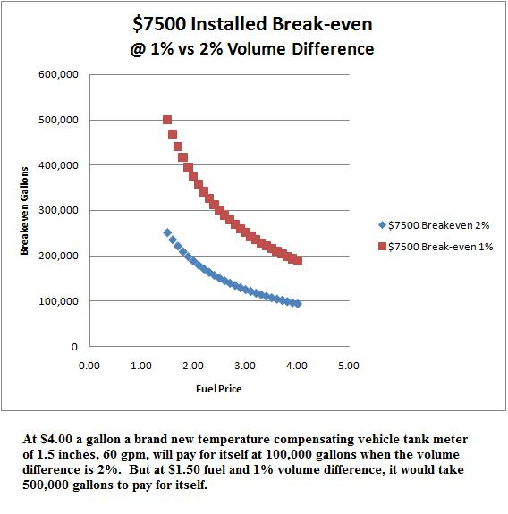

Figure 39 – Breakeven for ATC Devices

Price Rigidity in Remote Barge Communities

Comment was made to the draft report that the remote and risky conditions of barge communities in Alaska deserved particular attention as it pertains to ATC. We observe first that in such a community there is a strong expectation that after the last barge of the season, the price will remain the same until the next barge season. (This period is roughly October through May in Western Alaska)
We accept that as a feature of Alaskan communities with one additional observation: We have to allow that fly-in fuel is available year-round. Although it is more expensive than barging in large quantities generally, under the right conditions flown fuel can be competitive. If wholesale prices drop significantly, fuel flown in December can undercut barged fuel that was stored in September.
In addition when a village really does find itself with a fuel shortage, when the barged fuel will be completely exhausted before break-up, more expensive fuel can be flown in. It is not that the village will have no fuel at all – just very expensive fuel compared to what was sold by barge distributors.
Having said that, a fuel retailer is faced with the following planning problem: there are a number of costs that must be covered through the season. This would include expected loss of every type – fuel handling, sumpage, shrinkage or vapor loss, theft, spills, etc.
The argument goes that a conservative position to take if expected shrinkage is being factored in is to assume a somewhat worse than average amount of shrinkage. So if the average shrinkage from the fuel cooling is 2%, then assume somewhat more than 2%. This results in “over-charging” for shrinkage due to uncertainty under gross gallon sales.
First of all with respect to the value of ATC devices in remote barge areas, note that retail fuel in such communities is at the expensive end of the spectrum. Regardless of the amount of shrinkage, an ATC device pays more quickly wherever price is high. On the other hand it is also more expensive to ship, install and maintain an ATC device in remote Alaska communities.
In the months of October through May we have of course the colder months of the year so the difference between the gross and net gallon is widest. We have a recipe for strong ATC economics as shown in figure 39, despite high installation costs, all things considered. (High prices and large difference between gross and net gallons makes up for higher installation costs). It is easy to see where a 20 cent per gallon margin (or more) to net gallons vs. gross gallons is possible. That is quite a lot in an industry relying on small margins.
Industry officials suggesting the argument did not give examples of what kind of price premium they were expecting to obviate with ATC. It certainly cannot be much relative to the main benefit of selling the smaller gallon. ATC fuel at zero degrees has a 4% size margin advantage over gross gallons. At $7 per gallon the difference is 28 cents per gallon.
We point out that individual retailers do not set the market price. A firm cannot arbitrarily decide to be super-conservative and charge a high price in an environment where other firms are not. If ATC eliminates a risk it has to be something the market is doing as an equilibrium result as opposed to a firm “deciding” what his price will be. Perhaps so. But clearly the main motivation is the profitability of net gallons vis-à-vis gross gallons where consumers are ignorant to the difference.
Bush Alaska is where fuel is the most expensive to transport and where volumes are small. It is where installation of ATC is most costly. We have already observed that ATC devices can be individually profitable (meaning profits of the firm are higher with one than without one) but socially inefficient.
The first conversions to ATC earn a return from a margin gained against its competition not using them. That is true whether it is a Fairbanks heating oil delivery truck one in Unalaska. The last to convert is compelled to because everyone else in the industry is doing it to his disadvantage. Once ATC is universal the playing field is again level and the price is the same with the exception being the cost of the devices where ATC is sold. The consumer will bear that cost.

Bibliography

Access Economics Temperature Correction Consumer Friendly or Consumer Hostile? Prepared for the Australian Institute of Petroleum (1992).
Alaska Department of Labor: Alaska Population By Age, Race Alone and Male/Female, July 1, 2005.Table 1.19 http://almis.labor.state.ak.us/?PAGEID=67&SUBID=171
Alaska Division of Oil and Gas: Annual Report (2007) Section Five, Alaska Refining Sales and Consumption http://www.dog.dnr.state.ak.us/oil/products/publications/annual/report.htm
Alaska State Division of Tax 2008 Annual Report pg 49.
American Society for Testing Materials: Petroleum Measurement Tables, 1952.
Anderson, Ross Director of Weights and Measures, State of New York Comments on Fuel Delivery Temperature Study, Dec 9 2008. http://www.energy.ca.gov/transportation/fuel_delivery_temperature_study/documents/2008-12-09_workshop/comments/Ross_J_Anderson_TN-49465.PDF
Anderson, Ross, Director of Weights and Measures, State of New York. Understanding the Inventory Flow at the Retail Service Station. Jan 25 2009. http://www.energy.ca.gov/transportation/fuel_delivery_temperature_study/documents/2008-03-04_workshop/2008-03-06_ANDERSON_ROSS_UNDERSTANDING_INVENTORY_FLOW_RETAIL_STATION.PDF
Australian Industry Commission Petroleum Products Report No.40, 5 July 1994.
Australian Institute of Petroleum The Temperature Correction of Petrol. Australia 1996.
Butcher, Tina Meter Testing and Corrections – Corrections During Liquid Meter Testing National Institute for Standards and Testing 2006 http://ts.nist.gov/WeightsAndMeasures/upload/B-015.pdf
California Energy Commission: (Schremp and Janusch) Fuel Temperature Delivery Study. Transportation Committee Report. January 2009.
California Energy Resources Conservation and Development Commission: Staff Workshop: Implementation of Assembly Bill 868 Docket No.07-HFS-1: Fuel Delivery Temperature Study Hearing Transcripts Thursday, June 5, 2008
California Energy Resources Conservation and Development Commission Staff Workshop: Implementation of Assembly Bill 868 Fuel Delivery Temperature Study Schremp Presentation (March, 2008)
California Energy Resources Conservation and Development Commission Staff Workshop: Implementation of Assembly Bill 868 Fuel Delivery Temperature Study Schremp Presentation (June 5, 2008)
California Energy Resources Conservation and Development Commission Staff Workshop: Hearing Transcripts (June 5, 2008)
Cleary, Michael (Chairman NCWM) Testimony Before the House Committee on Oversight and Government Reform Subcommittee Domestic Policy: “Hot Fuels – The Impact on Commercial Transactions of the Thermal Expansion of Gasoline. June 8 2007.
Cooley, Hugh V.P. and Gen Mgr Shell Oil Wholesale Division “Written Statement Before the Subcommittee on Domestic Policy of the Committee on Oversight and Government Reform. July 25, 2007.
Consumer Affairs Victoria Volume Correction of Petrol and Diesel Fuel (PW 21533-4257) Victoria 2002.
Davis R, Dickerman J and Radian Corporation, (Sep 1982); Temperature Adjustment of Petroleum Products: Analysis of Data and Issues; pp. 6-15. Prepared for the American Petroleum Institute (API)
Institute for Social and Economic Research, Components of Delivered Fuel Prices in Alaska prepared for the Alaska Energy Authority June 2008.
Institute for Social and Economic Research, Alaska Community Fuel Use prepared for the Alaska Energy Authority October 2008.
Lenard, Jeff “What Consumer Behavior?” NACS Magazine, March 2008, p 16-25: http://www.nationalpaymentcard.com/releases/03-08_NACS.pdf
Mattimoe, George: Intellectually Dishonest Myth Regarding Accurate Delivery of a Gallon of Gas. Paper submitted to the California Energy commission, Jan 2009. http://www.energy.ca.gov/transportation/fuel_delivery_temperature_study/documents/comments/2009-01-13_George_Mattimoe-Intellectually_Dishonest_Myth_Re_Accurate_Deliver_of_a_Gallon_of_Gas_TN-49799.PDF
Measurement Canada Information Bulletin – Automatic Temperature Compensation and the Retail Sale of Gasoline and Diesel Fuel http://www.cbc.ca/consumers/market/files/cars/gasprice/faq.html
Measurement Canada: Policy on Use of Automated Temperature Compensation. 12/15/2008. http://www.ic.gc.ca/eic/site/mc-mc.nsf/eng/lm00106.html
Murphy, Kevin M., Topel, Robert H. White Paper: “Comments on the California Energy Commission’s Fuel Delivery Temperature Study.” University of Chicago, Jan 2009. http://www.energy.ca.gov/transportation/fuel_delivery_temperature_study/documents/comments/2009-01-12_Kevin_Murphy+Robert_Topel-Comments_TN-49832.PDF
National Association of Convenience Stores: 2008 Gas Price Kit – “Gas Prices are Consumers’ Top Economic Concern” http://www.nacsonline.com/NACS/News/Campaigns/GasPrices_2008/Pages/TopEconomicConcern.aspx
National Association of Convenience Stores: Industry Resources – Motor Fuels Sales at Convenience Stores. http://www.nacsonline.com/NACS/News/FactSheets/Pages/MotorFuels.aspx
National Conference on Weights and Measures: Automatic Temperature Compensation Steering Committee Progress Report Albuquerque, NM. (Power Point) Jan 28, 2008.
National Conference on Weights and Measures – State Survey on ATC http://www.ncwm.net/events/atc2007/States_Survey_On_ATC.doc
National Engineering Laboratory, Glasgow UK: Temperature Compensation of Liquid Fuels, a Study for the National Weights and Measures Laboratory, Teddington Middlesex, Project NWM006, July 1999.
Northern Economics Port of Anchorage Consolidation and Distribution Concept Feasibility Study prepared for Anchorage Economic Development Corporation, April 2006. http://www.muni.org/iceimages/port/AEDCBargeRepor4-20-06.pdf
Paton, R. and Boam, D. UK National Weights and Measures Temperature Compensation of Liquid Fuels Project No: NWM006; Report No: 184/99). Teddington, Middlesex: United Kingdom. National Weights and Measures Laboratory. (1999).
Suiter, Richard: Weights and Measures Program Coordinator National Institute of Standards and Technology Testimony Before the House of Representatives Committee on Oversight and Government Reform Subcommittee on Domestic Policy “Hot Fuels – The Impact on Commercial Transactions of the Thermal Expanse of Gasoline. June 8, 2007.
U.S. Bureau of Labor Statistics: State Occupational Employment and Wage Estimates http://www.bls.gov/oes/current/oessrcst.htm
U.S. Census Bureau. Current Population survey, Annual Social and Economic Supplement, 2005.
U.S. Energy Information Agency: Alaska Prime Suppliers Sales Volumes http://tonto.eia.doe.gov/dnav/pet/pet_cons_prim_dcu_sak_a.htm
U.S. Energy Information Agency State-Level Energy Consumption, Expenditures, and Prices, 2005 Table 1.6. Location: http://www.eia.doe.gov/emeu/aer/overview.html
U.S. Energy Information Agency: Petroleum Data Methodology http://www.eia.doe.gov/pub/oil_gas/petroleum/data_publications/petroleum_marketing_annual/current/pdf/enote.pdf
U.S. Government Accounting Office Stakeholder Views on Compensating for the Effects of Gasoline Temperature on Volume at the Pump – Report to the Chairman, Committee on Science and Technology, House of Representatives. Sept, 2008. http://www.gao.gov/new.items/d081114.pdf

Victoria Consumer and Business Affairs: Regulatory Impact Statement – Temperature Compensation of Petrol and Diesel Fuel, Nov. 2001
Victoria Office of Regulation Reform Regulatory Impact Statement: Temperature Compensation of Petrol and Diesel Fuel Victoria 2001.

Appendix 1

Temperature Data Analysis for Refineries, Tank Farms and Underground Tanks PLEASE REFER TO FILE Appendix 1 Alaska Fuel Metering Project

Appendix 2

Benefits Computations for ATC Regulatory Regimes PLEASE REFER TO FILE Appendix 2 Alaska Fuel Metering Project

Appendix 3

Estimated Fuel Use for Heating and Electricity Production PLEASE REFER TO FILE Appendix 3 Alaska Fuel Metering Project

Paton, R. and Boam, D. UK National Weights and Measures (1999), p 2.
There is a method of metering (mass flow metering) that is technically capable of determining the weight of fuel delivered – but it is much more expensive per unit.
http://www.energy.ca.gov/transportation/fuel_delivery_temperature_study/documents/2008-12-09_workshop/comments/Ross_J_Anderson_TN-49465.PDF
The National Institute of Standards and Technology (NIST) produces regulatory language for states that is often adopted (Alaska is one of those). Handbook 44 contains provisions pertaining to liquid measures of concern in this report.
Comment on the draft report questioned how tolerances specified in volume can be translated into temperature differences. It is through the temperature-volume expansion coefficient.
http://www.ic.gc.ca/epic/site/mc-mc.nsf/en/lm01094e.html Note: Between the time of initial literature review and final drafting of this report the information bulletin appears to have been superceded by a Policy Statement.
It is noted by Northern Economic Research Associates (NERA) that this witness did make generalizations that were untrue about the status of state laws and that the testimony of the NIST was more accurate on that subject.
http://www.ic.gc.ca/eic/site/mc-mc.nsf/eng/lm00106.html
Ibid – See section 3.0 “Background”.
This seems to be an ambient average rather than the underground fuel temperature average, which can be deduced by comparing the California section pertaining to Hawaii and the submission by Mr. Mattimoe.
http://www.energy.ca.gov/transportation/fuel_delivery_temperature_study/documents/comments/2009-01-13_George_Mattimoe-Intellectually_Dishonest_Myth_Re_Accurate_Deliver_of_a_Gallon_of_Gas_TN-49799.PDF
http://www.gao.gov/new.items/d081114.pdf
Passages from Dickerman and Radian (1982) p 6-15.
Access Economics (1992), p 4.
AIP(1996), p 1.
Industry Commission; (1994) p.243
Correspondence with Kevin Murphy March 13, 2009
Their analysis assumed for example that in the summertime people overestimated the energy content of gasoline. But an automobile cannot misperceive energy content. So regardless of what consumers perceive, the car cannot go further than the gasoline allows. So consumers must either adjust their perceptions about fuel content, or else budget constraints force them to curtail expenditures on all things, including gasoline (referred to as an “income effect”). So to the extent we claim gasoline is “overpurchased” with incorrect perceptions, reality nevertheless ameliorates those incorrect perceptions in some way.
AB 868 Fuel Delivery Temperature Study Staff Workshop California Energy Commission June 5, 2008 Gordon Schremp Fuels and Transportation Division pg 39
Transcripts from Staff Workshop before the California Energy Resources Conservation and Development Commission in then matter of: Implementation of Assembly Bill 868 Docket No. pg 130 onward
Ibid pg 8.
Ibid pg 146.
http://www.nist.gov/testimony/2007/rsuiter%20hover-govt%20subc%20dom%20pol%206-8-07.htm
The expansion coefficients for these products are an order of magnitude more than that for gasoline or fuel oil. In such cases temperature compensation has a much more pronounced effect in moderating variation amongst retailers when temperatures vary.
See Kucinich’s June 25 testimony: http://domesticpolicy.oversight.house.gov/documents/20070725132158.pdf
Ibid Pg 55, 56
The State DOG report, p 5-6, discusses the major discrepancy between state tax sources and federal data – international flight refueling. But there is clearly more than this.
ISER Fuel Price Components p 15.
The amount of finished product is not quite clear in the State DOG report
Elsewhere, including the report being referred to, a 210,000 barrel per day capacity is cited.
P 5-2 Alaska Refining. Alaska State DOG 2007 Annual Report
http://tonto.eia.doe.gov/dnav/pet/pet_cons_prim_dcu_sak_a.htm
The division did not report quantity of tax receipts nor imputed quantity of off-road diesel sales in the annual report. The tax is 2 cents per gallon.
General Howie Chandler, Commander of Pacific Air Forces, quoted in Fairbanks Daily News Miner July 19, 2008 http://newsminer.com/news/2008/jul/19/funding-biomass-fuels-may-be-hurdle/
This figure includes energy from all sources including hydro and natural gas, but even accounting for that seems to indicate this figure is high relative to the Alaska Prime Suppliers EIA data. The BTU figure cited there is actually for the fiscal year 2004
Interview with Dave Adam, Evert’s Air Fuel Feb 24, 2009.
The state data is for FY 2008 whereas the federal data are for calendar year 2007. So they overlap by six months and there can’t be this much difference.
It should be remembered that the tolerance specifications for temperature compensation mean in effect we cannot even measure differences in fuel temperatures accurately enough at delivery to make a practical difference until fuels vary by more than a few degrees.
http://www.ncwm.net/ppt/steering_committee_interim_report_2008.ppt
See Appendix 2 for derivations
See Appendix 2
This phenomenon is called an “income” effect. It causes demand to shift right in their analysis in the wintertime, and demand to shift left in the summertime, working against the underconsumption in winter and overconsumption in summer. The magnitude of the effect depends on the size of fuel purchases in the budget of consumers.
Consumer surplus is the idea that consumers receive more in value from the purchase of a product than they pay in price. People understand that when a good is put on sale they receive an extra benefit if they would have purchased the item at the old price anyway: consumer surplus is larger. On the other hand if the price increases from its previous level they may still purchase the good, but they are not as well off as before on balance. Consumer surplus is lower.
In the case of #2 fuel oil there are additives that help prevent gelling at low temperatures. The problem is apparently more significant in the dispensing mechanism rather than in the tank itself.
The assumption of uniform distribution for temperature variations is also clearly a best case for ATC since we can see that temperature variations are more likely to follow a bell-shaped curve about the mean. Small variations are much more likely than large variations from the mean.
http://www.bls.gov/oes/current/oessrcst.htm
This seems to raise the question about the variability of ATC deliveries in small retail quantities – whether it is slightly beyond that of the tolerance specifications mentioned elsewhere in this report. For if satisfying those tolerance specifications requires a preliminary flow of fuel this large first, then it seems logical that without the preliminary flow the delivery would be a slightly different quantity.
Alaska charges a registration fee of $19 per retail device whereas in California it is determined by counties, with a maximum of $1,000 under state law. Only one California county example was given at $100 per station plus $20 per dispenser. Discussions with Alaska Weights and Measures Staff indicates Alaska fees do not cover expenses fully as in the case of California counties.
ASTM-IP Petroleum Measurement Tables 5 and 6 are described here.
These were from the Doyle data set. It contained invoices with API values from the Nikiski refinery
http://www.nacsonline.com/NACS/News/Campaigns/GasPrices_2008/Pages/TopEconomicConcern.aspx
http://www.nacsonline.com/NACS/News/FactSheets/Pages/MotorFuels.aspx
International Aviation Services at the Anchorage International Airport – nearly a billion gallons in 2008.
Because Mr. Anderson in his comments above to the California Commission did not work out an example, he deduced that “if retailers were buying net and selling gross they would be amassing surpluses.” It was correct to deduce that inventory reconciliation would be a problem, but did not have the direction correct.
The comment was made to the draft report that notwithstanding the accounting clarifications here, firms lost money by “buying net and selling gross. At the risk of being repetitive, this position requires nonsensical accounting. If this argument is to be made coherently it has to demonstrate its merit with a month-to-month inventory reconciliation example, as here.
One of the notable observations in that report is that barge costs are about the same between a place such as Unalaska and Seattle vs. Unalaska and Cook Inlet, despite the difference in distance and time. The deciding factor is not shipping costs, but rather the price of fuel.
Pg 47 and pg 49. Note that the amount of taxes collected are in reality slightly different from the number of gallons times the tax rates. This is because refunds from a previous period are being received as taxes are remitted for a current period.

