The Report of the

Professional Development Committee (PDC)

Stacy Carlsen, Chairman

Marin County Weights and Measures

Novato, California

Reference

Key Number

###### INTRODUCTION

This is the report of the Professional Development Committee (hereinafter referred to as the “Committee” or PDC) for the 96th Annual Meeting of the National Conference on Weights and Measures (NCWM). This report is based on the Interim Report offered in the NCWM Publication 16, testimony heard at public hearings, comments received from the regional weights and measures associations and other parties, the addendum sheets issued at the Annual Meeting, and actions taken by the membership at the voting session of the Annual Meeting. The Informational items presented below were adopted as presented when the Committee’s report was approved.

Table A identifies the agenda and appendix items. Agenda items are identified in the Report by Reference Key Number, Item Title, and Page Number. Item numbers are those assigned in the Interim Meeting agenda. A Voting item is indicated with a “**V**” after the item number. An item marked with an “**I**” after the reference key number is an Informational item. An item marked with a “**D**” after the reference key number is a Developing item. The developing designation indicates an item has merit; however, the item was returned to the submitter for further development before any action can be taken at the national level. Table B lists the results of any voting items.

**Table A**

**Index to Reference Key Items**

**Reference**

**Key Number Title of Item Page**

400 INTRODUCTION PDC - 1

401 EDUCATION PDC - 2

401-1 I National Certification Program (NCP) PDC - 2

401-2 I Instructor Improvement PDC - 11

401-3 I Recommended Topics for Conference Training PDC - 12

402 PROGRAM MANAGEMENT PDC - 14

402-1 I Safety Awareness PDC - 14

402-2 I PDC Publication PDC - 15

**Appendices**

A [NCWM Curriculum Work Plan PDC - A1](#AppendixA)

B Package Checking Segments (Draft) PDC - B1

C Converting Technical Content to Training Material PDC - C1

**Table B**

**Voting Results**

|  |  |  |  |  |  |  |  |  |
| --- | --- | --- | --- | --- | --- | --- | --- | --- |
| ***Reference Key Number*** | | ***House of State Representatives*** | | | ***House of Delegates*** | | ***Results*** | |
| ***Yeas*** | | ***Nays*** | ***Yeas*** | ***Nays*** |
| No Voting items | |  |  |  |  | |  |

**Details of All Items**

(In Order by Reference Key Number)

###### 401 EDUCATION

401-1 I National Certification Program (NCP)

**Source:** Carry-over Item 401‑1. (This item originated from the Committee and first appeared on its Agenda in 2003.) The Committee has combined items previously numbered as Item 401-1 National Certification Program (NCP), Item 401-2 Create a Curriculum Plan, and Item 401-4 Certification into one item covering all aspects of the Certification Program.

**Background/Discussion:** For complete background information, see the Professional Development Committee (PDC) page or the PDC meeting archives on the NCWM website ([www.ncwm.net](http://www.ncwm.net)), or the previous Committee reports available from the National Institute of Standards and Technology (NIST) website (http://www.nist.gov/pml/wmd/pubs/index.cfm).

The Committee set a goal at the 2009 Annual Meeting to conduct an on-line beta test on the retail motor fuel curriculum. The beta test is completed and the results reviewed and analyzed.

**Results:**

* 63 took exam/43 completed exam/20 timed out and did not receive a score.
* 6 passed with passing set at 85 %.
* 20 would have passed if passing were set at 75 %.
* 27 would have passed if passing were set at 70 %.

**What did the results show about the exam process itself?**

* The settings of the service caused a large number of people to time out. Each section of the test was timed. Any remaining time from one section could not be added to the next sections, but the instructions did not make that clear to the candidates. In addition, if candidates timed out in the first section, they were not allowed to continue to the other sections. The NCWM staff has corrected this. In the future, if a candidate times out on a section, the candidate will just progress to the next section or the test will end. The candidate will receive the score for all questions answered correctly.
* Some candidates had web navigation issues. It was difficult or impossible to use an electronic version of Handbook 44 (HB 44) as a reference while taking the test. Reviewing past answers was cumbersome because the candidates were required to page back question by question. There is no solution for this, as this is the way the testing service operates. Candidates should consider using a hardcopy of HB 44 when taking the test.
* The illustration graphic quality needs improvement. We are going to make every effort to provide quality graphics in the first case, and to improve graphics where test results show that improvements are necessary.
* The grading of short answer questions was very intolerant of variations like capitalization and punctuation. The Committee believes that short answer questions are necessary to test for the ability to apply code requirements. To help in this regard, the Committee is working on improved instruction on how to take the test. A sample test, which will not be timed or graded, may be built into the test itself. The Committee is also looking at using a pull-down help feature on some questions to aid the candidate in properly formatting the answers.
* Some candidates could not see the entire question without scrolling down. Others experienced difficulty seeing the graphics. These problems relate to the candidates’ computer settings, and can be corrected by changing the screen resolution, or by using the zoom function on the bottom of the Internet browser. The graphics can be seen by adjusting the candidates’ browser security settings. The Committee thinks that the sample test can be designed so that the candidate discovers these problems before getting to the real test. The candidate will then have the opportunity to leave the exam and make the needed setting changes or consult with information technology (IT) specialists as needed. In addition, a guide to taking the NCWM certification tests could be written addressing frequently asked questions (FAQs) that arise out of taking the tests.

**What did the results show about the exam content?**

* The Committee analyzed the scoring versus the elapsed time on each section and found that 16 of the 20 people, who timed out on the test, did so on the first section, relating to general HB 44 questions. Three people timed out in the general liquid measuring section, and only one person timed out on the retail motor fuel device (RMFD) section. The Committee will be adjusting the timing by taking five minutes off the RMFD section, and adding it to the HB 44 section. The Committee also expects that timeout problems will decrease as candidates become accustomed to taking tests with timed sections.
* Questions with high error rates and low average times were identified as problem questions. People thought they knew the answers, as evidenced by the quickness of their responses, but the error rate indicates that something is potentially wrong with those questions. Questions with high error rates and long response times will also be subject to review to determine whether they exceed the learning objectives.
* Ms. Georgia Harris, NIST Weights and Measures Division, assisted the Committee with information on ISO 17204, which is the ISO guide for certification bodies. One component of this guide is analysis of the cut score that defines the passing grade. A wealth of information exists on setting the cut score to define the minimally competent person. The competent group includes individuals at the basic, proficient, and advanced levels. The Committee wants to ensure that the candidate at the bottom of the basically competent group has a reasonable chance of passing the test. Based upon the results of the beta test, the Committee thinks that the cut score for the RMFD test should be set at either 70 % or 75 %.
* Future tests will require similar question evaluation and cut score analyses; that will require staff resources to coordinate the review of questions and tests.

**Using what was learned from the beta exam, the Committee:**

* made changes to the time allocation on the test;
* adjusted the passing score;
* rewrote or eliminated problem questions;
* wrote a practice test which is included as an option on the exam site; and
* updated the instructions for taking the test.

The revised RMFD exam was made available November 1, 2010. As of January 1, 2011, 22 individuals had taken the exam 28 times resulting in 21 certifications issued. This indicates that some took the test more than once to achieve a passing score. The average passing score was 82 %.

The Committee received an update on the RMFD Certification exam covering results from November 2010 to July 1, 2011. Since the NCWM Certification Program went active on the Retail Motor Fuel Device exam in November 2010, there have been 49 completed exams. The overall results appear below. The median score for passing candidates was 82 % (with 70 % minimum score to pass). The high score thus far was 98 %. The Committee is pleased to see these results, as they support our expectations based on the analysis of the beta exam. Most importantly, we can see the separation between those that passed and those that failed.

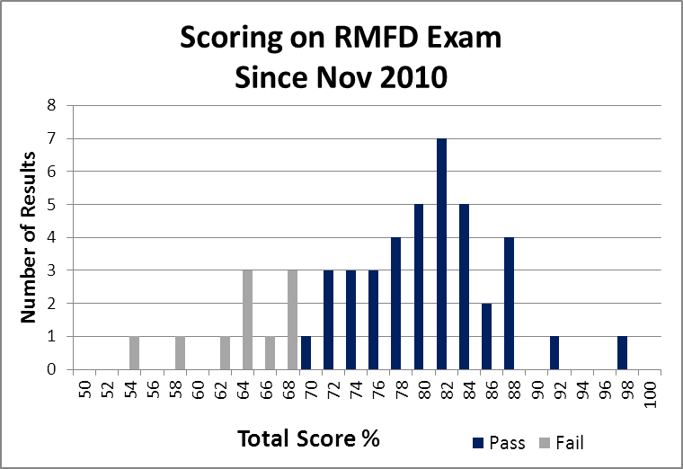

The critical role of the certification exam is not to showcase your successful candidates, but rather to separate the “minimally qualified candidate” from those that are not qualified. Our focus has to remain on the 70 % dividing line, to see if we can see the formation of two distributions; one for the passing candidates and one for the failing candidates. While we only have 10 failing candidates, it does appear that we are getting that separation.

The analysis also looked at scoring on each of the three parts of the exam. The two parallel graphs below present a comparison of the scoring by the passing candidates versus the failing candidates. The Committee sees the clear separation of those two categories in our exam. We see a normal bell curve appearing for the passing candidates, but see scoring well below the 70 % passing score and wide variation with the failing candidates.

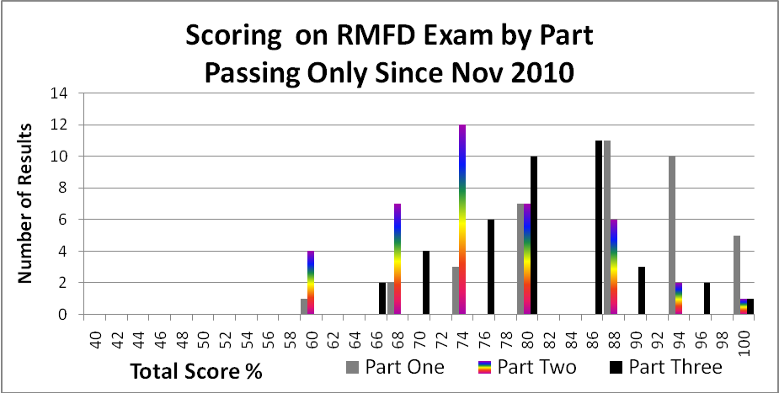

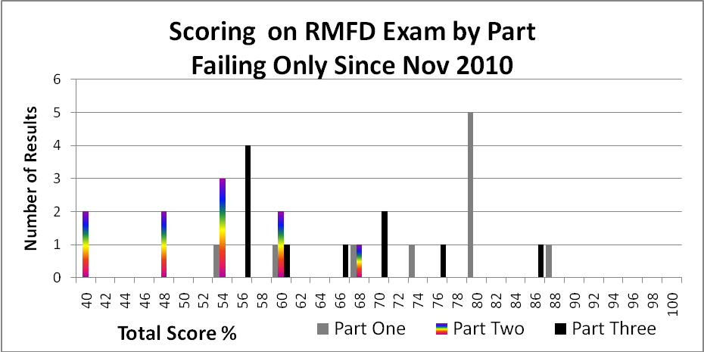

**What did the result show about the Committee’s plan for certification?**

The low passing rate on the beta exam may indicate that parts of the system are not working together. It is important that users of the NCWM Certification Program understand how the pieces fit together and form a coherent system. To illustrate the relationships we can describe the system as a triangle of interdependent parts (see diagram below). The standards come in the form of goals with measureable learning objectives. The education part involves training provided to help the candidate reach the desired level of proficiency for each of the learning objectives. The certification involves an assessment of proficiency that measures whether or not the objectives have been met.

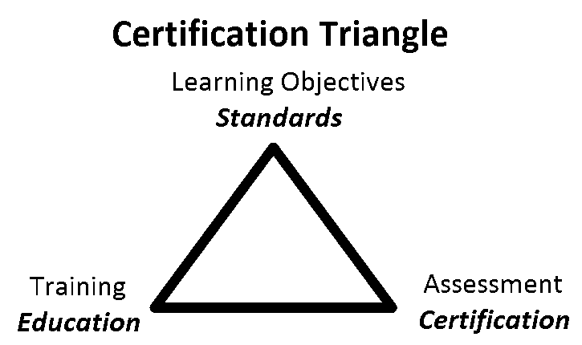

The Committee has until now focused attention on the standards and the certification pieces in the triangle as illustrated in the flowcharts below.

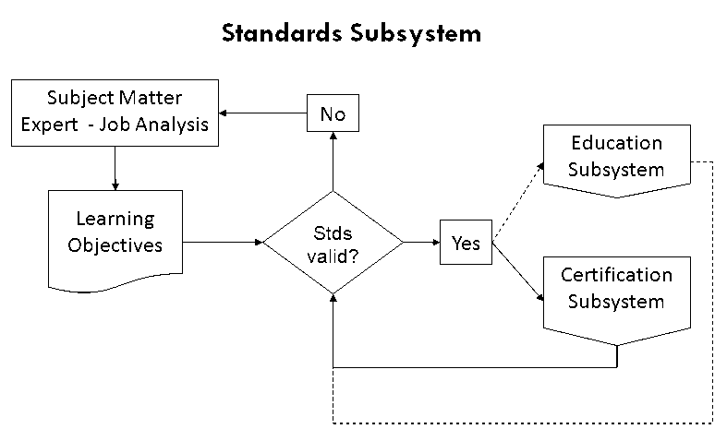

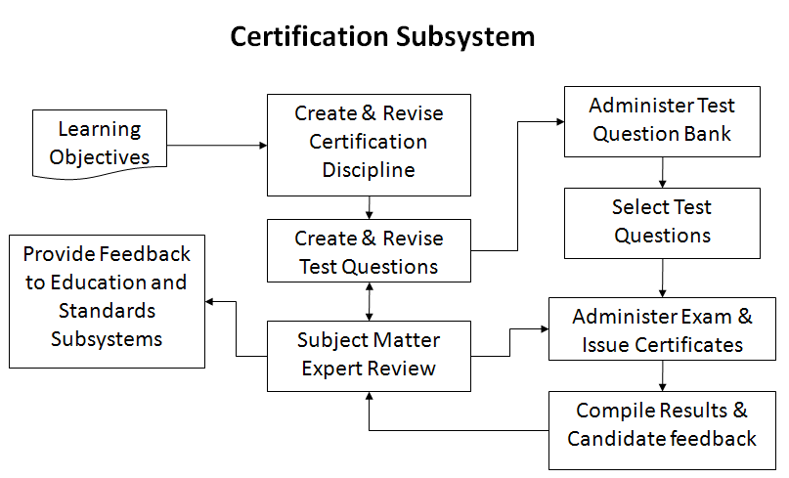

The Committee has described this work in a number of documents. Ms. Carol Hockert, NIST WMD has indicated that the partnership between NCWM, the states, and NIST WMD will benefit from consistency in the terms we use in our training/certification programs, and that the terms the Committee are using are not consistent with current usage in the education field. Therefore, the Committee has resolved to revise some of the terminology we use in our program. Changes to terminology are listed below.

**Body of Knowledge** (replaces “curriculum”) – refers broadly to the knowledge and skills required to function as a Weights and Measures Professional. The term or its acronym “BOK” may refer broadly to the entire scope of knowledge and skills required within the profession, or in a more directed manner to any selected subset for which the particular person is responsible. The BOK describes *what* you expect the Weights and Measures Professional to achieve, as opposed to, *how* he/she will achieve it. To make the BOK more manageable in administration of the National Certification Program, it will be subdivided into Modules in a tree-like structure moving from general knowledge and skills to more specific areas.

**Module** (formerly “curriculum segment”) **–** refers to a group of related subject materials within the BOK. The module contains the articulated learning objectives for the subject area. Each module can be thought of as a single, self-contained course of study. However, a broader course may span multiple modules, and refreshers, seminars, etc. may include only part of a module or parts of multiple modules. The PDC Committee has created a standard format to create modules for the NCWM National Certification Program. The Committee has also created the Curriculum Outline and Workplans to help manage the work activities within the program, to create the many modules necessary to cover the entire profession.

**Learning Objective** (formerly “outcome” or “milestone”) – refers to the articulation of expectations of performance in measureable terms. Learning objectives are stated using active terms, so as to be precise and measureable. There are two types of learning objectives, a “terminal objective” and an “enabling objective.” Terminal learning objectives state broadly the expectation of performance. The enabling objectives state the specific parts or steps required to demonstrate competence. The PDC has developed a guide to writing learning objectives of both parts, and this includes the active verbs associated with the cognitive levels in Boom’s Taxonomy. In training, the instructor will typically choose learning activities to explore each of the enabling objectives in an attempt to reach the terminal objective. In assessment, the questions will typically test for competence in each of enabling objectives to demonstrate that the terminal objective has been met.

**Certification** – refers to verification of competence relative to all or part of the body of knowledge for the profession as designated by the PDC for inclusion in a certification exam. The selected body of knowledge using modules is documented in a test description. Each of the modules, or combinations, are given a specific weighting in the design of the test. After obtaining a passing score on the exam, the candidate is issued a certificate stating he/she has met the competency standard.

**Curriculum** – refers to the list of Modules that are used to document the Body of Knowledge.

**Bloom’s Taxonomy –** refers to a classification of higher levels of cognitive learning, widely used in education, in many fields. The levels are knowledge, understanding, application, analysis, integration, and evaluation. The active verbs used in the articulation of learning objectives define the cognitive level. In training, the learning activities are matched to the cognitive level. In assessment, the form of the question is also matched to the cognitive level. The use of Bloom’s Taxonomy is described in detail in the Body of Knowledge Model document.

The Committee has prepared program documents that are available on the NCWM website. These documents will be revised, where required, to reflect the terminology changes in the near future and updated on the website.

* The Curriculum Outline, which breaks the profession of weights and measures into component parts called Modules.
* The Body of Knowledge Model (formerly Core Curriculum Model) explains how to create Modules to document the learning objectives.
* The Modules developed thus far (formerly Curriculum Segments).
* The Certifications developed thus far (formerly Certification Disciplines).

Results of the beta test indicate it will be very important as the program moves forward, that trainers integrate the learning objectives into their materials, and design courses in such a way that students will achieve the desired levels of learning. See Item 401-2 Instructor Improvement.

**Discussion:** At the 2011 Interim Meeting, the Committee addressed the need to build partnerships between the states, NIST, and NCWM. Each group has roles in relation to the Certification Triangle as shown in the following diagram.



Four of the critical elements for continuing development of certification programs are:

* Appointment by the NCWM Board of a Certification Exam Coordinator to ensure the credibility and integrity of the certification process;
* Enlistment of Subject Matter Experts (SME) from states, counties, industries, and NIST to identify the learning objectives for new disciplines, and for writing and reviewing test questions;
* Utilization by the states of the NCWM curriculum standards; and
* Improvement of instructors through training on how to use appropriate learning objectives (NCWM curricula) and adult learning methods.

With regard to the first bullet above, the Committee is pleased to have a staff person working for NCWM to coordinate the National Certification Program. Mr. Ross Andersen, New York State, retired, has been hired on a part-time basis by the Board to coordinate activities within the program in cooperation with the PDC. The following is an excerpt from the NCWM Certification Coordinator contract listing the duties:

1. Act out the duties defined in this contract, the direction of the NCWM Board of Directors, and the work of the Professional Development Committee (PDC) in the development of examination and certification of weights and measures professionals in the areas of small capacity scales, package checking, vehicle tank meters, and other areas as work progresses through the term of this contract.
2. Communicate effectively with the NCWM Executive Director, his staff, the PDC and others toward the successful coordination of efforts.
3. Participate in meetings and work sessions of the PDC when necessary, to the development of examinations for certification.
4. Identify an appropriate number of qualified Subject Matter Experts (SMEs) who will serve as volunteers to NCWM in developing certification exam questions, reviewing questions, and improving questions as necessary. Provide assistance and training to SMEs in performance of their activities.
5. Coordinate the efforts of the PDC, SMEs, and NCWM staff as outlined in Appendix A to this agreement.
6. Establish deadlines for each phase of the project and communicate those deadlines to volunteer leadership.
7. Provide curriculum segments, exam question banks, and beta analysis of test results in an expeditious manner to facilitate growth of the National Certification Program.
8. Provide maintenance analysis of existing exams upon request of the Executive Director.
9. Provide monthly status reports to the Executive Director on progress of each exam that is under development.

With regard to the second bullet, the Committee has developed a guide for Subject Matter Experts (SMEs) to help describe the activities we need them to provide. This document is under final review and will be posted soon on the NCWM website. The Certification Coordinator has enlisted a good number of SMEs to begin work on certification exam questions for the Small Capacity Scales Class III and Basic Package Checking certifications. We are also working to expand our list of state training coordinators, which we use to recruit SMEs to assist us in the program.

In open hearings, the Committee heard comments that local jurisdictions also be asked to provide SME volunteers. The Committee agrees, and will consider avenues to reach out to local jurisdictions. If experts from any jurisdiction or business are interested in volunteering, they can contact the Committee Chair through the PDC page on NCWM’s website.

The Certification segments currently developed (or in development) are:

* Retail Motor Fuels – certification available through NCWM;
* Basic Package Labeling/Checking;

* Small Capacity Scales; and
* Vehicle Tank Meters.

The Committee asked for feedback regarding which of the following segments should be developed next:

* Liquid Petroleum Gas (LPG);
* Large Capacity Scales;
* Taxi Meters; and
* Price Verification.

The Committee received no feedback at the Interim Meeting. Since then, the Committee has received comments from a state police agency in Oregon, asking if the NCWM could create a certification exam for police that use highway weight scales (i.e., wheel-load weighers and portable axle-load scales). The Committee also got a request from the Central Weights and Measures Association (CWMA) to consider creating NCWM certification exams for registered service persons. The problem noted is that our basic competence level in the exams, thus far, has been at the expectation of an employee with one-year experience. The CWMA believes that may not be reasonable for a registered service person. Industries with numerous service agents working across state lines, told the Committee that they saw great benefit in the development of a single exam that would eliminate duplication in testing on technical issues. It was recognized that agents would still have to apply to individual states administratively to get the license, but without the need for additional testing. The Committee also sees the benefit of a single technical exam, but this will require that we get buy-in from the states to accept the NCWM certification. It also means, possibly administering individual state specific exams covering laws and regulations, directed at service agents. We can consider moving down this path if we get some positive feedback from states with registered service persons. The Committee is planning to conduct a survey of the NCWM members on future priorities as we develop future certifications, and will include the issue of registered service agents.

The Committee also sought feedback regarding whether the Package Checking curriculum should stay close to the organization of HB 133, *Checking the Net Contents of Packaged Goods,* as written in Appendix B, or whether it should be re-written to match the organization of the three sections of the test:

* Core Procedure & General Considerations
* Packages Labeled by Weight (Standard & Random)
* Packages Labeled by Volume (Gravimetric & Volumetric)

The major difference between the two is that the core procedure (identifying lot, selecting random samples, testing the samples, and evaluating the results) is included with general considerations in the first section of the curriculum, but is included with Packages Labeled by Weight in NIST Handbook 133, which is the primary reference material.

The Committee received no feedback on this item. The Committee will post the Package Checking curriculum based upon the work of the CWMA PDC. (See Appendix B)

401-2 I Instructor Improvement

**Source:** Carry-over Item 401‑3 (This item originated from the Committee and first appeared on its agenda in 2003.)

**Background/Discussion:** Prior to the 2010 Annual Meeting, Ms. Harris, NIST WMD, provided the Committee with reference material on teaching methods and assessment of training success. Distilling the essence of these materials, the Committee feels that instructors need training in more than just the technical material; they need training in setting the learning objectives, developing the training materials with those objectives in mind, selecting training methods that incorporate adult learning styles, and evaluating the effectiveness of their training.

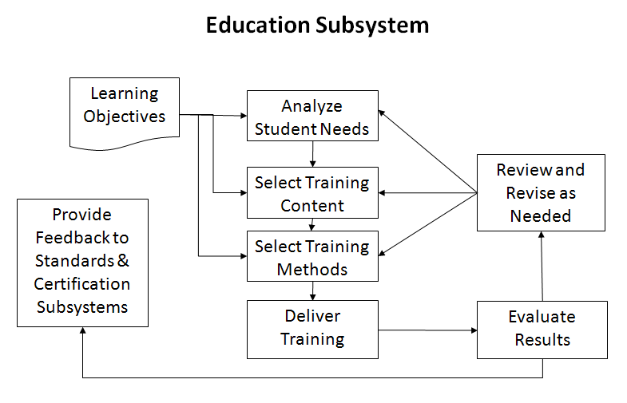

The chart below covers three levels of learning objectives and relates them to the training activities most likely to be successful, and demonstrates best methods for assessing the success of the training. The curriculum segments state the learning objectives using verbs similar to those in the bottom row of the table. These drive both the training activities required to promote adult learning, and the assessment tools appropriate to measure success at that level.

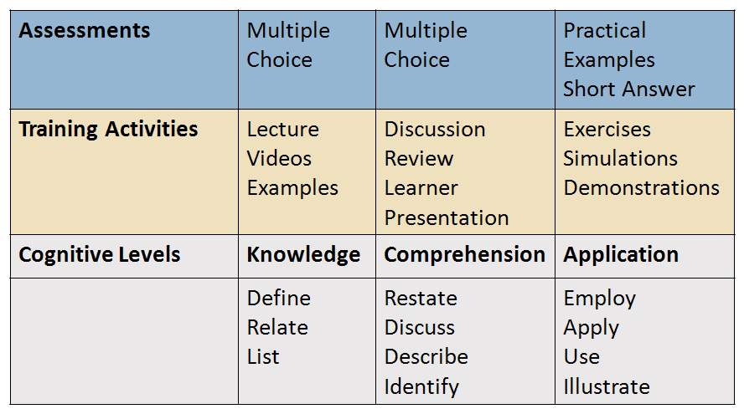

NIST WMD has expressed strong interest in collaborating with the NCWM in efforts to educate instructors in adult learning techniques and relating them to the learning objectives in the NCWM curriculum. Appendix C contains NIST material on converting technical content to training material. The importance of pre-training analysis and post-training evaluation cannot be overestimated. Failure to include these steps often leads to failure of training efforts.



**Discussion:** Ms.Carol Hockert (NIST), commented that NIST and PDC need to work together to clarify training terminology. She also suggests that the PDC needs to communicate with state directors to make sure we know their goals for the certification program, so that we are designing the tests to assess whether they are meeting those goals.

The Committee is calling on the states and other training developers to implement the Analysis, Design, Development, Implementation, and Evaluation (ADDIE) model in their training preparations and post training evaluation. Everyone needs to participate in the development of the curriculum segments, and then encourage their trainers to use them in their training plans.

401-3 I Recommended Topics for Conference Training

**Source:** Carry-over Item 401‑5 (This item originated from the Committee and first appeared on its agenda in 2003.)

**Background/Discussion**: The Board has charged the Committee with responsibility for selecting appropriate topics for the technical sessions at future Annual Meetings. The Board asked that the Committee review and prioritize possible presentations and submit those to the Chairman. The Chairman would then work with NCWM staff to make the arrangements and schedule the sessions.

The Committee continues to carry the following list and recommends these topics for possible training seminars, roundtables, or symposia for presentation at the NCWM meetings:

1. Marketplace Surveys;
2. Alternative Fuels (Fuel Volatility Issues and Ethanol Blending, and Biodiesel Blend Issues);
3. Ergonomics (including Proper Lifting Techniques, Back and Stress Techniques and Office Ergonomics);
4. Public Relations, specifically dealing with aggressive/angry people (recommended by the SWMA);
5. General Safety Issues (recommended by the WWMA);
6. Defensive Driving (recommended by the WWMA);
7. Administrative Civil Penalty Process (recommended by the WWMA);
8. Price Verification (recommended by the WWMA);
9. Customer Service (recommended by the WWMA);
10. Ethics (recommended by the CWMA);
11. Moisture Loss;
12. Economic Justification of W&M Programs;
13. Demonstrating the Value of Enforcement Programs;
14. Training the Trainer in Adult Learning Methods; and
15. Emerging Issues.

The Committee asked for suggestions for future training or recommendation on how to prioritize suggestions already on the list. Based on the needs identified in the first two items (401-1 and 401-2), the Committee would like to recommend that the regional associations and the NCWM consider offering training for trainers on how to identify learning objectives, and design training materials that integrate interactive activities and adult learning styles. NIST has a 1.5-hour course on taking technical material and turning it into a course for adult learners, which may be appropriate to fill this need.

Training Topics already covered may be available on the NCWM website by looking at the meeting archives:

1. Device Inspections Using a Sampling Model (Mr. Henry Oppermann 2010);
2. Corrosion Issues with Low Sulfur Diesel (Mr. Ron Hayes 2010);
3. Diesel Exhaust Fluid (DEF) (Mr. Gordon Johnson, Mr. Randy Moses 2009);
4. Alternative Fuels (Fuel Volatility Issues and Ethanol Blending, and biodiesel blend issues) (Mr. Ron Hayes 2009);
5. Investigative Techniques (Mr. Michael Cleary 2009);
6. Automatic Temperature Compensation (ATC) Analysis of Testing Data (Mr. Henry Oppermann 2008);
7. Effective Safety & Health Program (Mr. Dan Whipple 2008);
8. Handbook 44 Scale Code Tare Changes (Mr. Steve Cook);
9. Automatic Temperature Compensation Issues (Mr. Henry Oppermann and Mr. Ross Anderson 2007);
10. Analyzing Inspection Data (Mr. Henry Opermann and Mr. Steve Malone 2007);
11. Grocery Unit Pricing in the United States (Mr. David Sefcik, NIST WMD and Mr. Ian Jarratt, Queensland Consumer Association, Australia 2011); and
12. Hydrogen Measuring Systems: The Turning Point? (Ms. Kristen Macey 2011).

**Discussion:** At the 2011 Interim Meeting,comments were heard from Mr. Brett Gurney, Utah, that all stakeholders need training on how to demonstrate the value of our enforcement programs to administrative/legislative levels above us.

Mr. Oppermann suggested a topic of “Economic Justification of Weights and Measures Programs” using data from the latest census in conjunction with compliance data gathered before and after the end of a program or the installation of a new program.

**WWMA Discussion:** The PDC solicited topics from the WWMA for future conference training. The Committee recognized a need for promoting the value of our programs to stakeholders. Stakeholders include, but are not limited to, executive administrators, elected officials, and the public. During challenging economic times, it is critical that Weights and Measures maintain a strong presence in the marketplace. The NIST, WMD Chief suggested a session to teach trainers how to teach. The WWMA PDC sees a benefit in this type of training for developing presentation skills. The WWMA Board of Directors has recommended that the PDC develop a shared calendar of scheduled training events available to other jurisdictions. The WWMA Board of Directors has suggested that training be conducted, concurrent with, but independent of, the national and regional meetings. This training would utilize the same facilities and could allow for additional savings when negotiating conference locations. This would allow exposure to weights and measures officials that would not normally be able to attend conferences.

The WWMA PDC suggested topics are train the trainer and those topics that would promote Weights and Measures Programs to the stakeholders. One recommended format would be to facilitate a round table to identify success stories and best practices from weights and measures jurisdictions. The WWMA PDC recommends that the NCWM develop a shared calendar of scheduled training and consider scheduling training in conjunction with conferences.

###### 402 PROGRAM MANAGEMENT

402-1 I Safety Awareness

**Source:** Carry-over Item 402‑1 (This item originated from the Committee and first appeared on its agenda in 2003.)

**Background/Discussion:** In the past, the Committee’s responsibility extended to the identification of safety issues in the weights and measures field, and included efforts to increase safety awareness. Jurisdictions are encouraged to send their safety reports and issues to their regional safety liaison, who in turn will forward them to the PDC. Below is a list of the Regional Safety Liaisons.

SWMA Mr. Steve Hadder, Florida Department of Agriculture and Consumer Services

WWMA Mr. Douglas Deiman, Alaska Division of Measurement Standards/CVE

CWMA Ms. Julie Quinn, Minnesota Department of Commerce

NEWMA Mr. Michael Sikula, New York Bureau of Weights and Measures

The Committee will continue to ask the regions to prepare articles for the NCWM newsletter, and have revised the schedule as follows for future issues. The Committee plans to notify the Regional Safety Coordinators as their assignment date approaches.

|  |  |  |  |
| --- | --- | --- | --- |
| **Association** | **Issue** | **Publication Date** | **Article Deadline** |
| CWMA | 2011, Issue 3 | September | July 15, 2011 |
| NEWMA | 2012, Issue 1 | February | January 16, 2012 |
| SWMA | 2012, Issue 2 | June | April 16, 2012 |
| WWMA | 2012, Issue 3 | September | July 16, 2012 |

E-mail all articles to the NCWM headquarters at [info@ncwm.net](mailto:info@ncwm.net).

The Committee would like to thank those persons who submitted safety related articles to the NCWM Newsletter. In particular, the Committee recognizes the three contributors thus far, for the 2011 NCWM Newsletters.

* Consumer Tips for Proper Gasoline Handling, 2011 Issue 1 (Mr. Steve Hadder, Florida)
* Vehicle Safety Issues for Weights and Measures Inspector, 2011 Issue 2 (Mr. Douglas Deiman, Alaska)
* Controlling the Risk of Solitary Workers, 2011 Issue 2 (Mr. Brett Gurney, Utah).

The Committee asks for suggestions for safety articles people would like to see in future newsletters, and/or safety issues that need to be addressed immediately. They would like to remind regional associations to check the submission deadlines for their upcoming article assignments. Send completed articles to NCWM headquarters by the submission deadline.

The Committee received a request during the work session that the publication dates be kept current in this ongoing item.

402-2 I PDC Publication

**Background/Discussion:** The Committee is updating the National Certification pages on the website. These website changes will be demonstrated at the 2011 Annual Meeting. The three main sections of material include:

1. Program Administration – combines historical documentation (curriculum outline and work plan, etc.) with administrative procedures on administering exams and records of certifications;
2. Competency Standards – includes the curriculum segments that describe the objectives and measurable competencies that will be used in certification; and
3. Certification Disciplines – includes one document per certification area, delineating the standards from the curricula that will be covered in the exam and the weighting of the competencies.

All segments of the PDC publication will be posted online as they are developed. New pages within the NCWM website will be created for the curriculum disciplines and segments, so that interested parties can easily find and utilize this material.

At the 2011 Interim Meeting, no comments were received from the floor.

The Committee is in the process of revising its pages on the NCWM website. Some of the changes will include the new terminology (see Item 401-1). In addition, the Committee believes it is vital to move forward with a more formal set of administrative procedures for running a credible certification program. The Committee will be making efforts to continue work done by Mr. Michael Sikula, New York, at the request of the Board, to document our procedures following ISO 17024 guidelines for Certification Bodies.

Mr. Stacy Carlsen, Chair, Marin County, California

Ms. Julie Quinn, Minnesota

Mr. Dale Saunders, Virginia

Ms. Cheryl Ayer, New Hampshire

Mr. Steven Grabski, Walmart

**Professional Development Committee**

THIS PAGE INTENTIONALLY LEFT BLANK

**Appendix A**

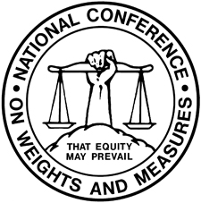

**National Conference on Weight and Measures**

**National Certification Program**

**NCWM CURRICULUM WORK PLAN**

*Revised January 2010*

**Segment/Subject**

**Level 1/Level 2/Level 3**

1. **Fundamentals of Weights and Measures**
   1. Introduction to Weights and Measures Programs
   2. W&M Laws and Regulations
   3. Field Standards and Test Equipment
   4. State Program Scope and Overview
   5. Enforcement Powers
2. **W&M Administration**
   1. Fundamentals of W&M Administration (Commercial System, Powers and Duties, etc.)
   2. Administration Functions (Personnel, Management, Budget, Safety, etc.)
   3. Legislation and Regulations (Legal Considerations, Interaction with Legislature, Stakeholders, Industry, etc.)
   4. Regulatory Control (Device Inspection, Commodities, Complaints)
   5. Laboratory Metrology Administration (Purpose of Laboratory, Responsibilities of Metrologist, NIST Expectations for Recognition of Laboratory, Quality System, Training Requirements, etc.)
   6. Public Relations and Communications (Publicity, Public Relations, Communications)
3. **Laboratory Metrology**
   1. NIST Basic Metrology
   2. NIST Intermediate Metrology
   3. NIST Advanced Metrology
4. **Device Control Program**
   1. Safety Considerations
   2. NIST Handbook 44 – Introduction to Device Control
   3. Weighing Systems, General
      1. Static Electronic Weighing Systems, General
      2. Static Mechanical and Hybrid Weighing Systems, General
      3. Dynamic Weighing Systems, General
      4. Precision Weighing Systems Class I and II
      5. Small Capacity Weighing Systems Class III
      6. Medium Capacity Weighing Systems Class III
      7. Large Capacity Class III and IIIL Weighing Systems (Vehicle and Livestock)
      8. Large Capacity Class III and IIIL Weighing Systems - Advanced
      9. Railroad Track Weighing Systems
      10. In-Motion Railroad Track Weighing Systems
      11. Hopper Weighing Systems
      12. Automatic Bulk Weighing Systems
      13. Automatic Weighing Systems
      14. Belt Conveyor Weighing Systems
      15. In-Motion Monorail Weighing Systems
      16. Point-of-Sale Weighing Systems
      17. Other Specialty Weighing Systems
   4. Dynamic Measuring Systems – General
      1. Retail Motor Fuel Dispensers
      2. Loading Rack and Other Stationary Metering Systems
      3. Loading Rack and Other Stationary Metering Systems – Advanced
      4. Vehicle-Tank Meter Systems
      5. Vehicle-Tank Meter Systems – Advanced
      6. Milk Metering Systems
      7. Water Meters
      8. LPG/Anhydrous Ammonia Liquid Metering Systems
      9. LPG/Anhydrous Ammonia Liquid Metering Systems – Advanced
      10. LPG Vapor Meter Systems
      11. Mass Flow Metering Systems
      12. Other Metering Systems (Cryogenics, Carbon Dioxide, etc.)
   5. Static Volume Measuring Systems – General
      1. Liquid Measures
      2. Farm Milk Tanks
      3. Dry Measures
   6. Other Measuring Systems
      1. Taximeters and Odometers
      2. Wire and Cordage Measuring Systems
      3. Linear Measures
      4. Timing Devices
      5. Weights
      6. Multiple Dimension Measuring Systems
   7. Quality Measuring Systems
      1. Grain Moisture Meters
      2. NIR Grain Analyzers
      3. Carcass Evaluation Systems
5. **Market Practices, Laws and Regulations (NIST HB 130) and Commodities (NIST HB 133)**
   1. Safety Considerations – Market Practices, NIST Handbook 130, NIST Handbook 133
   2. NIST Handbook 130 – Laws and Regulations
      1. NIST Handbook 130 – General Provisions
      2. Packaging and Labeling Regulations
      3. Method of Sale Regulations
      4. Quality of Automotive Fuels and Lubricants
      5. Price Verification
   3. NIST Handbook 133 – Package Net Contents Control
      1. Commodities – General
      2. Packages Labeled by Weight, Standard and Random
      3. Packages Labeled by Weight, Special Commodities
      4. Packages Labeled by Volume (Volumetric and Gravimetric Testing)
      5. Packages Labeled by Volume, Special
      6. Packages Labeled by Length/Area/Thickness
      7. Packages Labeled by Count
      8. Other Package Types
   4. Test Purchases
   5. E-Commerce

**Note:** Initial Verification has been intentionally been left off this listing and will be addressed later.

**Appendix B**

**Packaging Checking Segments (Draft)**

**National Conference on Weights and Measures**

**National Certification Program Curriculum**

**Segment 5.3.1**

**Commodities - General**

Overview and Scope

This segment sets standards for basic inspection and testing for checking the net contents of packaged goods. The segment is geared toward general and basic concepts that can be applied to all package checking. These concepts include such basics as selecting the point of enforcement; understanding lots, package requirements, and moisture allowances; choosing and applying sampling plans; identifying the jurisdictions of other regulatory agencies responsible for package regulations and requirements; and utilizing good measurement practices including the care and use of standards.

Prerequisites:

* None

Objectives and Competencies

1. When and Where to Use Package Checking Procedures

A weights & measures inspector should understand the principles of when and where to use package checking procedures. To demonstrate that understanding the inspector can:

* + List the types of products which may be tested;
  + Describe how marketplace surveys, sales volume surveys, and audits influence decisions on where to concentrate package checking resources; and
  + Decide the appropriate venue for the investigation being conducted:
    - Point of Pack;
    - Wholesale; and
    - Retail.

1. Package Requirements

A weights & measures inspector should understand the requirements that apply to inspection lots and to the individual packages within those lots. To demonstrate that understanding the inspector can:

* + Determine an inspection lot;
  + Describe the average requirement for the lot;
  + Describe the individual package requirement;
  + Determine the maximum allowable variation (MAV) for a package;
  + Determine and apply the appropriate moisture allowance if applicable; and
  + Describe exceptions to the average and individual package requirements:
    - For packages labeled by count for 50 or fewer items; and
    - For the capacity of molded glass tumblers and stemware.

1. Sampling Plans

A weights and measures inspector should understand the principles and reasons for sampling plans as well as the differences between sampling plans. To demonstrate that understanding the inspector can:

* + Determine when to use a category B sampling plan, and when to use Category A;
  + Explain why sampling is used to test packages, why sampling is random, and why statistical corrections are applied to the test results;
  + State the confidence level for each sampling category plan; and
  + Use audit tests and other shortcuts appropriately.

1. Other Regulatory Agencies Responsible for Package Regulations and Applicable Requirements

A weights and measures inspector should understand the relationships between various agencies with jurisdictions governing package labeling and contents. To demonstrate that understanding the inspector can:

* + List and describe the various other regulatory agencies, their jurisdictions and authorizing legislation:
    - U.S. Department of Agriculture;
    - U.S. Food and Drug Administration;
    - Federal Trade Commission;
    - U.S. Environmental Protection Agency;
    - Bureau of Alcohol, Tobacco and Firearms; and
    - State and Local Weights & Measures Agencies.

1. Good Measurement Practices

A weights and measures inspector should understand good measurement practices as they relate to test standards and equipment. To demonstrate that understanding the inspector can:

* + Determine that his/her standards and equipment meet the traceability requirement for measurement standards and test equipment; and
  + Determine that his/her standards and equipment meet the certification requirement for standards and test equipment.

Contributors:

5/15/08 – Initial Draft – CWMA (Ms. Rachelle Miller, Wisconsin, Chair)

01/12/11– Revised Draft – (Ms. Julie Quinn, Minnesota)

01/13/11 – Editorial revision by NCWM PDC (Mr. Stacy Carlson, Marin County, California, Chair)

**National Conference on Weights and Measures**

**National Certification Program Curriculum**

**Segment 5.3.2**

**Packages Labeled by Weight, Standard and Random**

Overview and Scope

This segment sets standards for basic inspection and testing for checking the net contents of packaged goods. The segment is geared toward specific concepts that can be applied to checking random and standard packages labeled by weight, including concepts relating to the device technology, inspection considerations and requirements, and test procedures.

Prerequisites:

* Segment 5.3.1 Commodities - General

Objectives and Competencies

1. Gravimetric Test Procedure for Checking the Net Contents of Packaged Goods.

A weights and measures inspector should understand that gravimetric testing is used to determine the net weight of packages labeled in weight, and be able to explain why it is the preferred method for testing most products.

1. Measurement Standards and Test Equipment.

A weights and measures inspector should understand the criteria for selecting test equipment and the procedures for verifying test equipment. To demonstrate that understanding the inspector can:

1. Calculate 16 MAV for any given package labeled by weight;
2. State how often and under what conditions a scale should be verified;
3. State what considerations affect measurement accuracy;
4. Utilize Table 1-1 and Table 1-2 to determine the tolerance which applies to the test scale;
5. Verify the test scale using the following procedures:
   * 1. Increasing Load Test;
     2. Decreasing Load Test; and
     3. Shift Test.
6. Select other standards and measurement equipment in accordance with the requirements of NIST Handbook 105, including:
7. Mass standards;
8. Volumetric flasks and cylinders;
9. Stopwatches; and
10. Thermometers.

3. Basic Test Procedure

A weights & measures inspector should understand the basic gravimetric test procedure. To demonstrate that understanding the inspector can:

1. Identify and define the inspection lot;
2. Determine whether the lot is random or standard pack;
3. Select the appropriate sampling plan;
4. Select the random sample;
5. Decide the appropriate type of tare to be used –
6. Used dry tare;
7. Unused dry tare; or
8. Wet tare.
9. Determine tare weight for the random sample;
10. Measure the net contents of the packages in the sample;
11. Evaluate compliance with the MAV requirement;
12. Evaluate compliance with the average requirement; and
13. Calculate and apply moisture allowance when appropriate.

Contributors:

5/15/08 – Initial Draft – CWMA (Ms. Rachelle Miller, Wisconsin, Chair)

01/12/11 – Revised Draft – Ms. Julie Quinn

01/13/11 – Editorial revision by NCWM PDC (Mr. Stacy Carlson, Marin County, California, Chair)

**National Conference on Weights and Measures**

**National Certification Program Curriculum**

**Segment 5.3.4**

**Packages Labeled by Volume (Volumetric and Gravimetric)**

Overview and Scope

This segment sets standards for basic inspection and testing for checking the net contents of packaged goods. The segment is geared toward specific concepts that can be applied to checking packages labeled by volume using either gravimetric or volumetric means. The segment includes concepts relating to device technology, inspection considerations and requirements, and test procedures.

Prerequisites:

* Segment 5.3.1. Commodities – General
* Segment 5.3.2. Packages Labeled by Weight, Standard and Random

Objectives and Competencies

1. Scope

A weights and measures inspector should understand which products may be tested using these procedures. To demonstrate that understanding the inspector can:

* 1. Explain the roles density and product temperature play in determining whether gravimetric or volumetric testing will be conducted; and
  2. Utilize Table 3-1 to determine the appropriate reference temperature for a liquid.

1. Measurement Standards and Test Equipment

A weights and measures inspector should understand the criteria for selecting test equipment, and the procedures for verifying test equipment. To demonstrate that understanding the inspector can:

* 1. Determine the density of the liquid and calculate the nominal gross weight of the package;
  2. Calculate 1/6 MAV for the package based upon its nominal gross weight;
  3. Select the appropriate volumetric measure based upon the declared volume of the package; and
  4. Select other standards and measurement equipment in accordance with the requirements of NIST Handbook 105, including:
     1. Stopwatches;
     2. Thermometers.

1. Basic Gravimetric Test Procedure

A weights and measures inspector should understand the basic gravimetric test procedure. To demonstrate that understanding the inspector can:

* 1. Identify and define the inspection lot;
  2. Select the appropriate sampling plan;
  3. Select the random sample;
  4. Bring the packages and their contents to the proper reference temperature;
  5. Determine tare weight for the random sample;
  6. Wet down a clean volumetric measure;
  7. Determine the density of the liquid and calculate the nominal gross weight of the package;
  8. Measure the net contents of the packages in the sample;
  9. Evaluate compliance with the MAV requirement; and
  10. Evaluate compliance with the average requirement.

1. Basic Volumetric Test Procedure

A weights & measures inspector should understand the basic gravimetric test procedure. To demonstrate that understanding the inspector can:

* 1. Identify and define the inspection lot;
  2. Select the appropriate sampling plan;
  3. Select the random sample;
  4. Bring the packages and their contents to the proper reference temperature;
  5. Wet down a clean volumetric measure;
  6. Measure the net contents of the packages in the sample;
  7. Evaluate compliance with the MAV requirement; and
  8. Evaluate compliance with the average requirement.

Contributors:

5/15/08 – Initial Draft – CWMA (Ms. Rachelle Miller, Wisconsin, Chair)

01/12/11 – Revised Draft – (Ms. Julie Quinn, Minnesota)

01/13/11 – Editorial revision

**Appendix C**

**Converting Technical Content to Training Material**

Speakers/Authors: Georgia L. Harris, Dana Leaman

National Institute of Standards and Technology (NIST)

100 Bureau Drive

Gaithersburg, MD 20899

G. Harris: 301-975-4014, [gharris@nist.gov](mailto:gharris@nist.gov)

D. Leaman: 301-975-4679, [dana.leaman@nist.gov](mailto:dana.leaman@nist.gov)

**Abstract:** This paper provides the basis for an interactive tutorial and covers how to convert technical content to training materials. It includes: defining the audience, writing Learning Objectives, designing content and activities to achieve objectives, engaging participants in learning activities using adult learning methods, and assessing the learning event to determine whether objectives have been met. Examples are provided from NCSL International[1] resources. The instructional approach in this paper covers the Analysis, Design, and Development phases of the ADDIE instructional system development (ISD) model; due to time constraints, it will only briefly touch on the Implementation and Evaluation phases. The paper integrates concepts from Bloom’s Taxonomy and criteria from the ANSI/IACET[2] standard for offering continuing education units as an Authorized Provider.

**Learning Objectives:** Given the handouts and practical experience during the tutorial session, participants will be able to successfully:

1. Identify the phases of the ADDIE instructional design model;
2. Define the appropriate audience for training content;
3. Identify and Create well-written Learning Objectives;
4. Give examples of Activities that will engage adult participants and achieve Learning Objectives; and
5. Identify appropriate Assessment methods to determine whether Learning Objectives have been met.

**Background**



Figure 1. Sample ANSI/IACET logo which we could apply to NCSLI content if we were an Authorized Provider.

The NCSLI Strategic Plan has identified an effort to create training resources to match with NCSLI publications as they are created and updated. NCSLI is also seeking to gain compliance with the International Association for Continuing Education and Training (ANSI/IACET) criteria for offering Authorized Provider Continuing Education Units (CEUs) to ensure continual improvement and professional training approaches in our metrology training. This session will use resources from three new NCSLI publications and their associated conference/section meeting presentations as *Application* examples throughout this paper. These publications include Recommended Practice (RP) 3, “*Calibration Procedures*”, Recommended Practice (RP) 20, “*Metrology Laboratory Workforce Planning*” and the “*Metrology Human Resource Handbook*” (HR Handbook).

The ANSI/IACET criteria require organizations to use a systematic design and development process for developing all training materials. Most professional instructional designers follow some type of model, probably the most common of which is the ADDIE instructional system development (ISD) process. ADDIE refers to the Analysis, Design, Development, Implementation, and Evaluation phases of the ISD process. One of the unique features of the metrology community is that instructors are often subject matter experts (SMEs) without a formal background in ISD. Our overall goal with this paper and mini-tutorial is to provide guidance to the NCSLI technical committee members who are SMEs to develop training resources that follow a standardized practice, or model process, that will enable consistency in course development as well as compliance to the ANSI/IACET requirements.

We will cover two modules (with integrated Activities) during the mini-tutorial. The first module provides background information on the ADDIE instructional system development model and the other provides *Application* examples for each phase in the ADDIE model. However, this paper integrates the *Applications* with each topic as it is covered. We have also organized the mini-tutorial modules directly around the five Learning Objectives stated on the first page. We will reflect on the Learning Objectives as we cover this ISD model and as we apply the model to our three case studies.

One of the key things to consider in all adult learning events is that adults often preview your objectives or abstract to determine if there is something in your session for them. They ask the question “what’s in it for me?” Adults juggle many priorities and their time is valuable. So, we can apply that concept, right now – why are you here? What is it in this particular session that you hope to get? What’s in it for you? Why are you reading this paper? During the mini-tutorial, we will take some time to reflect on what aspects of the session are most important for each participant.

To keep this session most applicable, we have selected three case studies and are relying on the subject matter experts (SMEs) from the committees responsible for the content to help us ensure the content meets the needs of the participants who might receive training. So, our design process overlays these educational design concepts onto the technical content. We hope that this approach will serve as a useful model for speakers who want to ensure that ideas they present are *applied* in the workplace and that committee members who want to develop training material based on the technical content in guides, standards, and recommended practices are able to *follow* these steps to be successful in creating effective training materials. Our number one goal in training materials is to be able to reach a designated level of *knowledge* or *application.*

**ADDIE Instructional Design Model**

There are many instructional system development models and you can see it graphically presented in a number of ways. The Laboratory Metrology Group of the Weights and Measures Division, National Institute of Standards and Technology (NIST) have chosen this particular approach because it follows a Plan, Do, Check, Act (PDCA) model with Evaluation forming a part of every phase. We will work through this diagram (See Fig. 2) and each of the phases, starting with Analysis. Every instructional designer ends up tailoring this model to his own processes, projects, and approaches to developing training. “One cardinal rule is to never leave out Analysis or Evaluation from the learning event development process because the projects can be spotted quickly – 1) these efforts seldom work to meet learning objectives and 2) no one ever really figures out why.”[3].

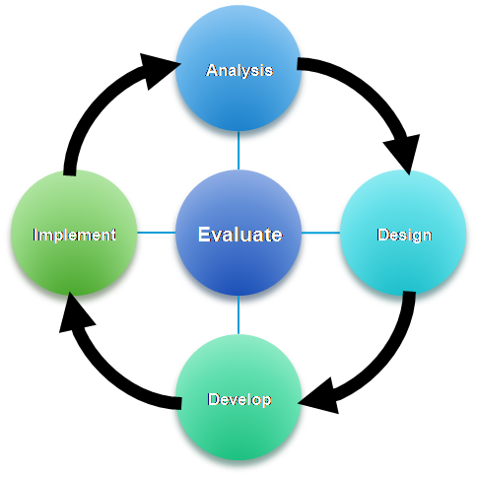

Figure 2. ADDIE Instructional System Development (ISD) Model. ADDIE: Analysis, Design, Development, Implementation, Evaluation.

There are a number of websites that cover Instructional Design concepts and the ADDIE model. Some additional references include:

* Hodell, Chuck, “ISD From the Ground Up, A No-Nonsense Approach to Instructional Design,” ASTD Press, August 2006.
* Elengold, Linda J., “Teach SMEs to Design Training,” ASTD Info-Line, Tips, Tools, and Intelligence for Trainers, 2001.
* Harris, Georgia L., “Development of a CD-ROM Metrology Course at NIST,” Measurement Science Conference, 2003. It is available here:

<http://ts.nist.gov/WeightsAndMeasures/upload/MSC2003CDROMPaper.pdf>

**Defining the Audience and Need for Training**

During the Analysis phase, the designer or, in most metrology cases, the instructor or SME defines the need, the target audience, and the expected outcome of the training. ANSI/IACET Criteria Number 4 is related to Learning Event Planning (4): “Each learning event is planned in response to the identified needs of a target audience.” There is room on the Case Study Planning Worksheet (Appendix A) and Learning Event Planning Worksheet (Appendix B) to make notes about the Audience and Need for a given training event.

As a first step in Analysis, we need to answer a number of questions:

* Who is the audience?
* Why conduct the training?
* What is the performance need?
* What is the root cause?
* How will the content be delivered and by whom?

We may need to answer these questions from the perspective of laboratory management as well as the metrologist or person being trained. We must have an effective partnership between the trainer, the manager, and the person being trained for the training to be effective and used/applied back on the job. If a manager does not support change that might be required for applying training content, the training will have no impact. Identifying the real need and the best solution are important for everyone.

One thing we might want to ask is: can other solutions meet the requirements without training? Sometimes when analyzing the need, we find that the root cause is lack of management support or lack of resources, rather than a lack of knowledge or awareness. Perhaps a simple publication and job aid such as a form or checklist serves an even better purpose than spending time in a training session. A step-by-step checklist or form may ensure consistent application of a new procedure, publication, or idea, without need for a training course.

If we look at the ANSI/IACET criteria for offering CEUs, one of the things we find is that we can also refer to a “job standard” to define the need for training. For example, any single item in the ISO/IEC 17025 standard for calibration and testing laboratories is rich as training content in the calibration world. One example might be a course on “Writing a Calibration Report (ISO/IEC 17025, Section 5.10.”

*Application: Identifying the Audience for our NCSLI Publications*

* The audience for the mini tutorial is primarily Committee Chairs and Members who want to develop training material from NCSLI publications. There might be additional benefits to regular conference presenters or tutorial instructors who want to improve the instructional value of their resources.
* The audience for RP 3, “*Calibration Procedures*” might be: Calibration Laboratory Managers, Metrologists/Engineers, Technical Managers, or the Procedure Writing/Validation Team.
* The audience for RP 20, “*Metrology Laboratory Workforce Planning*” and the “*Metrology Human Resources Handbook*” might include: Laboratory Managers, Human Resources staff, and Training Managers/Directors.

*Application: Examples of Need*

* The need for this mini-tutorial is that SMEs need formal training on methodologies and processes for developing training material from NCSLI publications to ensure compliance with standard training methodologies and the ANSI/IACET requirements.
* The need for training on RP 3, “*Calibration Procedures*” could include: a requirement in ISO/IEC 17025 to document calibration procedures and validate them.
* The need for training on RP 20, “*Metrology Laboratory Workforce Planning*” and the “*Metrology Human Resources Handbook*” include: a desire for international consistency and adoption of standardized job descriptions to enable recognition and professional status of metrology careers.

**Learning Objectives**

A Learning Objective or Learning Outcome (often interchangeably used), is a specific statement, written from the participant’s perspective, which provides information about what the participant will gain during a learning event. They are focused on participant performance, not teacher performance.

“Learning objectives: Statements about what a student will gain from a course or activity. These are specific statements about exactly what a student should know, be able to do, or value as a result of accomplishing a learning goal. Learning objectives form the basis for curriculum and course development as well as testing (Reed, 2005).”[4]

The “Bloom’s to Assessment” graphic (Fig. 5) and the Learning Event Planning Worksheet (Appendix B) are two tools that will help implement these concepts. They will help answer “what” and “why” of our learning event. Part of the Analysis phase helps determine what level of training and comprehension is required by the audience. Then, the Design process requires that we design training at the level needed to help the participant get what they need at the right level.

**Bloom’s Taxonomy**

We will consider these six levels of understanding before we consider writing effective Learning Objectives. We need to answer what level we want the participant to be able to know and apply the material. We must accurately identify the audience, understand their level of knowledge, and their unique needs. Each of the six areas in the taxonomy builds on the previous level of knowledge. A key design and development concept is that a participant must have Knowledge about a topic before they can Analyze it. In Table 1, the six areas noted in the Bloom’s graphic (Fig. 3) are listed, with a brief description of each category, and a list of verbs that can be used to describe what the participant will need to be able to Know, Do, or Think after the session. These sample verbs provide examples that can be used to reflect appropriate learning levels in each Learning Objective and to specify the level of mastery expected for the student.

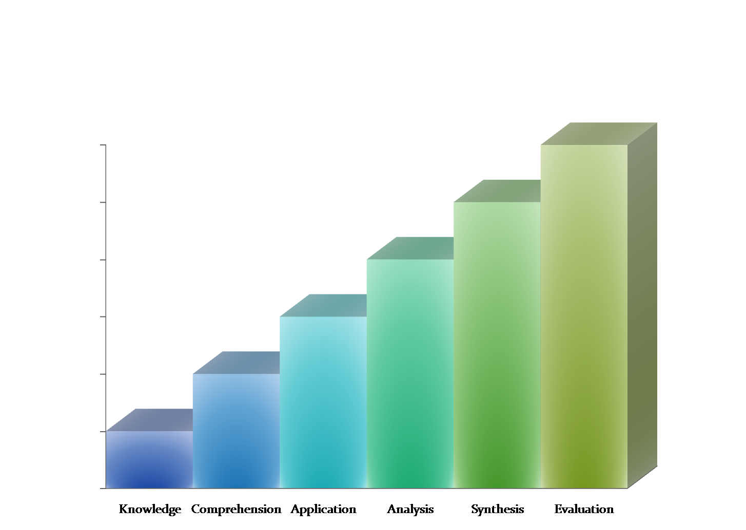

Figure 3. Bloom's Taxonomy Model.

Table 1. Bloom's Taxonomy - Descriptions and Sample Verbs.

|  |  |  |
| --- | --- | --- |
| **Level** | **Description** | **Sample Verbs** |
| Knowledge | Recall data or information | describe, identify, recall, arrange, define, duplicate, label, list, memorize, name, order, recognize, reproduce state |
| Comprehension | Understand the meaning of a problem, be able to translate into own words | comprehend, give example, classify, describe, discuss, explain, express, identify, indicate, locate, recognize, report, restate, review, select, translate |
| Application | Use a concept in a new situation | apply, change, construct, compute, choose, demonstrate, dramatize, employ, illustrate, interpret, operate, practice, schedule, sketch, solve, use, write |
| Analysis | Can split concepts into parts and understands the structure | analyze, break down, relate, appraise, calculate, categorize, compare, contrast, criticize, differentiate, discriminate, distinguish, examine, experiment, question, make inferences, find evidence, test |
| Synthesis | Produce something from different elements (e.g., a report) | summarize, arrange, combine, categorize, assemble, collect, compose, construct, create, design, develop, formulate, manage, organize, plan, prepare, propose, set up, write |
| Evaluation | Make judgments, justify a solution | appraise, interpret, argue, assess, attach, compare, defend, estimate, judge, predict, rate, core, select, support, value, evaluate, prove, deduct |

**How to Write Learning Objectives**

The ANSI/IACET standard for continuing education units identifies four categories in Section 5 related to writing Learning Objectives. These are the four criteria required for writing an effective Learning Objective.

1. They are written from the perspective of the learner, reflecting what the learner will achieve.
2. Learning objectives must be clear, specific, concise, and measurable (with four components):
   1. They state the performance the learner should be able to accomplish. (Behavior)
   2. They specify the conditions under which the learner is to perform. (Conditions)
   3. They specify the criteria for acceptable performance. (Criteria)
   4. They are directly related to the subject matter and content of the learning event.
3. Learning outcomes are established for each session within a large event, conference, or convention.
4. Instructional delivery includes discussion of learning outcomes.

If we expand on category number 2, and consider the four components of a clear, specific, concise, and measurable objective, here are some additional notes to clarify what is meant. Each Learning Objective should begin with: After this session (tutorial, paper, or workshop) the participant will__________.

Component 1: This component covers the expected behavior after the training. Think about performance in terms of active verbs related to what you want the participant to know, do, or be, after the training: identify, calculate, assess, present, analyze, and apply. (Refer back to Table 1 for additional examples.) At this point, select an appropriate verb for the level of knowledge or application that is expected.

Component 2: What are the conditions? Can the participant use their notes? Can they use a documented procedure? Can they use a calculator? Are computers allowed? Must they use Excel for calculations? Are there additional reference materials provided? Will they have to be assessed from memory?

Component 3: What criteria will be used to judge acceptable performance? Is an 80 % passing grade acceptable? Would it be okay if they submit their response in text-message format? Must they provide a written response or can it be oral? What will a valid uncertainty statement look like? (Instructors need to make sure that the criteria for successful performance are covered in the course!)

Component 4: Learning objectives must be directly related to the subject matter and content of the event. If you haven’t covered various types of statistical distributions in a course, you should not evaluate students against the criteria (unless of course it was given as a prerequisite). If a course is to cover how to correctly perform pressure calibrations, it would not make sense to have Learning Objectives related to the laboratory management system. This component should be obvious – but must be stated.

Another approach commonly used is the A-B-C-D approach to writing Learning Objectives. A, B, C, and D stand for Audience, Behavior, Condition, and Degree. This approach matches up nicely with the ANSI/IACET criteria, in that the objective must focus on the Audience, and be written from the student perspective. Then, it needs to specify what Behavior is expected as a result of the training, must address the Conditions that will be allowed, and the Degree or level of mastery required (the Criteria for measuring successful mastery). We may not use this model in this tutorial, but you might see it in some references on this topic and the approach may be helpful to you.

Developing Learning Objectives for our *Application* examples are next. You can see that we have included the Behavior, Condition, and Criteria in these examples. Note how you might improve or expand on ideas for appropriate Learning Objectives.

*Application: Examples for NCSLI Publications*

* Five Learning Objectives for this mini tutorial were stated earlier on page 1.
* Objectives for RP 3, “*Calibration Procedures*” might include: given resources and examples (*condition*), participants will be able to correctly (*criteria*) write, assess (identify good procedures, identify gaps and weaknesses), and validate procedures (*behavior*).
* Objectives for RP 20, “*Metrology Laboratory Workforce Planning*” might include: given the resources (*condition*), participants will be able to describe the overall workforce planning process (*behavior*), and successfully implement all or portions of (*criteria*) laboratory succession planning efforts (*behavior*), etc.
* Objectives for the “*Metrology Human Resources Handbook*” might include: given the resources (*condition*), participants will be able to update job descriptions (*behavior*) consistent with standard practice (*criteria*), collect employment data (*behavior*) according to standard classifications (*criteria*), participate in providing input to OPM/Department of Labor, etc.

**How to Select and Align Activities and Assessments with Learning Objectives**

The triangle shown in Figure 4 represents the relationship between Learning Objectives, Learning Activities and Assessment. If these three components are present and compatible then teaching and learning is enhanced, hence, this model is often called “The Magic Triangle.” If these three components are not congruent then students become discouraged and unhappy and make the assumption the objectives cannot be trusted and they will stop paying attention to them. A key factor to consider with this model is that if one side of the triangle is missing, the learning collapses and is not effective.

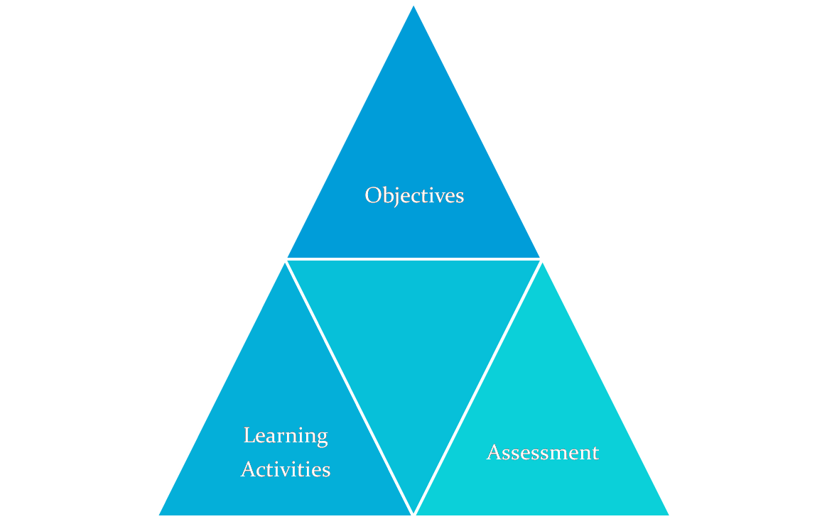

Figure 4. "The Magic Triangle." Used to align Learning Objectives, Activities, and Assessment Methods.

Note: Learning Activities are those things the instructional designer plans during the Design Phase and the student does to learn in the Implementation Phase. For example, listening to a lecture is a Learning Activity; engaging in a small group discussion led by a facilitator is a Learning Activity; evaluating a measurement instrument with a calibration technician clinician is a Learning Activity.

Evaluation or Assessment (of the student, not the course) is often thought of as a *testing* component. But, Assessment could also be a project assignment that is graded or otherwise evaluated. The important factor to consider is that whatever forms the Assessment takes, it

should measure the student’s accomplishment and provide specific feedback to the student(s) on how well they met the Learning Objectives.

Figure 5. From Bloom's to Assessment.

If you review the “Bloom’s to Assessment” graphic (Fig. 5), you can see that there are some activities more appropriate for some levels of learning than others. E.g., a Lecture/Test might be appropriate Activity and Assessment for the Knowledge level learning, but it is usually the lowest level of engagement and retention. A Case Study Activity and Assessment are more appropriate for the Application and Synthesis levels. The concept of the Magic Triangle (Fig. 4) should be considered when using the Learning Event Planning Worksheet (Appendix B) that we will also discuss later. Keep this idea in mind: the Objective, Activity, and Assessment components are all a part of the triangle, all are essential, and all must be considered during the Design process. They must be selected to match the appropriate level of Bloom’s taxonomy.

**Designing Content**

ANSI/IACET Criteria 7 states that: the content and instructional methods are appropriate for each learning outcome; content is organized in a logical manner in support of learning outcomes; instructional methods are consistent with learning outcomes regardless of delivery mode; and instructional methods accommodate various learning styles and are designed to promote interaction between and among learners, instructors, and learning resources to achieve the stated learning outcomes.

Depending on what topic is being converted to training material, a trainer might design around themes, chronology, or steps in a measurement process. It is important to make sure that topics are aligned around the objectives and to focus on ensuring that the technical content is effective as training material. Using a logical sequence of topics is one of the ANSI/IACET criteria and is important for training course development. One topic should typically build on the knowledge gained from previous topics or modules.

In this mini tutorial we are taking PowerPoint®[5] slide content that is “about a publication” and converting it to a “training resource.” If the content were not available, we would have to start from scratch and design and build everything. Our focus is to convert the content in such a way as to comply with recognized ISD education and training models.

Techniques, teaching methods, or activities need to be selected and aligned for each of our Case Studies to match the Bloom’s Taxonomy level we want to achieve, as well as the KSA (Knowledge, Skill, Ability) we are trying to ensure the participant can KNOW or DO at the conclusion of the session. What are the best instructional methods that are likely to be used during the Implementation phases? Instructional designers must think about best instructional and Assessment methods during Analysis and Design to select the best activities and methods for teaching. They must also consider the best Assessment methods. Table 2 lists several examples of Teaching Activities/Methods.

A traditional model of training that combines Activity and Assessment is Lecture, followed by a Test. In a conference setting, we often only see Lectures. As you can see by reviewing the “Bloom’s to Assessment” graphic (Fig. 5), this approach is not very effective if you want participants to know or do something different. What makes it worse is that adults prefer to be involved in their learning and tend to hate the Lecture/Test model. What comes to mind is “death by PowerPoint!” This approach provides the lowest level of engagement and retention and treats the audience as inexperienced/non experts (though they usually do bring *something* to the learning event). During the Analysis and Design phase we must answer whether we want people to only be able to LIST information or be able to fully ANALYZE and APPLY the material on the job. In most cases, we want to see performance improvements on the job and not simply improve a participant’s knowledge.

Table 2. Teaching Activities/Methods.

|  |  |
| --- | --- |
| **Activity or Method** | **Description** |
| Lecture | Presents factual material in a direct logical method. Useful for large groups. Should only be used in combination with other instructional techniques, unless there is a very inspirational instructor and the goal is to inspire learners. Lectures must include liberal use of visual, auditory, and kinesthetic (physical activity) approaches. Lectures are often passive and learning is generally at the lowest end of Bloom’s taxonomy. |
| Video | Can be entertaining if selected and done well. Video can be used as part of an Activity, but additional instructions need to be included, such as “watch this video and take notes on the measurement errors you observe.” |
| Discussion | Discussions are often started by asking open-ended questions and engaging all participants. They can be done in large groups, small groups, or as brainstorming sessions. The idea is to engage all participants. It is not practical for very large groups unless there is an option for breaking into smaller groups and reporting back. |
| Demonstration | In this method, the instructor or a member of the class might demonstrate a procedure or method to the rest of the class. Participants are given an idea of what something might look like in practice and have the opportunity to observe, ask questions, and critique. |
| Exercise/Drill | Perform a measurement procedure or review a specific procedure is an example of an exercise/drill activity. Exercises provide immediate opportunities to apply what has been learned. Students individually perform an experiment and then come together as a class to discuss the results. The hands-on application of a procedure and final expected results are often assessed. |
| Case Study | Case studies are practical examples related to the content that must also be relevant to the participant. Allows for application of content that has been learned and promotes analytical and problem solving skills. The case study must be complete enough for the participant to assess the entire case versus having too many unknown components that might simply frustrate the students (especially if the right answer is more fixed than students are led to believe). |

*Application: Selecting Activities*

To convert our technical content to training materials, we need to have some creative planning. Having a team of designers or instructors select energetic and applicable Activities can be an art. This phase is often quite a challenge for no-nonsense SMEs for whom the content is obvious and comes easily. During the design process we need to answer: What kind of activities will help participants understand, implement, analyze at the levels needed? We have selected some Activities for our Case Studies below. Can you identify additional Learning Activities that might be fun, engaging, and effective?

* Activities for this mini tutorial. We are making extensive use of real case studies from new NCSLI publications. These provide real examples of what we are trying to do.
* Activities for RP 3, “*Calibration Procedures*” might include: provide a procedure with parts missing – identify missing parts and consider the impact if they are not present; provide a procedure that is poorly written or unclear and consider the impact; provide a well written procedure, and consider what is needed to document the validation.
* An Activity for RP 20, “*Metrology Laboratory Workforce Planning*” might include: perform a knowledge/skills/ability Assessment for participants (make it real for each person) to answer the question, what would be required for succession planning to fill your own position.
* An Activity for the “*Metrology Human Resources Handbook*” might include: bring your own set of job descriptions to the course to assess them against the Handbook criteria.

**How to Ensure Learning Takes Place–Assessments**

Activities and Assessment methodologies must be considered in the context of Design, but the instructional designer must consider how they will be Implemented for each audience. The ANSI/IACET Criteria 8 specifies that Assessment must take place. Procedures established during event planning [Design, Development] are used to assess student’s achievement of the learning outcomes. Learners must also be provided feedback on their mastery of learning outcomes. During development we will develop the instructional content, but we must consider good design approaches in the Design phase. Later, Implementation also includes the Activities, and Assessments of whether students have mastered the topic at the expected or desired level.

It is important to align the Assessment method with the Learning Objective and Activity as shown in the Magic Triangle (Fig. 4) and the “Bloom’s to Assessment” graphic (Fig. 5). For adult audiences, it is important to integrate Assessment into the training as much as possible (versus issuing a post-test). According to the ANSI/IACET criteria, each person does not have to be assessed on achieving each objective in a course, but sometimes that is important for issuing certificates of successful completion or for demonstration of competency. For example, if you have objectives such as “each person will successfully calculate the standard deviation and get 100 % correct” or “each person will successfully calibrate item x during the seminar.” In those examples, the instructor will need to be able to review each person’s numbers or measured result to assess accuracy and achievement of the objectives, and also to provide feedback to the student. Sometimes there is also a need to assess post-event learning and application – e.g., use of proficiency testing for procedure training.

To improve Assessment efficiency, and to motivate and engage students, it is important to provide group feedback to let them know what you learned from the Assessments and what difference that information will make. All Assessments need to reflect back to measurable Learning Objectives to determine if the student has learned the material and it is important to provide feedback to the student so that they know whether they have learned the material correctly. That is, Assessment should be more than simply correcting a quiz and returning it with a grade. Table 3 provides a number of Assessment Methods that may be considered.

Table 3. Assessment Methods.

|  |  |
| --- | --- |
| **Assessment Method** | **Description** |
| Multiple Choice | A type of quiz or Assessment where the student must choose either the best answer or a number of answers that might be correct. Immediate review can be done to provide feedback. Discussion of “wrong” items often yields interesting applications that might not have been considered during the Analysis, Design, and Development phases. |
| True False | This is a simple type of quiz or Assessment that can be done orally or on paper. It can be done individually or in a large group setting. Right and wrong answers are usually provided. It can be done by raising of hands. E.g., how many of you think this statement is True? How many false? Can anyone give me a reason for their answer? Feedback might be as simple as “great job” or “here’s the correct answer.” |
| Fill in Blanks | This type of approach can be done in a group setting and handled orally, or even in teams. Most often it is used in a written test and will usually only have one right answer. |
| Essay/Reports | It is more difficult to assess essays/reports in a training session unless it is several days long and the instructor will have time to review and grade the content. Specific guidance may be needed in the Developed material to ensure that an instructor or facilitator knows the content adequately or has adequate information on which to base evaluation. A “one minute” Assessment can also be useful. For example, “write down one thing you learned [and can apply] during this session on this index card and pass it in.” |
| Simulation | The Assessment is made in each participant’s engagement, completion, and accuracy of the Learning Objectives and at the level of knowledge required. Job task analysis can help create an observational checklist. |
| Case Study | The application of a procedure and final expected results are often assessed. Group review of the final results can provide dynamic feedback or individual feedback may be provided to each participant. Teachers can use a checklist and observation to assess student success with the particular material. A minimum set of knowledge or skills can be included on the checklist. Job task analysis can help create an observational checklist. |
| Role Play | Specific guidance is given to the parties in the role-play and then observations and feedback from the group are collected. The instructor provides an overview of the Activity and summarizes the important components. Participants are encouraged to practice a role or skill. Teachers can use a checklist and observation to assess student success with the particular material. |
| Journaling | Students are asked to take specific notes during the session. For example, “write down one key idea from this session and write down one thing you can apply back on the job.” The summary notes are reviewed at the end of the class either as a group or individually. The notes can also be used to summarize or highlight the important aspects of what was learned to a manager or coworker back on the job. |

The Case Study Worksheet (Appendix A) and Learning Event Planning Worksheet (Appendix B) use tables that can be expanded like the one shown in Table 4. These worksheets can be using during the Design phase to consider effective methods in training resource development. But, this specific portion of the worksheets (Table 4) helps align the Learning Outcomes with the Activities and Assessment methods to ensure that all three sides of the Magic Triangle (Fig. 4) are aligned according to the “Bloom’s to Assessment” (Fig. 5) and that the instructional materials and methods will be effective. If Assessments are integrated into the Activity effectively, students may not realize whether they are learning or being assessed.

Table 4. Example Learning Outcomes, Instructional Methods, and Assessment Methods.

|  |  |  |  |
| --- | --- | --- | --- |
| **Item** | **Learning Outcome** | **Instructional Method (Activity)** | **Assessment Method** |
|  |  |  |  |
|  |  |  |  |
|  |  |  |  |

*Application: Matching Assessments to Activities and Learning Objectives*

* Activities and Assessment for this mini tutorial. We are making use of real case studies and reviewing possible *Applications* as we cover each Phase. Assessment will be done by evaluating the levels of participation and questions raised by participants. Feedback will be given during the session. Follow up Assessment will be done to determine the level at which new training materials comply with the ADDIE model and ANSI/IACET criteria.
* Activities for RP 3, “*Calibration Procedures*” might include: provide a procedure with parts missing – identify missing parts and consider the impact if they are not present; provide a procedure that is poorly written or unclear and consider the impact; provide a well written procedure, and consider what is needed to document the validation. In this case, was the participant able to identify missing items in a calibration procedure? This could be done through group discussions and a presentation with feedback from the facilitator. Assessing impact would be much more difficult as an Activity and one might question whether there is a list of key items one might consider in assessing the impact of poorly written calibration procedures. The content of the Assessment material must be covered in the training.
* An Activity for RP 20, “*Metrology Laboratory Workforce Planning*” might include: perform a knowledge/skills/abilities Assessment for participants (make it real for each person) to answer the question, “What would be required for succession planning to fill your own position?” If an Activity included discussion of each phase in Succession Planning, and the Learning Objective was to list three of the five phases, an oral examination, or team competition, might be used to assess whether the participants understood the topic at the level expected.
* An Activity for the “*Metrology Human Resources Handbook*” might include: bring your own set of job descriptions to the course to assess them against the Handbook criteria. However, the objective might have been to be able to list the three job titles that are in the handbook. In that case, a quiz at the end could determine if the participant is able to list all three job descriptions. A matching quiz could be used to match attributes with each job title.

**Developing a Lesson Plan, Agenda, Instructor’s Resources**

Once the course content is Designed, the course materials are Developed. Content that is developed might include an Agenda, Lesson Plan, Slides, Visual Aids, and Instructors Notes. It should also include any additional handouts or case study references that are not included as a part of the course reference materials. For example, in this mini-tutorial, we provide: a copy of this paper, copies of PowerPoint slides from the three Application examples, and additional References on a CD-ROM. We are also providing a set of PowerPoint slides (Notes version) and a paper copy of Appendix A for personal notes during the session. We are intentionally providing the Notes version because our time will be limited and we want to encourage participants to share this resource within their committees or with others who are developing training resources. Our goal is to encourage participants to implement the content at the Application level of Bloom’s Taxonomy. You will note that this goal was not stated as a Learning Objective, but is an outcome of the training that we hope will be fulfilled.

The agenda for the mini-tutorial includes:

* **Overview of the Session** (including Learning Objectives). We will ask participants to take notes on their own project or use the Case Study we will discuss.
* **Module 1:** ADDIE ISD Process/Theory. This is presented as Lecture with Group Oral Assessment.
* **Module 2:** ADDIE Process – Applied to One Case Study (the RP on Calibration Procedures). (Note: this paper provides references to three Applications, but there is not time to cover all three examples during the session; however, they are included in the Notes section of the slides/handouts.) The Five Steps of Adult Learning (Metrologist, July 2010) will be implemented as a part of the teaching/Activity. Assessment will include review of participant engagement. Are the questions applicable? Are groups interacting? Are new, creative ideas raised?

For a mini-tutorial that is presented in one and a half hours, we are not planning for any breaks. However, we want to cover the Overview and Module 1 fairly quickly so that we can ensure we spend the majority of our time on the *Applications* (Case Study). An estimated time might be 15 minutes for an Introduction and Overview, 30 minutes for Module 1, and 45 minutes for Module 2.

In general, PowerPoint® provides a Notes section that can be used for instructor guidance and reference. During the Development, and Implementation phases, it is important to ensure that the notes and content are enough for a knowledgeable and skilled instructor or SME to present the content. What else might be needed? Are the case studies included? Will there be a compiled handout for participants as well as instructors? What qualifications are needed (if any) for the instructor/facilitator? The instructor must have a background in the instructional design process, but because the process is fairly simple and the notes fairly complete, a good instructor could feasibly review the materials and facilitate the implementation with knowledgeable SMEs. In fact, the content for this mini-tutorial could easily be shared by an effective Committee Chair to the rest of their Committee to guide the development of new training resources.

**Implementation and Evaluation**

Implementation and Evaluation are the last two phases of the ADDIE model. It is arguable that Evaluation is last because we integrate it into each level of the process. It is beneficial to conduct dry-run evaluations and obtain feedback (beta testing) with instructors or SMEs to ensure the needs and objectives of the training material will be met. Adjustments in the content will often be made as the material is developed – and before the course is presented. Course evaluations and continual improvement (refinement) of content, objectives, activities, and Assessments also help to improve content over time.

Having an evaluation program that includes overall assessment of all program components, as well as individual course evaluations, is an essential part of the ANSI/IACET criteria, but we will not spend time on those phases during the mini-tutorial. This is not to minimize their importance as a part of the ADDIE process as much as it is related to the need to focus on Designing and Developing content in the available time. Recall what we said earlier: a cardinal rule is to never leave out Analysis or Evaluation from the learning event development process because the projects can be spotted quickly – 1) these efforts seldom work to meet learning objectives and 2) no one ever really figures out why.”

**Conclusions**

This paper is being presented as part of a mini-tutorial to help metrology subject matter experts design and develop training content that follows formal ISD models and to help comply with ANSI/IACET standards for Authorized Providers in NCSLI-developed training resources. The authors hope that this resource will be expanded and enhanced for use by NCSLI committees in the Analysis, Design, Development, Implementation, and Evaluation of training resources as well as used as a resource for converting or developing effective metrology training content.

**Acknowledgements**

The authors wish to acknowledge contributions from the Committee Chairs/Co-chairs (committee number provided), Gloria Neely (163), Caroline Dixon (163), and Thomas Flynn (176) for providing PowerPoint® slides related to each of their new publications and for participating in a preliminary webinar on these topics to provide subject matter guidance, Application examples, and feedback on the draft mini-tutorial presentations.

**Appendices and References**

* Appendix A: Case Study Planning Worksheet
* Appendix B: Learning Event Planning Worksheet
* Metrologist Articles: CEU (April 2009), Train the Trainer: Writing Learning Objectives (April 2010), 5 Steps for Adult Learning (July 2010), Activities and Assessments (October 2010, draft)
* NCSLI Website: Trainer Resources: <http://www.ncsli.org/NCSL/learning/Trainer_Resources.aspx>

**Appendix A**

**Case Study Planning Worksheet**

Title of Course/Tutorial:_________________________________

|  |  |
| --- | --- |
| **ADDIE Phase** | **Questions and Notes** |
| **Analysis** | What is the need?  Who is the audience?  What standards might be referenced?  What will success look like? |
| **Design** | Write Learning Objectives:  Using ____________________, participant will be able to _________________ (at this level_______________) after the training.  Level in Bloom’s Taxonomy?  Possible VERBS?  Match Activity – Align Assessment Method  What are some possible activities and Assessments that can be used?   |  |  |  | | --- | --- | --- | | **Learning Objective** | **Activity** | **Assessment** | |  |  |  | |  |  |  |   Tools: Learning Event Planning Worksheet, “Bloom’s to Assessment”, Writing Learning Objectives Article |
| **Develop** | Creating content…  Teacher’s Manual. Slides. Case Studies.  Often slides…. (or outline/notes)  Additional handouts? Worksheets? Case studies?  Additional considerations: Instructor notes. Agenda. Lesson Plan. Timing/breaks. Constraints. |
| **Implement** | Step 1: Set up the Activity.  Step 2: Conduct the Activity.  Step 3: Learners share and interpret their reactions.  Step 4: Participants identify concepts.  Step 5: Participants consider and share how they will apply these concepts.  Tools: Five Steps of Adult Learning |
| **Evaluate** | 1. Evaluate each phase of the ADDIE process. 2. Participant Assessment Methods. 3. Use of standard course evaluations.   Tools: Learning Event Planning Worksheet, “Bloom’s to Assessment” |

**Appendix B**

**Sample Learning Event Planning Worksheet (used for Analysis and Design Phases)**

**Title:**

|  |
| --- |
|  |

**Abstract:**

|  |
| --- |
|  |

**Constraints:**

* Instructor:
* Time/Date:
* Length of course:
* Prerequisites:       (e.g., previous course, downloadable reading, tasks/activities)
* Maximum number of students:
* Minimum number of students:
* Room set up:
* AV Required:

**Define the audience and need for this training** (e.g., laboratory management knowledge, skill, ability, standards such as ISO/IEC 17025, 17043, VIM, GUM, measurement parameter knowledge, skill, ability to perform calibrations, poor performance on proficiency tests, observed/requested needs):

|  |
| --- |
|  |

**Complete this table for each course/event:**

|  |  |  |
| --- | --- | --- |
| **Learning Objectives[6]** | **Instructional Method (Activity)[7]** | **Assessment Method[8]** |
|  |  |  |
|  |  |  |
|  |  |  |
|  |  |  |

**Agenda Outline** (Include highlight agenda items and attached detailed agenda and descriptions.)

|  |  |
| --- | --- |
| **Topic** | **Time** |
| Attendance, Group Introductions |  |
| Course Title, Description, and Successful Completion requirements |  |
| Learning Objectives |  |
| Module 1 Objective, Activity, Assessment |  |
| Module 2 Objective, Activity, Assessment |  |
| Module 3 Objective, Activity, Assessment |  |
| Review and Closure |  |
| Course and Student Assessments |  |

This page intentionally left blank

1. NCSL International (also known as National Conference of Standards Laboratories, International).
2. American National Standards Institute, International Association for Continuing Education and Training (ANSI/IACET). <http://www.iacet.org>, 2010.
3. Hodell, Chuck, “ISD From the Ground Up, A No-Nonsense Approach to Instructional Design,” ASTD Press, August 2006.
4. From the University of Texas at Dallas, glossary: <http://sacs.utdallas.edu/sacs_glossary> (March 2010).
5. The use of specific software products is not intended as an endorsement; it is simply the products that are commonly used in the development of training resources.
6. Note Bloom’s Taxonomy and write from the Learner’s perspective… e.g., At the end of this session, the learner will be able to use “x” tool to comply with section “y” of “q” standard; will be able to name the benefits of complying with the standard; will be able to tell others how to select the best tools from choices given to implement a program. This is NOT where the instructor says “here’s what we’re going to cover.” Suitable activities and Assessment methods are to be used to ensure participant learning at the desired level.
7. Think about Instructional methods and Learning activities. What are the Visual activities: observing slides, watching list of notes, demonstrations of documents, watching a measurement, watching a video, reading a procedure. What are the Auditory cues: lecture, discussion, question/answer, round the room sharing, brainstorming, and role-playing? What are the kinesthetic activities: making a measurement, taking time to reflect and write notes – journaling; sharing thoughts; reviewing and summarizing a document; note taking that includes key questions (and can be used for learner Assessment). Activities must be matched with Assessment method and Learning Objectives.
8. Think about how to provide immediate Assessment and feedback to adult learners and consider the Five Steps of Adult Learning. After a question directed to the group (whether they answer aloud or in writing), provide the right answer. Use a quick daily/hourly Quiz. Use a Q&A approach and provide answers. Ask individual participants to share their answers or examples. Use a competitive game. Use role-playing and have participants provide feedback to each other. Give immediate feedback when creating a group list by brainstorming.