Report of the
Professional Development Committee (PDC)
Angela Godwin, Committee Chair
Ventura County, California

400 InTRODUCTION
This is the final report of the Professional Development Committee (PDC) (hereinafter referred to as the “Committee”) for the 101st Annual Meeting of the National Conference on Weights and Measures (NCWM) held in Denver Colorado, July 24 - 28, 2016. This report is based on the Interim Report offered in the NCWM Publication 16, “Committee Reports,” testimony at public hearings, comments received from the regional weights and measures associations and other parties, the addendum sheets issued at the Annual Meeting, and actions taken by the membership at the voting session of the Annual Meeting. The Informational items shown below were adopted as presented when this report was approved.
Table A identifies the agenda items by reference key, title of item, page number and the appendices by appendix designations. The acronyms for organizations and technical terms used throughout the agenda are identified in Table B. The first three digits of an item’s reference key are assigned from the Subject Series List The status of each item contained in the report is designated as one of the following: (D) Developing Item: the Committee determined the item has merit; however, the item was returned to the submitter or other designated party for further development before any action can be taken at the national level; (I) Informational Item: the item is under consideration by the Committee but not proposed for Voting; (V) Voting Item: the Committee is making recommendations requiring a vote by the active members of NCWM; (W) Withdrawn Item: the item has been removed from consideration by the Committee.
Table C provides a summary of the results of the voting on the Committee’s items and the report in its entirety. Some Voting Items are considered individually; others may be grouped in a consent calendar. Consent calendar items are Voting Items that the Committee has assembled as a single Voting Item during their deliberation after the Open Hearings on the assumption that the items are without opposition and will not require discussion. The Voting Items that have been grouped into consent calendar items will be listed on the addendum sheets. Prior to adoption of the consent calendar, the Committee will entertain any requests from the floor to remove specific items from the consent calendar to be discussed and voted upon individually.
Proposed revisions to the handbook(s) are shown as follows: 1) deleted language is indicated with a bold face font using strikeouts (e.g., this report), and 2) proposed new language is indicated with an underscored bold faced font (e.g., new items). When used in this report, the term “weight” means “mass”.
Note: The policy is to use metric units of measurement in all of its publications; however, recommendations received by NCWM technical committees and regional weights and measures associations have been printed in this publication as submitted. Therefore, the report may contain references to U.S. customary units.

Subject Series List
Introduction 400 Series
Education 410 Series
Program Management 420 Series
Other Items 430 Series

Table A
Table of Contents
Reference Key |  | Title of Item | Page PDC

400 InTRODUCTION 1
410 EDUCATION 5
420 PROGRAM MANAGEMENT 19
410 EDUCATION 5
410-1 I Professional Certification Program 5
410-2 I Training 12
410-3 I Instructor Improvement 14
410-4 I Recommended Topics for Conference Training 17
420 PROGRAM MANAGEMENT 19
420-1 I Safety Awareness 19

Table B
Glossary of Acronyms and Terms

Acronym | Term | Acronym | Term
ADDIE | Analysis, Design, Development, Implementation, and Evaluation | NEWMA | Northeastern Weights and Measures Association
ANSI | American National Standards Institute | NIST | National Institute of Standards and Technology
BOK | Body of Knowledge | OWM | Office of Weights and Measures
CWMA | Central Weights and Measures Association | PDC | Professional Development Committee
ISO | International Standardization Organization | RSA | Registered Service Agents
ICE | Institute for Credentialing Excellence | SME | Subject Matter Expert
NCWM | National Conference on Weights and  Measures | SWMA | Southern Weights and Measures Association
 |  | WWMA | Western Weights and Measures Association

Table C
Voting Table

Reference Key  Number | Houe of State Representatives |  | House of Delegates |  | Results
 | Yeas | Nays | Yeas | Nays
To accept the Report | Voice Vote |  |  |  | Adopted

THIS PAGE INTENTIONALLY LEFT BLANK

Details of All Items
(In order by Reference Key)

410 EDUCATION

410-1 I Professional Certification Program
Professional certifications are offered in many industries as a means of demonstrating competence in a particular field of expertise. Certification may be a means of qualifying an individual for employment or a higher pay grade within a profession. The National Conference on Weights and Measures (NCWM) Professional Certification Program provides confidence that an individual has a strong understanding of U.S. weights and measures standards as adopted by NCWM and published in National Institute of Standards and Techology (NIST) Handbook 44 “Specifications, Tolerance, and Other Technical Requirements for Weighing and Measuring Devices,” NIST Handbook 130, “Laws and Regulations in the Areas of Legal Metrology and Engine Fuel Quality,” and NIST Handbook 133, “Checking the Net Content of Packaged Goods.”
Professional certification is available to NCWM members and non-members in the private sector and in government positions. Please note that the person taking the test must be an NCWM member in order to take the exams for free.
Three new Professional Certification exams were deployed in 2015. These include Medium Capacity Scales, Large Capacity Scales, and Vehicle-Tank Meters. The next exams to be completed will be Liquefied Petroleum Gas (LPG) and Price Verification, followed by Mass Flow Meters, Packaging and Labeling, and Precision Scales. Work has begun on the LPG exam and the Price Verification exam. The PDC is still looking for additional subject mater expert (SME) volunteers for both of these projects. Any interested parties should contact Mr. Andersen through the NCWM Headquarters at info@ncwm.net. The SME volunteers are the real heart of the certification program. The successful creation of these exams is dependent on willing volunteers.
Status of Current Tests
The NCWM has issued 310 professional certificates from inception of the Professional Certification Program to September 30, 2015. Of the certificates issued, six have been issued to individuals in the private sector (three for small scales, two for package checking, and one for retail motor-fuel dispensers). The balance of the certificates has been issued to regulators in 30 different states.
Number of Certificates NCWM Has Issued
as of the End of Fiscal Year 2015 (September 30th)
 | FY10-11 | FY11-12 | FY12-13 | FY13-14 | FY14-15
Count in Year | 44 | 94 | 106 | 70 | 186
Cumulative | 44 | 138 | 244 | 314 | 500

Certification (posted) | Certificates
RMFD (5/2010) | 230
Small Scales (8/2012) | 131
Package Checking (8/2012) | 78
Medium-Capacity Scales (4/2015) | 30
Large-Capacity Scales (4/2015) | 11
Vehicle-Tank Meters (4/2015) | 20
The following map includes 36 states with individuals holding a certificate in one or more disciplines. In addition to those certificates shown on the map, there are six certificates issued to private sector personnel.
Distribution of Certified Professionals per State
Updated: September 2015
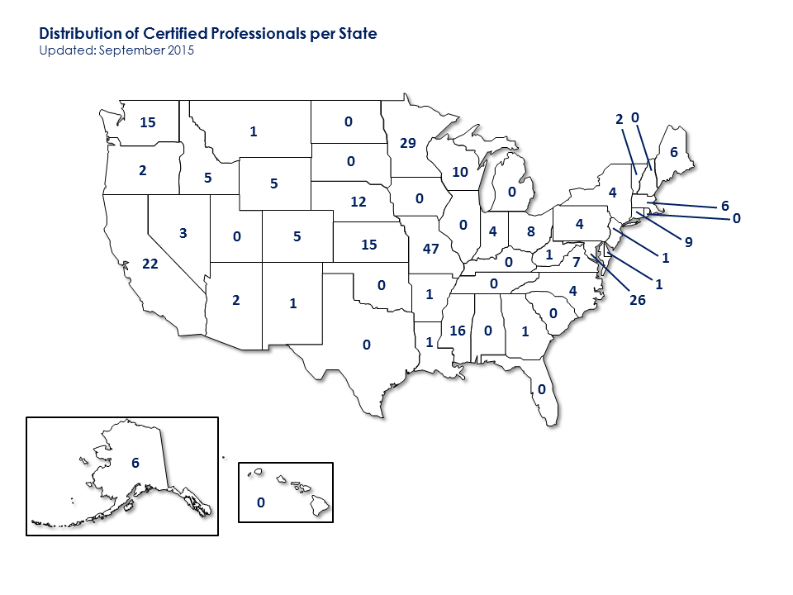

States with Largest Numbers of Certificates
State | Certificates | State | Certificates
Missouri | 90 | Mississippi | 15
Minnesota | 83 | Connecticut | 15
Maryland | 57 | Virginia | 14
Nebraska | 30 | Kansas | 13
Washington | 24 | Alaska | 11
Wisconsin | 22 | Maine | 10
California | 21

Distribution of Areas of Certification:
Retail Motor-Fuel Dispensing Systems
Updated: September 2015
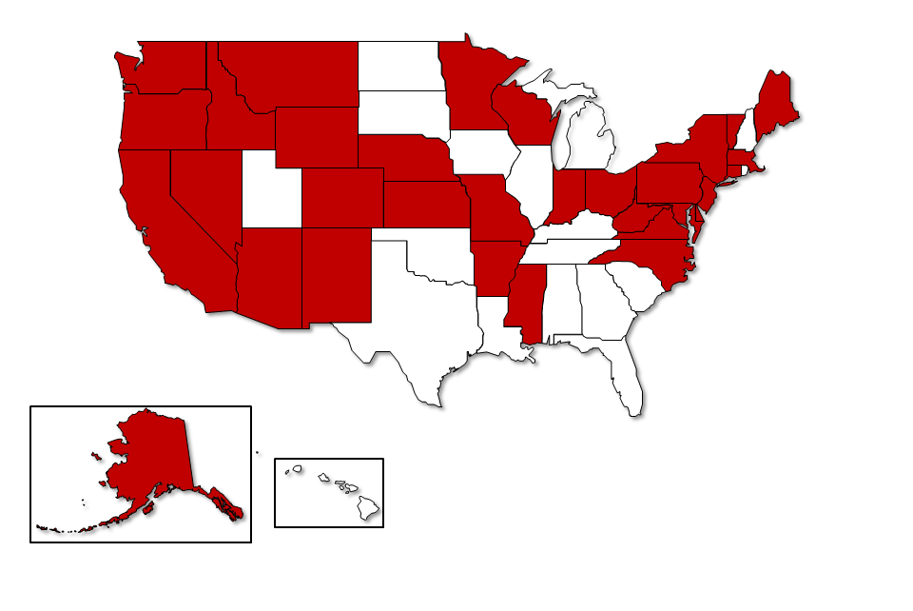

Distribution of Areas of Certification:
Vehicle-Tank Meters
Updated: September 2015
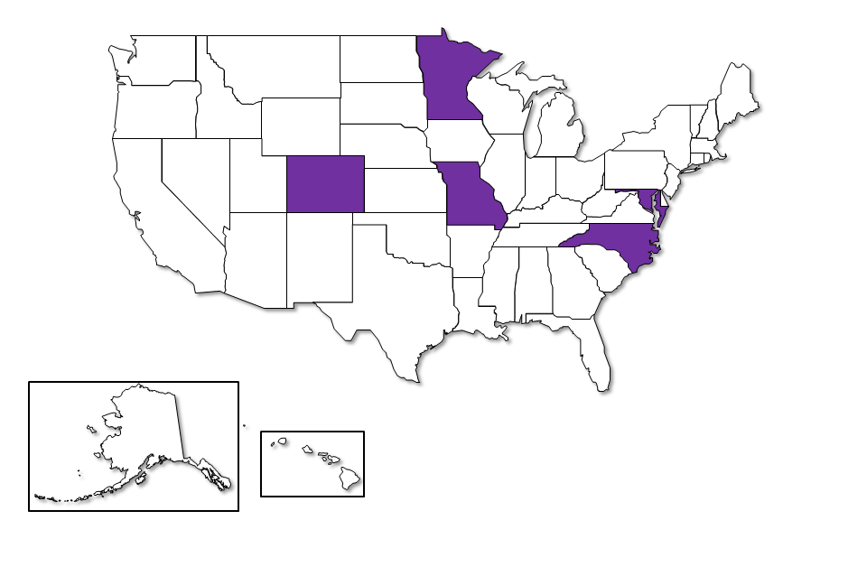

Distribution of Areas of Certification:
Small Capacity Weighing Systems, Class III
Updated: September 2015
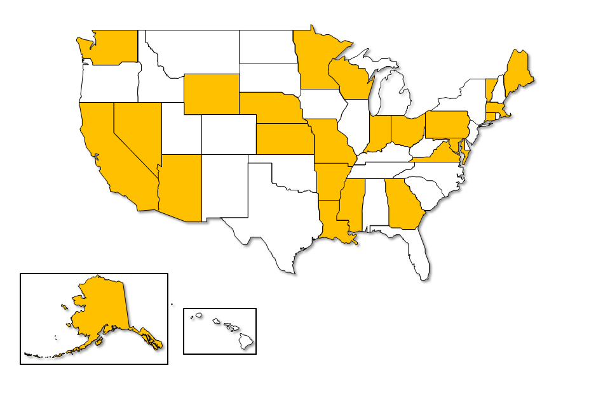

Distribution of Areas of Certification:
Medium Capacity Weighing
Updated: September 2015
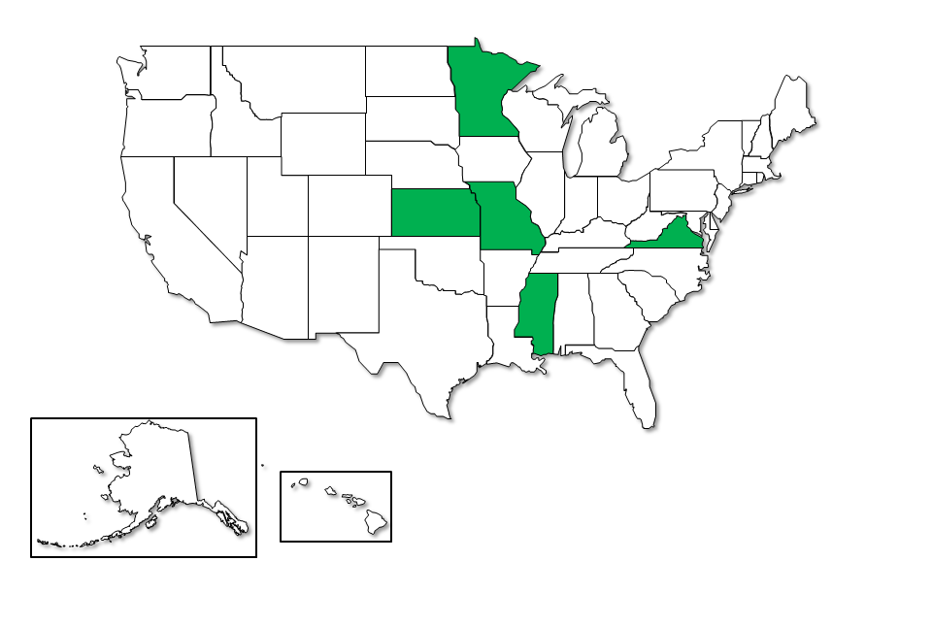

Distribution of Areas of Certification:
Large Capacity Scales
Updated: September 2015
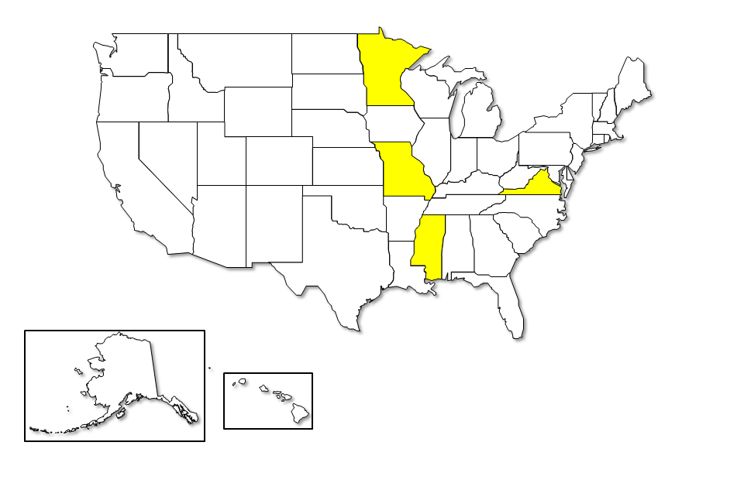

Distribution of Areas of Certification:
Package Checking, Basic
Updated: September 2015
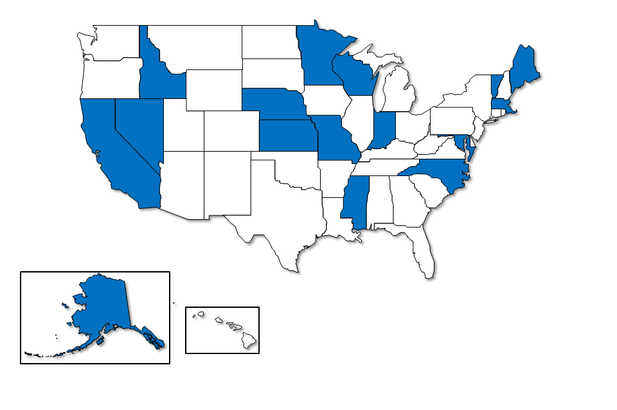
The Committee continually works to improve the exams and the exam experience. A key goal is to make sure the exams stay meaningful and current as handbook changes are made. This includes an annual review of the current exams by the Certification Coordinator. A short entry survey is being added to each exam to capture meta-data on who is taking the exams. Examples of meta-data include the candidate’s level of experience; whether the candidate is a regulatory official or a service agent; and so forth. The questions are in an untimed, unscored portion of the exam. Personal data will not be used in any analysis of the survey information.
In order to obtain valuable feedback on the Certification Program, the Committee has begun work on an exit survey, which will be implemented using Survey Monkey. The questions on the survey will address the mechanics of taking the exam, preparation for taking the exam, and general feedback (e.g., How did the candidate react to the content of the exam? Was it challenging? Was it too easy? Did the candidate feel the exam was fair?).
At the 2015 Interim Meeting, the Committee was asked to discuss and/or further develop multiple areas of the Certification program, including Accreditation; Proctoring Exams; Examination Protocol; and Intermediate Exams. At the 2015 Annual Meeting, the NCWM Board of Directors asked the Committee to explore the concept of basic competency exams. The Board also asked the Committee to consider whether there should be a distinction between exams for weights and measures officials vs. service personnel, and, if so, how to delineate between the exams.
Following the Annual Meeting, the Committee developed criteria for proctoring to meet accreditation requirements. Additionally, the PDC developed learning objectives to support basic competency exams for service agents and officials.
The Committee received multiple comments from the fall 2015 regional weights and measures association meetings. All four regional associations continue to express support for the certification program and support maintaining this item as an “Information” item on the Committee’s agenda.
The WWMA PDC reported hearing support from multiple jurisdictions regarding offering exams to service companies. Some jurisdictions felt there should be a distinction between the exams offered to service companies and those offered to officials. The WWMA heard from one industry member who expressed concern regarding any requirement for service companies to take tests when only a small number of officials have completed these exams. Others commented were should be language noting that there may be additional local requirements that would apply to service agents and suggested establishing links to state Registered Service Agent programs on the NCWM site. The WWMA continues to encourage more regulatory officials to take the exams, and noted that more regulatory officials might take the exams if the fee for non-NCWM members was waived either temporarily or indefinitely.
With regard to the idea of proctoring exams, the CWMA agreed this is a good way to protect the integrity of the testing process, but questioned if traveling to central locations to take tests might discourage participation by some candidates.
Some CWMA members questioned whether additional time might be allowed for completing an exam as a means to help alleviate some anxiety for candidates, thereby, increasing the likelihood of success. The CWMA also felt there is a need for a “cooling off” period between testing attempts; especially following a second failed attempt. There was no consensus on a recommended time frame.
Some questions were raised at the CWMA regarding scoring on the medium-capacity scales exam; the commenter was to follow up with the NCWM to address these questions so that it could be determined if problems exist.
At the 2016 Interim Meeting, the PDC met with the Board of Directors to confirm that the direction and priorities of this work was consistent with the Board’s expectations. During its working sessions prior to and during this meeting as well as discussions with the Board, the Committee has discussed possible ways in which proctoring of exams might be accomplished, including the use of independent proctoring services or the use of supervisory staff within weights and measures jurisdictions or other neutral individuals within those agencies. Some Committee members report that independent proctoring services may offer a wide number of locations in which testing can be offered, possibly providing an even wider choice of locations than might be practical through a weights and measures jurisdiction. The Committee will continue to explore the issue of proctoring exams and welcomes ideas and input from the community.
At its open hearings, the Committee asked NCWM members for feedback on the current Professional Certification exams. Multiple states commented that they use the existing exams to assess competency levels of staff members; identify gaps in performance; assess the effectiveness of training provided; and encourage the personal professional development of their staff. Julie Quinn (Minnesota) further noted that the exams are challenging and the candidates who successfully complete the professional certification exams feel a sense of professional pride and accomplishment.
The PDC presented the concept of new exams (which include a NIST Handbook 44 component and a device component) in the following areas:
- Basic Service Agent Competency – Weighing Devices
- Basic Service Agent Competency – Liquid Measuring Devices
- Basic Regulatory Official Competency – Weighing Devices
- Basic Regulatory Official Competency – Liquid Measuring Devices
The Committee asked NCWM members for input on the following questions:
- For those states that license service agents would the Service Agent Basic Competency Exam be of value in the licensing process?
- For states and other jurisdictions would the Basic Regulatory Official Competency Exams be of value in evaluating the effectiveness of training?
Many states spoke in support of the development of basic competency exams. Several states noted that they could use these exams for service agents as well as entry level officials.
During its working session, the Committee noted that the basic competency exams will only cover very general objectives in the weighing or measuring area. The Committee acknowledged comments from some weights and measures directors indicating that there may be a need for additional, more specific exams to demonstrate competency of service agents in focused topic areas. For example, a jurisdiction may want some evidence that a service agent who is going to be servicing LPG metering systems has demonstrated competence in that specific area, rather than just in the basic competency area of measuring devices. The Committee will continue to develop the concept of these basic exams while continuing to expand the Professional Certification Program to include new topic areas. The Committee appreciates and looks forward to continued input on both the Professional Certification exams as well as other exams that might be used to demonstrate lower levels of competency.
At its 2016 Annual Meeting, NEWMA heard several comments that states were interested in the basic competency exams and want to know what is going to be included on the exams. An industry representative was interested in having national basic competency exams that would be recognized across the country since it would help service companies that do business in several states. A member also questioned if the PDC was considering making the basic competency exams a prerequisite to taking the Professional Certification Exam.
At its 2016 Annual Meeting, the CWMA heard comments from attendees noting the need for testing to address the basic competencies needed by the service person and the regulatory official. The CWMA recognized that the basic competencies for both groups are identical. The consensus of CWMA members (15 for, 2 against) was to have one test on basic competencies to be used for both groups. Members commented that additional questions can be crafted to address differences between the two groups. Most important is that all have a basic understanding of NIST Handbook 44 and its application.
Several CWMA members expressed concern over the lack of feedback for the test taker with regard to areas that were answered incorrectly on the test. It is not necessary for the test taker to know the specific question(s) missed; however, the test taker needs information regarding the general principles that were missed. Learning is best done by addressing and correcting mistakes, and without feedback on areas answered incorrectly, there is no opportunity to correct the learning deficiency. Since test questions are tied to specific handbook references, it was suggested the NCWM PDC explore the possibility of infoming the test taker of the individual areas for review without revealing the exact question(s) missed.
Since the 2016 Interim Meeting, the Committee has worked with the Board regarding the direction for the basic competency exams. At the 2016 Annual Meeting, the Committee reported that two exams will be developed: Basic Weighing and Basic Liquid Measuring. The Committee plans for each exam to include two parts; each exam will include a total of thirty questions and participants will be allotted a one-hour time limit for the exam. Part one of the Weighing Exam will include questions on the General Code in NIST Handbook 44 and part two will include general questions on weighing devices covered in the Scales Code. Part one of the liquid-measuring exam will include questions on the General Code in NIST Handbook 44 and part two will include general questions on liquid-measuring devices covered in the Liquid-Measuring Devices Code, the Vehicle-Tank Meters Code, and the Mass Flow Meters Code.
The modules containing the learning objectives have been drafted for both exams and will be posted to the NCWM Web site shortly. The Committee plans to send copies of the modules to state directors with a very brief survey. The Committee is primarily interested in knowing if state directors would use exams in evaluating the training progress of their staff and if they would used the exams in the licensing of service agents in their states. The survey will also request feedback on whether the learning objectives are appropriate for basic competency of weights and measures officials and service personnel.

410-2 I Training
The purpose of this item is to share best practices and approaches to training in response to the broad training needs of weights and measures jurisdictions and to serve as a link to various training materials on the web.
At the 2014 Annual Meeting, the Committee announced that the NCWM Model Field Training Program, developed by a subcommittee chaired by Mr. Michael Cleary (California, retired), is available for use. During the remainder of 2014 and in 2015, Mr. Cleary provided instruction on the use of the program at multiple regional weights and measures association meetings, thanks to support from the Associate Membership. At the 2015 Annual Meeting, Mr. Cleary spoke about the training he provided at the regional meetings and stated that his PowerPoint presentation from the CWMA meeting is available on the NCWM Web site at http://www.ncwm.net/training/model_training. The Committee acknowledged the positive feedback received on the program and expressed appreciation to Mr. Cleary and the subcommittee members. As feedback has been received on the model program, minor changes have been made and the updated document can be found under the training section of the NCWM Web site through the Resources tab. If you have any suggestions or recommendations or if you need support for successful implementation, please contact a member of the PDC.
At the 2015 Interim and Annual Meetings, Ms. Tina Butcher (NIST Office of Weights and Measures [OWM]) reported that a training video on retail motor-fuel dispensers (RMFDs) was released by the NIST OWM in fall 2014 and work is underway on a similar video for small capacity scales. The RMFD video demonstrates and provides an overview of the inspection and testing of an RMFD for compliance with NIST Handbook 44. It includes how to select and maintain a standard, wet the standard, conduct normal and slow flow tests, and information on leveling, reading the meniscus, draining a test measure, and conducting the anti-drain test. The video is available in a 14-minute video segment or it may be viewed in individual segments. The video can be accessed from OWM’s home page at: http://www.nist.gov/pml/wmd/index.cfm. Select the “Legal Metrology Devices” link under “Programs.” On the “Legal Metrology Devices Program” page, click on “Training Materials” under “Related Links.” A NIST Handbook 44 Self-Study Course is also accessible on the “Training Materials” page.
At their fall 2015 meetings, all four regional weights and measures associations supported maintaining this item as an “Informational” item on the Committee’s agenda. The WWMA expressed continued support for the NCWM Model Field Training Program for use in training new officials as well as continued development of training videos by NIST. NEWMA expressed appreciation for the NIST videos and continued development and some NEWMA members reported using the video during training events.
During open hearings at the 2016 Interim Meeting, Mr. Stacey Carlsen (Marin County, California) commented he is encouraged to see how the sustained collaboration among the states, the PDC, and NIST, OWM continues to strengthen the foundation for professional development in the weights and measures community. Ms. Butcher (NIST, OWM) reported that NIST continues to develop a video on small capacity scales (similar to the previously referenced one for RMFDs ) and expects to have that available on its Web site later in 2016.
During NEWMA’s 2016 Annual Meeting, NIST, OWM commented that they are honoring current commitments for training, but it will take more lead time in the future to get a NIST trainer due to staffing shortages. NIST will continue to provide OWM training materials to anyone interested in doing their own training.
At its 2016 Annual Meeting, the CWMA expressed thanks to NIST for providing training on retail motor-fuel dispensers concurrently with its 2016 Annual Meeting. CWMA members suggested that training for the 2017 CWMA Annual Meeting cover medium capacity scales.
At the 2016 NCWM Annual Meeting, the Committee heard an update on NIST, OWM Training provided over the past 12 months. Mrs. Butcher (NIST, OWM) noted that OWM provided 47 classes in the past 12 months, resulting in the awarding of more than 1340 Continuing Education Units (CEUs). These classes involved both public and private sector participants (including other countries in Inter-American Metrology System [SIM]) and focused on the following areas.
- Laboratory Metrology (More than 470 students participated)
  - Seminars on Fundamentals on Mass and Volume Metrology and Lab Administration
  - Webinars for students from state and industry metrology laboratories on subjects such as document control, contract review, and procedures for documenting traceability and calibration intervals
- Weighing and Measuring Devices
  - Seminar in North Carolina on LPG Liquid-Measuring Systems (22 students from 13 states)
  - Seminar in South Dakota (held concurrently with the CWMA) on Retail Motor-Fuel Dispensers (24 students from 10 states)
  - Webinars on Pour and Drain Procedures (27 students from 16 states)
- Package Control
  - Seminars in Nevada, California, Texas, Nebraska, Kentucky and Other States on inspection of packages for accurate labeling and net weight (105 students)
  - Seminar in Nevada on Price Verification procedures in retail stores (19 students)
Ms. Butcher also reported that the following OWM training is scheduled for the remainder of 2016:
- August 2016 – NIST Trainer Seminar – packaging
- October 2016 – Liquefied Petroleum Gas Liquid-Measuring Systems (Alaska)
- October 2016 – Compressed Natural Gas Metering Systems (Utah)*
*Editor’s Note: This training on CNG Metering Systems has since been delayed to spring 2017 at the request of the host jurisdiction.

410-3 I Instructor Improvement
NIST OWM has provided legal metrology training for weights and measures jurisdictions and industry for many years, but does not have the resources to respond to the numerous training requests it receives. OWM has long recognized that there are many individuals with extensive legal metrology experience who have the skills needed to provide this type of training, and, in some cases, those individuals are already training within their own jurisdictions or regions. Drawing from this pool of individuals, OWM hopes to develop trainers who can present schools on behalf of NIST, thus, leveraging NIST resources; providing access to NIST training on a timetable that can meet jurisdictions’ needs; and providing a way to more broadly share the valuable expertise these individuals possess.
Several years ago, OWM renewed its efforts to develop trainers by providing a grant to the NCWM that is intended to pay travel costs of individuals to travel within their regions to conduct training and to participate in NIST training for trainers. This partnership has enabled NIST to bring in candidates for NIST-sponsored training such as “train the trainer” classes and to participate in NIST technical training schools. Through an application process, in collaboration with weights and measures directors and nominated training candidates, NIST has identified a group of people who are now working with NIST to develop the knowledge, skills, and abilities to present specific technical schools on behalf of NIST. Candidates not only participate in “train the trainer” seminars, but also work with NIST staff to participate in technical training schools, assist in teaching seminars, and to develop materials for use in NIST training schools.
NIST training seminars on field inspection topics are only held a limited number of times each year. This poses a challenge in sustaining regular interaction and involvement of NIST trainer candidates. The OWM is considering how to ensure timely mentoring and continuity for individual instructors who will provide training on behalf of NIST. A number of candidates in the NIST Trainer Program have already served as co-instructors for NIST technical training schools and have done an excellent job. The OWM sincerely appreciates the willingness of those trainers and their directors who have supported their participation to devote time to making these seminars successful.
A list of all people who have attended a “Train the Trainer” class has been posted on the NCWM Web site, whether or not they have worked with NIST as co-trainers or attended NIST technical training schools. OWM has not yet certified anyone (external to NIST) as a “NIST Trainer,” but looks forward to doing so once the structure of the Trainer Program is finalized and candidates have satisfied all requirements. At that point, a list of “NIST Trainers” will be posted along with the courses they are authorized to teach on behalf of OWM, and this list will be periodically updated as new trainers and technical areas are authorized. NIST does not have the resources to develop and sustain the development of all of the trainers it invites to participate in NIST trainer program activities and events; however, even if a candidate is not designated to present on behalf of NIST, they and their jurisdictions can benefit from the experience and the candidate can still provide valuable training in their jurisdiction and region.
OWM is also looking at ways to enhance and streamline its training and help prepare students prior to a training class. Students are currently required to complete a self-study course on NIST Handbook 44 prior to attending NIST device-related training seminars. NCWM has graciously agreed to offer an exam for this self-study course through the NCWM Certification Program system and is awaiting feedback from NIST on a beta version of the online exam. As an additional measure, NIST contracted with Mr. Henry Oppermann (W&M Consulting) who developed a Basic Measuring Course. NIST plans to offer this course as a self-study course and may require it as a prerequisite to participating in NIST seminars on measuring devices. OWM plans to develop a similar course for weighing devices.
OWM appreciates the strong support of the NCWM, the PDC, the volunteer trainers, and their administrators in continuing to develop the NIST Trainer Program. OWM will continue to provide the Committee with updates on its progress as well as continue to collaborate with and support the Committee in its work.
The Committee continues to hear comments from states expressing appreciation for the NCWM Professional Certification Program and the NIST Training Program. The Committee also heard favorable comments about the training materials and tools provided by NIST, including a video on testing retail motor-fuel dispensers (RMFDs). As noted in Item 410-2, the NIST video is divided into segments focusing on specific parts of the RMFD test procedure that can be used to supplement and enhance instructor-led training. The video can be accessed through OWM’s home page or by going directly to the following link: http://www.nist.gov/pml/wmd/lmdg/training-materials.cfm.
The Committee wants to reiterate that the responsibility for training employees rests with individual organizations (weights and measures jurisdictions and industry alike). While NIST and other training providers offer excellent sources of training and training materials, organizations must develop and manage their own training programs, including developing trainers; establishing individual development plans for employees; and identifying strategies for continually assessing and responding to training needs.
The Committee recognizes that NIST, OWM cannot possibly train all of the weights and measures inspectors in the country. The state and municipal jurisdictions have ultimate responsibility for training and qualifying their personnel. To fulfill this responsibility, jurisdictions should be making individual plans to maintain or bolster their training efforts. NIST, OWM should be viewed as one vital resource to support that effort. The PDC is another resource. The Committee is creating, and posting on its Web site, the “Body of Knowledge” to establish uniform learning objectives for weights and measures professionals. In addition, the Committee has posted a Model Field Training Program document on its Web site (See Item 410-2). This program outlines methods to evaluate and document training and offers guidance on training new inspectors and taking steps to ensure their ongoing development.
All of these initiatives require competent and qualified trainers and a centralized management plan within the jurisdiction. The Committee is beginning work, in partnership with NIST, OWM, to identify the basic competencies of those trainers and training managers so that jurisdictions can find the right people to manage and deliver training internally. It’s not enough just to be technically competent in a subject area to be a good trainer or to effectively manage a training program. It takes other tools, such as:
• ability to assess employee competence and training needs;
• ability to create learning materials from technical material;
• ability to use adult learning techniques adapted to individual and group needs;
• ability to plan training activities and find appropriate training venues;
• ability to find creative ways to deliver training with tight budgets; and
• ability to adapt the overall training program to best serve jurisdiction goals.
At their fall 2015 meetings, all four regional weights and measures associations supported maintaining this item as an “Information” item on the Committee’s agenda. WWMA continues to support the NIST instructor improvement program, and encourages jurisdictions to use this resource as training needs are identified within their organizations. NEWMA thanks NIST for the quality training provided to the states through the Train the Trainer Program. NEWMA members agreed that having NIST-trained individuals is valuable and several provided examples of how NIST-trained individuals have themselves been able to provide training at regional and state association meetings as a result of participating in the NIST training.
During open hearings at the 2016 Interim Meeting, Ms. Kristin Macey (California Division of Measurement Standards) commented that it would be helpful to have the “trainer” list on the NCWM Web site expanded to include more specific disciplines such as CNG. Ms. Butcher (NIST, OWM) provided an update on activities related to NIST Trainer Program. In spring 2015, NIST held two Instructor Training events (one for laboratory metrology trainers and one for field inspection trainers) in which a number of participants in the NIST Trainer Program participated. OWM hopes to hold another Instructor Training event in 2016, but a date has not yet been set.
In September 2015, The OWM finalized development of a NIST Instructor Training Program Instructor Competency Assessment and Feedback Instrument that can be used as a self-assessment tool by instructors and assist them in identifying and setting goals to strengthen and develop their personal skills as trainers. NIST plans to use this assessment tool to assess its trainers and assist them in their continued development. Included in this assessment tool is a broad list of competencies for trainers based on a model developed by the U.S. Department of Education (see http://www.pro-net2000.org/CM/content_files/70.pdf for details). OWM recognizes many trainers who are participating in the NIST Trainer Program have broader training responsibilities within their own agencies and may need to master all of the competencies in this broad list; however, for the purposes of serving as a NIST OWM trainer, only a subset of those competencies may be necessary. For example, a trainer may have responsibilities within his or her own jurisdiction related to the ongoing monitoring and development of individual students; however, this is not a responsibility required of a trainer when conducting a seminar on behalf of NIST. Thus, the OWM assessment tool includes the entire list of competencies found in the DOE model (for the convenience of those trainers with broader responsibilities), but designates those competencies with which OWM expects its external trainers to be proficient.
As previously reported, NIST, OWM is authorized by IACET to issue “Continuing Education Units” for certain training seminars and, as part of this authorization, there are certain provisions that an instructor must follow in order to meet these requirements. NIST Certificates and the accompanying CEUs can only be issued if these criteria are met; this includes ensuring that the material is presented consistent with the learning objectives and interpretations specified by NIST OWM and in the same time frame. OWM staff trainers have completed IACET training courses and are familiar with the procedures that OWM has implemented to ensure compliance with IACET-related requirements for NIST training courses. To ensure that external trainers in the NIST Trainer Program understand these provisions, OWM is continuing work on a series of short webinars that can be used to provide training to its external trainers. OWM will reach out to its trainers to participate in these webinars once they are ready.
Ms. Butcher also commented that OWM’s Laboratory Metrology Program has a well-developed mentoring program and has been using external trainers for some time. Over the past two years, OWM has also involved a number of trainers in NIST field training seminars and has received positive feedback from students and hosts on these seminars. She expressed appreciation to those trainers for their work as well as other trainers who have participated in the NIST Trainer Program events. She also thanked Mr. Onwiler and the other NCWM staff for their continued assistance in coordinating travel arrangements for these trainers under the NIST grant to NCWM to support such training activities.
At its 2016 Annual Meeting, NEWMA heard an update fromMr. Ken Butcher (NIST, OWM) who reported that NIST is providing two webinars for trainers: one on the ADDIE model and one on Blooms Taxonomy. NEWMA members in attendance were positive about the use of webinars to provide training. In 2017 NIST would like to provide a three-day train the trainer course. It is not certain if the seminar would be held in a single location such as Gaithersburg, Maryland, or if it would be held regionally. Ms. Lisa Warfield (NIST, OWM) also reported that OWM is looking for trainers who are interested in providing training on NIST Handbook 133.
At the CWMA Annual Meeting, many jurisdictions expressed thankfulness for the NIST Train-the-Trainer program and encourage its continuation. It was noted that the individuals trained in this program are able to return to their respective jurisdictions and tailor the training to meet the needs of the jurisdiction. This enhances training for new regulatory officials. It is also a benefit for trainers participating in this program to be able to meet their peers from across the country.
At the NCWM 2016 Annual Meeting, Ms. Butcher provided an update on activities in the NIST Trainer Program. She began by expressing sincere thanks to the states of Arizona, California, Colorado, Connecticut, Michigan, New York, Ohio, Oregon, and Pennsylvania. These states allowed their trainers to work with NIST staff in presenting a number of the seminars on device and package inspection. These trainers brought considerable expertise to these training events and were instrumental to the success of the events.
Mrs. Butcher also reported that NIST is making an additional $100,000 grant to NCWM to support travel and training events for the NIST Trainer program. OWM continues to work on formalizing the NIST Trainer Program. In the next few months, OWM plans to update records on trainer’s preferences and experience, identify needed training and development opportunities, and document requirements and guidelines for the NIST Trainer Program.
Ms. Butcher noted the following development opportunities for NIST Trainers scheduled in the coming months.
- NIST Handbook 133 class for 10 current NIST trainers
  - Testing Packages Labeled by Count and Dimension (August 2016)
- Introductory Webinars
  - Adult Learning Principles (e.g., Bloom’s Taxonomy and Introduction to ADDIE Model) (fall 2016)
  - Overview of Instructor Competencies (Spring 2017)
- Introductory three-day training session for new trainers in 2017
- Current trainers in LPG and RMFD will be invited to participate in review and revision of course materials (spring 2017)

410-4 I Recommended Topics for Conference Training
The Board of Directors has charged the Committee with recommending appropriate topics for the technical sessions at future annual meetings. The Board of Directors asks the PDC to review and prioritize possible presentation topics and to submit those to the NCWM Chairman. The Chairman will coordinate with NCWM staff to secure presenters.
The following is a list of technical presentations made at the NCWM since 2009. Presentations given since 2010 are available at www.ncwm.net/meetings/annual/archive.
- Motor Oil Quality Violations (Mr. Tom Glenn, Petroleum Quality Institute of America, 2014);
- Making Sense of Electronic Receipts (Mr. Justin Hotard, Vice President and General Manager, NCR Corporation, 2014);
- LNG & CNG Motor Fuel – A Technical Briefing from Industry (Mr. Doug Horne, President CVEF, Mr. Zack Wester, Blu, Mr. Jeff Clarke, NGVA, 2014);
- Taximeter Technology Advancements (Mr. Matt Daus, International Association of Transportation Regulators, 2013;
- Advanced Vehicles and Fuel Quality (Mr. John M Cabaniss, Jr., Association of Global Automakers, 2013);
- Economic Justification and Demonstrating Value of Weights and Measures (Mr. Tim Chesser, Arkansas Bureau of Standards, 2012);
- Conducting Effective Marketplace Surveys and Investigations (Ms. Judy Cardin, Wisconsin Weights and Measures, 2012);
- Public Relations and Customer Service as Regulators (Mr. Doug Deiman, Alaska Division of Measurement Standards/CVE, 2012);
- An Overview of Unit Pricing in the United States (Mr. David Sefcik, NIST, OWM, 2011);
- Grocery Unit Pricing in Australia (Mr. Ian Jarratt, Queensland Consumers Association, 2011);
- Grocery Unit Pricing in Canada (Mr. Ian Jarratt, Queensland Consumers Association, 2011);
- The U.S. Hydrogen Measuring System: The Turning Point? (Ms. Kristin Macey, California Division of Measurement Standards, 2011);
- Corrosion in Ultra Low Sulfur Diesel Underground Storage Systems (Mr. Prentiss Searles and Ms. Lorri Gainawi, American Petroleum Institute, 2010);
- Risk-Based Inspection Schemes (Mr. Henry Oppermann, Weights and Measures Consulting, LLC, 2010);
- Diesel Exhaust Fluid (DEF) (Mr. Gordon Johnson, Gilbarco, Inc., and Mr. Randy Moses, Wayne, 2009);
- Fuel Volatility and Ethanol Blending (Mr. Jim McGetrick, BP Products, 2009);
- Investigative Techniques (Mr. Michael Cleary, Retired, 2009);
- Automatic Temperature Compensation (ATC) Field Test Procedures (Mr. Don Onwiler, Chair ATC Steering Committee, 2008);
- Elements of an Effective Safety and Health Program (Mr. Dan Whipple, OHST Vermont Department of Labor, 2008);
- Analyzing Temperature Compensation Data (Mr. Henry Oppermann, NIST OWM, and Mr. Steven Malone, Nebraska Division of Weights and Measures, 2007);
- The Great Temperature Compensation Debate (Mr. Ross Andersen, New York Bureau of Weights and Measures, 2007);
- NIST Handbook 44, Scale Code Tare Changes (Mr. Steve Cook, NIST, OWM); and
- Transportation Network Systems (Panel discussion, NCWM Interim Meeting 2016).
At their fall 2015 meetings, all four regional weights and measures associations supported maintaining this item as an “Information” item on the Committee’s agenda. The regional associations suggested the following topics be considered for technical presentations at the NCWM meetings:
- audit trails; skimmers;
- witness testing of registered service agency tests;
- CNG/LNG testing; and
- master meters
The WWMA also suggested that the Committee clean up the listings of topics to eliminate older suggestions and topics that have already been covered.
During open hearings at the 2016 Interim Meeting, the Committee heard a suggestion from Ms. Kristin Macey (California Department of Measurment Standards) for a training session on transportation network systems. Mr. Doug Musick (Kansas) commented that this type of technology is showing up in applications other than just passenger transportation and suggested that training in GPS-based measuring systems in general would be beneficial. He noted that his jurisdiction is encountering a large number GPS-based measuring systems being used in assessing charges for the sale and application of crop fertilizers and other treatments and he noted that the monetary impact is significant.
The Committee also heard comments from Mr. Jim Pettinato (FMC), Chairman of the NTEP Software Sector, who noted that training on issues related to inspection of software-based systems may be beneficial to weights and measures jurisdictions. He noted that with the current progress of proposals through the NCWM process, the Sector is wrapping up its initial work and suggested that the Sector and its members might be able to provide assistance in training on legal metrology issues relative to software-based weighing and measuring systems. Ms. Julie Quinn (Minnesota) commented that this assistance might be particularly helpful in assisting weights and measures jurisdictions in understanding and educating inspectors and service personnel on audit trails used in these devices, and she noted that audit trail training is the most frequently requested training topic in her jurisdiction.
The Committee appreciates the input and ideas that it has received regarding suggested training topics. Based on the comments received during its open hearings, comments from the fall 2015 regional association meetings, past suggestions, and discussions during its Interim Meeting work sessions, the Committee proposes that the BOD consider offering technical presentations on the following topics:
- Verifying Compliance of Software-Controlled Weighing and Measuring Systems;
  - This might include the verification of software versions, security, and other metrologically significant issues.
- Understanding Transportation Network Systems;
- GPS-Based Measuring Systems Used in Applications Other Than Passenger Transport;
- Vehicle-Tank Metering Systems “Flush Systems”;
- Credit/Debit Card Skimmers.
The Committee also discussed the audience that is typically present at NCWM Annual and Interim Meetings, noting that inspectors and service personnel are not always able to participate in these meetings. The Committee believes it would be beneficial not only to offer training on key issues such as those listed above at the NCWM meetings, but to have the training made available at regional and state weights and measures association meetings where more inspectors and service personnel would be likely to attend. Some aspects of the training might need to be tailored more toward field inspection than weights and measures administration, but much of the content should be the same. The Committee would like to collaborate with regional weights and measures associations to suggest that similar training be provided at the regional level.
At the 2016 NCWM Annual Meeting, the Committee suggested that technical training on safety programs be included at Regional and National Meetings, including an update provided by Ms. Quinn at the 2016 Annual Meeting. The Committee received no additional suggestions or comments regarding proposed training topics.

420 PROGRAM MANAGEMENT

420-1 I Safety Awareness
One of the goals of the PDC is to educate jurisdictions on safety issues and to provide resources to help them implement effective safety and health management programs. The Committee intends to use the safety page on the NCWM Web site (https://www.ncwm.net/resource/safety) as a place for states to share information and resources to help them address each of the major steps in creating and maintaining an effective safety program.
One such resource is the recently published draft of OSHA’s Safety and Health Management Program Guidelines (https://www.osha.gov/shpmguidelines/SHPM_guidelines.pdf). This 44 page document is written in plain language and is aimed at helping small organizations establish, maintain, and improve safety and health management programs. It provides guidance on the seven core elements of safety and health program management:
- Management Leadership;
- Worker Participation;
- Hazard Identification and Assessment;
- Hazard Prevention and Control;
- Education and Training;
- Program Evaluation and Improvement; and
- Coordination and Communication on Multiemployer Worksites.
A link to these guidelines is available on the safety page of the NCWM Web site.
At their Fall 2015 meetings, the regional weights and measures associations expressed continued support for including this item as an Informational item on the Committee’s agenda. PDC members participating in the regional meetings highlighted the PDC’s work in this area and encouraged states to submit comments and concerns that would assist other jurisdictions in increasing awareness of safety related issues in various areas of weights and measures inspections. The WWMA heard comments regarding a particular need for safety-related information and training for new and emerging fuels and encouraged jurisdictions to pursue safety training in these inspection areas. NEWMA expressed support for the NCWM PDC’s efforts to gather and create a repository for safety-related incidents.
At the 2016 Interim Meeting, the Committee agreed that it is important for the Committee to open up dialog with the regions on safety awareness and on knowing how to mitigate or eliminate safety issues. Sharing reports of lost time and restricted work injuries can be one way for agencies to identify hazards which they might otherwise overlook. Following the 2016 Interim Meeting, the Committee designed an online survey covering incidents which resulted in lost or restricted time in 2015. NCWM invited jurisdictions to participate in that survey from February 1 - April 30. The results will be reported at the 2016 Annual Meeting. All responses will be confidential. Data will be grouped by region and also reported for the Nation as a whole. The Committee expects to repeat the survey annually. The intent is to use survey results to identify new hazards and training needs, and to establish a bench mark to measure whether safety is improving over time in the weights and measures field.
Other potential items for future inclusion on the safety page include links to resources on:
- OSHA consultation services;
- Job hazard analysis;
- Field level hazard analysis;
- Hierarchies of hazard control; and
- Safety training resources.
Each safety program is unique to its organization. Each agency is responsible for designing, implementing, and maintaining its own safety program. Resources provided on the web page are intended only to assist agencies as they develop and improve their own safety programs. Safety is not only first; it is first, last, and always. The work of maintaining and improving a safety program never ends.
Currently, the safety page houses the list of regional safety liaisons and an archive of past safety articles. The Committee wishes to thank the people listed below for their contributions.
Regional Safety Liaisons:
- Central Weights and Measures Association (CWMA): Ms. Julie Quinn, Minnesota Weights and Measures Division;
- Northeastern Weights and Measures Association (NEWMA): Mr. Michael Sikula, New York Bureau of Weights and Measures;
- Southern Weights and Measures Association (SWMA): Ms. Elizabeth Koncki, Maryland Department of Agriculture; and
- Western Weights and Measures Association (WWMA): Mr. Brett Gurney, Utah Department of Agriculture and Food.
NCWM Newsletter Safety Article Contributors:
- Elizabeth Koncki (MD): Driving While Towing a Trailer, 2015 Issue ;1
- Brett Gurney (UT): Don’t Be a Statistic: Watch for Workplace Hazards, 2015 Issue 2;
- Doug Rathbun (IL): Defensive Driving, 2015 Issue 3; and
- Mike Sikula (NY): Safety Recommendations: Climbing Tanker Trucks for Sampling or Inspection, 2016 Issue 1.
The Committee asks for suggestions for safety articles that people would like to see in future newsletters and/or safety issues that need to be addressed immediately. The Committee reminds regional associations to check the submission deadlines for their upcoming article assignments. E-mail all articles to NCWM headquarters at info@ncwm.net.
Issue Article Source Article Deadline
Issue 2: May 2016 SWMA April 15, 2016
Issue 3: September 2016 SWMA August 15, 2016
Issue 1: February 2017 CWM January 15, 2017
Issue 2: May 2017 NEWMA April 15, 2017
Issue 3: September 2017 SWMA August 15, 2017
Issue 1: February 2018 WWMA January 15, 2018
At its 2016 Annual Meeting, NEWMA expressed interest in reviewing the statistics from a safety survey sent out by the NCWM to State Directors. At the CWMA 2016 Annual Meeting, Ms. Quinn, Central NCWM Representative to the PDC, gave a presentationon on the results of that survey. The presentation included statistics for the Central region and spoke to the need to identify and develop safety programs to eliminate employee injuries and loss. Jurisdictions are encouraged to continue participation in the annual survey. NIST, OWM representatives at the meeting stated that this is a great start to improve safety awareness. The presentation will be posted to the CWMA web site for review by interested parties.
At the 2016 NCWM Annual Meeting, the Committee presented a slide show covering the following points. This presentation will also be available on the NCWM Web site.
- What the NCWM Safety Survey is and how your organization can participate in it;
- How to calculate different types of incident rates for your organization and why these numbers are important;
- What the results of the NCWM Safety Survey were so that you can compare your program to regional and national results;and
- How to assess, prioritize, and mitigate safety hazards using this information.
The results of the National Safety Survey are shown below. If you did not participate, but would still like to contribute 2015 safety data to this survey, please contact NCWM Executive Director, Mr. Don Onwiler. Industry is also invited to participate and provide data. Updated survey results will be presented at the 2017 NCWM Interim Meeting. A survey requesting 2016 data will be opened for submissions in March 2017.
The following summarizes the:
Data Provided by States and Organized by Region:
Number of States | Region | Employees | Hours | Lost | Restricted | LRT | Total | DART
2 | North East | 222 | 155000.0 | 0 | 0 | 0 | 0 | 0.0
2 | Southern | 140 | 281020.0 | 5 | 0 | 1 | 6 | 4.3
8 | Central | 185 | 341089.1 | 7 | 1 | 5 | 13 | 7.6
5 | Western | 114 | 193822.5 | 3 | 2 | 3 | 8 | 8.3
17 | Total | 661 | 970931.6 | 15 | 3 | 9 | 27 | 5.6
The following summarizes the:
Causes of Incidents that Led to Days Away/Restricted Time (DART):
National Safety Survey Data Summary
Cause | Central | Southern | Western | Totals
Chemical agent | 0 | 1 | 0 | 1
Vechicle accident | 2 | 0 | 0 | 2
Slips, trips, falls | 1 | 1 | 2 | 4
Lifting, bending, twisting | 5 | 3 | 3 | 11
Totals | 8 | 5 | 5 | 18
The reported impact of each cause is summarized in the following slides excerpted from Ms. Quinn’s presentation.
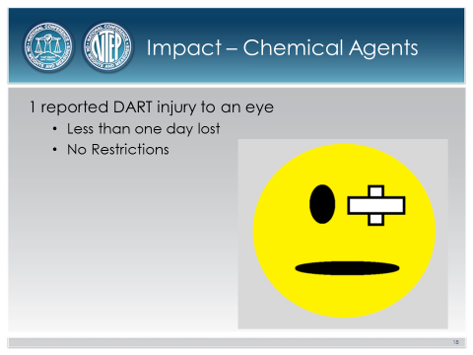 | 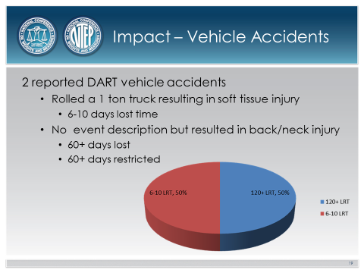
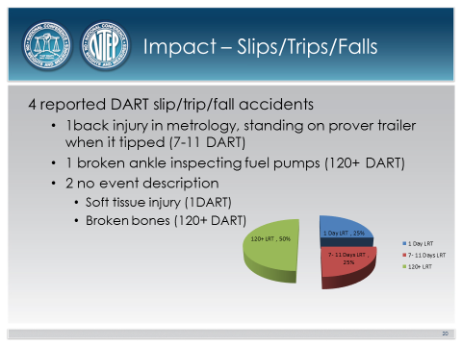 | 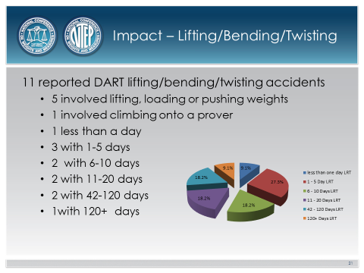

Ms. Angela Godwin, Ventura County, California | Committee Chair
Mr. Stacy Carlsen, Marin County, California | Member
Ms. Julie Quinn, Minnesota | Member
Mr. Doug Killingsworth, Georgia | Member
Ms. Cheryl Ayer, New Hampshire Member
Mr. Richard Shipman, Rice Lake Weighing Systems | Associate Membership Representative
Ms. Tina Butcher | NIST Liaison
Mr. Ross Andersen | Certification Coordinator
Professional Development Committe

DART Days Away/Restricted Time.

