Report of the
Professional Development Committee (PDC)
Stacy Carlsen, Marin County, California
Committee Chair

4000 INTRODUCTION
This is the final report of the Professional Development Committee (PDC) (hereinafter referred to as the “Committee”) for the 102nd Annual Meeting of the National Conference on Weights and Measures (NCWM) held in Pittsburgh, Pennsylvania, July 16 - 20, 2017. This report is based on the Interim Report offered in the NCWM Publication 16, “Committee Reports,” testimony at public hearings, comments received from the regional weights and measures associations and other parties, the addendum sheets issued at the Annual Meeting, and actions taken by the membership at the voting session of the Annual Meeting. The Informational items shown below were adopted as presented when this report was approved.
Table A identifies the agenda items by reference key, title of item, page number and the appendices by appendix designations. The acronyms for organizations and technical terms used throughout the agenda are identified in Table B. The first four digits of an item’s reference key are assigned from the Subject Series List The status of each item contained in the report is designated as one of the following: (D) Developing Item: the Committee determined the item has merit; however, the item was returned to the submitter or other designated party for further development before any action can be taken at the national level; (I) Informational Item: the item is under consideration by the Committee but not proposed for Voting; (V) Voting Item: the Committee is making recommendations requiring a vote by the active members of NCWM; (W) Withdrawn Item: the item has been removed from consideration by the Committee.
Table C provides a summary of the results of the voting on the Committee’s items and the report in its entirety. Some Voting Items are considered individually; others may be grouped in a consent calendar. Consent calendar items are Voting Items that the Committee has assembled as a single Voting Item during their deliberation after the Open Hearings on the assumption that the items are without opposition and will not require discussion. The Voting Items that have been grouped into consent calendar items will be listed on the addendum sheets. Prior to adoption of the consent calendar, the Committee will entertain any requests from the floor to remove specific items from the consent calendar to be discussed and voted upon individually.
Proposed revisions to the handbook(s) are shown as follows: 1) deleted language is indicated with a bold face font using strikeouts (e.g., this report), and 2) proposed new language is indicated with an underscored bold-faced font (e.g., new items). When used in this report, the term “weight” means “mass”.
Note: The policy is to use metric units of measurement in all its publications; however, recommendations received by NCWM technical committees and regional weights and measures associations have been printed in this publication as submitted. Therefore, the report may contain references to U.S. customary units.

Subject Series List

Introduction 4000 Series
Education 4100 Series
Program Management 4200 Series
Other Items 4300 Successions

Table A
Table of Contents
Reference Key | Title of Item | PDC -Page

4000 INTRODUCTION 1
4100 EDUCATION 3
4100-1 I Professional Certification Program 3
4100-2 I Training 10
4100-3 I Instructor Improvement 14
4100-4 I Recommended Topics for Conference Training 15
4200 PROGRAM MANAGEMENT 17
4200-1 I Safety Awareness 17
APPENDIX
A 4100-1 Draft Guidelines for Proctoring of Professional Certification Exams A1

Table B
Glossary of Acronyms and Terms

Acronym | Term | Acronym | Term
ADDIE | Analysis, Design, Development, Implementation, and Evaluation | NIST | National Institute of Standards and Technology
ANSI | American National Standards Institute | OWM | Office of Weights and Measures
BOK | Body of Knowledge | PDC | Professional Development Committee
CWMA | Central Weights and Measures Association | RSA | Registered Service Agents
ISO | International Standardization Organization | SIM | Inter-American Metrology System
ICE | Institute for Credentialing Excellence | SME | Subject Matter Expert
NCWM | National Conference on Weights and Measures | SWMA | Southern Weights and Measures Association
NEWMA | Northeastern Weights and Measures Association | WWMA | Western Weights and Measures Association

Table C
Voting Table

Reference Key  Number | House of State Representatives |  | House of Delegates |  | Results
 | Yeas | Nays | Yeas | Nays
To accept the Report | Voice Vote |  |  |  | Adopted

Details of All Items
(In order by Reference Key)

4100 EDUCATION

4100-1 I Professional Certification Program
Professional certifications are offered in many industries as a means of demonstrating competence in a field of expertise. Certification may be a means of qualifying an individual for employment or a higher pay grade within a profession. The NCWM Professional Certification Program provides confidence that an individual has a strong understanding of U.S weights and measures standards as adopted by NCWM and published in NIST Handbooks 44, “Specifications, Tolerances, and Other Technical Requirements for Weighing and Measuring Devices; 130, “Uniform Laws and Regulations in the Areas of Legal Metrology and Engine Fuel Quality,” and 133, “Checking the Net Contents of Packaged Goods.”
Professional certification is available to NCWM members and non-members in the private sector and in government positions. Please note that the person taking the test must be an NCWM member to take the exams for free. Professional Certifications are now available in six areas covering (in order of deployment): Retail Motor-Fuel Devices, Small Capacity Scales Class III, Package Checking – Basic, Medium Capacity Scales, Large Capacity Scales, and Vehicle-Tank Meters.
In December 2016, the Certification Coordinator delivered the materials for two new, basic competency exams. The NCWM staff is in the process of posting these exams to the testing website. The basic competency exams were created to provide an objective measure of development of new hires among regulatory officials and potentially test service agents for basic knowledge of weights and measures requirements. However, deployment of these new exams is on hold until the NCWM can establish a proctoring system to better ensure the integrity of the testing process. (See discussion later in this item.)
Work continues on additional certification exams. Priorities had been set to complete Liquid Petroleum Gas (LPG) Meters and Price Verification next. However, the Committee is elevating the priority of the Precision Scales exam ahead of the Price Verification exam considering comments heard at the 2017 Interim Meeting.
The PDC is always looking for additional subject matter experts (SME) volunteers for all active projects. Any interested parties should contact Mr. Andersen through the NCWM Headquarters at info@ncwm.net. The SME volunteers are the real heart of the certification program. The successful creation of these exams is dependent on willing volunteers.
Status of Current Tests
The NCWM has issued 638 professional certificates from inception of the Professional Certification Program to September 30, 2016. Of the certificates issued, six have been issued to individuals in the private sector (three for small scales, two for package checking, and one for retail motor-fuel dispensers). The balance of the certificates has been issued to regulators. It is important to note that some of the early certificates issued for Retail Motor-Fuel Devices have reached their five-year expiration. Those who earned certificates over five years ago will need to seek recertification. This will also begin to impact certifications for Small Scales and Package Checking that will reach five years of activity this August. The Committee is working with NCWM staff to find ways to alert certificate holders of expiration in advance so they can plan for recertification.
Number of Certificates NCWM Has Issued
as of the end of Fiscal Year 2016 (September 30)
 | FY 11-12 | FY 12-13 | FY 13-14 | FY14-15 | FY 15-16
Count in Year | 94 | 106 | 60 | 199 | 135
Cumulative | 138 | 244 | 304 | 503 | 638

Certification (posted) | Certificates
RMFD (5/2010) | 272
Small Scales (8/2012) | 153
Package Checking (8/2012) | 97
Medium-Capacity Scales (4/2015) | 48
Large-Capacity Scales (4/2015) | 30
Vehicle-Tank Meters (4/2015) | 38
The following map includes 31 states with individuals holding an active certificate in one or more disciplines. Please note that the six-active certificates issued to private sector individuals are included in these figures, for example, the two certificates in Arkansas are private sector individuals. This data only includes certificates that have not expired as of September 30, 2016.

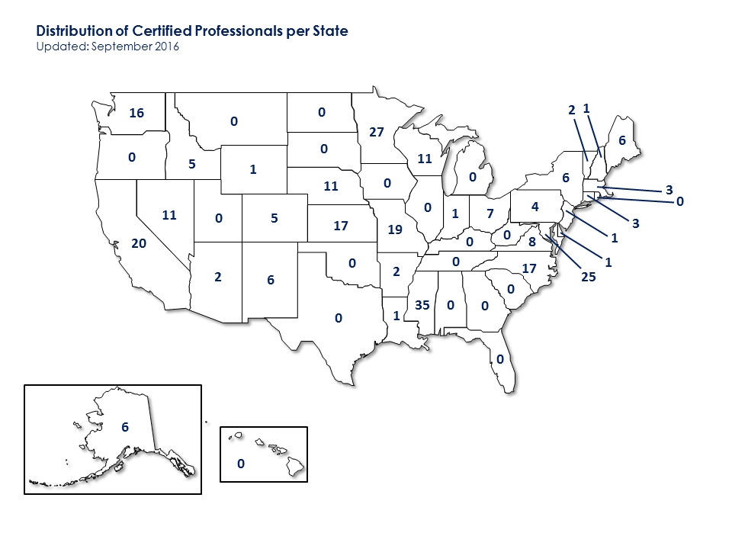

Number of Certificates Issued by State Since Program Inception*
State | Certificates | State | Certificates
Missouri | 100 | Idaho | 8
Minnesota | 92 | Maine | 8
Maryland | 65 | Colorado | 6
Mississippi | 40 | Pennsylvania | 6
Nebraska | 33 | New York | 5
Washington | 26 | Vermont | 5
Wisconsin | 26 | Wyoming | 5
North Carolina | 24 | Arkansas | 3
Alaska | 22 | Delaware | 3
Nevada | 22 | Arizona | 2
California | 21 | Michigan | 2
Virginia | 21 | Oregon | 2
New Mexico | 18 | Georgia | 1
Kansas | 17 | Louisiana | 1
Connecticut | 15 | Montana | 1
Ohio | 13 | New Hampshire | 1
Indiana | 12 | West Virginia | 1
Massachusetts | 11
* Includes expired certificates
The following maps show the states with individuals presently holding professional certification.
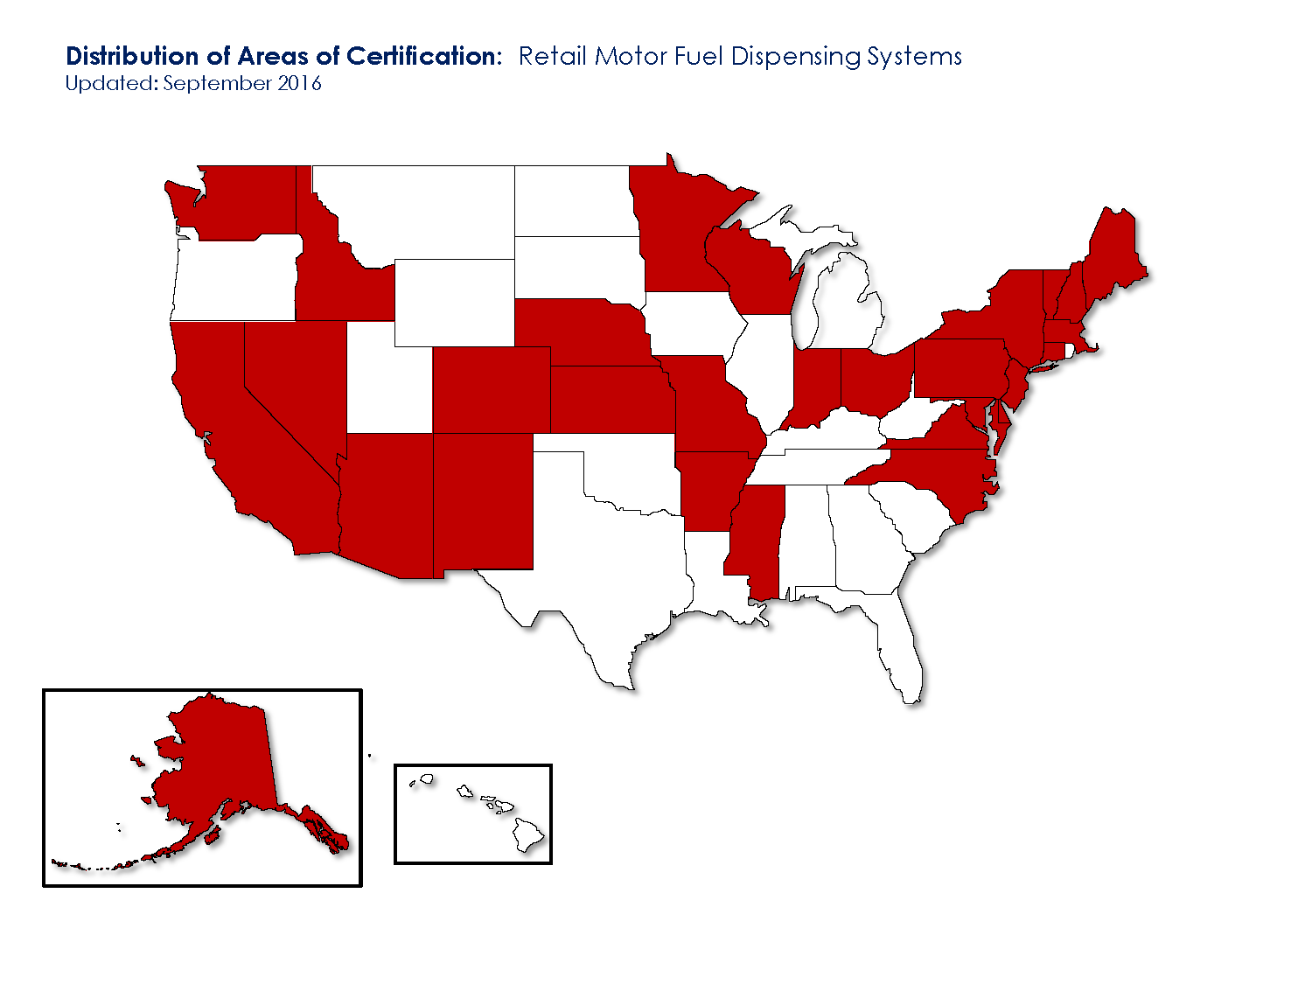

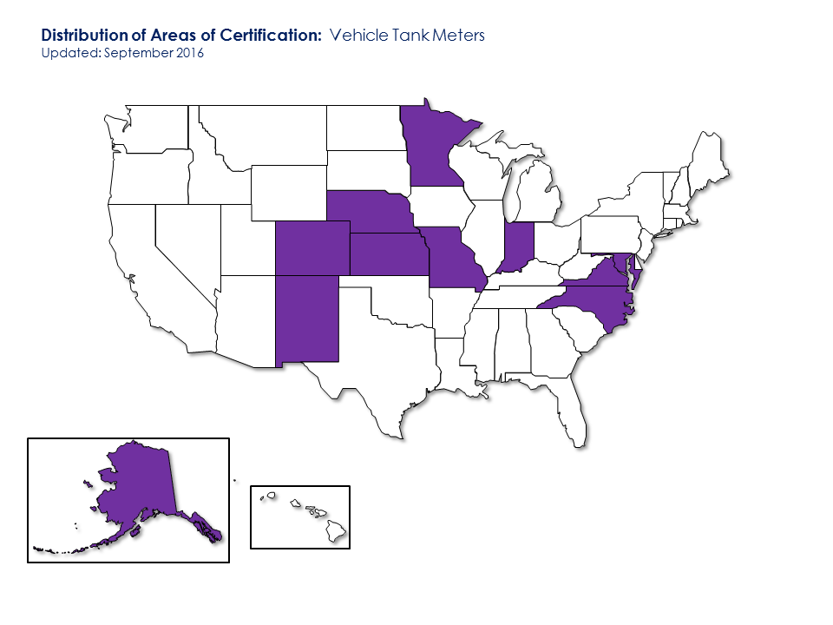

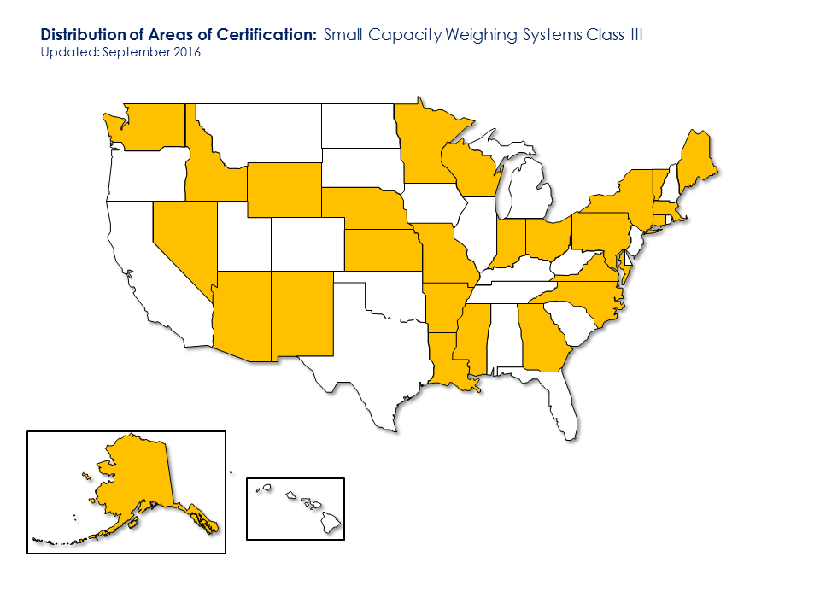

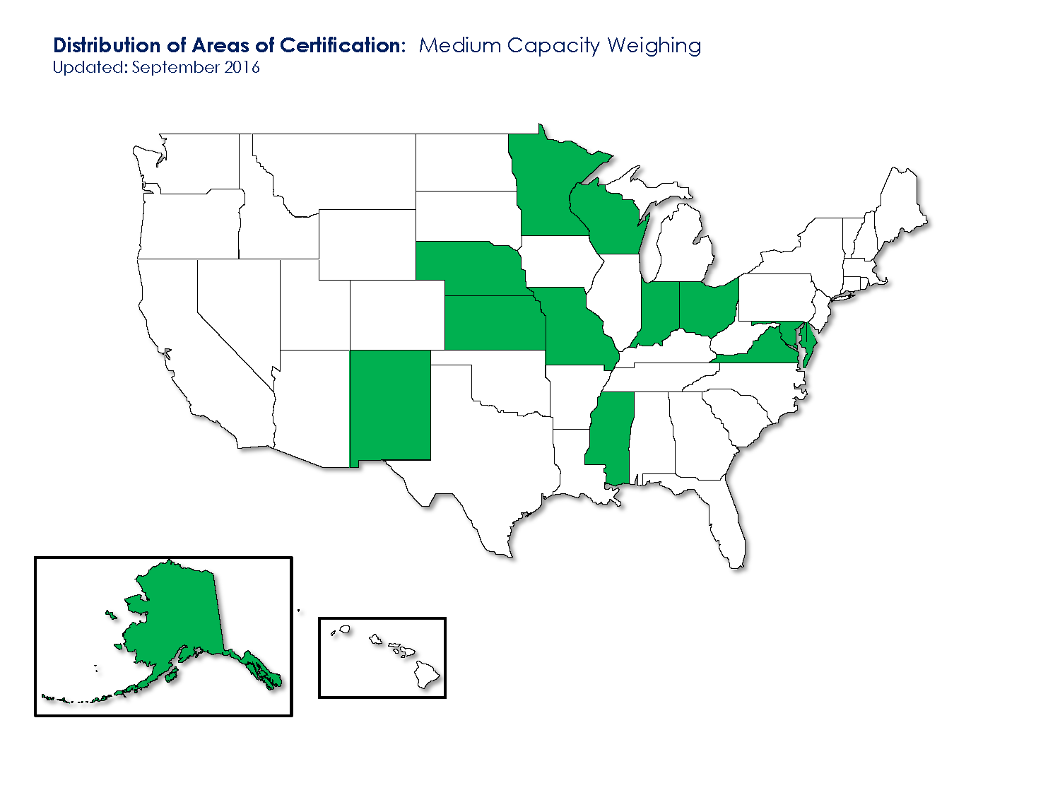

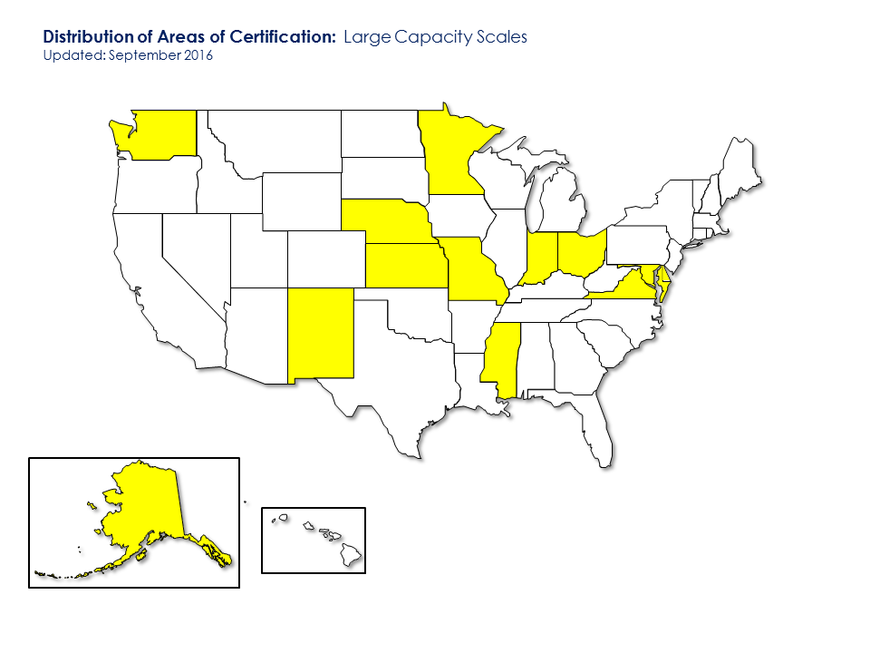

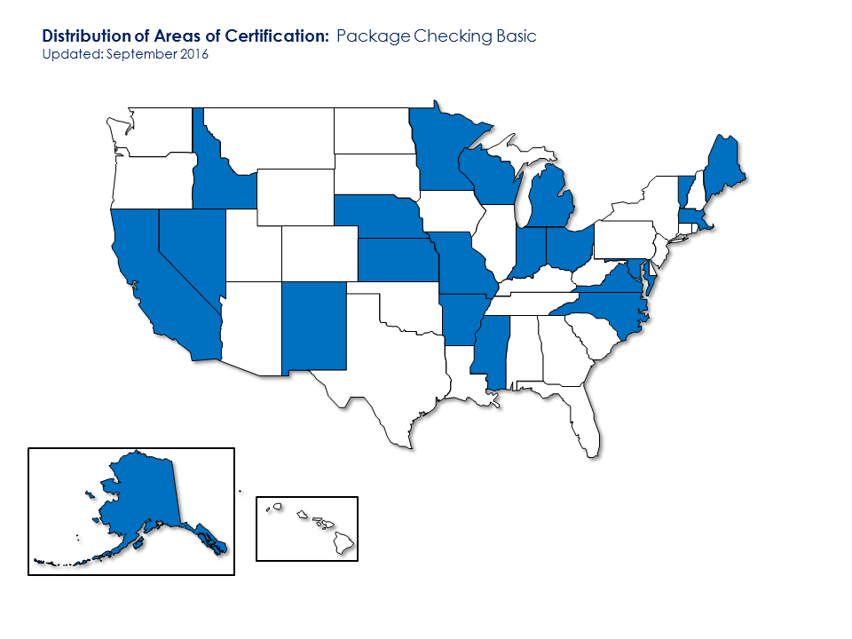
The Committee continually works to improve the exams and the exam experience. The key goal is to make sure the exams stay meaningful and current as handbook changes are made. This includes an annual review of the current exams by the Certification Coordinator. The Committee considered adding a short entry survey to each exam to capture meta-data on who is taking the exams. Examples of meta-data would have included the candidate’s level of experience, whether the candidate is a regulatory official or a service agent, and so forth. The plan was to place the entry survey questions in an untimed, unscored portion of the exam. However, we could not implement the plan because of limitations in the exam hosting software. Any questions added, even unscored, get counted in the total number of questions for calculation of the percentage. Since no correct answers were possible, these survey questions would have counted as wrong answers for the percent correct.
In order to obtain valuable feedback on the Certification Program, the Committee has been working to create an exit survey, which will be implemented using Survey Monkey. The questions on the exit survey will address the meta-data mentioned earlier, mechanics of taking the exam, preparation for taking the exam, and general feedback (e.g., How did the candidate react to the content of the exam? Was it challenging? Was it too easy? Did the candidate feel the exam was fair?). The Committee has prepared a series of survey questions and will be working with the NCWM staff to deploy the survey. When it is ready, we will create links to the survey from the NCWM website. We highly encourage candidates to take the survey after their exam experience.
Status of Current Projects
The Committee keeps the goal of accrediting the Professional Certification Program as an important long-term objective. The PDC endeavors to create an infrastructure that will eventually support accreditation. Proctoring is one of those infrastructure items we believe is necessary to accreditation. The Committee worked on a set of guidelines for proctoring. These guidelines impact both the candidate and the proctor. For the candidate, the guidelines will prohibit bringing materials into or taking materials out of the exam, having a cell phone activated, accessing the internet, or other computer programs while taking the exam, etc. For the proctor, the guidelines will establish who can serve as a proctor (with approval of the NCWM). The Committee is looking at allowing state weights and measures divisions to provide the proctor but is recommending the proctor be someone other than an immediate supervisor. It could be someone from the personnel department or some independent third party. The Committee is still considering using private proctoring services. The guidelines specify what the proctor must provide the candidate, items such as scrap paper, clean copies of pertinent NIST Handbooks, computer access, and a quiet environment to take the exam, etc. It further requires the proctor to collect all scrap paper, as no written materials may be removed from the testing site to protect the integrity of the questions. The current draft of the guidelines appears in Appendix A.
A decision was made in the fall of 2016 to establish cooling-off periods. We found that some candidates were taking the exam three or more times in rapid succession. The candidates were originally allowed two attempts to pass the exam for one fee. Candidates were simply paying the fee again and retaking the exam, and for those who were members, the fee was zero. The Committee recommended to the NCWM Executive Director that we establish a cooling-off period of four weeks for professional certifications and two weeks for the basic competency exams. This will allow additional preparation time for the candidate before taking the exam again.
As mentioned earlier, the two basic competency exams were delivered to NCWM by the Certification Coordinator and are awaiting the proctoring piece before being implemented. Each two-part exam has a general component covering NIST Handbook 44 and a specific part covering the basic elements of the measurement type. Each exam is based on 30 questions with a one-hour time limit. The exams are almost entirely multiple-choice questions, but candidates will find it beneficial to understand how to search NIST Handbook 44 to find pertinent code sections. The weighing exam includes those devices in the Scales Code. The measuring exam includes devices in the Liquid-Measuring Devices Code and the Vehicle-Tank Meters Code. Based on guidance from the Board, the exams apply equally to regulatory officials and service agents. The Committee hopes the states may use the exams in their Service Person Registration Programs.
While awaiting the implementation on proctoring, the Committee is working with NCWM to get the modules for the basic competency exams up on the website. The modules contain the learning objectives on which the exam is based. You can find all the existing modules on the NCWM website by pointing to Professional Certification on the top navigation bar. Then select Body of Knowledge, and this page shows the curriculum workplan. You will find the active modules are hyperlinked. Click the module you want and download it to your computer. The NCWM modules are intended for wide distribution and may be freely copied.
The Committee appreciates the comments received at the 2017 Interim Meetings. Of note, Mr. Steve Giguere (Maine) asked if there was a mechanism that would notify the supervisor with the results when an employee takes a certification exam? The Committee explained the log-in credentials permit a candidate to go to the test site and access copies of all active certificates earned. Currently, this places the responsibility on the candidate to alert their supervisors. The Committee further committed to consider options to notify second parties.
A comment was received from Ms. Kristen Macey (California ) asking to upgrade the priority of the Precision Scale certification based on the new phenomenon of cannabis as a legally traded commodity. The Committee deliberated and, as noted above, directed the Certification Coordinator to move the priority for this exam ahead of Price Verification.
Regional Association Comments:
The WWMA PDC continues to support this item as Informational. The Committee heard comments supportive of the testing programs during the open hearings and suggestions for using the program in RSA licensing.
The CWMA reported that the bulk of the comments were from people wanting to know the area of competency the participant got wrong for further study. People also said they wanted the results to be forwarded to state jurisdictions and employers. There was consensus that taking basic competency tests would make both service agents and regulatory officials more proficient in NIST handbooks, because instead of knowing just the details of a specific device, they will know where to look for the answers.

4100-2 I Training
The purpose of this item is to share best practices and approaches to training in response to the broad training needs of the weights and measures jurisdictions and to serve as a link to various training materials on the web.
At the 2016 NCWM Annual Meeting, the Committee heard an update on NIST OWM Training provided over the past 12 months. Ms. Tina Butcher (NIST OWM) noted that OWM provided 47 classes in the past 12 months, resulting in the awarding of more than 1340 Continuing Education Units (CEUs). These classes involved both public and private sector participants (including other countries in the Inter-American Metrology System [SIM]) and focused on the following areas.
- Laboratory Metrology (more than 470 students participated)
  - Seminars on Fundamentals on Mass and Volume Metrology and Lab Administration
  - Webinars for students from state and industry metrology laboratories on subjects such as document control, contract review, and procedures for documenting traceability, and calibration intervals
- Weighing and Measuring Devices
  - Seminar in North Carolina on LPG Liquid-Measuring Systems (22 students from 13 states)
  - Seminar in South Dakota (held concurrently with the CWMA) on Retail Motor-Fuel Dispensers (24 students from 10 states)
  - Webinars on Pour and Drain Procedures (27 students from 16 states)
- Package Control
  - Seminars in Nevada, California, Texas, Nebraska, Kentucky, and other states on the inspection of packages for accurate labeling and net weight (105 students)
  - Seminar in Nevada on Price Verification procedures in retail stores (19 students)
Ms. Butcher also reported that the following OWM training was scheduled for the remainder of 2016:
  - August 2016 – NIST Trainer Seminar – Packaging
  - October 2016 – Liquefied Petroleum Gas Liquid-Measuring Systems (Alaska)
  - October 2016 – Compressed Natural Gas Metering Systems (Utah)*
*Editor’s Note: This training on CNG Metering Systems has since been delayed until spring 2017 at the request of the host jurisdiction.
At the 2017 Interim Meeting, Ms. Tina Butcher (NIST OWM) provided an overview of NIST training courses planned in the coming year. She noted information regarding these classes, including whether space is still available, which can be found on NIST’s website under NIST OWM’s “Calendar of Events.”
Ms. Butcher reported that NIST will be hosting two Weights and Measures Administrators’ Workshops on March 27 - 31, 2017, and 10 - 14, 2017. The workshops will be structured to cover information primarily of interest to new administrators at the beginning of each workshop, and information relevant to experienced administrators will be during the latter portion of each workshop with a day of overlap in between. However, all experience levels are encouraged to attend the entire workshop, and this wide range of participation would greatly enhance the experience for all participants. The agenda will include industry panels and presentations of best practices from current administrators.
Ms. Kristin Macey (California) commented that many jurisdictions are dealing with the sale of legalized marijuana as well as other new technologies and applications. She asked Ms. Butcher if NIST has considered this and other areas regarding the availability of NIST training and technical materials. She also asked Mr. Ross Andersen (NCWM Certification Coordinator) if this has been considered within the NCWM Certification Program. Ms. Butcher and Mr. Andersen reported that this area isn’t currently addressed but could be considered in the future. Both acknowledged the need to continually consider new areas when prioritizing work and expressed appreciation for the ideas.
At the 2017 Annual Meeting, Ms. Butcher provided a brief update on the courses planned for the coming year and noted that a full listing will be included in the Committee’s Final Report; the full listing appears below. She also noted that scheduled training is contingent on NIST OWM’s budget, and anyone interested in these courses should consult OWM’s “Calendar of Events” at: www.nist.gov/pml/weights-and-measures/about-owm/calendar-events.
Packaging & Price Verification
NIST Handbook 133 – “Checking the Net Contents of Packaged Goods,” Basic:
- March 2017 – Illinois and North Carolina (complete)
- October 23 - 27, 2017 – Sonoma, California
- November 27 - 28, 2017 – Gaithersburg, Maryland (Industry Only)
- February 5 - 8, 2018 – San Diego, California
- March 26 - 29, 2018 – Lebanon, Missouri
- April 16 - 19, 2018 – Montgomery, Alabama
- May 14 - 17, 2018 – Pompano Beach, Florida
NIST Handbook 130 – “Uniform Laws and Regulations in the Areas of Legal Metrology and Engine Fuel Quality,” Packaging and Labeling
- April 2017 – Texas and June 2017 – Maryland (complete)
- September 25 - 28, 2017 – Burnsville, Minnesota
- March 12 - 15, 2018 – Orange County, California
- June 5 - 7, 2018 – Cleveland, Ohio
Price Verification
- May 2017 – NEWMA Annual Meeting (complete)
- October 10 - 11, 2017 – SWMA Annual Meeting, Little Rock, Arkansas,
Laboratory Metrology
Fundamentals of Metrology
- December 4 - 8, 2017 – Gaithersburg, Maryland
Mass Metrology Seminar
- October 23 - November 3, 2017
Advanced Mass Seminar
- August 21 - 31, 2017 – Gaithersburg, Maryland
Balance & Scale Calibration & Uncertainties (User Uncertainties
- January 9 - 12, 2018 – Gaithersburg, Maryland
Webinars – August 2017 through October 2018
- Multiple webinars are being offered; see OWM Calendar of Events for a complete listing with dates.
Topics include:
  - Contract Review
  - Document Control and Record Keeping
  - State Lab Annual Submission Process
  - Internal Auditing Best Practices
  - Conducting an Effective Management Review
Regional Measurement Assurance Programs
- Northeast Measurement Assurance Program (NEMAP)
  - September 18 - 21, 2017 – Charleston, West Virginia
- Southwestern Assurance Program (SWAP)
  - October 2 - 5, 2017 – Topeka, Kansas
- Mid-America Measurement Assurance Program (MidMAP)
  - October 16 - 19, 2017 – Lansing, Michigan
Weighing and Measuring Devices
Compressed Natural Gas Metering Systems
- April 2017 – Utah and June 2017 – Indiana (complete)
- Spring 2018 – Sacramento, California
LPG Liquid-Measuring Systems
- April 2017 – Oregon (complete)
- Spring 2018 – Sacramento,California
- June 11 - 15, 2018 – Ohio
Retail Motor-Fuel Dispensers
- June 2017 – California (complete)
- October 23 - 26, 2017 – Harrisburg, Pennsylvania, Pennsylvania Weights and Measures Association
Livestock and Animal Scales
- May 2017 – Kansas (complete)
- September 26 - 28, 2017 – WWMA Annual Meeting - Arizona
Medium Capacity Scales
- May 2017 – CWMA Annual Meeting (complete)
Ms. Butcher reported that based on the number of registrants, only one of the Administrator Workshops (referenced at the 2017 Interim Meeting) was held in spring 2017.
Regional Association Comments:
The WWMA recommended keeping this item Informational, recognizing the continued effort to increase our professional skills. The Committee appreciates the financial support and partnership between NIST OWM and NCWM.
The CWMA received comment that Nebraska would be hosting NIST OWM Medium Capacity Scale Training in conjunction with the CWMA Annual Meeting with fourteen seats available at the time of their fall meeting. Registration can be completed on the NIST OWM site. Participants must attend all sections of the two-day training to receive credit.
At the May 2017 CWMA Annual Meeting, a representative of Minnesota mentioned that a NIST Packaging and Labeling class is being offered in September in Burnsville, Minnesota. Registration for this class may be found at www.nist.gov/owm. A comment was made that people would like to see NIST administrator trainings happen more frequently or at least every two years.

4100-3 I Instructor Improvement
NIST OWM has provided legal metrology training for weights and measures jurisdictions and industry for many years but does not have the resources to respond to the numerous training requests it receives. OWM has long recognized there are many individuals with extensive legal metrology experience who have the skills needed to provide this type of training, and, in some cases, those individuals are already training within their own jurisdictions or regions. Drawing from this pool of individuals, OWM hopes to develop trainers who can present schools on behalf of NIST, thus leveraging NIST resources; providing access to NIST training on a timetable that can meet jurisdictions’ needs; and providing a way to more broadly share the valuable expertise these individuals possess.
Several years ago, OWM renewed its efforts to develop trainers by providing a grant to the NCWM that is intended to pay travel costs of individuals to travel within their regions to conduct training and to participate in NIST training for trainers. This partnership has enabled NIST to bring in candidates for NIST-sponsored training such as “train the trainer” classes and to participate in NIST technical training schools. Through an application process, in collaboration with weights and measures directors and nominated training candidates, NIST has identified a group of people who are now working with NIST to develop the knowledge, skills, and abilities to present specific technical schools on behalf of NIST. Candidates not only participate in “train the trainer” seminars, but also work with NIST staff to participate in technical training schools, assist in teaching seminars, and develop materials for use in NIST training schools.
NIST training seminars on field inspection topics are only held a limited number of times each year. This poses a challenge in sustaining regular interaction and involvement of NIST trainer candidates. OWM is considering how to ensure timely mentoring and continuity for individual instructors who will provide training on behalf of NIST. A number of candidates in the NIST Trainer Program have already served as co-instructors for NIST technical training schools and have done an excellent job. OWM sincerely appreciates the willingness of those trainers and their directors who have supported their participation to devote time to making these seminars successful.
A list of all people who have attended a “Train the Trainer” class has been posted on the NCWM website, whether or not they have worked with NIST as co-trainers or attended NIST technical training schools. OWM has not yet certified anyone (external to NIST) as a “NIST Trainer,” but looks forward to doing so once the structure of the Trainer Program is finalized and candidates have satisfied all requirements. At this point, a list of “NIST Trainers” will be posted along with the courses they are authorized to teach on behalf of OWM, and this list will be periodically updated as new trainers and technical areas are authorized. NIST does not have the resources to develop and sustain the development of all the trainers it invites to participate in NIST trainer program activities and events; however, even if a candidate is not designated to present on behalf of NIST, they and their jurisdictions can benefit from the experience, and the candidate can still provide valuable training in their jurisdiction and region.
OWM is also looking at ways to enhance and streamline its training and help prepare students prior to a training class. Students are currently required to complete a self-study course on NIST Handbook 44 prior to attending NIST device-related training seminars. NCWM has graciously agreed to offer an exam for this self-study course through the NCWM Certification Program system and is awaiting feedback from NIST on a beta version of the online exam. As an additional measure, NIST contracted with Mr. Henry Oppermann (Weights and Measuring Consulting) who developed a Basic Measuring Course. NIST plans to offer this course as a self-study course and may require it as a prerequisite to participating in NIST seminars on measuring devices. OWM plans to develop a similar course for weighing devices.
OWM appreciates the strong support of the NCWM, the PDC, the volunteer trainers, and their administrators in continuing to develop the NIST Trainer Program. OWM will continue to provide the Committee with updates on its progress as well as continue to collaborate with and support the Committee in its work.
The Committee continues to hear comments from states expressing appreciation for the NCWM Professional Certification Program and the NIST Training Program. The Committee also heard favorable comments about the training materials and tools provided by NIST, including a video on testing retail motor-fuel dispensers
Regional Association Comments:
The WWMA supports the ongoing efforts of the NIST, OWM Train the Trainer Program.
The CWMA reported that members expressed the desire for NIST to complete certification of some of the Train-the-Trainer participants so they would be available to independently lead more trainings in more settings. Comments were also heard that jurisdictions would like multiple routes to meet NIST OWM advanced course prerequisites. Examples would be equivalent training from other trainers, training organizations, or competency tests.

4100-4 I Recommended Topics for Conference Training
The Board of Directors has charged the Committee with recommending appropriate topics for the technical sessions at future Annual Meetings. The Board of Directors asks the PDC to review and prioritize possible presentation topics and to submit those to the NCWM Chairman. The Chairman will coordinate with the NCWM staff to secure presenters.
The following is a list of technical presentations made at the NCWM since 2009. Presentations given since 2010 are available at www.ncwm.net/meetings/annual/archive.
- Planning and Coordinating a National Market Place Survey (Ms. Rachelle Miller, Wisconsin, 2017);
- The Life Cycle of Petroleum from Well to Retail (Mr. Prentiss Searles, API, 2017);
- The United States Mint at Denver, Colorado – Gold, Coins, and Embezzlement (Mr. Thomas Fesing, 2016)
- Understanding Transportation Network Systems (Ms. Andrea Ambrose Lobato, Lyft and Mr. Bob O’ Leary, Uber, 2016)
- Regulatory Consideration for Legalized Marijuana (Ms. Julie Quinn, Minnesota, and Mr. Nick Brechun, Colorado, 2016)
- Motor Oil Quality Violations (Mr. Tom Glenn, Petroleum Quality Institute of America, 2014);
- Making Sense of Electronic Receipts (Mr. Justin Hotard, Vice President and General Manager, NCR Corporation, 2014);
- LNG and CNG Motor Fuel – A Technical Briefing from Industry (Mr. Doug Horne, President CVEF, Mr. Zack Wester, Blu and Mr. Jeff Clarke, NGVA, 2014);
- Taximeter Technology Advancements (Mr. Matt Daus, International Association of Transportation Regulators, 2013);
- Advanced Vehicles and Fuel Quality (Mr. John M Cabaniss, Jr., Association of Global Automakers, 2013);
- Economic Justification and Demonstrating Value of Weights and Measures (Mr. Tim Chesser, Arkansas Bureau of Standards, 2012);
- Conducting Effective Marketplace Surveys and Investigations (Ms. Judy Cardin, Wisconsin Weights and Measures, 2012);
- Public Relations and Customer Service as Regulators (Mr. Doug Deiman, Alaska Division of Measurement Standards/CVE, 2012);
- An Overview of Unit Pricing in the United States (Mr. David Sefcik, NIST OWM, 2011);
- Grocery Unit Pricing in Australia (Mr. Ian Jarratt, Queensland Consumers Association, 2011);
- Grocery Unit Pricing in Canada (Mr. Ian Jarratt, Queensland Consumers Association, 2011);
- The U.S. Hydrogen Measuring System: The Turning Point? (Ms. Kristin Macey, California Division of Measurement Standards, 2011);
- Corrosion in Ultra Low Sulfur Diesel Underground Storage Systems (Mr. Prentiss Searles and Ms. Lorri Gainawi, American Petroleum Institute, 2010);
- Risk-Based Inspection Schemes (Mr. Henry Oppermann, Weights and Measures Consulting, LLC, 2010);
- Diesel Exhaust Fluid (DEF) (Mr. Gordon Johnson, Gilbarco, Inc., and Mr. Randy Moses, Wayne, 2009);
- Fuel Volatility and Ethanol Blending (Mr. Jim McGetrick, BP Products, 2009);
- Investigative Techniques (Mr. Michael Cleary, Retired, 2009);
During open hearings at the 2016 Interim Meeting, the Committee heard a suggestion from Ms. Kristin Macey (California Division of Measurement Services) for a training session on transportation network systems. Mr. Doug Musick (Kansas) commented that this type of technology is showing up in applications other than just passenger transportation and suggested that training in GPS-based measuring systems in general would be beneficial. He noted his jurisdiction is encountering large numbers of GPS-based measuring systems being used in assessing charges for the sale, application of crop fertilizers, and other treatments. He noted that the monetary impact is significant.
The Committee also heard comments from Mr. Jim Pettinato (FMC), Chairman of the NTEP Software Sector, who noted that training on issues related to inspection of software-based systems may be beneficial to weights and measures jurisdictions. He noted that, with the current progress of proposals through the NCWM process, the Sector is wrapping up its initial work and suggested the Sector and its members might be able to assist in training on legal metrology issues relative to software-based weighing and measuring systems. Ms. Julie Quinn (Minnesota) commented that this assistance might be particularly helpful in assisting weights and measures jurisdictions in understanding and educating inspectors and service personnel on audit trails used in these devices. She noted the audit trail training is the most frequently requested training topic in her jurisdiction.
The Committee appreciates the input and ideas it has received regarding suggested training topics. Based on the comments received during its open hearings, comments from the fall 2015 regional association meetings, past suggestions, and discussions during its Interim Meeting work sessions, the Committee proposes that the BOD consider offering technical presentations on the following topics:
- Verifying Compliance of Software-Controlled Weighing and Measuring Systems
  - This might include the verification of software versions, security, and other metrologically significant issues.
- Understanding Transportation Network Systems
- GPS-Based Measuring Systems Used in Applications Other Than Passenger Transport
- Vehicle-Tank Metering Systems “Flush Systems”
- Credit/Debit Card Skimmers
The Committee also discussed the audience that is typically present at NCWM Annual and Interim Meetings, noting that inspectors and service personnel are not always able to participate in these meetings. The Committee believes it would be beneficial not only to offer training on key issues such as those listed above at the NCWM meetings, but to have the training made available at regional and state weights and measures association meetings where more inspectors and service personnel would be likely to attend. Some aspects of the training might need to be tailored more toward field inspection than weights and measures administration, but much of the content should be the same. The Committee would like to collaborate with regional weights and measures associations to suggest that similar training be provided at the regional level.
At the 2016 NCWM Annual Meeting, the Committee suggested that technical training on safety programs be included at Regional and National Meetings, including an update provided by Ms. Julie Quinn at the 2016 Annual Meeting. The Committee received no additional suggestions or comments regarding proposed training topics.
Regional Association Comments:
The WWMA PDC recommends continued support for ongoing training opportunities.
The CWMA recommended two topics for the CWMA Annual Meeting, which might also be of interest to the NCWM:
- A panel on blender pumps relating to flex fuel and biodiesel blending. Topics to include dispenser labeling, blend ratios, proper sampling, flow rates, and other mechanical issues affecting accuracy.
- Protecting employees from active shooters and interpersonal violence in remote locations.
Mr. Prentiss Searles from API also volunteered to provide a presentation at the 2017 Annual Meeting on “The Life Cycle of Petroleum from Well to Retail” if there is interest from the group. Mr. Paul Lewis from Rice Lake recommended that the local OSHA inspector be asked to talk at the NCWM Annual Meeting about what OSHA standards apply to weights and measures work.
The SWMA received comment from Mr. Russ Lewis, representing API, who offered to provide A to Z distribution awareness training on petroleum fuels to all regions. This offer was received well by the Committee and members.
NEWMA received a suggestion for “Software Systems” training. At a minimum, the regulator was interested in a basic training for audit trails since there is advancing and changing technologies.

4200 PROGRAM MANAGEMENT

4200-1 I Safety Awareness
One of the goals of the PDC is to educate jurisdictions on safety issues and to provide resources to help them implement effective safety and health management programs. The Committee intends to use the safety page on the NCWM website (www.ncwm.net/resource/safety) as a place for states to share information and resources to help them address each of the major steps in creating and maintaining an effective safety program.
One such resource is the recently published draft of OSHA’s Safety and Health Management Program Guidelines (www.osha.gov/shpmguidelines/SHPM_guidelines.pdf). This 44-page document is written in plain language and is aimed at helping small organizations establish, maintain, and improve safety and health management programs. It provides guidance on the seven-core elements of safety and health program management:
• Management Leadership
• Worker Participation
• Hazard Identification and Assessment
• Hazard Prevention and Control
• Education and Training
• Program Evaluation and Improvement
    - Coordination and Communication on Multi-Employer Worksites
Ms. Julie Quinn (Minnesota), PDC Safety Liaison, reported on the results of the 2017 safety survey, which covers incidents occurring in 2016. The top three causes of lost or restricted time for the second year in a row were:
  - Lifting/twisting/bending 54.5 % – 6 incidents
    - Soft tissue injuries (3), Back or neck injuries (3)
- Lost days – 60 + days (2), 21 - 60 days (2), 0 - 5 days (2)
- Restricted days – 60 + days (1), 16 - 20 days (1), 6 - 10 days (1), 0 - 5 days (3)
  - Slips/trips/falls 18.2 % – 2 incidents
- Soft tissue injuries (1), broken bones (1)
- Lost days – 21 - 60 days (1), 6 - 10 days (1)
- Restricted days – 16 - 20 days (1), 6 - 10 days (1)
  - Vehicle accidents 18.2 % – 2 incidents
    - Soft tissue injuries (2)
    - Lost days – 0 - 5 days (2)
    - Restricted days – none
Ms. Quinn also reported the NCWM Safety Task Group had its inaugural meeting on Sunday, July 16. Their first meeting focused on the economic impact of safety. At this meeting, the Task Group decided to add one more question to the 2018 survey to track those “near-miss” incidents which had property damage costs or other expenses associated with them. The Task Group also began developing a spreadsheet that will help agencies track information to be included in the survey. This includes information such as the cost of incidents resulting in lost and restricted days; near-miss incidents, which do not result in lost or restricted time beyond the initial day of injury but result in property damage, medical expenses, or other costs; and other information.
The Committee expresses appreciation to the members of the Safety Task Group for their willingness to volunteer for this important work.
- Ms. Julie Quinn (Minnesota), Chair
- Mr. Jason Flint (New Jersey)
- Ms. Georgia Harris (NIST OWM)
- Ms. Elizabeth Koncki (Maryland)
- Mr. Matt Maiten (Santa Barbara County, California)
- Ms. Brenda Harkey (South Dakota)
- Mr. Mike Sikula (New York)
- Ms. Tisha Arriaga (Marathon Petroleum)
- Mr. Bill Callaway (Crompco)
- Mr. Remy Cano (Northwest Tank and Environmental Services, Inc.)
- Mr. Joe Grell (Rice Lake Weighing Systems, Inc.)
- Mr. Brad Fryburger (Rinstrum, Inc.)
- Mr. Robert LaGasse (Mulch and Soil Council)
- Mr. John Lawn (Rinstrum, Inc.)
Other potential items for future inclusion on the safety page include links to resources on:
• OSHA consultation services
• Job hazard analysis
• Field level hazard analysis
• Hierarchies of hazard control
• Safety training resources
Each safety program is unique to its organization. Each agency is responsible for designing, implementing, and maintaining its own safety program. Resources provided on the web page are intended only to assist agencies as they develop and improve their own safety programs. Safety is not only first; it is first, last, and always. The work of maintaining and improving a safety program never ends.
Currently the NCWM safety page houses the list of regional safety liaisons and an archive of past safety articles.
Regional Safety Liaisons:
Central Weights and Measures Association (CWMA):
Ms. Julie Quinn, Minnesota Weights and Measures Division
Northeastern Weights and Measures Association (NEWMA):
Mr. Michael Sikula, New York Bureau of Weights and Measures
Southern Weights and Measures Association (SWMA):
Ms. Elizabeth Koncki, Maryland Department of Agriculture
Western Weights and Measures Association (WWMA):
Mr. Brett Gurney, Utah Department of Agriculture and Food
Regional Association Comments:
The WWMA PDC continues to support the importance of safety and the work being done by NCWM. The CWMA received comment that people would like to hear from an OSHA consultant at the NCWM meeting. The Committee encouraged all states to participate in the next safety survey. Private companies are also urged to participate. Government agencies will be invited to participate via the Director’s list service or private companies should contact Mr. Don Onwiler at the NCWM so they can be included in the e-mail invitation.
NEWMA expressed appreciation to Ms. Julie Quinn (Minnesota) for the fine job she did compiling the safety information she received, and the report she presented at the 2016 NCWM Annual Meeting. Individuals from NEWMA that were in attendance, agreed that Julie’s presentation was very well done and contained valuable information. It was stated that it was disappointing that the PDC agenda review took place so late in the day and there were so few individuals in attendance. Because of this situation, NEWMA heard several comments in favor of changing the order of the Standing Committee’s agenda reviews so Committees have equal exposure. Mr. Jimmy Cassidy, NCWM Chair-Elect, was in attendance and supported the concept of changing the order of the Committee’s agenda reviews.

Mr. Stacy Carlsen, Marin County, California | Committee Chair
Ms. Lori Jacobson, South Dakota | Member
Mr. Gene Robertson, Mississippi | Member
Ms. Cheryl Ayer, New Hampshire | Member
Mr. Marco Mares, San Diego County, California | Member
Mr. Richard Shipman, Rice Lake Weighing Systems | Associate Membership Representative
Ms. Julie Quinn, Minnesota | Safety Liaison
Ms. Tina Butcher | NIST Liaison
Mr. Ross Andersen | Certification Coordinator
Professional Development Committee

THIS PAGE INTENTIONALLY LEFT BLANK

Appendix A
Draft Guidelines for Proctoring Professional Certification Exams
Revised December 9, 2016
Rules for the Candidate
- Exams are Open Book but limited to the following:
- NIST Handbooks 44 (“Specifications, Tolerances, and Other Technical Requirements for Weighing and Measuring Devices”), 133 (“Checking the Net Contents of Packaged Goods”), and/or 130 (“Uniform Laws and Regulations in the Areas of Legal Metrology and Engine Fuel Quality”), as appropriate to the exam. Handbooks must be clean copies without margin notes or highlights.
- NIST Examination Procedure Outlines (EPOs) must also be clean copies.
- All questions on the exam are copyrighted by the NCWM. NO copying or sharing of the questions or answers is permitted in any form without expressed written approval of NCWM.
- Calculators may be used for the exam if they have been approved or supplied by the proctor. Approved models may have scientific and statistical functions and be capable of storing numeric values. Programmable calculators are not permitted, that is, those capable of storing multiple operation functions and calculation sequences.
- While taking the NCWM exam, candidates are not permitted to:
  - Receive assistance from any other person in answering questions;
  - Access e-mail, software applications, apps, or websites other than the NCWM testing service;
  - Use or operate cameras, cell phones, or memory devices, such as flash drives; or
  - Rewrite or copy questions or answers, in whole or in part. Candidates may use note paper, provided by the proctor, to perform calculations. All paper will be collected by the proctor at the end of the exam and will be destroyed.
- Candidates shall not write in the reference materials provided by the proctor and shall return any computers, calculators, or reference materials provided by the proctor in good condition.
Qualifications for Proctors
- Independent party, for example, a Human Resources representative, or an individual with limited conflict of interest and is removed from direct weights and measures training responsibilities, (e.g., Administration);
- Chosen by the State or local jurisdiction; and
- Approved by NCWM.
Rules for the Proctor
- Sign an agreement with NCWM acknowledging responsibilities and duties as a proctor.
- Provide a suitable environment for the candidate to take the exam and where the candidate’s activities can be closely monitored. Space should be free from outside noise, interruptions, etc.
- Provide a computer with internet capability for the exam. Under certain conditions, an approved and suitable computer may be provided by the candidate for exam use.
- Verify that the copies of reference materials used by the candidate are clean and free of margin notes or highlights. Exams are Open Book but limited to the following:
- NIST Handbooks 44, 133, and/or 130, as appropriate to the exam
- NIST Examination Procedure as applicable to the test, and the EPO(s) for devices included in the exam Announcement covered by the exam.
- Provide three sheets of blank copy paper for calculations. Additional sheets may be requested if required.
- Approve candidate’s calculator or supply an eight-digit scientific calculator with statistical functions for mean and standard deviation. Approved models may have scientific and statistical functions and may store values in memory. Programmable calculators are not permitted, that is, those capable of storing multiple operation functions and calculation sequences. If the calculator is provided by the proctor, ensure the candidate has time to become familiarized with the operations before the exam begins.
- Access the NCWM testing service through the NCWM website and enter the log-in credentials for the candidate.
- During the exam, the proctor shall ensure the candidate:
  - Does not receive assistance from any other person in answering the exam questions;
  - Does not access e-mail, software applications, apps, or websites other than the NCWM testing service;
  - Does not use or operate cameras, cell phones, or memory devices such as flash drives while taking the NCWM exam;
  - Does not rewrite or copy questions or answers, in whole or in part; or
  - Uses only note paper provided by the proctor to perform calculations.
- Answer questions from the candidate only with regard to the operation of the computer or the calculator provided by the proctor.
- After the candidate completes the exam, collect and account for all paper provided to the candidate and destroy any paper written on by the candidate.
- Ensure all computers, calculators, and reference materials provided by the proctor are returned in good condition.

