V. Examination Procedure for Price Verification

as adopted by
The National Conference on Weights and Measures*

A. Background

The NCWM established the Price Verification Working Group in 1993 to respond to public concern about price accuracy in retail stores. More than 500 retailers, consumer representatives, and state and local weights and measures officials participated in the development of the procedure. It was adopted by the NCWM at the 80th Annual Meeting in 1995.

The procedure applies to all retail stores, including food, hardware, general merchandise, drug, automotive supply, convenience, and club or other stores. Model inspection reports are included to promote the collection of uniform data. The model reports and uniform procedures will serve as the foundation for the collection and summarization of price accuracy data on a national basis. This information may be used to provide reliable information on price accuracy with a national perspective. The procedure provides administrators with the tools, guidance, and background information, as well as uniform test procedures and enforcement practices, to enhance the economic well being of consumers and retail businesses in their jurisdiction. By implementing this program in cooperation with industry, officials will help to restore and maintain consumer confidence in retail pricing practices and technologies, such as scanners, and provide economic benefits for consumers and the business community.

B. Status of Promulgation

The Examination Procedure for Price Verification was recommended for adoption by the Conference in 1995. The table beginning on page 10 shows the status of adoption of the procedure.

*The National Conference on Weights and Measures (NCWM) is supported by the National Institute of Standards and Technology (NIST) in partial implementation of its statutory responsibility for “cooperation with the states in securing uniformity in weights and measures laws and methods of inspection.”

THIS PAGE INTENTIONALLY LEFT BLANK
Examination Procedure for Price Verification

Table of Contents

Section Page
Section 1. Scope 193
Section 2. Definitions 193
2.1. Area. 193
2.2. Cents-off Representation. 193
2.3. Direct-Store-Delivery (DSD) Item. 193
2.4. Displays. 193
2.5. Hand-held Scanning Device. 193
2.6. Enforcement Levels. 193
2.7. Inspection Types. 194
2.8. Inspection Frequency. 194
2.9. Inspection Lot. 194
2.10. Merchandise Group. 194
2.11. Not-on-File Item. 194
2.12. Notification of Noncompliance. 194
2.13. Price Look-Up Code (PLU). 194
2.14. Prices. 195
2.15. Pricing Coordinator. 195
2.16. Pricing Integrity. 195
2.17. Sample. 195
2.18. Scanner. 195
2.19. Stock-Keeping Unit (SKU). 195
2.20. Store-Coded Item. 195
2.21. Stop-Sale Order. 195
2.22. Ticketed Merchandise. 195
2.23. Universal Product Code (UPC). 195
Section 3. Test Notes 196
3.1. Safety and Health. 196
3.2. Confidentiality of Findings. 196
Section 4. Materials and Equipment 196
Section 5. Pre-Inspection Tasks 196
Section 6. Inspection 197
6.1. Position of Equipment. 197
6.2. Other. 197
Section 7. Test Procedures 197
7.1. Application of Sampling Plans. 197
7.2. Table 1. Samples, Sample Collection, and Accuracy Requirements. 197
7.2.1. How to Use the Table 197
7.2.2. Samples. 198
7.3. Sample Collection Procedures (for use with either manual or automated inspection procedures). 198
7.3.1. Randomized Sample Collection. 199
7.3.1.1. Example 1. Illustrations of the Randomized Sampling Procedure. 200
7.3.2. Stratified Sample Collection. 203
7.3.2.1. Example 2. Two-Stage Manual Inspection using the Stratified Sampling Procedure. 205
7.4. Procedures for Test Purchases, Investigation of Consumer Complaints, and for Verification of Manually Entered Prices. 207
7.4.1. Procedure. 207
7.4.2. Alternative Procedure - Consumer Complaints. 208
7.4.3. Evaluation of Results. 208
Section 8. Documentation of Findings 208
Section 9. Evaluation of Inspection Results 208
9.1. Definition of Errors. 208
9.2. Computing Sample Errors. 209
Section 10. Accuracy Requirements 209
10.1. Accuracy Requirements. 209
10.2. Accuracy. 209
10.3. Ratio of Overcharges to Undercharges. 209
Section 11. Enforcement Procedures 210
11.1. Enforcement Steps. 210
11.2. Model Enforcement Levels. 211
Section 12. Post-Inspection Tasks 212
Section 13. Supervisory Activities 212
13.1. Baseline Surveys. 212
13.2. Follow-up Inspections. 212
13.3. Management Information Systems. 212
Section 14. Model Forms for Price Verification Inspections 213

Examination Procedure for Price Verification

Section 1. Scope

These procedures may be used to conduct price verification inspections in any type of store, including those that use Universal Product Code (UPC) scanners and price-look-up codes at the check-out counter as a means for pricing. Procedures are included for test purchases and verifying manual entries. The purpose of the procedure is to ensure that consumers are charged the correct price for the items they purchase. The “randomized” and “stratified” sampling procedures are intended for use in routine inspections to determine how well a store is maintaining price accuracy. Nothing in this procedure should be construed or interpreted to redefine any state or local law or limit any jurisdiction from enforcing any law, regulation, or procedures that relates to the accuracy of advertisements of retail prices, or any other legal requirement.
Section 2. Definitions

2.1. Area. – “entire store,” a “department,” “grouping of shelves or displays,” or other “section” of a store as defined by the inspector from which samples are selected for verification. “Non-public” areas of a store are not included (e.g., the area in a pharmacy where controlled drugs are kept or product store rooms).

2.2. Cents-off Representation. – Any printed matter consisting of the words “cents off” or words of similar import placed upon any item or on a label affixed or adjacent to an item, stating or representing by implication that it is offered for sale at a lower price than the ordinary and customary retail selling price (e.g., 15 % off, bonus offers, 2 for 1, or 1-cent sales, etc.).

2.3. Direct-Store-Delivery (DSD) Item. – An item delivered to a store, and usually priced, by route salespeople (e.g., milk, beer, soft drinks, bread, and snack foods).

2.4. Displays.

(a) Aisle Stacks or End-of-Aisle Displays. – Displays located in freestanding units or attached at the end of or adjacent to a tier of shelves.

(b) Tie-in Displays. – Displays of related products at secondary locations in a store (e.g., barbecue sauce on shelves in an aisle that may also be simultaneously displayed in the meat department of a food store).

(c) Multiple Displays. – Displays of the same product at several locations in a store.

2.5. Hand-held Scanning Device. – A portable device that scans UPC codes and also allows for the comparison of the price displayed on a shelf, item, or otherwise advertised to the price for the item in the point-of-sale database.

NOTE: These devices either retain a “batch” file of entered prices and identities for later comparison to the database or operate “on-line” via FM radio to the database. When used for price verification, they shall only be used with the active point-of-sale database. If you use a hand-held scanner, verify all price discrepancies by scanning the item at a check-out register and request a printed receipt to document the price that consumers would be charged.

2.6. Enforcement Levels.

NOTE: These recommendations are not intended to modify the enforcement policy of any jurisdiction unless they are adopted by the jurisdiction.

(a) Lower levels of enforcement actions. – Includes increased inspection frequency, stop-sale or correction orders, warning letters, and other notifications of noncompliance.

(b) Higher levels of enforcement actions. – Includes issuance of citations, administrative hearings, civil penalties, or prosecution under criminal statutes.

2.7. Inspection Types.

(a) Automated Inspection. – Inspections that are conducted using a hand-held scanning device.

(b) Manual Inspection. – Removing items from displays and taking them to a check-out terminal to verify the price (e.g., select the items and either (1) take them to a check-out terminal for scanning or (2) record the product identity, UPC number, and shelf price for each package on an inspection report) and then manually entering the UPC numbers in the register. The manual entries may be made by the official or by a store employee.

2.8. Inspection Frequency.

These recommendations do not modify the inspection policy of any jurisdiction unless adopted by the jurisdiction.

Inspection Control. – After a program has been in place for a period of time and a database is established, procedures can be developed to randomly select stores for inspection, or to focus inspections on stores with low levels of compliance.

(a) Normal Inspection Frequency. – An inspection made at the customary time interval used by an enforcement agency. Inspections may be conducted during normal business hours. Stores under this normal frequency should be inspected semi-annually or annually.

(b) Increased Inspection Frequency. – An inspection made more often than with the customary time interval, usually as a follow-up on prior violations. Inspections may be conducted during the normal business hours. Stores under this increased frequency should be inspected on a quarterly, bi-monthly, or more frequent basis.

(c) Term of Increased Inspection Frequency. – A store placed on an increased inspection frequency shall remain at that frequency until there are two consecutive inspections with an accuracy of 98 % or higher.

(d) Special Inspection. – An inspection that is conducted as a follow-up to a prior inspection or to investigate a complaint.

2.9. Inspection Lot. – A group of items available for testing in an “area” or “areas.” (See 2.1. “Area.”)

2.10. Merchandise Group. – A group of products identified under a common heading for inspection purposes only (e.g., “advertised sale” items, “end-of-aisle” items, “direct delivery” items, “cents-off” items, or all the items in the “men’s” department in a department store).

2.11. Not-on-File Item. – Items not found in the point-of-sale database. When found, another item is selected at random (e.g., an item on either side of the one that was not on file) to replace the item in the sample. A “not-on-file” item is not an error unless you determine that the price “charged” for the item is incorrect by conducting a test purchase or by asking the check-out clerk to determine the price by using the store’s written or stated policy or procedures. If the price is found to be inconsistent, the error is included in the total.

2.12. Notification of Noncompliance. – Any written notice given to a store describing the violations of the law that were found.

2.13. Price Look-Up Code (PLU). – A pricing system where numbers are assigned to items or commodities, and the price is stored in a database for recall when the numbers are manually entered. PLU codes are used with scales, cash registers, and point-of-sale systems.

2.14. Prices. – These definitions do not amend or effect the provisions of any law, regulation, or other test procedure.

(a) Misrepresented Price. – The price charged differs from the price at which the item is offered, exposed, or advertised for sale, or that the price is different from the price on the item, shelf label, or sign.

(b) Price Charged. – The price charged for an item and either displayed on the automated device or on the receipt issued by the device, whether the item is scanned or actually purchased, the device is computing or recording while in a training or inspection mode, or by using the hand-held device tied to the point-of-sale database.

(c) Overcharge. – The price charged for an item is more than the lowest advertised, quoted, posted, or marked price.

(d) Undercharge. – The price charged for an item is less than the lowest advertised, quoted, posted, or marked price.

(e) Intentional Undercharge. – Undercharges are not counted as errors if the store provides, at the time of inspection, information that confirms that the price error was intentional (e.g., an undercharge that occurs when a store lowers a price in a database before it changes shelf tags or signs in anticipation of selling the item at a lower price, or when a store increases the price or advertised price of an item, and then increases the price in the database, or when a discounted price is rounded to a lower value).

2.15. Pricing Coordinator. – The individual designated by the store to control and maintain “pricing integrity” in the store, although the title will differ among retailers.

2.16. Pricing Integrity. – Ensuring that the computer price file and/or the price charged to consumers at a cash register is the same price that is marked on the product, in an advertisement, and/or the shelf tag.

2.17. Sample. – The number of items selected for testing from the inspection lot.

2.18. Scanner. – An electronic system that employs a laser bar code reader to retrieve product identity, price, and other information stored in computer memory.

2.19. Stock-Keeping Unit (SKU). – A system of product identity and pricing similar to PLUs.

2.20. Store-Coded Item. – The application of UPC codes to items in the store. Scales in the meat, deli, and other departments generate UPC labels that include identity and price information that can be read by point-of-sale scanners.

2.21. Stop-Sale Order. – An official document placing a package or an amount of any commodity off-sale, that is offered or exposed for sale in violation of the law.

2.22. Ticketed Merchandise. – Items from which the price must be read from a ticket (or price sticker) and manually keyed into a register.

2.23. Universal Product Code (UPC). – A unique symbol that consists of a machine readable code and human-readable numbers. UPCs are printed on package labels or are applied with tags or labels. UPC codes may be printed for random weight packages by price computing scales. UPC symbols must meet the standards established by the Uniform Code Council (UCC) in order for them to “scan” accurately. The size and clarity of the print and clear area surrounding the symbol are just a few of the factors that affect accuracy. The UCC issues codes and answers technical questions. For more information, contact: The Uniform Code Council, Inc., 7887 Washington Village Drive, Suite 300, Dayton, OH 45459. Telephone: (937) 435-3870, or on the Internet at www.uc-council.org.
Section 3. Test Notes

3.1. Safety and Health. – Practice safe work habits to avoid personal injuries or property damage. Be aware of and follow all safety or sanitation rules at the inspection site. Handle perishable, dairy, or frozen products properly to avoid damage (e.g., avoid defrosting frozen foods or allowing dairy products to warm to room temperature that may result in spoilage).

3.2. Confidentiality of Findings. – Inspection findings should be discussed only with an authorized store representative and released only in accordance with applicable public records laws.
Section 4. Materials and Equipment

The following materials and equipment are recommended for use in conducting the inspections in this procedure:

Inspection report:

- Copy of laws or regulations
- Hand-held counter or Price Verification Tally Sheets
- 1 lb (or 1 kg) test standard
- Merchandise cart (if required and available)

Other equipment and materials provided by the store when available:

- Current newspaper advertisement or store sales brochures

- Hand-held scanning device(s). Stores are not required to have this equipment or to make it available for your use. However, many stores use this equipment to maintain price integrity and may make it available for your use on request.
Section 5. Pre-Inspection Tasks

Prior to conducting an inspection, it is recommended that you contact the store management, identify yourself, and explain the purpose of your visit. Determine if there are any health, sanitation, or safety rules. If requested, provide information on the law or the inspection procedure.

NOTE: When verifying manual price entries or conducting test purchases, store management is typically not notified of the test until the items have been totaled and the transaction completed.

(a) Notify store representatives that they are invited to participate in the inspection.

(b) If the store makes a hand-held scanning device available for use, request instructions on how to operate it properly. It is acceptable for the “pricing coordinator” to operate the scanning device and participate in the inspection.

(c) If you use the manual inspection procedure, advise the store representative that you will return the merchandise to its display location unless the store representative wants to restock the items, which is acceptable. Determine which check-out location to use. Arrange to have the register set so that the items you verify are not included in sales records.

(d) Conduct inspections in a manner that does not disrupt normal business activities.
Section 6. Inspection

Perform the following inspections:

6.1. Position of Equipment. – Determine if customer indications on point-of-sale systems meet NIST Handbook 44, General Code, User Requirement, 3.3. Position of Equipment. A device equipped with a primary indicating element and used in direct sales shall be so positioned that its indications may be accurately read and the weighing and measuring operation may be observed from some “reasonable” customer position.

NIST Handbook 44 defines “point-of-sale system” as an assembly of elements including a weighing element, indicating element, and a recording element (and may be equipped with a scanner) used to complete a direct sale transaction.

NOTE: The importance of consumer access to the cash register display of product information and price cannot be overstated. If consumers cannot verify prices as the items are being scanned, they must wait until the transaction is completed (i.e., they must pay by cash, check, or credit card) before they receive the receipt and can confirm the prices charged for the items.

6.2. Other.

(a) If you use a cash register, verify the accuracy and legibility of information provided on register receipts.

(b) Conduct inspections to enforce local requirements if your jurisdiction has specific laws or regulations relating to price marking, shelf labels, or unit pricing.
Section 7. Test Procedures

These procedures shall be used to conduct inspections in any type of store, whether the store uses scanners or automated price look-up registers, or where a clerk manually enters the prices.

7.1. Application of Sampling Plans.

(a) For normal or increased frequency inspections, follow the procedures referred to in Columns 1, 2, and 3 in Table 1. Samples, Sample Collection, and Accuracy Requirements.

(b) For special inspections, use the test procedures in Section 7.2. Table 1. Samples, Sample Collection, and Accuracy Requirements or 7.4. Procedure for Test Purchases and for Verifying Manually Entered Prices.

7.2. Table 1. Samples, Sample Collection, and Accuracy Requirements.

7.2.1. How to Use the Table:

(a) Look in Column 1 for the type of store you are inspecting; select the appropriate sample size from Column 2; then refer to Column 3 for the type of sample collection plan to use.

(b) Follow the single-stage or two-stage sampling plans to conduct the inspection and collect the samples using either the “randomized” or “stratified” sample collection procedures described in Section 7.3. Sample Collection Procedures or the procedure in Section 7.4. Procedure for Test Purchases and for Verifying Manually Entered Prices.

(c) Apply the accuracy requirements for the appropriate sample size in Column 4.

7.2.2. Samples. – Refer to Column 2 in Table 1. Samples, Sample Collection, and Accuracy Requirements to determine how many items to select for the store type and whether to use the single-stage or two-stage sampling plan. You may use either:

(a) Single-Stage Sample. – A single-stage sample is typically used for, but is not limited to, stores where a hand-held scanner device is available for the inspection; or

(b) Two-Stage Sample. – A two-stage sample saves time. If the sample (usually one-half the total sample size) taken in the first-stage meets the accuracy requirements specified in Column 4 in Table 1. Samples, Sample Collection, and Accuracy Requirements, the inspection is complete. However, if the errors in the first-stage sample fall within the limits set in Column 4, the second-stage of the sample is taken.

7.3. Sample Collection Procedures (for use with either manual or automated inspection procedures). – These sample collection procedures may be used to conduct either manual or automated inspections with a single-stage or two-stage sample. That is, you can either use a hand-held scanning device to verify the price of an item (automated), or you can remove the items from display and take them to a check-out location to verify the price of the item (manual) regardless of which sample collection procedure is used. No sample collection procedure is ideal for all retail store arrangements. You can modify the procedure to fit each store, but you should adhere to the sample size and sample collection procedures described in Table 1. Samples, Sample Collection, and Accuracy Requirements. When using any of the procedures, test the store as a whole unit by taking samples from all parts of the store, or divide the store into “areas” and select samples from several “areas” (e.g., at least 10 areas, or one-third or one-half of the “areas”).

Table 1. Samples, Sample Collection, and Accuracy Requirements
Column 1.  Type of Store | Column 2.  Samples | Column 3.  Sample Collection Procedures | Column 4.  Accuracy Requirements  (See Section 10)
Convenience or Any Other Small Retail Store  NOTE: For this procedure, a small store is typically one with three or fewer check-out registers. | Two-Stage Sample:  First Stage = 25 items  Second Stage = 25 items or more  Total = 50 items or more  or  Single-Stage Sample:  50 items or more | Use the Randomized Sample Collection in 7.3.1 or the Stratified Sample Collection in 7.3.2.  and  Use Manual or Automated Inspection Procedures  NOTE: Test the store as a whole unit by taking samples from all “areas” of the store,  or  divide the store into “areas” and select samples from several “areas” (e.g., at least 10 or one-third of the “areas”) | If 1 error is found in the 25-item sample, test an additional 25 items.  If more than 1 error is found in the 50-item sample, the store fails.  NOTE: If more than 1 error is found in the first 25 items, the store fails.
All Other Retail Stores | Two-Stage Sample:  First Stage = 50 items  Second Stage = 50 items or more  Total = 100 items or more |  | If 1 error is found in the 50-item sample, the store passes.  If 2 errors are found in the 50-item sample, test an additional 50 items.  If more than 2 errors are found in the 100 item sample, the store fails.  NOTE: If more than 2 errors are found in either stage, the store fails.
 | Single-Stage Sample:  100 or more items |  | If more than 2 errors are found in the 100-item sample the store fails, or  If more than 100 items are sampled, the error rate shall not exceed 2 %.

NOTE 1: These sampling procedures allow flexibility in sample collection for use in any type or size of store. You can take several different approaches and select a number of “areas” to sample using the sample sizes in Table 1. For example, to perform a 100-item inspection in a department store with 20 “areas,” you can either verify 5 items in an “area,” 10 items in each of 10 “areas,” or 20 items from each of 5 “areas.”

NOTE 2: The sample sizes used for routine inspections in this procedure should not be used to estimate the overall accuracy of prices in a store.

NOTE 3: In some stores, price reductions are not programmed into the point-of-sale system. Instead, discounts are manually entered by a sales clerk; however, the sales clerks should have a means of identifying a sale item. When conducting normal inspections, verify the price of the sale items by allowing the sales clerk to determine the price of the item using the store’s customary procedures. This will ensure that the customer receives the correct price regardless of the location where the check-out occurs.

7.3.1. Randomized Sample Collection. – In “randomized” sample collection, all items in an “area” have an equal chance of being included in the sample. This test procedure has several benefits, including: (1) having more effective coverage and being simpler to conduct because you select items by count following a systematic pattern throughout the store, and (2) ensuring that a wider range of items are verified, which increases scrutiny; therefore, there is greater confidence in the results. With most samples, several items will be verified in each “area” of the store. Since store sizes differ, this number will vary, but samples should be taken from a wide variety of items (and merchandise groups) from locations throughout the store or “area.”

The steps of the randomized sampling collection procedure are as follows:

(a) Count the number of “areas” in the store which have products to be verified:

(1) Stand-alone counters and displays or whole departments (e.g., bakery or seafood, or “men’s clothing” or “sporting goods” department, etc.) are considered and counted as individual “areas” to be sampled.

(2) End of aisle displays may be considered as a single, distinct “area” and either verified separately or included as part of one side of an aisle.

(b) The sample size (e.g., 100 items) is divided by the number of “areas” to determine the number of items to be sampled from each “area.” Depending on the number of areas in the store, you may calculate a fractional number of items per area. In this case, round off the sample size and select one or two additional items from an “area” to complete the full sample size of 100 items.
7.3.1.1. Example 1. Illustrations of the Randomized Sampling Procedure.

- Figure 1 illustrates how the randomized sampling procedures are used in a food store. This example is based on a 100-item sample. To simplify the selection process, simply divide the store into 4 major “areas” and select samples as follows:

Examples:

- Select 5 items from all of the shelves and displays in the produce section which are grouped as a single “area,”

- Select 85 items by choosing 5 items from either side of several of the 13 aisles (e.g., there are 26 rows of shelves from which samples may be selected. To select 85 items, select 5 items from 17 of the 26 rows of shelves).

- Select 5 items from the counters along the back of the store, and

- Select 5 items from the deli-bakery and the cash register areas which are grouped as a single “area.”

- Figures 2 and 3 illustrate how the randomized sampling procedures may be used in any store. The examples are based on a 100-item sample for stores that have a total of 30 “areas” to sample. The procedure allows the flexibility needed to adjust the sample to fit the store layout. To simplify the selection process, the stand-alone displays may be grouped together as an “area” to be sampled.

The following breakdown of “areas” is illustrated in Figure 2; the same approach is used in Figure 3. Figure 4 illustrates an example of sampling 100 items by selecting 20 items from 5 different areas in a department store.

1 - | All shelves and displays in the produce section are grouped as a single “area.”
28 - | The 13 aisles (26 rows of shelves), the counters along the back of the store, and the cash register areas are counted as “areas.”
1 - | The “end-of-aisle” displays at the front and back of the store are grouped as a single “area.”
30 - | Total “areas”

- To select samples from the entire store, divide 100 by 30 to calculate how many “samples” to take from each “area.” In this example, 100 ÷ 30 = 3.3 items per area. Rounding down to 3 items, take a total of 90 samples from the different “areas,” then select an additional one (1) item from each of 10 “areas” to obtain a sample of 100 items.

- If you round up to 4 items per area, you take a total of 120 samples, or

- You may select 10 items from 10 “areas.”

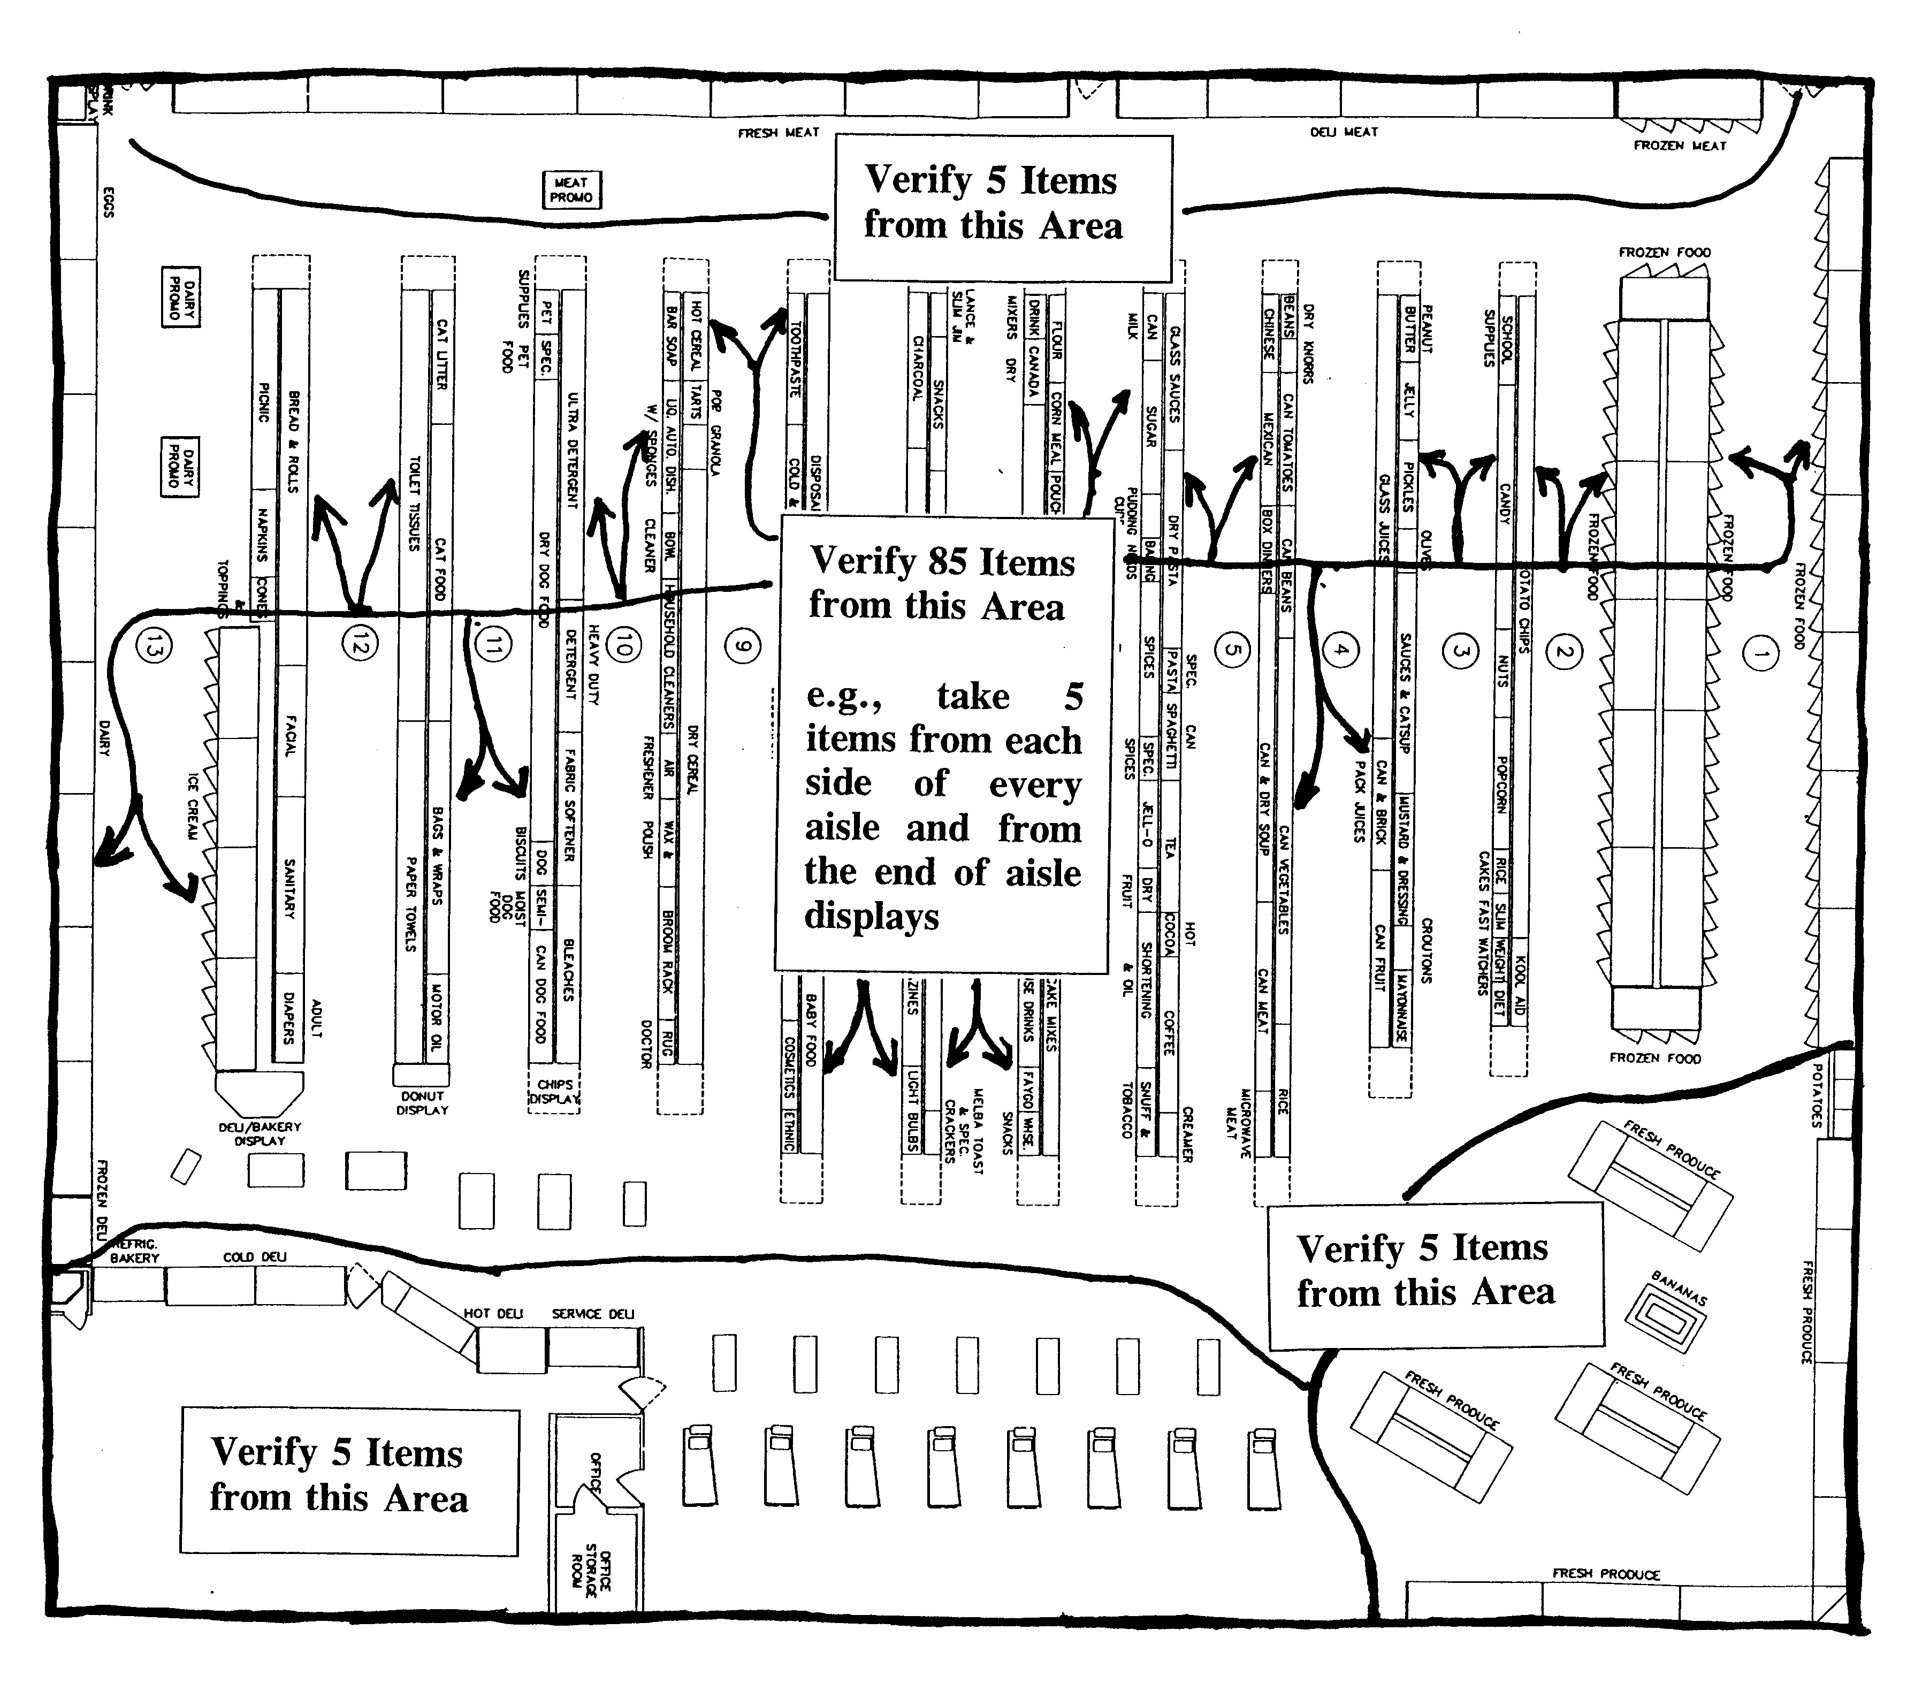
Figure 1. Illustration of the Randomized Sampling Procedure

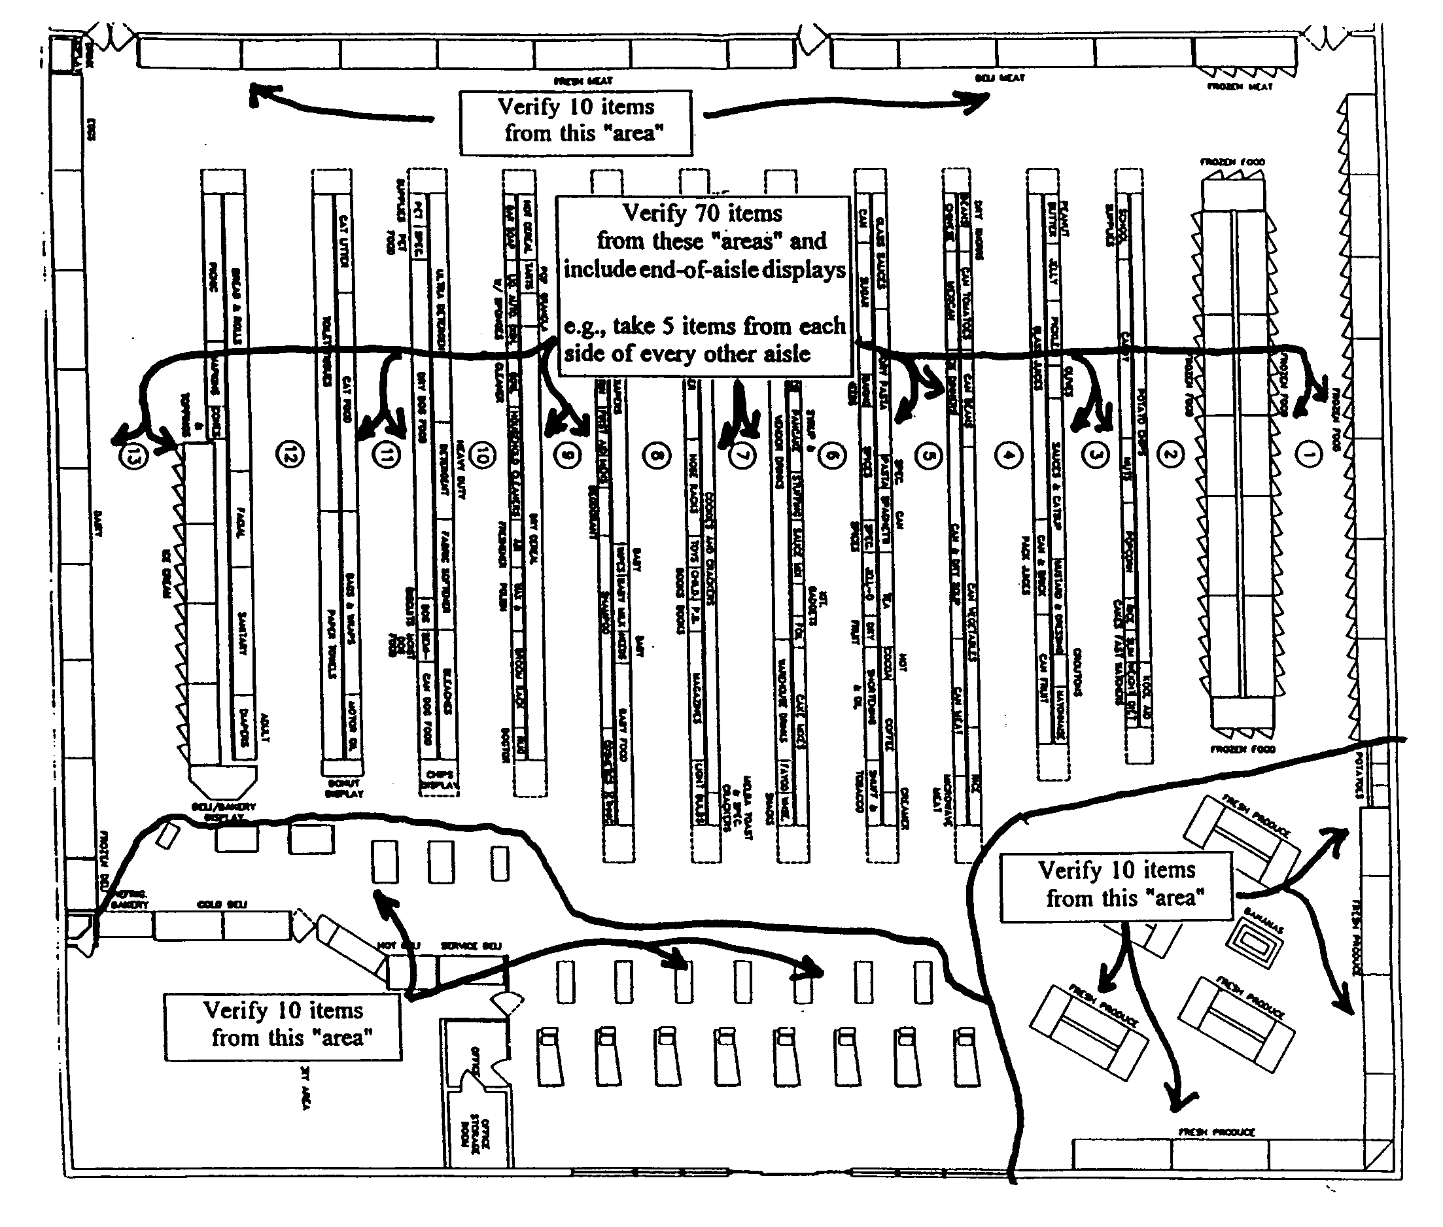
Figure 2. Illustration of the Randomized Sampling Procedure

- Start in any “area” in the store at any shelf, rack, or display (top, bottom, front, back; anywhere on a circular rack or display). Begin with the first, second, or third item and count either 5, 10, or 15 items along the shelf (varying the number of items counted depending on how many items are available on the shelf) or along the aisle. Select the 5th, 10th, or 15th item as appropriate (See Figures 5, 6, and 7). Only select one item from each brand or product (if they are the same price) from a display that has two or more items of the same product size and price displayed side by side. You can change the number of items you count off as often as necessary during the inspection.

- Either verify the price with a hand-held scanning device or take the item (along with the other items you select) to the check-out location to verify the price, keeping count of the items using a hand counter or tally sheet. If the price of an item is incorrect, record the item’s name, description, and price along with other information (e.g., whether the product is on sale, aisle location so you can easily find the items again to verify the error, etc.).

- From the first item sampled, move down (or up) one shelf to the item most directly below (or above) and count 5, 10, or 15 items in the same direction and sample the 5th, 10th, or 15th items, as appropriate. After the number of items to be verified in each “area” have been selected, go to the next “area” and start on the next shelf (either down or up) from where the previous sample was selected, count 5, 10, or 15 items and select the appropriate item using the count system until the required number of samples is selected. If you have sampled an item on the bottom (or top) shelf and have more items to test in the “area,” simply go up (or down) one shelf. This will create a “zigzag” trail up and down the display.

NOTE: Randomness can be increased by starting on different shelves or at the midpoint or rear of an aisle during an inspection, or by starting at different locations in a store on subsequent inspections. Always start at a different location on subsequent inspections of a store. To maintain “randomness,” do not search for obvious pricing errors. If you see pricing errors, have them corrected. The sample should not include more than one of the same item from the same display. If an item is out of stock, select the next item.

- This procedure is repeated for all “areas” until you complete the sample. (See following Notes)

NOTE 1: Include at least 5-10 Price Look Up (PLU) and store-coded items in the samples. In food stores, these items do not usually have to be removed from the produce, bulk foods section, or deli display for use in this procedure. You can use a hand-held scanner or record the identity and item price designated at the product sales display of the items from the different department (produce, bakery, deli), if available, for price comparison through either the PLU programmed in the department’s scale or at the point-of-sale system. Have the PLU entered in the scale (See Note 2) or point-of-sale system (or have “store-coded” items scanned) and record the price, comparing it with the displayed sale price. Record any errors (See Note 3). When checking “store-coded” items from the meat or other departments, remember that a “UPC symbol” on a random weight label is read by a scanner to obtain the total price and identity. The price is not stored in the point-of-sale database, but in the memory of the prepackaging scale.

NOTE 2: Some scales or point-of-sale systems do not display or record the unit price associated with the PLU unless a weight is on the scale. For this type of device, a one pound standard (or 1 kg) is placed on the scale load-receiving element. Some systems automatically deduct tare, so check to make sure that this does not affect the price indication.

NOTE 3: When you manually enter PLU codes and find errors, reenter the PLU number to ensure that the error was not caused by a keying mistake and that the item was identified accurately.

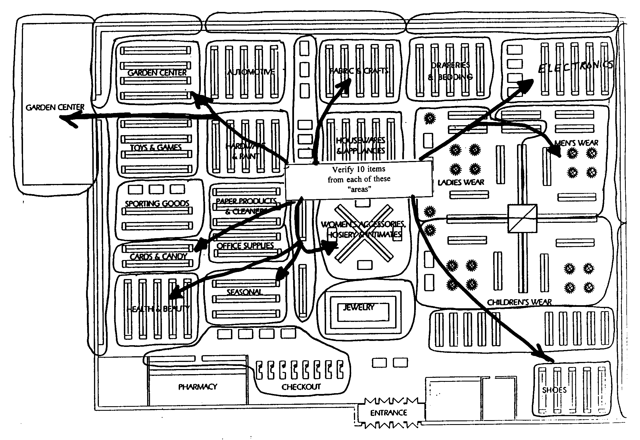
Figure 3. Illustration of the Randomized Sampling Procedure

7.3.2. Stratified Sample Collection. – Stratified sample collection (i.e., selecting samples from specific merchandise groups) of items on sale, specials, seasonal items, or items on end-of-aisle displays) is typically used (e.g., if a store has failed an inspection based on the randomized sample collection procedures) to focus on specific merchandise groups that appear to have more errors than others (e.g., you find that many of the errors found in the randomized sample were in “advertised specials” or with “discontinued items”). You can also combine sample collection procedures by using a “randomized/stratified” approach. The “stratified” approach may be used the first time you inspect a store, in stores that have just implemented scanning, in stores that have high error rates on particular groups of items in past inspections, or in responding to consumer complaints involving a particular group of items.

For stratified sample collection, items are randomly selected from different “merchandise groups” in a store. They are tested in the first stage of the two-stage manual sampling plan to determine if (1) any group has more errors than any other and (2) the sample taken in the first stage meets accuracy requirements. This method should be modified depending on the marketing practices of the store in which it is used (e.g., if you are in a department store, there may be fewer groups to sample from, or the list provided below may not include the types of groups typically encountered in a hardware superstore). The next example shows how to conduct a stratified sample and how it is used, but it should not be the sole basis for sample collection because a specific list of items does not look at the store as a whole. Focusing on specific merchandise groups takes time, but this may be necessary when investigating a complaint or following up on a prior noncompliance. Select only one item from each brand or product from a display that has two or more items of the same product, size, and price displayed side by side if they are the same price.

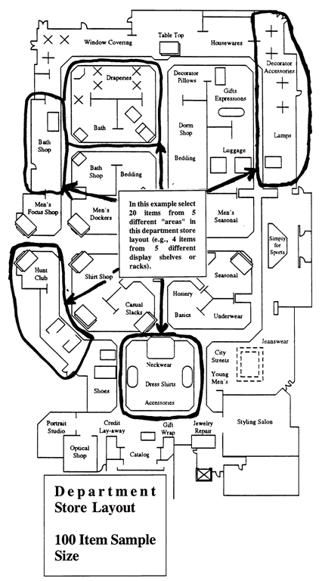 |  | 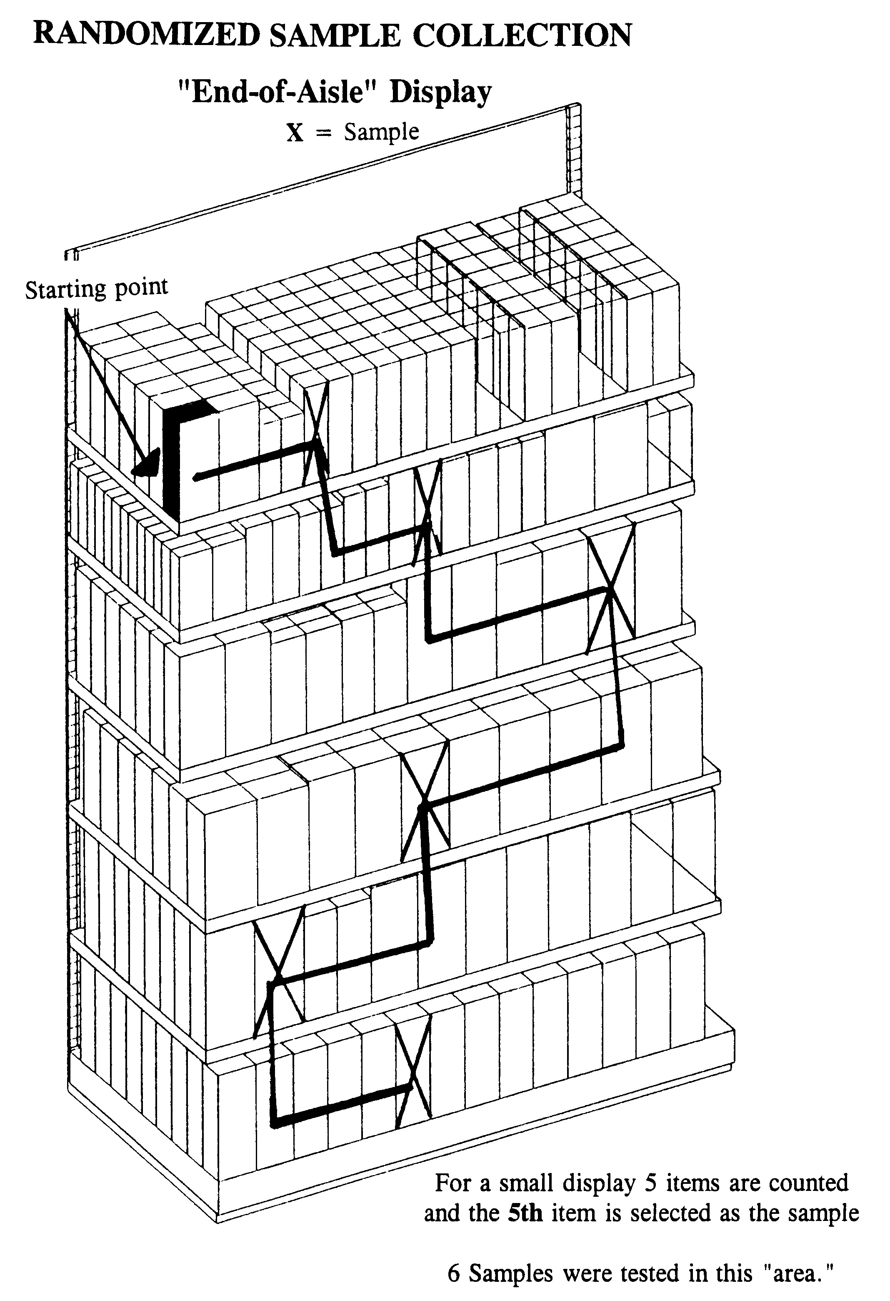
Figure 4. Stratified Sample Collection |  | Figure 5. Randomized Sample Collection

Sample Size. – In this example, a large food store is inspected using a two-stage sampling plan (50 items/100 total items). The inspection begins with an initial sample of 50 items (see Column 1. Type of Store for All Other Retail Stores and Column 2. Sample Sizes in Table 1).

Stratified Sample Collection. – Select 50 items from the merchandise groups listed below (provided as examples only; stores may have other groups that should be included). This procedure allows you to focus on specific merchandise groups to determine if errors are indeed occurring in groups where they are thought to occur most frequently (e.g., sale and direct delivery items).
7.3.2.1. Example 2. Two-Stage Manual Inspection using the Stratified Sampling Procedure.

If there is an insufficient number of items in any merchandise group, or if the group of items is not available, increase the number of “randomized” items selected from the overall inspection lot to obtain a total of 50 items. As marketing practices evolve, these groups may change as well. You may substitute “other” or new merchandise groups for any of those listed below (e.g., you may have identified errors in the “health and beauty aids” section or on “manager specials” during a previous inspection, so samples from these groups may be substituted for any of the groups listed below). Model “Price Verification Tally Sheets” in Section 14. Model Forms for Price Verification Inspections are provided for your use with the test procedures to keep track of the number of items selected.

First-Stage: 50 items. – Use the “randomized” sample collection procedures described in 7.3.1. Randomized Sample Collection to select the following items. These sample collection procedures simplify the inspection process and ensure that samples are collected as randomly as possible.

Examples:

- Twenty-five “Regular Priced” items. Select one or two items at random from different shelves in each “area” or limit your sampling to shelves in one-half the “areas” in the store, and

- Twenty-five Items. Select a total of 25 items. Include several items from any of the following merchandise groups:

- “Direct-Store-Delivery (DSD)” items. If the store allows vendors to price DSD items, include those items in the sample.

- “End-of-Aisle” or “Tie-In-Display” items. This group can include both regular and sale-priced items.

- “Advertised Sale” items. Use the store’s sales brochure or newspaper advertisements to identify sale items.

- “Special” items. This includes any item with a reduced price (e.g., items on “special” including “cents-off” or “percentage-off” items, 2-for-the-price-of-1 specials, manager and in-store specials, or discontinued items). Items typically discounted on a percentage basis include a manufacturer’s product line, greeting cards, magazines, or books.

- “PLU” items. This includes both regular and sale priced items offered in the produce, bakery, or bulk food departments and over scales at the direct sale counters. For direct service departments (e.g., produce, deli, specialty meats, etc.), select products at random (include some sale or special prices) and enter the code in the scale ^{[NOTE 1, page 206]} to verify that the coded price matches the advertised price ^{[NOTE 2, page 206]}.

- “Store-coded” items. This includes items offered in the produce, bakery, or meat departments that have labels with the UPC symbol generated by scales and printers in the store. For store-coded items, scan the item and determine if the total price and identity on the label are accurately read by the point-of-sale system. When checking “store-coded” items from the meat or other departments, remember that a “UPC symbol” on a random weight label is read by a scanner to obtain the total price and identity. The price is not stored in the point-of-sale database.

- “Other” items. This category is included to provide flexibility in selecting a sample so that “seasonal” items, or products unique to the store or local market, can be included. Both regular and sale-priced items can be included in this category.

NOTE 1: Some scales or point-of-sale systems do not display or record the unit price associated with the PLU unless weight is on the scale. For these devices, a 1 lb (or 1 kg) standard is placed on the scale load-receiving element. Some systems automatically deduct tare, so make sure this does not affect the price indication.

NOTE 2: When a not-on-file item is found, another item is selected at random to replace it in the sample. A “not-on-file” item is not an error unless you determine (e.g., by conducting a test purchase or by asking the check-out clerk to determine the price of the item using the store’s customary procedures) that the price “charged” for the item is incorrect. If the price determined is not correct, the error is included in the total.

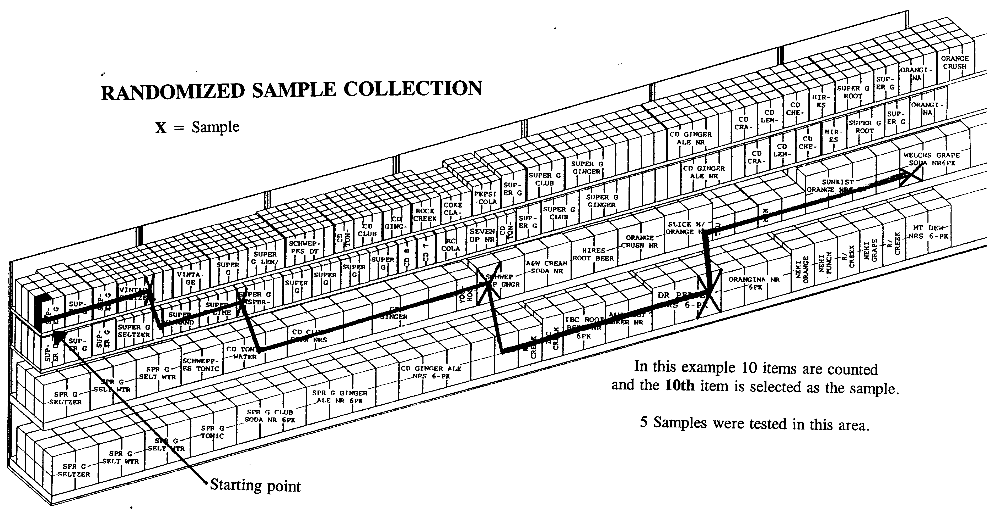
Figure 6.
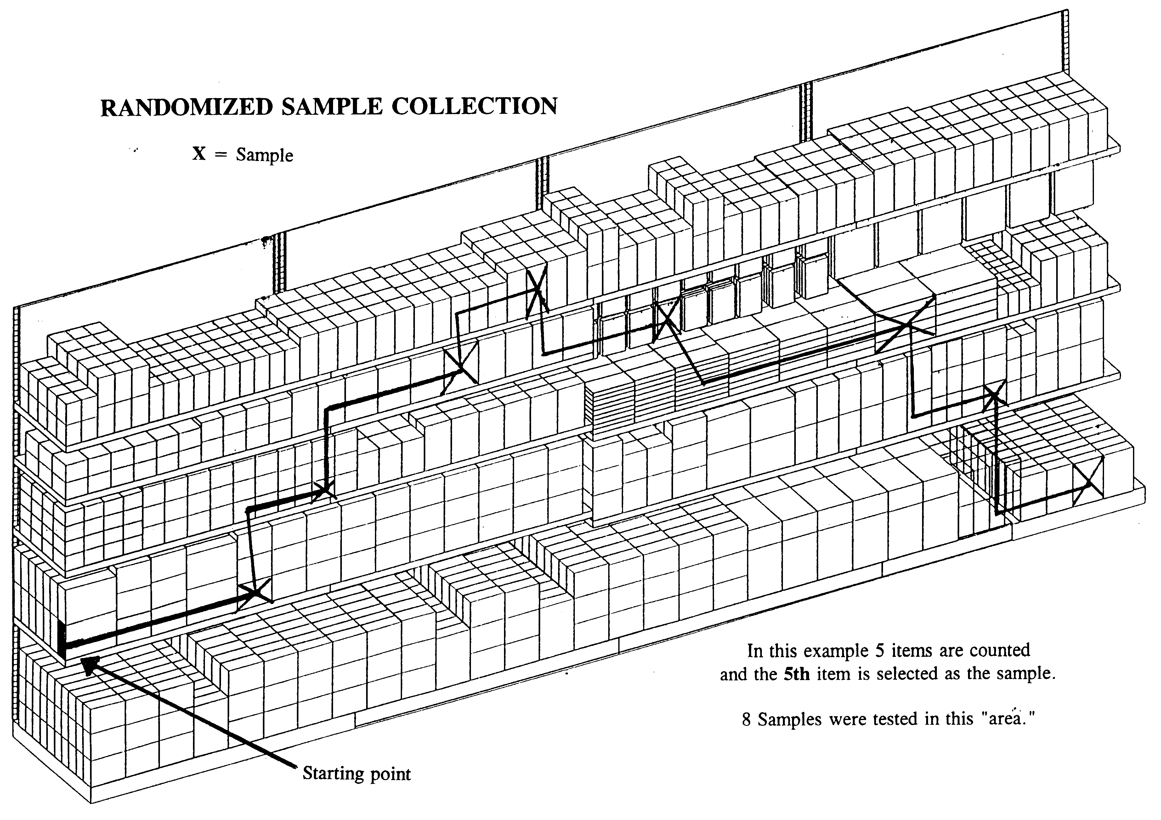
Figure 7.

Identify the item on an inspection report (e.g., record a brief description, item number, shelf, or advertised price and aisle location. The aisle location makes it easy to find the product if errors are found and to re-shelve the items). As items are selected, use the “Price Verification Tally Sheet,” or other means, to keep track of the number of items collected. (See Section 14. Model Forms for Price Verification Inspections. The “Model Price Verification Reports” in this proposal were developed with the assumption that it is only necessary to record information of items found with price errors, not all items verified. This reduces paperwork and saves time.) Either use a hand-held scanning device or take the items to a cash register, verify the prices by scanning the items or entering a PLU code into the register and printing a receipt. The prices “charged” at the register are then compared to the advertised price of each item. For large or perishable items, record the identity, UPC Code, location, and price and manually enter the UPC number into the register to verify the price. However, this method is subject to recording and key entry errors.

Evaluation of Results on First-Stage.

See Section 9. Evaluation and Inspection Results for guidance on which errors are considered violations: One error in a 50-item sample is permitted. If not more than one error is found and verified, the store passes; if 3 items are found in error in the first 50 items, the store fails and the inspection is complete.

If two errors are found, collect 50 more items using the randomized sampling procedures and verify a total of 100 items. If errors were found in any specific merchandise group (or groups) of items (e.g., direct-store-delivery items, PLU codes, or specials), the additional 50 items should include items from those merchandise groups.

Accuracy.

Refer to Column 4 in Table 1. Samples, Sample Collection, and Accuracy Requirements. The required accuracy is 98 % on the 100-item sample (that is, at most two errors are permitted on a 100-item sample). If more than two errors are found and verified, the store does not meet the accuracy requirement.

NOTE: The “randomized” and “stratified” sample collection procedures in this section are intended for use in routine inspections to determine how a store is maintaining price accuracy on all of the items it offers for sale. If you use these sampling procedures in routine inspections and uncover a significant number of errors in a particular merchandise group (e.g., a significant number of the pricing errors are found with “advertised sale item” items), a randomized sample can be collected entirely within this specific merchandise group. For example, if the error rate for “advertised specials” is higher than the rate for regular priced items, a more focused inquiry to determine if there is a significant error rate in this merchandise group may be justified. If several “advertised specials” have been the subject of consumer complaints, or if they are repeatedly found to be in error during routine inspections, then a randomized sample can be limited to the “advertised specials” merchandise group. In this case, a randomized sample (e.g., a 50/100 item two-stage approach) is taken from all of the “advertised sale items” offered for sale in the store or in a specific “area.” The results of this sample are applicable only to the “advertised specials” group and not to all items in the store.

7.4. Procedures for Test Purchases, Investigation of Consumer Complaints, and for Verification of Manually Entered Prices.

7.4.1. Procedure. – This procedure may be used to (1) investigate consumer complaints, (2) determine if a store has corrected a pricing error after being notified that an error occurred, or (3) determine if manually keyed-in prices or PLU codes are accurate.

NOTE: When verifying manual price entries, store management is typically not notified of the test until the items have been totaled and the transaction completed.

- Do not alert the clerk to the fact that the test purchase procedure is being conducted. Do not ask questions concerning any errors that you observe or offer any information if asked the price of an item, in cases where the item price is illegible, or where the item is not on file.

- Use the “randomized” sampling procedures to select a sample of 10 to 50 items that includes regular and sale priced items, PLU items, and advertised specials from various “areas.” It is acceptable to purchase only one or just a few items if you are investigating a complaint on a specific item. Record the name and identity of the product, as well as the labeled or advertised price, for each item.

- Proceed through a check-out as if you were a customer and pay for the purchase. Obtain the original sales receipt, and compare the price charged with the labeled or advertised price for each item. Record the time of day, lane number, and the identity of the checker. Before leaving the store, determine if any errors have occurred. Identify yourself and inform the store management that a test purchase was conducted and report the results. (In many instances, the store will credit back all of the items and refund the test purchase money.) Record the information on the test report form and determine the cause of the error (e.g., operator error, mislabeling, or incorrect price sign).

7.4.2. Alternative Procedure - Consumer Complaints. – Complaints can be investigated by using any of the test procedures described above or by verifying only the price of the item or items subject to the complaint. If the complaint is valid, you can limit your inspection to the items described in the complaint or you may conduct a complete inspection.

7.4.3. Evaluation of Results. – The errors for items verified using these procedures should be evaluated according to Sections 9. Evaluation of Inspection Results and 10. Accuracy Requirements.
Section 8. Documentation of Findings

Several examples of Model Price Verification Reports are contained in pages 214 to 219. These forms were developed so that you only have to record the items found with price errors.

- Record errors and provide information on the cause, if determined. Indicate if the errors are considered to be violations, if stop-sale orders were issued, or if the violation was corrected.

- Notices of violations or other significant comments (e.g., warnings or violations ordered corrected) should always be included on the test form.

- Cash register receipts on verified items should be retained and attached to the inspection report as evidence.

- Printed advertisements and sales flyers should be retained and attached to the inspection report when errors are found in these categories.
Section 9. Evaluation of Inspection Results

9.1. Definition of Errors. – An error found to result from any of the following causes should not be considered a violation for enforcement purposes:

- An intentional undercharge if documentation or confirmation of the date and time of the price change is provided at the time of the inspection.

- An error caused by a mistake made in any kind of advertisement (e.g., newspaper, printed brochure, or radio or television advertisement) if the store has placed a notice adjacent to the item indicating that a mistake occurred in the advertisement.

- An error obviously caused by a price label that is missing or that has fallen off the shelf, or the item or the price label or sign has obviously been relocated by an unauthorized person.

- A “not-on-file” item is not an error unless you determine that the price “charged” for the item is incorrect (e.g., by conducting a test purchase or by asking the check-out clerk to determine the price of the item using the store’s documented or customary procedures. If the price determined is incorrect, it is considered an error.)

NOTE: It is recommended that you work with the store representative to identify the cause of any error and note the problem/cause on the report. This may not change your findings, but will help to identify problems related to staff errors, failure to follow through on established store pricing procedures, data entry errors, or failure of management to provide correct written data, etc. The supporting information will help with enforcement decisions as well as in-house monitoring of product pricing.

9.2. Computing Sample Errors. – The following formulas are used to determine sample error and the overcharge to undercharge ratio:

- Adjust the total sample by subtracting any items or errors specified in 9.1. Definition of Errors.

- To compute the sample error, divide the number of errors by the total sample size to obtain the error in percent.

For example: a sample of 100 items is verified; 3 overcharges and 1 undercharge are found for a total of 4 errors:

4 ÷ 100 = 4 % sample error.

- To compute the ratio of overcharges to undercharges (used on large samples and in follow-up activities), total the overcharges/undercharges and compare the numbers:

3 overcharges/1 undercharge = a 3 to 1 ratio.
Section 10. Accuracy Requirements

10.1. Accuracy Requirements. – Accuracy information, based on a percentage of errors found in a sample and the ratio of overcharges to undercharges, constitutes useful criteria for evaluating the “pricing integrity” of the store. Both overcharges and undercharges should be considered as errors in taking lower level enforcement actions since (1) either type of error misrepresents the price of the item; and (2) the occurrence of any error in a randomized sample may indicate poor pricing practices that would result in errors where additional items were sampled. For higher levels of enforcement only overcharges are considered.

10.2. Accuracy. – The accuracy requirement for a sample must be 98 % or higher to “pass” a single inspection. See Column 4, Accuracy Requirements, in Table 1. Samples, Sample Collection, and Accuracy Requirements.

10.3. Ratio of Overcharges to Undercharges. – With large sample sizes, overcharges should not exceed the undercharges. A high rate of overcharges to undercharges (2 to 1, or 3 to 1) may indicate systematic problems with a store’s pricing practices.

NOTE: As the history of store compliance develops, the number of overcharges and undercharges may be evaluated to determine if systematic errors or other problems exist. This ratio should be maintained when at least 10 errors are found over several inspections, or in a single large sample size (e.g., the results of several 100-item inspections collected over a period of time or if 1000 items are sampled in one inspection.)

Table 2. Price Errors
(This table shows the percentage of errors in different sample sizes)
Percentage of Errors
Sample Size
No. of  Errors | 25 | 50 | 100 | 150 | 200 | 300
1 | 4 % | 2 % | 1 % | 0.67 % | 0.50 % | 0.33 %
2 | 8 % | 4 % | 2 % | 1.33 % | 1.00 % | 0.67 %
3 | 12 % | 6 % | 3 % | 2.00 % | 1.50 % | 1.00 %
4 | 16 % | 8 % | 4 % | 2.67 % | 2.00 % | 1.33 %
5 | 20 % | 10 % | 5 % | 3.33 % | 2.50 % | 1.67 %
6 | 24 % | 12 % | 6 % | 4.00 % | 3.00 % | 2.00 %
7 | 28 % | 14 % | 7 % | 4.67 % | 3.50 % | 2.33 %
8 | 32 % | 16 % | 8 % | 5.33 % | 4.00 % | 2.67 %
9 | 36 % | 18 % | 9 % | 6.00 % | 4.50 % | 3.00 %
10 | 40 % | 20 % | 10 % | 6.67 % | 5.00 % | 3.33 %

NOTE: Random pricing errors are to be expected, but the ratio of overcharges to undercharges will rarely be exactly 1 to 1 (e.g., of 10 errors, 5 overcharges and 5 undercharges); the ratio will likely vary both ways over several inspections. If a store has more overcharges than undercharges (e.g., 2 to 1, or 3 to 1), it may indicate that the store is not following good pricing practices, but enough errors must be present in order to make this determination. (Consider the example of 12 pricing errors consisting of 8 overcharges and 4 undercharges: the ratio of overcharges to undercharges is 2 to 1. Similarly, 10 pricing errors consisting of 6 overcharges and 4 undercharges correspond to a ratio of 1.5 to 1; since all decimal values are truncated to whole numbers, 1.5 is truncated to 1, and the ratio becomes 1 to 1.)

The one-to-one ratio should be applied to any sample size if at least 10 errors are present. For example, if 1000 items are verified and 10 items are found in error, the sample has an accuracy of 99 %. However, if 9 of the 10 errors are overcharges (i.e., a ratio of 9 overcharges to 1 undercharge), the store should be considered to have poor pricing practices or other problems; if 100 items are verified and a 90 % accuracy is found, 10 items in error not meeting the overcharge to undercharge ratio can be used in enforcement action as evidence of poor pricing practices.
Section 11. Enforcement Procedures

11.1. Enforcement Steps.

- Compliance is based on the accuracy found on a sample collected according to this procedure.

- Errors should be corrected immediately, or if the correction cannot be made immediately, a stop-sale order shall be issued before you leave the business. If the errors are not corrected in your presence, a follow-up inspection may be made later in the day or the following day to ensure the store has corrected the error. If a store fails to correct the error by that time, higher level enforcement action should be taken.

- Enforcement action for large monetary errors on individual items, confirmed overcharges on items verified in response to complaints, or errors found on follow-up inspection of items ordered corrected, should be taken independently from any sample, giving consideration to the magnitude of the violation, corrective action by the establishment, and any other relevant information. Action may be initiated at any time in the inspection process based on the facts of the individual case.

- Overcharges and undercharges are used to determine lower levels of enforcement actions, but higher levels of enforcement action (e.g., fines or penalties) are taken only on the overcharges found in the sample.
(Amended 2001)

NOTE: Many computer systems do not allow for the immediate correction of errors in the database. Downloading information throughout the day may not be possible. Therefore, for the purposes of this section, “immediate” correction of errors may entail the removal or correction of problem signs, manually changing marked prices, or communicating notice of the corrected price to all applicable stores through facsimile, e-mail, or any other appropriate medium to ensure that consumers are charged the correct price.

11.2. Model Enforcement Levels.

These recommendations do not modify the enforcement policy of any jurisdiction unless adopted by that jurisdiction.

- Ninety-Eight Percent or Higher. – If price accuracy is 98 % or higher on a sample of 50 or more items, and if overcharges do not exceed undercharges on sample sizes of 100 or more items, and the store is on a normal inspection frequency:

  - a notice of noncompliance is issued on violations, and the store is maintained on a normal inspection frequency; or

  - if the store is on increased inspection frequency, it remains on this frequency until inspection results conform to Terms of Increased Inspection Frequency.

- Less Than 98 Percent. – If price accuracy is less than 98 % on a sample of 50 or more items and if overcharges do not exceed undercharges on large sample sizes, and the store is on normal inspection frequency:

  - A notice of noncompliance is issued and the store is placed on an increased inspection frequency.

  - A second inspection should be conducted within 30 business days. If the price accuracy then is not 98 % or higher, a warning is issued.

  - A third inspection should be made within 60 business days. If the price accuracy is again less than 98 %, higher level enforcement action should be taken.
(Amended 2001)

If the store is on increased inspection frequency, a warning should be issued and the store re-inspected within 30 business days. If price accuracy is less than 98 %, higher levels of enforcement action should be taken.
(Amended 2001)

Examples for the 100-item sample size:

- If 100 items are verified and 3 overcharges are found in the sample, the error rate is 3 %. In this example, higher levels of enforcement action should be taken.

- If 100 items are verified and 3 overcharges and 2 undercharges are found, the error rate on the sample is 5 %, but overcharges are 3 %. In this example, higher levels of enforcement action should be taken.

- If 100 items are verified and 2 overcharges and 3 undercharges are found, the error rate is still 5 %, but overcharges are only 2 % of the sample. In this example, a lower level enforcement action would be taken.

- Terms of Increased Inspection Frequency. – When a store is on increased inspection frequency, it shall remain at that frequency until two consecutive inspections reveal an accuracy of 98 % or higher.

- Higher Levels of Enforcement Action. – Overcharges and undercharges are used to determine lower levels of enforcement actions, but higher levels of enforcement action (e.g., fines or penalties) are taken only on overcharges. A store’s history of error rates, the time it takes a store to correct the errors, the difference in inaccuracy rates found between “regular” and “sale” priced items, the ratio of overcharges to undercharges, a record of valid consumer complaints, and the magnitude of the error(s) may be used to support enforcement action.
Section 12. Post-Inspection Tasks

- You should meet with the store representative to review your findings. Have the inspection report completed prior to the meeting and be prepared to briefly summarize your findings and recommended actions, and provide a copy to the store representative.

- Return borrowed safety, sanitation, and/or test equipment.

- If you removed items from display, ensure that the items are returned to their proper location on the store shelves unless the representative requests to have the items returned by a store employee, which is permitted.

- Advise the representative of your findings. Explain any violations and errors. Explain any orders issued and be sure the individual acknowledges understanding of what corrective action is expected, if any.

- If necessary, describe the implications of the inspection results and advise the store of the action that you intend to take. If an increased inspection frequency is called for due to the accuracy level found during the inspection, advise the firm that re-inspections will be made, but do not indicate when they may occur.
Section 13. Supervisory Activities

13.1. Baseline Surveys. – Price verification programs require management support so that the program’s objectives and desired benefits can be incorporated into the enforcement agency’s work plans and budget. Surveys to measure pre- and post-implementation accuracy should be used to establish a base from which to measure whether a cost/benefit has been obtained.

13.2. Follow-up Inspections. – Inspections that reveal errors exceeding the accuracy requirements recommended above must include follow-up action to ensure that the store fulfills it obligations regarding accurate prices.

13.3. Management Information Systems. – To ensure adequate control and follow-up, a database should be established in each jurisdiction to provide information on every store, including:

For stores:  - store name  - address  - telephone  - type of store  - frequency of inspection  - sample size  - accuracy  - number of overcharges  - dollar value of overcharges  - number of undercharges  - dollar value of undercharges  - average money value of undercharges  - ratio of overcharges to undercharges | For program review:  - total number of undercharges  - total dollar value of undercharges  - average dollar value of undercharges  - percent undercharges of total  - ratio of overcharges to undercharges  - total error in percent  - accuracy levels of stores  - store type  - total stores tested  - total stores tested (each type)  - total items tested  - total number of overcharges  - total dollar value of overcharges  - average dollar value of overcharges  - percent of overcharges of total
Section 14. Model Forms for Price Verification Inspections

These models can be used to develop formal report forms, or they can be copied and used as worksheets for conducting inspections:

- Sample Tally Sheets: These forms can help you keep track of the number of items verified. They provide spaces to record the item’s display location (e.g., aisle or department), a description of the item, and the shelf or advertised price. The worksheets are set up for the stratified sample collection described above to help identify the types of products to select.

    - Price Verification Tally Sheet – Food Stores. (See page 214.)

    - Price Verification Tally Sheet – Department Stores. (See page 215.)

- Model Inspection Form I: This can be used to document violations and record findings. A completed sample is provided.

    - Price Verification Report I – sample blank form. (See page 216.)

    - Price Verification Report I – completed sample form. (See page 217.)

- Model Inspection Form II: This can be used in stores where a hand-held scanning device is not available, or when it is inconvenient to take items (e.g., a large ladder in a hardware store) to a check-out register to verify the price. You can record an identity, the UPC or PLU code, and advertised price so that you can manually enter the codes to verify the price. The form can also be used to record findings. A completed sample is provided.

    - Price Verification Report II – sample blank form. (See page 218.)

    - Price Verification Report II – completed sample form. (See page 219.)

Price Verification Tally Sheet - Food Stores
“End of Aisle” or  “Tie-In Display” | Item | Location | UPC/Identity | Shelf Price
“End of Aisle” or  “Tie-In Display” | 1. ___________ | 1. ___________ | 1. ___________ | 1. ___________
“End of Aisle” or  “Tie-In Display” | 2. ___________ | 2. ___________ | 2. ___________ | 2. ___________
“End of Aisle” or  “Tie-In Display” | 3. ___________ | 3. ___________ | 3. ___________ | 3. ___________
“End of Aisle” or  “Tie-In Display” | 4. ___________ | 4. ___________ | 4. ___________ | 4. ___________
“End of Aisle” or  “Tie-In Display” | 5. ___________ | 5. ___________ | 5. ___________ | 5. ___________
“PLU or  Coded” Items | 6. ___________ | 6. ___________ | 6. ___________ | 6. ___________
“PLU or  Coded” Items | 7. ___________ | 7. ___________ | 7. ___________ | 7. ___________
“PLU or  Coded” Items | 8. ___________ | 8. ___________ | 8. ___________ | 8. ___________
“PLU or  Coded” Items | 9. ___________ | 9. ___________ | 9. ___________ | 9. ___________
“PLU or  Coded” Items | 10. __________ | 10. __________ | 10. __________ | 10. __________
“Advertised Sale” Items | 11. __________ | 11. __________ | 11. __________ | 11. __________
“Advertised Sale” Items | 12. __________ | 12. __________ | 12. __________ | 12. __________
“Advertised Sale” Items | 13. __________ | 13. __________ | 13. __________ | 13. __________
“Advertised Sale” Items | 14. __________ | 14. __________ | 14. __________ | 14. __________
“Advertised Sale” Items | 15. __________ | 15. __________ | 15. __________ | 15. __________
“Advertised Sale” Items | 16. __________ | 16. __________ | 16. __________ | 16. __________
“Advertised Sale” Items | 17. __________ | 17. __________ | 17. __________ | 17. __________
“Advertised Sale” Items | 18. __________ | 18. __________ | 18. __________ | 18. __________
“Advertised Sale” Items | 19. __________ | 19. __________ | 19. __________ | 19. __________
“Advertised Sale” Items | 20. __________ | 20. __________ | 20. __________ | 20. __________
Items on “Special” | 21. __________ | 21. __________ | 21. __________ | 21. __________
Items on “Special” | 22. __________ | 22. __________ | 22. __________ | 22. __________
Items on “Special” | 23. __________ | 23. __________ | 23. __________ | 23. __________
Items on “Special” | 24. __________ | 24. __________ | 24. __________ | 24. __________
Items on “Special” | 25. __________ | 25. __________ | 25. __________ | 25. __________
“Direct Store Delivery” Items | 26. __________ | 26. __________ | 26. __________ | 26. __________
“Direct Store Delivery” Items | 27. __________ | 27. __________ | 27. __________ | 27. __________
“Direct Store Delivery” Items | 28. __________ | 28. __________ | 28. __________ | 28. __________
“Direct Store Delivery” Items | 29. __________ | 29. __________ | 29. __________ | 29. __________
“Direct Store Delivery” Items | 30. __________ | 30. __________ | 30. __________ | 30. __________
“Randomly Selected” Items | 31. __________ | 31. __________ | 31. __________ | 31. __________
“Randomly Selected” Items | 32. __________ | 32. __________ | 32. __________ | 32. __________
“Randomly Selected” Items | 33. __________ | 33. __________ | 33. __________ | 33. __________
“Randomly Selected” Items | 34. __________ | 34. __________ | 34. __________ | 34. __________
“Randomly Selected” Items | 35. __________ | 35. __________ | 35. __________ | 35. __________
“Randomly Selected” Items | 36. __________ | 36. __________ | 36. __________ | 36. __________
“Randomly Selected” Items | 37. __________ | 37. __________ | 37. __________ | 37. __________
“Randomly Selected” Items | 38. __________ | 38. __________ | 38. __________ | 38. __________
“Randomly Selected” Items | 39. __________ | 39. __________ | 39. __________ | 39. __________
“Randomly Selected” Items | 40. __________ | 40. __________ | 40. __________ | 40. __________
“Randomly Selected” Items | 41. __________ | 41. __________ | 41. __________ | 41. __________
“Randomly Selected” Items | 42. __________ | 42. __________ | 42. __________ | 42. __________
“Randomly Selected” Items | 43. __________ | 43. __________ | 43. __________ | 43. __________
“Randomly Selected” Items | 44. __________ | 44. __________ | 44. __________ | 44. __________
“Randomly Selected” Items | 45. __________ | 45. __________ | 45. __________ | 45. __________
“Randomly Selected” Items | 46. __________ | 46. __________ | 46. __________ | 46. __________
“Randomly Selected” Items | 47. __________ | 47. __________ | 47. __________ | 47. __________
“Randomly Selected” Items | 48. __________ | 48. __________ | 48. __________ | 48. __________
“Randomly Selected” Items | 49. __________ | 49. __________ | 49. __________ | 49. __________
“Randomly Selected” Items | 50. __________ | 50. __________ | 50. __________ | 50. __________
Price Verification Tally Sheet - Department Stores
“End of Aisle” or  “Tie-In Display” | Identity | Location | Advertised
“End of Aisle” or  “Tie-In Display” | 1. ___________ | 1. ___________ | 1. ___________
“End of Aisle” or  “Tie-In Display” | 2. ___________ | 2. ___________ | 2. ___________
“End of Aisle” or  “Tie-In Display” | 3. ___________ | 3. ___________ | 3. ___________
“End of Aisle” or  “Tie-In Display” | 4. ___________ | 4. ___________ | 4. ___________
“End of Aisle” or  “Tie-In Display” | 5. ___________ | 5. ___________ | 5. ___________
“Advertised Sale”  Items | 6. ___________ | 6. ___________ | 6. ___________
“Advertised Sale”  Items | 7. ___________ | 7. ___________ | 7. ___________
“Advertised Sale”  Items | 8. ___________ | 8. ___________ | 8. ___________
“Advertised Sale”  Items | 9. ___________ | 9. ___________ | 9. ___________
“Advertised Sale”  Items | 10. __________ | 10. __________ | 10. __________
“Advertised Sale”  Items | 11. __________ | 11. __________ | 11. __________
“Advertised Sale”  Items | 12. __________ | 12. __________ | 12. __________
“Advertised Sale”  Items | 13. __________ | 13. __________ | 13. __________
“Advertised Sale”  Items | 14. __________ | 14. __________ | 14. __________
“Advertised Sale”  Items | 15. __________ | 15. __________ | 15. __________
Items on  “Special” | 16. __________ | 16. __________ | 16. __________
Items on  “Special” | 17. __________ | 17. __________ | 17. __________
Items on  “Special” | 18. __________ | 18. __________ | 18. __________
Items on  “Special” | 19. __________ | 19. __________ | 19. __________
Items on  “Special” | 20. __________ | 20. __________ | 20. __________
Items on  “Special” | 21. __________ | 21. __________ | 21. __________
Items on  “Special” | 22. __________ | 22. __________ | 22. __________
Items on  “Special” | 23. __________ | 23. __________ | 23. __________
Items on  “Special” | 24. __________ | 24. __________ | 24. __________
Items on  “Special” | 25. __________ | 25. __________ | 25. __________
“Randomly Selected”  Items | 26. __________ | 26. __________ | 26. __________
“Randomly Selected”  Items | 27. __________ | 27. __________ | 27. __________
“Randomly Selected”  Items | 28. __________ | 28. __________ | 28. __________
“Randomly Selected”  Items | 29. __________ | 29. __________ | 29. __________
“Randomly Selected”  Items | 30. __________ | 30. __________ | 30. __________
“Randomly Selected”  Items | 31. __________ | 31. __________ | 31. __________
“Randomly Selected”  Items | 32. __________ | 32. __________ | 32. __________
“Randomly Selected”  Items | 33. __________ | 33. __________ | 33. __________
“Randomly Selected”  Items | 34. __________ | 34. __________ | 34. __________
“Randomly Selected”  Items | 35. __________ | 35. __________ | 35. __________
“Randomly Selected”  Items | 36. __________ | 36. __________ | 36. __________
“Randomly Selected”  Items | 37. __________ | 37. __________ | 37. __________
“Randomly Selected”  Items | 38. __________ | 38. __________ | 38. __________
“Randomly Selected”  Items | 39. __________ | 39. __________ | 39. __________
“Randomly Selected”  Items | 40. __________ | 40. __________ | 40. __________
“Randomly Selected”  Items | 41. __________ | 41. __________ | 41. __________
“Randomly Selected”  Items | 42. __________ | 42. __________ | 42. __________
“Randomly Selected”  Items | 43. __________ | 43. __________ | 43. __________
“Randomly Selected”  Items | 44. __________ | 44. __________ | 44. __________
“Randomly Selected”  Items | 45. __________ | 45. __________ | 45. __________
“Randomly Selected”  Items | 46. __________ | 46. __________ | 46. __________
“Randomly Selected”  Items | 47. __________ | 47. __________ | 47. __________
“Randomly Selected”  Items | 48. __________ | 48. __________ | 48. __________
“Randomly Selected”  Items | 49. __________ | 49. __________ | 49. __________
“Randomly Selected”  Items | 50. __________ | 50. __________ | 50. __________
Price Verification Report I
Page ___ of ___
Inspection:  1st  2nd  3rd Frequency:  Normal  Increased Type:  Stratified  Automated  Randomized Complaint: 
Location of Test (Store Name, Address, County, ZIP Code) |  | Date: |  | Telephone:
 |  | Manager: |  | Type of Store:
Identity, Brand Name, Item or Style Number | Number of Items, Size, Location in Store, or  UPC Code |  | Offered Price |  | Price Charged | Error (±)
1.

 Stop Sale Issued  Corrected | Comments:
2.

 Stop Sale Issued   Corrected | Comments:
3.

 Stop Sale Issued  Corrected | Comments:
4.

 Stop Sale Issued  Corrected | Comments:
5.

 Stop Sale Issued  Corrected | Comments:
6.

 Stop Sale Issued  Corrected | Comments:
7.

 Stop Sale Issued  Corrected | Comments:
8.

 Stop Sale Issued  Corrected | Comments:

Inspection Results:
_____ (Sample Count) - _____ (#Not on File) = _____ (Adjusted Sample Count [ASC])
_____ (#Errors) ÷ _____ (ASC) =_____ (Error Percentage)
(Accuracy Percentage) = _____ % Overcharges/Undercharges Ratio = _____:_____
Inspector Name: __________________________________ | Report Acknowledgement:
Time In: __________ Time Out: __________ | Name/Title: ______________________________________
Comments/Remarks: _______________________________ | Comments/Remarks: _______________________________
_________________________________________________ | ________________________________________________
_________________________________________________ | ________________________________________________
Price Verification Report I (completed sample)
Page _1_ of _1_
Inspection: √ 1st  2nd  3rd Frequency: √ Normal  Increased Type: √ Stratified  Automated  Randomized Complaint: 
Location of Test (Store Name, Address, County, ZIP Code)  Barkers Food Store  1361 Macon Street |  | Date:  3/10/95 |  | Telephone:  (301) 555-4868
Belle, New Jersey 31756 |  | Manager:  C. Barker |  | Type of Store:  Food Store
Identity, Brand Name, Item or Style Number | Number of Items, Size, Location in Store, or  UPC Code |  | Offered Price |  | Price Charged | Error (±)
1. Smith Cake Mix | 32 oz. 313461346177 |  | 3.19 |  | 4.19 | +1.00
 Stop Sale Issued √ Corrected | Comments: Sale sign not removed
2. Natural Fruit Juice | 1 Liter 617369345619 |  | 2.25 |  | 2.75 | +.50
 Stop Sale Issued √  Corrected | Comments:
3. Clocks Soap | 8oz. 936125376558 |  | 1.19 |  | 1.00 | -.19
 Stop Sale Issued √ Corrected | Comments:
4.

 Stop Sale Issued  Corrected | Comments:
5.

 Stop Sale Issued  Corrected | Comments:
6.

 Stop Sale Issued  Corrected | Comments:
7.

 Stop Sale Issued  Corrected | Comments:
8.

 Stop Sale Issued  Corrected | Comments:

Inspection Results:
100 (Sample Count) - 0 (#Not on File) = 100 (Adjusted Sample Count [ASC])
3 (#Errors) ÷ 100 (ASC) = 3 (Error Percentage)
(Accuracy Percentage) = 97 % Overcharges/Undercharges Ratio = 2 : 1
Inspector Name: __ T. Price_________________________ | Report Acknowledgement:
Time In: __8:15_____ Time Out: ___9:30____ | Name/Title: _ Chris Barker__________________________
Comments/Remarks: _______________________________ | Comments/Remarks: _______________________________
_________________________________________________ | ________________________________________________
_________________________________________________ | ________________________________________________
Price Verification Report II
Page ___ of ___
Inspection:  1st  2nd  3rd Frequency:  Normal  Increased Complaint: 
Location of Test (Name, Address, County, ZIP Code) |  |  | Date: |  |  | Telephone:
 |  |  | Manager: |  |  | Type of Store:
Item/Size or Style Number | Offered  Price | Price  Charged | Price  Error (±) |  | Item/Brand/Description/Code/Size |  | Offered  Price | Price  Charged | Price  Error (±)
1. Identity: |  |  |  |  | 11. Identity:
UPC/PLU: |  |  |  |  | UPC/PLU:
Comments: |  |  |  |  | Comments:
2. Identity: |  |  |  |  | 12. Identity:
UPC/PLU: |  |  |  |  | UPC/PLU:
Comments: |  |  |  |  | Comments:
3. Identity: |  |  |  |  | 13. Identity:
UPC/PLU: |  |  |  |  | UPC/PLU:
Comments: |  |  |  |  | Comments:
4. Identity: |  |  |  |  | 14. Identity:
UPC/PLU: |  |  |  |  | UPC/PLU:
Comments: |  |  |  |  | Comments:
5. Identity: |  |  |  |  | 15. Identity:
UPC/PLU: |  |  |  |  | UPC/PLU:
Comments: |  |  |  |  | Comments:
6. Identity: |  |  |  |  | 16. Identity:
UPC/PLU: |  |  |  |  | UPC/PLU:
Comments: |  |  |  |  | Comments:
7. Identity: |  |  |  |  | 17. Identity:
UPC/PLU: |  |  |  |  | UPC/PLU:
Comments: |  |  |  |  | Comments:
8. Identity: |  |  |  |  | 18. Identity:
UPC/PLU: |  |  |  |  | UPC/PLU:
Comments: |  |  |  |  | Comments:
9. Identity: |  |  |  |  | 19. Identity:
UPC/PLU: |  |  |  |  | UPC/PLU:
Comments: |  |  |  |  | Comments:
10. Identity: |  |  |  |  | 20. Identity:
UPC/PLU: |  |  |  |  | UPC/PLU:
Comments: |  |  |  |  | Comments:

Inspection Results:
_____ (Sample Count) - _____ (#Not on File) = _____ (Adjusted Sample Count [ASC]) Stop-Sale Order Issued? 
_____ (#Errors) ÷ _____ (ASC) =_____ (Error Percentage)
(Accuracy Percentage) = _____ % Overcharges/Undercharges Ratio = _____:_____
Inspector Name: __________________________________ | Report Acknowledgement:
Time In: __________ Time Out: __________ | Name/Title: ______________________________________
Comments/Remarks: _______________________________ | Comments/Remarks: _______________________________
_________________________________________________ | ________________________________________________
__________________________________________________ | _________________________________________________
Price Verification Report II (completed sample)
Page _1_ of _1_
Inspection: √ 1st  2nd  3rd Frequency: √ Normal  Increased Complaint: 
Location of Test (Name, Address, County, ZIP Code)  Mark Downtown Department Store  11650 Main St.  Alice, MN 61619 |  |  | Date:  3/16/95 |  |  | Telephone:  (614) 555-6146
 |  |  | Manager:  Jim Chester |  |  | Type of Store:  Department Store
Item/Size or Style Number | Offered  Price | Price  Charged | Price  Error (±) |  | Item/Brand/Description/Code/Size |  | Offered  Price | Price  Charged | Price  Error (±)
1. Identity: Sony Color TV |  |  |  |  | 11. Identity:
UPC/PLU: 38569 |  |  |  |  | UPC/PLU:
Comments: Model 6136X | 189.00 | 199.00 | +10.00 |  | Comments:
2. Identity: Moore Lawn Mower |  |  |  |  | 12. Identity:
UPC/PLU: 31619 |  |  |  |  | UPC/PLU:
Comments: Shp with bagger | 96.00 | 91.00 | -5.00 |  | Comments:
3. Identity: Taft Rake |  |  |  |  | 13. Identity:
UPC/PLU: 39916 |  |  |  |  | UPC/PLU:
Comments: Not on file | 8.99 |  |  |  | Comments:
4. Identity: Calendar |  |  |  |  | 14. Identity:
UPC/PLU: 615191 |  |  |  |  | UPC/PLU:
Comments: | 5.50 | 7.10 | +1.60 |  | Comments:
5. Identity: |  |  |  |  | 15. Identity:
UPC/PLU: |  |  |  |  | UPC/PLU:
Comments: |  |  |  |  | Comments:
6. Identity: |  |  |  |  | 16. Identity:
UPC/PLU: |  |  |  |  | UPC/PLU:
Comments: |  |  |  |  | Comments:
7. Identity: |  |  |  |  | 17. Identity:
UPC/PLU: |  |  |  |  | UPC/PLU:
Comments: |  |  |  |  | Comments:
8. Identity: |  |  |  |  | 18. Identity:
UPC/PLU: |  |  |  |  | UPC/PLU:
Comments: |  |  |  |  | Comments:
9. Identity: |  |  |  |  | 19. Identity:
UPC/PLU: |  |  |  |  | UPC/PLU:
Comments: |  |  |  |  | Comments:
10. Identity: |  |  |  |  | 20. Identity:
UPC/PLU: |  |  |  |  | UPC/PLU:
Comments: |  |  |  |  | Comments:

Inspection Results:
50 (Sample Count) - 1 (#Not on File) = 49 (Adjusted Sample Count [ASC]) Stop-Sale Order Issued? 
3 (#Errors) ÷ 49 (ASC) = 6 (Error Percentage)
(Accuracy Percentage) = 94 % Overcharges/Undercharges Ratio = 2 : 1
Inspector Name: __Tim Marlowe_____________________ | Report Acknowledgement:
Time In: __10:25 AM__ Time Out: __4:45 PM_ | Name/Title: _Jim Chester, Manager___________________
Comments/Remarks: _______________________________ | Comments/Remarks: _______________________________
_________________________________________________ | ________________________________________________
_________________________________________________ | _________________________________________________

THIS PAGE INTENTIONALLY LEFT BLANK

