NIST Handbook
NIST HB 130-2024
Uniform Laws and Regulations in the Areas of Legal Metrology and Fuel Quality
as adopted by the
108th National Conference on Weights and Measures

John T. McGuire
David A. Sefcik
Lisa Warfield
Yvonne A. Branden
Katrice A. Lippa
Physical Measurement Laboratory
Office of Weights and Measures

This publication is available free of charge from:
https://doi.org/10.6028/NIST.HB.130-2024-upd1

February 2024
INCLUDES UPDATES AS OF 02-24-2024; SEE APPENDIX D
Supersedes NIST Handbook 130, December 2023 Edition
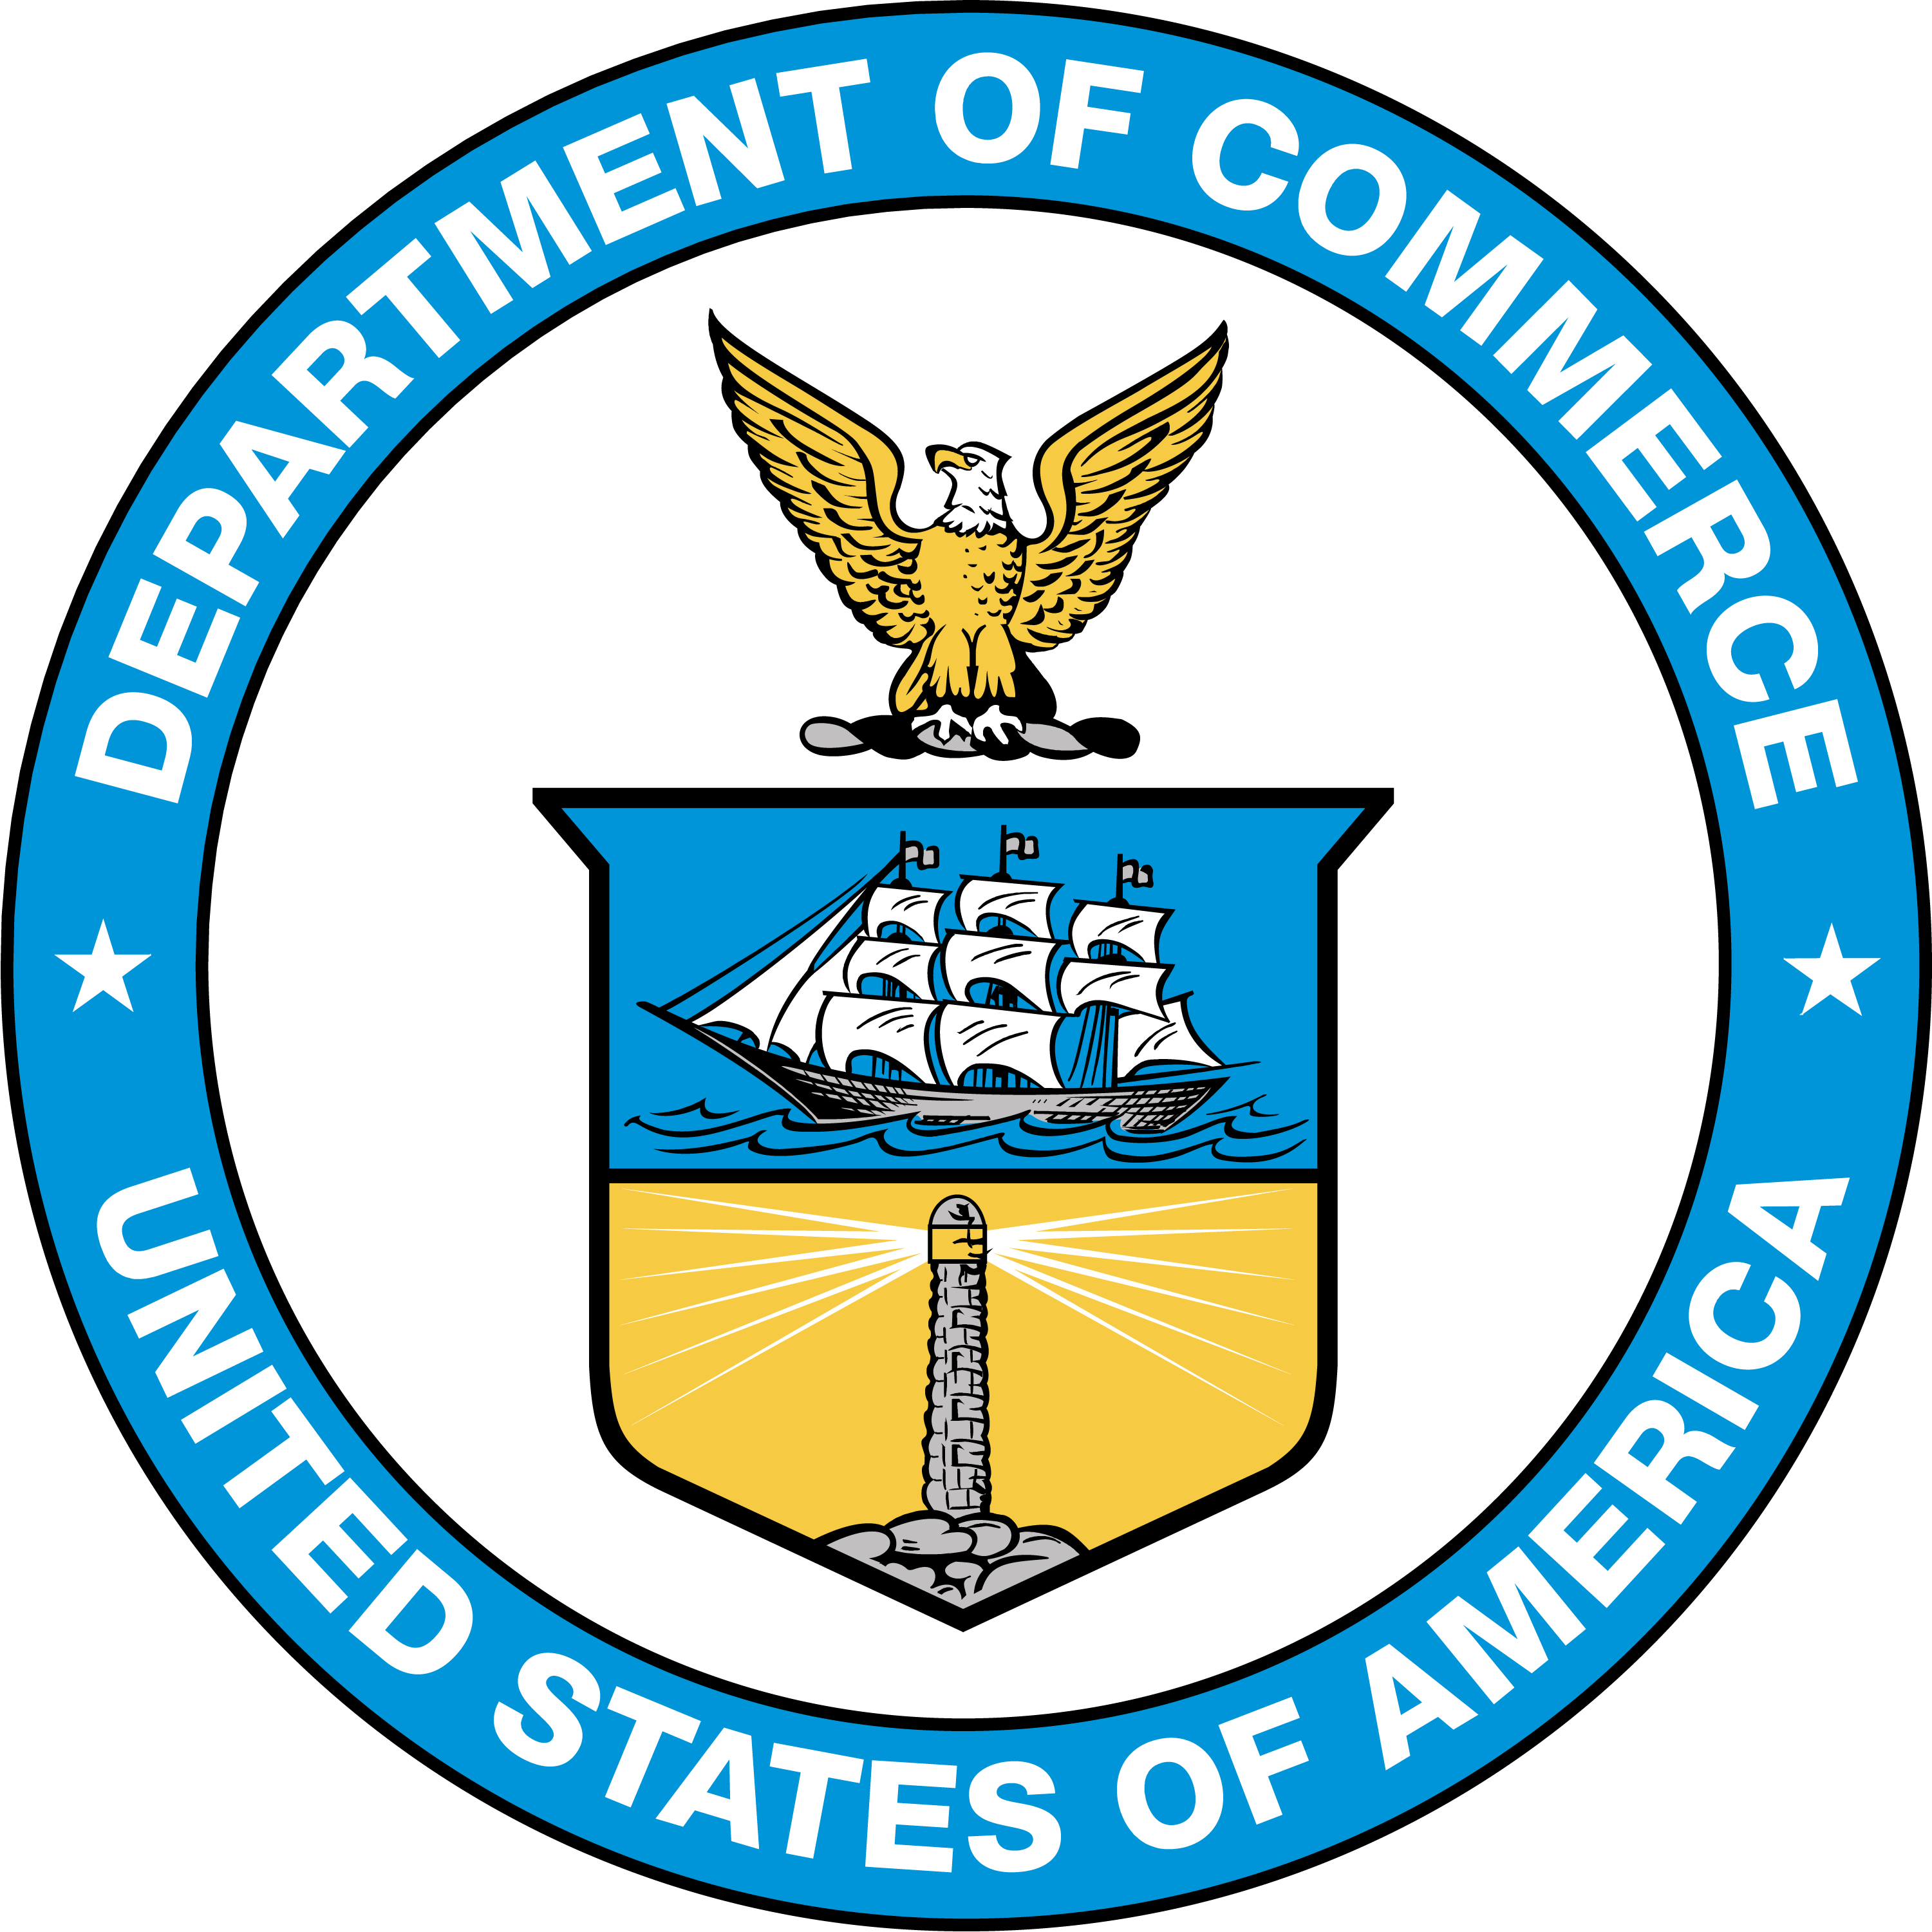
U.S. Department of Commerce
Gina M. Raimondo, Secretary
National Institute of Standards and Technology
Laurie E. Locascio, NIST Director and Under Secretary of Commerce for Standards and Technology

Certain commercial entities, equipment, or materials may be identified in this document to describe an experimental procedure or concept adequately. Such identification is not intended to imply recommendation or endorsement by the National Institute of Standards and Technology (NIST), nor is it intended to imply that the entities, materials, or equipment are necessarily the best available for the purpose.
This handbook promotes the primary use of the International System of Units (SI) by citing SI units before U.S. customary units where both units appear together, and by placing separate sections containing requirements for SI units before corresponding sections containing requirements for customary units. In some cases, however, trade practice is currently restricted to the use of U.S. customary units; therefore, some requirements in this handbook will continue to specify only U.S. customary units until the National Conference on Weights and Measures (NCWM) achieves a broad consensus on the permitted metric units.
Marijuana (also referred to as cannabis) remains a Schedule I substance under the Controlled Substances Act. As with all materials, the NIST Office of Weights and Measures (OWM) provides technical analysis and any relevant expertise to help ensure that the standards as developed through the NCWM process are technically sound. As such, NIST publishes the adopted model regulations for cannabis and cannabis-containing commodities by the NCWM in the NIST Handbook 130 as part of NIST’s statutory mission to promote uniformity in state laws, regulations, and testing procedures.
NIST Technical Series Policies
Copyright, Fair Use, and Licensing Statements
NIST Technical Series Publication Identifier Syntax
Publication History
Approved by the NIST Editorial Review Board on 2024-02-25
Supersedes NIST Handbook 130 – 2024 (December 2023) https://doi.org/10.6028/NIST.HB.130-2024
Approved by the NIST Editorial Review Board on 2023-12-12
Supersedes NIST Handbook 130 – 2023 (December 2022) https://doi.org/10.6028/NIST.HB.130-2023
How to Cite this NIST Technical Series Publication
McGuire J, Sefcik D., Warfield L,, Branden Y., and Lippa K, (2024) Uniform Laws and Regulations in the Areas of Legal Metrology and Fuel Quality. (National Institute of Standards and Technology, Gaithersburg, MD), NIST Handbook (HB) NIST HB 130-2024. https://doi.org/10.6028/NIST.HB.130-2024-upd1
NIST Author ORCID iDs
J McGuire: 0009-0006-7396-155X
D Sefcik: 0000-0001-7407-1950
L Warfield: 0000-0003-0576-8572
Y. Branden: 0009-0009-0008-1721
K Lippa: 0000-0001-8651-8326
Contact Information
owm@nist.gov
NIST Office of Weights and Measures
Attention: Publications Coordinator
100 Bureau Drive, MS 2600
Gaithersburg, MD 20899

NIST does not have a policy role related to the legalization of the production, sale, distribution, or use of cannabis (including hemp and marijuana).

