NIST Handbook  
NIST HB 133-2025

Checking the Net Contents of Packaged Goods

*as adopted by the   
109th National Conference on Weights and Measures*

John T. McGuire

David A. Sefcik

Loren Minnich

Isabel Chavez Baucom

Katrice A. Lippa

*Physical Measurement Laboratory  
Office of Weights and Measures*

This publication is available free of charge from:

[https://doi.org/10.6028/NIST.HB.133-202](https://doi.org/10.6028/NIST.HB.133-2023)5

December 2024

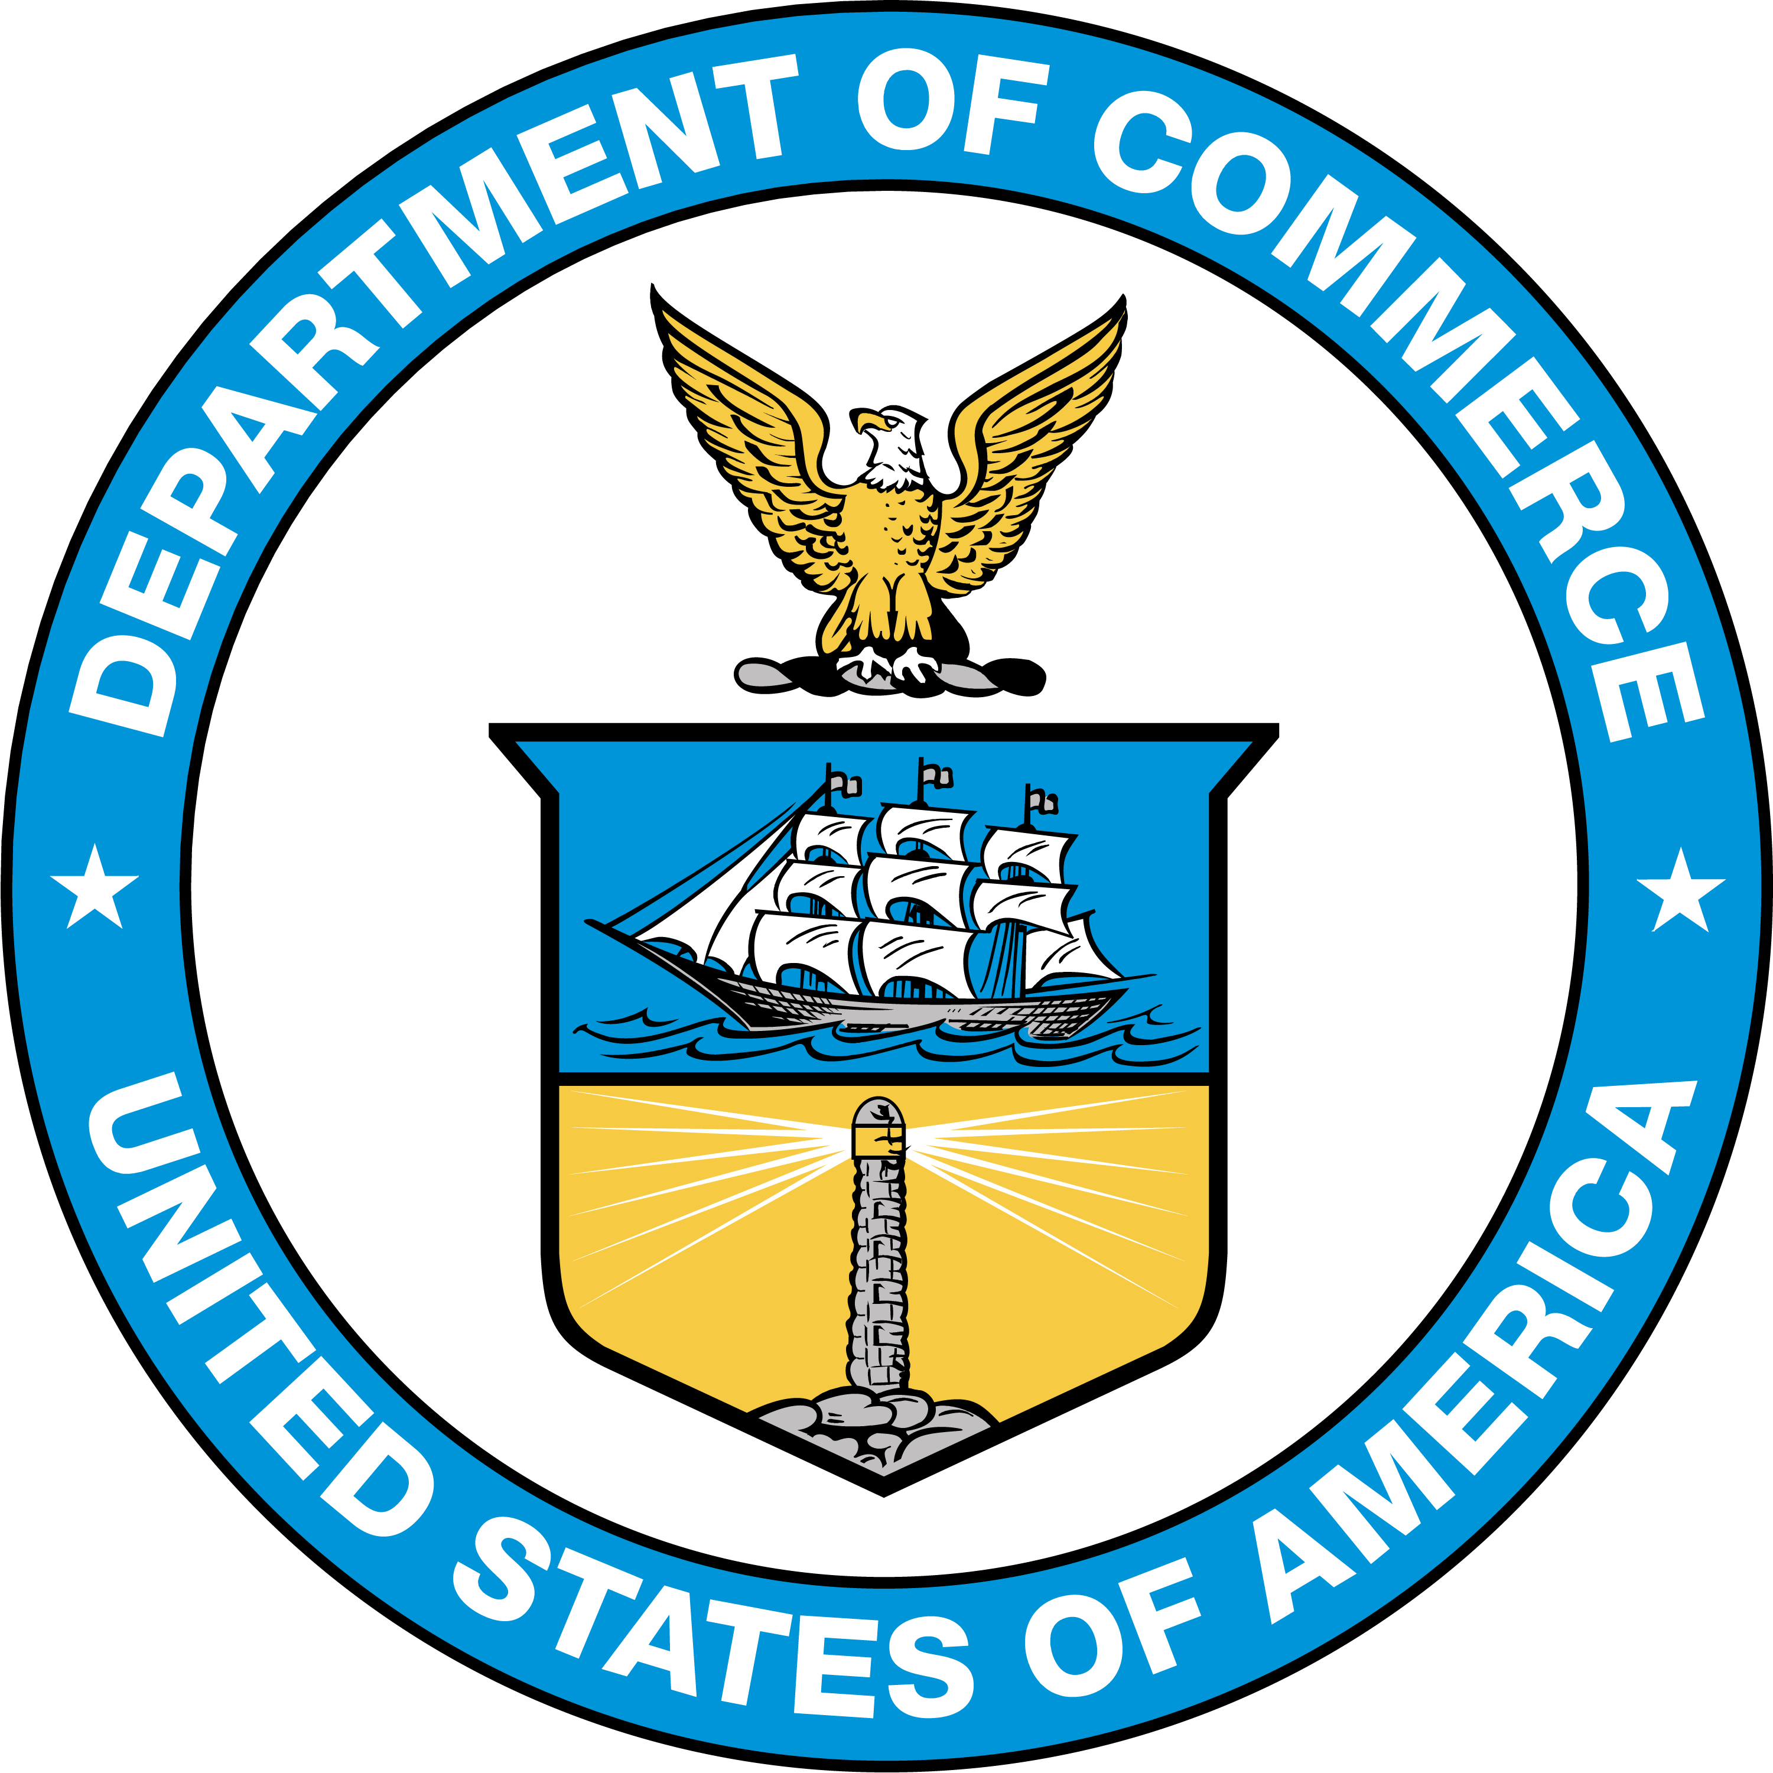

U.S. Department of Commerce

*Gina M. Raimondo, Secretary*

National Institute of Standards and Technology

Laurie E. Locascio, NIST Director and Under Secretary of Commerce for Standards and Technology

Certain commercial entities, equipment, or materials may be identified in this document in order to describe an experimental procedure or concept adequately. Such identification is not intended to imply recommendation or endorsement by the National Institute of Standards and Technology, nor is it intended to imply that the entities, materials, or equipment are necessarily the best available for the purpose.

This handbook conforms to the concept of primary use of SI (metric) measurements recommended in the Omnibus Trade and Competitiveness Act of 1988 by citing SI units before U.S. customary units where both units appear together and placing separate sections containing requirements in SI units before corresponding sections containing requirements in U.S. customary units. In some cases, however, trade practice is currently restricted to the use of U.S. customary units; therefore, some requirements in this handbook will continue to specify only U.S. customary units until a broad consensus is achieved on the permitted SI units.

NIST Technical Series Policies

[Copyright, Fair Use, and Licensing Statements](https://doi.org/10.6028/NIST-TECHPUBS.CROSSMARK-POLICY)

[NIST Technical Series Publication Identifier Syntax](https://www.nist.gov/nist-research-library/nist-technical-series-publications-author-instructions#pubid)

Publication History

Approved by the NIST Editorial Review Board on 2024-10-25  
Supersedes NIST Handbook 133 - 2023 (January 2023) https://doi.org/10.6028/NIST.HB.133-2023

How to Cite this NIST Technical Series Publication

McGuire JT, Sefcik DA, Minnich LB, Baucom ICh, and Lippa KA, (2025) Checking the Net Contents of Packaged Goods. (National Institute of Standards and Technology, Gaithersburg, MD), NIST Handbook (HB) NIST HB 133-2025. https://doi.org/10.6028/NIST.HB.133-2025

NIST Author ORCID iDs

JT McGuire 0009-0006-7396-155X

DA Sefcik: 0000-0001-7407-1950  
LB Minnich: 0009-0006-8082-2726

ICh Baucom: 0009-0004-8989-2021  
KA Lippa: 0000-0001-8651-8326

Contact Information

[**owm@nist.gov**](mailto:owm@nist.gov)

NIST Office of Weights and Measures  
Attention: Publications Coordinator   
100 Bureau Drive, MS 2600  
Gaithersburg, MD 20899

Abstract

This handbook has been prepared as a procedural guide for the compliance testing of net content statements on packaged goods. Compliance testing of packaged goods is the determination of the conformance results of packaging, distribution, and sale of commodities to specific legal requirements for net content declarations. This handbook has been developed primarily for the use of state, local, and some federal officials. However, it should be useful to commercial and industrial establishments areas of packaging, distribution, and sale of commodities.

NIST has statutory responsibility for “cooperation with states in securing uniformity of weights and measures laws and methods of inspection and publishes this and other NIST Handbooks in partial fulfillment of this responsibility. This 2025 edition includes amendments made through the Committee on Laws and Regulations of the National Conference on Weights and Measures (NCWM) with technical guidance from the Office of Weights and Measures (OWM) of the National Institute of Standards and Technology (NIST) and input from weights and measures officials and industry representatives. These amendments were adopted by the NCWM at its 109th Annual Meeting in July 2024. There may be years where there are no changes to this NIST Handbook 133; therefore, it would not be published on an annual basis in such instances.

In conducting compliance testing, the conversion of measured quantity values between systems of measurement (e.g., from the metric system to the U.S. customary system) should be handled with careful regard to the implied correspondence between measurement accuracy and the number of digits displayed. For all conversions, the number of significant figures retained should be congruous with the accuracy of the corresponding measurement. For this edition of NIST Handbook 133, all quantity values obtained from devices or through test procedures have been rounded to two significant digits (e.g., 2.5 cm to 1.0 in), or to a precision level applicable to the test equipment (e.g., 200 kPa for 25 psi or 35 MPs for 5000 psi).

Keywords

count; labeling; measures; packaging; testing procedures; testing methods; weight; volume; length; scale; area; thickness.

Author Contributions

**John T. McGuire**: Data Curation, Writing - Reviewing and Editing; **David A. Sefcik**: Data Curation, Writing - Reviewing and Editing; **Loren Minnich:** Reviewing and Editing; **Isabel Chavez Baucom**: Reviewing and Editing; **Katrice A. Lippa**: Supervision.

Acknowledgments

Committee on Laws and Regulations of the   
109th National Conference on Weights and Measures

Mike Brooks, Arizona

Tory Brewer, West Virginia

Mauricio Mejia, Florida

Walt Remmert, Pennsylvania

Mike Harrington, Iowa

Associate Membership Representative: Brent Price, Gilbarco Inc.

Canadian Technical Advisors: Rowan Hemsing, Measurement Canada

NIST Technical Advisors: John McGuire,   
NCWM Committee Coordinator: Constantine Cotsoradis

Past Chairs of the Committee

|  |  |  |  |
| --- | --- | --- | --- |
| Conference | Chair | Conference | Chair |
| 41 | G. H. Leithauser, MD | 79 | B. Bloch, CA |
| 42-43 | F. M. Greene, CT | 80 | S. Rhoades, AZ |
| 44 | G. L. Johnson, KY | 81 | L. Straub, MD |
| 45 | R. Williams, NY | 82 | S. Millay, ME |
| 46-49 | J. H. Lewis, WA | 83-84 | K. Angell, WV |
| 50-51 | L. Barker, WV | 85 | S. Morrison, CA |
| 52 | M. Jennings, TN | 86 | R. Williams, TN |
| 53 | W. A. Kerlin, CA | 87 | P. D’Errico, NJ |
| 54-55 | J. F. Lyles, VA | 88-89 | D. Johannes, CA |
| 56-58 | S. D. Andrews, FL | 90 | J. Gomez, NM |
| 59 | R. M. Leach, MI | 91 | J. Benavides, TX |
| 60 | R. L. Thompson, MD | 92 | J. Cassidy, MA |
| 61-62 | C. H. Vincent, Dallas, TX | 93 | Vicky Dempsey, OH |
| 63 | J. T. Bennett, CT | 94 | Joe Gomez, NM |
| 64 | R. W. Probst, WI | 95 | Joe Benavides, TX |
| 65 | D. I. Offner, MO | 96 | John Gaccione, NY |
| 66-68 | J. J. Bartfai, NY | 97-98 | J. Cardin, WI |
| 69 | W. R. Mossberg, CA | 99 | R. Johnson, NM |
| 70 | E. Skluzacek, MN | 100 | T. Lloyd, MT |
| 71 | D. Stagg, AL | 101 | R. Lewis, GA |
| 72 | A. Nelson, CT | 102-103 | Ethan Bogren, NY |
| 73-74 | K. Simila, OR | 104 | Michelle Wilson, AZ |
| 75 | S. B. Colbrook, IL | 105 | Ethan Bogren, NY |
| 76 | A. Nelson, CT | 106-107 | John McGuire, NJ |
| 77 | B. Bloch, CA | 108 | Doug Rathbun |
| 78 | F. Clem, OH | 109 | Mike Brooks |