Robotic Disassembly/Assembly NIST Task board 3 BENCHMARK

Reference No / Version  URL  Authors  Institution | RAL-SI-2020-B-3 [Benchmarking Protocols for Evaluating Small Parts Robotic Assembly Systems]-V1.0
 | https://www.nist.gov/el/intelligent-systems-division-73500/robotic-grasping-and-manipulation-assembly/assembly
 | Kenneth~Kimble, Karl~Van~Wyk, Joe~Falco, Elena~Messina, Yu~Sun, Mizuho Shibata, Wataru Uemura, Yasuyoshi~Yokokohji
 | National Institute of Standards and Technology, University of South Florida (USF), Kindai University, Ryukoku University, Kobe University
Contact information | Joseph.falco@nist.gov, Kenneth.kimble@nist.gov
Adopted Protocol | RAL-SI-2020-P [Benchmarking Protocols for Evaluating Small Parts Robotic Assembly Systems]-V1.0  Kenneth Kimble¹, Karl Van Wyk², Joe Falco¹, Elena Messina¹, Yu Sun³, Mizuho Shibata⁴, Wataru Uemura⁵, Yasuyoshi Yokokohji⁶  ¹National Institute of Standards and Technology (NIST), ²NVIDIA, ³University of South Florida, ⁴Kindai University, ⁵Ryukoku University, ⁶Kobe University
Scoring | Assembly  Description Qty Task 1 Task 2 per task Total  Wire transport 12 Contact with board 12  1 pt 1  Pin insertion 24 inserted seated 72  2 pts 1 pt 3  Wire routed 12 elastic retainer corner post 60  1 pt each 1 pt each  ____ / 3 ____ / 2 5  Wired correctly 6 connector LED is lit 18  3 3  Max score: 162  Disassembly  Description Qty Task 1 Total  Wires bundled 5 Bound at each retainer 25  5 pts  Connector detach 8 Removed from joining part 24  3 pts  Harness removal 1 Fully removed from board 5  5 pts  Max score: 54  Example of a fully assembled task board. Corresponds to the set-up just prior to the disassembly task or an assembly trial with 100% completion.  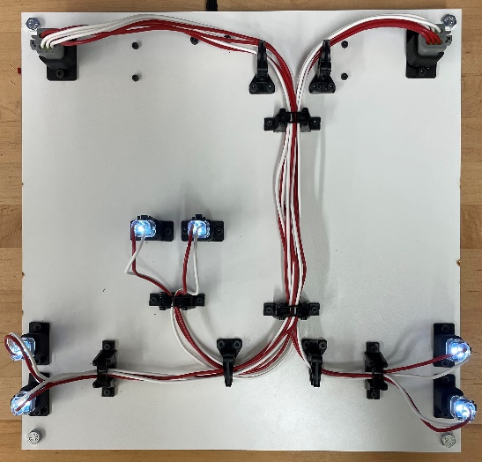
Details of Setup | Describe your system design including robots and end-effector technologies used, perception type and how it is used to localize board, kit and components, use of CAD. Also describe all tools used with end-effectors.
Results to Submit | Submit scoresheets and a summary of results over 32 trials to include analysis of speed, completion, and reliability. Make notes in the summary of the incomplete/failed tasks and the reasons for the failure. Speed is measured as the completion time of a task board as:  T_{taskboard} = T_{finish} − T_{start}.  Task board completion should be reported as the percentage of total points received for each task board for disassembly and assembly.  % Assembled = Total Score/162 x 100  % Disassembled = Total Score/54 x 100  For each set of 32 trials, compute the mean, standard deviation, and 95% confidence interval of the completion times, disassembly completion and assembly completion.  Reliability can also be captured as the probability of successfully completing a task or sub-task. The theoretical upper bound probability for successfully inserting a component (PS) is calculated given a confidence level (CL), the number of successes (m), and the number of independent trials (n). Given the binomial cumulative distribution function:  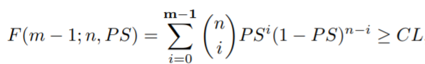  The PS is its minimum value to some precision while still satisfying the above inequality

