Chapter 4 -- How to Use NIST Handbook 44

Chapter Objectives

After studying the contents of this chapter and completing the exercises, you should be able to:

1. Describe the application and contents of Section 1.10, the General Code, and its relationship to specific device codes.

2. Use annual reports of the NCWM Specifications and Tolerances Committee and other committees, and other archival publications to research the history and rationale for specific requirements.

3. Describe in general terms the contents and use of NIST Examination Procedure Outlines (EPOs), NIST training courses, and other reference materials to obtain guidance in interpreting and applying NIST Handbook 44 requirements.

Introduction to the General Code

The requirements of the General Code apply to all weighing and measuring devices used in commercial or law enforcement activities, whether or not they also fall under one of the "device codes" of Handbook 44 (as most do), unless there is conflict between a particular General Code requirement and one in a specific device code (see G-A.2., discussed below).

Because of this broad scope, the requirements are general in nature. But that does not mean that they are less important than requirements in the device-specific codes. Some General Code requirements are not restated in the device codes, and you should be careful not to overlook these distinct requirements when examining a device.

In addition, the general nature of these requirements often makes them applicable when no requirement covering a specific feature or situation exists in the device code.

The organization and content of the General Code mirror the organization and content of the device codes. So in this chapter we'll review the General Code, not only as an illustration of the principles described in Chapter 3, but also to show how Handbook 44 requirements are stated and how they are interpreted and applied.

The discussion below follows the sequence in which the requirements are presented in the General Code, presenting some commentary on the most important points in each paragraph and clarifying the meaning of the requirement with examples.

To follow this discussion, you should have a copy of the current edition of NIST Handbook 44 to reference. Turn to the General Code and read each paragraph carefully. Then return to the text and read the brief discussion before proceeding to the next paragraph.

Section G-A. -- Application

Requirements grouped together under the section designated "A" in a code define the scope of application for the code as a whole. As you go through the General Code, however, note that paragraphs, subparagraphs, etc. can have more limited applicability. For example, G-S.5.2.1. is applicable to analog indications only.

In addition to stating the devices to which a particular code applies, the application section may also state that specific devices do not fall under the code. Sometimes devices are exempted when designed or used in some specified manner; sometimes the exemption is general.

For example, if you look at Section 2.21 (Belt-Conveyor Scale Systems), paragraph A.2., you will notice that several specific types of devices are mentioned: devices used for discrete weighing while moving on conveyors, devices that measure quantity on a time basis and, check-weighers. In addition, this paragraph excludes controllers or other auxiliary devices, "except as they may affect the weighing performance of the belt-conveyor scale."

G-A.1. Commercial and Law-Enforcement Equipment

This paragraph defines the scope of application of the General Code:

- to all weighing and measuring devices used in commercial service;

- to accessories used in connection with devices that can affect their accuracy (for example, an automatic temperature compensator used to correct indications on a metering device to the volume of product at a predetermined temperature); and

- to weighing and measuring equipment used in law enforcement activities or by government agencies for collecting data (for example, some axle-load scales, portable wheel-load weighers, etc.).

The application of the General Code, as defined here, is very broad. It applies to any device used commercially, regardless of the amount of the transaction, or whether it is a wholesale or retail sale.

Also, the term "device," which we've used for convenience, comprises not just mechanical devices, but weights (i.e., calibrated weights used with scales) and measures (e.g., vehicle tanks that are used as volume measures) -- anything that is used to weigh or measure. All devices, no matter how crude or how sophisticated, are covered.

G-A.2. Code Application

This paragraph is extremely important, since it deals with conflict between the General Code and device codes: in all cases of conflict, the requirements of the specific code supersede those of the General Code.

Such conflicts are not common, but they do occur. For example, G-S.5.5. states that a digital money-value indication must be in mathematical agreement with the associated quantity representation "to the nearest one cent" (we'll look at the meaning of this requirement later in this chapter). However, Section 3.31 (Vehicle-Tank Meter Code), paragraph S.1.4.4. states that the agreement must be "to within one cent."

Given a money-value computed mathematically of $12.6563, the only indicated value that would comply with G-S.5.5. is $12.66, since this is the value "to the nearest cent." However, indications of $12.65 or $12.66 would meet the requirement of Section 3.31, para. S.1.4.4., since either is "within one cent" (that is, the difference between the mathematically computed value and either of these indicated values is less than one cent: e.g. $12.6563 - $12.65 = $0.0063).

G-S.5.5. is clearly the stricter requirement. However, in accordance with G-A.2., the requirement of the device code supersedes it. Still, remember that it is superseded only for devices to which the Vehicle-Tank Meter Code applies. If some other device is covered by a different code which has no conflict with G-S.5.5., that General Code requirement remains applicable.

G-A.3. Special and Unclassified Equipment

This paragraph simply states that, where appropriate, requirements of the General Code and/or specific device codes, apply to equipment that for one reason or another does not fall clearly under the stated application of a single device code.

In some cases, it is necessary to apply requirements from different codes to a device that does not clearly fall within any single code, or that has special features.

G-A.4. Metric Equipment

The NCWM has consistently maintained that weights and measures regulations should not discourage use of the metric system in the United States. In fact, the NCWM has taken positions strongly in favor of conversion to the metric system.

NIST Handbook 44 conforms to the concept of primary use of SI (metric) measurements recommended in the Omnibus Trade and Competitiveness Act of 1988 by citing SI units before inch-pound units where both units appear together and placing separate sections containing requirements in SI units before corresponding sections containing requirements in inch-pound units. However, in some cases, where current trade practice is restricted to the use of inch-pound units, citations may be in terms of inch-pound units only. This does not mean that only devices indicating in inch-pound units are covered or that metric equipment is prohibited. In cases where no metric unit is cited alongside an inch-pound unit, the equivalent metric weight or measure can be assumed to be implied.

G-A.5., G-A.6., and G-A.7.

The terms "retroactive" and "nonretroactive" and the effective date of requirements when not specified were described in detail in Chapter 3.

Section G-S. Specifications

Specification requirements (prefixed by the letter "S") relate to the design of equipment. In a sense, they are addressed primarily to manufacturers of devices, who have a legal responsibility to ensure that new models of weighing and measuring devices for use in commerce meet these specifications.

However, the owner of the device is also legally responsible for conformance with all weights and measures requirements, including specification requirements. Likewise, service company personnel must also be familiar with these requirements since they are hired by the owner to service the device to comply with applicable Handbook 44 requirements.

These responsibilities are spelled out in Section 22 of the Uniform Weights and Measures Law, which has been adopted by most of the States. Section 22 states, in part, that "no person shall: (a) use or have in possession for use in commerce, [or] . . . (b) sell or offer for sale for use in commerce any incorrect weight or measure."

Because weights and measures officials must ensure compliance of a device with all applicable requirements in Handbook 44, the weights and measures official must also be knowledgeable about specification requirements. It is not adequate for a weights and measures official or service person to simply apply accuracy requirements to a device. A device must comply with all applicable Handbook 44 requirements.

G-S.1. Identification

The most authoritative source of technical information about a device is generally the manufacturer, and the basic information needed to identify the manufacturer, and the particular device, must be readily available, both to the operator and to weights and measures officials.

It is also important to be able to identify a specific piece of equipment so that, for example, a weights and measures official can identify a new piece of equipment that has not been inspected previously, or check the inspection history of a device that has been in service for some time. In order to apply non-retroactive requirements properly, it is often necessary to determine when a device was manufactured. The serial number may help the weights and measures official determine when the device was manufactured since some manufactures can track the manufacture date of a device with the serial number.

For this reason, G-S.1. has, since 1968, required that each device display a nonrepetitive serial number, making that piece of equipment uniquely identifiable. The provision in G-S.1., that the serial number be prefaced by words or a symbol clearly identifying it as the required serial number, was added later to prevent confusion between the required serial number and other numbers that might be marked on the device. A similar provision was added for identifying the model designation.

The identification information is not required to be located conspicuously, but simply so that it is readily observable without using means separate from a device (such as a tool) to disassemble a part of the device. The identification information could, for example, be located under a scale platform, as long as the platform could be lifted off readily, without having to first use a screwdriver to loosen several screws.

Note that portions of G-S.1. are nonretroactive and that those portions are nonretroactive as of different dates. It is not uncommon for an additional requirement to be added to a paragraph at a later date in this way.

Paragraph G-S.1.1., which was added to Handbook 44 in 2003, addresses marking requirements for “not built-for-purpose” software-based devices. A “built-for-purpose” device is defined as any main device or element which was manufactured with the intent that it be used as, or part of, a weighing or measuring device or system. “Not built-for-purpose” devices are, therefore, devices which were not manufactured with the original intention of being used as (or as part of) a weighing or measuring device, but which could be adapted for such use. For example, a personal computer could, with appropriate software, be adapted for use as part of a vehicle scale weighing system.

Paragraph G-S.1.2. was added in 2001 to address marking requirements for devices and main elements which have been remanufactured. Definitions for “manufactured device,” “remanufactured device,” “repaired device,” “repaired element,” and “remanufactured element” are included in Appendix D, Definitions of Handbook 44.

G-S.2. Facilitation of Fraud

The General Code requires that all weighing and measuring devices and all mechanisms, software, and devices attached to or used with any weighing or measuring device be constructed, assembled, and installed so that they do not "facilitate the perpetration of fraud." A design feature that could make it easy for the owner/operator to commit fraud is unacceptable, whether or not there is evidence that the device is actually being used fraudulently.

As you become familiar with Handbook 44, you will find that the device codes often include language to address specific cases where the potential for fraudulent use has been identified. In the Scales Code, for example, an electronic scale with two or more load-receiving elements is required to have some means to prohibit more than one load-receiving element from being activated at a time. It must also have a light or some other means that clearly identifies which load-receiving element is in use at any particular time.

Such requirements are intended to ensure that weighing and measuring equipment does not make it easy for operators to defraud customers. Of course, with constant changes in equipment technology and use, not every potentially fraudulent situation can be anticipated. Consequently, G-S.2. is a catch-all requirement that can be used to stop unanticipated situations in which the design, assembly, or installation of a device could facilitate fraud.

G-S.3. Permanence

The permanence requirement is intended to ensure that equipment will maintain its accuracy, function as intended, and remain in adjustment for some reasonable period of time.

Note that the requirement is not specific with respect to the period of time that would be considered reasonable or the type of material, design, or construction that is appropriate. It would not be practical to specify this information because of the number of weighing and measuring devices, and such specificity could also inhibit innovation.

In some cases it may be obvious that the material, design, or construction of a particular device will not result in adequate service over a reasonable period of time. For example, a scale platform made of thin plywood may be clearly inappropriate for a scale intended to weigh very heavy loads. In most cases, however, judgments concerning permanence must be made based upon the history of a device and its performance relative to the norm for equipment of the same type.

G-S.4. Interchange or Reversal of Parts

In general, a weighing or measuring device should be designed in such a way that parts can not be readily interchanged or reversed, since such a feature could facilitate fraud. This is often accomplished by providing means for sealing device components that could affect the measurement so that they can not be interchanged without leaving evidence of tampering. In some cases, the manufacturer will design the device such that, when parts are reversed, the device will not function or will give an obvious error message.

Some devices must have readily interchangeable parts. For example, milk meters must be partially dismantled and cleaned frequently for sanitation reasons. If a meter is reassembled with a part from another meter, it may not measure accurately.

Similarly, the removable pans of a mechanical equal-arm scale may differ in shape or weight, and the device may not weigh accurately if the left pan is placed on the right arm and the right pan placed on the left arm.

Paragraph G-S.4. is intended to help prevent the intentional (or unintentional) abuse of such devices. According to this requirement, all removable or reversible parts must either be constructed so that their interchange or reversal will not affect the accuracy of the device, or marked to show their proper positions. For example, the removable pans on an equal-arm scale would have to be marked 'Left' and 'Right', or with some similar marking that indicates the correct side.

G-S.5. Indicating and Recording Elements

G-S.5.1. General

All weighing and measuring devices must be provided with indicating or recording elements. Some devices have both.

An indicating element is the means by which the weight or measure (and sometimes a computed money value) determined by a device is "read" from the device itself. Examples of indicating elements are a weighbeam-and-poise combination, an index and graduated scale combination (with numbers to represent the value of some or all of the graduations), or a digital indicator.

A recording element is the means by which the weight or measure (and computed money value, if any) determined by a device is permanently recorded on a tape, card, ticket, or the like. An example of a recording element is a ticket printer in a vehicle-tank metering system that produces a delivery ticket after a delivery of home heating oil.

Primary indicating and recording elements are those that are actually used to determine the quantity or total price in a transaction. A device may also have additional auxiliary indicating or recording elements for the convenience of the owner or operator.

G-S.5.2. Graduations, Indications, and Recorded Representations

Devices are described as analog devices or digital devices, according to the manner in which they indicate measured values.

An analog device is one in which indicated or recorded values are presented as a series of graduations in combination with an indicator, or in which the most sensitive element of the indicating system moves continuously during the operation of the device

The most important feature of an analog device is that it provides continuous indications. A mechanical gas pump with revolving indicating wheels like the one shown in Figure 4-1 is a good example of an analog device.

The upper set of wheels indicates the total price of the sale, the middle set the quantity, and the bottom set the price per quantity unit (in this case, gallons). During a delivery of product, the top two sets of wheels turn to indicate the quantity delivered and the price. The unit price (e.g., price-per-gallon) wheel, of course, does not move or change during the delivery. Let's look at the middle set of wheels, which indicates the quantity.

The right hand quantity indicating wheel, which usually has graduations representing tenths of a gallon, is the most sensitive element of the system, since it indicates the smallest quantity unit.

Adjacent to this graduated wheel is a fixed indicator. As the wheel turns during operation of the metering system, the position of the graduations with respect to the indicator changes. But the indicator is always adjacent to some point on the wheel, and is thus indicating continuously. For example, the quantity wheels in the drawing indicate approximately 10.05 gallons of product delivered.

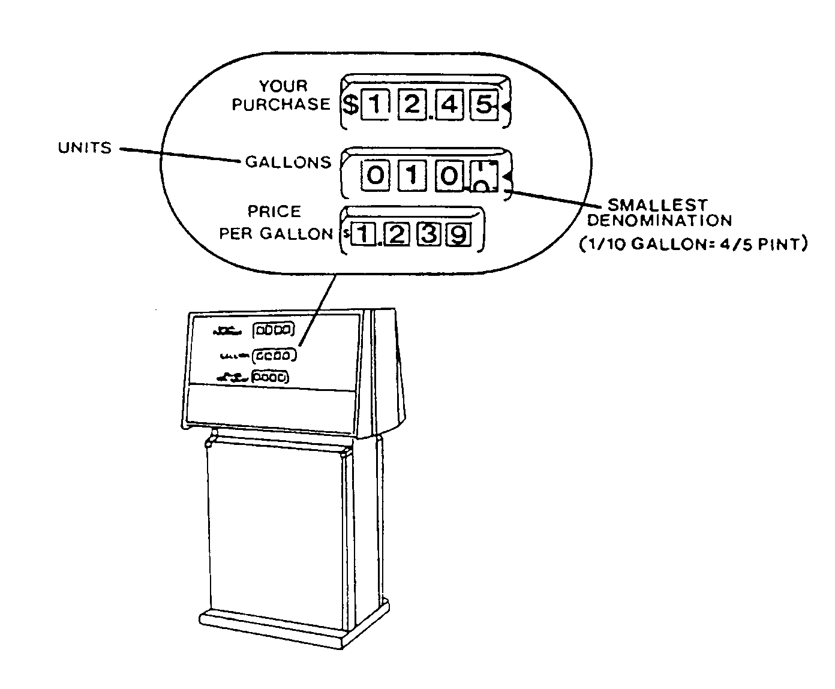

Figure 4-1. Analog Device

The total price indicating wheels (shown on top in Figure 4-1) work in the same way, with the most sensitive element, here the wheel with graduated intervals representing one cent, indicating continuously.

Theoretically, this type of indicator is capable of indicating an infinite number of values between successive graduation lines (although in practice, the value of the closest graduation is usually read).

In contrast, a digital type device indicates values intermittently:

A digital device employs a system of indicating or recording of the selector type, or one that advances intermittently in which all values are presented digitally, or in numbers. In a digital indicating or recording element, or in digital representation, there are generally no graduations.

Think of the digital type indicators that are found on some gas pumps, like the one shown in Figure 4-2. Again, only the quantity and money value indicators, the top two rows shown in the drawing, change during the course of a delivery of product. Let's look at the quantity indicator.
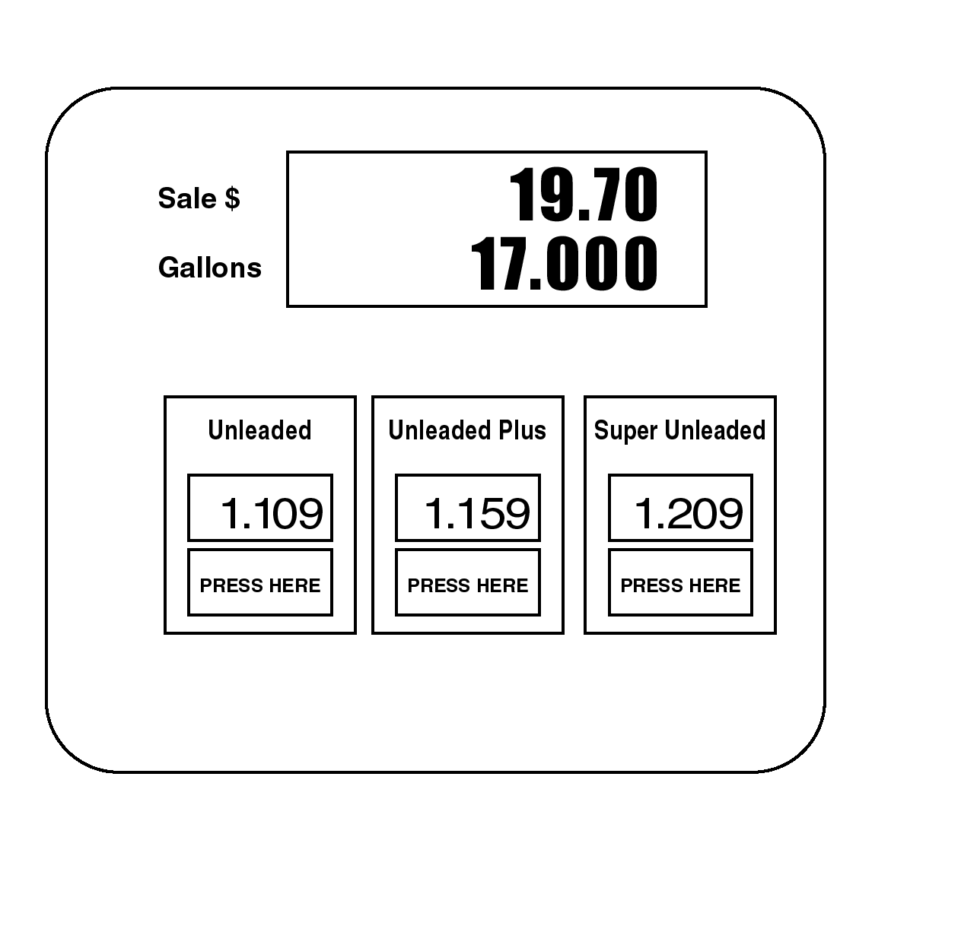
Figure 4-2. Digital Device

As the pump is operated, the most sensitive element of the indication -- here the right hand digit, which represents thousandths of gallons -- changes instantaneously from one successive value to the next: the indication of 17.000 gallons will be followed by an indication of 17.001 gallons when that additional amount of gas has been pumped.

Because the indicated value on a digital device changes in fixed increments, the most sensitive element can not display any intermediate values (e.g., 17.0004 gallons), even theoretically.

It might seem from these examples that the analog device is capable of greater accuracy, since it displays an infinite number of values. But this is not necessarily the case.

Notice that in the examples we've seen -- which are typical of actual devices -- the digital indicator is capable of displaying values in thousandths of gallons clearly.

To obtain a reading in thousandths of gallons from the analog indicator, one would have to visually subdivide the interval between successive tenth-of-a-gallon graduations into hundredths and then judge which of these divisions is closer to the position of the indicator. This is not easy to do if the distance between one-tenth graduations is only about one inch.

Thus, the accuracy of an indicator is determined by its design and not its type (analog or digital).

Some devices have a combination of analog and digital indication and recording. To stay with our familiar example, an analog type gas pump may be connected to a console inside the attendant's booth that displays digital indications of the quantity. In addition, if the system is equipped with an automatic receipt printer, the recorded values will be printed digitally.

Study the separate requirements in G-S.5. for analog and digital indication and representation with these definitions in mind.

G-S.5.2.1. Analog Indication and Representation

All analog devices must be provided with graduations and a suitable indicator. A scale consisting simply of numbers, without graduation lines, would not be acceptable. Graduation lines are necessary to show clearly the division between successive values. Graduations must be of lengths and widths that promote correct reading, and the indicator must clearly indicate the correct value. Most specific codes have additional requirements regarding the size, width, and placement of the indicator and graduations to promote designs which facilitate clear and consistent readings. See also G-S.5.2.3., discussed below.

G-S.5.2.2. Digital Indication and Representation

These requirements are intended to ensure that digital representations and recorded values accurately reflect the quantity measured:

a) If a measuring system displays more than one digital reading of the same quantity (e.g., the quantity reading recorded on a gas station console and the quantity recorded on the printed receipt), all readings must agree exactly.

b) G-S.5.2.2.(b) applies to systems that combine digital and analog indications. For example, if the digital display on a gas station console reads 10.224 gal, the analog indicator on the gas pump must read 10.2 gal, when read to the nearest graduation.

c) Digital devices must be designed to round to the nearest unit that can be indicated or recorded. Usually, devices are designed to change their indication at the midpoint between successive divisions. For example, a digital scale that indicates in increments of 0.01 lb must display 14.23 lb for quantities between 14.225 lb and 14.235 lb, and must display 14.24 lb for quantities between 14.235 and 14.245 lb.

d) G-S.5.2.2.(d) establishes the method of zero balance indication that is acceptable on a digital device.

If a display of quantity includes a decimal point, then the correct display of zero is at least one digit to the left and all zeroes to the right of the decimal point. For example, an indicator that displays values to thousandths of a pound would have to display 0.000, although additional zeroes to the left could also be displayed (e.g., 000.000).

If the display does not include a decimal point, then it must display zeroes for each place of the displayed scale division. For example, if a device displays weight in 2g divisions, at least one zero must be displayed (e.g., 0); if the device displays in 10g divisions, at least two zeroes have to be displayed (e.g., 00); if 100g divisions, three zeroes (e.g., 000, which includes one for each place of the scale division), etc.

An additional example illustrating the application of G-S.5.2.2.(d) is shown below:

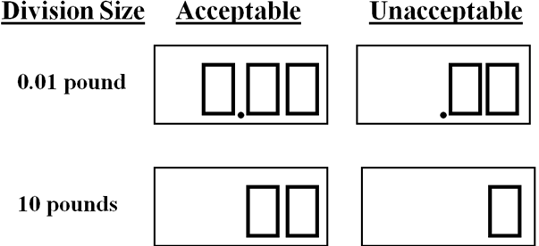

G-S.5.2.3. Size and Character

This requirement ensures that indications can be read without confusion. Note that it does not specify the size and character of graduations, numbers, or units, but requires uniformity within a series.

Consider the graduated scales for two different indicators depicted in Figure 4-3. Both scales indicate weight in inch-pound units. The value of the smallest graduated interval for the upper scale is 2 oz, the value of the smallest interval for the lower scale is 0.5 oz. On both scales, multiples of subordinate intervals are distinguished by graduations of different sizes. Some of these intervals correspond: for example, both scales have distinctive graduations at intervals of 0.25 lb.

However, you can see that the two scales are quite different in detail. For example, the upper scale has major divisions marked at 5-pound intervals, with subordinate (1-pound) graduations numbered serially; the lower scale has major 1-pound intervals, with subordinate divisions (4-oz) numbered as subdivisions of the larger unit (pounds).

Despite these differences in design, both scales are readily readable. One important reason for this is that within each series of graduations (that is, within 5lb intervals on the upper scale and within the 1lb intervals on the lower scale) the pattern of divisions -- distinguished by different size graduations and numbers -- is uniform. It is this type of consistency -- uniformity within a series of graduations, numbers, and units -- that is required by G-S.5.2.3.

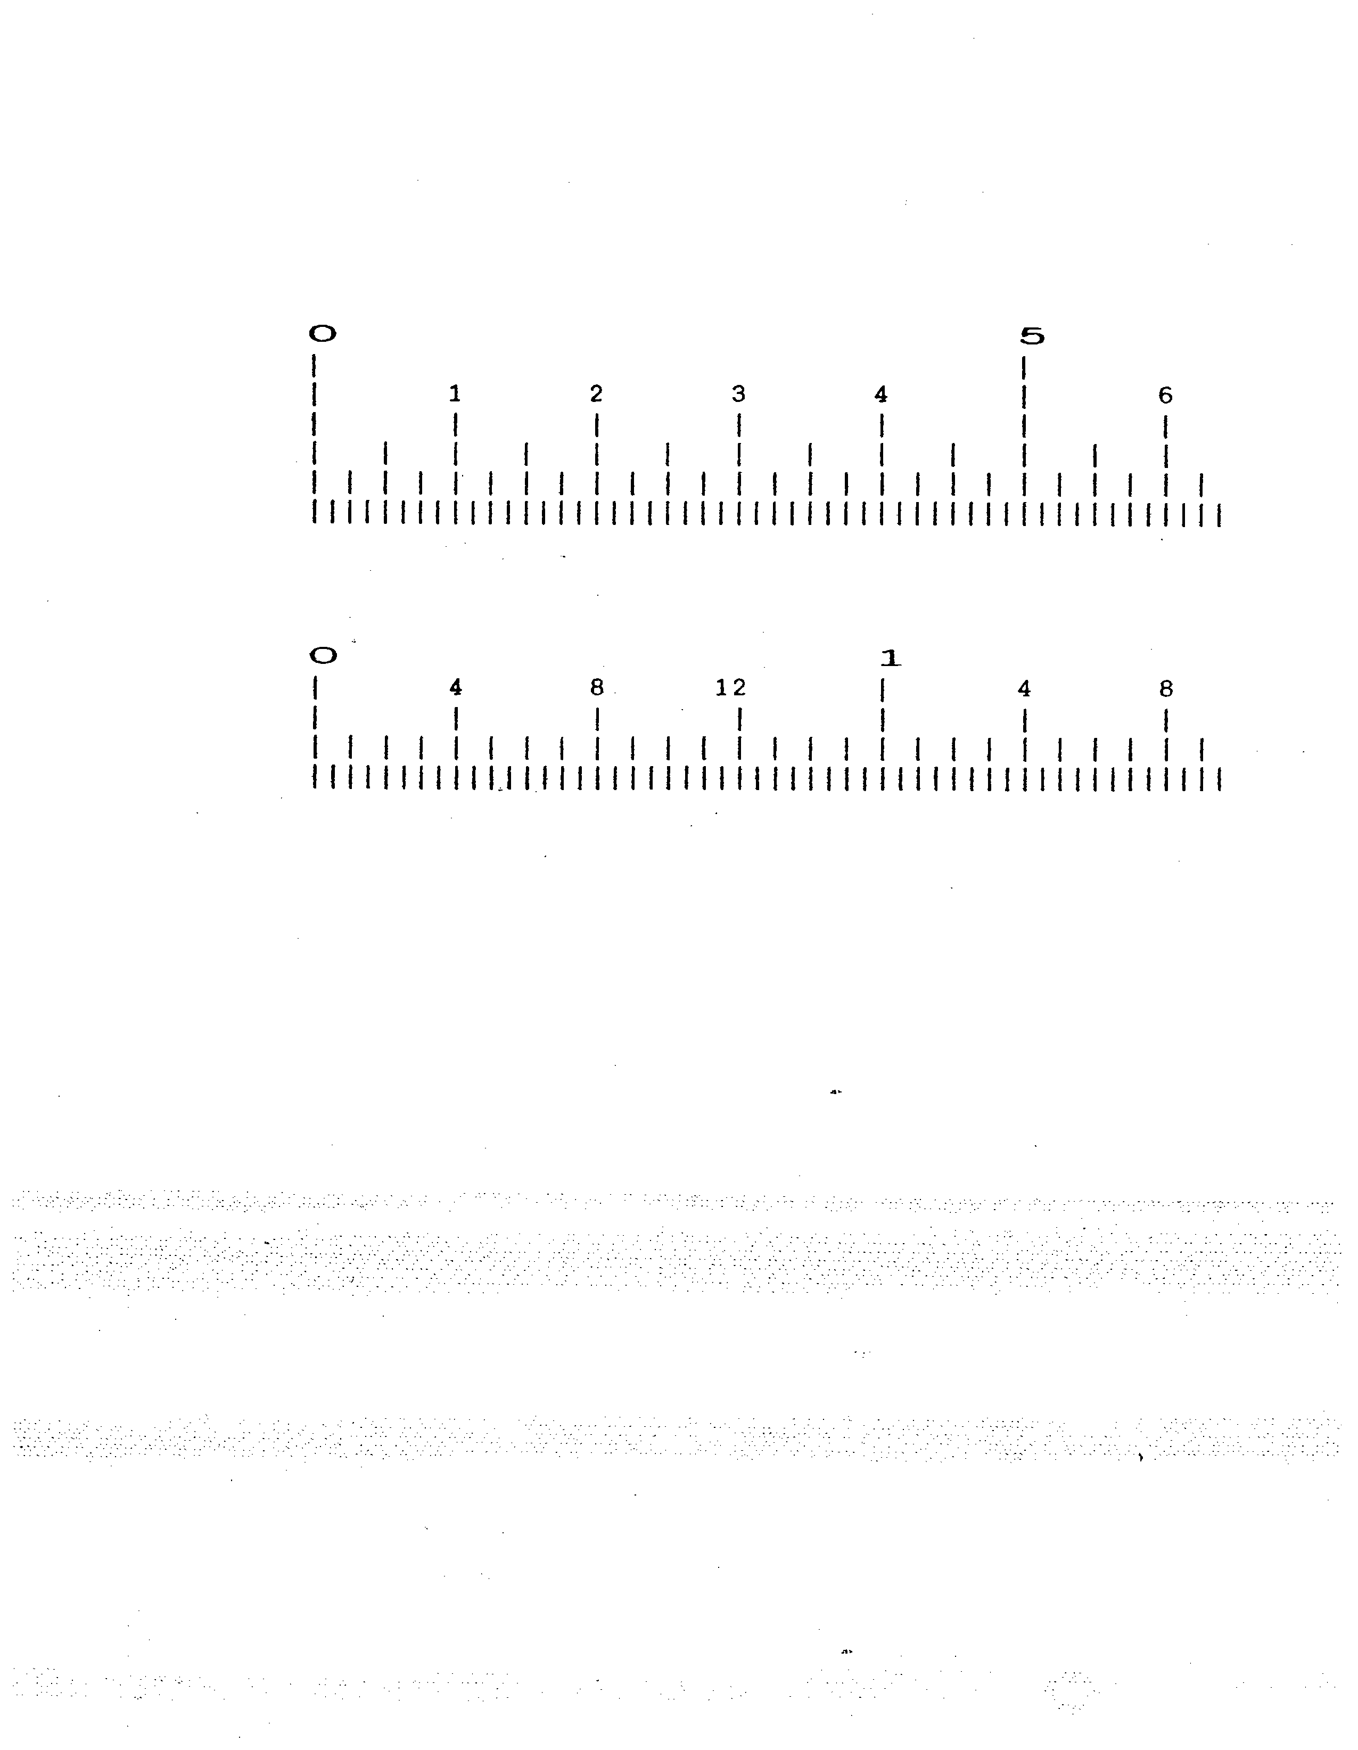

Figure 4-3. Size and Character (G-S.5.2.3.)

Note the parenthetical statement at the end of the paragraph, indicating that this requirement was made retroactive as of January 1, 1975. As you have learned, this means that after that date the requirement was enforceable for all devices, regardless of when they were manufactured or placed in service.

G-S.5.2.4. Values

This requirement is also intended to avoid indications or recorded representations that could be confusing or misleading.

For example, the graduated scales depicted in Figure 4-3 would require a legend printed in close proximity to the scales to indicate the unit of measure to which major divisions correspond (in both cases, pounds).

Similarly, in accordance with this requirement, a printed ticket would have to display a value of "3 lb 4 oz" (or "3.25 lb", or "52 oz"), not simply "3 04", "3.25", "52" or the like, since without the specific unit the recorded representation could easily be misinterpreted.

G-S.5.2.5. Permanence

It is important that all elements of indications or recorded representations be clear and legible and that they not be capable of being altered. For this reason, devices must be designed so that graduations, numbers, and words do not tend to become easily obliterated or illegible. For example, a retail motor-fuel dispenser is installed and used outdoors and is, thus, exposed to environmental elements such as heat, cold, rain, ice, and snow; therefore, the words or symbols used to define the quantity indications (e.g., “liters” or “gallons”) or monetary unit (e.g., “dollars” or “$”) must be designed so that they do not fade or fall off when exposed to such influences.

G-S.5.3. Values of Graduated Intervals or Increments

This requirement simply states that successive graduations in a series of analog indications or increments of a digital indication or recorded representation must have the same value assigned to them.

A graduated interval is the distance between successive graduations in a series. It is defined in Appendix D, Definitions, of NIST Handbook 44 as: “graduated interval. The distance from the center of one graduation to the center of the next graduation in a series of graduations. (Also see “value of minimum graduated interval.”)[1.10]”

The value of the graduated interval is the value assigned to this interval; that is, the quantity of a commodity that has been measured when the indicator has passed through or by two successive graduations. It is defined in Appendix D, Definitions, of NIST Handbook 44 as: “value of minimum graduated interval. The value represented by the interval from the center of one graduation to the center of the succeeding graduation. Also, the increment between successive recorded values. (Also see “graduated interval.”)[1.10]”

The increment of a digital indication or recorded representation is the value of the smallest change that can be indicated or recorded. It is defined in Appendix D, Definitions, of NIST Handbook 44 as: “increment. The value of the smallest change in value that can be indicated or recorded by a digital device in normal operation.[1.10]”

For example, successive graduations on an analog scale can not have values of 2 g, 4 g, and 10 g, since the values assigned to the graduated intervals would not be uniform. The scale would either have to have a series of 2g graduations or a series of 10g graduations and another (complete) series of 2g subdivisions.

Similarly, a digital indicator can not display successive quantities of 2 g, 4 g, and 10 g: the increment would either have to be uniformly 2 g or uniformly 10 g within a single weighing range.

G-S.5.3.1. On Devices That Indicate or Record in More Than One Unit

Imagine, for example, a scale that indicates pounds and kilograms. A series of numbers alone to indicate the values of the graduations would not be sufficient, since the values are in different units. Abbreviations or symbols for pounds (lb) and kilograms (kg) would have to be used to identify the different units.

G-S.5.4. Repeatability of Indications

This is basically a performance requirement (see the section on Tolerances, below), stated in terms of the design of the device. In other words, the device must be designed so as to be able to repeat its indications and recorded representations within the limits prescribed by applicable tolerances under repeated operations reflecting the normal conditions of use. This sets the limit on the amount of variation permitted when a weighing or measuring operation is repeated under reasonably similar conditions. For example, if the same load were applied and removed multiple times (in approximately the same position) from a scale and the individual readings compared, the readings should not differ by more than the tolerance that applies to the individual load. Since installation and maintenance can also affect repeatability, many device-specific codes include additional requirements for device repeatability.

Repeatability and its relationship to tolerances are discussed in detail in Chapter 5, and additional information can be found in the individual device courses.

G-S.5.5. Money Values, Mathematical Agreement

Some devices are designed to automatically compute the price of a sale based upon the measured quantity and a price per unit.

For example, think of the computing scales that are often found at supermarket deli counters. When the clerk places an item on the scale and enters the unit price, the scale calculates and the weight and the price. Some of these scales are also capable of printing out a label, which also shows the unit price, and is placed on the container or bag in which the commodity is weighed.

Paragraph G-S.5.5. applies only to digital indications and recorded representations of computing type devices. Individual device codes have specific requirements for analog type computing devices.

The requirement states that the indicated or recorded money value must agree with the value computed mathematically to the nearest 1 cent of money value. To test a device for conformance with this requirement, the indicated quantity is multiplied by the unit price, and the result is compared with the indicated or recorded money value.

For example, if a computing scale indicates a quantity of 2.43 pounds and the unit price of the product is $0.89 per pound, the mathematically computed price would be 2.43 x 0.89 = $2.1627. Rounded off to the nearest one cent, this is $2.16. The money values indicated on the scale and on a printed ticket or label must therefore be $2.16. (If the indicated money value is expressed with three or more decimal places, it is also rounded off to the nearest cent before comparison).

Note also that this requirement applies only to computing type devices that are used for retail sales, and does not apply to auxiliary indications, such as totalizers, that are intended for the operator's use only.

As mentioned earlier, this requirement is in conflict with corresponding requirements in the Vehicle-Tank Meter Code (Section 3.31, paragraph S.1.4.4.). It is therefore superseded by the Vehicle-Tank Meters Code for devices covered by that code.

G-S.5.6. Recorded Representations

This requirement simply extends the application of specifications for indicating and recording elements to recorded representations. It also requires that indications be printed digitally rather than as analog indications.

G-S.5.6.1. Recorded Representation of Metric Units on Equipment with Limited Character Sets

This paragraph specifies acceptable forms of abbreviations to be used for indicated and recorded representation of units. Devices manufactured after January 2008 must use defining symbols found in NIST SP 811 “Guide for the Use of International System of Units (SI)” and NIST Handbook 44 Appendix C – General Tables of Units of Measurement. Devices manufactured prior to that time and having limited character sets may use the table associated with General Code paragraph G-S.5.6.1., Table 1.

G-S.5.7. Magnified Graduations and Indications

This requirement simply means that the requirements for graduations and indications are applied after magnification rather than before magnification.

G-S.6. Marking, Operational Controls, Indications, and Features

This requirement is intended to ensure that anyone testing or using a device, including a weights and measures official, is aware of the meaning of controls, indications, and features. The requirement is nonretroactive as of January 1, 1977.

G-S.7. Lettering

G-S.7., which applies to all required markings and instructions, is parallel to G-S.5.1. and G-S.5.2.5., which specify legibility and permanence for graduations, indications, and recorded representations.

G-S.8. Provision for Sealing Electronic Adjustable Components

This paragraph requires manufacturers to design devices so that a security seal (such as a lead-and-wire seal or a pressure sensitive seal) can be applied to any electronic adjusting mechanism that affects the performance of the device or compliance with NIST Handbook 44 in such a way that the seal, once applied, would have to be broken before an adjustment or any other change that could affect the metrological integrity of the device could be made. This requirement, in combination with G-UR.4.5. (which requires that a seal must be applied to any adjustment mechanism designed to be sealed) is intended to discourage tampering with the device.

Subparagraph G-S.8.1. requires that multiple weighing or measuring elements which share a common provision for sealing be designed such that a change to any metrological parameter of any weighing or measuring element shall be individually identified. For example, on a two-meter blend dispenser that had been officially rejected for accuracy, this would enable the weights and measures official to determine upon re-inspection whether adjustments had been made to both meters (elements) in the dispenser or to just one meter.

Paragraph G-S.8. recognizes the use of other approved means of security, including electronic means of security through the use of data audit trails. A number of specific device codes in Handbook 44 include more specific requirements for the permissible form of an audit trail used on the device types covered by the specific code.

G-N. Notes

Requirements designated as Notes and (those preceded by the "N" prefix) usually cover the types of tests to be conducted, test conditions and procedures, and other information relating to the testing of devices to determine conformance with other requirements. They are, therefore, addressed primarily to weights and measures officials, but apply to any test of a device under official test conditions (for example, by a repair person), and are also of interest to device manufacturers and users, whose equipment will be tested according to these guidelines.

G-N.1. Conflict of Laws and Regulations

The first paragraph under the Notes section of the General Code is something of a departure from the usual information included in such sections, since it addresses conflicts between the requirements in Handbook 44 and existing State laws and regulations rather than testing information. As stated in the Introduction section of Handbook 44, “Notes” paragraphs (designated with “N.”) are directed primarily toward the official testing the device.

Legal requirements of the jurisdiction regarding health, safety, and fire prevention take precedence over weights and measures regulations for obvious reasons. In the event of a conflict, G-N.1. says that the applicable weights and measures requirements should be suspended until the conflict is resolved.

This would not affect the other specific requirements for design, accuracy, or use, unless these requirements were also in conflict.

G-N.2. Testing With Nonassociated Equipment

In general, tests of weighing and measuring devices should be conducted under conditions that come as close as possible to those experienced during normal service. However, in some instances it is impossible to test a device without subjecting it to conditions that are created artificially.

One such test is conducted to determine whether an electronic device is adequately shielded from radio-frequency interference (RFI), which is produced by radio transmissions. RFI can interfere with signals produced by measuring and indicating elements and thereby affect accuracy.

In these tests, RFI is actually produced by the inspector, using equipment of the type that is customarily used on the site. The effects of the RFI are then determined by observing the performance of the device.

This Note simply states that in tests of this kind, in which the inspector actually creates a set of conditions, these conditions should approximate those of normal service. No attempt should be made, for example, to reproduce the conditions stated by the manufacturer as maximum conditions for the device, unless these actually correspond to conditions under which the device is normally used.

Some specific device codes include additional requirements that stipulate testing in the same manner as the device is used. For example, the Liquid-Measuring Devices Code requires that a liquid-measuring device be tested with a liquid of the same type as that which the device is used to normally measure in the application.

G-T. Tolerances

Paragraphs in this section (prefixed by "T") state performance requirements for devices, in terms of tolerances. Tolerances set the acceptable limits of inaccuracy for devices under conditions of normal service or when tested under conditions that approximate normal service.

The theory and design of tolerances are complex topics. For a further discussion of these and the various types of tolerances specified in Handbook 44, see Chapter 5.

The General Code does not specify any tolerances, which are provided in the individual device codes. It does, however, define several important terms.

G-T.1. Acceptance Tolerances

Acceptance tolerances could be considered to be baseline tolerances, since they apply to equipment that is new or has recently been placed into commercial service, repaired or recalibrated after official rejection, or reconditioned and therefore should be expected to perform more accurately than equipment that has been in service for some period of time. Paragraph G-T.1. also specifies that acceptance tolerance applies to equipment undergoing type evaluation. “Acceptance Tolerances” are generally more stringent than are “Maintenance Tolerances;” however, some specific device codes specify the same tolerance values for both “Acceptance” and “Maintenance” tolerances. For further discussion, see Chapter 5.

G-T.2. Maintenance Tolerances

Maintenance tolerances are established in recognition of the fact that the accuracy of a device will change slightly with use and age. Maintenance tolerances provide a limited allowance for such changes.

The purpose of maintenance tolerances is to reduce the burden of repair, reconditioning, or replacement for device owners whose equipment is still capable of adequate performance, while still requiring that new devices (or devices recently placed into commercial service or being retested after official rejection or major reconditioning) perform without the benefit of any allowance for age or wear (acceptance tolerances). Maintenance tolerances are often, though not always, twice the value of acceptance tolerances.

G-T.3. Application

Tolerances specified as "in excess" or "in deficiency" in the device codes of Handbook 44 apply to devices that do not have mechanical measuring or indicating elements.

For example, a measure container has a nominal capacity -- the quantity that is represented to be contained when it is filled to the fill line. If the actual quantity delivered from the measure (e.g., to a test measure) is greater than its nominal capacity, then it is said to be "in excess": if the quantity delivered is less than the nominal capacity, then it is said to be "in deficiency." Tolerances for these devices limit the amount of error in terms of the amount of excess or deficiency. For example, Section 4.43. Measure Containers specifies tolerances “in excess” and “in deficiency.”

Devices that have mechanical measuring and indicating elements, such as meters and scales, are said to register quantities, and errors are said to be errors of overregistration or underregistration. If the quantity indicated by the device is greater than the actual quantity, the device is said to be overregistering; if the indicated quantity is less than the actual quantity, the device is underregistering. Device code tolerances for these devices are specified in terms of underregistration or overregistration.

In fact, the difference between tolerances "in excess or deficiency" and tolerances in terms of "overregistration or underregistration" is simply a matter of different terms for the same thing.

G-T.4. For Intermediate Values

Tolerances for some devices are related to specific capacities, or quantities, or test loads. For example, tolerances are stated for metal tapes (Section 5.52, para. T.2.) in terms of nominal intervals from zero: 6 ft or less, 7 to 30 ft inclusive, 31-51 ft inclusive, etc. For a test of a metal tape at 30.5 ft (an intermediate value between two ranges), the tolerance for the lower range (7-30 ft inclusive) would apply, in accordance with G-T.4.

G-UR. User Requirements

User Requirements (designated with a "UR" prefix) relate to the selection, installation, operation, and maintenance of weighing and measuring devices. As the name implies, they are addressed primarily to the user of the device, the owner or operator. However, as with “Specifications,” weights and measures officials and service personnel must be familiar with these requirements to ensure that the device being inspected or serviced complies with the applicable requirements.

It may be more difficult for the weights and measures inspector to determine whether an operator is complying with some User Requirements -- especially those related to operation --in the course of an official field examination. However, the inspector should question the operator about his procedures, observe the operator using the device, or look for other signs of how the device is being used (e.g., posted tare charts on a deli scale or posted procedures for using a device) especially if he or she has reason to believe that the device may be misused or complaints have been received from consumers.

G-UR.1. Selection Requirements

G-UR.1.1. Suitability of Equipment

This paragraph requires that devices be suitable for the service in which they are used. Most devices have certain limitations of use or operating characteristics that make them suitable for some applications and unsuitable for other applications. Use of a device in service for which it is not suited can affect its accuracy.

For example, if a meter is designed to measure accurately at flow rates between 20 and 100 gallons per minute, and the nature of the normal service in which it is used necessitates delivery at flow rates outside that range, it is more than likely that the accuracy of the meter will suffer. It is also likely that the meter will wear more quickly, possibly drifting out of tolerance more quickly and ultimately providing less service life to the device owner.

Similarly, if a computing scale or point-of-sale system does not have a tare feature, but is being used where tare is present, the device is not suitable. Or if a livestock scale has a tare feature and is used to weigh livestock where no tare is applicable, it is also unsuitable for its application (and could also facilitate fraud). You will learn more about how to determine if a device is suitable for a particular application when you study the individual device courses.

G-UR.1.2. Environment.

The accuracy of many weighing and measuring devices is affected by environmental conditions such as those mentioned in G-UR.1.2. It is the owner's responsibility to select equipment that is suitable for the environment in which it is normally used. For further discussion of the effects of environmental conditions on the accuracy of weighing and measuring devices, see Chapter 5.

G-UR.2. Installation Requirements

G-UR.2.1. Installation.

The manufacturer's instructions for installation generally specify certain conditions that are necessary for proper and correct operation.

For example, the level condition of the device may be significant, or the device may require certain clearances from adjacent surfaces for ventilation of electronic components. If the device is sensitive to vibration, it may have to be mounted in a particular way to minimize this factor. Consequently, it is very important that devices be installed in accordance with all manufacturer's instructions, as required in this paragraph.

G-UR.2.1.1. Visibility of Identification

This repeats the requirement of G-S.1. that required information be readily observable, but restates it in terms of the installation of the device.

This is important, because G-S.1., which is addressed primarily to manufacturers, relates to the design of the device. However, in many instances the manufacturer has no control over the installation of the device, and information that is visible in accordance with G-S.1. might not be visible if the equipment is installed improperly.

G-UR.2.1.1. also extends the requirement to all required information, including not only markings required by the General Code, but also any special markings required by the device codes.

G-UR.2.2. Installation of Indicating or Recording Element

This requirement is intended to apply to installations in which the measuring and indicating elements are separated by some distance. For example, vehicle scales are sometimes installed so that the load-receiving element is not visible by the operator who is monitoring the indicator. In this situation, the operator can not determine whether the load is being applied correctly except by direct oral communication with the driver or some other individual located at the load-receiving element.

A scale that is used in direct sales also must comply with the requirements of G-UR.3.3. (see below). Consequently, in the situation described in the above paragraph, where the driver cannot see the operator's indications, a remote indicator or some other means would have to be provided for the driver (unless it would be customary for the driver to leave the truck and go to the location of the primary indicator, for example, to pick up a weight ticket).

G-UR.2.3. Accessibility for Inspection, Testing, and Sealing Purposes

If test equipment must be moved to the device or the device brought to the test equipment, the owner may be required to provide assistance. For example, narrow fences designed to control animals at a livestock auction, or muddy ground, may make it difficult to move a weight cart to a livestock scale. In such a situation, the owner or operator could be required to temporarily remove the fence rails or provide a ramp for the weight cart.

Also, if components of a device that are subject to inspection or testing are enclosed behind a housing or in a locked cabinet or vehicle cab, the operator must provide direct access (e.g., by removing the housing or providing the inspector with a key).

It is the device owner or operator's responsibility to supply special facilities needed (including labor) to inspect, test, and seal the device, and to transport testing equipment to and from the device as required by the weights and measures official.

G-UR.3. Use Requirements

G-UR.3.1. Method of Operation

Operation of a weighing or measuring device in a manner other than that indicated by its construction or by instructions on the equipment may result in inaccurate measurement.

For example, some devices are equipped with an automatic zero-reset mechanism, which is intended to ensure that the device is reset to zero between successive sales or measurements. A familiar example is a retail motor-fuel device, or gas pump, which is equipped with a shutoff lever that must be switched to the "off" position in order to hang the nozzle back on the dispenser at the end of a delivery. When the lever is moved to the "on" position for the next delivery it activates a reset mechanism, which automatically sets the indicator to zero.

However, this mechanism can be bypassed if the nozzle is not re-hung between deliveries. An unscrupulous attendant could therefore collect the indicated price for one delivery of gas and then make another delivery without resetting to zero. If the second motorist is not attentive, he could be charged both for the fuel that he received and for that delivered to (and paid for by) the previous patron. This is an obvious example of abuse resulting from operating a device in a manner other than that indicated by its construction.

Another example of improper operation is operating a metering system at a discharge rate that is outside the range of rates recommended by the manufacturer (this range is required to be marked on the meter, and thus constitutes an instruction to the operator). This often happens when the operator is in a hurry to make deliveries and steps up the discharge rate of the system in order to finish sooner. The result, again, is likely to be inaccurate measurement.

G-UR.3.2. Associated and Nonassociated Equipment

Often other equipment is operated in the proximity of weighing and measuring devices during normal service. This could be "associated equipment" (all equipment used with a measuring system, including equipment that is not involved in the quantity determination), such as a printer or auxiliary indicator that is part of a scale system, or a console that displays readouts from motor-fuel dispensers at a gas station. Or it could be "nonassociated equipment," such as motors, compressors, pumps, conveyors, ventilation equipment, two-way radios operated in the vicinity of the device, etc.

This equipment may share the same power source as the weighing or measuring device, generate electromagnetic interference (EMI), produce significant vibration, or in some way create factors that could affect the accuracy of the device. The device must be capable of performing within applicable tolerances in spite of the operation of this equipment.

This requirement is obviously related to other Specification and User Requirements we've looked at concerning the suitability of equipment for service under normal conditions.

G-UR.3.3. Position of Equipment

This requirement ensures that in a transaction in which both buyer and seller are present, both can observe the entire measurement operation, verify indications, and see whether the weighing or measuring device is being used properly.

For example, a customer must be capable of seeing that the operator is not manipulating the load placed on a scale or the elements of the scale, and at the same time observe the indicating element that displays the weight of the commodity.

G-UR.3.4. Responsibility, Money-Operated Devices

This requirement is intended primarily for money-operated devices like car washes, laundromats, recycling machines, bottled water dispensers, and similar devices that are operated by the customer, often when the owner or operator of the device is not present.

Providing information regarding the method of obtaining a refund when the device does not operate correctly protects the customer who uses such devices and might otherwise have no way of knowing how to seek return of his money when the equipment malfunctions. Note that parking meters are specifically exempted from this requirement.

G-UR.4. Maintenance Requirements

G-UR.4.1. Maintenance of Equipment

This paragraph requires that all equipment covered by Handbook 44 be continuously maintained in proper operating condition throughout the period of service.

The second part of this requirement is intended to prevent a device owner from taking advantage of tolerances and adjusting a number of devices to overregister or perform in deficiency to a degree that is not illegal for any individual device but has the cumulative effect of providing significant unfair profit from overcharging.

According to this paragraph, the inspector is not required to have any evidence of intentional abuse, but may act on the basis of the circumstantial evidence of a consistent pattern of performance. However, the inspector must be judicious in invoking this requirement, since the sanction of rejecting all equipment is severe. The number of devices must be considered, along with the past history of the operation, complaints from customers, etc. In general, there should be some further evidence of intent, even if it is only circumstantial.

A common application of this paragraph is at the retail motor-fuel service station where an inspector may find multiple dispensers or a pattern of dispensers (for example, only the regular unleaded, self-serve dispensers) set in a direction favorable to the device owner. Again, the inspector must be judicious in the application of G-UR.4.1. to these scenarios. Many jurisdictions have well-defined guidelines for applying this paragraph to certain device applications.

G-UR.4.2. Abnormal Performance

This paragraph states the responsibility of the owner or operator of the device to make corrections for abnormal or unstable performance whenever it is observed, not just when discovered and cited during a weights and measures examination of the equipment.

G-UR.4.3. Use of Adjustments

Many weighing and measuring devices are capable of being adjusted or recalibrated to make them perform more accurately. Since use and age are likely to adversely affect the performance of devices, the periodic use of such adjustments to maintain acceptable accuracy is proper.

However, when a device is badly worn or damaged in service, simple adjustments will not be sufficient, and the device will have to be repaired, reconditioned, or replaced. This is the responsibility of the owner and is considered part of proper maintenance of the device.

For example, some beam scales, particularly vehicle scales, have a balance ball with vertical adjustments. When such a scale fails the sensitivity test because it is not plumb and level, or because knives and pivots are worn, the sensitivity of the scale can be increased by raising the balance ball. Such an adjustment might result in the scale passing the test, but it would not correct the underlying problem.

Similarly, when performance tests for a liquid-measuring device show a large difference in meter error between slow-flow and normal tests, this is a good indication that the meter is badly worn. In some cases, it may be possible to adjust the meter to perform within tolerances on both slow-flow and normal tests, but this often involves increasing the error at normal flow, which is obviously undesirable, since this generally is closer to the discharge rate at which the meter is normally operated. Furthermore, such adjustments will not correct the underlying problem of a badly worn meter that is in need of thorough reconditioning, repair, or replacement.

Adjustments must not be used, moreover, to correct conditions resulting from improper installation. In such cases, the device must be reinstalled in a proper manner.

Whenever adjustments are made, the objective should be to bring the performance of the device as close as possible to zero error, not the error permitted by tolerances. Again, tolerances must not be abused to save money on repairs or to obtain unfair benefit from overcharging.

G-UR.4.4. Assistance in Testing Operations

Jurisdictions have different policies regarding the provision of assistance by the owner or operator of the device. Some will provide as many inspectors as are required to perform inspection and test procedures. Some require that the owner provide a technician to operate the device. In any case, the owner must, within reason, provide whatever assistance is deemed necessary. Ask your supervisor what the policy is in your jurisdiction.

For example, at an installation where above-ground storage tanks are used for gasoline, the owner may be asked to furnish assistance in the form of climbing a ladder to return the contents of a test measure to a storage tank. Another example is providing assistance to move large test weights to the proximity of a livestock or hopper scale.

G-UR.4.5. Security Seal

As discussed earlier, this requirement, in combination with G-S.8., is intended to discourage tampering that could affect the accuracy of the device and facilitate fraud.

Most of the device codes include specifications and requirements regarding elements that must be sealed. These requirements generally cover at least adjustment mechanisms for the measuring and indicating elements, but also apply to other components, such as air eliminators or automatic temperature compensators.

Aids to Using Handbook 44

Your jurisdiction will provide you with training in the application of Handbook 44 requirements to enforcement activities, especially the program of official field examinations of weighing and measuring devices used in commercial service and law enforcement.

Other sources of information and guidance related to inspection activities are made available by the NIST. These are the training courses in the NIST National Training Program and the NIST Examination Procedure Outlines (EPOs) for a number of specific types and classes of devices.

NIST Training Courses

The objectives of the NIST Training Program and the general character of the training courses included in this program were described in Chapter 1.

NIST offers a variety of courses and formats to meet the specific training needs of individuals or groups. The courses were originally designed primarily for formal training of weights and measures officials. However, they contain detailed discussions of many technical subjects, including the design and operation of devices, explanations and interpretations of requirements, lists of source materials, checklists and model report forms, and step-by-step descriptions of examination procedures, which may make them useful to a wider audience, including service personnel. As mentioned in Chapter 1, while some of the courses are designed primarily to provide structured and uniform training for new officials and service people, experienced officials and service people also benefit from continuing education and training.

While not intended to be used as primary field references, the NIST training courses are nonetheless a valuable resource, and should be consulted when you have questions or feel the need for further guidance.

NIST training courses have been developed for many weighing and measuring devices; more are in the process of being developed. At the present time, the following "device" courses are available:

General Courses
Introduction to NIST Handbook 44 (self-study)

Weighing Devices and Systems
Retail Computing Scales
Medium-Capacity Scales
Livestock and Animal Scales
Meat Beams and Monorail Scales
Vehicle and Axle-Load Scales

Metering Devices and Systems
Motor-Fuel Dispensers and Consoles
Vehicle-Tank Meters
Loading-Rack Meters
Liquefied Petroleum Gas Liquid-Measuring Devices

Commodities:
Checking the Net Contents of Packaged Goods
Commodity Regulations

NIST also publishes field manuals for some device types, including Taximeters (NBS Handbook 137, Examination of Distance Measuring Devices) and LPG Vapor Meters (NBS Handbook 117, Examination of Vapor-Measuring Devices for Liquefied Petroleum Gas) and is in the process of developing others.

More information about NIST training courses is available from the NIST Weights and Measures Division.

Examination Procedure Outlines (EPOs)

The requirements set forth in Handbook 44 provide the basis for field examination procedures, but they are organized in a way that suits their primary function as legal documents, and as a result are often not well suited to use in the field.

Specific requirements that govern a particular component or feature of a device sometimes appear in different sections of a code, and some requirements are applicable to more than one element of a weighing or measuring system.

In recognition of the need for a more systematic organization of requirements, suited to efficient field procedures, the Weights and Measures Division at NIST, working with legal metrology experts in the weights and measures community, has developed Examination Procedure Outlines (EPOs) for many weighing and measuring devices.

The next page reproduces a page from a typical EPO. As you can see, the EPO has a systematic organization, referencing the applicable paragraphs of both the General Code and the device code for each of the major functional components of this measuring system.

The first part of the EPO outlines the inspection portion of the examination. A subsequent section of the EPO presents a step-by-step procedure for conducting performance tests specified for the device in Handbook 44.

Each EPO contains safety reminders which are intended to raise the awareness of the safety considerations involved in conducting performance tests. These reminders are based on the July 1991 Final Report of the NCWM Task Force on Safety and are general guidelines only.

Because of its systematic organization, the EPO is a useful guide for the inspector in the field, and can be used as a checklist to ensure that all applicable requirements have been reviewed and all steps in the examination have been performed.

The EPO is intended as an outline of what should be considered a minimum examination procedure. When the inspector encounters a device that has features that he or she is unfamiliar with, or in non-routine examinations (conducted in response to complaints, when there is reason to suspect that the device is being used improperly or to facilitate fraud, etc.), further procedures are likely to be needed.

At one time, the EPOs were published in NIST Handbook 112, “Examination Procedure Outlines for Weighing and Measuring Devices.” The EPOs are published individually and are available through the NIST Weights and Measures Division. EPOs are included in each of the device courses in the NIST training program and are updated each time that NIST teaches the specific course.

Figure 4-4. Sample Page from Retail Computing Scales Examination Procedure Outline (EPO)

Interpretation of Handbook 44 Requirements

Because of the technical complexity of many weighing and measuring devices now in use and the diversity of designs and features, you will often have to determine not only what requirements are applicable in a given situation, but also how they should be applied.

In addition, you must be prepared to explain the meaning and rationale of specific requirements to device owners, manufacturers and distributors of devices, and interested members of the public.

You will often find it necessary to research a particular requirement to determine its proper application to the situation at hand.

Your jurisdiction may have policies and interpretations that provide some guidance, and you should, of course, avail yourself of the interpretive explanations provided in this manual or other NIST training courses. But even these resources will often not be able to provide concise answers to the most difficult questions or for many unique situations. You should therefore be aware of other sources of interpretive information regarding Handbook 44 requirements.

One important source is in the final reports of the NCWM Specifications and Tolerances Committee. These reports often include detailed information regarding the rationale and intent of specific Handbook paragraphs at the time that specific language was adopted. These reports, dating back to the first NCWM in 1905, are available on a DVD from the NIST Weights and Measures Division.

Another valuable source of information is NCWM Publication 14, Technical Policy, Checklists, and Test Procedures for the National Type Evaluation (NTEP). While directed toward type evaluation, these documents include valuable information regarding how the provisions of NIST Handbook 44 are to be interpreted during type evaluation.

Summary

- The General Code establishes requirements that are applicable to all weighing and measuring devices, except that a particular requirement in the General Code is superseded by a conflicting requirement in a device-specific code. The organization of the General Code mirrors that of the device codes.

- These requirements are general in nature, and generally supplement more specific requirements found in the device codes. However, they are important and should not be overlooked, since many of the requirements are not repeated in the device codes, and because their general nature makes them broadly applicable to situations that might not be covered by narrower device-specific requirements. This is especially true for Specification and User Requirements.

- The NCWM has developed training courses for a number of devices and classes of devices that are covered by Handbook 44 requirements. Although not designed specifically as reference sources, these courses contain much valuable information about the devices and the application of Handbook 44 requirements to field examinations. In addition the explanations and interpretations of specific requirements included in these courses have been approved by the NCWM and may be considered authoritative.

- It is often necessary to research a particular requirement to determine its correct application in a given situation or to provide guidance to device users, manufacturers and distributors, or the general public.

- If further guidance is needed, the annual Conference Reports of the NCWM, especially the report of the Committee on Specifications and Tolerances often contain useful discussions of proposed changes that have been brought before the Conference. You should consult the Conference Report for the year preceding the year in which change became effective. A DVD containing past NCWM reports is available through the NIST Weights and Measures Division at no charge.

- Insight on interpreting NIST Handbook 44 can also be found in the specific device checklists NCWM Publication 14. Publication 14 can be purchased from the NCWM at www.ncwm.net.

Review Questions – Chapter 4
Introduction to NIST Handbook 44

Circle the correct answer(s) for each question or respond as otherwise indicated. If a multiple choice question does not specifically ask for "all correct answers" it may be assumed that only one of the answers listed is correct.

1. If a requirement in the General Code and a requirement in a device code are in conflict:

a. the requirement in the device code supersedes the requirement in the General Code.

b. the requirement in the General Code supersedes the requirement in the device code.

c. the more stringent requirement applies.

d. the less stringent requirement applies.

2. True or False. A device may be rejected if its design could facilitate fraud, even if there is no evidence that the device has been abused.

3. A device that displays continuous indications is called a(n)
____________________________________________.

4. According to the General Code, a digital money value on a retail sale device must agree with it associated quantity indication:

a. exactly.

b. to the nearest 1 cent.

c. within 1 cent.

d. within 3 cents.

5. You are examining a device that was rejected as inaccurate two weeks ago but has since been adjusted. What tolerance applies?

a. maintenance

b. acceptance
6. If a metering device indicates more than the quantity actually delivered it is said to be:

a. in excess.

b. in deficiency.

c. overregistering.

d. underregistering.

7. Selection requirements are addressed primarily to the:

a. device manufacturer.

b. device user.

c. weights and measures official.

d. consumer.

8. True or False. The owner or operator of a device is not responsible for inaccurate performance resulting from environmental conditions.

9. An EPO is:

a. interference caused by an electromagnetic field.

b. an outline of an official field examination.

c. an official report of test.

d. a device used to correct for errors resulting from the effects of temperature change.

10. Authoritative interpretations of Handbook 44 requirements can be found in:

a. Handbook 44.

b. Handbook 130.

c. NCWM Final Reports

d. Appendix C.

Answer Key for Chapter 4 Review Questions:

1. a

2. True

3. analog device

4. b

5. b

6. c

7. b

8. False. The device must be suitable for its application under all normal operating conditions and must be installed properly.

9. b

10. c

