National Institute of Standards
and Technology

Introduction to NIST Handbook 44

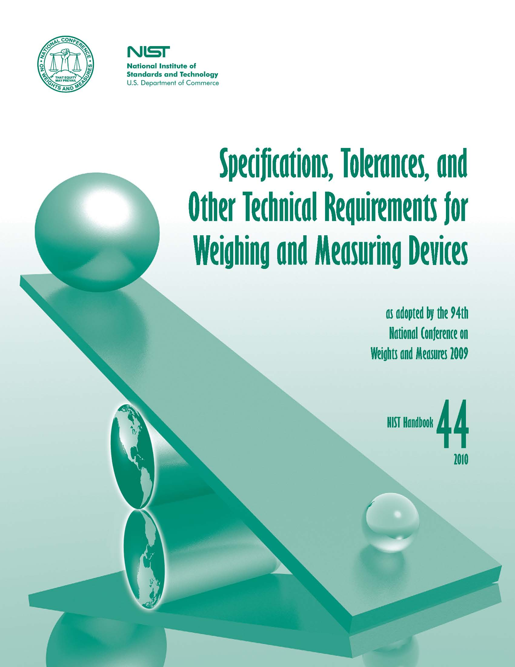

A Self-Study Course
Acknowledgements

Developing a national training program for weights and measures officials is a challenging and ambitious project. It requires contributions of time, dedication, and expertise from individuals from a variety of constituencies involved in the profession.

It is impossible to list the names of the many people who contributed to the development of this course. However, gratitude is extended to the following groups, whose dedication and commitment have made this training program a reality:

- Members of the National Conference on Weights and Measures (NCWM) Committee on Administration and Public Affairs of the National Conference on Weights and Measures

- The staff of the Weights and Measures Division of the National Institute of Standards and Technology (NIST)

- The weights and measures programs in the States of California, Maryland, Nebraska, North Carolina, and West Virginia, which participated in the field test of this course

It is sincerely hoped that this course helps weights and measures officials throughout the country to meet their personal and professional objectives.

The staff of Industrial Training Corporation, Inc.

Acknowledgement for the 1995 Edition

A number of individuals contributed to the development of the 1995 revision of Course 102. Special thanks go to:

- Joan Mindte, NIST Weights and Measures Division (retired), who prepared the revisions

- NCWM Committee on Administration and Public Affairs.

Acknowledgement for the 2009 Edition

Tina G. Butcher, Richard A. Harshman, and G. Diane Lee, NIST Weights and Measures Division

NIST HB 44 Self-Study (Rev-10-09) Page ii

Table of Contents

Acknowledgements ii

Chapter 1 – Introduction to the Course

Objectives 1-1
NIST National Training Program 1-1
Course Objectives 1-2
Prerequisites 1-3
How to Use This Training Course 1-3
Summary 1-5

Chapter 2 -- Background

Objectives 2-1
What Is Handbook 44? 2-1
History of Handbook 44 2-3
Adoption of NCWM-Recommended Requirements 2-4
Revision of Handbook 44 Requirements 2-5
Application of Handbook 44 Requirements 2-6
Summary 2-6
Review Questions 2-7

Chapter 3 – Organization and Format

Objectives 3-1
Organization of Handbook 44 3-1
Format of Requirements 3-5
Retroactive vs. Nonretroactive Requirements 3-8
Amendments 3-9
Appendices to Handbook 44 3-11
Summary 3-18
Review Questions 3-19

NIST HB 44 Self-Study (Rev-10-09) Page iii
Chapter 4 -- How to Use NIST Handbook 44

Objectives 4-1
Introduction to the General Code 4-1
Aids to Using Handbook 44 4-21
Interpretation of Handbook 44 Requirements 4-24
Summary 4-25
Review Questions 4-27

Chapter 5 -- Basic Principles Underlying NIST Handbook 44

Objectives 5-1
Tolerances 5-1
Rounding Off Numerical Values 5-15
Rules for Reading Indications 5-17
Summary 5-19
Review Questions 5-20

Index of Topics

Index of Citations from NIST Handbook 4

NIST HB 44 Self-Study (Rev-10-09) Page iv

