Webinar on DNA Mixtures: A NIST Scientific Foundation Review
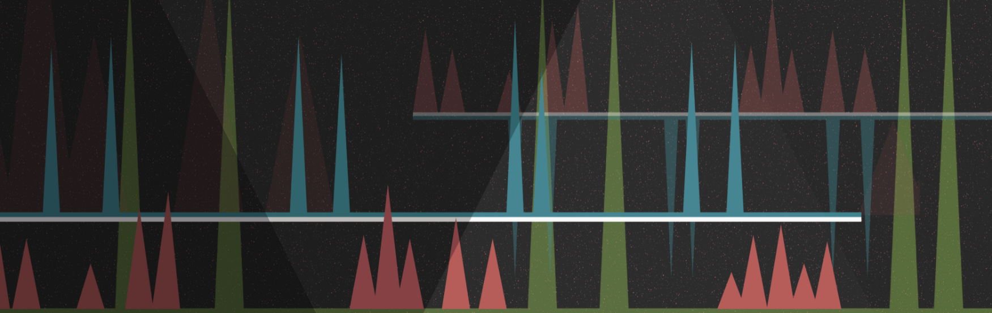

July 21, 2021

Ms/Mr. xxxxxx
Email:

RE: Certificate of Attendance

Dear Ms/Mr. xxxxx,

This is confirming that xxxxxxx registered to attend the Webinar on DNA Mixtures: A NIST Scientific Foundation Review held on July 21, 2021. Please note that NIST did not confirm attendance for the entire three-hour event.

Please feel free to contact me if you have any further questions.

Sincerely,
John M. Butler
Title: NIST Fellow & Special Assistant to the Director for Forensic Science
National Institute of Standards and Technology
100 Bureau Drive, Mailstop 4701
Gaithersburg, MD 20899
Email: john.butler@nist.gov

