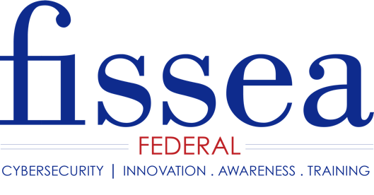
Call for Presentations

FISSEA 32nd Annual Conference
FISSEA, founded in 1987, is an organization run by and for information systems security professionals to assist federal agencies in strengthening their information systems security awareness and training programs.

June 27th – 28th, 2019

At the National Institute of Standards and Technology

Gaithersburg, Maryland

NOW ACCEPTING SUBMISSIONS
Submission Deadline: April 9, 2019

Innovations in Cybersecurity Awareness and Training:
A 360-Degree Perspective

Join us for our 32nd annual conference by sharing your expertise and creative ideas with a highly motivated professional audience from government, industry, and academia. Our focus is on the awareness and training aspects of information security. Topics of interest are based on this year’s three tracks:

Track 1: Building Innovative Approaches to Awareness Programs

How do you build an effective cybersecurity awareness program? Now is the time to provide specifics -- what exactly is an innovative awareness program? In this FISSEA track, we are looking for presentations that raise the bar for cybersecurity awareness programs, products, events, activities. We are looking for presentations on how your organization’s cybersecurity culture changed; institutionalizing information security into the organization’s mindset through a comprehensive awareness program (not an hour a year) – come tell us what innovations you are doing to champion and lead this transformation.

Track 2: Developing Skills through Innovative Role-Based Training

How do you address individual training requirements when individuals perform multiple roles; Is it the content, the instructor, the student interaction, the delivery medium, or the location that has the most influence on training acceptance? What factors make the most difference in learner acceptance and transference? Share your innovations with the FISSEA community and make a difference in shaping the future of the cybersecurity workforce.

Track 3: Implementing Comprehensive Awareness and Training Programs

How are you using awareness and training to engage all employees at your organization? In this track, we are looking for presentations that help to answer questions such as how you have built a comprehensive awareness and training program that includes managers, executives, technical, nontechnical staff; how do you ensure employees know their cybersecurity responsibilities and how they contribute to risk reduction; and how do you measure performance and demonstrate benefits?
Special Topic: Tell us about your successful insider threat awareness and training program.
Special Topic: Tell us about your successful phishing awareness campaigns; the lessons you have learned; and, how you are transforming employee behavior through phishing exercises.
FISSEA invites proposals for Panel Discussions, Topic Sessions, and FISSEA Ignite. Please keep in mind that sessions are not marketing opportunities, thus corporate marketing materials are not permitted during the sessions.

Email submission form to fissea-call@nist.gov
FISSEA website: https://nist.gov/fissea
Submission Form for Proposed Presentation

FISSEA 2019 Conference

Please Note: FISSEA is seeking speaker presentations (i.e., not papers). If you submit a proposal, we will assume that you will be available to present on June 27th or 28th. Topic and panel sessions, including Q&A, will be limited to 30 or 45 minutes.

FISSEA Ignite! are short 10 minute presentations about an idea you are passionate about. They are quick, creative, and informative sessions we have formatted after a well-known series of talks that encompass Technology, Education, and Design, and we’re excited to add this new feature again to the conference.

[Note: Please submit a separate form if you would like to submit more than one presentation.]

Name:

Title:

Organization:

Email Address:

Mailing Address:

Phone (Work): Phone (Cell):

Title of Presentation:

Type: [ ] Panel Discussion (45 min) [ ] Topic Session (30 min) [ ] FISSEA Ignite

Length of Time Needed (if longer than 45 minutes is requested) ____

Synopsis/Overview (100-250 words to be used by the selection committee and in the conference program).

Level of Discussion (Introductory/Intermediate/Advanced):

Desired Learning Outcomes:

Directions for Submission

Email Submission Form for Proposed Presentation to: fissea-call@nist.gov

All submissions must be in Microsoft Word.
The subject line for the email:
FISSEA 2019 Conference – Submission Form for Proposed Presentation

Remember the April 9th Submission Deadline!

