Grasp Cycle Time

Metric
Grasp cycle time is a measure of the minimum time required for a robotic hand to achieve full closure from a known pre-grasp configuration and to return to the pre-grasp configuration from the grasp position. This measure will yield information regarding a particular hand’s closing/opening speed capabilities.

Dependencies
Closing/Opening time is a function of the hand’s actuator capabilities, motion controllers, mechanical design and grasp configuration.

Test Method
Artifact: NIST Split Cylinder Artifact or application relevant artifact with internal force sensing.

Description:
Of the previously listed dependencies, only the grasp configuration and object size are assumed controllable. Two common grasp types can be chosen for investigation – pinch and wrap. The pinch grasp allows for measuring closing/opening performance associated with precision grasping while the wrap grasp allows for measuring performance associated with power grasping. The grasp cycle of a wrap grasp is depicted in Figure 1. Artifact sizing should be chosen based on the intended application and the parts being handled. Otherwise, a reference artifact can be used to facilitate benchmarking across a variety of robotic hands.

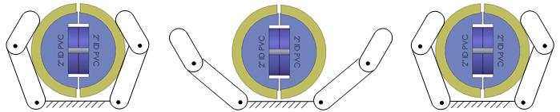
Start Release 1 Fully Open Start Release 2

Figure 1: Split cylinder artifact in zero degree orientation relative to power grasp stages

Performance Measures:
For each set of instantaneous force readings F₁, F₂, … F_{i} from the NIST cylindrical artifact or a similar artifact design, determine the total time between quasi-static closure force attained to yield a grasp cycle time$T_{grasp_cycle}$,

$$T_{grasp_cycle }= T_{stop}-T_{start}$$

T_{start} and T_{stop} are chosen as the first indication of grasp release for two subsequent grasp cycles performed (see Figure 2). Quasi-static grasp forces are chosen for evaluation as they remove impact effects and give a more accurate estimate of the time required to attain an object. For thorough experimentation, several runs should be conducted to compute T_{grasp_cycle} using two quasi-static grasp force events over two grasp cycles. Then compute the grasp cycle time mean and 95% confidence intervals.

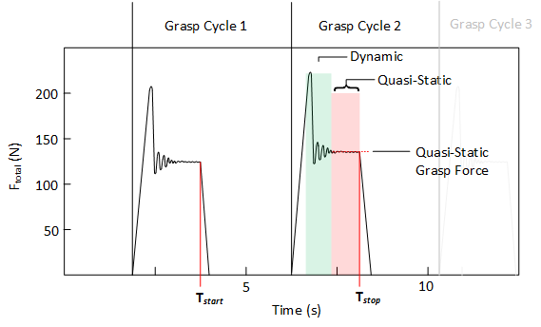
Figure 2: Depiction of dynamic and quasi-static force regions during grasp cycles.

Example Implementation (use artifact and touch sensors)
Test Setup:

Robot 2 is used with the 50.8 mm (2 inch PVC pipe) split cylinder artifact Force data was captured from two load cells while fully opening and closing the robotic hand in a power grasp around the artifact 32 times for the 0 degree and 90 degree orientations. The test setup is shown in Figure 3.

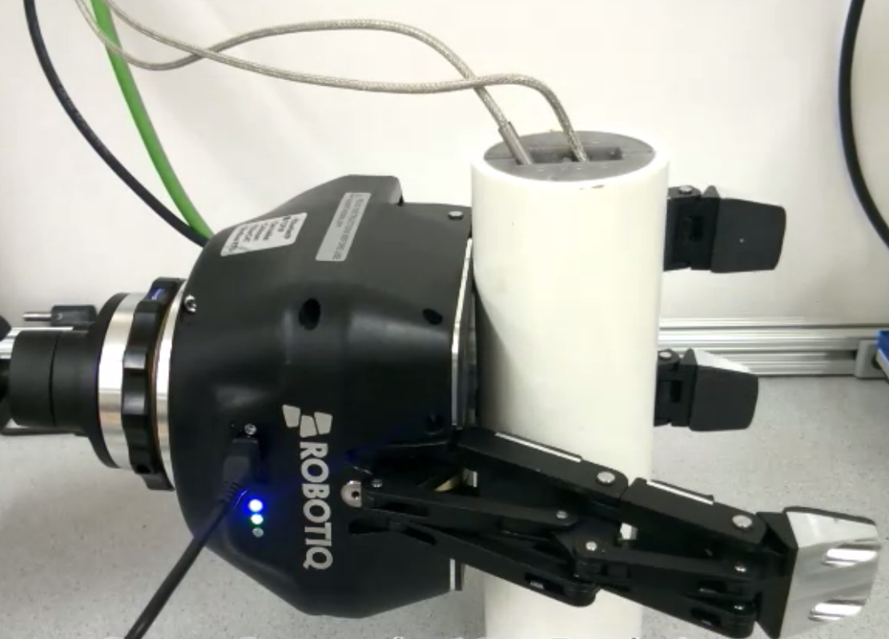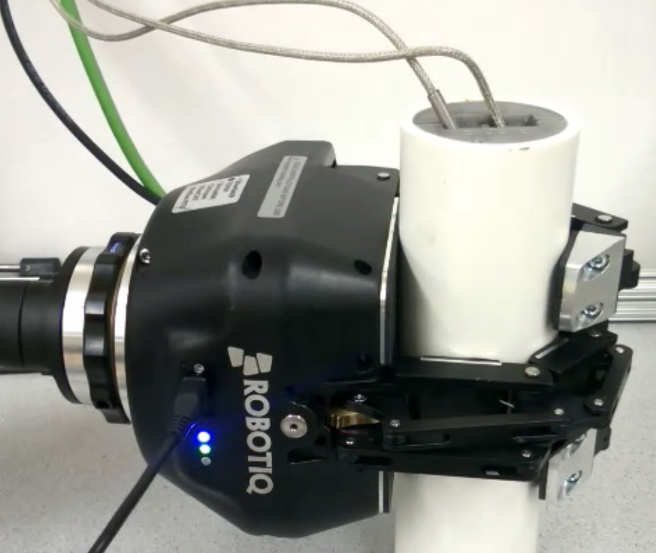
Figure 3: 50.4 mm (2 inch) diameter split cylinder artifact oriented at 0 degrees with Robotic Hand 2 performing wrap grasp cycles.

Results:
A data plot of F1 and F2 from the split cylinder artifact load cells throughout the 32 grasp cycles, is shown in Figure 4. The mean quasi-static grasp forces were extracted for each data set. Next, the mean and 95% confidence intervals for the force data collected in the zero degree orientation and the $L_{2}$ norms are computed for both hands. The results are shown for Hand 2 in Table 1.
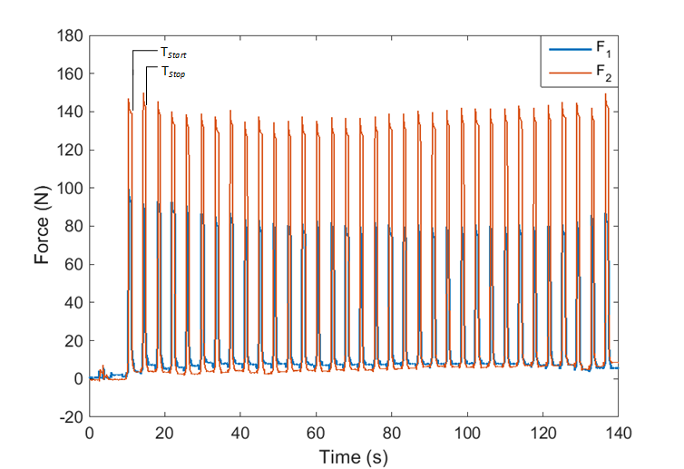
Figure 4: Shows the load cell forces for the 50.4 mm (2 inch) diameter split cylinder artifact oriented at 0 degrees created by grasp cycles from Robotic Hand 2

Table 1. The mean and 95% confidence intervals of the internal grasp force for Hand 2.
 | $$T_{grasp_cycle }$$
Robot | Mean (s) | 95% Confidence Interval (s)
Robot 2 | 3.8207 | [3.6432,3.9898]

Data:
Data File Archive: | Grasp Cycle Time.zip
Data Files: | Hand2_Grasp_Cycle_Time.csv
File Format: | ASCII, comma delimited
Data Values: | F₁ and F₂ (one set per line)
Units: | Newtons
Data Sample Rate: | 1 kHz

