ICRA 2022 Grasping and Manipulation Competition: Manufacturing Track - Task Rules

Background

We are entering a new manufacturing era where more and more small and medium sized enterprises (SMEs) are looking to implement robotic solutions into their production operations. SMEs represent the majority of manufacturers worldwide and they most often produce in batches with product variation from batch to batch, often called high-mix, low-volume production. To support production in such an environment where robot expertise is often limited, and cost is always a factor, robot systems must be easy to deploy and reconfigure with minimal retooling.

Assembly is one of the most difficult operations for robots, often relying on specialized tooling or jigs to ensure that a part can be positioned by a robot within the required assembly tolerances. These positioning tolerance requirements can also lead to time consuming robot programming strategies to precisely align a part for assembly. This competition challenges teams to develop robot systems that are easy to deploy and program with the goal of handling small batch assembly operations with part variations between batches. The robot systems will also be tested on their ability to disassemble parts.

Teams will compete with the goal of disassembling and assembling a task board containing a variety of insertion, meshing, screwing, and deformable material routing operations using an autonomous robot system. Less time spent fixturing and programming the system for operation will inevitably lead to more components being disassembled and assembled in the allotted time and possibly time bonus points upon full completion of the process faster than the allotted time. The main system components expected to achieve a truly autonomous system include one or more of the following: vision sensors, force sensors, robots, robot hands, flexible gripper systems and hand tools as well as the use of part and assembly CAD data.

Teams should design and test the operation of their systems prior to the competition using the practice task board provided. While we will attempt to ship practice boards to all registered teams, if you wish to purchase the components to build your own task boards, all details can be found at IROS 2022 Robotic Grasping and Manipulation Competition: Manufacturing Track | NIST

A new task board and parts to be disassembled and assembled will be distributed for final competition runs where part locations on the task boards and kit layout are different from the practice set, but the parts to be disassembled/assembled remain the same. The location of the task components will be randomized as described in the Setup section below. In addition, CAD data for the task board and kit layout in the same format provided with the practice materials will be supplied at competition start time. During the competition, the task boards must first be disassembled and then assembled by the competing robot systems per the following rules.

The manufacturing track is composed of two sub-tasks: assembly and disassembly. The assembly subtask 1 starts with an empty task board, where components are presented in kit form and assembled onto the task board. The disassembly subtask 2 starts with a fully assembled task board where components are removed from the task board and placed into a bin. Team rankings will be determined by the results of these two sub-tasks. The task board presented with these rules closely resembles the practice and competition task boards. These rules are tentative and subject to change. Figure 1(a) shows the practice board for which designs were distributed to teams months before the competition. Figure 1(b) shows the concept for the competition board. The competition task board will place the assembly of belt drive and screws on a vertical plane.

Note: Due to budget constraints, the shipment of the new competition boards will not include some of the components. The teams will re-use the parts from the practice board on their competition board. (i.e. connectors, screws, gears, pegs, belt, etc.)

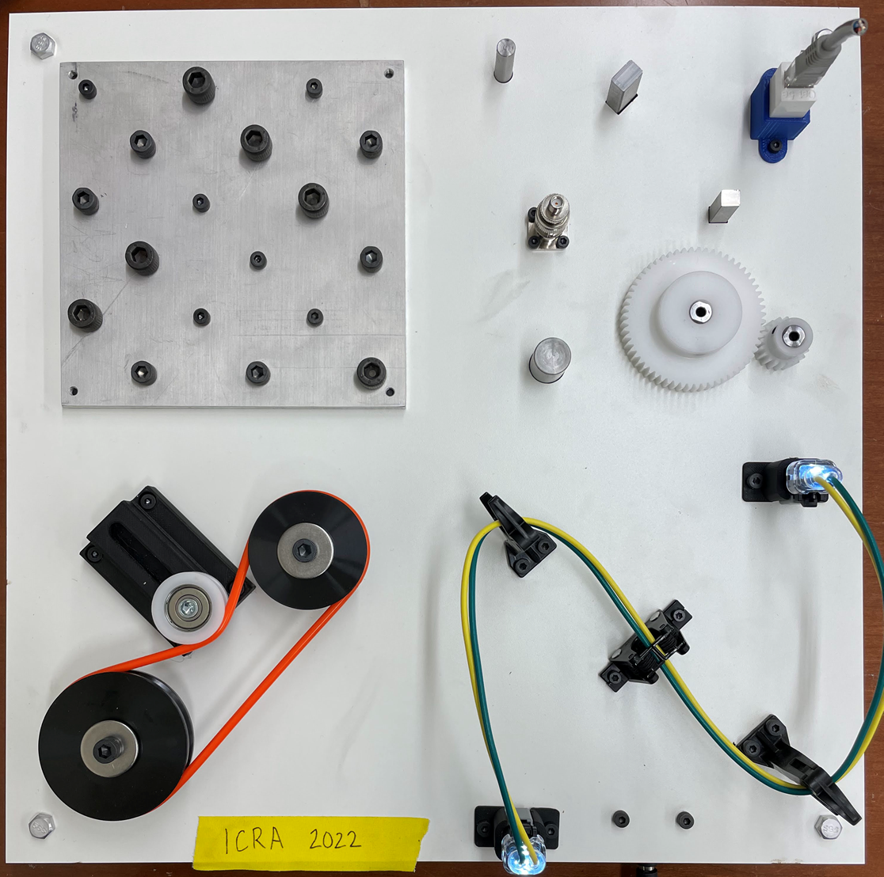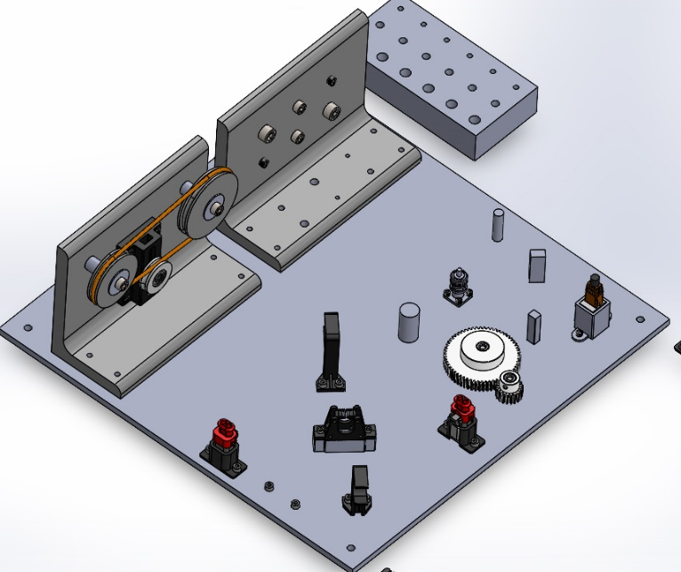
Figure 1: (a)Fully assembled ICRA/Practice 2022 task board. (b)Concept for competition board

Parts (See Figure 1):
- Board with slip-fit holes, threaded holes, female electrical connectors, wire harness components and initial belt drive components.
- Components:
  - Metric pegs of various diameters and cross-sectional shapes
  - Standard Socket Cap Screws (sizes M4-0.7, M6-1.0, M8-1.25)
    - Socket cap screws with captured washer (size: M6)
  - Various male electrical connectors
  - Gears
  - Wires
  - Belt drive assembly components (collars, pulleys, and belt)
  - Kit mat
  - Computer Aided Design (CAD) data for all parts and the task board.
This task consists of the following two subtasks:
- Subtask 1: Board Assembly
- Subtask 2: Board Disassembly
Setup
Prior to the start of the competition, teams must define the planar workspace of their robot system on the table surface. Teams will be given a roll of black electrical tape to mark this work area that must be at minimum dimensions of 60 cm x 100 cm. Approximate locations for the task board, kit tray and kit mat are shown in Figure 2. Teams may set their preferred general object orientation (i.e. side of task board which faces a robot). Judges (remote or in-person) will then communicate to the teams as they place the task board and kit mat within the workspace to ensure random placement. The kit tray locations will be set by the teams. All objects will be fixed flat to the table surface. Methods for dispensing screws and wires to the robot system for assembly are at the discretion of the teams and this can be done outside of the defined work area. Figure 2 shows the initial setup.

Note: Practice task boards and associated parts must be stored to not interfere with the competition.
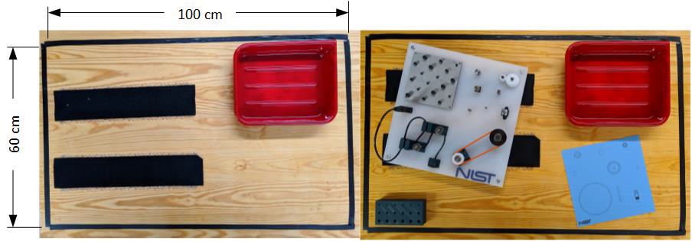
Kit mat
Task board
Figure 2: The initial layout where task board and kit layout are randomized. Teams use the electrical tape supplied to mark a 60 cm x 100 cm work area on a surface. General orientation of the task board and kit layout are specified by the teams and the judge ensures that final placement is random.

Subtask 1: Task Board Assembly
Base Time Limit: 80 minutes
Number assembly parts: 31
Achievable Points: 232+ Time bonus
Description: Pegs, male electrical connectors, routed wires, screws and belt drive assembly components are placed on designated locations in the kit area by the team. The goal for the robot system is to pick all screws, pegs, gears, male electrical connectors, wires, and a belt drive assembly from the kit layout/bolt dispenser and assemble them into their defined locations on the task board. Points are assessed on a per part basis. Figure 3 (a) shows an example setup before assembly and Figure 3 (b) shows the setup after assembly.
Setup: Teams gather all components (from task board, table, and kit tray) and place them on kit layout. Belt is placed on the mat roughly centered on the concentric circle template. Wires are placed in wire dispenser. Judges ensure that the task board is empty, and the layout is correct. Teams can remove the kit tray from the work area if desired.

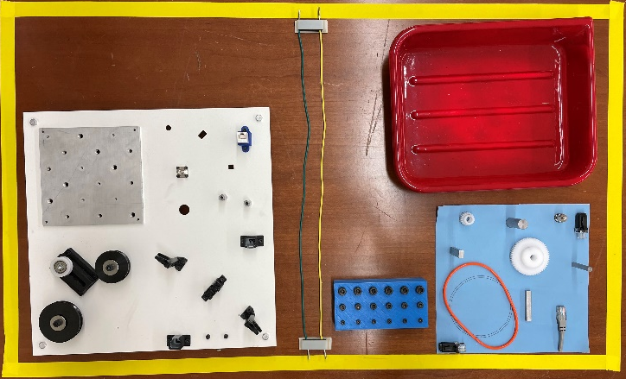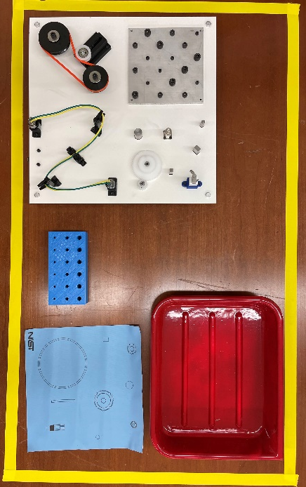
Figure 3: Subtask 1 – Assembly. This subtask starts with a fully disassembled task board with parts placed on kit layout template and fasteners and wires placed in a dispensing mechanism (a). Completion results in a fully assembled task board (b)

Steps (Judge records start time):
- Expedient lead through programming methods applied if applicable. (Note: teams cannot change setup)
- The robot picks a part from the kit layout.
- The robot system assembles the part into its location on the board.
- Repeat 2) and 3) for all parts.
- Team informs judge to record end time and assess
Scoring:
- 1 point for each part that contacts the task board surface before the grasp is released or if the part is dropped and remains on the task board (total: 31 points)
- Assembly points are based on the following criteria: (total: 203)
  - 14 fastener screwing operations, 12 screws, 2 with captured washers (total: 42 points)
  - 8 insertion operations (total: 40 points)
  - 6 inverted insertion operations, part with negative is inserted over peg (total: 30 points)
  - 4 pin insertion operations (total: 20 points)
  - 6 wire routing operations (total: 36 points)
  - 2 thread belt / 1 tensioning operation (total: 30 points)
  - 1 wiring check (total: 5 points) (connectors light when wired correctly)
Total achievable: 31 + 203 = 234
Table 1: Assembly Points
Operation | Number of operations | Points | Success measure
Fastener screwing | 14 | 2 | Screw cannot be lifted from hole and freely turns to tighten (threaded)
 |  | 1 | Head of screw fully seated on board (washer test)
Insertion | 8 | 3 | Insertion into mating counterpart (Male)
 |  | 2 | Fully seated and locked into place
Inverted Insertion | 6 | 3 | Insertion over mating counterpart (Female)
 |  | 2 | Fully seated against base part
Belt threading | 2 | 10 | Belt sits in a pulley groove
Tensioning | 1 | 10 | Belt tensioned/screw tightened (seated in both pulley grooves)
Pin insertion | 4 | 3 | Pin is inserted into connector
 |  | 2 | Fully seated and locked into place
Wire routing | 6 | 6 | Wire is correctly routed through retainers
Wiring | 1 | 5 | Correct pin location

- Time Bonus: Time bonus = INT((end time[sec] – start time[sec]) / 31) x 1 point
Rules:
- Time bonus points are only available if all parts are successfully assembled onto the task board (maximum points achieved) as shown in Figure 1 and Figure 4(b).
- Points are only awarded for assembly of a part into its designated location. (e.g. no points for inserting 8mm peg into 16 mm hole)
- No manual or teleoperated intervention by human operator (e.g., no manual tool changes)
- No restriction on number of arms, grippers, sensors used
- Use of hand tools (e.g., wrenches, electric drivers) is allowed provided the robot acquires these tools without human assistance.
- Perception system markers (e.g., reflectors, AR tags, QR codes) may not be placed on the individual parts to be assembled.
- Perception system markers can be placed on the task board and kit.
- Working area is the area within which the end-effector of the robot can move. The maximum size of the working area is the tabletop which is estimated to be 150 cm x 75 cm.
- A reset is allowed in order to make program changes or repair/secure a task board. During a reset, teams must disassemble all parts from the task board and reset in kit area. All accumulated points are reset to zero. The clock continues to run throughout the reset.

Subtask 2: Task Board Disassembly
Description:
Screws, pegs, gears, male electrical connectors, wire harness, and belt drive components are already assembled on the task board. The goal is for the competing robot system to remove all non-permanent components from the board and place them in the predefined kit space. Points are assessed on a per part basis. See Figure 4(a) for an example task board before disassembly and Figure 4(b) for an example task board after disassembly.
Base Time Limit: 40 minutes
Number of disassembly parts:
Achievable Points: 94 + Time bonus
Setup: Teams gather all components and assemble them into the task board in its 100% completed state. Kit mat and dispensing mechanisms may be removed. A completed wire harness is placed in the wire routing quadrant (can be completed by hand). Judges ensure the task board is assembled correctly.

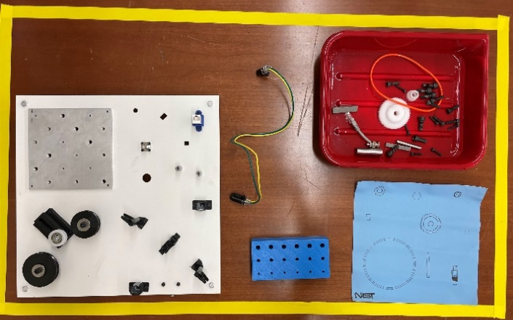
Figure 4: Subtask 2 – Disassembly. This subtask starts with a fully assembled task board (a). Completion results in a fully disassembled task board with all loose components placed in tray (b).

Steps:
- Expedient teaching methods applied if applicable. (teams cannot change setup)
- The robot system disassembles a part from the task board
- The robot system places the removed part into the associated kit tray
- Repeat 2) and 3) for all parts.
- Team informs judge to record end time and assess
Scoring:
- 1 point for each part placed into the kit tray. (total: 28 points)
- Assembly points are based on the following criteria: 2 points for each part removed from the board. (total: 60)
  - 14 screws (2 with captured washers)
  - 4 pegs
  - 2 gears
  - 1 BNC connector
  - 1 Ethernet Connector
  - 2 AT connectors
  - 1 completed wire harness
  - 2 pulleys
  - 2 collars
  - 1 belt
- 2 points for removal of wire from each router (total: 6)
Total achievable: 28 + 60 + 6 = 94

Note: Teams that were unable to finish the wire harness assembly task in the assembly subtask 1 portion must assemble the wire harness by hand for disassembly.

Table 2: Disassembly Points
Part name | Number of operations | Points | Success measure
Screws M4, M6, M8 | 14 | 42 | Screws unthreaded from the board and placed into kit tray
Pegs | 4 | 12 | Pegs removed from the board and placed into kit tray
Gears | 2 | 6 | Gears removed from the board and placed into kit tray
BNC connector | 1 | 3 | BNC removed from the board and placed into kit tray
Ethernet connector | 1 | 3 | Ethernet removed from the board and placed into kit tray
Belt | 1 | 3 | Belt removed from the board and placed into kit tray
Metal collars | 2 | 6 | Collars removed from belt-drive and placed into kit tray
Pulleys | 2 | 6 | Pulleys removed from belt-drive and placed into kit tray
AT02 connectors (attached to wire harness) | 2 | 4 | Connector unclipped and removed from female housing (wire harness component, 0 points for placement into kit tray)
Unrouted wires | 3 | 6 | Wires removed from routing channels. (wire harness component, 0 points for placement into kit tray)
Completed Wire Harness | 1 | 3 | Completed harness removed from the board and placed into kit tray

- Time Bonus: Time bonus = INT((end time[sec] – start time[sec]) / 30) x 1 point
Rules:
- Time bonus points are only available if all removable parts are successfully disassembled into the kit tray (maximum points achieved) as shown in Figure 3.
- A part is considered removed from the task board even if it is dropped by the robot system.
- No points for placement in the kit tray if part touches the table surface.
- No manual or teleoperated intervention by human operator (e.g., no manual tool changes)
- No restriction on number of arms, grippers, sensors used.
- Use of hand tools (e.g., wrenches, electric drivers) is allowed provided the robot acquires these tools without human assistance.
- Perception system markers (e.g., reflectors, AR tags, QR codes) may not be placed on the individual parts to be disassembled.
- Perception system markers can be placed on the task board and kit.
- Working area is the area within which the end-effector of the robot can move. The maximum size of the working area is a typical tabletop which is estimated to be 150 cm x 75 cm.
- A reset is allowed in order to make program changes or repair/secure a task board. During a reset, teams must reassemble all parts on the task board. All accumulated points are reset to zero. The clock continues to run throughout the reset. Organizers will supply replacement boards or parts to teams as necessary, while supplies last.

Time Shift
120 (= 80 + 40) minutes are allotted to each team for completing subtask 1 and subtask 2. At the 80-minute mark, all teams must end subtask 1 (assembly). At the end of 40-minutes from the start time of subtask 2, all teams must end subtask 2 (disassembly).
An additional 60 minutes will be provided for teams to account for set up before and between subtasks. A total 180 minutes is the competition time given to teams.
Note: subtask 2 (40 minutes) will start at 140 minutes regardless of a team’s set-up/preparedness. This is to ensure each competition run ends at the 180-minute total.

Remote Judging
For remote competition format teams must provide three camera feeds to a remotely connected judge for real-time observation of the competition. The first camera must be positioned so that a judge can observe the entire workstation in operation including all computer systems and robot controllers. The second camera will be focused on the robot work area and positioned to minimize occlusions from the manipulator(s). A third camera should be used as a mobile camera for human positioning to provide better detailed views during the scoring process. Prior to the competition date, an organizer will connect via teleconferencing software and ensure that cameras are properly positioned and functional via video conferencing. All three video feeds should be recorded by the teams and submitted.

