The Title Should be: Single Spaced, Times New Roman, Bold 14-point, and all the Text Should be Left Justified

First Author¹, Second Author^{2*} and Third Author³ (Times New Roman 12-pt left justified) Each name should have a superscript Arabic number to reference the author’s affiliation. A superscript asterisk after the affiliation number indicates the contact author. Use single line spacing. Leave one blank line between the title and author list, and one blank line after the authors’ names before the list of affiliations.

^{1.} Affiliation of the first author, including Department/Institution, City and Country. (12pt)
^{2.} Affiliation of the second author, including Department/Institution, City and Country. (12pt)
^{3.} Affiliation of the third author, including Department/Institution, City and Country. (12pt)
* Corresponding author: SAuthor@prydonian.edu Leave one blank line after authors’ affiliations.

The abstract should be a brief version of your presentation and include some significant findings. Please keep the abstract to a single page. Your abstract must be submitted in a Microsoft Word(.doc or .docx) format. Use a 12-point Times New Roman typeface and single spacing between lines. Use italics for taxonomic terms. Document margins should be one inch (25.4 mm) top and bottom and 0.75 inches (19.1 mm) left and right. Skip a line before each new paragraph, but do not indent paragraphs. Please use full justification of the text.

References may be included at the end of the text, still on a single page. All submissions are reviewed by the Program Committee according to the following criteria: (a) relevance to the conference, (b) content and quality of the text, (c) clarity of the text, and (d) compliance with the format. Abstracts not meeting these criteria will not be accepted.

All accepted abstracts must be presented by a meeting registrant. If the registrant cannot attend due to unforeseen circumstances, an alternate presenter should be arranged by the submitter.

References: (Times New Roman, 12-pt, left justified)

[1] F Author et al., Conference Proceedings (year) p. 1.
[2] F Author, S Author and TH Author, Journal volume (year), p. 1.

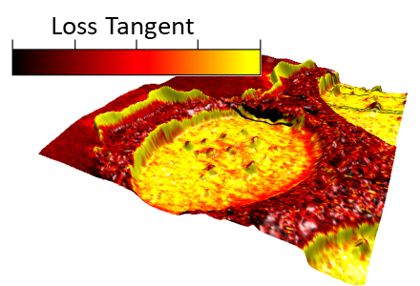
Figure 1. Times New Roman, 12pt. Provide a short description of the figure, including labels and scale markers as appropriate.

