**Appendix C**

**History of Instructor Improvement**

**Source:**

Carryover Item 401-3 (This item originated from the Committee and first appeared on its agenda in 2003.)

**Background/Discussion:**

Prior to the 2010 Annual Meeting, Ms. Harris, NIST OWM, provided the Committee with reference material on teaching methods and assessment of training success. Distilling the essence of these materials, the Committee

believes that instructors need training in more than just the technical material; they need training in setting the

learning objectives, developing the training materials with those objectives in mind, selecting training methods that incorporate adult learning styles, and evaluating the effectiveness of their training.

**Education Subsystem**

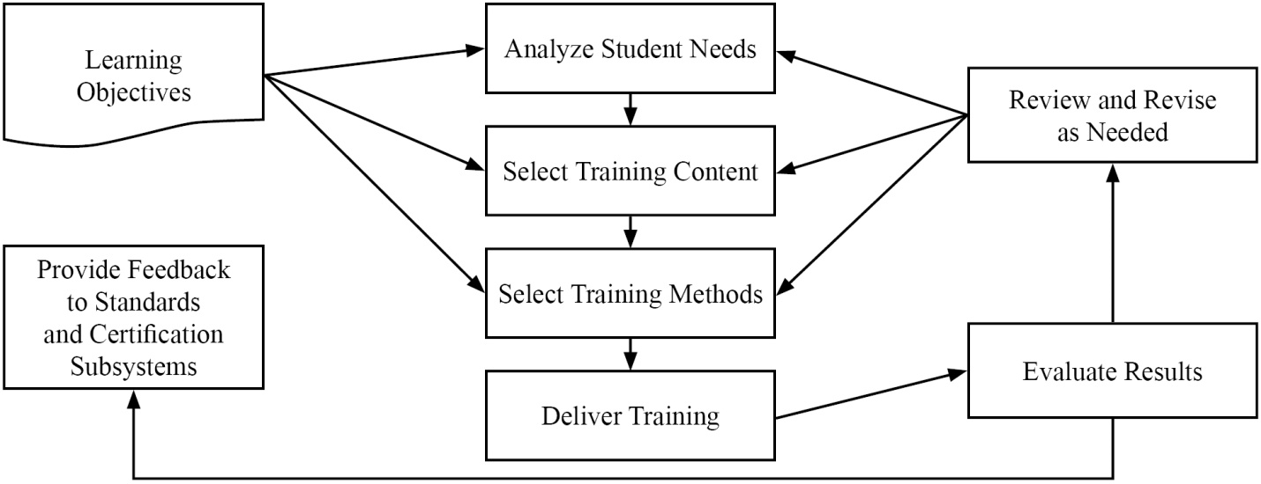

The chart below covers three levels of learning objectives and relates them to (1) the training activities most likely to be successful and (2) the best methods for assessing the success of the training. The curriculum segments state the learning objectives using verbs similar to those in the bottom row of the table. These drive both the training activities required to promote adult learning and the assessment tools appropriate to measure success at that level.

|  |  |  |  |
| --- | --- | --- | --- |
| **Assessments** | Multiple Choice | Multiple Choice | Practical Examples Short Answer |
| **Training Activities** | Lecture  Videos  Examples | Discussion  Review Learner Presentation | Exercises  Simulations  Demonstrations |
| **Cognitive Levels** | **Knowledge** | **Comprehensive** | **Application** |
|  | Define  Relate  List | Restate  Discuss Describe Identify | Employ  Apply Use Illustrate |

NIST, OWM has expressed strong interest in collaborating with NCWM in efforts to educate instructors in adult learning techniques and relating them to the learning objectives in NCWM curriculum. The Committee will be posting NIST, OWM material on converting technical content to training material on the PDC training resources web pages. The importance of pre-training analysis and post-training evaluation cannot be overestimated. Failure to include these steps often leads to failure of training efforts.

**Professional Certification Program**

Systems Approach to Training Evaluation

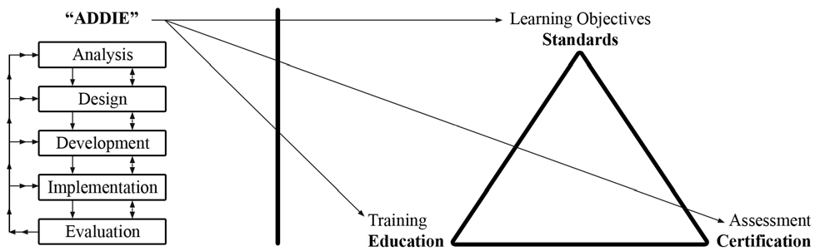

The Committee is calling on the states and other training developers to implement the Analysis, Design, Development, Implementation, and Evaluation (ADDIE) model in their training preparations and post training evaluation. Everyone needs to participate in the development of new BOK modules and then encourage their trainers to use existing BOK modules in their training plans.

The Committee encourages members to also look at the presentation on *A Complete Training Program* prepared by Carol Hockert, NIST, OWM. The presentation outlines ways to develop training programs and improve instruction of weights and measures material. Contact Ms. Hockert for a copy.

NCWM 2012 Interim Meeting: Advisors from NIST, OWM reported that they are using NCWM BOK in preparing new training initiatives. They are stressing adult learning techniques, particularly focusing on the use of hands-on training as the most popular and effective training tool. This ties in closely with the new baseline competency exams discussed in Item 410-1. NIST, OWM is using these exams to ensure students in NIST sponsored training courses are competent in prerequisite course materials prior to taking training. They reported that they are already drafting questions for the baseline competency exams. They see significant efficiencies in using NCWM testing services for this purpose since they are already in place.

Ms. Hockert, NIST, OWM, recommended a basic math prerequisite for persons taking Metrology or other related weights and measures courses sponsored by NIST. The math exam would allow trainees to demonstrate entry level math skills and make the training process more efficient and effective. One official discussed the California licensing requirement of a college degree which requires a certain number of math courses and asked if this would satisfy the need for the math prerequisite. Several California officials expressed concern about the Professional Certification Program replacing existing state licensing programs, and if adopted it might require amendment of existing state statutes. Because math competency is an essential skill for weights and measures work, the Committee recommends that the PDC include in its scope the development of an exam to demonstrate basic math competency before taking the Fundamentals of Metrology or other training courses at NIST.

SWMA 2011 Annual Meeting: It was stated that we should consider training state trainers on adult learning techniques as well as subject matter. No further recommendations were made.

NCWM 2012 Annual Meeting: The Committee stressed instructor improvement. The Committee reviewed the importance of using the NCWM learning objectives and the ADDIE model in training. This stresses the importance of training to the goals in the Body of Knowledge and not training to pass the test. If the training is appropriate and has been delivered effectively, the employee should have no problem passing a fair exam. The end is not a certificate on the wall, but rather a competent inspector. In other words;

JOB SUCCESS = EXAM SUCCESS

Carol Hockert, NIST OWM, stressed that good training requires a partnership between the trainee, trainer, and the supervisor. The Committee agrees that buy-in from all levels is critical to training success.

CWMA 2012 Interim Meeting: The Committee recommended archiving most of the content in this item to the

NCWM website as reference material.

WWMA 2012 Annual Meeting: The Committee noted it is in the best interest of NIST and NCWM that regional training efforts be of the highest quality and uniform throughout the United States. The Committee recommends the following:

• Regional trainers be selected as per the process agreed upon between NIST and NCWM;

• Regional trainers receive courses on adult learning techniques and converting technical information into training materials;

• Regional trainers be afforded the opportunity to shadow NIST trainers as they perform training in individual jurisdictions; and

• The use of funds from the Associate Membership Committee or the NIST Training Initiative Grant is made available for this purpose.

NEWMA 2012 Interim Meeting: Members expressed interest in NIST Train-the-Trainer classes. A demonstration was provided on how to access materials for taking the Professional Certification Exams and then for taking the exams. The Committee encouraged those in attendance to seek certification of their inspectors.

THIS PAGE INTENTIONALLY LEFT BLANK