Appendix D
NIST Handbook 44 – Vehicle-Tank Meters
Item 331-1:
N.4.2.1. Determination of Error on Vehicle-Tank Meters with Multiple Flow Rates and Calibration Factors
How Slow Flow Errors Affect VTM’s
Imagine a typical VTM which is calibrated using a 100 gallon prover for a bulk delivery company whose customers’ tanks are typically between 100 and 1,000 gallons. The meter has an electronic register programmed with a slow flow rate for start-up and shut-down, and a high-flow rate for typical deliveries. Startup and shutdown deliveries are 10 gallons each regardless of total quantity delivered.
Now imagine that the service agent calibrating the meter didn’t check the slow flow rate and didn’t know that the meter was long 0.4 gallons on a 100 gallon test. Instead, he calibrated the normal flow rate without testing the slow flow and introduced a linear error which increases the farther the transaction quantity deviates from the prover size. On a 100 gallon delivery the meter would appear to be accurate, but on a 500 gallon delivery a -0.4 gallon error has been introduced. That is within tolerance, but if all of his meters have similar errors in the same direction, typical deliveries will be in the operator’s favor at the expense of his customers.

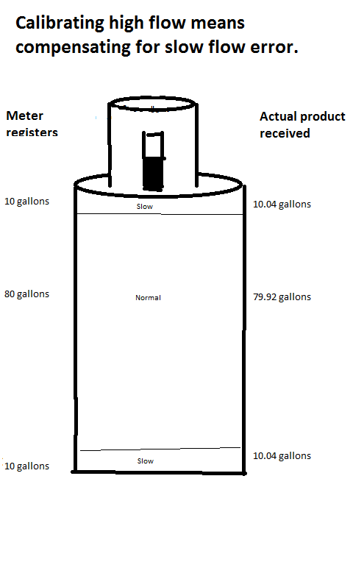
When calibrating at the normal speed, the meter registers 20 gallons of product for the startup and shutdown, but actually delivers 20.08 gallons. (10.04 gallons delivered for every 10.00 gallons registered at slow speed.) If the service technician calibrates the meter to zero at normal speed, the meter will actually deliver 79.92 gallons for every 80.00 gallons it registers at that flow rate.

Every subsequent delivery of 100 gallons should receive exactly the right amount. Every delivery exceeding 100 gallons will be ‘short’ and every delivery less than 100 gallons will be ‘long.’
To determine the error on a typical delivery, the service agent needs to calculate the error introduced by the startup and shutdown gallons, and then the error introduced at the higher flow rates.
For a 500 gallon delivery in this example, the meter would register 10 gallons on startup but actually deliver 10.04 gallons. It would then jump to normal rate and deliver 79.92 gallons for every 80 gallons it registers until it goes into shutdown mode when it slows down and again delivers 10.04 gallons as it registers only an additional 10 gallons.

The error would be well within maintenance tolerance so the Weights and Measures official need only be concerned if the slow flow errors on all the meters for a particular product are in the same direction. At that point, the official should determine the direction of the error on a typical deliver to determine if the equipment is being properly maintained. Device users can ensure they have no problems with this requirement by making sure that slow flow errors are not predominantly in one direction.

