Appendix G

NIST Handbook 44 – Multiple Dimension Measuring Devices

Item 358-1:
Load Volume Scanner, Proposals for Integration into NIST Handbook 44

Load Volume Scanner

Proposals for Integration into NIST Handbook 44

A submission to NCWM

Author: Adrian Ruthe Technical Manager
LoadScan Ltd, New Zealand

Contents

Introduction 2

Applicability of MDMD Code to the LVS 3

Tolerances 3

Limitations on Use 4

Test Procedures – Accuracy Testing 5

Test Procedures – Disturbance Testing 7

Appendix - LVS Type Approval History Outside of the USA 8

New Zealand 8

Australia 9

Introduction

At the time of writing, the LoadScan Load Volume Scanner (LVS) has been granted ‘Developing Item’ status by NCWM and it is now up to LoadScan as the device manufacturer to prepare specific language for NIST Handbook 44 amendment. Multiple Dimension Measuring Devices (MDMD) has been identified as the most suitable classification into which to incorporate the LVS and our aim is to prepare amendments to the MDMD specification, or if not feasible, to submit a new instrument specification modeled on MDMD.

At this stage formal language has not been developed. This document identifies only the most significant areas where the MDMD code cannot be directly applied to the LVS and proposes solutions for consideration by the relevant authorities. Other minor discrepancies between LVS and MDMD can be readily addressed by minor amendments to the MDMD code. Formal code will be developed and minor discrepancies between LVS and MDMD addressed only when consensus and approval in principle has been reached on the key issues.

It is strongly recommended to read the appendix to this document, LVS Type Approval History Outside of the USA before considering the proposals below. Some topics are also discussed in more detail in the supporting document to this submission, Load Volume Scanner - General Metrology, Test Methods and Suitability for Use (revision of a previously submitted document, not US specific).

Applicability of MDMD Code to the LVS

The LVS has some notable similarities to MDMD:
• MDMD typically uses the same non-contact laser measurement technology as the LVS.
• MDMD and LVS both compute volume from a set of linear dimensional measurements.
• MDMD and LVS both typically measure moving targets passing below the measurement elements of the instrument.
• MDMD and LVS both measure the target relative to a zero reference profile formed by the surface or container that carries the object or load being measured.

There are also some notable differences:
• MDMD measures discrete objects (boxes, packages etc) whereas LVS measures bulk loose flowable solid materials (materials that form heaps).
• MDMD uses a set of rules to compute the volume of a hexahedron occupied by the measured object whereas LVS measures the actual volume of the heap of measured material (“loose” volume based on the
surface contour).
• MDMS intended for calculating freight, storage, or postal charges based on the dimensions and/or volume occupied by the object whereas LVS intended for determining quantities of material where that material is traded by volume.
• MDMS zero reference is generally a flat conveyor-belt or table top and can be treated as a static 2D profile whereas LVS zero reference is the entire load-bearing container (truck trailer or bin) that moves with the measured load and must be treated as a moving 3D profile.

So consider NIST Handbook 44, Section 5.58. Multiple Dimension Measuring Devices, Application:

A.2. Other Devices Designed to Make Multiple Measurement Automatically to Determine a Volume. – Insofar as they are clearly applicable, the provisions of this code apply also to devices designed to make multiple measurements automatically to determine a volume for other applications as defined by Section 1.10. General Code paragraph G-A.1. Commercial and Law-Enforcement Equipment.

This applies to the LVS. However, the need for an instrument description that more explicitly describes the LVS principle of operation and application should be considered, if only to define a clear sub-category that variations in the MDMD code can be specifically applied to. As the manufacturer of a specific instrument, it may not be appropriate for us to define the limitations or terminology of this specific sub-category. But for the purposes of this document “LVS” will refer to such a sub-category of MDMD instruments that the Load Volume Scanner belongs to.

Tolerances

NIST Handbook 44, Section 5.58. Multiple Dimension Measuring Devices, Tolerances:

T.3. Tolerance Values. – The maintenance and acceptance tolerance values shall be ± 1 division.

It is not be feasible for the LVS to meet these requirements (and the requirements of paragraph S.1.5 and T.2.3) without a multi-interval implementation and choices of division sizes for each interval that may not be suitable for intended application in some cases.

We propose the following variation for instruments of the LVS class:

The maintenance and acceptance tolerance values shall be ± 1 division or 1 percent of measured load;
whichever is the greater.

In practice, the minimum feasible scale division for the LVS is 0.1 cubic meter or 0.1 cubic yard, dependent on regional configuration. To meet the requirements of the US bark and mulch industries the maximum capacity will need to be
130 cubic meters or 170 cubic yards per individual truck bin.

We realize that this effectively puts the LVS in a lower accuracy classification than allowed for other classes of instrument such as weigh scales used for trade.

The closest comparable class I can find in NIST Handbook 44 for the volumetric measure of dry solid material is Dry Measures (section 4.45). Obviously the LVS does not fit into this classification. However, as a point of note, the maintenance tolerances for a 1bushel dry measure (the largest measure specified) are 50 cubic inches in excess and 25 cubic inches in deficiency with acceptance tolerances being one-half the maintenance tolerances (NIST Handbook 44, section 4.45. Dry Measures, Tolerances). Averaging over “in excess” and “in deficiency” this is equivalent to maintenance and acceptance tolerances of approximately 1.74% and 0.87% respectively. And by extension, the same tolerances apply to quantities resulting from multiple 1 bushel dry measures.

What must be considered is the intended purpose and suitability for use of the instrument. This is discussed in the supporting document to this submission, Load Volume Scanner - General Metrology, Test Methods and Suitability for Use.

Limitations on Use

Consider the following excerpts from Handbook 130:

2.18.2. – All mulch shall be sold, offered, or exposed for sale in terms of volume measure in SI units in terms of the cubic meter or liter or in inch-pound units in terms of the cubic yard or cubic foot.

2.29 (a) – Top soil, fill dirt, aggregate or chipped rock, sand (including concrete and mortar sand), decomposed granite, landscape type rock, and cinders must be sold by the cubic meter or cubic yard or by weight.

The LVS was designed to meet the requirements of specific industries such as the mulch and civil construction industries and their suppliers, who either trade by volume already, or would prefer to, if suitable measurement equipment were available. The LVS is intended to meet the requirements of these industries and is not intended as a general use instrument to replace truck scales. As such we propose the following limitations on use for instruments of the LVS class:

a) To soil, clay, sand, aggregate or chipped rock and similar excavated or mined materials
b) Mulch, compost, specialty horticultural and landscaping mixes and primary constituent materials thereof.
c) Woodchip, sawdust, bark and similar materials d) Coal, unprocessed ore, mining waste
e) Bulk recycled or waste materials in crushed, shredded or similar form
f) Lumpy, irregular mixed materials only where traded as waste or debris

A shorter list may be possible if worded so as to be suitably inclusive.

Test Procedures – Accuracy Testing

NIST Handbook 44, Section 5.58. Multiple Dimension Measuring Devices, Notes:

N.1.1. General. – The device shall be tested using test standards and objects of known and stable dimensions.

N.1.4.1. Test Objects. – Verification of devices may be conducted using appropriate test objects of various sizes and of stable dimensions. Test object dimensions must be known to an expanded uncertainty (coverage factor k = 2) of not more than one-third of the applicable device tolerance. The dimensions shall also be checked to the same uncertainty when used at the extreme values of the influence factors. The dimension of all test objects shall be verified using a reference standard that is traceable to NIST (or equivalent national laboratory) and meet the tolerances expressed in NIST Handbook 44 Fundamental Considerations, paragraph 3.2. (i.e., one-third of the smallest tolerance applied to the device).

Due to the practical difficulties in generating LVS test loads of known and stable dimensions, as discussed in the Test Methods section of the supporting document Load Volume Scanner - General Metrology, Test Methods and Suitability for Use, we propose that the system of test objects/standards used for certification testing in Australia be adopted (see notes and photos in Australia section of the appendix to this document, LVS Type Approval History Outside of the USA). This system combines a rectangular bin trailer with moveable false floor and rigid test objects and is suitable for generating test loads with volume known to the required level of expanded uncertainty for the tolerances proposed above. The dimensions of all test objects/bins can readily be verified with a tape measure (NIST traceable reference standard).

Code language to facilitate this could be along the lines of:

Test objects approximating the shape of a heaped load and with geometry that facilitates determination of volume by measurement of linear dimensions may be used to generate test loads in a suitable mobile test container. A raised floor or rigid objects covering the entire test container floor such that no edges are visible may be placed in the test container, supporting the test objects, to generate test loads at larger volumes.

This method of using dedicated test equipment is only suitable for generating test volumes of a limited size. At this stage we have only used this method to test up to 35 cubic meters (45 cubic yards).

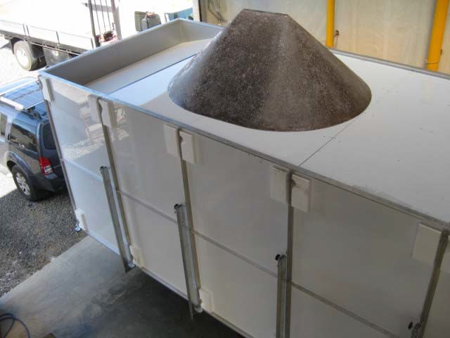

NIST Handbook 44, Section 5.58. Multiple Dimension Measuring Devices, Notes:

N.1.4. Test Object Size. – Test objects may vary in size from the smallest dimension to the largest dimension marked on the device, and for field verification examinations, shall be an integer multiple of “d.”

This does not explicitly require testing to maximum capacity. As discussed in the supporting document to this submission, Load Volume Scanner - General Metrology, Test Methods and Suitability for Use, correct operation within accuracy capability for the LVS can theoretically be confirmed at any test volume. We propose the following variation for LVS class instruments:

Test loads shall vary in size from zero (empty test container) to at least 25 % of instrument capacity including minimum capacity and at least one other intermediate volume.

For a maximum capacity of 130 cubic meters or 170 cubic yards this would be feasible. This is similar to the requirement for scales with a capacity above 20,000kg or 40,000lb as specified in NIST Handbook 44, Section 2.2.

Scales, Notes, Table 4. It may be considered necessary to specify the 25% rule for instruments with a capacity above a set value as for scales. See further discussion of a Standardized Test Method and other test methods in the supporting document to this submission, Load Volume Scanner - General Metrology, Test Methods and Suitability for Use.

Note that in New Zealand all official certification/verification testing is performed with a single rigid test object of 2.1 cubic meters, which equates to 3.2% of approved maximum capacity of 65m3 per bin (see appendix to this document, LVS Type Approval History Outside of the USA).

Type approval testing may need to be conducted to maximum capacity. This is possible by finding a suitable, very large truck-trailer and manually dimensioning this trailer in detail and generating test loads by a combination of methods. This is very time consuming and requires a lot of resources. This is feasible for one-time type approval testing but not for regular verification testing.

Additionally, it is not practical to generate larger test loads to an integer multiple of the scale interval “d” by the proposed test method. However, the LVS instrument has a test mode that displays measurements at a higher resolution, allowing accurate comparison between measurement indications and computed test load volumes. We propose a requirement along the lines of the following:

The instrument shall have a special test mode that can only be activated for accuracy testing and causes all measurement indications to be output to a resolution of at least 10 times “d”.

Test Procedures – Disturbance Testing

It is simply not feasible to put a standard LVS system in an environmental chamber and perform disturbance tests for type approval. Requirements for any laboratory testing will need to be discussed. Please see the Australia section of the appendix to this document, LVS Type Approval History Outside of the USA for notes on how this was handled for type approval in Australia. We propose a similar approach be adopted for NTEP testing.

APPENDIX - LVS TYPE APPROVAL HISTORY OUTSIDE OF THE USA

NEW ZEALAND

The LVS was granted type approval in New Zealand in 1999. Approval was based loosely on the OIML specification for Automatic Catchweighing Instruments (OIML R51-1). This was prior to the release in 2000 of the OIML specification for Multi-Dimensional Measuring Instruments (OIML R129) which is the equivalent of MDMD. The New Zealand Certificate of Approval 1556 (type approval) is available for reference. No type approval guide document exists.

The following are some specific points of note.

1. Initial approval was only up to 20m3 load per bin (maximum capacity) with limitation to measurement of sand, gravel and small rock. However, Trading Standards New Zealand (TSNZ) monitored our systems for some time, were happy with the performance and since 2007 approval has been up to 65m3 per bin, for any solid material with a particulate size of less than or equal to 200mm. Minimum capacity is 0.5m3.

2. We have successfully performed field testing with the TSNZ up to 105m3 per bin but have not applied for a type approval variant up to this volume as it is not currently required for the size of trucks operated in New Zealand.

3. We have about 50 trade-legal certified LVS systems operating in New Zealand. There have been no complaints to TSNZ in the 13 years since initial type approval.

4. The accuracy class specified is a variant on Catchweigher class Y(b). For our implementation with a scale interval of 0.1m3 this is similar to US weight class IIII up to 40m3 and better than class IIII above 40m3.

5. Type approval does not require accuracy testing up to maximum capacity. This recognizes the fact that due to the principle of operation of the LVS, measurement accuracy can effectively be confirmed at any volume (see support document Load Volume Scanner - General Metrology, Test Methods and Suitability for
Use). Type evaluation testing was of course conducted to maximum capacity.

6. Several methods for generating test loads are approved. However LoadScan maintains a single 2.1m3 test load (reference standard) for all certification/verification testing. This is a rigid profile approximating the shape of a load. The test load is annually re-certified by TSNZ. Volume is determined by the displacement of water in a rectangular tank.

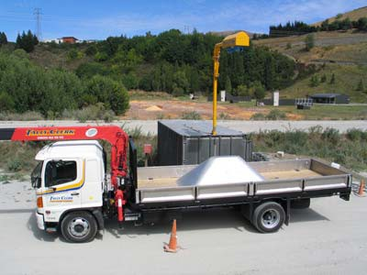

AUSTRALIA

The LVS was granted type approval in Australia in 2010. Type Approval was based as closely as practical on the OIML specification for Multi-Dimensional Measuring Instruments (OIML R129). Before conducting type evaluation the Australian National Measurement Institute (NMI) prepared a type evaluation guide called Guidelines for the Pattern Approval of Systems used for the Determination of Load Volumes. This is based primarily on the Australian general guidelines for pattern approval and the OIML specification for Multi-Dimensional Measuring Instruments (OIML R129). This document and Certificate of Approval No 13/1/15 (type approval) are available for reference. The following are some specific points of note.

1. Current approval is only up to 35m3 load per bin. This is not a limitation imposed by NMI but the result of the resources we had available when field evaluation was conducted only being suitable for loads up to
35m3. This is adequate to cover the requirements of the construction and most other industries except the mulch industry. Minimum capacity is 1.0m3. Further testing will be conducted with NMI for higher volumes.

2. The LVS is approved for measurement of ‘flowable solids such as sand, soil, gravel and agricultural materials’.

3. Approval requires accuracy testing “near (as close as practical)” to maximum capacity. The volume of test loads must be determined to an expanded uncertainty of one fifth of the maximum permissible error or less, in line with the OIML specification for Multi-Dimensional Measuring Instruments (OIML R129).

4. The approval certificate does not require an accuracy class to be marked on the instrument. Only maximum permissible errors (tolerances) are specified. NMI’s view is that no formal accuracy classes exist for this type of instrument so it does not make sense to mark a class. This also allows the instrument to be tested to different accuracy “classes” within the maximum tolerances specified, depending on the intended application and the type/quality of test loads available.

5. The maximum tolerances specified in the approval are based on weight class 5 from the OIML specification for Automatic instruments for weighing road vehicles in motion and measuring axle loads (OIML R134). This is a low accuracy class (basically a 2.5% class). The reason for this is not the accuracy

of the LVS system but the difficulty in generating test loads with sufficiently accurately known volume
(expanded uncertainty 1/5th MPE) to perform accuracy testing up to maximum capacity. However, the LVS
may be also be tested to class 2 (1% class) if suitable test loads/standards are available.

6. It is up to individual state authorities to specify any additional limitations on use, depending on the accuracy class the LVS is tested to.

7. LVS approval requires that all measured volume indications are accompanied by a statement that the volume indicated is that at the time of measurement. This reflects the fact that flowable solid volumes can fluctuate slightly over time (see support document Load Volume Scanner - General Metrology, Test Methods and Suitability for Use).

8. For practical reasons laboratory testing in an environmental chamber for type approval was conducted with a modified mounting system for the LVS to allow it to fit into the test chamber. The testing was also conducted with static (non-moving) test profiles and a modified version of the system software. NMI took the approach that the ability of the LVS software to compute accurate volumes from the raw laser distance measurement data can be determined by field-testing and that for laboratory testing it is only necessary to test the ability of the laser distance measuring components to provide suitable data for the software to process. A variation on the disturbance and other tests given in the OIML specification for Multi- Dimensional Measuring Instruments (OIML R129) were conducted.

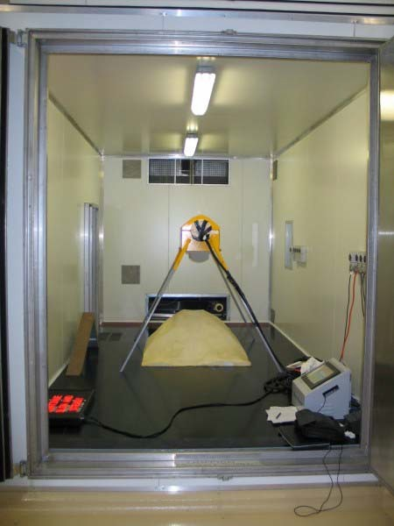Custom-mounted LVS in environmental test chamber, NMI, Sydney, Australia

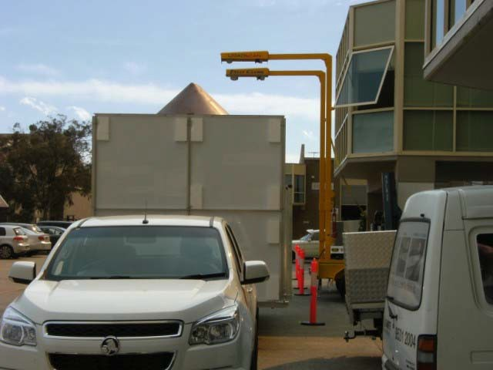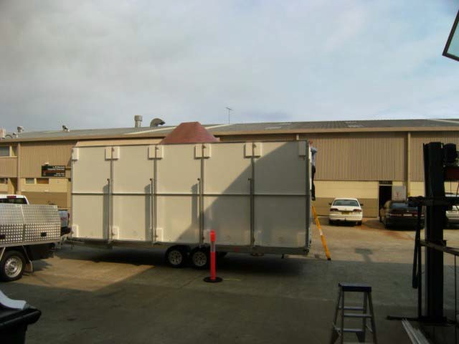9. LoadScan maintains a ‘test trailer’ and a 1.0m3 test load (reference standard) for certification testing in Australia. The test trailer is a dimensionally accurate rectangular bin with a false floor that can be positioned at different heights to simulate different levels of loading. The 1.0m3 test load is placed on the trailer floor or false floor to create a more realistic load profile and to test at minimum capacity. The trailer is fully mobile and can be disassembled. The 1.0m3 test load is dimensionally accurate and design is based on basic geometrical shapes so that its volume can be determined by manual measurement with tape measure. Test load volumes can be determined with enough accuracy to test to class 2 (1% class) with this equipment.

