Electrical Safety

NIST N 7101.64
Effective Date: 10/23/2015
Document Approval Date: 10/23/2015

- PURPOSE
This Notice establishes the requirements, roles, responsibilities, and authorities for performing energized electrical work, including electrical lockout/tagout (electrical LOTO). It will remain in place from its issuance date until the effective date of NIST Suborder (S) 7101.64: Electrical Safety.

NOTE: NIST expects NIST S 7101.64: Electrical Safety to be effective on April 1, 2017, with deployment commencing in the 3rd quarter of FY 2016. NIST S 7101.64 will incorporate the requirements of this notice.

- BACKGROUND
  - Energized electrical work, including electrical LOTO, can present significant electrical-shock and arc-flash hazards absent implementation of the safety requirements herein.

  - The contents of this Notice are based on the current editions of Occupational Safety and Health Administration (OSHA) standards in 29 CFR 1910, Subpart S, Electrical, and National Fire Protection Association (NFPA) codes/standards NFPA 70, 70B, and 70E.

- APPLICABILITY
- The requirements of this Notice apply to the following, regardless of the physical location in which the work is being performed:

- NIST employees and associates who could be exposed to electrical hazards, e.g., shock, arc flash, while performing energized electrical work, including electrical LOTO, in the performance of their duties; and
- NIST employees who are responsible for outside service providers performing energized electrical work, including electrical LOTO, and as such, are responsible for ensuring that other NIST employees and associates are not exposed to the hazards of that work.

- REFERENCES
  - OSHA 29 CFR 1910 Subpart S, Electrical

  - NFPA 70, National Electric Code, current edition

  - NFPA 70B, Recommended Practice for Electrical Equipment Maintenance, current edition

  - NFPA 70E, Electrical Safety in the Workplace, current edition

- APPLICABLE NIST OCCUPATIONAL SAFETY AND HEALTH SUBORDERS
  - NIST S 7101.20: Work and Worker Authorization Based on Hazard Reviews;

  - NIST S 7101.21: Personal Protective Equipment; and

  - NIST S 7101.56: Control of Hazardous Energy (Lockout/Tagout).

- REQUIREMENTS
Section 6a delineates conditions under which work on electrical equipment and circuits may be conducted in an energized state. Sections 6b and 6c delineate the requirements for de-energizing and re-energizing, respectively, equipment and circuits. Sections 6d and 6e delineate the requirements for performing energized electrical work without and with, respectively, an Energized Electrical Work Permit (EEWP; see Section 7, Definitions).

  - Conditions under which Work on Electrical Equipment and Circuits May Be Conducted in an Energized State

  - Work on electrical, electronic, and electro-mechanical equipment and circuits shall be performed in a de-energized state unless at least one of the following conditions is met:

- Energized electrical conductors and circuit parts to which employees and associates could be exposed operate at less than 50 volts and no other electrical hazards, e.g., potential for electrical burns or explosion, exist;

- It can be demonstrated to the responsible OU management that de-energizing would introduce additional hazards, would introduce increased risk, or could cause significant property damage or loss of critical data,;

- It can be demonstrated to the responsible OU management that performing the work in a de-energized state is infeasible (not just inconvenient) due to equipment design or operational limitations; or

- Normal operation of equipment or circuits for their intended purpose(s) provided the equipment or circuits and any upstream protective devices are known to be properly installed and maintained.

  - De-Energizing Electrical Equipment or Circuits to Perform Work

This section applies to de-energizing electrical equipment or circuits and verifying zero energy in the process of performing electrical LOTO. It does not apply to:

- Work on electrical conductors and circuit parts that operate at less than 50 volts provided no other electrical hazards exist; or

- When equipment is to be taken out of service and workers will not be exposed to electrical hazards.

    - Electrical LOTO shall be conducted in accordance with the requirements in Section 6 of NIST S 7101.56, Control of Hazardous Energy (Lockout/Tagout) and the requirements delineated in the remainder of this subsection.

    - Instructions for de-energizing equipment or circuits shall include procedures for:

- Disconnecting equipment and circuits to be worked on from all electric energy sources;

- Control circuit devices, such as push buttons, selector switches, and interlocks, shall not be used as the sole means for de-energizing equipment or circuits;
- Releasing from components stored electric energy that might endanger personnel;

- Capacitors shall be discharged; and

- High-capacitance elements shall be short-circuited and grounded;

- Blocking stored non-electrical energy in devices that could re-energize electric circuit parts; and

- Performing electrical LOTO, including steps for inhibiting automatic and remotely activated functionality.

- Locks and tags used in conducting electrical group LOTO shall:

  - Have a distinguishing identifier to identify it as an electrical group LOTO lock;

  - Locks shall not be keyed alike except to a single master for each work group; and

  - Each lock shall be individually numbered.

- A lock and a tag shall be placed on each disconnecting means used to de-energize equipment and circuits on which work is to be performed. The lock shall be attached so as to prevent persons from operating the disconnecting means unless they resort to undue force or the use of tools.

- Equipment with a source voltage of 240 volts or less fed by a single cord and plug shall not be required to have a lock and tag on the plug provided that all hazardous energy to which the worker could be exposed is controlled by unplugging the equipment and the plug is under the exclusive control of the worker. Such equipment shall have a lock and tag applied to the plug when workers are not present and there are exposed electrical circuits, components, or parts.

- A tag may be placed without a lock only if a lock cannot be applied or ALL of the following conditions are met:

- Only one piece of equipment or one circuit is de-energized;

- The tag is supplemented by at least one additional safety measure that provides a level of safety equivalent to that obtained by the use of a lock, as determined by the OSHE Electrical Safety Engineer (ESE);

- The lockout period does not extend beyond the work shift; and

- Employees and associates exposed to the hazards associated with re-energizing the equipment or circuit are trained in this procedure.

- An interlock for electric equipment may not be used as a substitute for written electrical LOTO procedures except in a laboratory (see Section 7, Definitions) or in an installation designated for research-and-development (R&D) (see Section 7, Definitions) when all of the following conditions are met:

  - The electrical LOTO is part of a laboratory or R&D activity;

  - The interlock is supplemented with a written procedure resulting from an approved OU hazard review; and

  - Proper PPE is worn in accordance with the procedure resulting from an approved OU hazard review.

- The following requirements for verifying the de-energized condition shall be met before any equipment can be considered and worked on as de-energized:

- A qualified person (see Section 7, Definitions) shall operate the equipment operating controls or otherwise verify that the equipment cannot be restarted.

- A qualified person shall use test equipment to verify that electrical parts of equipment and circuit elements to which employees or associates will be exposed are de-energized.

- A qualified person shall use test equipment to determine if any energized condition exists as a result of inadvertently induced voltage or unrelated voltage back-feed even though specific parts of the circuit have been de-energized and presumed to be safe.
- For voltages below 600 volts or when it has been determined that there are no voltages over 600 volts, a voltmeter or multimeter on the appropriate range/scale shall be used by a qualified person to verify zero volts phase-to-phase and phase-to-ground for all source phases. Testing shall be as follows:

- The meter shall be tested on a known source of the same voltage as that being verified for zero electrical energy;

- The meter shall be used to test the equipment for zero electrical energy; and

- The meter shall be tested again on a known source of the same voltage as that being verified for zero electrical energy.

- Until it is determined that the voltage level is 600 volts or less, it shall be assumed that the voltage is above 600 volts and special voltage measuring devices rated for the anticipated voltages shall be used when taking voltage measurement.

- Proximity testers or “tic tracers” shall not be used to verify zero volts in the performance of electrical LOTO.

  - Re-Energizing Electrical Equipment or Circuits

- The following requirements for re-energizing equipment or circuits shall be met, in the order given, before equipment or circuits are re-energized:

- A qualified person shall conduct tests and visual inspections, as necessary, to verify that all tools, electrical jumpers, shorts, grounds, and other such devices have been removed.

  - Energized Electrical Work Not Requiring an EEWP

- Energized electrical work may be performed without an EEWP (see Section 7, Definitions) provided the qualified person conducting the work:

- Has been trained on the appropriate safe work practices associated with the task(s);

- Uses the required personal protective equipment (PPE) in accordance with Appendices B through G to perform the task(s); and

- Performs one of these types of tasks:
- Work on energized electrical conductors and circuit parts operate at less than 50 volts and no other electrical hazards exist;

- Diagnostics, i.e., taking readings or measurements of electrical equipment with approved test equipment that do not require making any physical changes to the equipment;

- Thermography and visual inspections if the restricted approach boundary is not crossed;

- Tasks involving access to and egress from an area with energized electrical equipment or circuits if no energized electrical work is performed and the restricted approach boundary is not crossed; or

- General housekeeping and miscellaneous non-electrical tasks if the restricted approach boundary is not crossed and all automatic/remotely activated controls are inhibited.

- Energized electrical work that can be performed without an EEWP must still be authorized in accordance with the requirements of NIST S 7101.20: Work and Worker Authorization Based on Hazard Reviews.

  - Energized Electrical Work Requiring an EEWP (a.k.a. Permit-Required Energized Electrical Work)

- The following types of energized electric work may be conducted only in accordance with the requirements of an authorized EEWP, as described in Section 6f:

- Work, other than that described in Section 6d, requiring the qualified person to work within the restricted approach boundary;

- Work requiring the qualified person to interact with (e.g., operate, service, maintain, adjust) the equipment when conductors or circuit parts are not exposed but an increased likelihood of injury from an exposure to an arc-flash hazard exists;

- Work requiring the qualified person to interact with equipment or circuits that are not known to be properly installed or maintained; or
- Work requiring the qualified person to interact with equipment or circuits⁴ when the upstream protective devices are not known to be properly installed or maintained.

  - EEWPs (NIST-380 and NIST-380A Forms)

OUs shall authorize permit-required energized electrical work by completing EEWPs in accordance with the requirements of this section. There are two categories of permit-required energized electrical work:
- Permit-required energized electrical work associated with laboratory and R&D activities covered by OU-approved hazard reviews, as described in Section 6f(1); and
- All other permit-required energized electrical work, as described in Section 6f(2).

    - Permit-Required Energized Electrical Work Covered by OU-Approved Hazard Reviews

For permit-required energized electrical work covered by an OU-approved hazard review, the following shall apply:

        - The hazard review shall comply with the requirements of NIST S 7101.20, Work and Worker Authorization Based on Hazard Reviews.

        - The NIST-380A EEWP short form (see Appendix H) shall be used to document the following:

          - Justification for performing the energized work:

- Why de-energizing the equipment or circuit introduces additional hazards, introduces increased risk, or could cause significant property damage or loss of critical data; or

- Why de-energizing the equipment or circuit is infeasible (not just inconvenient) due to equipment design or operational limitations;

          - The hazard analysis of the energized electrical work to be performed;

          - The requestor; and

          - The approval of the NIST-380A short form by the OSHE Electrical Safety Engineer (ESE) (see Section 7, Definitions).

        - The approved NIST-380A short form shall be appended to the OU-approved hazard review.

        - The approved NIST-380A short form and OU-approved hazard review shall be readily available to those performing the energized electrical work.

    - All Other Permit-Required Energized Electrical Work

For all other permit-required energized electrical work, the NIST-380 EEWP form (see Appendix I) shall be used to document the following:

        - Details of the work to be completed, including:

- The work order associated with the work (if applicable);

- Location of the work to be performed;

- Description of the electrical equipment and circuit description;

- Description of the task;

- The requestor;

- The qualified person(s) requested to perform the work; and

- The first-level supervisor(s) of the qualified person(s) requested to perform the work.

        - Justification for performing the energized electrical work based upon one of the following circumstances (it is understood that an outage was first requested and denied if applicable):

          - Why de-energizing the equipment or circuit introduces additional hazards; introduces increased risk, or could cause significant property damage or loss of critical data, or

          - Why de-energizing the equipment or circuit is infeasible (not just inconvenient) due to equipment design or operational limitations.

        - The hazard analysis of the energized electrical work to be performed.

        - The approval of the NIST-380 form by the OSHE ESE (see Section 7, Definitions).

        - The authorization of the ESE-approved NIST-380 form by the responsible OU Director or an individual designated by the OU Director to authorize the form on his or her behalf.

    - Just prior to the commencement of work, a documented pre-work meeting shall be held by the first-level supervisor or designee with the employee(s) and associate(s) performing the work to review the authorized NIST-380 form, work steps, and job/site/environment specific hazards.

    - The authorized NIST-380 form shall be located at the work site for the duration of the work.

    - Any general comments or issues encountered during the energized electrical work shall be noted on the authorized NIST-380 form so that appropriate revisions to planning and implementation of future energized electrical work can be made.

    - Hard or electronic copies of authorized NIST-380 forms shall be kept by the OUs for a minimum of 1 year from the completion of the work.

  - Energized Electrical Work Other than Electrical LOTO Performed by Outside Service Providers

- Outside service providers shall not be permitted to commence energized electrical work other than electrical LOTO on NIST electrical, electronic, or electro-mechanical equipment or circuits until:

- They have exchanged energized-electrical work programs with the NIST controlling organization; and

- Arc flash and shock protective boundaries have been established using approved methods to prohibit NIST employees and associates from entering the work area(s).

  - Equipment Labeling

    - Electrical equipment such as switchboards, panelboards, industrial control panels, meter-socket enclosures, motor-control centers, and 3-phase service disconnects shall be field-marked with an electrical-safety label containing all the following information for all new installations and when any modifications, i.e. addition/deletions of components or major repairs, of existing installations are performed:

      - Available incident energy;

      - Arc flash boundary;

      - Working distance;

      - Corresponding working distance;

      - Nominal system voltage;

      - Limited approach boundary;

      - Restricted approach boundary;

      - Building number;

      - Panel number or equipment buss name;

      - Upstream protective device panel number/name; and

      - Date label issued.

    - Electrical safety label format shall be as depicted in Appendix J.

  - Training

    - Employees and associates whose duties require them to be qualified persons (see Definition 7, Definitions) shall complete:

      - The training provided by OSHE on the electrical safe work practices, the scope of which will depend on the nature of the work the qualified person is to perform; and

      - The OU-provided activity-specific training on the tasks they perform, including training on the proper use of electrical test equipment, as applicable.

    - Employees and associates whose duties require them to be competent persons (see Definition 7, Definitions) shall:

    - Meet all the requirements of a qualified person; and

    - Be approved by the Authority Having Jurisdiction (AHJ) as having detailed knowledge regarding the exposure to electrical hazards, the appropriate control methods to reduce the risk associated with those hazards, and the implementation of those methods.

  - Incident Response

      - Employees and associates who have received electric shocks or been exposed to arc flashes shall immediately receive medical evaluations.

  - Incident Investigations

    - The OSHE ESE (or designee) shall be included in investigations of safety incidents involving electric shocks or arc flashes.

- DEFINITIONS
  - Authority Having Jurisdiction (AHJ) – The OSHE individual responsible for enforcing the requirements of fire, electrical, and life safety codes and standards at sites owned and operated by NIST, and for approving, as necessary, applicable equipment, materials, installations, and procedures.

  - Arc Flash – A flashover of electric current through the air from one conductor to another, or to ground.

  - Arc Flash Boundary – An approach limit at a distance from exposed live parts at which a person could receive a second degree burn if an electrical arc flash were to occur. The boundary is established at the point away from a potential arc source where the incident energy would be reduced to 1.2 cal/cm².
  - Competent Person – An individual who:

    - Meets all the requirements of a qualified person;

    - Is responsible for all work activities or safety procedures related to custom or special equipment used in laboratory or R&D activities; and

    - Has been approved by the AHJ, or by the OSHE ESE as delegated by the AHJ, as having detailed knowledge regarding the exposure to electrical hazards, the appropriate control methods to reduce the risk associated with those hazards, and the implementation of those methods.

  - De-energized – Free from any electrical connection to a source of potential difference and from electrical charge; not having a potential different from that of the earth.

  - Diagnostics – Taking readings or measurements of electrical equipment with approved test equipment that does not require making any physical change to the equipment.

  - Electrical Hazard – A dangerous condition such that contact or equipment failure can result in electric shock, arc flash burn, thermal burn, or blast. The limited and restricted approach boundaries (for shock) and the arc flash boundary are the boundaries within which potential electrical hazards to workers exist.

  - Electrical Safe Work Condition – A state in which an electrical conductor or circuit part has been disconnected from energized parts, locked/tagged in accordance with established standards, tested to ensure the absence of voltage, and grounded if determined necessary.

  - Energized Electrical Work – Work conducted by an employee or associate on electrical, electronic, or electro-mechanical equipment or circuits where:

  - The equipment or circuit is either known to be energized or not known to have been de-energized in accordance with the requirements of this suborder; and

  - The employee or associate is within the restricted-approach boundary or interacts with the equipment or circuit within the arc-flash boundary.

  - Energized Electrical Work Analysis and Authorization Permit – A document that details the following:

- The circuit, equipment, and location of the job/task to be conducted.
- The work that is to be done.

- Justification of why the circuit or equipment cannot be de-energized or the work deferred until the next scheduled outage.

  - Equipment – A general term, including circuits, components, devices, and the like, used as a part of, or in connection with, an electrical installation.

  - Exposed (as applied to energized electrical conductors or circuit parts) – Capable of being inadvertently touched or approached nearer than a safe distance by a person. It is applied to electrical conductors or circuit parts that are not suitably guarded, isolated, or insulated.

  - High Voltage – Voltages above 600 volts.

  - Incident Energy – The amount of energy impressed on a surface, a certain distance from a source, generated during an electrical arc event. The incident energy level is expressed in calories per centimeter-squared (cal/cm²) and is a measure of the heat created by the electrical arc.

  - Laboratory – A building, space, room, or group of rooms intended to serve activities involving procedures for investigation, diagnostics, product testing, or use of custom or special electrical components, systems, or equipment.

  - Limited Approach Boundary – An approach limit at a distance from an exposed energized electrical conductor or circuit part within which a shock hazard exists.

  - Low Voltage – Voltages 600 volts and below.

  - Notice – A temporary directive issued in response to any matter requiring prompt action. Occupational safety and health notices are reviewed annually and automatically renewed unless rescinded by the Chief Safety Officer.

  - OSHE Electrical Safety Engineer – The individual in OSHE designated by the AHJ to:

- Approve EEWPs; and

- Make recommendations to the AHJ on interpretations of the applicable codes/standards, the approval of equipment and materials, and the granting of special permission contemplated in some of the rules.

  - Properly Installed – Equipment or circuit that has been installed in accordance with applicable industry codes and standards and the manufacturer’s recommendations.

  - Properly Maintained – Equipment or circuit that has been maintained in accordance with applicable industry codes and standards and the manufacturer’s recommendations.

  - Qualified Person – One who has demonstrated knowledge, skills, and abilities related to the construction, installation, and operation of specific electrical equipment or circuits and has received safety training to identify and avoid the hazards involved.

  - Repair – Any physical alteration of electrical equipment, e.g., making or tightening connections, removing or replacing components.

  - Research and Development – An activity in an installation specifically designated for research or development conducted with custom or special electrical equipment.

  - Restricted Approach Boundary – An approach limit at a distance from an exposed live part within which there is an increased risk of shock, due to electrical arc-over combined with inadvertent movement, for personnel working in close proximity to the live part. This area is reserved only for qualified persons. Shock protection techniques and safety equipment are required.

  - Suborder – A directive within the NIST Directives Management System that establishes authorities, technical requirements, and assignment of responsibilities in a specific subject area under an order and focuses on the technical details of the program.

  - Testing – See definition of “Diagnostics”.

  - Work – See definition of “Working On”.

  - Working – See definition of “Working On”.

  - Working On (Energized Electrical Conductors or Circuit Parts) – Intentionally coming in contact with energized electrical conductors or circuit parts with the hands, feet, or other body parts, with tools, probes, or with test equipment, regardless of the personal protective equipment (PPE) a person is wearing. There are two categories of “working on”: “Diagnostics” (“Testing”) and “Repair” (see definitions).

- ACRONYMS
  - ac – Alternating Current

  - AHJ – Authority Having Jurisdiction.

  - EEWP – Energized Electrical Work Permit

  - dc – Direct Current

  - ESE – Electrical Safety Engineer

  - LOTO – Lockout/Tagout

  - NFPA – National Fire Protection Association

  - OU – Organizational Unit

  - OSHA – Occupational Safety and Health Administration

  - OSHE – Office of Safety, Health, and Environment

  - PPE – Personal Protective Equipment

  - R&D – Research and Development

- RESPONSIBILITIES
For responsibilities applicable to all NIST OSH Suborders, see the “Responsibilities” section of NIST O 7101.00.

  - OU Directors are responsible for:

- Ensuring that the requirements of this notice are met in their respective OUs; and

- Authorizing EEWPs.

  - OU Line Management is responsible for:

    - Authorizing, in accordance with OU procedures, energized electrical work not requiring EEWPs.
  - Those Responsible for Outside Service Providers Performing Energized Electrical Work are responsible for:

- Ensuring that NIST employees and associates are prohibited access to area(s) in which energized electrical work is taking place until they have been informed of the hazards and of the measures necessary to avoid exposure.

  - Competent Persons are responsible for:

    - The safety of, and safety procedures related to, custom or special equipment associated with laboratory or R&D activities.

  - OSHE ESE is responsible for:

- Approving EEWPs;

- Participating in (or designating another individual to participate in) investigations of safety incidents involving electric shocks or arc flashes;

- Recommending to the AHJ interpretations of the applicable codes/standards, deciding on the approval of equipment and materials, and granting the special permission contemplated in some of the rules; and

- Recommending to the AHJ the approval of individuals as competent persons.

  - AHJ is responsible for:

- Making interpretations of the applicable codes/standards, deciding on the approval of equipment and materials, and granting the special permission contemplated in some of the rules, i.e., waiving specific requirements in the codes/standards or permitting alternative methods where it is assured that equivalent objectives can be achieved by establishing and maintaining effective safety;

- Approving individuals as competent persons; and

- Maintaining a list of competent persons.

- AUTHORITIES
Authorities common to all NIST OSH suborders can be found in the “Authorities” section of NIST O 7101.00. Authorities specific to this suborder are:

  - OU Directors:

- To delegate to OU Deputy Directors and Division Chiefs (or equivalent) the authority to authorize EEWPs on their behalf.

  - AHJ:

- To delegate to the OSHE ESE the authority to carry out the AHJ responsibilities listed above as they apply to this Notice.

- DIRECTIVE OWNER
Chief Safety Officer

- APPENDICES
  - Revision History

  - Approach Boundaries to Energized Electrical Conductors or Circuit Parts for Shock Protection for Alternating-Current Systems

  - Approach Boundaries to Energized Electrical Conductors or Circuit Parts for Shock Protection, Direct-Current Voltage Systems

  - Arc Flash Hazard Identification Table

  - Arc-Flash Hazard PPE Categories for Alternating Current (ac) Systems

  - Arc-Flash Hazard PPE Categories for Direct Current (dc) Systems

  - PPE Categories

  - NIST-380A Form: Energized Electrical Work Permit (EEWP) Short Form

  - NIST-380 Form: Energized Electrical Work Permit (EEWP)

  - Electrical Safety Label Format

Revision | Date | Responsible Person | Description of Change
None | 10/21/2015 | Monroe Charlton | None – Initial document

 | (1) |  | (2) |  | (3) |  | (4)
 |  |  | Limited Approach Boundaries |  |  |  | Restricted Approach Boundary; Includes Inadvertent Movement Adder
 | Nominal System Voltage Range, Phase to Phase |  | Exposed Movable Conductor |  | Exposed Fixed Circuit Part
 | <50 V |  | Not specified |  | Not specified |  | Not specified
 | 50 V–150 V |  | 3.0 m (10 ft 0 in.) |  | 1.0 m (3 ft 6 in.) |  | Avoid contact
 | 151 V–750 V |  | 3.0 m (10 ft 0 in.) |  | 1.0 m (3 ft 6 in.) |  | 0.3 m (1 ft 0 in.)
 | 751 V–15 kV |  | 3.0 m (10 ft 0 in.) |  | 1.5 m (5 ft 0 in.) |  | 0.7 m (2 ft 2 in.)
 | 15.1 kV–36 kV |  | 3.0 m (10 ft 0 in.) |  | 1.8 m (6 ft 0 in.) |  | 0.8 m (2 ft 7 in.)
 | 36.1 kV–46 kV |  | 3.0 m (10 ft 0 in.) |  | 2.5 m (8 ft 0 in.) |  | 0.8 m (2 ft 9 in.)
 | 46.1 kV–72.5 kV |  | 3.0 m (10 ft 0 in.) |  | 2.5 m (8 ft 0 in.) |  | 1.0 m (3 ft 3 in.)
 | 72.6 kV–121 kV |  | 3.3 m (10 ft 8 in.) |  | 2.5 m (8 ft 0 in.) |  | 1.0 m (3 ft 4 in.)
 | 138 kV–145 kV |  | 3.4 m (11 ft 0 in.) |  | 3.0 m (10 ft 0 in.) |  | 1.2 m (3 ft 10 in.)
 | 161 kV–169 kV |  | 3.6 m (11 ft 8 in.) |  | 3.6 m (11 ft 8 in.) |  | 1.3 m (4 ft 3 in.)
 | 230 kV–242 kV |  | 4.0 m (13 ft 0 in.) |  | 4.0 m (13 ft 0 in.) |  | 1.7 m (5 ft 8 in.)
 | 345 kV–362 kV |  | 4.7 m (15 ft 4 in.) |  | 4.7 m (15 ft 4 in.) |  | 2.8 m (9 ft 2 in.)
 | 500 kV–550 kV |  | 5.8 m (19 ft 0 in.) |  | 5.8 m (19 ft 0 in.) |  | 3.6 m (11 ft 10 in.)
 | 765 kV–800 kV |  | 7.2 m (23 ft 9 in.) |  | 7.2 m (23 ft 9 in.) |  | 4.9 m (15 ft 11 in.)
Note (1): For arc flash boundary, see 130.5(A).
Note (2): All dimensions are distance from exposed energized electrical conductors or circuit part to employee.
a For single-phase systems above 250V, select the range that is equal to the system’s maximum phase-to- ground voltage multiplied by 1.732.
b See definition in Article 100 and text in 130.4(D)(2) and Informative Annex C for elaboration.
c Exposed movable conductors describes a condition in which the distance between the conductor and a person is not under the control of the person. The term is normally applied to overhead line conductors supported by poles.
d This includes circuits where the exposure does not exceed 120V.

(1) | (2) | (3) | (4)
 | Limited Approach Boundaries |  | Restricted Approach Boundary; Includes Inadvertent Movement Adder
Nominal Potential Difference | Exposed Movable Conductor | Exposed Fixed Circuit Part
<100 V | Not specified | Not specified | Not specified
100 V–300 V | 3.0 m (10 ft 0 in.) | 1.0 m (3 ft 6 in.) | Avoid contact
301 V–1 kV | 3.0 m (10 ft 0 in.) | 1.0 m (3 ft 6 in.) | 0.3 m (1 ft 0 in.)
1.1 kV–5 kV | 3.0 m (10 ft 0 in.) | 1.5 m (5 ft 0 in.) | 0.5 m (1 ft 5 in.)
5 kV–15 kV | 3.0 m (10 ft 0 in.) | 1.5 m (5 ft 0 in.) | 0.7 m (2 ft 2 in.)
15.1 kV–45 kV | 3.0 m (10 ft 0 in.) | 2.5 m (8 ft 0 in.) | 0.8 m (2 ft 9 in.)
45.1 kV– 75 kV | 3.0 m (10 ft 0 in.) | 2.5 m (8 ft 0 in.) | 1.0 m (3 ft 2 in.)
75.1 kV–150 kV | 3.3 m (10 ft 8 in.) | 3.0 m (10 ft 0 in.) | 1.2 m (4 ft 0 in.)
150.1 kV–250 kV | 3.6 m (11 ft 8 in.) | 3.6 m (11 ft 8 in.) | 1.6 m (5 ft 3 in.)
250.1 kV–500 kV | 6.0 m (20 ft 0 in.) | 6.0 m (20 ft 0 in.) | 3.5 m (11 ft 6 in.)
500.1 kV–800 kV | 8.0 m (26 ft 0 in.) | 8.0 m (26 ft 0 in.) | 5.0 m (16 ft 5 in.)
Note: All dimensions are distance from exposed energized electrical conductors or circuit parts to worker.
* Exposed movable conductor describes a condition in which the distance between the conductor and a person is not under the control of the person. The term is normally applied to overhead line conductors supported by poles.

Task | Equipment Condition* | Arc Flash PPE  Required
Reading a panel meter while operating a meter switch | Any | No
Normal operation of a circuit breaker (CB), switch, contactor, or starter | All of the following:  The equipment is properly installed  The equipment is properly maintained  All equipment doors are closed and secured  All equipment covers are in place and secured  There is no evidence of impending failure | No
 | One or more of the following:  The equipment is not properly installed  The equipment is not properly maintained  Equipment doors are open or not secured  Equipment covers are off or not secured  There is evidence of impending failure | Yes
For ac systems: Work on energized electrical conductors and circuit parts, including voltage testing | Any | Yes
For dc systems: Work on energized electrical conductors and circuit parts of series-connected battery cells, including voltage testing | Any | Yes
Voltage testing on individual battery cells or individual multi-cell units | All of the following:  The equipment is properly installed  The equipment is properly maintained  Covers for all other equipment are in place and secured  There is no evidence of impending failure | No
 | One or more of the following:  The equipment is not properly installed  The equipment is not properly maintained  Equipment doors are open or not secured  Equipment covers are off or not secured  There is evidence of impending failure | Yes
Removal or installation of CBs or switches | Any | Yes

Task | Equipment Condition* | Arc Flash PPE  Required
Removal or installation of covers for equipment such as wireways, junction boxes, and cable trays that does not expose bare energized electrical conductors and circuit parts | All of the following:  The equipment is properly installed  The equipment is properly maintained  There is no evidence of impending failure | No
 | Any of the following:  The equipment is not properly installed  The equipment is not properly maintained  There is evidence of impending failure | Yes
Removal of bolted covers (to expose bare energized electrical conductors and circuit parts). For dc systems, this includes bolted covers, such as battery terminal covers. | Any | Yes
Removal of battery intercell connector covers | All of the following:  The equipment is properly installed.  The equipment is properly maintained  Covers for all other equipment are in place and secured  There is no evidence of impending failure | No
 | One or more of the following:  The equipment is not properly installed  The equipment is not properly maintained  Equipment doors are open or not secured  Equipment covers are off or not secured  There is evidence of impending failure | Yes

Task | Equipment Condition* | Arc Flash PPE  Required
Opening hinged door(s) or cover(s) (to expose bare energized electrical conductors and circuit parts) | Any | Yes
Perform infrared thermography and other noncontact inspections outside the restricted approach boundary. This activity does not include opening of doors or covers. | Any | No
Application of temporary protective grounding equipment after voltage test | Any | Yes
Work on control circuits with exposed energized electrical conductors and circuit parts, 120 volts or below without any other exposed energized equipment over 120 V including opening of hinged covers to gain access | Any | No
Work on control circuits with exposed energized electrical conductors and circuit parts, greater than 120 V | Any | Yes
Insertion or removal of individual starter buckets from motor control center (MCC) | Any | Yes
Insertion or removal (racking) of CBs or starters from cubicles, doors open or closed | Any | Yes
Insertion or removal of plug-in devices into or from busways | Any | Yes
Insulated cable examination with no manipulation of cable | Any | No
Insulated cable examination with manipulation of cable | Any | Yes
Work on exposed energized electrical conductors and circuit parts of equipment directly supplied by a panelboard or motor control center | Any | Yes
Insertion and removal of revenue meters (kW-hour, at primary voltage and current) | Any | Yes
For dc systems, insertion or removal of individual cells or multi-cell units of a battery system in an enclosure | Any | Yes

Task | Equipment Condition* | Arc Flash PPE  Required
For dc systems, insertion or removal of individual cells or multi-cell units of a battery system in an open rack | Any | No
For dc systems, maintenance on a single cell of a battery system or multi-cell units in an open rack | Any | No
For dc systems, work on exposed energized electrical conductors and circuit parts of utilization equipment directly supplied by a dc source | Any | Yes
Arc-resistant switchgear Type 1 or 2 (for clearing times of  <0.5 sec with a prospective fault current not to exceed the arc-resistant rating of the equipment) and metal enclosed interrupter switchgear, fused or unfused of arc resistant type construction, tested in accordance with IEEE C37.20.7:  •Insertion or removal (racking) of CBs from cubicles  •Insertion or removal (racking) of ground and test device  •Insertion or removal (racking) of voltage transformers on or off the bus | All of the following:  The equipment is properly installed  The equipment is properly maintained  All equipment doors are closed and secured  All equipment covers are in place and secured  There is no evidence of impending failure | No
 | One or more of the following:  The equipment is not properly installed  The equipment is not properly maintained Equipment doors are open or not secured  Equipment covers are off or not secured  There is evidence of impending failure | Yes
Opening voltage transformer or control power transformer compartments | Any | Yes
Outdoor disconnect switch operation (hookstick operated) at 1 kV through 15 kV | Any | Yes
Outdoor disconnect switch operation (gang-operated, from grade) at 1 kV through 15 kV | Any | Yes

Note: Hazard identification is one component of risk assessment. Risk assessment involves a determination of the likelihood of occurrence of an incident, resulting from a hazard that could cause injury or damage to health. The assessment of the likelihood of occurrence contained in this table does not cover every possible condition or situation. Where this table indicates that arc flash PPE is not required, an arc flash is not likely to occur

Equipment | Arc Flash PPE Category | Arc-Flash Boundary
Panelboards or other equipment rated 240 V and below  Parameters: Maximum of 25 kA short-circuit current available; maximum of 0.03 sec (2 cycles) fault clearing time; working distance 455 mm (18 in.) | 1 | 485 mm  (19 in.)
Panelboards or other equipment rated >240 V and up to 600 V  Parameters: Maximum of 25 kA short-circuit current available; maximum of 0.03 sec (2 cycles) fault clearing time; working distance 455 mm (18 in.) | 2 | 900 mm  (3 ft)
600-V class motor control centers (MCCs)  Parameters: Maximum of 65 kA short-circuit current available; maximum of 0.03 sec (2 cycles) fault clearing time; working distance 455 mm (18 in.) | 2 | 1.5 m (5 ft)
600-V class motor control centers (MCCs)  Parameters: Maximum of 42 kA short-circuit current available; maximum of 0.33 sec (20 cycles) fault clearing time; working distance 455 mm (18 in.) | 4 | 4.3 m (14 ft)
600-V class switchgear (with power circuit breakers or fused switches) and 600 V class switchboards  Parameters: Maximum of 35 kA short-circuit current available; maximum of up to 0.5 sec (30 cycles) fault clearing time; working distance 455 mm (18 in.) | 4 | 6 m (20 ft)
Other 600-V class (277 V through 600 V, nominal) equipment  Parameters: Maximum of 65 kA short circuit current available; maximum of 0.03 sec (2 cycles) fault clearing time; working distance 455 mm (18 in.) | 2 | 1.5 m (5 ft)
NEMA E2 (fused contactor) motor starters, 2.3 kV through  7.2 kV  Parameters: Maximum of 35 kA short-circuit current available; maximum of up to 0.24 sec (15 cycles) fault clearing time; working distance 910 mm (36 in.) | 4 | 12 m  (40 ft)
Metal-clad switchgear, 1 kV through 15 kV  Parameters: Maximum of 35 kA short-circuit current available; maximum of up to 0.24 sec (15 cycles) fault clearing time; working distance 910 mm (36 in.) | 4 | 12 m  (40 ft)
Arc-resistant switchgear Type 1 or 2 [for clearing times of  < 0.5 sec (30 cycles) with a perspective fault current not to exceed the arc-resistant rating of the equipment], and  metal-enclosed interrupter switchgear, fused or unfused of  arc-resistant-type construction, tested in accordance with IEEE C37.20.7, 1 kV through 15 kV  Parameters: Maximum of 35 kA short-circuit current available; maximum of up to 0.24 sec (15 cycles) fault clearing time; working distance 910 mm (36 in.) | N/A (doors closed) | N/A (doors closed)
 | 4 (doors open) | 12 m (40 ft)
Other equipment 1 kV through 15 kV  Parameters: Maximum of 35 kA short-circuit current available; maximum of up to 0.24 sec (15 cycles) fault clearing time; working distance 910 mm (36 in.) | 4 | 12 m  (40 ft)

Equipment | Arc Flash PPE Category | Arc-Flash Boundary
Storage batteries, dc switchboards, and other dc supply sources

100 V > Voltage < 250 V Parameters:
Voltage: 250 V
Maximum arc duration and working distance: 2 sec @ 455 mm (18 in.)
Short-circuit current < 4 kA | 1 | 900 mm  (3 ft)
4 kA ≤ short-circuit current < 7 kA | 2 | 1.2 m  (4 ft)
7 kA ≤ short-circuit current < 15 kA | 3 | 1.8 m  (6 ft)
Storage batteries, dc switchboards, and other dc supply sources

250 V ≤ Voltage ≤ 600 V Parameters:
Voltage: 600 V
Maximum arc duration and working distance: 2 sec @ 455 mm (18 in.)
Short-circuit current 1.5 kA | 1 | 900 mm  (3 ft)
1.5 kA ≤ short-circuit current < 3 kA | 2 | 1.2 m  (4 ft)
3 kA ≤ short-circuit current < 7 kA | 3 | 1.8 m  (6 ft.)
7 kA ≤ short-circuit current < 10 kA | 4 | 2.5 m  (8 ft)
Note: Apparel that can be expected to be exposed to electrolyte must meet both of the following conditions:
- Be evaluated for electrolyte protection in accordance with ASTM F1296, Standard Guide for Evaluating Chemical Protective Clothing
- Be arc-rated in accordance with ASTM F1891, Standard Specification for Arc Rated and Flame Resistant Rainwear, or equivalent

PPE Category | PPE
1 | Arc-Rated Clothing, Minimum Arc Rating of 4 cal/cm2 (see Note 1)
 | Arc-rated long-sleeve shirt and pants or arc-rated coverall
 | Arc-rated face shield (see Note 2) or arc flash suit hood
 | Arc-rated jacket, parka, rainwear, or hard hat liner (AN)
 | Protective Equipment
 | Hard hat
 | Safety glasses or safety goggles (SR)
 | Hearing protection (ear canal inserts)
 | Heavy duty leather gloves (see Note 3)
 | Leather footwear (AN)
2 | Arc-Rated Clothing, Minimum Arc Rating of 8 cal/cm2 (see Note 1)
 | Arc-rated long-sleeve shirt and pants or arc-rated coverall
 | Arc-rated flash suit hood or arc-rated face shield (see Note 2) and arc-rated balaclava
 | Arc-rated jacket, parka, rainwear, or hard hat liner (AN)
 | Protective Equipment
 | Hard hat
 | Safety glasses or safety goggles (SR)
 | Hearing protection (ear canal inserts)
 | Heavy duty leather gloves (see Note 3)
 | Leather footwear
3 | Arc-Rated Clothing Selected so That the System Arc Rating Meets the Required Minimum Arc Rating of 25 cal/cm2 (see Note 1)
 | Arc-rated long-sleeve shirt (AR)
 | Arc-rated pants (AR)
 | Arc-rated coverall (AR)
 | Arc-rated arc flash suit jacket (AR)
 | Arc-rated arc flash suit pants (AR)
 | Arc-rated arc flash suit hood
 | Arc-rated gloves (see Note 1)
 | Arc-rated jacket, parka, rainwear, or hard hat liner (AN)
 | Protective Equipment
 | Hard hat
 | Safety glasses or safety goggles (SR)
 | Hearing protection (ear canal inserts)
 | Leather footwear
4 | Arc-Rated Clothing Selected so That the System Arc Rating Meets the Required Minimum Arc Rating of 40 cal/cm2 (see Note 1)
 | Arc-rated long-sleeve shirt (AR)
 | Arc-rated pants (AR)
 | Arc-rated coverall (AR)
 | Arc-rated arc flash suit jacket (AR)
 | Arc-rated arc flash suit pants (AR)
 | Arc-rated arc flash suit hood
 | Arc-rated gloves (see Note 1)
 | Arc-rated jacket, parka, rainwear, or hard hat liner (AN)
 | Protective Equipment
 | Hard hat
 | Safety glasses or safety goggles (SR)
 | Hearing protection (ear canal inserts)
 | Leather footwear
 | AN: as needed (optional). AR: as required. SR: selection required.
Notes: | (1) Arc rating is defined in Article 100.
 | (2) Face shields are to have wrap-around guarding to protect not only the face but also the forehead, ears, and neck, or, alternatively, an arc-rated arc flash suit hood is required to be worn.
 | (3) If rubber insulating gloves with leather protectors are used, additional leather or arc-rated gloves are not required. The combination of rubber insulating gloves with leather protectors satisfies the arc flash protection requirement.

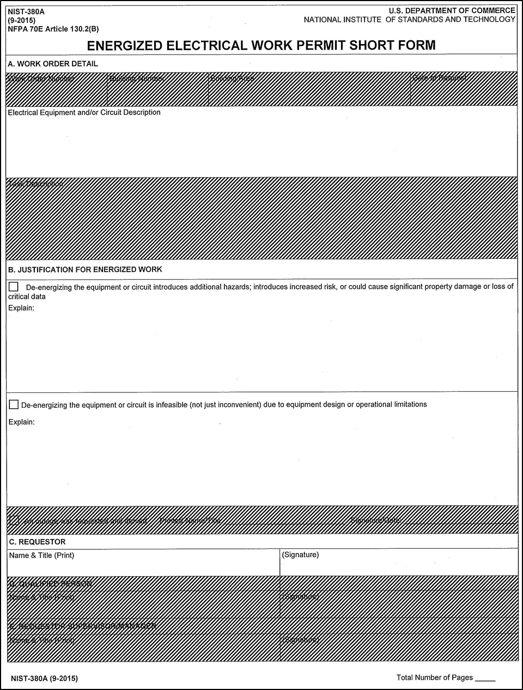
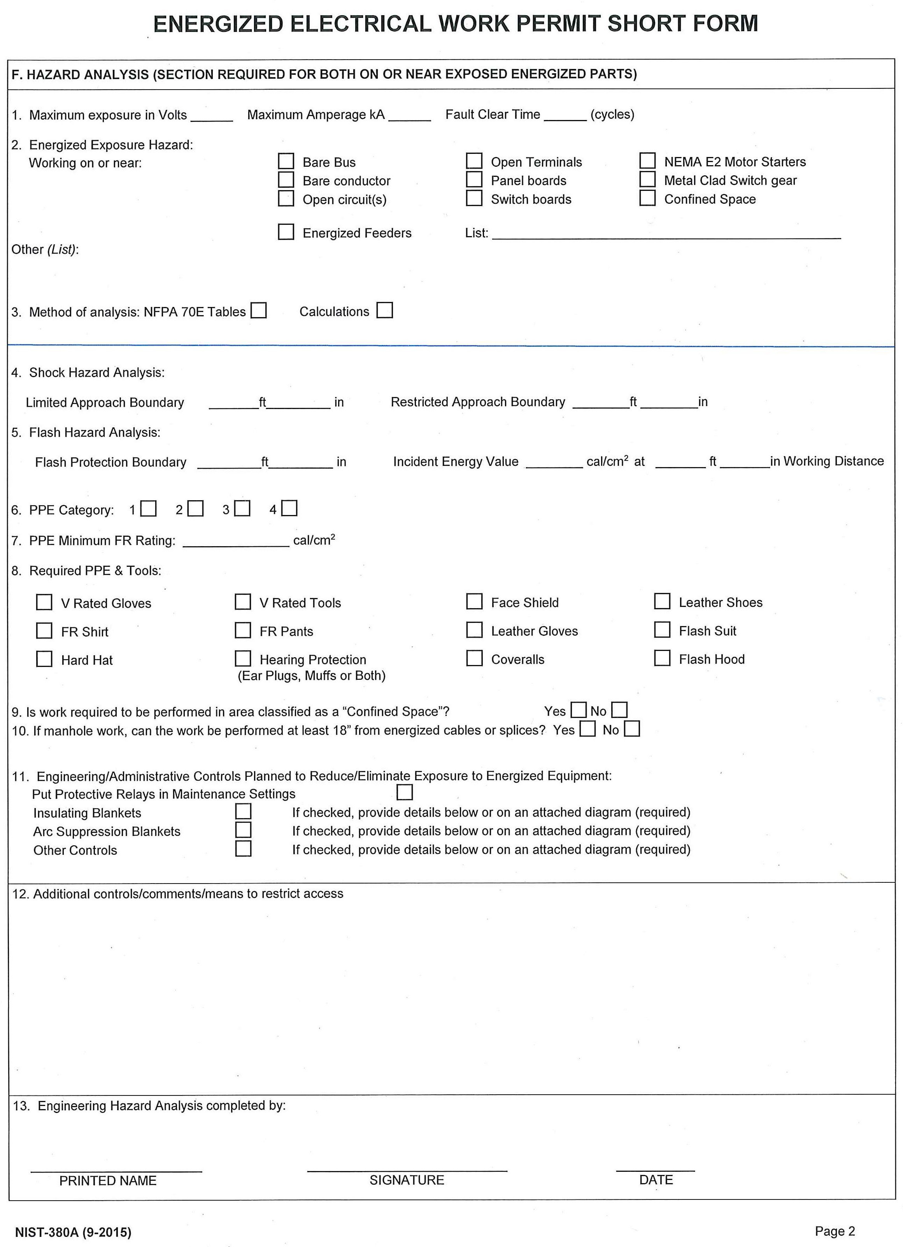
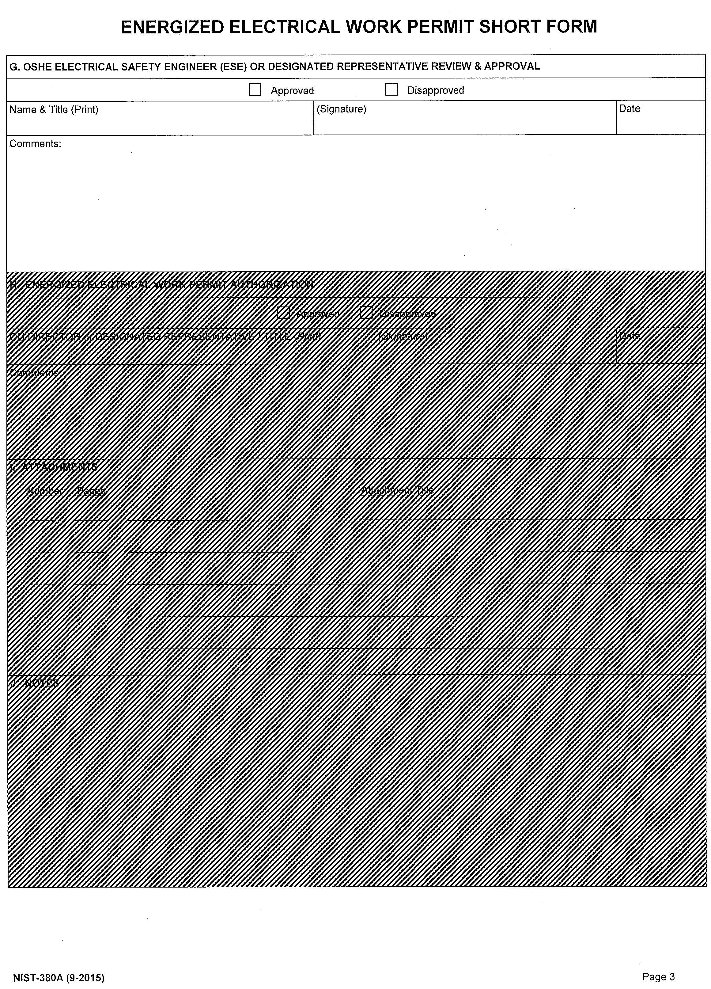
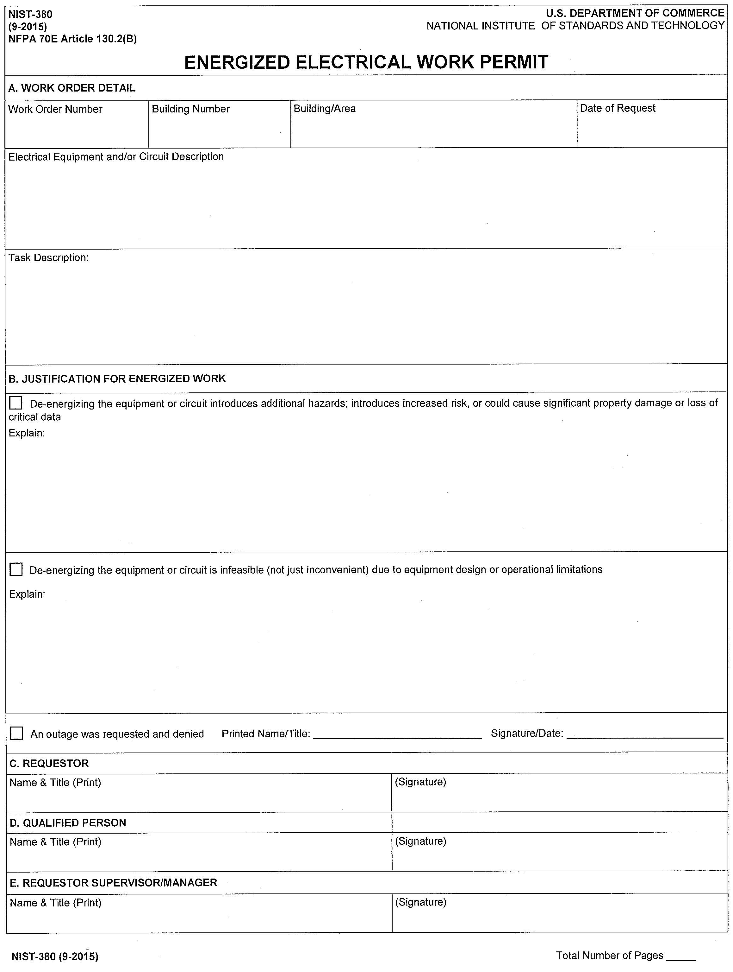
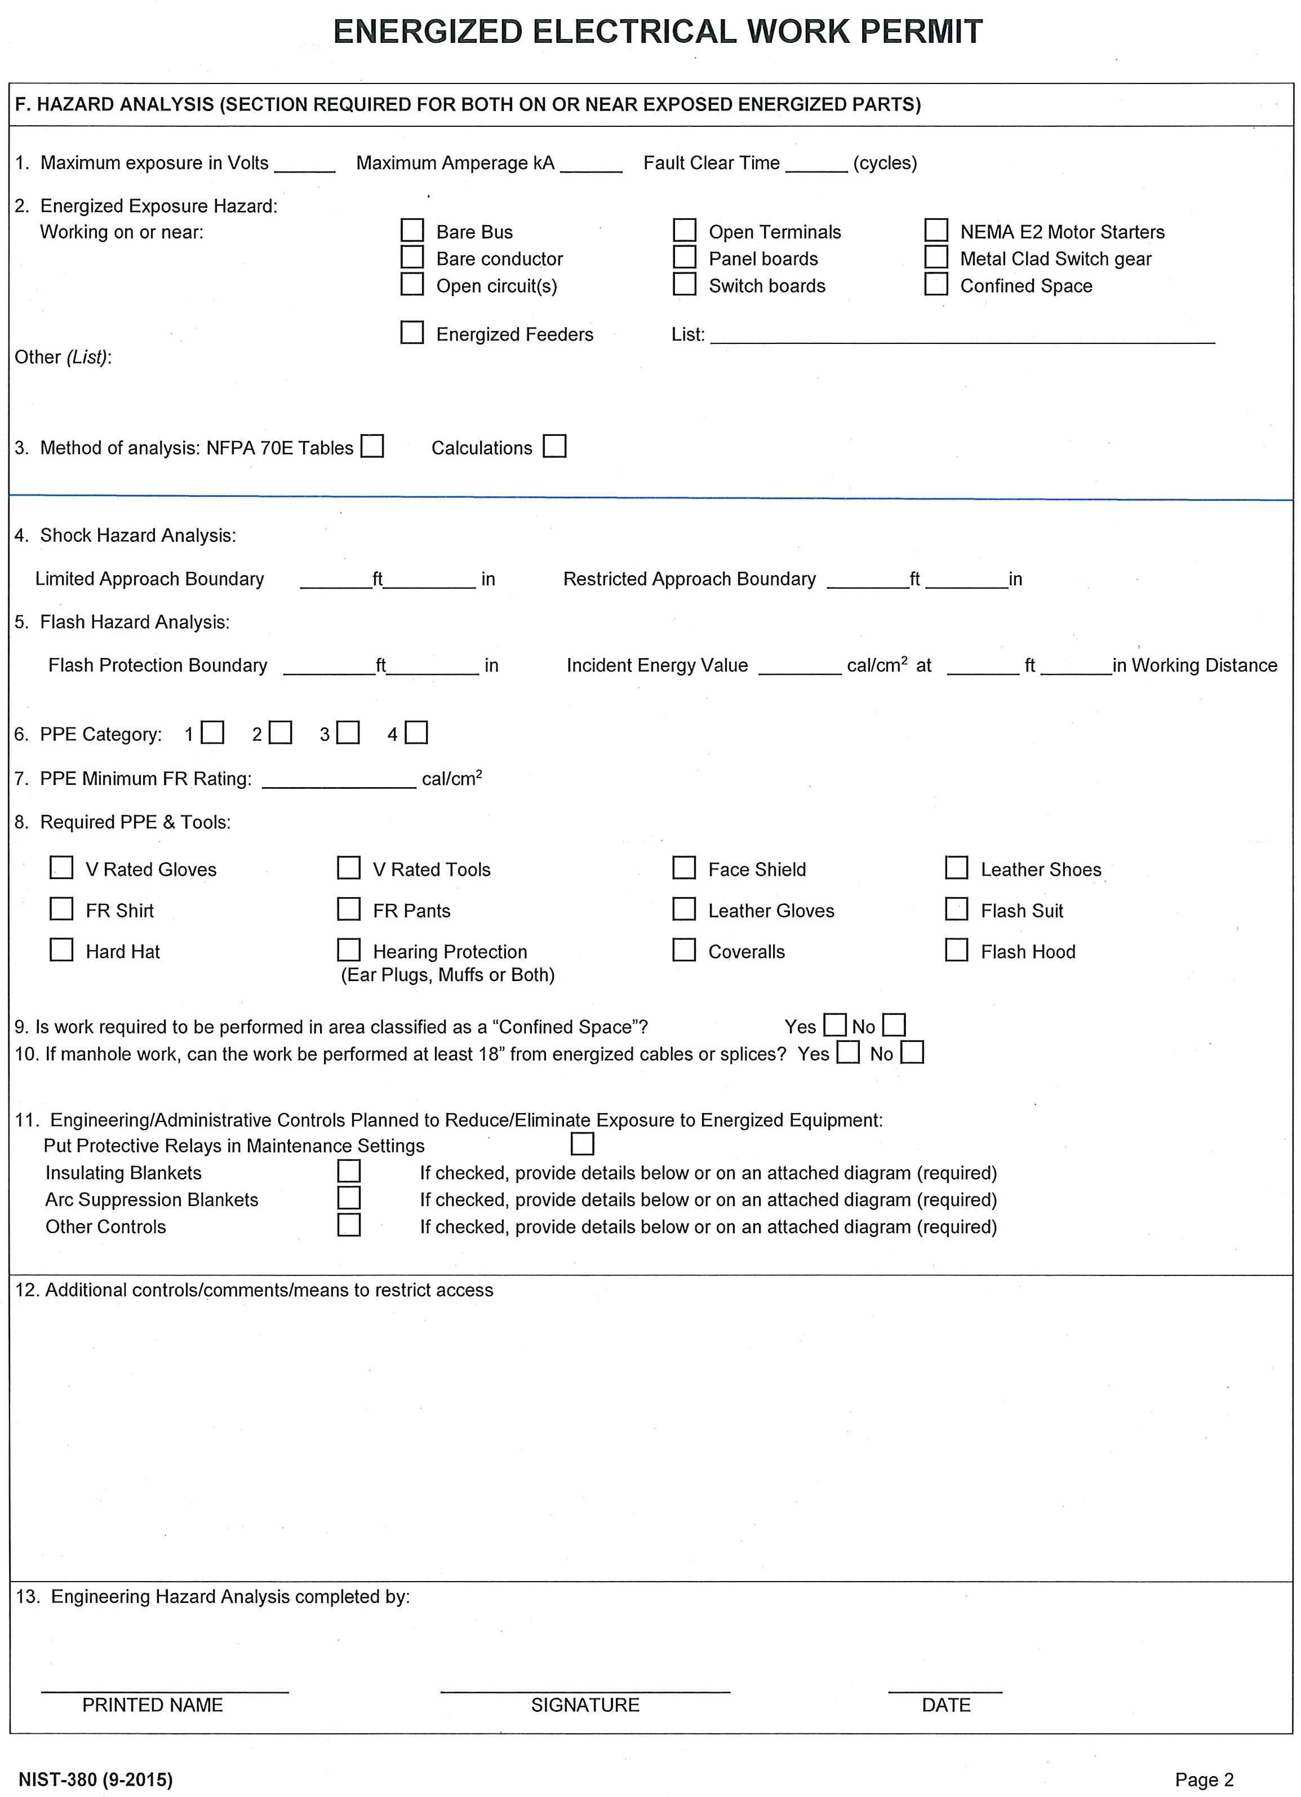
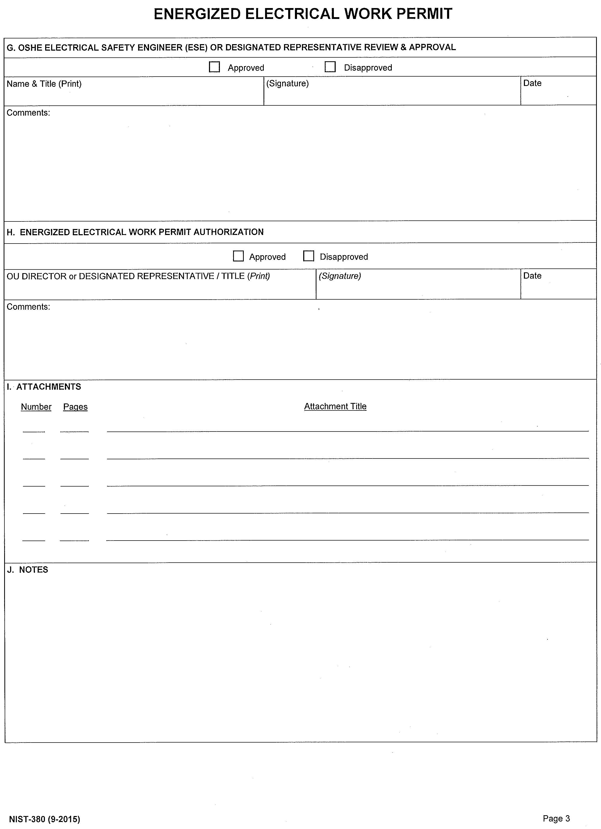
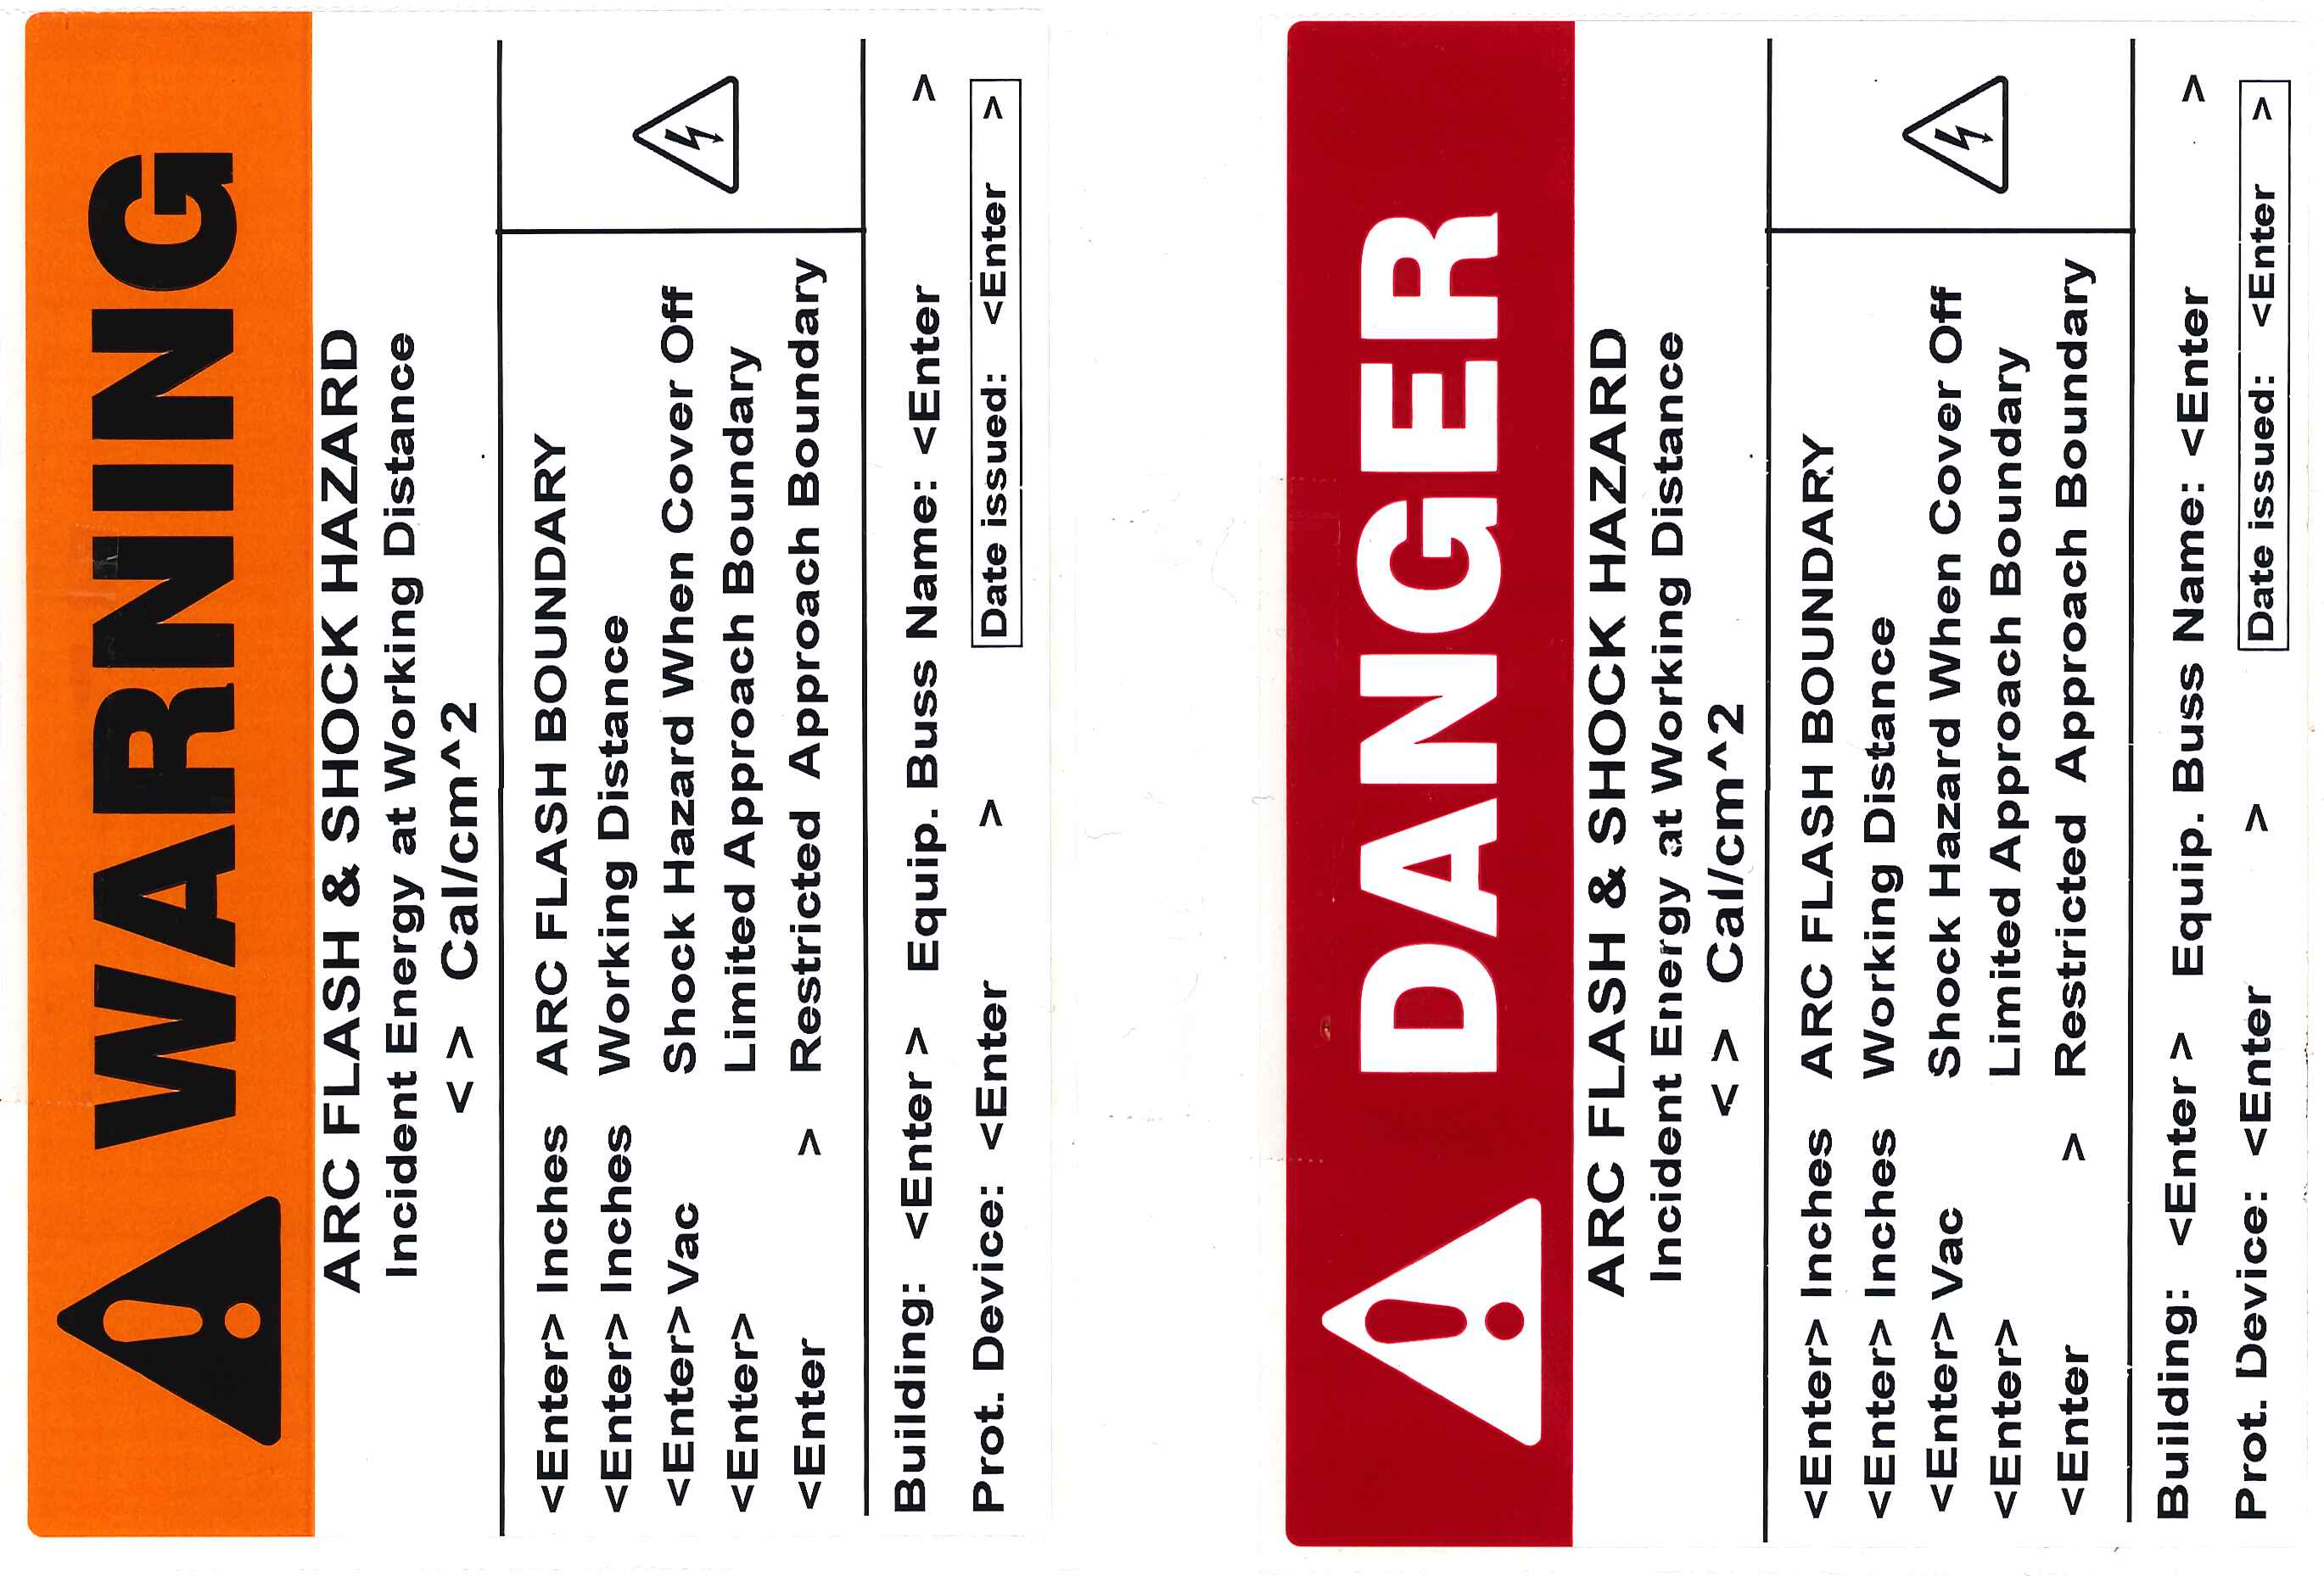

For example, as in the case of interruption of life-support systems or mission-critical equipment or research, deactivation of emergency alarm systems, and shutdown of hazardous location ventilation equipment.
For example, as in the case of diagnostics that can only be performed with the circuit energized, and work on circuits that form an integral part of a continuous process that would otherwise need to be shut down completely to allow work on one circuit or piece of equipment.
Exceptions may be possible for laboratory test equipment with built-in mechanisms designed to de-energize the output and control the electrical hazards associated with the normal use of the equipment. Contact the OSHE Electrical Safety Engineer for further information.
If the components, such as the capacitors, or associated equipment are handled in meeting this requirement, they shall be treated as energized.
Examples of additional safety measures include the removal of an isolating circuit element, blocking of a controlling switch, or opening of an extra disconnecting device.
These requirements do not apply to plugging equipment into, or unplugging equipment from, receptacles or to operating lights utilizing switch-rated devices.
The NIST-380A short form contains Sections A (in part), B, C, F, and G of the NIST-380 form. The hazard review must contain all applicable information required by the other sections of the NIST-380 form.
Electrical LOTO performed by outside service providers is addressed in NIST S 7101.56: Control of Hazardous Energy (Lockout/Tagout) [see Section 6b(1)].

