The Title Should be: Capitalized, Single Spaced, Times New Roman, Bold 14-point, and all the Text Should be Left Justified

First Author¹, Second Author^{2*} and Third Author³ (Times New Roman 12-pt left justified) Each name should have a superscript Arabic number to reference the author’s affiliation. A superscript asterisk after the affiliation number indicates the contact author. Use single line spacing. Leave one blank line between the title and author list, and one blank line after the authors’ names before the list of affiliations.

^{1.} Affiliation of the first author, including Department/Institution, City and Country. (12pt)
^{2.} Affiliation of the second author, including Department/Institution, City and Country. (12pt)
^{3.} Affiliation of the third author, including Department/Institution, City and Country. (12pt) Leave one blank line after authors’ affiliations.
* Corresponding author: SAuthor@prydonian.edu

The paper should be a condensed version of your presentation and include all significant findings. Write the text so that readers who are not specialists can appreciate the purpose of the study and understand the procedures and conclusions. The text, entirely written in English, should include a brief introduction and motivation of the study, including experimental procedures, main results, and conclusions. It is not necessary to divide the text into sub-sections, except for the References section.

Capitalize all major words in your title as shown in the example above (nouns, pronouns, verbs, adjectives, adverbs, and some conjunctions). Use lowercase for articles: the, a, and an; for the following conjunctions: and, but, for, or, and nor; for the part of a proper name that would be lowercased in the text, such as de or von; and for the second part of a species name, such as fulvescens in Acipenser fulvescens, even if it is the last word in a title or subtitle.

Your paper must be submitted as Adobe PDF format with NO document security and with the .pdf file name extension, AND as an editable word processing file (preferably Microsoft Word) in .doc or .docx formats. The PDF of the paper MUST have fonts and images embedded. Use a 12-point Times New Roman typeface and single spacing between lines. Use italics for taxonomic terms. Avoid individualized formatting and special typefaces. Document margins should be one inch (25.4 mm) top and bottom and 0.75 inches (19.1 mm) left and right. Papers must be two pages long and conform to these layout requirements; those with fewer pages will be rejected. Page 1 should contain text only, using fully justified formatting with no figures. Skip a line before each new paragraph, but do not indent paragraphs.

Page 2 may contain figures, figure captions, and tables in addition to text. Include figure labels and scale markers on all figures. Captions should be placed below all figures and tables. Artwork and tables must be electronically inserted into the document. Color figures may be used and will be reproduced in any electronic proceedings distributed. If printed, paper copies will be in grayscale, so ensure that color coding used for legends is distinguishable in grayscale. Line art must be created either in drawing software or scanned into a suitable format for importing into the document. Check that the line widths and font sizes allow the figure to be clear at its final size.

References should be included at the end of the text, on page 2, with the appropriate reference styles for conference proceedings [1], journal articles [2], book sections [3], online documents [4], and websites [5]. Indicate references in the text with Arabic numbers in square brackets, preferably at the end of the sentence, before the period. For four or more authors, use the first-named author followed by “et al.”. Acknowledgments should be included as the last reference and cited at the end of the last sentence of the text.

All submissions are reviewed by the Program Committee according to the following criteria: (a) relevance to the workshop, (b) content and quality of the text, (c) clarity of the text, and (d) compliance with the format. Papers not meeting these criteria will not be accepted.

All accepted papers must be presented by a meeting registrant. If the registrant cannot attend due to unforeseen circumstances, an alternate presenter should be arranged by the submitter.

References: (Times New Roman, 12-pt, left justified)

[1] F Author et al., Conference Proceedings (year) p. 1.
[2] F Author, S Author and TH Author, Journal volume (year), p. 1.
[3] F Author in “Introduction to abstract writing”, ed. D Writers, (Publisher, City) p.1.
[4] F Author and S Author, Journal [Online] volume, Article number (year), http://www.website.com (accessed Month Day, Year).
[5] Title of website, http://www.examplewebsite.com (accessed Month Day, Year).
[6] The authors acknowledge funding from the Great Academy, N-File Department. Dr. Smith is thanked for her many useful discussions and contributions to this work.
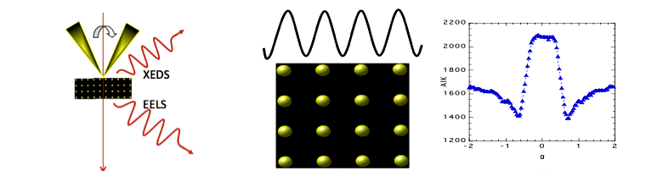
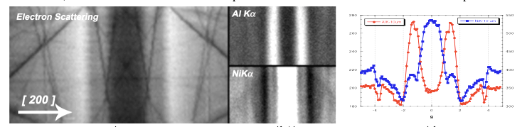
Figure 1. Times New Roman, 12pt. Provide a short description of the figure, including labels and scale markers as appropriate.
Figure 2. Times New Roman 12pt. Provide a short description of the figure, including labels and scale markers as appropriate.

