**OSAC 2025-N-0003  
Standard Terminology for Shooting Reconstruction**

Crime Scene Investigation & Reconstruction Subcommittee

Scene Examination Scientific Area Committee (SAC)

Organization of Scientific Area Committees (OSAC) for Forensic Science



**OSAC Proposed Standard**

**DRAFT OSAC 2025-N-0003  
Standard Terminology for Shooting Reconstruction**

Prepared by

Crime Scene Investigation & Reconstruction Subcommittee  
Version: 1.0

October 2024

**Disclaimer:**

This OSAC Proposed Standard was written by the Crime Scene Investigation & Reconstruction Subcommittee of the Organization of Scientific Area Committees (OSAC) for Forensic Science following a process that includes an [open comment period](https://www.nist.gov/topics/organization-scientific-area-committees-forensic-science/registry-approval-process). This Proposed Standard will be submitted to a standard developing organization and issubject to change.

There may be references in an OSAC Proposed Standard to other publications under development by OSAC. The information in the Proposed Standard, and underlying concepts and methodologies, may be used by the forensic-science community before the completion of such companion publications.

Any identification of commercial equipment, instruments, or materials in the Proposed Standard is not a recommendation or endorsement by the U.S. Government and does not imply that the equipment, instruments, or materials are necessarily the best available for the purpose.

**Foreword**

This document was developed to provide recommended terminology for shooting reconstruction. These terms address basic shooting reconstruction and related concepts.

This document should be utilized in conjunction with local regulations and any requirements set forth by entities examining collected evidence to inform or augment policies relating to collecting and preserving physical evidence.

This document has been drafted by the Crime Scene Investigation and Reconstruction Subcommittee of the Organization of Scientific Area Committees (OSAC) for Forensic Science through a consensus process.

All hyperlinks and web addresses shown in this document are current as of the publication date of this standard.

**Keywords:** *crime scene investigation, crime scene reconstruction, shooting reconstruction*

**Table of Contents**

1 Scope 5

2 Normative References 5

3 Terms and Definitions 5

Appendix A 17

Appendix B 18

**Standard Terminology for Shooting Reconstruction**

# Scope

This document provides a list of recommended terminology to be used in published manuscripts, forensic reports discussing the conclusions of scientific examination of shooting scenes, in courtroom testimony, and when teaching shooting reconstruction. The target audience of this document includes crime scene reconstructionists, crime scene investigators, forensic scientists, investigators, attorneys, judges, and researchers.

# Normative References

No normative references.

# Terms and Definitions

For purposes of this document, the following definitions and acronyms apply.

NOTE:  In a situation that involves a potentially criminal act, the definition in 3.70 would be preceded by "crime" (e.g., crime scene reconstruction).

**accidental discharge**

The inadvertent discharge of a firearm as a result of a mechanical failure on the part of the firearm. (AFTE Glossary 6th Ed, Version 6.091922, modified)

**ammunition**

Unfired cartridge(s) designed to be discharged in a firearm. (OSAC 2021-N-0019)

**angle of deflection**

The angle formed between the path of the departing [projectile](https://afte.org/members/databases/glossary?t=projectile) subsequent to an impact and the pre-impact path of the projectile’s flight. (AFTE Glossary 6th Ed, Version 6.091922) (Figure 1)

**angle of incidence**

The angle formed between the nominal path of a projectile and the plane of the target. (AFTE Glossary 6th Ed, Version 6.091922, modified) (Figures 1 and 2)

**angle of ricochet**

The angle defined by the path taken by the ricocheted projectile as it departs the impacted surface. (AFTE Glossary 6th Ed, Version 6.091922, modified) (Figure 2)

**azimuth angle**

See *horizontal angle*.

**ballistics**

The science of projectiles in motion. Usually divided into three parts:

**exterior ballistics**

The branch of ballistics that studies a projectile's flight in air.

**interior ballistics**

The branch of ballistics that studies a projectile's initial acceleration and performance in the weapon and the related processes.

**terminal ballistics**

The branch of ballistics that studies the effect of a projectile’s impact with the target.

**backscatter**

A debris pattern resulting from target material ejected in the opposite direction of the projectile’s motion.

**backspatter pattern**

A bloodstain pattern resulting from blood drops which can be produced when a projectile creates an entrance wound. (ASB Technical Report 033, First Edition 2017, Terms and Definitions in Bloodstain Pattern Analysis)

**bow effect**

For crescent cracking around a low-angle projectile impact.

**bullet**

A non-spherical projectile designed specifically to be fired from a rifled firearm. (AFTE Glossary 6th Ed, Version 6.091922, modified)

**bullet core**

The inner portion of a jacketed bullet, often made of lead. (AFTE Glossary 6th Ed, Version 6.091922, modified)

**bullet drift**

The lateral deviation in a bullet’s flight through the atmosphere due to rotational effects. (AFTE Glossary 6th Ed, Version 6.091922 modified)

**bullet drop**

The vertical distance a bullet has fallen, under the influence of gravity, at any point in its flight path. The distance is measured from a point on its path to the straight line from the axis of the bore to target. (AFTE Glossary 6th Ed, Version 6.091922)

**bullet jacket**

The outer covering enclosing the core of a projectile that is typically of metallic construction. (AFTE Glossary 6th Ed, Version 6.091922, modified)

**bullet path**

The arched path of a projectile from the muzzle to the target. (AFTE Glossary 6th Ed, Version 6.091922, modified)

**bullet splash**

A deposit of pulverized or particulate bullet material observed adjacent to a projectile impact. Bullet splash can be useful in establishing the downrange side of a projectile impact. Also known as lead splash.

**bullet wipe**

The discolored area caused by a physical transfer from the surface of a projectile to a target on the immediate periphery of a projectile entrance.

**bullet yaw**

The angle between the longitudinal axis of a projectile and the line of the projectile’s trajectory. (AFTE Glossary 6th Ed, Version 6.091922, modified) (Figure 3)

**caliber**

The nominal diameter of a projectile, the nominal inner diameter of a barrel, or a term also used to designate the specific cartridge(s) for which a firearm is chambered. (OSAC 2021-N-0019)

**cartridge**

A single unit of ammunition consisting of the case, primer, and propellant with one or more projectile(s). Also applies to a shotshell. (AFTE Glossary 6th Ed, Version 6.091922, modified)

**cartridge case**

The fired or unfired component of metallic ammunition, the purpose of which is to hold the primer, propellant, and projectile.

NOTE: the terms *casing, shell,* and *brass*areoften used incorrectly for the term cartridge case.

**chamber**

The rear part of the barrel bore that has been formed to accept a specific cartridge or shotshell. In a revolver, the holes in the cylinder represent multiple chambers. (AFTE Glossary 6th Ed, Version 6.091922, modified)

**chisum trail**

An elongated transference of bullet metal at the departure end of a ricochet mark on smooth, flat, unyielding surfaces that indicates the twist direction of the firearm rifling. (AFTE Glossary 6th Ed, Version 6.091922, modified) (Figure 4)

NOTE: Left-side elongation indicates left twist origin and right-side elongation indicates right twist origin.

**choke**

An interior constriction at or near the muzzle end of a shotgun barrel bore for the purpose of controlling shot dispersion. (AFTE Glossary 6th Ed, Version 6.091922)

**concentric fractures**

Cracks in brittle materials (e.g., ceramic, glass, bone) that take a generally circular form around an impact site. (Figure 7)

**cone fracture**

The characteristic cone shape on the exit side of a projectile impact through a relatively brittle medium (e.g., ceramic, glass, bone) caused by spalling around the exit. Also known as a Hertzian cone or beveling. (AFTE Glossary 6th Ed, Version 6.091922, modified) (Figures 5 and 6)

**critical angle**

The angle of incidence at which a projectile transitions from perforation/penetration to ricochet.

NOTE: Dependent on bullet type, target material, and velocity.

**defect**

A generic term for any surface damage. (OSAC 2021-N-0019)

**deflection**

A change in the nominal path of a projectile due to an impact.

**dicing**

The breaking of tempered glass into small pieces as opposed to large shards.

**directionality**

The property of a trajectory that describes which way a projectile was traveling. (OSAC 2021-N-0019)

**distance determination**

The process of determining how far away the muzzle of a firearm was from a target at the time a shot was fired, based on one or more methods such as gunshot residue patterns and pellet or buffer patterns. (OSAC 2021-N-0019)

**downrange**

Any location forward of the plane of the muzzle of a firearm.

**drop-off distance**

The distance at which a firearm-ammunition combination will no longer leave detectable gunshot residues on a target.

**ejection pattern**

The spatial relationship between a semi-automatic firearm and ejected cartridge cases or shotshells from that firearm.

**ejecta**

Target material that was expelled as the result of an impact.

**elevation angle**

See *vertical angle*.

**firearm**

Any weapon designed to expel a projectile with the energy generated by combustion. (OSAC 2021-N-0019)

**forward spatter**

A bloodstain pattern resulting from blood drops which can be produced when a projectile creates an exit wound. (ASB Technical Report 033, First Edition 2017 Terms and Definitions in Bloodstain Pattern Analysis)

* 1. **gauge (shotguns)**

A term used in the identification of the internal diameter of a shotgun bore. (AFTE Glossary 6th Ed, Version 6.091922, modified)

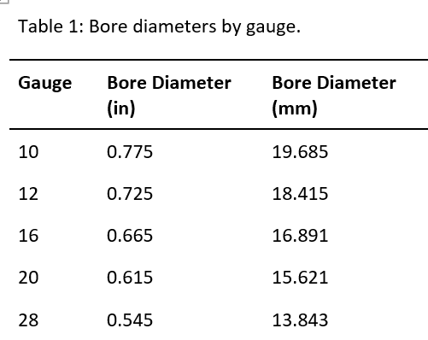NOTE: Table 1 shows the bore diameters in inches and millimeters for common shotgun gauges.

**gunshot residue**

**GSR**

The total of all residues resulting from the discharge of a firearm. (OSAC 2022-S-0036)

NOTE: Examination of GSR can include chemical analysis to identify the presence of GSR or interpretation of GSR patterns to determine the location or position of a firearm at the time of discharge.

**gunshot residue pattern**

The form, density, and spatial distribution of combustion products deposited on a surface from the discharge of a firearm.

**horizontal angle**

The angle in a horizontal plane typically between the path of a bullet and an object that was struck, also known as *azimuth angle*. (OSAC 2021-N-0019)

**keyhole**

A projectile impact that retains the general profile of a bullet that was destabilized and impacted the target surface at a canted angle.

**laminated glass**

Layers of glass bonded to a plastic/polymer material commonly seen in automobile glass. May also be referred to as safety glass. (AFTE Glossary 6th Ed, Version 6.091922, modified)

**lead-in mark**

A visible, thin, elongated deposition of bullet wipe transferred to a surface as a bullet first makes contact with that surface at a shallow angle of incidence. (AFTE Glossary 6th Ed, Version 6.091922, modified)

NOTE: The lead-in mark is useful in establishing the entrance side of the projectile impact.

**misfire**

A failure of a cartridge to discharge after an adequate primer impact by a firing pin.

**muzzle**

The end of a firearm barrel from which the projectile(s) emerges. (AFTE Glossary 6th Ed, Version 6.091922, modified)

**non-penetrating impact**

Projectile damage where the projectile strikes but does not penetrate a target. (OSAC 2021-N-0019)

**orthogonal**

Perpendicular or forming a right angle.

**pellet pattern**

The distribution of shot pellets fired from a firearm that may be used to estimate the muzzle-to-target distance. (OSAC 2021-N-0019, modified)

**penetrating impact**

Projectile damage where the projectile entered and did not exit a target. (OSAC 2021-N-0019)

**perforating impact**

Projectile damage where the projectile entered and exited a target. (OSAC 2021-N-0019)

**pinch point**

A small area of surviving paint that is located at the initial contact point of an angled projectile impact on a painted surface.

NOTE: The pinch point is useful in establishing the entrance side of the projectile impact.

**point of aim**

The exact point on which the firearm’s sights are aligned. (SAAMI Glossary, modified)

**point of impact**

The point at which a bullet hits a target. (SAAMI Glossary)

**powder stippling**

(1) Small hemorrhagic lesions on the skin produced by non-embedded gunpowder particles.

(2) On inanimate objects, it is the creation of small pits or defects caused by the impact of unburned and partially burned gunpowder particles. AFTE Glossary 6th Ed, Version 6.091922, modified)

**powder tattooing**

The embedded, unburned and partially burned gunpowder particles in the skin or other tissue with accompanying hemorrhagic lesions associated with living tissue. (AFTE Glossary 6th Ed, Version 6.091922, modified)

**primer gunshot residue**

**pGSR**

A subcategory of gunshot residue considering only chemicals generated from the priming mixture. Typically composed of very small particles containing lead, barium, and antimony, and detected using scanning electron microscopy. (OSAC 2021-N-0019)

**projectile**

An object propelled with an initial velocity then acted upon by gravity, air drag, and other outside forces. (OSAC 2021-N-0019)

NOTE: A projectile can be complete, fragmented, or other ejected material.

**projectile fragment**

Any portion of a projectile that retains characteristics permitting it to be identified as having been part of a projectile. (OSAC 2021-N-0019)

**projectile impact**,*noun*

Damage determined to have been caused by a projectile. (OSAC 2021-N-0019)

**pseudostippling**

Small hemorrhagic lesions on the skin produced by the impact of ejecta (e.g., fine fragments of glass or other brittle materials).

**radial fractures**

Cracks in brittle materials (e.g., ceramic, glass, bone) that extend outward from an impact site. (Figure 7)

**range**

The distance from a firearm to the initial projectile impact. (OSAC 2021-N-0019)

**ricochet**

A surface deflection of a projectile without penetration or perforation of the target. (Figure 2)

**rifling**, *noun*

Spiral features inside the barrel that impart spin on the projectile for the purpose of stabilizing it in flight. The raised portions of the rifling are known as lands and the recessed portions are known as grooves.

**secondary projectile**

Any object propelled by the energy imparted by the impact of a projectile.

**scene reconstruction**

The utilization of information gathered from the investigative process to develop or eliminate possible explanations for how an incident occurred. (ANSI/ASB Standard 159)

**shooting reconstruction**

A scene reconstruction focused on the discharge of a firearm(s).

**shot**, *noun*

Generally spherical projectiles used in loading shotshells. Commonly formed from lead but may be made from steel or other material. (SAAMI Glossary, modified)

**shot cartridge**

A centerfire or rimfire cartridge loaded with small diameter shot. (SAAMI Glossary)

**shotgun**

A long gun designed to shoot from the shoulder, typically having a smooth bore and designed to fire shotshells. (AFTE Glossary 6th Ed, Version 6.091922)

NOTE: Some firearms (not considered shotguns), including derringers, revolvers, and other designs, can sometimes accommodate shotshells.

**shot pattern**

The distribution of multiple projectile impacts from a fired shotshell.

**shotshell**

A unit of ammunition that may contain a single projectile or multiple projectiles/pellets. Generally, shotshells are designed to be fired from shotguns. (AFTE Glossary 6th Ed, Version 6.091922)

**slug**

A single projectile fired from a shotgun. (SAAMI Glossary, modified)

NOTE: The term slug isoften used incorrectly for a fired bullet.

**spall**

Chipped or fragmented material as a result of projectile impact in brittle or frangible materials. (AFTE Glossary 6th Ed, Version 6.091922, modified)

**stippling**

See *powder stippling*

**target**, *noun*

Any object struck by a projectile, regardless of whether it was struck intentionally. (OSAC 2021-N-0019)

**trajectory**

The arched path that a projectile follows in flight, typically modeled as a straight line for short-range paths. (OSAC 2021-N-0019)

**trajectory analysis**

The determination of a projectile's flight path. (OSAC 2021-N-0019)

**twist**

The direction of turn of the rifling helix, such as left hand or right-hand twist. (AFTE Glossary 6th Ed, Version 6.091922)

**uprange**

Any location behind the plane of the muzzle of a firearm.

**unintentional discharge**

The inadvertent discharge of a firearm in the absence of a mechanical malfunction of the firearm.

**vertical angle**

The angle in a vertical plane typically between the path of a bullet and level, also known as *elevation angle*. (OSAC 2021-N-0019)

**wad**

A felt, paper, cardboard, or plastic component used in a shotshell for various purposes. (AFTE Glossary 6th Ed, Version 6.091922, modified)

**wound ballistics**

A subset of terminal ballistics that considers projectile impacts to tissue and tissue simulants. (OSAC 2021-N-0019)

## Appendix A

(informative)

**Bibliography**

1. [1] AFTE Glossary 6th Ed, Version 6.091922, <https://afte.org/resources/afte-glossary>
2. [2] Sporting Arms and Ammunition Manufacturers’ Institute (SAAMI), https://saami.org/saami-glossary/

## Appendix B

**FIGURES**

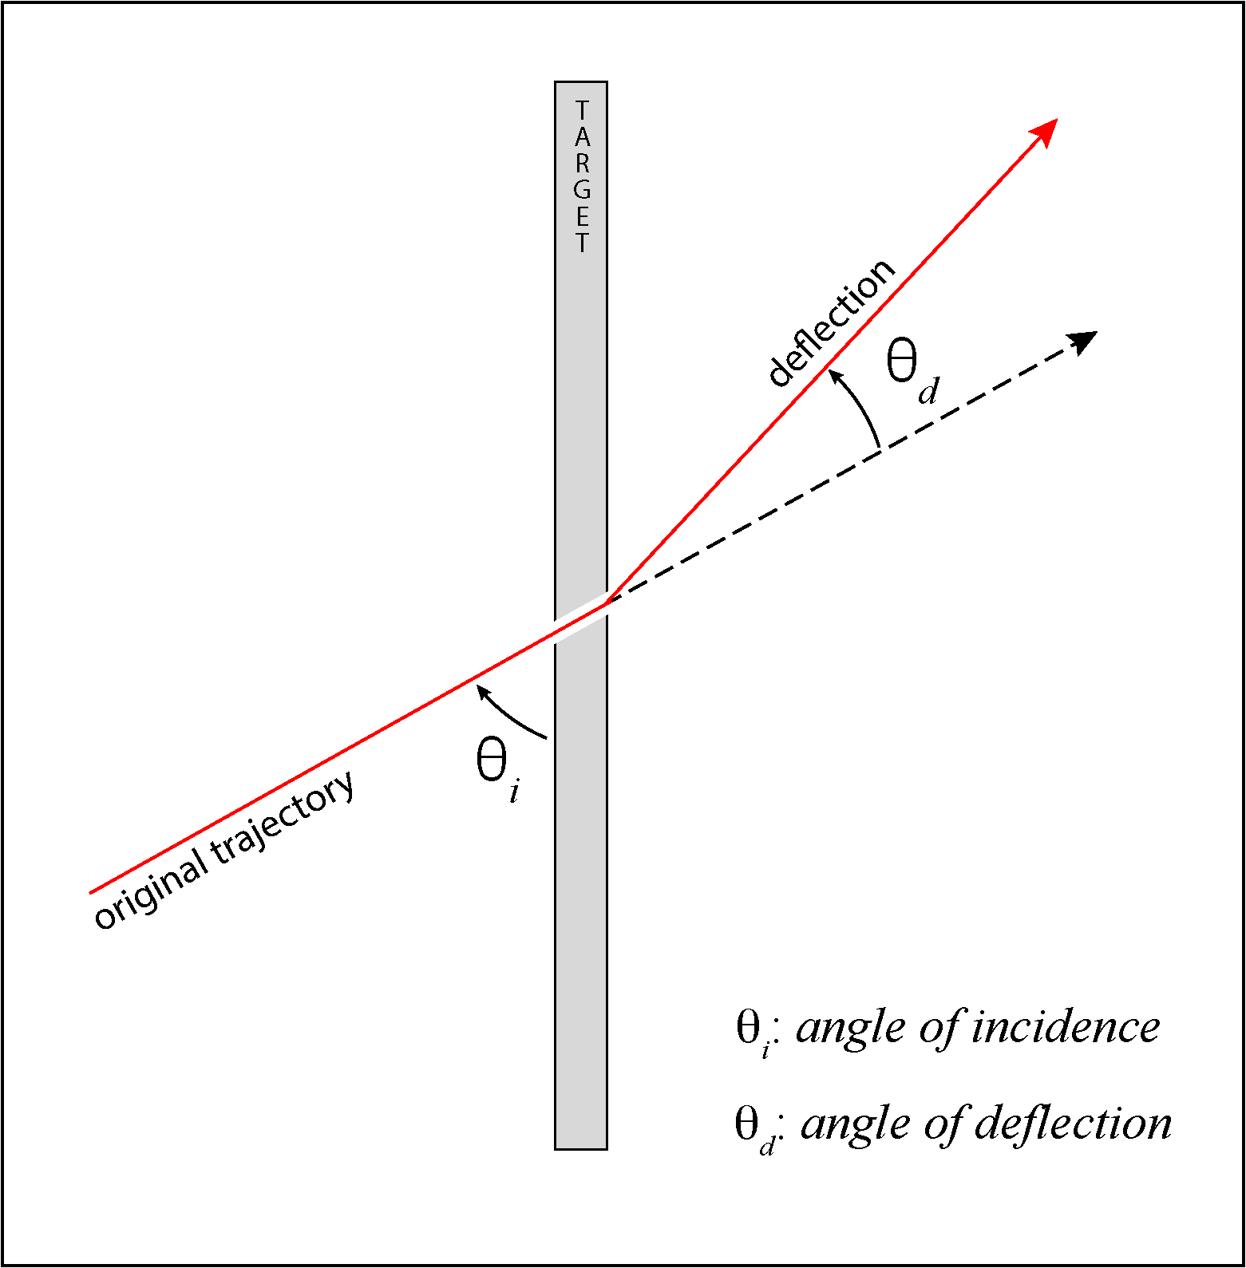

**Figure 1:** A projectile perforation that shows the original trajectory which forms the *angle of incidence* (3.4) with the target surface and the deflected path of the projectile that forms the *angle of deflection* (3.3) with the unaltered path (dashed line).

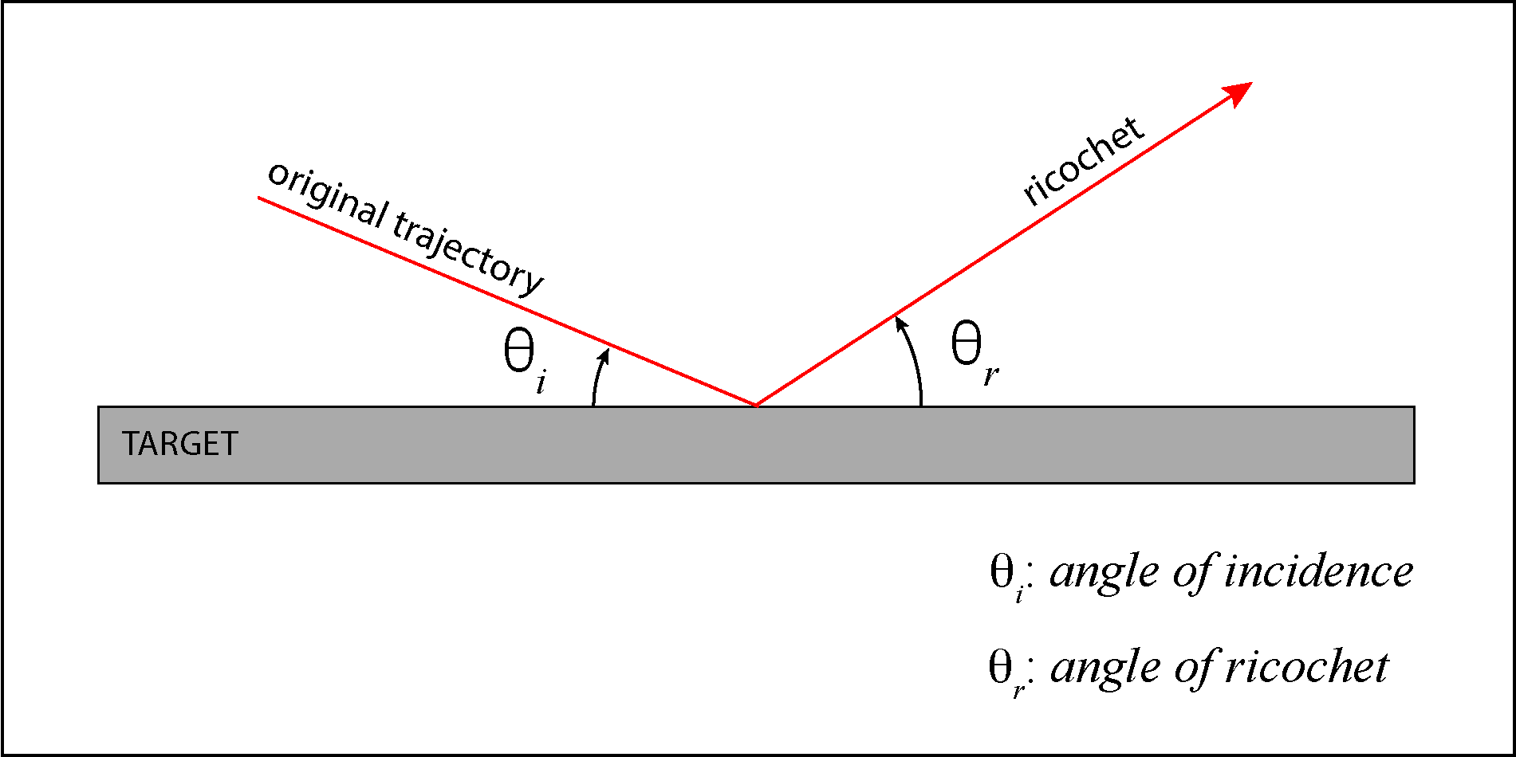

**Figure 2:** A projectile ricochet that shows the original trajectory which forms the *angle of incidence* (3.4) with the target surface and the deflected path of the *ricochet* (3.xx) that forms the *angle of ricochet* (3.5) with the target surface.

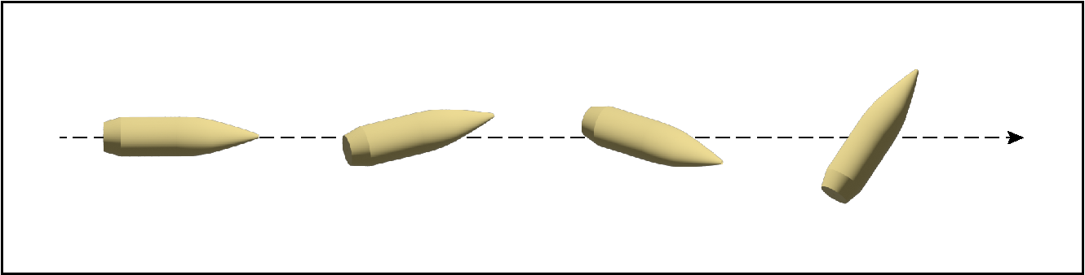

**Figure 3:** Depiction of *bullet yaw* (3.19). From left to right, the bullet starts in stable flight then yaw becomes increasingly more pronounced.

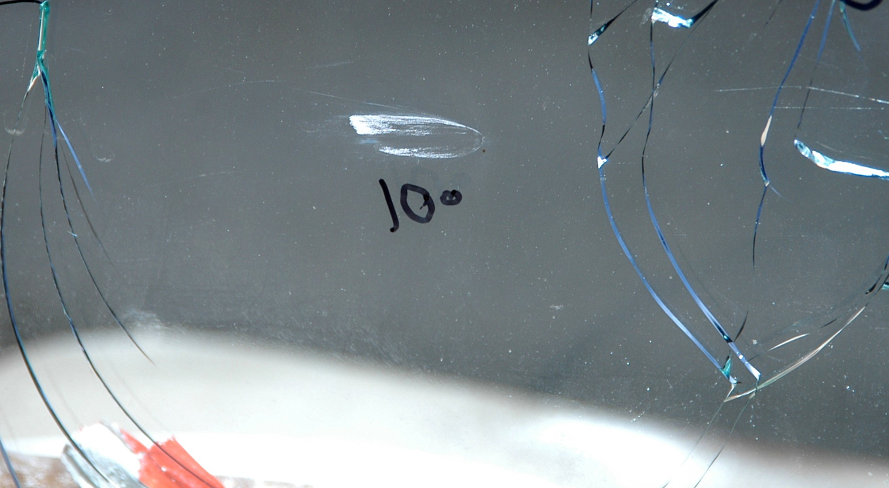

**Figure 4:** A *Chisum trail* (3.24) on glass traveling from right to left. The elongation on the top of the mark indicates a bullet with a right-hand spin.

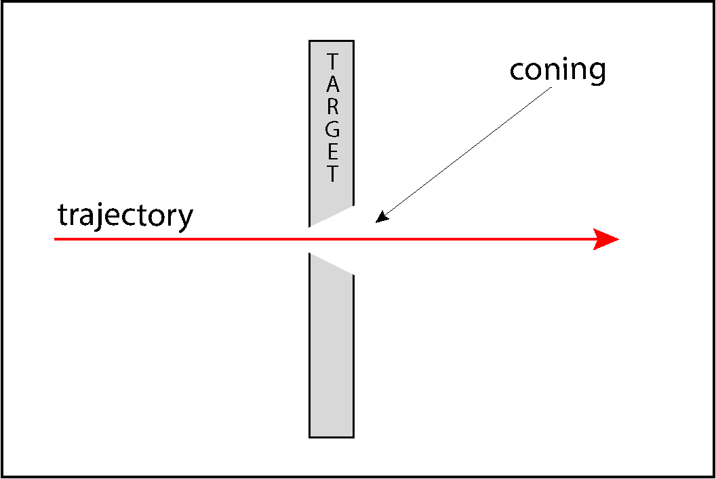

**Figure 5:** A cross-section of a projectile perforation through a brittle material that shows the orientation of the *cone* (3.27) with the larger diameter side on the exit surface.

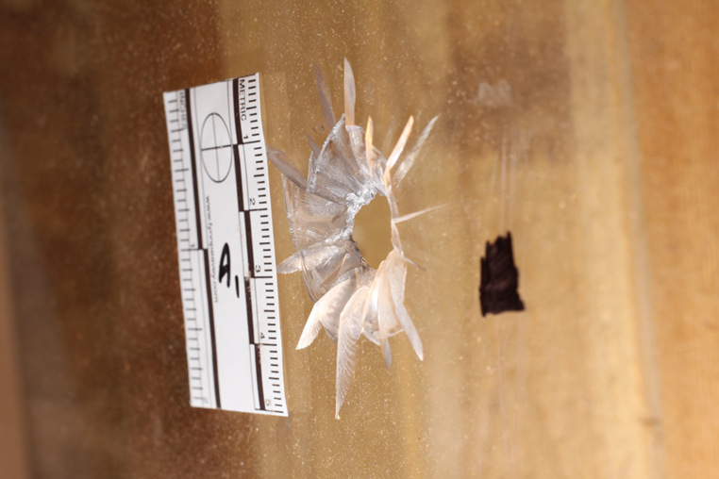

**Figure 6:** A projectile perforation through a brittle material (plexiglass) that shows the orientation of the *cone* (3.27) with the larger diameter side on the exit surface.

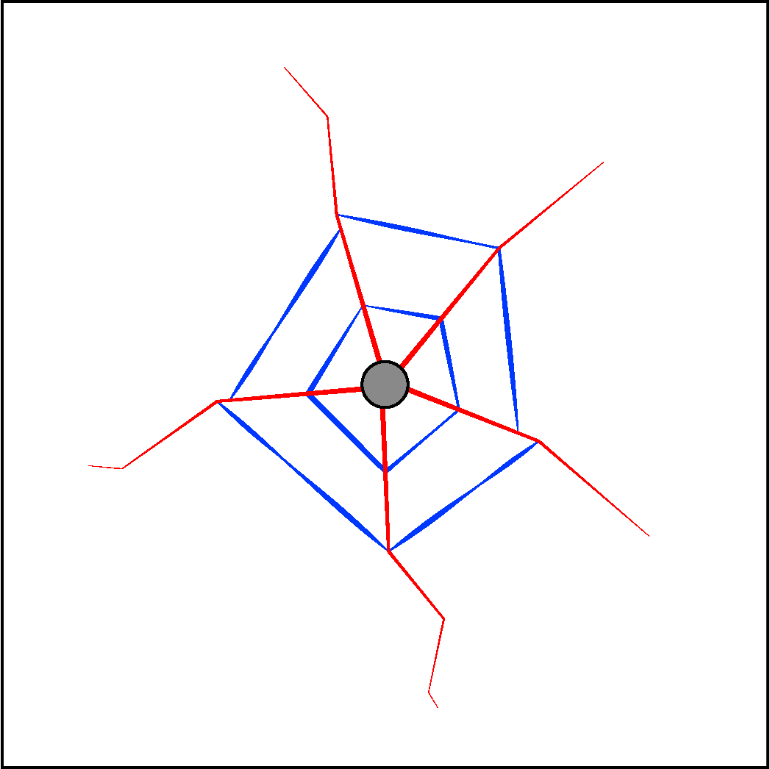

**Figure 7:** *Concentric fractures* (3.26) (shown in blue) are oriented in a generally circular form around the impact site. *Radial fractures* (3.65) (shown in red) that extend outward from the impact site.