Key Considerations for Microbial Viability Measurements
Joy P. Dunkers^{1*}, Sandra da Silva¹, Stephanie Servetas¹, James J. Filliben², Guilherme Pinheiro³ and Nancy J. Lin¹

^{1.} Biosystems and Biomaterials Division, National Institute of Standards and Technology, Gaithersburg, MD, US
^{2.} Statistical Engineering Division, NIST, Gaithersburg, MD, US
^{3.} Division of Metrology Applied to Life Sciences, National Institute of Metrology, Quality and Technology, Brazil
*Corresponding author: joy.dunkers@nist.gov

Making reliable measurements of antimicrobial killing efficacy requires careful consideration of the sources of biological variability, measurement bias and error throughout the entire workflow. For ultraviolet-C (UV-C) disinfection, killing efficacy is most commonly measured using plate counting where the log₁₀ reduction in colony forming units (CFUs) is calculated using the inoculum CFU count before and after UV-C exposure. Although CFU counting is not a rapid diagnostic, it is fit-for-purpose for testing UV-C sources and establishing room disinfection protocols. Best practices for minimizing biological and technical error in plate counting have been established [1]. Careful consideration of sources of variability during all experimental stages can help minimize error propagated to the final log₁₀ reduction value. Instrument calibration, sample preparation, counting and viability measurements performed at NIST provide insights that could further improve confidence in killing efficacy results.

Samples for UV-C killing efficacy testing are prepared using bacteria at a target concentration, which is measured using a spectrophotometer and converted to bacterial concentration using an OD₆₀₀ -bacteria concentration calibration curve. Characterization of spectrophotometer performance for linearity and offset against OD standards is an essential first step for accurate and comparable measurements. Figure 1 shows an example spectrophotometer calibration, where the linear operating range is only up to ≈ 0.9 OD, illustrating that high OD cultures should be diluted to the linear range for accurate measurement.

The OD-bacterial concentration calibration curve is typically based on CFU counts. The use of counting devices such as a Coulter (impedance) counter, flow cytometer or optical microscope can improve calibration reliability by providing an object count rather than a culturable cell count. These types of calibration curves must be collected for each strain and culture condition being studied, as the relationship between OD and concentration will vary. For instance, E. coli cultures diluted to the same cell concentration had very different OD readings when they were grown either in rich or in minimal media. Using alternate counting methods helps in understanding how well CFUs compare with maximum attainable count.

Microbe aggregation contributes to counting error, so disaggregation while maintaining viability can improve viable cell counts accuracy. In one approach, a focused ultrasonic instrument is used to break microbial aggregates into single cells to improve counting accuracy. A. naeslundii, an aggregated facultative anaerobe, is highly disaggregated after focused ultrasonic treatment optimization (Figure 2). Comparison of CFU count and Coulter counter count as a function of ultrasonic treatment time showed that an optimum treatment time can maximize viable counts of disaggregated A. naeslundii.

The accuracy and precision of CFU measurements is also dependent on microorganism size,
concentration and morphology (chain vs single). Comparison of CFUs to Coulter counter results has been performed using S. cerevisiae (spherical yeast), B. thuringiensis (spores), B. thailandenis (short rods), and S. mutans (chains). A 2 µm bead concentration standard was used for absolute count. Agreement between CFU and Coulter counter results varied by microorganism, although there was very good counting agreement between known bead concentration and Coulter counter results. B. thailandenis had lower precision for both CFU and Coulter counter compared to the other organisms. For S. mutans, plate counting had much lower precision than the Coulter counter. The addition of Coulter counter data aids in evaluating robustness in plate counting.

Orthogonal methods for viability provide independent results, albeit with different caveats. Orthogonal methods are not meant to be run regularly, but as a check on the primary method. A desirable orthogonal method to CFUs would allow for increased throughput and more robust statistics. Flow cytometry and automated optical microscopy are two high throughput methods that both rely on fluorescent probe intensity as a surrogate for viability. In selecting a fluorescent probe, the mechanism of cell death should be considered. For UV-C killing, DNA strand breakage and base rearrangement have been identified as the main killing mechanisms [2]. Membrane integrity fluorescent probes have been used as viability markers [3] but may not be suitable for testing UV-C killing efficacy. Loss of membrane potential may be considered independent of killing method, and membrane potential fluorophores as viability markers have been studied in bacteria [4] and yeast [5].

Robust measurement methods and technology innovation for cell count and viability are needed to improve confidence in plate counting as a measure of UV-C killing efficacy.
Official contribution of the National Institute of Standards and Technology; not subject to copyright in the United States.
References:
[1] ASTM International. D5465-93(2012) Standard Practice for Determining Microbial Colony Counts from Waters Analyzed by Plating Methods. West Conshohocken, PA; ASTM International, 2012.
[2] T D Cutler and J J Zimmerman, Animal Health Res Rev 12 (2011), p. 15.
[3] M Berney, F Hammes, F Bosshard, H-U Weilenmann, T Egli, Appl Environ Microb 73(10) (2007), p.3283.
[4] S Rezaeinejad and V Ivanov, Microb Res 166 (2011), p. 129-135.
[5] J Suchodolski and A Krasowska, Microorganisms 7 (2019), p. 110.
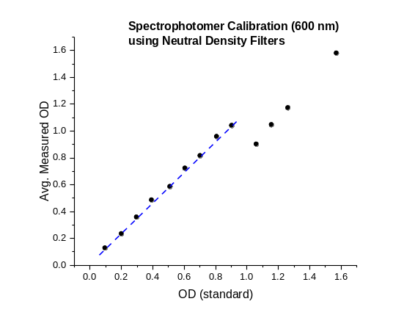
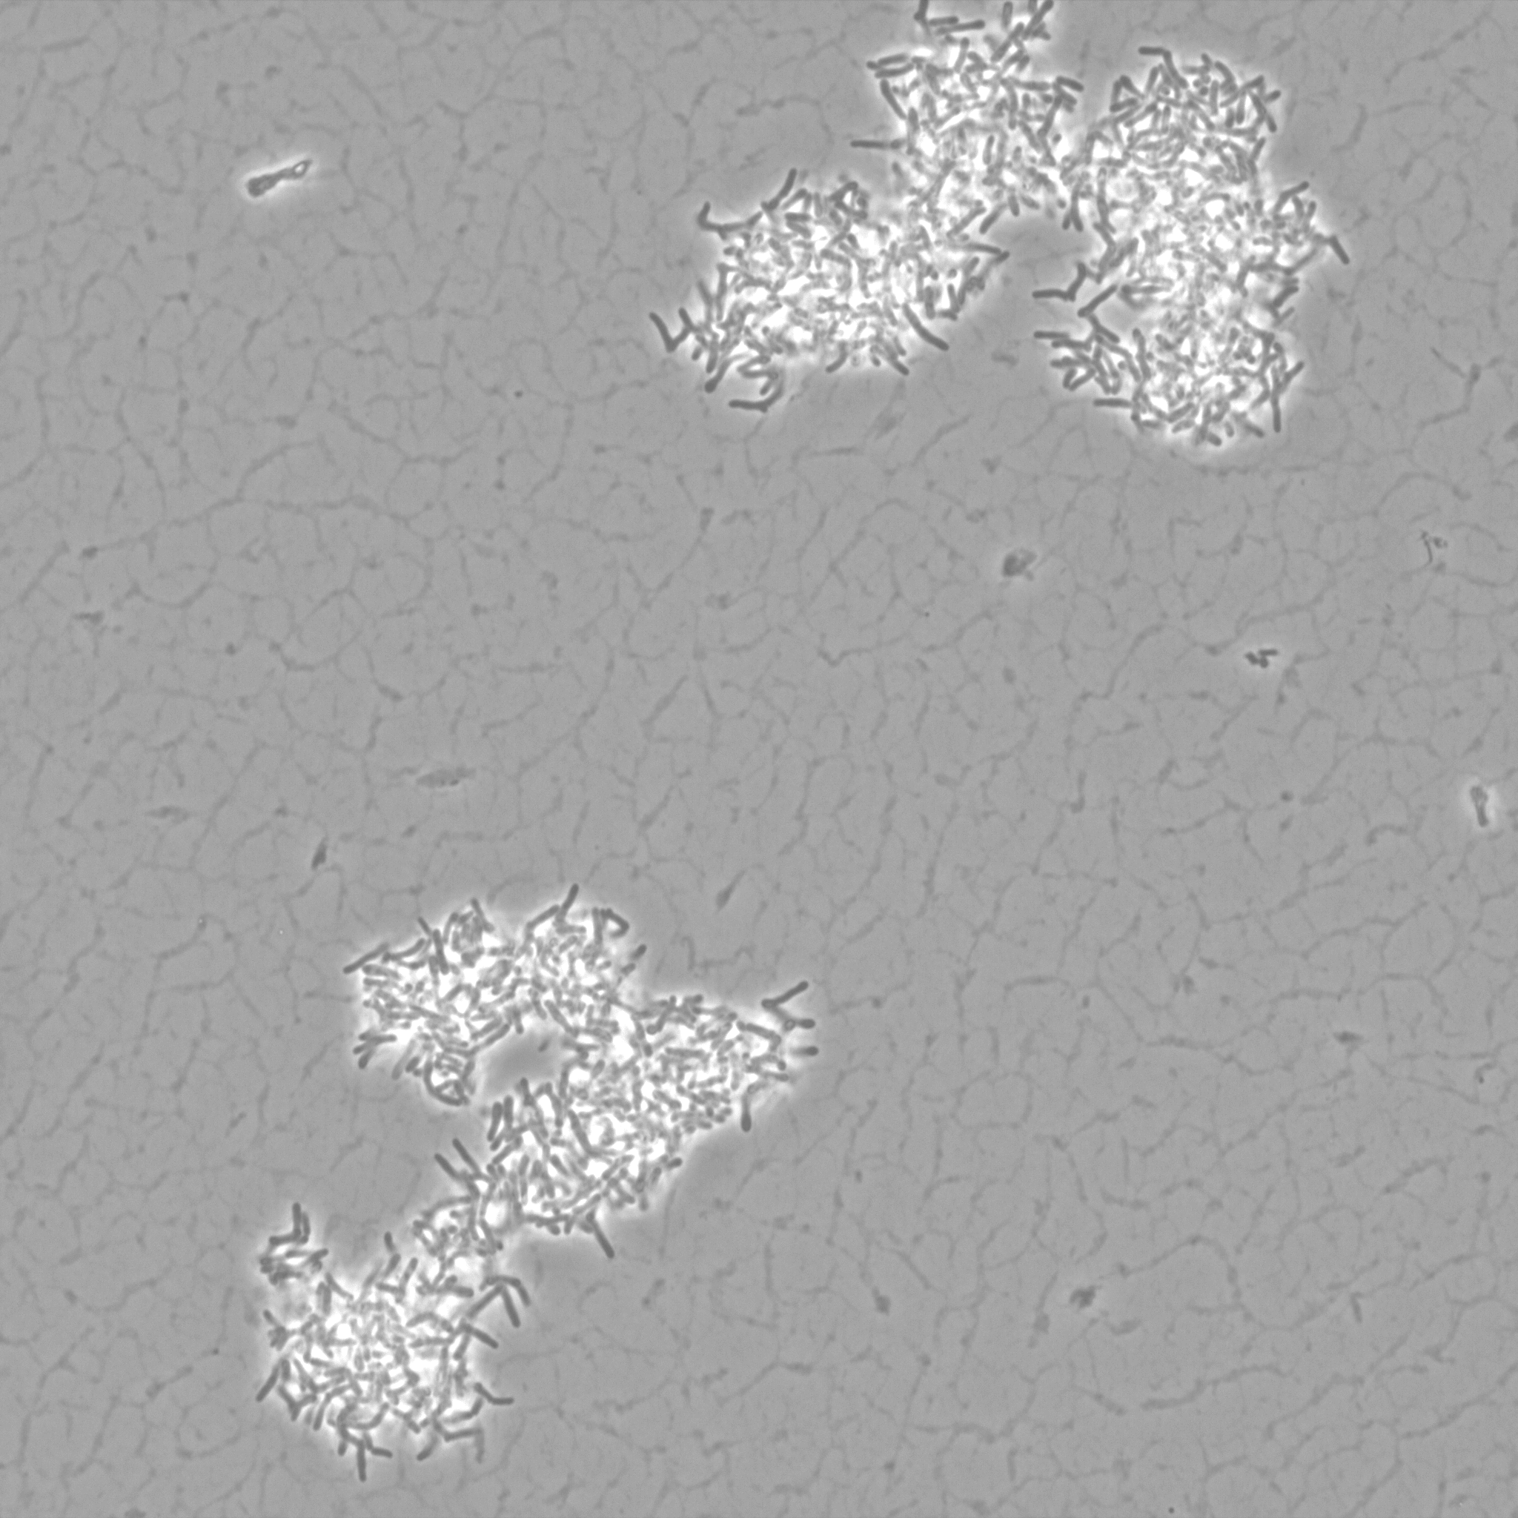
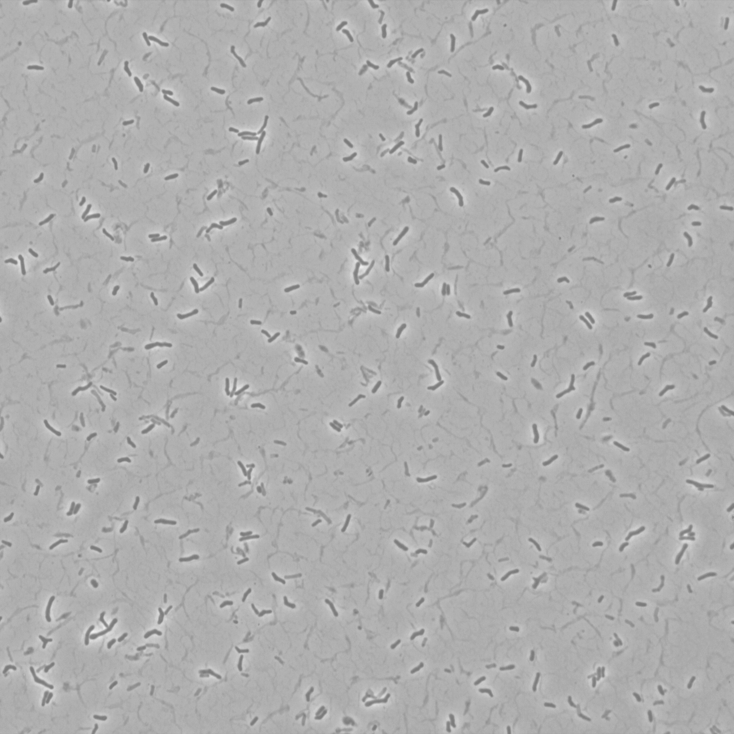
A.
B.

10 μm

Figure 2. A. naeslundii before (A) and after (B) focused ultrasonic treatment.

Figure 1:
Figure 1: Linear relationship between standard and measured OD only extends to 0.9 OD.

