IROS 2021 Robotic Grasping and Manipulation Competition: Manufacturing Track - Task Rules

Background

We are entering a new manufacturing era where more and more small and medium sized enterprises (SMEs) are looking to implement robotic solutions into their production operations. SMEs represent most manufacturers worldwide and they produce in batches with product variation from batch to batch, often called high-mix, low-volume production. To support production in such an environment where robot expertise is often limited, and cost is always a factor, robot systems must be easy to deploy and reconfigure with minimal retooling.

Assembly is one of the most difficult operations for robots, often relying on specialized tooling or jigs to ensure that a part can be positioned by a robot within the required assembly tolerances. These positioning tolerance requirements can also lead to time consuming robot programming strategies to precisely align a part for assembly. This competition challenges teams to develop robot systems that are easy to deploy and program with the goal of handling small batch assembly operations with part variations between batches.

Teams will compete with the goal of assembling a NIST task board (NTB) containing a variety of insertion, meshing, screwing, and deformable material routing operations using an autonomous robot system. Less time spent fixturing and programming the system for operation will inevitably lead to more components being assembled in the allotted time and possibly time bonus points upon full completion of the process faster than the allotted time. The main system components expected to achieve a truly autonomous system include: robot manipulators, robot hands / flexible gripper systems,vision sensors, force sensors, and hand tools as well as the use of part and assembly CAD data.

Teams should design and test the operation of their systems prior to the competition using the practice task board provided. While we will attempt to ship practice boards to all registered teams, if you wish to purchase the components to build your own task boards, all details can be found at: https://www.nist.gov/el/intelligent-systems-division-73500/iros-2021-robotic-grasping-and-manipulation-competition

The same task board and parts to be assembled will be used for final competition runs, however part locations on the competition belt drive assembly bracket and kit layout will be different from the practice set. The location of the task components will be randomized as described in the Setup section below. In addition, CAD data for the task board and kit layout in the same format provided with the practice materials will be supplied at competition start time. During the competition, the task boards must first be assembled by the competing robot systems per the following rules.

Overview

The manufacturing track of the IROS 2021 Robotic Grasping and Manipulation Competition will consist of two subtasks; a wire harness construction subtask and an assembly subtask, both using a task board. Each subtask will be performed on the same NTB beginning with subtask 1: the construction of a wire harness on the lower half of the board. Subtask 1 is complete when the harness has been removed from the NTB. Subtask 2 starts with an empty task board, where components are presented in kit form and assembled onto the task board. Team rankings will be determined by the results of these two sub-tasks. The task board presented with these rules closely resembles the practice and competition task boards. These rules are tentative and subject to change. Figure 1 shows the design to be used for the IROS 2021 task board.

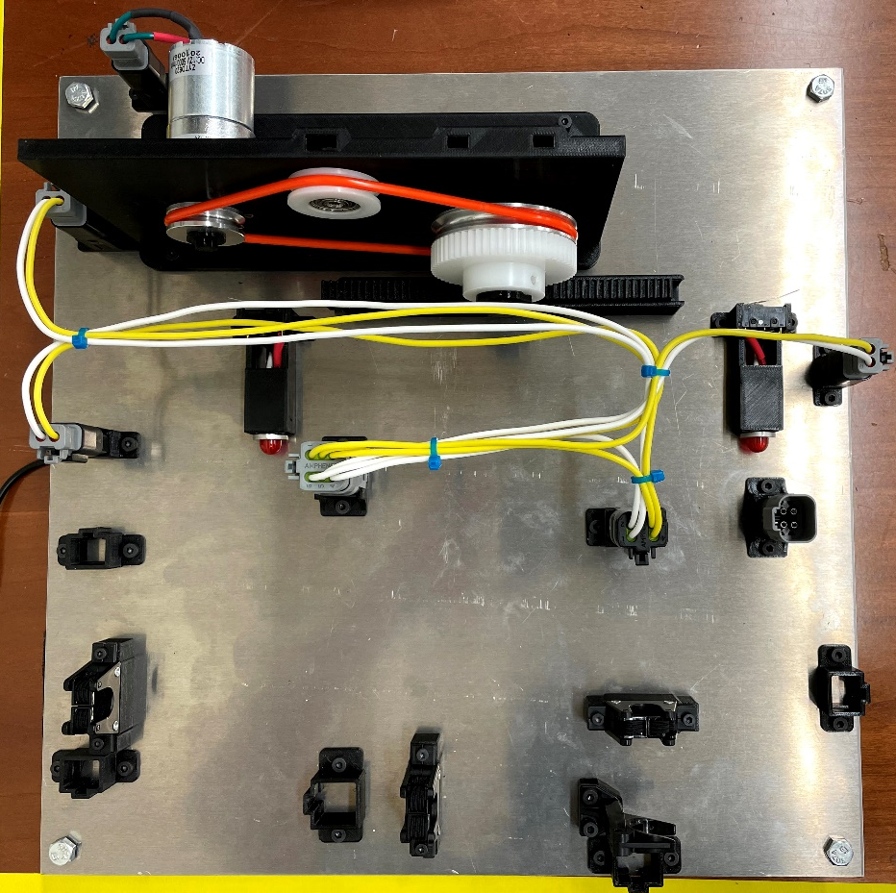
Figure 1: IROS 2021 Competition Task Board

Task: Board Assembly
Parts (figure 1a & 1b):
- Board with connector housings, Female press-fit connectors, Linear gear track, and Belt drive mounting plate.
- Components (tentative):
  - Male AT connectors (2, 4, and 6 PIN), Various wire lengths, Wire clips
  - 12V geared motor with previously threaded M3 screws, Hinge pin bearing
  - Standard metric screws (M3 and M4)
  - Hinge Pin, Idler, square nut
  - Pulleys (small and large), gear, Press-fit caps (small and large)
  - Linear rack
  - Belt
- Kit mat
- Computer Aided Design (CAD) data for all parts and the task board.

This task consists of the following two subtasks:
Subtask 1: Wire Harness Construction
Subtask 2: Belt Drive Assembly

An additional final manual task will be performed by teams that are able to complete subtasks 1 and 2. This task will be testing the completed assembly for operation.

Setup

Prior to the start of the competition, teams must define the planar workspace of their robot system on the table surface. Teams will be given a roll of black electrical tape to mark this work area that must be at minimum dimensions of 60 cm x 100 cm. Competition organizers will then define placement areas for the task board (Velcro), kit tray (for this year’s competition teams will mark a kit tray location rather than use an actual tray so this location will be fixed), and kit layout (adhesive tape) and each will be placed randomly about team defined locations where teams can choose their preferred general object orientation (i.e. side of task board which faces a robot). Random planar, linear offsets relative to object centers will be kept at less than 10 cm in any direction and less than 30 degrees about the axis normal to the table. All objects will be fixed flat to the table surface. Methods for dispensing screws and wires to the robot system for assembly are at the discretion of the teams and this can be done outside of the defined work area. NIST will provide files for printable screw and wire dispensing fixtures for teams use if desired. Figure 2 shows the initial setup.

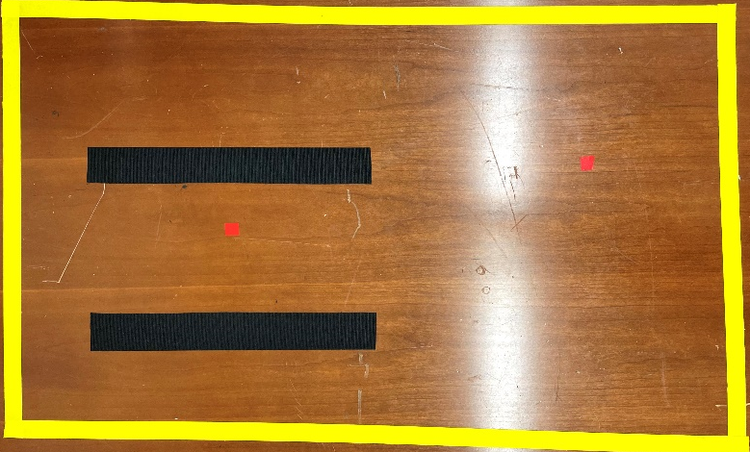
Figure 2: The initial layout as defined through a cooperative effort between teams and judges

Note: Practice task boards and associated parts must be stored as to not interfere with the competition.

Component preparation

There are a few components that must be set up by hand before beginning the competition.
- Two M3 screws must be threaded into the motor according to Figure 3(a). Be sure that there is at least 5mm between the head of the screw and the motor face.
- The small set screw on each pully and the plastic gear must be set so that each part engages with the D-slot of the motor shaft and hinge pin. This will ensure that the belt drive transfers rotation to the linear rack. Make sure the set screw isn’t such a tight tolerance that the task of inserting the pulleys and gear onto the shafts is made more difficult. See Figures 3(b) and 3(c)
- (b) (c)

Figure 3: (a) Two screws preassembled into motor, (b) setscrew preassembled into metal pulley, and (c) setscrew preassembled into plastic gear.

Subtask 1: Wire Harness construction

Description:
Task board starts fully disassembled (Figure 5 – left). The goal is for the competing robot system to place each ATP connector in its respective housing on the board then route the appropriate wires between each connector following a wire diagram (Figure 6). Pins on the ends of each wire must be fully pressed into the appropriate connector sockets and the wire must be correctly routed through the on-board retainers. Upon completion of the wire harness assembly by the competing autonomous robot system, the clock is stopped, wire ties are applied manually to bundle wire, and a team member manually removes the completed wire harness from the task board. Points are assessed on a per part basis.

Base Time Limit: 60 minutes

Number of operations: 41

Achievable Points: 111 + Time bonus

Setup:
- Teams gather all components and place them on the kit layout according to their part templates. Judges ensure that the task board is empty.

Steps (Judge records start time):
- Expedient lead-through programming or calibration methods applied if applicable. (teams cannot change setup)
- The robot system picks a part from the kit layout or wire dispensing mechanism
- The robot system assembles the part into its location on the board.
- Repeat 2) and 3) for all parts.
(Team informs judge to record end time and assess)

Scoring:
- 1 point for each part that contacts the task board surface before the grasp is released or if the part is dropped and remains on the task board (total: 13 points, 8 wires + 5 connectors)
- Assembly points found in Table 1 are based on the following criteria:
  - 5 Connectors in housings (total: 10 points)
  - 16 Pin insertion/snap-fit operations (total: 48 points)
  - 20 wire routing operations (total: 40 points)

Table1: Assembly Points – Subtask1
Operation | points | Success measure
Connectors in housing | 2 | Connector rests flat on the board within the housing
Pin in socket | 2 | pin inserted into connector (no metal showing)
 | 1 | Locked(snap-fit) into housing (A slight tug of the wire does not remove the pin)
Wire routed | 2 | Cable is properly routed in plastic retainers

- Time Bonus: Time bonus = INT ((end time[sec] – start time[sec]) / 41) x 1 point

Rules:
- Time bonus points are only available if all parts are successfully assembled onto the task board (maximum points achieved) as shown in Figure 4 and Figure 5.
- Points are only awarded for assembly of a part into its designated location.
- No manual or teleoperated intervention by human operator (e.g., no manual tool changes)
- No restriction on number of arms, grippers, sensors used
- Use of hand tools (e.g., wrenches, electric drivers) is allowed provided the robot acquires these tools without human assistance.
- Perception system markers (e.g., reflectors, AR tags, QR codes) may not be placed on the individual parts to be assembled.
- Perception system markers can be placed on the task board and kit.
- Working area is the area within which the end-effector of the robot can move. The maximum size of the working area is the table-top which is estimated to be 150 cm x 75 cm.
- A reset is allowed, to make program changes or repair/secure a task board. During a reset, teams must disassemble all parts from the task board and reset in kit area. All accumulated points are reset to zero. The clock continues to run throughout the reset.

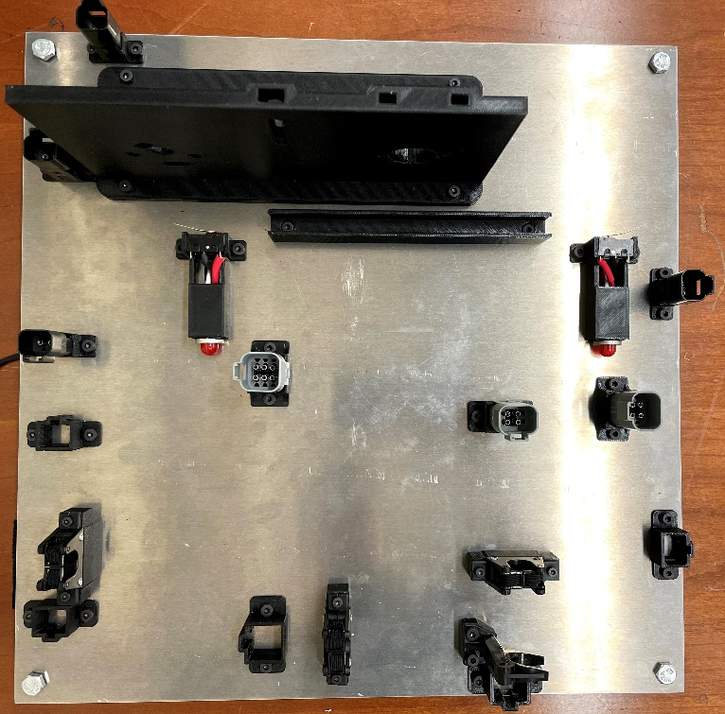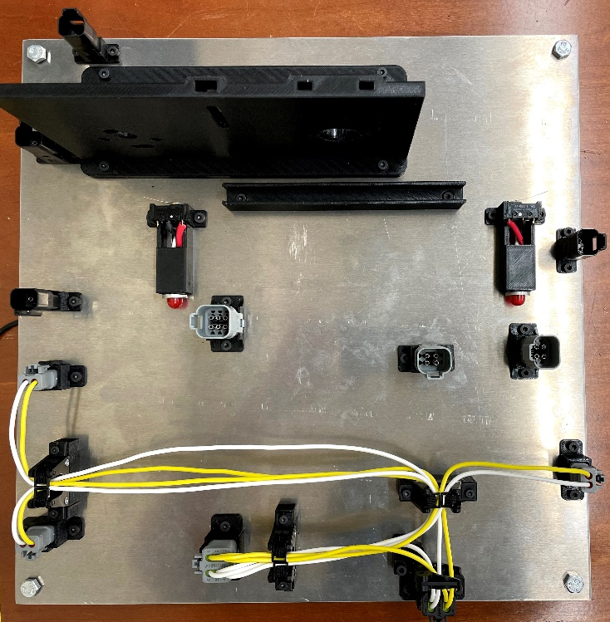
Figure 4: Fully disassembled Task Board and task board with completed wire harness

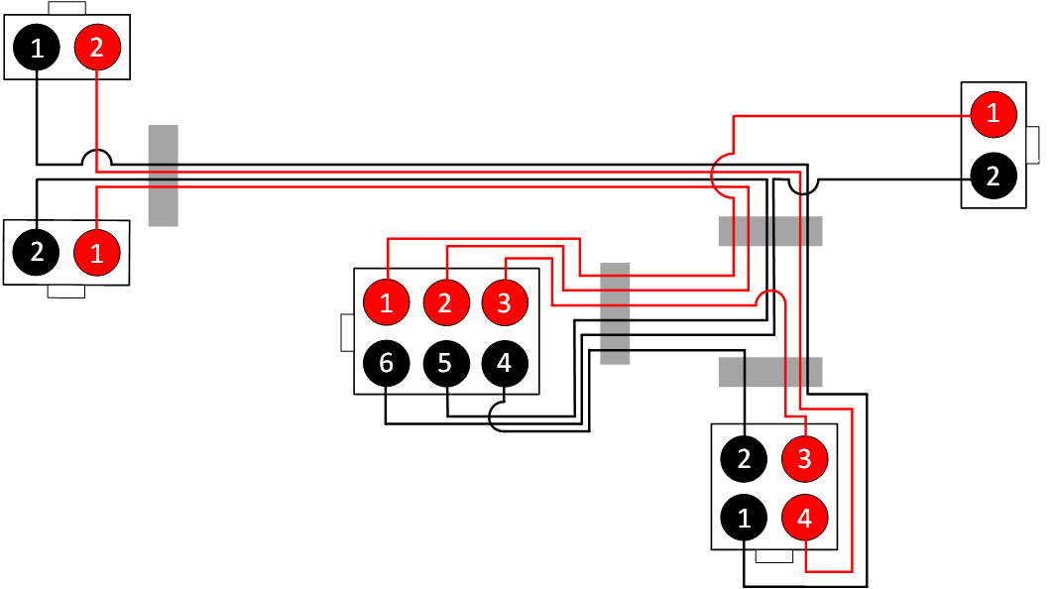
Figure 5: Wiring Diagram.

Once teams complete the wire harness routing they may manually cable tie the wire harness and remove it.

Subtask 2: Belt Drive Assembly

Base Time Limit: 60 minutes

Number assembly operations: 23

Achievable Points: 111 + Time bonus

Description:
Pegs, male electrical connectors, routed cables, screws, and belt drive assembly components are placed on designated locations in the kit area by the team. The goal is for the robot system is to pick all screws, pegs, gears, male electrical connectors, routed cables, and a belt drive assembly from the kit layout/bolt dispenser and assemble them into their defined locations on task board. Points are assessed on a per part basis.

Setup:
- Teams gather all components (from task board, table, and kit tray) and place them on kit layout. The belt is placed on the mat roughly centered on the concentric circle template. Judges ensure that the task board is empty, and the layout is correct as shown in Figure 6.

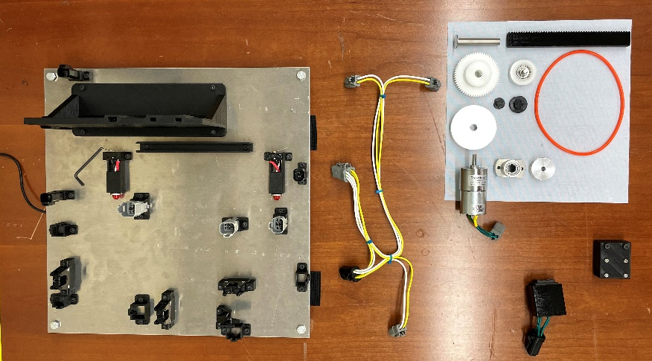
Figure 6: Layout for assembly-subtask 2 showing task board and kit layout with
a method of dispensing screws.

Steps (start time = end time from subtask 1):
- Expedient lead-through programming or calibration methods applied if applicable.
Note: teams cannot change setup
- The robot picks a part from the kit layout.
- The robot system assembles the part into its location on the board.
- Repeat 2) and 3) for all parts.
(Team informs judge to record end time and assess)

Scoring:
- 1 point for each part that contacts the task board surface before the grasp is released or if the part is dropped and remains on the task board (total: 18 points)
- Assembly points found in Table 2 are based on the following criteria:
  - 1 Motor attachment operation (total: 5 points)
  - 6 Screw threading operations (total: 18 points)
  - 3 Pulley/gear threading operations (total: 15 points)
  - 2 Press-fit cap connection operations (total: 6 points)
  - 3 Belt threading operations (total: 15 points)
  - 3 Nut insertion operations (total: 9 points)
  - 1 Tensioner threading operation (total: 5 points)
  - 1 Bearing insertion operation (total: 5 points)
  - 1 Pin insertion operation (total: 5 points)
  - 1 Tensioning operation (total: 5 points)
  - 1 Linear rack threading operation (total: 5 points)

Table 2: Assembly Points – Subtask 2
Operation | points | Success measure
Motor inserted/locked into mounting plate | 3 | Motor remains in plate when gripper is removed
 | 2 | Motor is fully rotated holes align with mounting plate
Screws threaded and tightened | 2 | Screw cannot be pulled from hole and freely turns to tighten
 | 1 | Head of screw fully seated
Pulley/gear threaded onto shaft | 3 | Pulley/gear tracks onto shaft
 | 2 | Pully/gear fully seated
Press-fit caps | 2 | caps remain on shaft when released
 | 1 | Cap top/underside is fully seated against end of the shafts
Bearing inserted into mounting plate | 3 | Bearing remains in mounting plate when released
 | 2 | Bearing is seated against mounting plate (washer test)
Square nut into mounting plate | 3 | Nut inserted into square cavity in mounting plate
Belt threaded around pulley | 5 | belt fully tracked into pulley U-groove
Slide tensioner attachment | 3 | Tensioner remains connected to mounting plate when released
 | 2 | Tensioner is fully seated against mounting plate (washer test)
Hinge pin inserted into bearing | 3 | Pin is inserted into bearing and remains attached when released
 | 2 | Pin is fully seated within bearing
Minimum tension | 5 | Tensioner rests at the highest point in mounting plate
Linear rack threaded into track guide | 3 | Rack easily slides while within track guide
 | 2 | Rack aligns and threads with gear when turned

- Time Bonus: Time bonus = INT ((end time[sec] – start time[sec]) / 23) x 1 point

Rules:
- Time bonus points are only available if all parts are successfully assembled onto the task board (maximum points achieved) as shown in Figure 7.
- Points are only awarded for assembly of a part into its designated location.
- No manual or teleoperated intervention by human operator (e.g., no manual tool changes)
- No restriction on number of arms, grippers, sensors used
- Use of hand tools (e.g., wrenches, electric drivers) is allowed provided the robot acquires these tools without human assistance.
- Perception system markers (e.g., reflectors, AR tags, QR codes) may not be placed on the individual parts to be assembled.
- Perception system markers can be placed on the task board and kit.
- Working area is the area within which the end-effector of the robot can move. The maximum size of the working area is the tabletop which is estimated to be 150 cm x 75 cm.
- A reset is allowed to make program changes or repair/secure a task board. During a reset, teams must disassemble all parts from the task board and reset in kit area. All accumulated points are reset to zero. The clock continues to run throughout the reset.
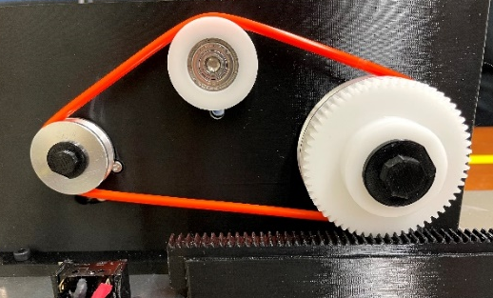
Figure 7: The belt drive task with all parts successfully assembled.

Testing
Subtask completions will undergo final testing for additional points. Ultimately, teams will use their completed wire harness to power the belt drive. In the case that teams do not successfully complete the wire harness, Organizers will provide a correctly wired wire harness for testing the belt drive assembly. Teams may manually install the wire harness in the task board making sure to fully seat each connector in its housing. Figure 1 shows the completed task board with wire harness installed.
Scoring:

- Teams will attach the provided rocker switch to the board using the 4 pin test connector. The following tests will be performed to determine score using Table 3. (Total: 30 points)
  - Pressing switch results in motor rotation ( total: 10 points)
  - Using rocker switch, move linear rack in both directions to engage limit switch (total: 10 points)
  - Using rocker switch, move linear rack in each direction until LED (total: 10 points)

Table 3: Operational Test Points
Test Point: | Team Harness | Pre-Assembled NIST Harness
Working motor | 10 | 0
Moving linear rack | (5 points per direction) = 10 | (5 points per direction) = 10
Limit switch LED lit | (5 points per LED) = 10 | 0

- If teams successfully assemble their own wire harness and use it to operate the belt drive assembly, a total of 30 points are achievable. If instead the organizer provided wire harness is used for testing, only a total of 10 points can be achieved.
Time Shift
Teams are allotted 60 minutes per subtask. Subtask 1 may not be worked on once subtask 2 is started. Time remaining in subtask 1 cannot be applied to subtask 2. Teams may move onto subtask 2 from subtask 1 at any time.

Remote Judging
Teams will reserve a competition date and time with the competition organizers. Teams must provide three camera feeds to a remotely connected judge for real-time for observation of the competition. The first camera must be positioned so that a judge can observe the entire workstation in operation including all computer systems and robot controllers. The second camera will be focused on the robot work area and positioned to minimize occlusions from the manipulator(s). A third camera should be used a mobile camera for human positioning to provide better detailed views during the scoring process. Prior to the competition date, an organizer will connect via teleconferencing software and ensure that cameras are properly positioned and functional via video conferencing. All three video feeds should be recorded by the teams and submitted
Scoring Guidance – IROS 2019 – Robotic Grasping and Manipulation Challenge – Manufacturing Track

The following images and captions provide guidance for scoring each task. The tasks are not necessarily in the order that they will be performed. Points shown are the total achieved in reaching the pictured state.

Pin insertion: 3 points each
16 pin insertion tasks

pin inserted into connector but does not *click*, does not show from the bottom of the connector. (2 points)

Pin is fully seated. Cannot be removed with a slight tug. Can be seen from the bottom of the connector. (3 points)

Cable routing: 2 points
20 wire routing tasks, points are given at each retainer, 1 for direction 1 for containment (engaged within the retainer)

Correct direction but not contained. (1 point)

Cable is properly routed in plastic retainers. Correct path direction and containment achieved. (2 points at each retainer)

Motor attachment: 5 points
1 motor attachment task
Motor is fully rotated, locking it in place; holes align with mounting plate holes. (5 points)

Motor remains in plate when gripper is removed but isn’t locked into place. (3 points)

Screw threading: 3 points per task
6 threading tasks: 2 into bearing, 4 through mounting plate securing motor.
Fully seated; successful fastener operation. (3 point)

Threaded but isn’t fully seated – can be advanced by hand (2 points)

Note: Motor begins with 2 screws already loosely threaded into correct holes. The threading task occurs when securing the motor to the mounting plate
Note: In all cases above, cross threading and destruction of threads receives not points. Judges check this by screwing/unscrewing fastener with ease.

Pin insertion: 5 points
1 pin insertion task: Pin into bearing
Pin is fully seated against bearing. (5 points)

Pin is inserted into bearing and remains inserted when released. (3 points)

Pulley/gear threading: 5 points per task
3 pulley/gear threading tasks: 2 Pulley, 1 gear
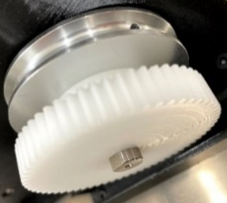
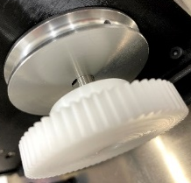
Pulley/gear is fully seated. (5 points)

Pulley/gear is inserted on to pin but not seated against back surface. (3 points)

Nut insertion: 3 points each
3 nut insertion tasks, 1 M6 nut, 2 M3 nuts
Nut rests at the bottom of the hole. (3 points)

Square holes in mounting plate. Nuts resting on top of the hole or unsuccessfully placed within the hole. (0 points)

Tensioner threading: 5 points
1 tensioner attachment task
Tensioner is threaded to the mounting plate leaving no gap. (5 points)

Tensioner remains connected to mounting plate when released but visual gap remains. (3 points)

Bearing insertion: 5 points
1 bearing insertion task
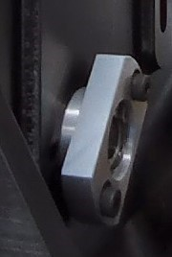
Bearing is fully seated into mounting plate. (5 points)
Bearing remains within the mounting plate when released but isn’t seated against the back of the plate. (3 points)

Press-fit cap connection: 3 points each
2 Press-fit cap insertion tasks, 1 6mm, 1 10mm
Cap is fully seated against the pulley/gear. (3 points)
caps remain on shaft when released but aren’t fully seated against the pulley/gear. (2 points)

Belt Threading: 5 points each
3 belt threading tasks, 1 around large pulley, 1 around small pulley, 1 around tensioner
Two Pulleys correctly threaded. (10 points)

All three Pulleys/tensioners correctly threaded. (15 points)

One pulley correctly threaded. (5 points)

Tensioning:
Fully Tensioned. Tensioner rests at the highest point in mounting plate. (5 points)

Not tensioned. (0 points)

Linear rack threading: 5 points
1 linear rack threading task
Rack aligns and threads with gear when turned. (5 points)
Rack is contained within the guide and easily slides in both directions but isn’t tracked with the gear. (3 points)

Scoring Sheet: IROS 2021 Robotic Grasping and Manipulation Competition – Manufacturing Track
SubTask1: Wire Harness

Team Name: ____________________________

Team Leader: ___________________________ ___________________________________
Team Leader Signature

Judge: _________________________________ ___________________________________
Judge Signature

Start Time: ______________________________ End Time: ___________________________

SubTask 1: Delivery to board
Component | Contact task board |  | Number of parts | Total | Total possible
Connectors | 1 point | X | ____ / 5 |  | 5
Wire | 1 point | X | ____ / 8 |  | 8
 |  |  |  |  | / 13

SubTask 2: Task operation
Component | Partial points |  | Number of completions |  | Completion points |  | Number of completions | Total | Total possible
Connectors in housing |  |  |  | + | Seated: 2 points | X | _____ / 5 |  | 10
Pin in socket | Inserted: 2 points | X | ____ / 16 | + | Seated: 1 point | X | ____ / 16 |  | 48
Wire routed | Correct direction: 1 point | X | ____ / 20 | + | Containment: 1 point | X | ____ / 20 |  | 40
 |  |  |  |  |  |  |  |  | / 98

Total: _______ + _______ = / 111
Scoring Sheet: IROS 2021 Robotic Grasping and Manipulation Competition – Manufacturing Track
SubTask2: Belt Drive

Team Name: ____________________________

Team Leader: ___________________________ ___________________________________
Team Leader Signature

Judge: _________________________________ ___________________________________
Judge Signature

Start Time: ______________________________ End Time: ___________________________

SubTask 1: Delivery to board
Component | Contact task board |  | Number of parts | Total | Total possible
Motor with inserted screws | 1 point | X | ____ / 1 |  | 1
Screws | 1 point | X | ____ / 4 |  | 4
Pulleys/gear | 1 point | X | ____ / 3 |  | 3
Press-fit caps | 1 point | X | ____ / 2 |  | 2
Belt | 1 point | X | ____ / 1 |  | 1
Slide tensioner | 1 point | X | ____ / 1 |  | 1
Square nuts | 1 point | X | ____ / 3 |  | 3
Bearing | 1 point | X | ____ / 1 |  | 1
Hinge pin | 1 point | X | ____ / 1 |  | 1
Tension
Linear rack | 1 point | X | ____ / 1 |  | 1
 |  |  |  |  | / 18

SubTask 2: Task operation
Component | Partial points |  | Number of completions |  | Completion points |  | Number of completions | Total | Total possible
Motor inserted/locked into mounting plate | Inserted: 3 points | X | ____ / 1 | + | Locked: 2 points | X | ____ / 1 |  | 5
Screws threaded and tightened | Threaded: 2 points | X | ____ / 6 | + | Seated: 1 point | X | ____ / 6 |  | 18
Pulley/gear inserted onto shaft | Threaded: 3 points | X | ____ / 3 | + | Seated: 2 points | X | ___ / 3 |  | 15
Press-fit caps | Threaded: 2 points | X | ____ / 2 | + | Seated: 1 point | X | ___ / 2 |  | 6
Belt threaded around pulley |  |  |  | + | Threaded: 5 points | X | ____ / 3 |  | 15
Slide tensioner onto mounting plate | Threaded: 3 points | X | ____ / 1 | + | Seated: 2 points | X | ____ / 1 |  | 5
Square nuts inserted into mounting plate |  |  |  | + | Threaded: 3 points | X | ____ / 3 |  | 9
Bearing inserted into mounting plate | Inserted: 3 points | X | ____ / 1 | + | Seated: 2 points | X | ___ / 1 |  | 5
Hinge pin inserted into bearing | Inserted: 3 points | X | ____ / 1 | + | Seated: 2 points | X | ___ / 1 |  | 5
Minimum tension |  |  |  | + | Tension: 5 points | X | ____ / 1 |  | 5
Linear gear threaded into track | Inserted: 3 points | X | ____ / 1 | + | Meshed with pulley: 2 points | X | ____ / 1 |  | 5
 |  |  |  |  |  |  |  |  | / 93

Total: _______ + _______ = / 111

Scoring Sheet: IROS 2021 Robotic Grasping and Manipulation Competition – Manufacturing Track
Final Task: Testing

Team Name: ____________________________

Team Leader: ___________________________ ___________________________________
Team Leader Signature

Judge: _________________________________ ___________________________________
Judge Signature

Final task: Scoring
Testing operation | Completion points |  | Number of completions | Condition | Total | Total possible
Working motor | Motor rotates in either direction: 10 points | X | ____ / 1 | ½ points for using provided wire harness |  | 10
Moving linear rack | Linear track moves in one direction: 5 points | X | ____ / 2 | ½ points for using provided wire harness |  | 10
Limit switch LED lit | LED lights when switch is pressed: 5 points | X | ____ / 2 | ½ points for using provided wire harness |  | 10
 |  |  |  |  |  | / 30

FINAL Total: _______ + _______ + _______ = / 252
Wire harness + Belt Drive + Testing

