Draft Standard for Accessibility: Augmentation to the 2002 Voting Systems Standard

Draft Version March 2, 2005

28 July 2026

National Institute of Standards and Technology (NIST)

Provided for consideration by the Technical Guidelines Development Committee (TGDC) and the Election Assistance Commission under the requirements of the Help America Vote Act (HAVA) of 2002.

Acknowledgements
The National Institute of Standards and Technology (NIST) would like to acknowledge the individuals and groups who helped contribute to the preparation of this document. Members of the NIST voting team provided substantial assistance, especially John Cugini, Sharon Laskowski and Barbara Guttman. Whitney Quesenbery, chair of the Human Factors and Privacy Subcommittee of the Technical Guidelines Development Committee (TGDC) provided strong leadership and guidance. NIST would also like to acknowledge the IEEE organization for permission to use excerpts from the IEEE P1583 Draft Standard for the Evaluation of Voting Equipment.

Authority
This document has been provided for consideration by the Technical Guidelines Development Committee (TGDC) and the Election Assistance Commission under the requirements of the Help America Vote Act (HAVA) of 2002.

Disclaimer
This document is a work in progress, provided solely as draft input to the TGDC. Portions of this document may change substantially. This document references some material from an unapproved draft of a proposed IEEE Standard, P1583. As such, the material is subject to change in the final standard. Because this material is from an unapproved draft, the IEEE recommends that it not be utilized for any conformance/compliance purposes. It is used at your own risk.

[COMMENTS: Throughout, editorial comments and questions appear in brackets.]

[SOURCES: The material in this document was adapted primarily from the following sources:
-- HAVA 301 (a)(3)
-- VSS sections 2.2.7 and 3.4.9
-- NASED Technical Bulletins #1 and #2
-- draft requirements from IEEE P1583 section 5.3.7
-- ADAAG chapter 3
-- Sec 508 1194.23-41
-- EU clauses 62-64
]

[DEGREE OF CHANGE: There is very little truly novel material herein. This mostly consolidates existing sources. Exception: requirements were added for usability testing by vendor of various disability conditions. The vast majority of the current VSS 2.2.7 retained in substance if not verbatim. There are a few proposed deletions; most of these belong under usability rather than accessibility so they are really merely being moved, not deleted.]

[DOCUMENT FORMAT: We have adopted a more structured approach to the requirements than is used in the 2002 VSS.

Each requirement is numbered according to a hierarchical scheme in which higher-level requirements (such as "provide access for visually impaired") are supported by lower-level requirements ("allow voter to select larger font size").

Some of these requirements are directly testable, and some not. The latter tend to be higher-level; they are included because
- they are testable indirectly insofar as their sub-requirements are testable, and
- they often provide the structure and rationale for lower-level requirements.

Directly testable requirements are denoted by the word "TEST" following the requirement.

Each testable requirement also carries two designations:
- SCOPE: whether it applies primarily to voting equipment, documentation, environment, procedures, or some combination of these.
- PHASE: which phase of the voting model it applies to.

Where a requirement or its rationale may not be self-evident, a DISCUSSION paragraph is appended. The discussion herein is somewhat minimal and may be augmented in later versions. ]

[REQUIREMENTS ON NON-VENDORS: The higher-level requirements are not strictly limited to voting equipment, since accessibility depends on the whole environment, (including polling place and ballot design) as well as on the equipment per se. Directly testable requirements, for now however, do apply only to voting equipment, since only the equipment is under the control of vendors. The point is to show how equipment requirements derive from more general requirements. We defer the question of how requirements for other aspects of the voting environment might be incorporated into a more general process of testing and validation. If approved by the TGDC, requirements that apply mainly to voting officials (as opposed to equipment vendors) will be added (e.g. provision for access to the polling place).]

[RECOMMENDATIONS: No recommendations ("should"s) have been included.]

[PRELIMINARY TEST ANALYSIS:
Although detailed test protocols are not yet included, we have provided a preliminary estimate of the difficulty of testing that would be needed for each testable requirement. There are two dimensions of difficulty: technical complexity and analytic judgment.

- Technical complexity of test execution:

  - SM: simple - test procedures are basic and only simple measurement tools (if any) are used.

  - CX: complex - test procedures and/or measurement tools are at least somewhat complex and require some expertise for correct execution.

- Analytical judgment and expertise:

  - BC: basic - the tester needs only basic judgment to execute the test and determine results.

  - MD: moderate - the tester has to apply a moderate amount of judgment and analysis to execute the test and interpret results.

  - LG: The tester must be fluent in a foreign language.

  - EX: expert - the requirement is not readily susceptible to objective measurement. The tester must have specialized expertise and judgment which is used to estimate the result of the test.

Note that the latter type of testing (EX) should be reserved for only those special cases where objective measurement is difficult and for which some estimate (even if somewhat subjective) of conformance to the requirement is critical.
]

=================================================================

2.2.7 Accessibility

HAVA section 301 (a)(3) reads in part:

"Accessibility for individuals with disabilities.--The voting system shall-- A. be accessible for individuals with disabilities, including nonvisual accessibility for the blind and visually impaired, in a manner that provides the same opportunity for access and participation (including privacy and independence) as for other voters;"

The requirements of this section are intended to address that mandate. Ideally every voter would be able to vote independently and privately. As a practical matter, there may be a small number of voters whose disabilities are so severe that they will need personal assistance. Nonetheless, the requirements of this section are meant to make the voting system directly accessible to as many voters as possible.

Note that this section does not replace requirements of other sections, but adds to them. In particular, the requirements of section 2.4.3.4 on Usability [new section to be added; several of the existing "accessibility" requirements really apply to everyone and thus are to be handled under usability] apply to all voting stations; many of these requirements enhance accessibility as well as general usability.

Throughout this section, "Common Industry Format (CIF)" refers to the format described in ANSI/INCITS 354-2001 "Common Industry Format (CIF) for Usability Test Reports".

Acronyms used throughout:
AVS: Accessible Voting Station
ATI: Audio/Tactile Interface
ALVS: Alternative Language Voting Station

=================================================================
Requirements for Section 2.2.7
=================================================================

OUTLINE:
1. Accessibility
1.1 Disabled
1.1.1 General
1.1.2 Visual
1.1.2.1 General
1.1.2.2 Impaired
1.1.2.3 Blind
1.1.3 Motor Control
1.1.4 Wheelchair
1.1.5 Hearing
1.1.6 Speech
1.1.7 Cognitive
1.2 Non-English
1.3 Provisional ballots
=================================================================

1. All eligible and potentially eligible voters shall have access to the voting process without discrimination. When the provision of this access involves alternative formats for ballot presentation, the complete instructions for voting (i.e. those available to non-disabled, English-literate voters) shall also be made available in those formats.

1.1 The voting process shall provide facilities for voters with physical or mental disabilities. This requirement may be satisfied either by insuring that all voting stations in a polling place have accessibility features or by providing at least one station with special features to accommodate the disabled (see HAVA 301 (a)(3)(B)). A station with such special features is referred to herein as an accessible voting station (AVS).

1.1.1 The voting process shall incorporate features that accommodate a range of disabilities.
DISCUSSION: These design features are applicable to several types of disability.

1.1.1.1 An AVS shall provide direct accessibility such that a voter's personal assistive technology is not required for voting.
TEST: SM, BC
SCOPE: equipment
PHASE: A1.5.7-A1.5.10
DISCUSSION: Voters should not be obliged to supply any special equipment in order to vote.

1.1.1.2 When the primary means of voter identification or authentication uses biometric measures that require a voter to possess particular biological characteristics, the voting system shall provide a secondary means that does not depend on those characteristics.

TEST: SM, BC
SCOPE: equipment, procedures
PHASE: A1.5.1-A1.5.4

1.1.1.3 No voting station shall cause the screen to flicker with a frequency greater than 2 Hz and lower than 55 Hz.
TEST: CX, BC
SCOPE: equipment
PHASE: A1.5.7-A1.5.10
DISCUSSION: Among other reasons, this protects voters with epilepsy.

1.1.1.4 No information shall be kept with the Cast Vote Record that identifies any accessibility feature(s) used by a voter.
TEST: SM MD
SCOPE: equipment
PHASE: A1.5.11-A1.5.12
DISCUSSION: This protects against possible violations of voter privacy.

1.1.1.5 Any aspect of the AVS that is adjustable by a voter shall reset upon completion of that voter's session. This implies that the AVS shall have the same initial appearance and for every voter.
TEST: SM, BC
SCOPE: equipment
PHASE: A1.5.7-A1.5.10

1.1.2 The voting process shall accommodate voters with visual disabilities.
[Nothing in here to address remote/absentee voting - e.g. can voters request large-print absentee ballots?]

1.1.2.1 The voting process shall provide features that accommodate various visual disabilities.
DISCUSSION: These features may be useful for voters with minor impairments as well as to blind voters.

1.1.2.1.1 If the AVS has mechanically operated controls or keys, they shall be tactilely discernible without activating the controls or keys.
TEST: SM, BC
SCOPE: equipment
PHASE: A1.5.7-A1.5.10

1.1.2.1.2 On an AVS, the status of all locking or toggle controls or keys (such as the "shift" key) shall be visually discernible, and discernible either through touch or sound.
TEST: SM, BC
SCOPE: equipment
PHASE: A1.5.7-A1.5.10

1.1.2.1.3 On all voting stations, color coding shall not be used as the only means of conveying information, indicating an action, prompting a response, or distinguishing a visual element, i.e. some other non-color mode must also be used.
TEST: SM, MD
SCOPE: equipment
PHASE: A1.5.7-A1.5.10

1.1.2.2 The AVS shall provide features to accommodate voters with visual impairments that degrade their reading ability.

1.1.2.2.1 The vendor shall conduct usability tests on the AVS with visually impaired (either naturally or artificially, for test purposes) subjects and shall report the test results according to the Common Industry Format (CIF).
TEST: SM, MD [note: the conformance test is simply to confirm that the usability test is reported.]
SCOPE: documentation
PHASE: A1.5.7-A1.5.10

1.1.2.2.2 An AVS with an electronic image display shall be capable of showing all information in at least two font sizes, a) 6.3-9.0 mm and b) 3.0-4.0 mm, under control of the voter.
TEST: SM, BC
SCOPE: equipment
PHASE: A1.5.7-A1.5.10
DISCUSSION: While larger font sizes may assist most voters with poor vision, certain disabilities such as tunnel vision are best addressed by smaller font sizes.

1.1.2.2.3 An AVS with a black and white electronic image display shall be capable of showing all information in high contrast either by default or under the control of the voter. High contrast is defined as a figure-to-ground ambient contrast ratio for text and informational graphics of at least 6:1.
TEST: CX, BC
SCOPE: equipment
PHASE: A1.5.7-A1.5.10

1.1.2.2.4 An AVS with a color-only electronic image display shall allow the voter to adjust the figure-to-ground ambient contrast ratio. The minimum value available shall be in the range 2.7-3.3 : 1. The maximum value available shall be in the range 5.7-6.3 : 1.
TEST: CX, BC
SCOPE: equipment
PHASE: A1.5.7-A1.5.10

1.1.2.2.5 An AVS with a color-only electronic image display shall allow the voter to adjust the red, green, and blue components of the foreground and background color.
TEST: SM, BC
SCOPE: equipment
PHASE: A1.5.7-A1.5.10

1.1.2.2.6 On all voting stations, color coding shall be presented so as to assure correct perception by voters and operators with color blindness.
TEST: -- EX
SCOPE: equipment
PHASE: A1.5.7-A1.5.10

1.1.2.3 The AVS shall provide features to accommodate blind voters.

1.1.2.3.1 The vendor shall conduct usability tests on the AVS with blind [or blindfolded subjects? not for testing in the longer term, but for the purposes of the augmented 2002 VSS] and shall report the test results according to the Common Industry Format (CIF).
TEST: SM, MD
SCOPE: documentation
PHASE: A1.5.7-A1.5.10

1.1.2.3.2 The AVS shall provide an audio/tactile interface (ATI) that supports the full functionality of a normal ballot interface, as specified in section 2.4. This includes at least:
-- instructions and feedback to the voter on how to operate the
AVS, including settings and options (e.g. volume control,
repetition, navigation),
-- instructions and feedback for voter selections in races and
referenda, including write-in candidates,
-- instructions and feedback on confirming and changing selections
-- instructions and feedback on final submission of ballot.
TEST: CX, MD
SCOPE: equipment
PHASE: A1.5.7-A1.5.10

1.1.2.3.2.1 The ATI of the AVS shall provide the same capabilities to vote and cast a ballot as are provided by the non-accessible stations or by the visual interface of the AVS. Therefore, functional features that exceed the requirements of section 2.4 must be provided on a non-discriminatory basis.
TEST: CX, MD
SCOPE: equipment
PHASE: A1.5.7-A1.5.10
DISCUSSION: For example, if a "normal" ballot supports voting a straight party ticket and then changing the choice in a single race, then so must the ATI.

1.1.2.3.2.2 The ATI shall enable the voter to have any information provided by the system repeated.
TEST: SM, BC
SCOPE: equipment
PHASE: A1.5.7-A1.5.10

1.1.2.3.2.3 The ATI shall enable the voter to pause and resume the audio presentation.
TEST: SM, BC
SCOPE: equipment
PHASE: A1.5.7-A1.5.10

1.1.2.3.2.4 The ATI shall offer a new personal headphone to each voter.
TEST: SM, BC
SCOPE: equipment, procedures
PHASE: A1.5.6

1.1.2.3.2.5 The ATI shall provide the audio signal through an industry standard connector for private listening using a 3. [was 1/8 inch in the existing VSS - conflicting testimony, but consensus seems to be that 3.5mm is the current de facto standard] stereo headphone jack to allow individual voters use their own headphones.
TEST: SM, BC
SCOPE: equipment
PHASE: A1.5.6-A1.5.10

[Dropped from VSS: "Provide ...a wireless coupling for devices ... when a system utilizes a telephone style handset" because of security concerns. Yes/No? ]

1.1.2.3.2.6 The ATI shall provide a volume control with an adjustable amplification from a minimum of 20dB up to a maximum of 105 dB, in increments no greater than 10dB.
TEST: CX, BC
SCOPE: equipment
PHASE: A1.5.7-A1.5.10

1.1.2.3.2.7 The initial volume of the ATI for each voter shall be between 50 and 70 dB. [Tightened up the IEEE spec - OK?]
TEST: CX, BC
SCOPE: equipment
PHASE: A1.5.7-A1.5.10

1.1.2.3.2.8 The audio system of the ATI shall be able to reproduce frequencies over the audible speech range of 315 Hz to 3150 Hz.
TEST: CX, BC
SCOPE: equipment
PHASE: A1.5.7-A1.5.10

1.1.2.3.2.9 The ATI shall meet the requirements of ANSI C63.19-2001 Category U4 to avoid electromagnetic interference with assistive hearing devices.
TEST: CX, BC
SCOPE: equipment
PHASE: A1.5.7-A1.5.10

1.1.3 The AVS shall provide features to accommodate voters who lack fine motor control.

1.1.3.1 The vendor shall conduct usability tests on the AVS with subjects lacking fine motor control and shall report the test results according to the Common Industry Format (CIF).
TEST: SM, MD
SCOPE: documentation
PHASE: A1.5.7-A1.5.10

1.1.3.2 All keys and controls on the AVS that are normally operated e a single finger shall not have a key repeat feature enabled.
TEST: SM, BC
SCOPE: equipment
PHASE: A1.5.7-A1.5.10

1.1.3.3 All keys and controls on the AVS shall be operable with one hand and shall not require tight grasping, pinching, or twisting of the wrist. The force required to activate controls and keys shall be no greater 5 lbs. (22.2 N) and no less than ??? lbs. [shouldn't there be a lower boundary to prevent it from being too sensitive?]
TEST: CX, BC
SCOPE: equipment
PHASE: A1.5.7-A1.5.10

1.1.3.4 The AVS controls shall not require human touch or for the body to be part of any electrical circuit.
TEST: SM, BC
SCOPE: equipment
PHASE: A1.5.7-A1.5.10
DISCUSSION: This ensures that they are operable by individuals using prosthetic devices.

1.1.4 The AVS shall provide features to accommodate voters confined to a wheelchair.

1.1.4.1 The vendor shall conduct usability tests on the AVS with subjects confined to a wheelchair (either naturally or artificially, for test purposes) and shall report the test results according to the Common Industry Format (CIF).
TEST: SM, MD
SCOPE: documentation
PHASE: A1.5.7-A1.5.10

1.1.4.2 The AVS must be accessible to voters using a wheelchair via either a forward or side approach or both.
TEST: SM, BC
SCOPE: equipment, environment
PHASE: A1.2.1, A1.5.7-A1.5.10

1.1.4.3 All controls, keys, audio jacks and any other part of the AVS which might need to be touched by the voter shall be within the reach region as specified below under 1.1.4.3.

1.1.4.3.1 If the AVS has 1) no obstruction to its approach or 2) a forward approach with an obstruction no more than 20 inches (50.8cm)in depth, or 3) a side approach with an obstruction no more than 10 inches (25.4cm) in depth, then the maximum high reach shall be 48 inches (121.9cm) and the minimum low reach shall be 15 inches (38.1cm). See Figures 2.2.7-1 and 2.2.7-3.
TEST: SM, BC
SCOPE: equipment, environment
PHASE: A1.2.1, A1.5.7-A1.5.10

1.1.4.3.2 If the AVS has a forward approach with an obstruction (such as a shelf) that must be reached over, the following constraints within 1.1.4.3.2 shall be observed. See Figure 2.2.7-2.

1.1.4.3.2.1 The clear floor space shall extend beneath the obstruction for a forward depth not less than the required forward reach depth over the obstruction.
TEST: SM, BC
SCOPE: equipment, environment
PHASE: A1,2,1, A1.5.7-A1.5.10

1.1.4.3.2.2 The height of the top of the obstruction shall be no greater than 34 [make it the same as for a side obstruction?] inches (86.4cm). The height of the bottom surface of the obstruction shall be no less than 26 [Anyone have a better number?] inches (66.0cm). [nothing like this in existing sources - but seems like there should be.]
TEST: SM, BC
SCOPE: equipment
PHASE: A1.5.7-A1.5.10

1.1.4.3.2.3 The maximum forward reach depth over the obstruction shall be 25 inches (63.5cm).
TEST: SM, BC
SCOPE: equipment
PHASE: A1.5.7-A1.5.10

1.1.4.3.2.4 Where the obstruction projects 20 to 25 inches (50.8 to 63.5cm) deep, the maximum forward reach height shall be 44 inches (111.8cm).
TEST: SM, BC
SCOPE: equipment
PHASE: A1.5.7-A1.5.10

1.1.4.3.3 If the AVS has a side approach with an obstruction (such as a shelf) that must be reached over whose depth is greater than 10 inches (25.4cm), the following constraints under 1.1.4.3.3 shall be observed. See Figure 2.2.7-4.

1.1.4.3.3.1 The maximum side reach depth over the obstruction shall be 24 inches (61.0cm).
TEST: SM, BC
SCOPE: equipment
PHASE: A1.5.7-A1.5.10

1.1.4.3.3.2 The height of the top of the obstruction shall be no greater than 34 inches (86.4cm).
TEST: SM, BC
SCOPE: equipment
PHASE: A1.5.7-A1.5.10

1.1.4.3.3.3 The maximum side reach height shall be 44 inches (111.8cm).
TEST: SM, BC
SCOPE: equipment
PHASE: A1.5.7-A1.5.10

[1.1.4.3 above may look different, but I believe it is logically equivalent to the draft IEEE specs.]

1.1.4.4 All displays, controls, keys, audio jacks and any other part of the AVS which might need to be seen by the voter shall be within easy sight of a voter in a wheelchair who is in an appropriate position and orientation with respect to the AVS. [not much about this aspect in existing sources, except for the "tilt" clause in IEEE draft.]
TEST: -- EJ
SCOPE: equipment, environment [can be glare issues]
PHASE: A1.2.1, A1.5.7-A1.5.10

1.1.4.4.1 [details about angles, line of sight? Such details would obviate need for expert judgment above.]

1.1.5 The voting process shall accommodate voters with hearing disabilities.

1.1.5.1 The AVS shall incorporate the features listed under 1.1.2.3.2 to assist those with diminished hearing.
TEST: as per 1.1.2.3.2.
SCOPE: equipment, procedures
PHASE: A1.5.7-A1.5.10
DISCUSSION: Note especially the requirements for volumr initialization and control.

1.1.5.2 If a voting station provides sound cues as a method to alert the voter about a certain condition, such as the occurrence of an error or a confirmation, the tone shall be accompanied by a visual cue.
TEST: SM, BC
SCOPE: equipment
PHASE: A1.5.7-A1.5.10

1.1.6 The voting process shall accommodate voters who cannot speak.

1.1.6.1 No voting equipment shall require voter speech for its operation.
TEST: SM, BC
SCOPE: equipment
PHASE: A1.5.7-A1.5.10

1.1.7 The voting process shall accommodate voters with cognitive disabilities, such as ??? [any thoughts? Expert inspection for excessively confusing instructions? Anything unique to cognitive disabilities not already covered by normal usability?].
TEST: -- EX
SCOPE: equipment, environment
PHASE: A1.2.1, A1.5.7-A1.5.10

1.2 The voting process shall accommodate voters who are not fully literate in English. This requirement may be satisfied by providing voting stations [how many??] in a polling place that accommodate those without a full command of English. See HAVA 301 (a)(4) and 241 (b)(5). Such a facility is defined as an alternative language voting station (ALVS).

1.2.1 All the information presented in the normal case of English-literate voters (including instructions, warnings, messages, and ballot choices) shall also be presented by the ALVS, whether the language is written or spoken.
TEST: CX, LG
SCOPE: equipment
PHASE: A1.5.7-A1.5.10

1.2.2 Regardless of the language, candidate names shall be displayed or pronounced in English on all ballots. For written languages that do not use Roman characters (e.g. Chinese, Japanese, Korean, Arabic), the ballot shall be capable of including transliteration of candidate names into the relevant language.
TEST: SM, LG
SCOPE: equipment
PHASE: A1.5.7-A1.5.10

1.2.3 For literate voters, the ALVS shall provide printed or displayed instructions, messages, and ballots in their preferred language, consistent with state and Federal law.
TEST: SM, LG
SCOPE: equipment
PHASE: A1.5.7-A1.5.10

1.2.3.1 The vendor shall conduct usability tests on the ALVS with literate subjects who neither speak nor read English and shall report the test results according to the Common Industry Format (CIF).
TEST: SM, MD
SCOPE: documentation
PHASE: A1.5.7-A1.5.10

1.2.4 For illiterate voters, the ALVS shall provide spoken instructions and ballots in the preferred language of the voter, consistent with state and Federal law. Note that some languages have no widely accepted written form. The requirements and sub-requirements of 1.1.2.3.2 shall apply to this mode of interaction.
TEST: SM, LG
SCOPE: equipment
PHASE: A1.5.7-A1.5.10

1.3 The voting process shall support provisional voting for those whose eligibility is in question, consistent with state and Federal law. [The thought here is that voters whose registration has mistakenly been dropped have had their access denied and that's why it's reasonable to handle this issue under accessibility.]
TEST: SM, BC
SCOPE: procedures
PHASE: A1.1.5, A1.5.1-A1.5.5

Figures for Accessibility

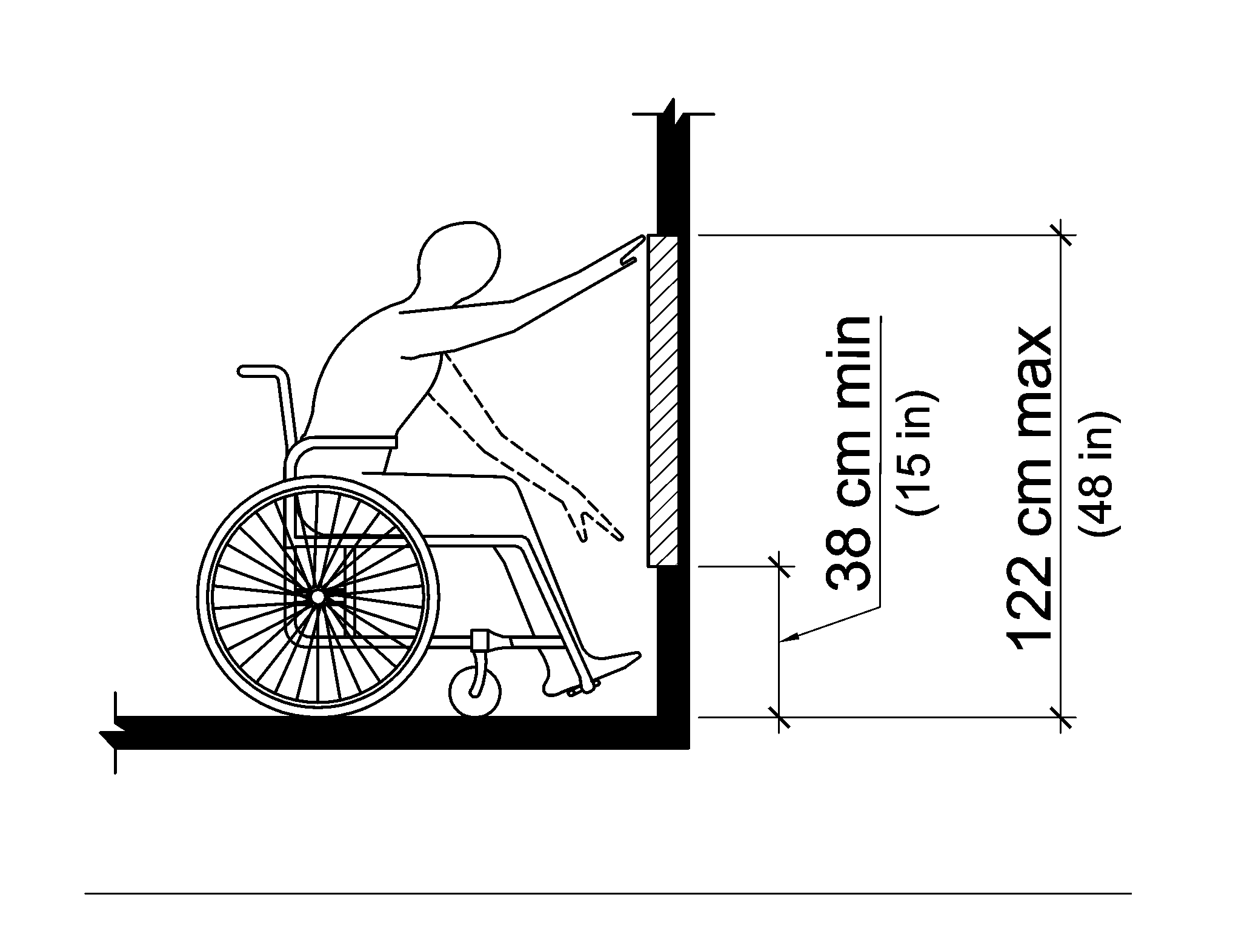 | 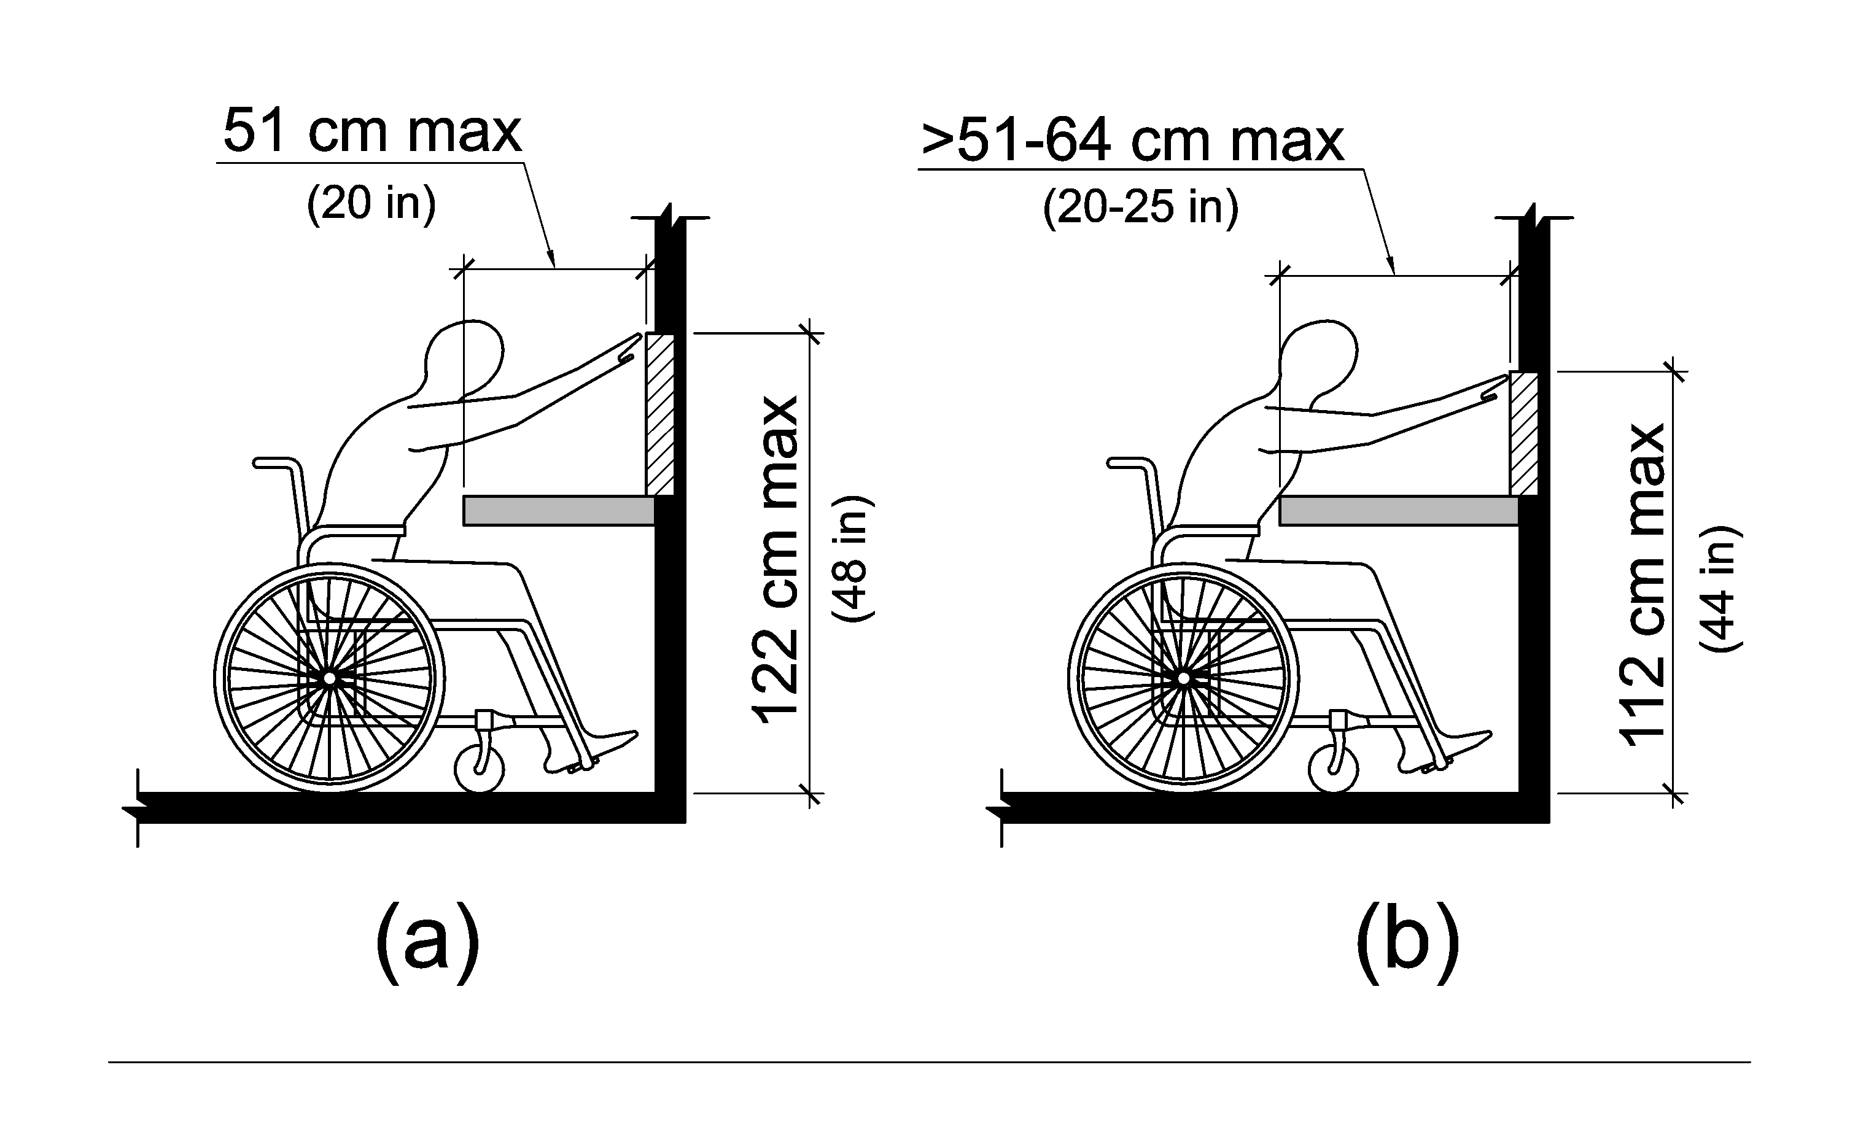
Figure 2.2.7-1  Unobstructed forward reach | Figure 2.2.7-2  Obstructed forward reach  (a) for an obstruction depth of up to 20 inches  (b) for an obstruction depth of up to 25 inches
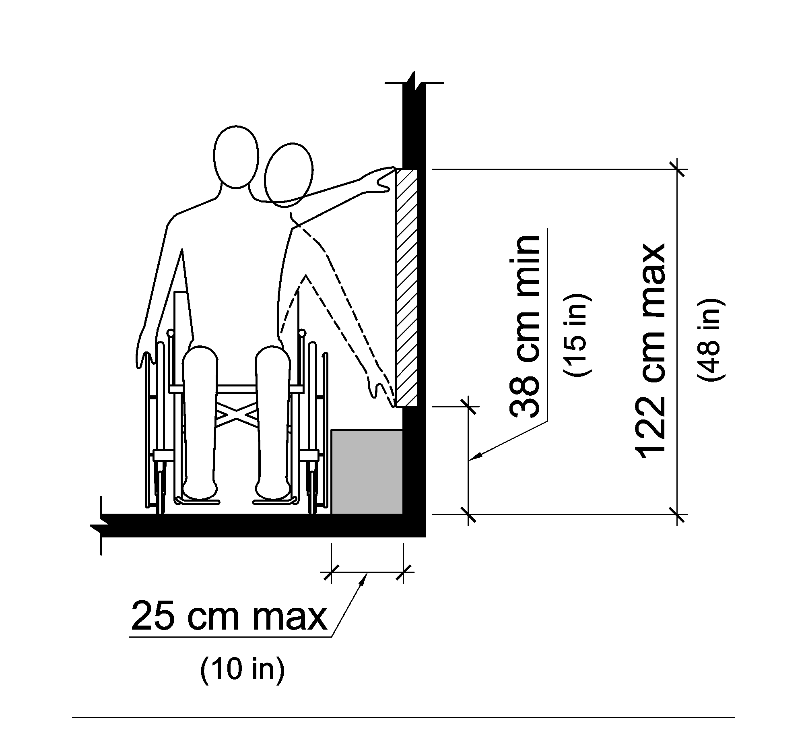 | 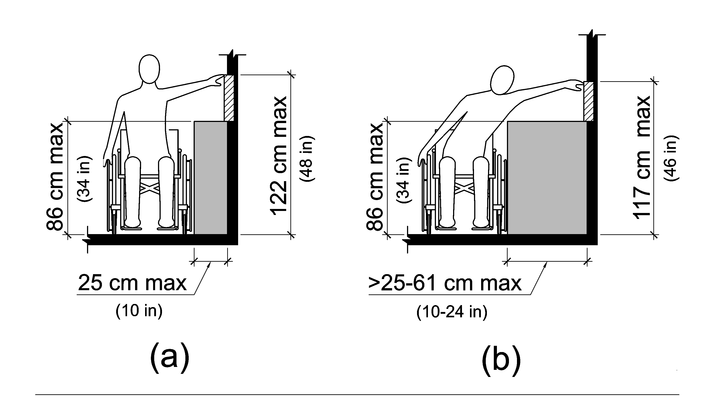
Figure 2.2.7-3  Unobstructed side reach with an allowable obstruction less than 10 inches deep. | Figure 2.2.7-4  Obstructed side reach  (a) for an obstruction depth of up to 10 inches  (b) for an obstruction depth of up to 24 inches

