SOP 23

**Recommended Standard Operations Procedure for**

**Calibrations of PI Tapes**

**Bench Method**

1. Introduction
   1. Purpose

PI tapes are circumferential measuring tapes that are wrapped around a circular or cylindrical object and when read, indicate the diameter of the object. The tapes are manufactured for various diameter ranges and for either outside diameters (OD) or inside diameters (ID). The test method described here provides a procedure to calibrate such tapes to four decimal places in inches (diameter). A calibrated length bench (transfer standard, calibrated using SOP 11) is used as the standard.

1.2 Prerequisites

1.2.1 Valid calibration certificates with appropriate values and uncertainties must be available for all of the standards used in the calibration. All standards must have demonstrated metrological traceability to the international system of units (SI), which may be to the SI through a National Metrology Institute such as NIST.

1.2.2. The ocular microscope used in measuring differences in lengths must be in good operating condition and must be equipped with a graduated reticle having established traceability.

1.2.3. The operator must be trained and experienced in precision measuring techniques with specific training in GMP 2, GMP 8, GMP 9, SOP 11, SOP 23, and SOP 29.

1.2.4. Laboratory facilities must comply with following minimum conditions to meet the expected uncertainty possible with this procedure. Equilibration of length bench and tapes requires environmental stability of the laboratory within the stated limits for a minimum of 24 hours before a calibration.

**Table 1. Environmental conditions.**

|  |  |
| --- | --- |
| Temperature Requirements During a Calibration | Relative Humidity  (%) |
| Lower and upper limits: 18 °C to 22 °C  Maximum changes: < ± 1 °C / 24 h and ± 0.5 °C / 1 h | 40 to 60 ± 10 / 4 h |

2. Methodology

2.1. Scope, Precision, Accuracy

The precision and accuracy attainable depend upon the care exercised in aligning the tape on the length bench, and the skill acquired in the use of an optical micrometer to measure scale differences.

2.2 Physical Characteristics

2.2.1. PI tapes are manufactured with corrections built into the tape where they will indicate the proper diameter without using extensive mathematical corrections. These corrections will have to be taken into consideration when calibrating a PI tape on a flat horizontal surface.

OD PI tapes are referenced to 20 °C with 2.25 kg (5 lb) tension (within ± 0.5 percent of the load, i.e., Class F mass standards are more than adequate.) applied. **There is concern about the proper tension to apply to an ID PI tape since they are normally used under some degree of compression.** Most tapes are made of 1095 spring steel, which has a coefficient of thermal expansion of 0.00000633 / °F.

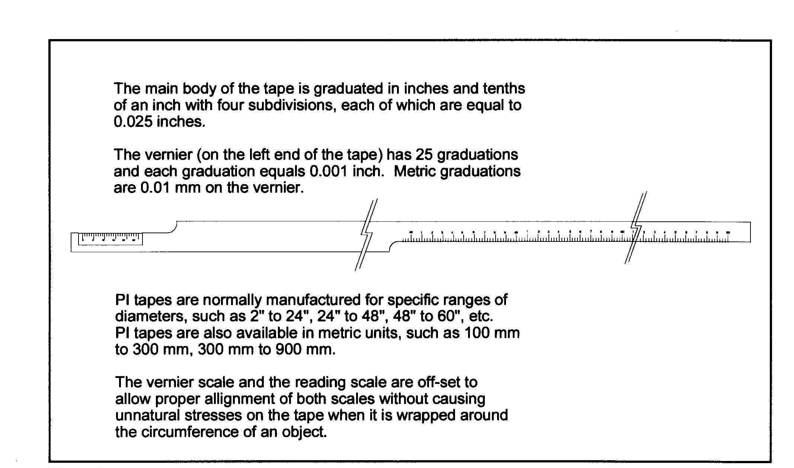

**Figure 1. Schematic drawing of Pi tape**

As the tape is wrapped around the circumference of an object, the reading portion of the tape and the vernier come into alignment. The smallest graduation on the main body equals 0.5 mm (0.025 in). The line on the vernier scale which comes closest to lining up with a graduation on the main body is the value to be added to the reading. The vernier allows readings to be made to the nearest 0.001 in, as shown in Figure 2.

**Figure 2. Reading the Vernier scale on a Pi tape.**



* 1. Fundamental Considerations
     1. The relationship of circumference, C, diameter, D, and pi (π)is C = π(D), D = C/π. See Figure 3 where π = 3.141592654

**Figure 3. Circumference, diameter, pi (π).**

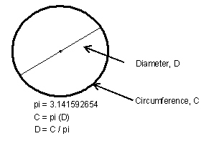

* + 1. The thickness of the tape will affect the measurements in two locations, as shown in Figure 4. L1 is the outside portion of the tape, which becomes longer when the tape is bent. L2 is the center of the tape (neutral axis). It remains the same length when the tape is bent. L3 is the inside portion of the tape and it compresses and becomes shorter when the tape is bent.

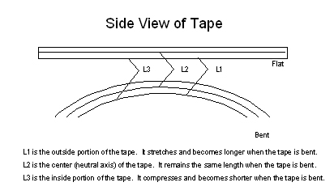

**Figure 4. Side view of tape.**

2.3.3 Another point that must be taken into consideration is that the tape was tested for accuracy on a flat horizontal surface but now it is curved around an object. The tape becomes temporarily deformed but the amount of distortion is predictable using the modulus of elasticity. As shown in the diagram (Figure 4.), the outside portion of the tape stretches and the inside compresses but there is a point midway through the thickness of the tape which does not change in length and is called the neutral axis.

For all homogeneous beams with the same modulus of elasticity in tension and compression, the neutral axis passes through the center of the section. If the tape has a thickness of 0.010 inch, the distance from the neutral axis to the surface of the object is 0.005 inch. Therefore, the reading we obtained is not the distance on the outside surface of the tape but is actually the distance along the neutral axis of the tape. When we calculate a diameter, this is actually the diameter of the neutral axis of the tape. Since this thickness affects the diameter in two locations, the amount of correction that must be taken into account is 0.010 inches.

2.4. Summary

The tape to be calibrated is laid over the bench scale and tension is applied to ensure that it lies flat on the bench. Differences between the graduation on the tape and that of the bench scale are measured using an ocular micrometer. The temperature of the tape is observed and corrections applied to the reference temperature of 20 °C. Tapes longer than the length bench may be calibrated in segments, using the last calibrated graduation as the zero graduation mark for the succeeding segments. PI tape graduations represent object diameters and may not directly coincide with length bench graduations.

* 1. Apparatus/Equipment Required
     1. Calibrated thermometers with sufficiently small resolution, stability, and uncertainty, capable of indicating temperatures in the range of 15 °C to 30 °C, and accurate to ± 0.5 °C.
     2. Calibrated 5 meter (16 foot) length bench.
     3. Microscope with graduated reticle having graduations spaced at intervals no greater than 0.002 inch.
     4. Clamps, fabric tape in lengths required to connect tension weights to the tape being calibrated, and weights to apply an appropriate tension to the tape under calibration. (See "Tension Specifications", in Appendix C.3 in SOP 11).
  2. Symbols

**Table 2. Symbols used in this procedure.**

|  |  |
| --- | --- |
| **Symbol** | **Description** |
| *S* | Standard |
| *X* | Unknown |
| *d0i* | Initial zero difference |
| *d0f* | Final zero difference |
| *X0L* | Left edge of zero on unknown |
| *X0R* | Right edge of zero on unknown |
| *S0L* | Left edge of zero on standard |
| *S0R* | Right edge of zero on standard |
| *Xm* | Center of graduation of unknown |
| *Sm* | Center of graduation of standard |
| *d* | Difference of interval between *X* and *S* |
| *t* | Average of initial and final temperatures |
| *tcorr* | Temperature correction |
| *Ln* | Nominal length of tape interval under test in inches |
| *LX* | Calibrated length of tape interval under test in inches |
| *α* | Linear coefficient of thermal expansion for the standard bench (0.00001063  /  ºC) |
| *β* | Linear coefficient of thermal expansion for the tape (0.00001160 / ºC) |
| *Ld* | Diameter length of interval |
| *π* | 3.141592654 |

* 1. Procedure
     1. Inspect the tape to ensure that no kinks, dents, or other damage are present which will affect the accuracy of the tape.
     2. Clean the tape by first wiping with a soft cloth, and then with a soft cloth saturated with alcohol to remove the protective oil film. (See Appendix C, Section C.1 for SOP 11).‑
     3. Place the tape, under the clamp, at the zero end of the bench, and adjust so the starting mark on the tape is near the zero graduation on the length bench.
     4. Lay the tape flat on the bench. The tape should extend well beyond the end roller of the bench to permit tension to be applied. Slide one end of a fabric strap onto another tape clamp. Fasten this tape clamp to the tape on the portion that extends below the end roller. Hang the tension weight from the bottom of the fabric strap. Check to see that the tape is lying straight on the bench and parallel to the bench scale. Adjust, if necessary. Apply tension using a weight of 2.25 kg (5 lb) unless other tension is specified. (See Appendix C.3 in SOP 11.) When a tape is shorter than the 5 m length bench, fabric strap will be be used to effectively lengthen the tape so that the tension weight is properly suspended below the rollers of the length bench.
     5. Lay two thermometers (see 2.4.1.) on the bench at intervals of one-third and two‑thirds of the length of the bench to determine its temperature at the time of test.
     6. Adjust the tape clamp on the zero end of the bench so that the tape zero graduation coincides with the center of the zero graduation of the bench.
     7. Check all alignments and coincidence of zero graduations before proceeding with the calibration. Use the lateral adjustments of the left end of the bench to facilitate alignment. Caution! Take care that the tape is not touched or disturbed during the following sequence of measurements. Record all observations on a suitable data sheet. (See SOP 11, Appendix A.)
     8. Record the temperatures indicated by the two thermometers.
     9. Place the ocular microscope on the bench in the vicinity of the zero position and align it so that its scale is parallel to the tape under test. (See GMP No. 2 for instructions on how to make readings.)
        1. Observe readings of left and right sides of zero graduation of tape and record to the nearest 0.001 inch. The mean of these values will be used to determine the center of the tape graduation.
        2. Observe readings of left and right sides of zero graduation of bench and record to the nearest 0.001 inch. The mean of these values will be used to determine the center of the bench graduation.
     10. Move the ocular microscope successively to each graduation that is to be calibrated and record readings similarly as in 2.7.9.1 and 2.7.9.2.
     11. Return the ocular microscope to the zero graduation and repeat readings to verify that the tape has not moved. Accept all previous data if the initial zero reading does not disagree with the final zero reading by more than 0.001 inch; otherwise, discard previous data and repeat entire sequence of readings until a satisfactory set is obtained.
     12. Loosen the tape by removing the tension weights, move the tape, hang the tension weights back on the fabric strap, and realign the zero marks on the tape and bench to coincidence.
     13. Repeat 2.7.9. thru 2.7.12. for every 15 foot (5 meter) section of the tape requiring calibration. This will require repositioning the tape, aligning the last measured interval graduation on the tape with the zero graduation of the bench.
     14. Make a second set of measurements as directed in 2.7.9 through 2.7.13.
     15. After the final measurement is taken and accepted, record the temperatures indicated by the two thermometers.
     16. After all measurements are completed, apply a thin film of oil to the tape.

1. Calculations

3.1. Calculate the Initial Zero Difference, *d0i* (2.6.9.)

 (1)

3.2. Calculate the Final Zero Difference, *d0f* (2.6.11.)

 (2)

3.3. Calculate the center of graduation for unknown, *Xm,* and standard, *Sm,* for each set of measurements and each scale interval.

 (3)

 (4)

3.4. Calculate the difference, *d*, between *X* and *S* for each scale interval.

 (5)

3.5. Obtain the correction to the standard, *CS*, for the measured interval from the calibration certificate for the length bench scale.

3.6. Calculate the temperature correction, *tcorr*.

 (6)

3.7. Calculate a correction, *CX*, for each trial and each scale interval.

 (7)

3.8. Calculate and report the mean,, of the two corrections for each interval.

3.9. Calculate the length of tape under the 10 pound load.

  (8)

3.10. As appropriate, convert the flat length of the tape to an outside diameter (OD) measurement using the following formula:

 (9)

3.11. As appropriate, convert the flat length of the tape to an inside diameter (ID) measurement using the following formula:

 (9)

1. Measurement Assurance

4.1. Duplicate the process with a suitable check standard or have a suitable range of check standards for the laboratory. See NISTIR 7383 SOP 17, SOP 20 and NISTIR 6969 SOP 30. Plot the check standard length and verify it is within established limits OR a *t*-test may be incorporated to check the observed value against an accepted value. The mean of the check standard observations is used to evaluate bias and drift over time. Check standard observations are used to calculate the standard deviation of the measurement process which contributes to the Type A uncertainty components.

4.2 If a standard deviation chart is used for measurement assurance, the standard deviation of each combination of Trial 1 and Trial 2 is calculated and the pooled (or average) standard deviation is used as the estimate of variability in the measurement process. Note: the pooled or average standard deviation over time will reflect varying conditions of test items that are submitted to the laboratory. A standard deviation chart will be needed for each interval calibrated (at least initially) so that the variability resulting from transfers will be measured.

5. Assignment of Uncertainty

5.1. The limits of expanded uncertainty, *U*, include estimates of the standard uncertainty of the length standards used, *us*, estimates of the standard deviation of the measurement process, *sp*, and estimates of the effect of other components associated with this procedure, *uo*. These estimates should be combined using the root-sum-squared method (RSS), and the expanded uncertainty, *U*, reported with a coverage factor to be determined based on degrees of freedom, which if large enough will be 2, (*k* = 2), to give an approximate 95 percent level of confidence. See NISTIR 6969, SOP 29 (Standard Operating Procedure for the Assignment of Uncertainty) for the complete standard operating procedure for calculating the uncertainty.

5.1.1 The expanded uncertainty for the standard, *U*, is obtained from the calibration report. The combined standard uncertainty, *uc*, is used and not the expanded uncertainty, *U*, therefore the reported uncertainty for the standard will usually need to be divided by the coverage factor k.

5.1.2. The standard deviation of the measurement process, *sp*, is taken from a control chart for a check standard or standard deviation charts. (See SOP 17, SOP 20, and SOP 30)

* + 1. Uncertainty associated with bias, *ud*. Any noted bias that has been determined through analysis of control charts and round robin data must be less than limits provided in SOP 29 and included if corrective action is not taken. See SOP 29 for additional details
    2. Uncertainty associated with temperature correction includes values for the linear coefficients of expansion for the Standard and Unknown, the accuracy of temperature measurements, and factors associated with potential gradients in measuring the temperature on the length bench and tape.
    3. Other standard uncertainties usually included at this calibration level include uncertainties associated with the ability to read the graduated reticle, only part of which is included in the process variability due to parallax and visual capabilities, and uncertainties associated with the graduations of the reticle.

**Table 3. Example uncertainty budget table.**

|  |  |  |
| --- | --- | --- |
| **Component** | **Description** | **Reference** |
| us | Standard uncertainty for standards | Calibration report, divide by k |
| sp | Standard uncertainty for the process | Measurement assurance process; range charts |
| ugr | Standard uncertainty for graduated reticle | Must be assessed experimentally or from a calibration certificate |
| utc | Standard uncertainty for temperature correction | Calibration certificate |
| ut | Standard uncertainty for temperature | Handbook 143 accuracy guideline, 0.1 °C |
| ulce (α,β) | Standard uncertainty for linear coefficient of expansion | 5 % to 10 % of the coefficient of expansion value |
| utw | Standard uncertainty for tension weights | Calibration certificate |
| ud | Standard uncertainty for disparity due to drift/bias | Rectangular distribution and reasons, 0.577 d, 0.29 d;  SOP 29 (NISTIR 6969) |
| ures | Standard uncertainty due to resetting of the tape | Must be assessed experimentally |
| uo | Standard uncertainty for other factors |  |

1. Report

Report results as described in SOP No. 1 Preparation of Calibration Certificates.

**Appendix A**

Bench Method Data Sheet

|  |  |  |  |  |  |  |  |  |  |  |  |
| --- | --- | --- | --- | --- | --- | --- | --- | --- | --- | --- | --- |
| Date | |  | | Environmental parameters | | | |  | | | |
| Metrologist | |  | |  | Before | After |  | Unc/ability to measure | | | |
| Test No. | |  | | Temperature |  |  | °C |  | °C |  | |
| *sp* |  | | in | Pressure |  |  | mmHg |  | mmHg |
| *df* |  | |  | Humidity |  |  | % |  | % |
| Based on NISTIR 6969, SOP 29, Appendix A at 95.45 % probability distribution: *k* factor | | | | | | | | | | |  |

|  |  |  |  |  |  |  |  |  |  |  |
| --- | --- | --- | --- | --- | --- | --- | --- | --- | --- | --- |
|  | | ID | | Range | |  | Linear coefficient of thermal expansion | | | |
| *S* | Bench |  | | 16 ft (5 m) | | *α* | 0.000 010 63 | | /°C |
| *X* | Tape |  | |  | | *β* | 0.000 011 60 | | /°C |
| Tension |  | lb |  | | Support | |  | |  | |

|  |  |  |  |  |  |  |  |  |  |
| --- | --- | --- | --- | --- | --- | --- | --- | --- | --- |
| Initial temperatures | | |  | Final temperatures | | |  | | |
| *t1* |  | °C | *t3* |  | °C | Average temperature |  | °C |
| *t2* |  | °C | *t4* |  | °C |  | | |

|  |  |  |  |  |  |  |  |  |  |  |  |  |  |
| --- | --- | --- | --- | --- | --- | --- | --- | --- | --- | --- | --- | --- | --- |
| **Interval, ft** | | **Trial** | **Initial Zero Graduations** | | | | | |  | | | | |
| Bench | Tape | Tape | | | Bench | | |  | |  | | |
| 0 | 0 | 1 | *X0L* | *X0R* |  | *S0L* | *S0R* |  |
|  |  |  |  |  |  |
| Initial zero, difference between *X* and *S*, *d0i* | | | | | | |  | in |
| 2 | *X0L* | *X0R* |  | *S0L* | *S0R* |  |  |  |
|  |  |  |  |  |  |  |  |
| Initial zero, difference between *X* and *S*, *d0i* | | | | | | |  | in |
|  | | | **Intervals after zero** | | | | | |  | | | | |
| Tape | | | Bench | | |
|  |  |  | *X1L* | *X1R* | *Xm* | *S1L* | *S1R* | *Sm* | *d* | *CS* | *tcorr* | *CX* | *Range* |
| 1 |  |  |  |  |  |  |  |  |  |  |  |
| 2 |  |  |  |  |  |  |  |  |  |  |
| Average *CX* | | | | | | | | | |  | in |
|  |  |  | *X1L* | *X1R* | *Xm* | *S1L* | *S1R* | *Sm* | *d* | *CS* | *tcorr* | *CX* | *Range* |
| 1 |  |  |  |  |  |  |  |  |  |  |  |
| 2 |  |  |  |  |  |  |  |  |  |  |
| Average *CX* | | | | | | | | | |  | in |
|  | | | **Final Zero Graduations** | | | | | |  | | | | |
| Tape | | | Bench | | |
| 0 | 0 | 1 | *X0L* | *X0R* |  | *S0L* | *S0R* |  |
|  |  |  |  |  |  |
| Final zero, difference between *X* and *S*, *d0f* | | | | | |  | in |  | | |
| Difference between Initial Zero and Final Zero, *d0i* - *d0f* | | | | | | |  | in |
| | *d0i* - *d0f*| ≤ 0.001 in? | | | | | | | If YES, accept previous data. | | | | |
| 2 | *X0L* | *X0R* |  | *S0L* | *S0R* |  |  | | | | |
|  |  |  |  |  |  |
| Final zero, difference between *X* and *S*, *d0f* | | | | | |  | in |  | | |
|  | | Difference between Initial Zero and Final Zero, *d0i* - *d0f* | | | | | | |  | in |
| | *d0i* - *d0f*| ≤ 0.001 in? | | | | | | | If YES, accept previous data. | | | | |

**  **