User Guide
(Draft -1.0)


ValidatePDU Version 3.0

National Institute of Standards and Technology

01/09/08

Table of Contents
Table of Contents 2
GENERAL INFORMATION 3
INSTALLATION 4
GETTING STARTED 5

GENERAL INFORMATION

NIST researchers are collaborating with medical device experts to facilitate the development and adoption of standards for medical device communications throughout the healthcare enterprise as well as integrating it into the electronic health record. NIST researchers developed a validation tool, in collaboration with the Integrating Healthcare Enterprise (IHE) Patient Care Devices (PCD) domain and the ISO TC215 & IEEE 11073 medical device communication working groups which analyzes medical device message protocol data units (PDUs). The tool, at this point, addresses the application layer PDUs (or APDUs) of the International Organization for Standardization’s Open Systems Interconnection (ISO-OSI) seven layer communications model. The tool’s output is a validation report indicating incorrect syntax, data type errors and performs semantic checking (in addition to syntactic) to help ensure that communicating entities can correctly exchange and interpret medical device data.

The tool takes an X73 message encoded in MDER as input, processes it, and generates a validation reports. It validates the correctness of the message structure and incorporates semantic checking at different levels using the ISO/IEEE 11073 Nomenclature, ISO/IEEE 11073 Data Information Model (DIM) standard and also using a device profile (device specialization), with Implementation Conformance Statements (ICSc) generated by the NIST ICSGenerator tool. The device profile is a specification of the X73 DIM standard that lists supported objects, attributes, notification, behaviors and their characteristics.

INSTALLATION

Before installing the tool make sure that the following prerequisite is met:
- JDK 1.6 is installed on your computer.

To install ValidatePDU tool, download the installer from our website, then open it and follow the instructions.

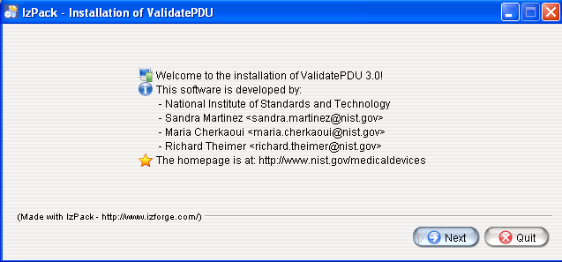
Figure 1

GETTING STARTED

When you start ValidatePDU application you get the following screenshot, figure 2:

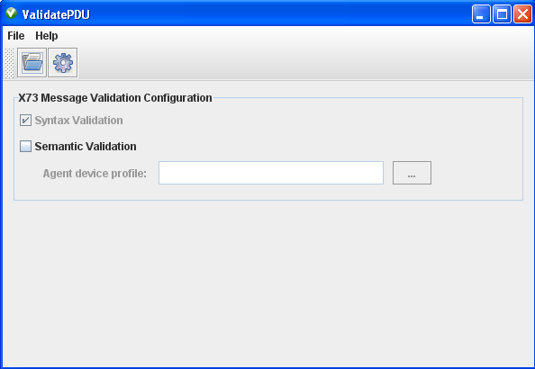
Figure 2

To perform validation of a message, first, select the “.mder” file that represents your message, by clicking on “open” menu item in the “file” menu. Some test files are provided under “mder” folder. You can select one of the provided “.mder” files to start with.

When you select a file, it is automatically processed and validated syntactically.
You get the screenshot in figure 3.

At the left side of figure 3 we notice a tree representation of the message. The tree follows the ASN.1 definitions provided by the DIM standard. Some fields of the tree might be highlighted in red. When it is the case it means that an error has been detected at their level.
The user has other formats available to display the message: XER and MDER. To switch from one format to another select the appropriate tab at the bottom of the message display panel.

At the right side of the message tree in figure 3 there are four boxes one under the other:

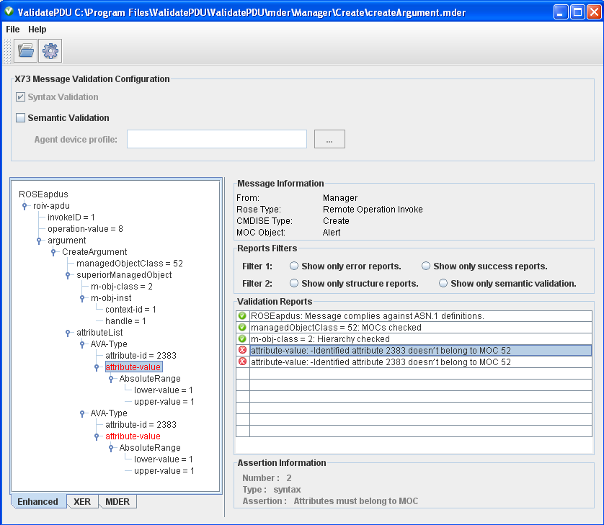
The first box has the title “Message Information”, it provides information about:
Figure 3
- The message sender, whether it is an agent or a manager.
- The Rose PDU type contained in the message (Remote Operation Invoke, Remote Operation Result, Remote Operation Error, Remote Operation Reject, or Linked Invoke).
- CMDISE Type: This describes whether the used service is an Event Report, Confirmed Event Report, Get, Set, Confirmed Set, Action, Confirmed Action, Create or delete
- MOC Object: This is the name of the MOC that provides the service.
- Notification/Method name: the name of notification or method when it is sent in the message.
Under the message information box there is the reports filters box. It allows the user to apply a filter to the validation reports in order to display only relevant validation messages. For example you can display only error reports by using filter1.

The third box contains a table of validation reports. The error reports are preceded by a red icon and the valid ones are preceded by a green icon. Notice that when you select a report, the corresponded field in the tree representation of the message is highlighted.

The last box describes the assertion that a selected validation report, refers to.

To perform a semantic validation of the message, check the box for “semantic validation” in the configuration panel and then select the XML file (i.e. profile) you want to validate the message against. Then click on validate menu item in the file menu to update the reports table. Some test profiles are provided under “xml” folder.

