Version
1.0

VALIDATEPDU
USER’S Guide
ValidatePDU User’s Guide

Background
The ValidatePDU tool was developed to validate the basic syntax and structure of messages passed between communicating medical devices. The Abstract Syntax Notation(ASN.1) from the various IEEE 1073 standard documents was converted into an XML Schema file. This
XML Schema file is then used to validate XML wrapped medical device messages. Figure 1 contains a snippet of ASN.1 from the IEEE 1073.2.1.1 document and the corresponding schema definition created. Figure 2 contains an example of an XML instance file created from the MDCIG IEEE 1073 Baseline Profile Demonstration Project Messaging Specification Document. The XML instance file is an example of a CREATE Context Scanner(Manager to Agent) message.

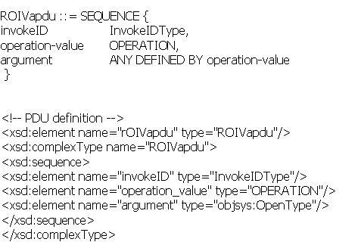

ASN.1 for a Remote Operation Invoke and corresponding schema definition

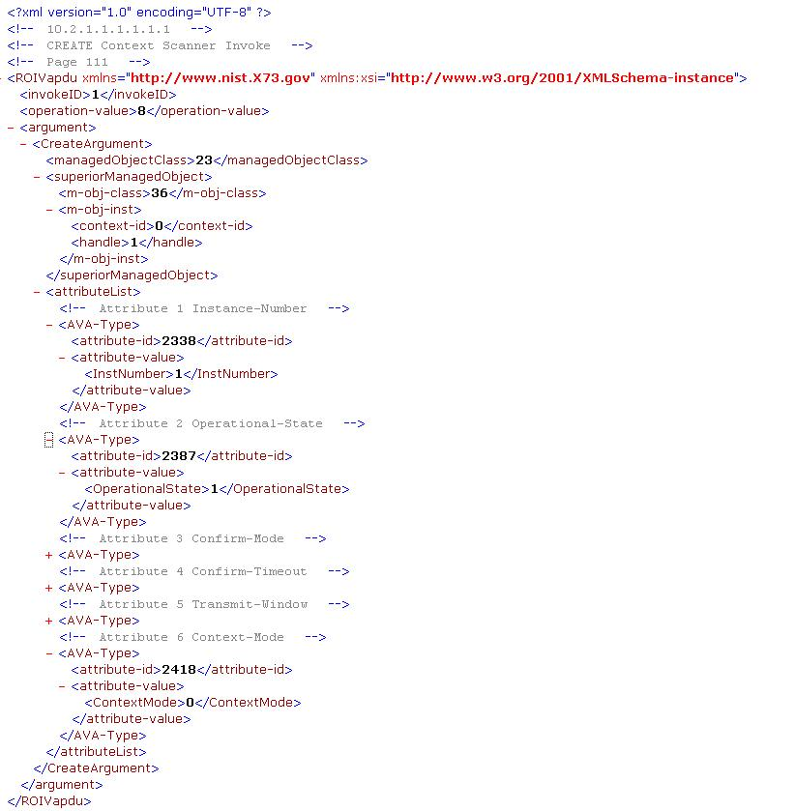

Installation
Java 1.4.2 or later is needed to compile and execute the code.

Click on ValidatePDU to download the ValidatePDU Tool.

Unzip the VALIDATE-1.0.ZIP file. This should create the following directories:

- C:/X73-Tool/xml XML instance files created
from the MDCIG IEEE 1073 Baseline Profile Demonstration Project Messaging Specification Document.

- C:/X73-Tool/src Java source files

- C:/X73-Tool/Readme.html Installation instructions

- C:/X73-Tool/Modified_X73-FINAL.xsd XML Schema file created
from ASN.1

- C:/X73-Tool/x73-Tool-020406.jar JAR file containing compiled
Schema Java types.
Download and unzip XMLBEANS(Version 2.1.0)
Add the following files to you CLASSPATH
c:/x73-Tool/x73-Tool-020406.jar c:/xmlbeans-2.1.0/lib/jsr173_1.0_api.jar c:/xmlbeans-2.1.0/lib/xbean.jar c:/xmlbeans-2.1.0/lib/xbean_xpath.jar
Running the ValidatePDU Tool

Go to source directory

cd C:/X73-Tool/src

Compile and execute the Validate Tool using the following two commands:
javac *.java java ValidatePDUManagementView
The ValidatePDU main screen should pop up.
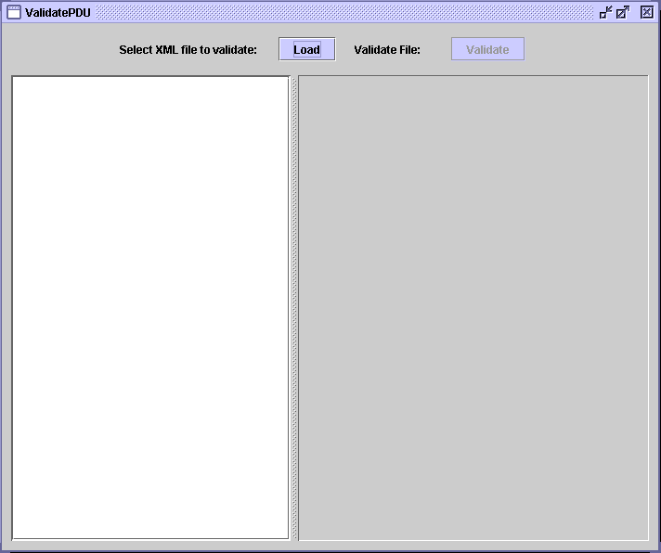
Click on Load

This Screen appears after selecting a file and clicking on Load
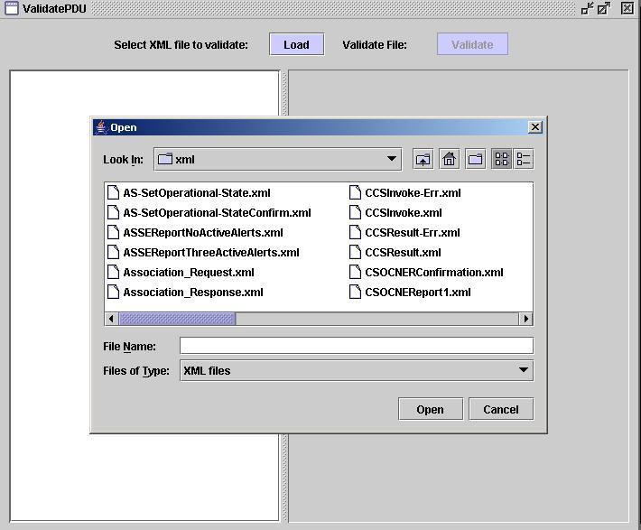
Highlight a File
Click on Open

After the file has been loaded the following screen will appear. The left hand panel contains a JTREE representation of the XML instance file.
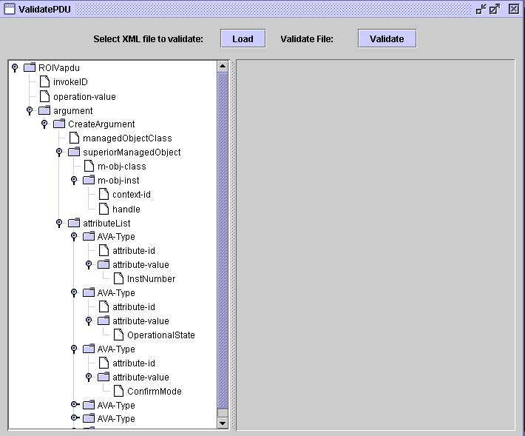

Click on Validate
The file selected will now be validated against the schema.

The following screen will appear if the file has been successfully validated. Notice the green background which signifies a successful validation.

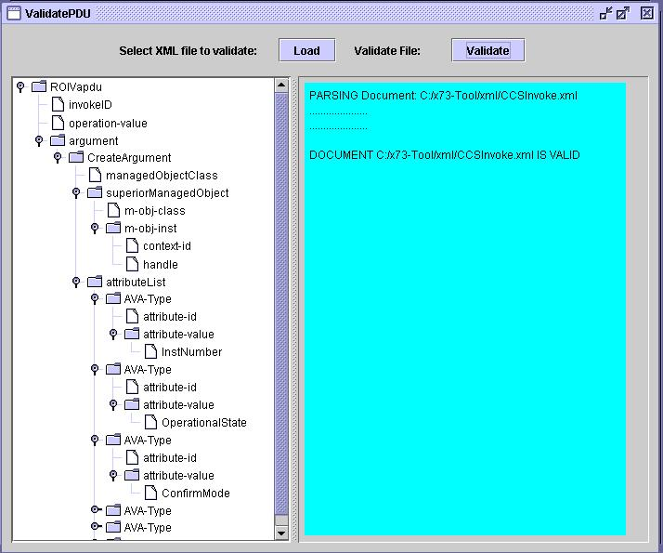

The following screen will appear if the validation is unsuccessful. Notice the red background on the right hand panel which signals unsuccessful validation.

